January 12, 2005

A Summary of Coho Salmon Aging Problems and Aging Validation Studies in Southeast Alaska

Leon Shaul, Coho Research Project Leader

Commerical Fisheries Div., Alaska Dept. of Fish and Game

Douglas

One of the first tasks undertaken when the coho research project was established in this Southeast Alaska in 1969 was to collect and age scales from fisheries throughout the region. Early readers recognized that determining the freshwater age of coho salmon was a difficult and uncertain task, but it was not until 2 1/2 decades later that we realized just how uncertain. Substantial annual collections of fishery and escapement scales were aged from the early 1980s through the mid-1990s. Occasional cases in which collections aged by independent readers were assigned far different ages than those assigned by other readers provided impetus to validate aging for this species. Craig Farrington who was responsible for most coho salmon aging in the early 1990's decided to conduct an aging validation experiment at Auke Creek near Juneau. While his results have unfortunately never been published, they provided the impetus for further work on this problem.

Auke Creek Study

Based on years of scale reading, the Auke Creek coho stock was thought to have virtually no age-1 coho smolts (to the extent that NMFS tried using inseason aging to detect and remove all age 1.1 fish which were believed to be hatchery strays from a nearby marine release site). Regular aging conducted for well over a decade at the time indicated that age-3 smolts formed the most abundant age class, on average. Craig Farrington, Jerry Taylor (NMFS) and others incubated eggs from 1992 Auke Creek spawners and planted them as fin clipped unfed fry in suitable coho habitat in Auke Lake and Lake Creek (inlet) in late May 1993. In 1995, they captured young-of-the-year nomad fry at the weir, marked them with an adipose clip and half-length CWT and planted them in three release sites (different code for each site) in early to mid-June.

In both studies, all marked smolts were sampled for scales at the weir and CWT'd smolts from the second study were sacrificed for their tags. Given what was "known" about the age of Auke Creek coho salmon including particularly the scarcity of age-1 smolts, it was a major surprise when 518 clipped fry were found in the 1994 migration of 7,416 smolts. Even more interesting was the fact that they were represented in all size categories, including six marked smolts in the extra-large category (>125 mm). The following spring (1995), only 64 marked age-2 smolts emigrated in a total population of 4,864 smolts averaging 129 mm, with over half (35) of the marked smolts in the largest size category (>125 mm).

In 1996, 64 marked fish were found in a total population of 3,963 smolts of which 62 had tags from the 1995 marking (brood year 1994) and two did not have marks. The tagged age-1 smolts averaged 110 mm (range 94-130 mm). In spring 1997, 12 marked smolts were recovered (of which 10 had CWT's) from a total migration of 6,207 smolts. All ten were age-2 smolts in the extra-large (128-150 mm) category.

Whereas age-3 smolts had been thought to predominate in most years, the results of the two fry marking experiments indicated that about 86-89% of the smolts were age-1 with age-3s being insignificant. Two experienced scale readers took a blind test with 105 known-age Auke Creek scales. Both readers rejected three scales as unreadable. Out of the remaining 102 scales, one reader aged two (2) correctly and the other aged one (1) correctly for an average aging accuracy rate of 1.5%.

Current Studies

Based on Craig's findings, we realized that we couldn't just continue sending scale readers into the dark room while plugging their results into brood tables. We did not have additional funds for the task, so incorporated fry marking into smolt projects on two of our primary long-term indicator stocks that represent substantially different habitats.

We began marking fry up to 38 mm in length in the Berners River in May 1996 and at Hugh Smith Lake in May 1997. The small cut-off size essentially eliminates fish with significant growth after emergence and was chosen because we've collected rearing coho salmon very near emergence size in both the Berners River and Hugh Smith Lake in late October-early November. The tagging objective is about 5,000 fry in each system. In recent years, Berners River fry have been tagged with different tag codes (about 3,000 on each code) and released at two different sites (one a major channel and the other a prime beaver pond complex). Small dip nets are used to capture fry in main channel areas of the Berners River where they aggregate around the spillways from beaver ponds. At Hugh Smith Lake, dip nets are also deployed in the two major inlet streams. A fyke net or beach seine is also used at Hugh Smith, depending on conditions and fry movement. Fry are transported to the outlet for tagging and released back at the inlets where they were captured.

Smolts are sampled for ad clips and CWT's (using a field detector) at both locations. A sample of about 200 tagged smolts per system per year is sacrificed to obtain known-age samples. The first 100 tagged fish are collected and a sub-sample thereafter. Older, larger smolts tend to migrate earlier so this helps insure that we obtain some known-age samples from age-2 and 3 smolts. Smolt capture on the Berners River is less complete (18% of total smolt production is marked on average) and targets more selected habitats with beaver dam drop traps and an incline plane trap on a major slough. Survival and recapture rates are much higher from the major pond complex compared with the slough but scale patterns in the pond may be less representative of the overall system. The Berners River study has also documented some interesting long-distance movement of tagged juveniles from other systems in upper Lynn Canal.

Molly Kemp, our division's primary coho scale reader in Southeast, has expressed concern that adult scales are more difficult to age, so we are planning to produce some known-age adults from Hugh Smith Lake by placing an external mark (identifiable on adults) on smolts that are surplus to the sample we sacrifice for tags. We have also discussed trying produce adult known-age samples for the Berners River by matching scales with all heads collected in the Lynn Canal fishery. However, the amount of labor involved would be very high to produce a very small number of useable samples from either the fishery or escapement without a quick method of detecting half-length tagged fish.

When we initiated the current study, DFO was using fin ray cross-sections to age some northern B.C coho smolt collections. We decided to collect the samples necessary to validate fin rays and otoliths as well as scales. However, we have not had the funding and labor necessary to evaluate these alternative structures, and my understanding is that DFO has reverted to back to using scales in most cases in which they had been using fin ray cross sections. While we have no current plan to process and analyze them, we have continued to collect preserved matched samples of known-age smolts that could be used to evaluate alternative age structures whenever interest and funding is available.

Based on our observations so far for Hugh Smith Lake and the Berners River, problems in accurate aging appear to vary from river to lake systems. Aging problems at Hugh Smith Lake appear somewhat similar to Auke Lake. Using the known-age samples as a guide, Molly Kemp has re-aged the Berners River adult collection and we are in the process of updating the escapement goal. Her recent ages for 1985-1988 Berners adult scales averaged 38% age 1.1, 62% age 2.1 and 0% age 3.1 compared with original ages averaging 30% age 1.1, 66% age 2.1 and 4% age 3.1. Age composition estimates assigned to Berners River smolts for the 1989-1993 smolt migration years (prior to results of age verification research) averaged 23% age 1, 75% age 2 and 2% age 3 (Table 1). The age composition of known-age smolts sampled from the Berners River in 1998-2004 averaged 63% age 1 and 36% age 2 (weighted to account for the annual number of tagged fry released). Two known-age 3 smolts have been recovered from the Berners River to date. The average age assigned to known-age smolts sampled from the Berners River in 1999-2004 was 1.4 years compared with an average age of 1.8 years assigned to 1983-1993 smolts sampled and aged from the same locations in the Berners River before the first results were available from the Auke Creek study. Smolt samples from the Berners River were primarily from select pond habitats in the lower valley and may not accurately reflect the age composition of the entire smolt population in the system. However, the known-age and pre-study smolts were collected from the same habitats, so a comparison of the period averages should be indicative of error in pre-study aging (assuming there has not been a temporal shift in age of seaward migration).

Aging differences for the lake systems have been substantially greater. Age composition estimates assigned to Hugh Smith Lake smolts for the 1983-1993 smolt migration years (prior to results of age verification research) averaged 14% age 1, 61% age 2, 24% age 3 and 1% age 4 (Table 2). The age composition of known-age smolts sampled at the outlet of Hugh Smith Lake in 1999-2004 averaged 85% age 1 and 15% age 2 (weighted to account for the annual number of tagged fry released). This result is consistent with the ages of known-age smolts that migrated from Auke Creek in 1994-1997 (86-89% age 1). The average age assigned to known-age smolts sampled at Hugh Smith Lake in 1999-2004 (1.1 years) was 1-year younger than the average age assigned to 1983-1993 smolts (2.1 years) sampled and aged before the first results were available from the Auke Creek study. Whereas age 3 was the second most prevalent age assigned to Hugh Smith Lake smolts before 1994, no known-age 3 smolts have been recovered from that system to date.

A main cause of upward bias in aging of coho salmon is the presence of extra checks that are confused with annuli. The reason for these checks is unclear, although we have speculated that it occurs during periods of slow growth and stress during prolonged dry periods in the summer. We are at a loss to explain why this problem seems to be more apparent in lake systems that have a more stable environment compared with non-lake systems.

Outlook

We are in the last year of a small SSSF grant ($12.5K/year) that helps support the aging validation work and we will complete an analysis and final report for the project in the next year. The Berners River known-age collection has been digitized using opscan equipment and the Hugh Smith Lake collection will be finished in March. Kent Crabtree (with assistance from John Wilcox) will develop models to classify the known age samples based on scale variables. He will evaluate year-to-year and system-to-system consistency in the variables and hopefully be able to recommend some useful guidelines for coho scale reading.

Scale patterns are highly variable and it is sometimes very difficult to distinguish annuli from false checks. We are guessing that the best predictive variables that come out of the analysis of the digitized images will be fairly simple, such as total number of circuli or total distance in the freshwater zone. There appear to be some cases in which a fairly strong delineation exists between the ages in the total number of circuli. We will try to quantify the degree to which these features are consistent from year-to-year and from system-to-system.

We are finding a high degree of variation among patterns within a system in a single year and also from one year to the next. Scales seem to fall into three categories. First, there is a substantial proportion that can be aged with good accuracy and precision once the reader figures out the predominant pattern for a particular system. However, there are other samples (perhaps 5%) that have clear but misleading patterns that lead the reader to the wrong age even when following the guidelines they have established based on the majority. Finally, there are other scales that have confusing patterns and are difficult to classify at all.

In addition to the objectives of improving the accuracy in scale reading by our project and producing a quantitative assessment, our electronic library of images of coho smolt scales of known age will be available as a reference and potential aid for anyone attempting to age coho scales.

In the mean time, we plan to continue marking newly emerged fry at the Berners River and Hugh Smith Lake until we are able to determine if consistent guidelines can be applied to aging from year-to-year and the extent to which ongoing generation of known-age samples is advisable. Preliminary observations indicate that predictive variables are probably not highly stable from year-to-year. It also appears that criteria for determining age will have to be fairly specific to the system or at least the type of system. Criteria that seem to work best for Berners River scales appear to give very misleading results for Hugh Smith scales. The predominant type of habitat seems to be a major factor in the pattern seen in scales and Hugh Smith Lake scale development appears to be closer to Auke Creek (another lake system) than the Berners River. Sue Millard, who also ages coho and chinook scales has used our known-age collection as a guide in her aging of mainland river and lake collections for the Sport Fish Division. She has been a strong proponent of expanding this type of study to more systems.

It seems clear at this point that we will never attain close to 100% accuracy in aging individual scales. Our hope is to efficiently classify those samples that lend themselves to accurate classification and find some way of minimizing bias in classifying the remainder of samples.

It's important for people running projects to understand the problems in aging of coho salmon, so efforts can be made to develop appropriately informed, experienced scale-reading staff and to conduct additional aging validation studies where needed and feasible. Unfortunately, achieving accurate aging of coho scales (for more northern systems at least) is not as simple as many of us who overseeing coho assessment projects would like to think. It's an important remaining challenge to developing accurate stock assessment for coho salmon in Southeast Alaska.
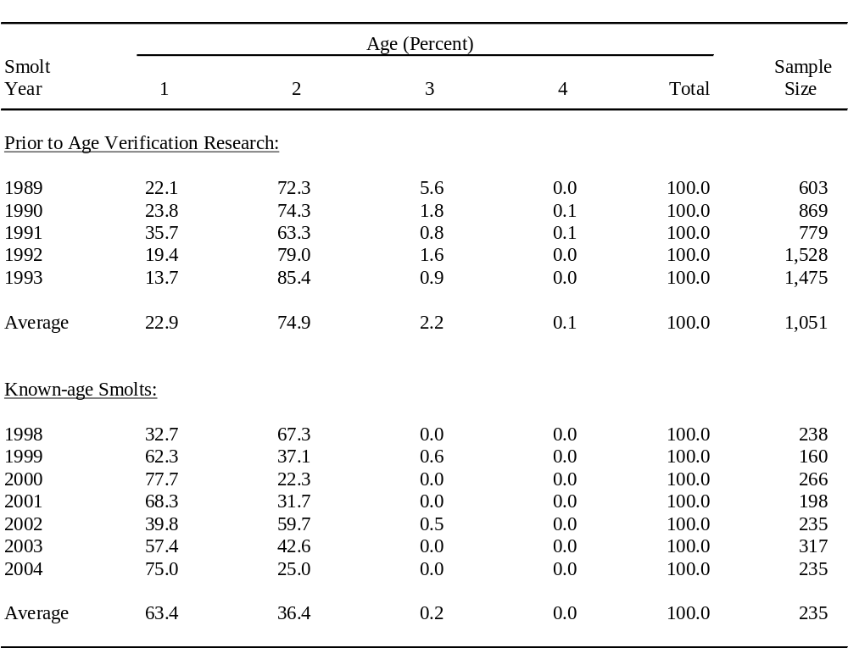
Table 1. Estimated age composition (percent by age class) of Berners River coho salmon smolts prior to age verification research in Southeast Alaska (1989-1993) compared with the age composition of known-age smolts migrating from the Berners River in 1998-2004. Known-age smolt percentages are weighted by the inverse of the number of newly emerged fry marked by brood year.

Table 2. Estimated age composition (percent by age class) of Hugh Smith Lake coho salmon smolts prior to age verification research in Southeast Alaska (1983-1993) compared with the age composition of known-age smolts migrating from Hugh Smith Lake in 1999-2004. Known-age smolt percentages are weighted by the inverse of the number of newly emerged fry marked by brood year.
