Sarah Power Dec. 13, 2018 preliminary analysis for Heather Finkle, Birch Foster, cc Kevin Schaberg.

I tried various options for the end anchor point. In order to allow the data to speak for the curve, (and less so the introduced anchor) there were two things I could adjust, the day of the year the anchor point would fall on and the weight that point would have. Moving it to September 1 seems to give the point a similar distance from the curve as the early anchor of May 25. Once moved it didn’t matter which weight I gave to it, the curves looked similar to each other, but different than the original graphs (Graph set A).

I tried a weight of 1600, mean(1/var), min(1/var), and 0 weight (Graph sets B, C, D, and E respectively.) They are ordered going from giving the end anchor point the most weight to the least. Graphs sets B through E are almost indistinguishable from each other. You will notice they are different from Graph set A particularly in years 2015, 2017, and 2018. These are more recent years and perhaps they also correlate with warmer ocean temperatures and/or less favorable conditions for the run.

For analysis purposes I would suggest moving the anchor dates out to September 1 and changing the weight to 0, to let the rest of the data speak for itself.

One could argue that current escapement goals are built on early run escapement being finished by August 1. To that I would say escapement goals are in the process of being reevaluated. For past years perhaps we will be able to visit run timing using the distribution method to see how run timing may have changed though time.

Graph set A: Anchors: 5/25 with 0 weight, 8/1 with inv_var =1600 weight:

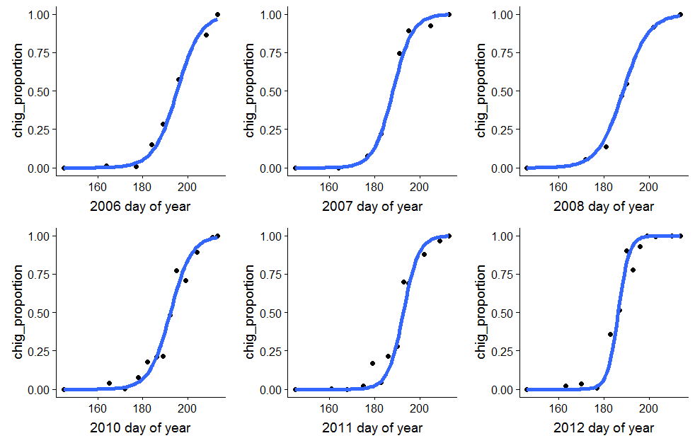

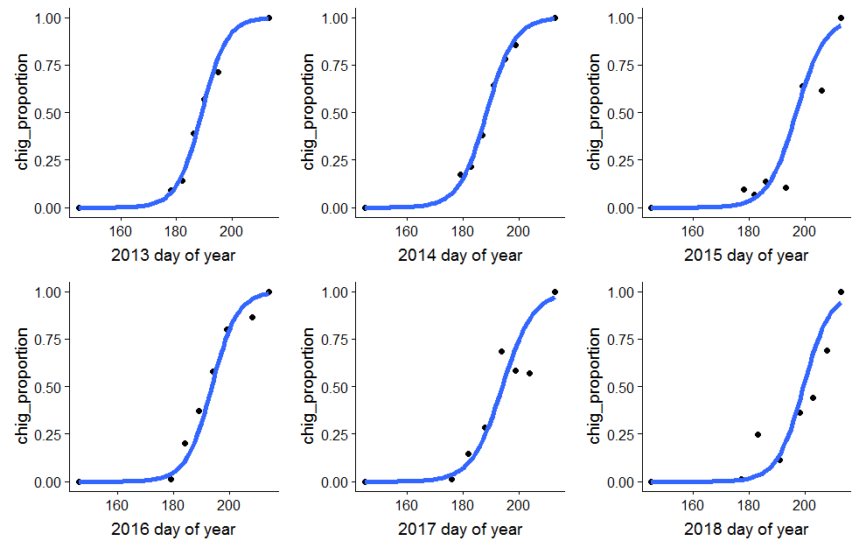

Graph set B: Anchors: 5/25 with 0 weight, 9/1 with inv_var =1600 weight:

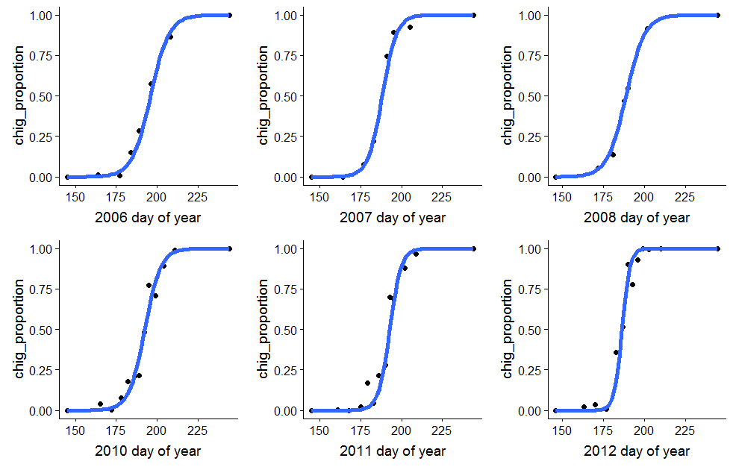

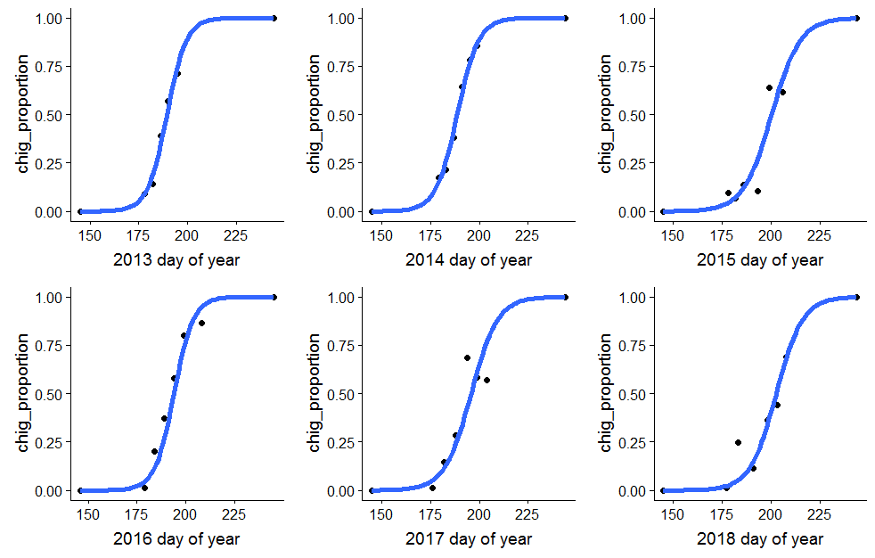

Graph set C: Anchors: 5/25 with 0 weight, 9/1 with mean(inv_var) weight:

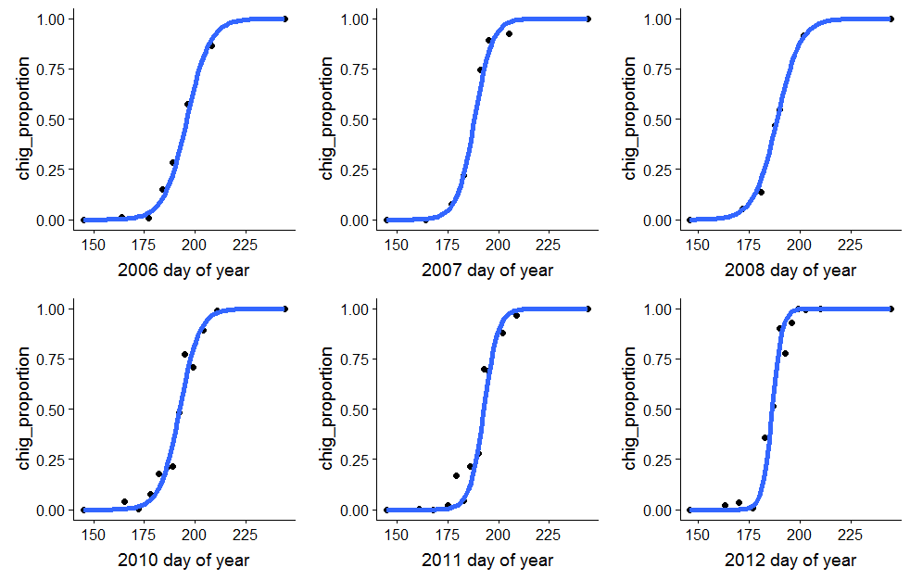

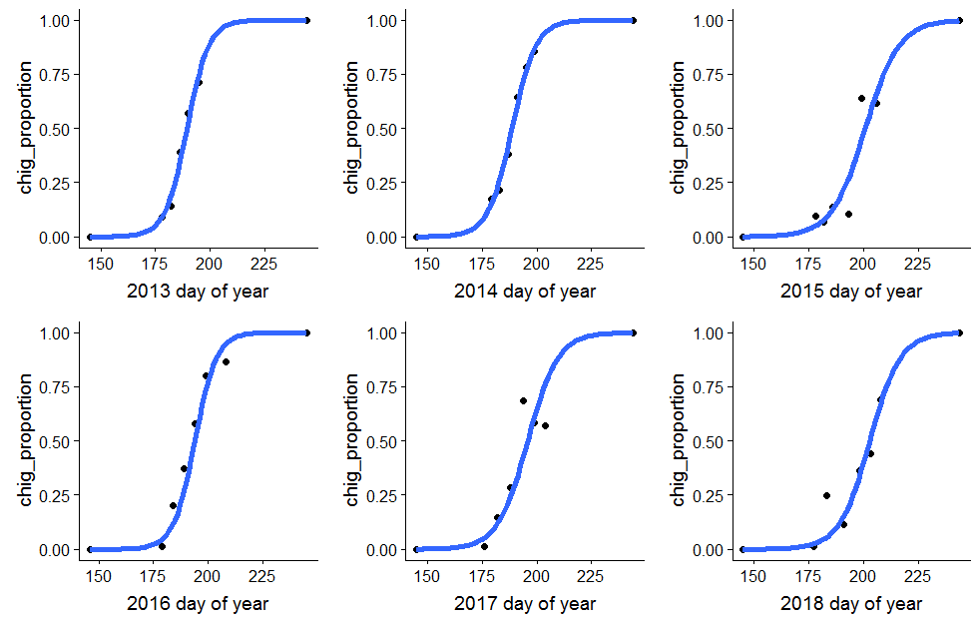

Graph set D: Anchors: 5/25 with 0 weight, 9/1 with min(inv_var) weight:

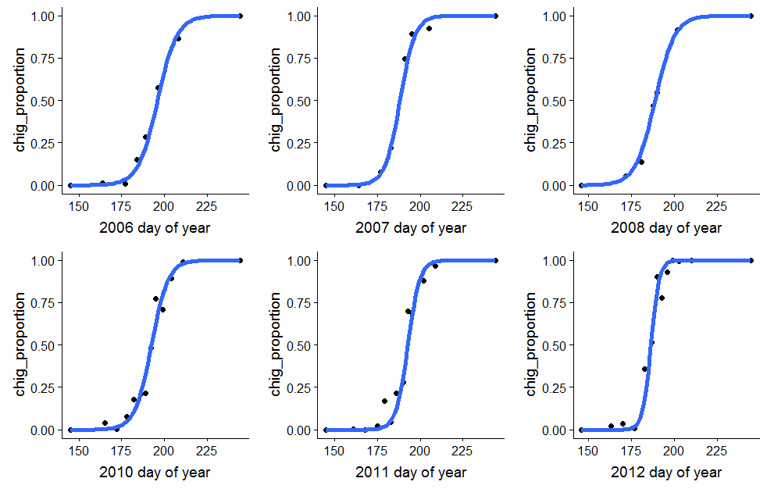

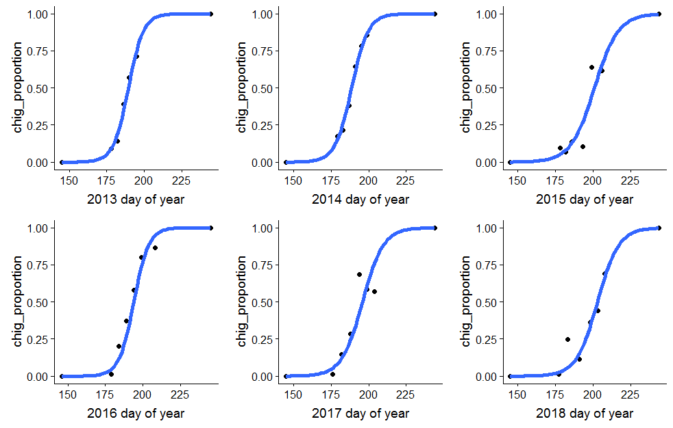

Graph set E: Anchors: 5/25 with 0 weight, 9/1 with 0 weight:

