2019 Chatham Strait Sablefish Stock Assessment

Authors: Jane Sullivan, Ben Williams, and Andrew Olson

To: Andrew Olson

Cc: Chris Siddon, Ben Williams

# Assessment timeline

Presentation to industry: Tuesday, April 30

Initial Draft: Friday, March 1

Internal ADF&G review: TBD

Final version approved by reviewers & managers: TBD

Public announcement of formal quota: TBD

# Summary table

|  |  |  |  |
| --- | --- | --- | --- |
| Quantity | 2018 | 2019 | Percent change (%) |
| Exploited abundance (2018 value from last year) | 1,931,191 | 2,486,487 | 28.8 |
| Exploited biomass (round lb, 2018 value from last year) | 16,454,232 | 20,146,483 | 22.4 |
| $$F_{ABC}=F_{50}$$ | 0.0635 | 0.0632 | -0.4 |
| Mortality from discards (round lb) |  | 19,156 |  |
| Recommended $ABC$ (round lb) | 965,354 | 1,058,840 | 9.7 |

# Summary

* The commercial catch in Chatham Strait in 2018 was 874,788 round lb (Figure 1).
* The 2019 recommended Allowable Biological Catch ($ABC$) for Northern Southeast Inside Waters (NSEI - Chatham Strait) at a fully-selected fishing mortality of $F_{50\%}$ = 1,058,840 round lb (Table 1). This is a 93,486 lb increase (9.7%) from the 2018 $ABC$ of 965,354 round lb.
* The population estimate from the 2018 mark-recapture study in Chatham Strait is 2.70 individuals (Table 1). This is an increase from the forecasted 2017 mark-recapture estimate of 1.93 sablefish. The forecast abundance for 2019 is 2.49 individuals (Figure 2; Table 1). Note that the forecasted abundance will always be lower than the current year’s estimate of abundance under the current management model.
* Despite the large increase in abundance, fish younger than 7 years comprise approximately 20% of the forecasted abundance for 2019 and less than 50% of females are estimated to be mature at this age (Figure 3). Using a discard mortality of 16%, the estimated mortality from discarding small fish is 19,156 round lb. We recommend that this discard mortality is accounted for in the calculation of the Annual Harvest Objective ($AHO$). The methods used to estimate discard mortality are described in Sections I and IV of this document.
* Female sablefish continue to be retained in greater proportion in the commercial fishery. The proportion of females observed in the commercial catch is greater than the proportion of females in the longline survey for all ages (Figure 4).
* Catch per unit effort (CPUE) in the 2018 ADF&G Chatham Strait longline survey decreased relative to 2017 from 0.23 to 0.21 numbers per hook (8.7%) (Figure 5). This reflects a 4.5% decrease from the ten year average CPUE of 0.22 sablefish per hook. Survey CPUE has been stable since 1997 and has not tracked trends in abundance estimated from mark-recapture studies (Figure 2).
* Commercial longline fishery CPUE increased relative to 2017 from 0.81 to 0.97 lb per hook (18.8%) (Figure 6). This increase could be attributed to the large influx of fish recruiting to the fishery from the 2014 year class. However, fishery CPUE in 2018 was only a 14.0% increase from the ten-year average CPUE of 0.85 lb per hook. Fishery CPUE has been relatively stable since 2006.
* The 2013 and 2014 year classes were well-represented in the ADF&G longline survey age composition (Figure 7). The 2014 year class was first observed in the 2016 commercial fishery age-composition data as age-2 fish (Figure 8).
* The NSEI sablefish assessment was developed as a reproducible research product (de Leeuw 2001). It is hosted publicly on the web-based version control service GitHub at <https://github.com/commfish/seak_sablefish>. This product is considered conditionally reproducible, meaning that potential users must formally request any confidential data sourced in the code to produce the full assessment (Schwab et al. 2000). However, survey and other non-confidential data are made available, and all queries and subsequent transformations to the data are included in the analysis.

# Section I: Changes to the NSEI sablefish assessment for 2019 relative to 2018

1. Fishermen in State waters are allowed to discard small, unmarketable fish as long as they are healthy (i.e not dead, sand flea bitten, etc.). Due to the high volume of small fish encountered in the 2017 and 2018 fisheries, discard mortality was incorporated directly into last year’s population dynamics model (Sullivan et al. 2018). These methods were refined in 2019 using equations commonly applied in size-structured models to king and tanner crab stocks in Alaska (e.g. Zheng and Siddeek 2018). Because data on discards is not collected, the probability of a fish being retained was informed by processor grade definitions and prices and modeled as a function of weight, sex, and age (Figure 9). This method of accounting for discards shifts fishing mortality toward older ages, especially for males that are slower growing than females (Figure 10). Stachura et al. (2012) estimated discard mortality of sablefish to be 11.7% using release-recapture data from a longline survey in Southeast Alaska. However, it is likely that discard mortality in a fishery is higher due to careful fish handling on survey vessels during tagging experiments. We therefore used 16%, the discard mortality rate from the Pacific halibut fishery (Gilroy and Stewart 2013). The halibut fishery is assumed a good proxy for sablefish, because the fisheries utilize similar gear and frequently the same vessels and crew participate in both fisheries. Moreover, both species are considered hardy, do not experience barotrauma, and are known to survive well in laboratory experiments.
2. In 2018 the abundance estimate of exploited abundance used to determine the $ABC$ was adjusted to account for uncertainty in recent recruitment events. Estimates of a single recruitment event can decrease significantly as the year class is observed over multiple years of age compositions, and the 2014 year class is now estimated to be 30% less than it was last year (Hanselman et al. 2017, Figure 3.57, Hanselman et al. 2018). In 2018, the adjustment was made by using the 15th percentile from the posterior distribution of the mark-recapture abundance estimate instead of the mean as the input to the forecast model (Sullivan et al. 2018). This adjustment was a subjective, precautionary measure aimed at stabilizing the fishery by slowing the rate of increase in harvest and reducing the risk of overfishing if the 2013 and 2014 year classes are estimated to be smaller as subsequent years of data are added (i.e. negative retrospective bias).

We do not recommend using the 15th percentile method again in 2019. Instead, we recommend that conservation measures are made through the management framework by accounting for discards of small fish in the fishery. Mortality from discarding small fish is estimated to be 19,156 round lb in the 2019 fishery, and we recommend this be deducted from the $ABC$ in the calculation of the $AHO$ (Table 1). In addition, we recommend continued work on an integrated age-structured model, so that methods for incoporating uncertainty into the estimation of management reference points can be improved in the future.

1. In 2018 and in past assessments, fishery weight-at-age was used to calculate exploited biomass and $ABC$. In 2019, longline survey weight-at-age predicted from a weight-based Ludwig von Bertalanffy growth model was used for all calculations. Longline survey weight-at-age provides a more accurate portrayal of size-at-age of the exploitable population, because it includes smaller fish that would be discarded in the fishery (Figure 11). The fishery opens directly following the end of the longline survey, as such, it is unlikely a seasonal effect could account for the differences in fishery and survey weight-at-age.
2. In past assessments the plus group (age 42+) weight-at-age was calculated as the empirical mean weight from all samples aged 42 and older. Because this estimate was influenced by outliers, we now use the predicted value for age-42 fish from the weight-based von Bertalanffy growth model used to estimate weight-at-age for all other ages. Weight-at-age and maturity estimates used in the yield-per-recruit model, estimate of biomass, and $ABC$ calculations are presented in Figure 11.
3. A preliminary age-structured model is presented as an Appendix to this report. Once reviewed by managers and stakeholders, it will be presented as an alternative to the current management model.

# Section II: 2018 Acceptable Biological Catch (ABC)

The 2018 marking survey released 9,678 tagged fish. We accounted for tags recovered outside of the NSEI or period of recapture, natural and fishing mortality, and differences in the size of fish captured in the pot survey and the longline fishery (Section III). Alternative candidate models that accounted for movement in and out of Chatham Strait and incorporated fishery CPUE were explored.

The 2018 abundance estimate of 2.70 was partitioned into sex-specific age classes using the 2018 commercial fishery age compositions and projected into 2019 (Section IV). This produced an estimated forecast of exploited abundance of 2.49 individuals for 2019. Multiplying by longline survey weight-at-age produced a forecast of exploited biomass of 20,146,483 round lb (Table 1). Mean weight-at-age was predicted from a weight-based Ludwig von Bertalanffy growth model fit to survey weight and age data from 1997 to 2018 (Figure 11).

Fishing mortality $F$ was obtained from a yield-per-recruit analysis and fixed to $F=F_{50}$, where $F_{50}$ corresponds to the $F$ that would reduce the spawning biomass to 50% of the unfished biomass. Biological inputs to the yield-per-recruit model included longline survey weight-at-age and estimated maturity from the longline survey (Figure 11). An $ABC$ of 1,058,840 round lb was calculated as the landed portion of the total catch under $F_{50}$. The discarded portion of the catch that is assumed to die given a 16% discard mortality rate was calculated as 19,156 round lb (Section IV, Table 1).

Unlike last year, the resultant changes in $ABC$ from 2017 to 2018 are different between NOAA and ADF&G. Although the Federal stock assessment for sablefish reported an increase in the survey index and had projected an increase in biomass in 2018, they saw a decrease in estimated spawning biomass and recommended that the Allowable Biological Catch for 2019 stay constant from 2018. The recommended Federal $ABC$ for the 2019 commercial longline sablefish fishery is 15,068 tons, a 0.7% increase from the 2018 $ABC$ of 14,957 tons after whale depredation was accounted for (Hanselman et al. 2018). This reflects a 45% reduction from the maximum permissable $ABC$ (Hanselman et al. 2018). This recommendation was accepted by the North Pacific Fishery Management Council in December 2018. Here a 9.7% incease is recommended. As in past years, it is important to remember that the $F_{ABC}$ presented in the summary table above is not directly comparable to the Federal harvest policy of $F_{40\%}$, because the methods used to assess abundance and determine $F$ values are different.

# Section III: Mark-recapture analysis

The mark-recapture study forms the foundation for current sablefish management in Chatham Strait. The most commonly used method for abundance estimation and the model that was used for many years by ADF&G is the Chapman estimator:

$$N=\frac{(K+1)(n+1)}{k+1}-1,$$

where $N$ is the estimated population abundance, $K$ is the total number of individuals tagged in the population, $n$ is the number of individuals checked for marks at the time of recapture, and $k$ is the number of marked individuals out of $n$. The variance of the abundance estimate is calculated as

$$var(N)=\frac{(K+1)(n+1)(K-k)(n-k)}{(k+1)^{2}(k+2)}.$$

A description of all model variables is found in Table 2, and a summary of the mark-recapture data since 2005 is found in Table 3. ADF&G did not conduct a tagging survey in 2011, 2014, or 2016 due to budget restrictions.

There are four primary assumptions integral to the Chapman estimator, which have been discussed in detail in previous iterations of this memo (Williams and Van Kirk 2017, Dressel 2009, Mueter 2010). Briefly, these assumptions include a closed population (no movement in or out of the study area), equal probability of recapture, sufficient time between marking and recapture to allow for marked individuals to be randomly distributed throughout the unmarked population, and no tag loss or errors. Violations to these assumptions can be mitigated through study design, treatment of data, and changes to model structure. A combination of approaches were utlized to meet or relax these assumptions including:

1. Potential differences in the size selectivity between the pot survey and longline survey and fishery were accounted for by (1) estimating growth between May and August using known length recaptured individuals, (2) comparing the cumulative length distributions between tagged and recaptured fish, and (3) adjusting sample sizes accordingly. Despite the differences in selectivity between pot and longline gear, minimal differences in the cumulative length distributions between marked and recaptured since 2005 were found, which suggests that in most years the size distribution tagged in the pot survey well represents the the fishery (Figure 12). The 2018 survey was a notable exception; the size distribution of the recaptured fish was much larger than that of the released (Figure 12). A record number of fish were tagged in 2018, and catch rates were so high that the number of pots fished in a set was reduced from 40 to 20. Because a large number of small fish were tagged and none of the tags were recovered in the fishery, 518 tags were removed prior to analysis (Table 3).
2. To assess the assumption that there is sufficient time between marking and recapture to allow for tagged individuals to be randomly distributed, movement in the population between statistical areas was explored. Results suggest that the population is sufficiently mixed across study years (Figure 13). These findings are consistent with Mueter (2010) and lend support to the current study design of the mark-recapture project.
3. A suite of alternative models that are stratified by time were developed in order to account for natural and fishing mortality, potential changes in the probability of recapture, and tag loss from other fisheries or outside the NSEI. This allows for greater precision in the estimates of abundance, as each time-period compensates for changes in $K$, $n$, and $k$.
4. To account for potential violations of the closed population assumption, two of the alternative models estimate an additional parameter for migration (see Models 2 and 4, Table 4).
5. To further address a potential change in capture probability through time, two of the alternative models incorporate fishery CPUE data to account for seasonal changes in catch rates or fish abundance (see Models 3 and 4, Table 4).

The mark-recapture models used in this analysis are based on analyses by Mueter (2010). Population estimates from a simple Chapman estimator (Model 0) are compared with estimates from several extensions of a stratified Peterson estimator that account for changes in capture probability through time, natural and fishing mortality, migration, and seasonal trends in catch rates. These alternative model structures (Models 1-4) are implemented in the Bayesian open source software JAGS 4.3.0 (Depaoli 2016). The Bayesian approach is preferred, because it allows the incorporation of prior information and additional parameter uncertainty into the model. Previous methods used arbitrary break points (e.g. 5 or 10 days) to define temporal strata throughout the fishing season (Mueter 2010, Van Kirk et al. 2016). Here cumulative catch over time is used to define temporal strata. A combination of convergence criteria, deviance information criterion (DIC; Spiegelhalter et al. 2002), and an examination of seasonal trends in abundance was used in model selection.

## Model 1: Time-stratified Petersen estimator

The abundance of sablefish in Chatham Strait in a given time period $N_{i}$ was assumed to follow a normal distribution with an uninformed prior (precision = $1×{10}^{-12}$) centered on past assessments’ forecast of abundance.

For any given time period $i$ (see Table 2 for variable definitions):

$$K_{i}=\left\{\begin{matrix}(K_{0}-D_{0})*exp(-M*t_{i}) & i=1 \\ (K_{i-1}-k_{i-1}-D_{i-1})*exp(-M*t_{i}) & i>1\end{matrix}\right.$$

.

$$N_{i}=\left\{\begin{matrix}(N_{i}*exp(-M*t_{i}) & i=1 \\ (N_{i-1}-C_{i-1})*exp(-M*t_{i}) & i>1\end{matrix}\right.$$

The probability that a sablefish caught in a given time period is marked $p_{i}$ is informed by the ratio of marks in the population to the total population at that time $K_{i}/N_{i}$. Each $p_{i}$ is assumed to follow a beta prior distribution $p_{i}=beta(α,β)$, where $α=(K_{i}/N_{i})*x$, $β=(1-K_{i}/N_{i})/x$, and a large $x$ indicates confidence in $K_{i}/N_{i}$. Because $N_{i}$ was previously assumed to follow vague normal prior, $p_{i}$ was assigned an informed prior by setting $x$ equal to 10,000.

In a given time period, the likelihood of recapturing $k$ marked sablefish given $n$ sampled individuals follows a binomial distribution, where

$$Pr(k|n,p)=\left({n \atop k}\right)p^{k}(1-p)^{n-k}.$$

The final estimate and credible interval reported for $N$ is the mean $N$ across all time periods.

## Model 2: Accounting for movement

Following Mueter (2010), the time-stratified Peterson estimator was extended by estimating a parameter for net migration $r$. If $r$ is positive, it indicates that there was net positive movement of sablefish into Chatham Strait during the fishery. Conversely, a negative $r$ would suggest net movement out of Chatham during the fishery. Following Mueter (2010), $r$ was assigned a vague normal prior distribution, centered at +5,000 individuals (precision = $1×{10}^{-12}$). This parameter is incorporated into the model with the addition of $r$ into the abundance equation from Model 1:

$$N_{i}=(N_{i-1}-C_{i-1})*exp(-M*t_{i})+r*t_{i}.$$

## Models 3 and 4: Including fishery CPUE data

As an extension to the above models and to account for seasonal trends in abundance and fishing effort, fishery CPUE data was included in the model. An examination of fishery CPUE annually since 2005 (omitted for brevity), shows slight increasing or decreasing linear trends in fishery CPUE over the fishing season. This suggests a change in fish abundance or density throughout the fishing season and that the direction of this change is variable between years. Fishery CPUE in a given time period, defined as number of sablefish per 1,000 hooks, was back-calculated using mean fish weight in the fishery and weight of the landing from fish tickets.

Versions of Models 1 and 2 were adapted to include fishery CPUE data (Models 3 and 4 in Table 4) following the methods in Mueter (2010). Fishery CPUE was assumed proportional to total sablefish abundance in each time period

$$CPUE_{i}=q*N_{i},$$

where catchability $q$ is the constant of proportionality. These models were fit to the mark-recapture and fishery CPUE data by maximizing the combined likelihood, which consisted of a binomial likelihood component for the mark-recapture data and a normal likelihood for the fishery CPUE data. Both likelihood components received equal weights in the combined likelihood, thus fishery CPUE and mark-recapture data contribute equally to the parameter estimation.

## Results and model selection

A total of 32 models (4 models $×$ 8 time periods) were fit for each tagging survey year from 2005 to 2018 (11 distinct years). Trace plots were examined visually, and a convergence diagnostic was used to test the convergence of MCMC chains (Gelman and Rubin 1992). All models converged except for versions of Models 3 and 4 with fewer than 4 time periods. Models 3 and 4 used fishery CPUE data to estimate $q$, so these models require more observations of CPUE (i.e. more time periods) to converge. Therefore, Models 3 and 4 with fewer than 4 time periods were omitted from further consideration.

A combination of DIC and visual examination of trends in abundance estimates were used in the remaining model selection. A tradeoff existed between the number of time periods $P$ and the ability to accurately describe seasonal trends. Consistent with last year, a comparison of Models 1-4 across a range of time periods $P$ showed that the final estimate of $N$ stabilizes after $P≥6$ for most years (Sullivan et al. 2017). Because capturing this temporal trend was a motivating factor in the development of these models, models with $P<6$ were eliminated, and the remaining models were compared using DIC.

The models with the most support in all years were Models 1 and 2 by DIC ($ΔDIC≤2$) (Burnham and Anderson 2003). The point estimate and credible interval for $N$ for the top candidate models for 2018 are found in Table 5. The simple Chapman estimator (Model 0) does not account for natural or fishing mortality or changes in abundance throughout the season but provides a comparable estimate of abundance to Models 1-4 (Table 5). Although Model 2 had statistical support via DIC, the resultant abundance estimates and variance from Model 2 were greater than Model 1 (Table 5). The estimates and credible intervals for net migration ($r$) were wide for all years, and the direction of net migration (positive or negative) was inconsistent across years (Figure 14). Interestingly, Model 2 results in 2018 suggest record migration into Chatham, which could account for the rapid increase in abundance since 2016. Model 4, which includes migration and CPUE data, fit better than Model 3, which was unable to capture the increasing trend in CPUE over the fishery (Figure 15).

Model 1 with $P=6$ was selected for the 2019 forecast. Retrospective analysis shows Model 1 abundance estimates follow a similar trend and general magnitude as past model estimates (Figure 2).

# Section IV: Determining Allowable Biological Catch

Using the abundance estimate in 2018 ( $N_{2018}$ in the equation below), the vulnerable abundance-at-age for ages 2+ in 2019 was obtained by partitioning the estimated exploited abundance into cohorts using commercial fishery age compositions and applying fishing and natural mortality:

$$N_{2019,s,a}=\left\{\begin{matrix}\frac{N_{2018,s,a-1}p_{s,a-1}ϕ_{s}}{S_{a-1,s}}exp(-Z_{2018,s,a-1}) & a_{0}<a<a_{+} \\ \frac{N_{2018,s,a-1}p_{s,a-1}ϕ_{s}}{S_{a-1,s}}exp(-Z_{2018,s,a-1})+\frac{N_{2018,s,a}p_{s,a}ϕ_{k}}{S_{a,s}}exp(-Z_{2018,k,a}) & a=a_{+}\end{matrix}\right.$$

where $p_{s,a}$ is the fishery age composition by sex $s$ in 2018, $ϕ_{s}$ is the sex ratio in the fishery in 2018, and $S_{s,a}$ is the sex-specific fishery selectivity-at-age (Hanselman et al. 2018).

Total instantaneous mortality-at-age $Z_{s,a}$ is the sum of fishing mortality $F_{s,a}$ and natural mortality $M$, which is assumed to be 0.10 (Johnson and Quinn, 1998). Fully-selected fishing mortality $F$ is obtained from yield-per-recruit tables, and fixed to $F=F_{50}$, where $F_{50}$ corresponds to the $F$ that would reduce the spawning biomass to 50% of the unfished biomass. Biological inputs to the yield-per-recruit model included longline survey weight-at-age and estimated maturity from the longline survey (Figure 11).

Fishing mortality is modeled as a function of fishery selectivity $S_{k,a}$, retention probability $R_{k,a}$ (the age-specific probability of being landed given being caught), and discard mortality $Ω$, which is assumed to be 0.16:

$$F_{s,a}=S_{s,a}(R_{s,a}+Ω(1-R_{s,a}))F.$$

Discard mortality is assumed to be 0.16, the discard mortality used in the Pacific halibut fishery (Gilroy and Stewart 2013). Pacific halibut are a reasonable proxy for sablefish because they are large-bodied, long-lived benthic fish that do not experience barotrauma. Retention probability by sex and age $R_{a,s}$ is informed by processor grade and price and defined as a function of weight, which is converted to age and sex using survey weight-at-age (Figure 9). This method of accounting for discards shifts fishing mortality toward older ages, especially for males that are slower growing than females (Figure 10).

Using longline survey weight-at-age by sex $w_{s,a}$ from a weight-based von Bertalanffy growth model, a modified Baranov catch equation is used to calculate the expected landed biomass in 2019 $L_{2019}$:

$$L_{2019}=\sum_{s=1}^{2}{\sum_{a=2}^{a+}{w_{s,a}}}(N_{2019,s,a})\frac{R_{s,a}S_{s,a}F}{Z_{s,a}}(1-exp(-Z_{s,a})).$$

Similarly, the biomass of discarded sablefish estimated to die with an assumed discard mortality of 0.16 $D_{2019}$ is

$$D_{2019}=\sum_{s=1}^{2}{\sum_{a=2}^{a+}{w_{s,a}}}(N_{2019,s,a})\frac{ΩS_{s,a}(1-R_{s,a})F}{Z_{s,a}}(1-exp(-Z_{s,a})).$$

The 2019 $ABC$ is calculated as the difference between the landed catch and the amount of fish dying due to discard, $ABC_{2019}=L_{2019}-D_{2019}$. The landed and discarded portions of the catch were estimated to be 1,140,009 and 20,672 round lb, with a resulting $ABC$ of 1,119,337 round lb.

# Section V: Future work and recommendations

1. We recommend that data input and storage methods for the mark recovery and countback data be improved. The countback data are stored in spreadsheets on the network drive. The spreadsheets are heavily formatted, do not use consistent data types, and contain no metadata. Consequently, they are difficult to use, and easily lost or changed by anyone with network access.
2. It is a continued priority for the Region I Groundfish Project and biometric team to develop and implement an integrated age-structured assessment for this stock. We recommend staff time be allocated to the continued development of the model outlined in the Appendix to this document.
3. The tagging survey is integral to understanding the population dynamics of sablefish in Chatham Strait and providing sound management advice. Consequently, we recommend the continuation of an annual tagging survey.

# References

Burnham, K.P. and Anderson, D.R. 2003. Model selection and multimodel inference: a practical information-theoretic approach. Springer Science & Business Media.

Depaoli, S., James P. Clifton, and Patrice R. Cobb. 2016. Just Another Gibbs Sampler (JAGS) Flexible Software for MCMC Implementation. Journal of Educational and Behavioral Statistics 41.6: 628-649.

Dressel, S.C. 2009. 2006 Northern Southeast Inside sablefish stock assessment and 2007 forecast and quota. Alaska Department of Fish and Game, Fishery Data Series No. 09-50, Anchorage.

de Leeuw, J., Reproducible Research. The Bottom Line, Department of Statistics, UCLA, Department of Statistics Papers, Paper 2001031101, March 2001. Available online at <https://escholarship.org/uc/item/9050x4r4>

Gelman, A and Rubin, DB (1992) Inference from iterative simulation using multiple sequences, Statistical Science, 7, 457-511.

Gilroy, H.L., and I.J. Stewart. 2013. Incidental mortality of halibut in the commercial halibut fishery (Wastage). In: International Pacific Halibut Commission Report of Assessment and Research Activities 2012, pp. 53-60. <http://www.iphc.int/publications/rara/2012/rara2012053_commwastage>. pdf

Hanselman, D. H., C. J. Rodgveller, K. H Fenske, S. K. Shotwell, K. B. Echave, P. W. Malecha, and C. R. Lunsford. 2018. Chapter 3: Assessment of the sablefish stock in Alaska. *In:* Stock assessment and fishery evaluation report for the groundfish resources of the GOA and BS/AI as projected for 2019. North Pacific Fishery Management Council, 605 W 4th Ave, Suite 306 Anchorage, AK 99501.

Hanselman, D. H., C. J. Rodgveller, C. R. Lunsford, and K. H Fenske. 2017. Chapter 3: Assessment of the sablefish stock in Alaska. *In:* Stock assessment and fishery evaluation report for the groundfish resources of the GOA and BS/AI as projected for 2018. North Pacific Fishery Management Council, 605 W 4th Ave, Suite 306 Anchorage, AK 99501.

Johnson, S. L., and T. J. Quinn II. 1988. Catch-Age Analysis with Auxiliary Information of sablefish in the Gulf of Alaska. Contract report to National Marine Fisheries Service, Auke Bay, Alaska. 79 pp. Center for Fisheries and Ocean Sciences, University of Alaska, Juneau, Alaska.

Kirtman, B.P., D. Min, J.M. Infanti, J.L. Kinter, D.A. Paolino, Q. Zhang, H. van den Dool, S. Saha, M.P. Mendez, E. Becker, P. Peng, P. Tripp, J. Huang, D.G. DeWitt, M.K. Tippett, A.G. Barnston, S. Li, A. Rosati, S.D. Schubert, M. Rienecker, M. Suarez, Z.E. Li, J. Marshak, Y. Lim, J. Tribbia, K. Pegion, W.J. Merryfield, B. Denis, and E.F. Wood, 2014: The North American Multimodel Ensemble: Phase-1 Seasonal-to-Interannual Prediction; Phase-2 toward Developing Intraseasonal Prediction. Bull. Amer. Meteor. Soc., 95, 585–601, <https://doi.org/10.1175/BAMS-D-12-00050.1>

Mueter, F. 2010. Evaluation of stock assessment and modeling options to assess sablefish population levels and status in the Northern Southeast Inside (NSEI) management area. Alaska Department of Fish and Game, Special Publication No. 10-01, Anchorage.

Schwab M., M. Karrenbach, and J. Claerbout, Making scientific computations reproducible, Computing in Science & Engineering, vol. 2, no. 6, pp. 61-67, Nov. 2000. Available online at <http://sepwww.stanford.edu/doku.php?id=sep:research:reproducible:cip>.

Stachura, M. M., Lunsford, C. R., Rodgveller, C.J. and Heifetz, J., 2012. Estimation of discard mortality of sablefish (*Anoplopoma fimbria*) in Alaska longline fisheries. Fish. Bull. 110.2: 271-279.

Sullivan, J., B. Williams, and A. Olson. 2018. 2018 NSEI Sablefish Assessment. State of Alaska, Department of Fish and Game, Division of Commercial Fisheries Memorandum. June 20, 2018.

Williams, B, and K. Van Kirk. 2017. 2017 NSEI Sablefish Assessment. State of Alaska, Department of Fish and Game, Division of Commercial Fisheries Memorandum. March 16, 2017.

Zheng, J. and M. S. M. Siddeek. 2018. Bristol Bay Red King Crab stock assessment in Fall 2018. *In* Stock assessment and fishery evaluation report for the King and Tanner crab fisheries of the Bering Sea and Aleutian Islands Regions. North Pacific Fishery Management Council, 605 W 4th Ave, Suite 306 Anchorage, AK 99501.

##### Full ABC summary table

# Tables

Table 1. Estimated and forecasted exploited abundance, biomass, target fishing mortality $F$, mortality from discarded fish, and the recommended acceptable biological catch $ABC$ for 2018 and 2019. For abundance, biomass, and $ABC$, the 2018 value from last year (forecasted from the 2017 tagging survey) is compared to current 2018 estimates

|  |  |  |  |
| --- | --- | --- | --- |
| Quantity | 2018 | 2019 | Percent change (%) |
| Exploited abundance (2018 value from last year) | 1,931,191 | 2,486,487 | 28.8 |
| Updated exploited abundance | 2,704,444 | 2,486,487 | -8.1 |
| Exploited biomass (round lb, 2018 value from last year) | 16,454,232 | 20,146,483 | 22.4 |
| Updated exploited biomass (round lb) | 19,005,932 | 20,146,483 | 6.0 |
| $$F_{ABC}=F_{50}$$ | 0.0635 | 0.0632 | -0.4 |
| Mortality from discards (round lb) |  | 19,156 |  |
| Recommended $ABC$ (round lb) | 965,354 | 1,058,840 | 9.7 |

##### Mark-recapture variable definitions

Table 2. Notation for mark-recapture models used in the 2018 stock assessment.

|  |  |
| --- | --- |
| Variable | Definition |
| $$N_{0}$$ | Number of sablefish in Chatham Strait at time of marking during the ADF&G pot survey |
| $$K_{0}$$ | Number of tags released in the ADF&G pot survey |
| $$D_{0}$$ | Number of tagged fish that are not available to either the ADF&G longline survey or to the fishery (tags recovered in halibut fishery or outside of Chatham Strait) |
| $$i$$ | Subscript for each time period, which may refer to the ADF&G longline survey ( $i$ = 1) or to one of the fishery time periods based on time of landing |
| $$N_{i}$$ | Number of sablefish in Chatham Strait at the beginning of time period $i$ |
| $$D_{i}$$ | Number of tags lost in time period $i$ that should be decremented from the next time period |
| $$C_{i}$$ | Total catch (number of sablefish removed) during time period $i$ |
| $$K_{i}$$ | Number of tagged sablefish in Chatham Strait at the beginning of time period $i$ |
| $$t_{i}$$ | Number of days in time period $i$ |
| $$n_{i}$$ | Observed catch during period $i$ (number of sablefish that were checked for marks) |
| $$k_{i}$$ | Number of marked fish recovered in period $i$ |
| $$p_{i}$$ | Probability of recapture in time period $i$ |
| $$M$$ | Natural mortality decremented daily and fixed at 0.1 following Johnson and Quinn (1988) |
| $$r$$ | Net number of tagged individuals entering or leaving Chatham Strait (migration parameter) |
| $$q$$ | Catchability coefficient for the fishery relating fishery CPUE in period $i$ to sablefish abundance $CPUE_{i}=q*N_{i}$ |
| $$P$$ | Total number of time periods |

##### Tag summary

Table 3. A summary of data inputs to the mark-recapture models, including total individuals tagged ($K$), the total number of tags remaining once size-selectivity is accounted for ($K_{0}$), tags not available to the longline survey or fishery (captured in other fisheries or outside Chatham, $D_{0}$), recaptured individuals in the longline survey and fishery ( $k_{srv}$ and $k_{fsh}$), number of sampled individuals in the longline survey and fishery ( $n_{srv}$ and $n_{fsh}$), tags not available to the fishery (captured outside Chatham or in other fisheries during the survey, $D_{srv}$), and tags recaptured in other fisheries or outside Chatham during the fishery ($D_{fsh}$) for years with a tagging survey from 2005-2018.

|  |  |  |  |  |  |  |  |  |  |
| --- | --- | --- | --- | --- | --- | --- | --- | --- | --- |
| Year | $$K$$ | $$K_{0}$$ | $$D_{0}$$ | $$k_{srv}$$ | $$n_{srv}$$ | $$D_{srv}$$ | $$k_{fsh}$$ | $$n_{fsh}$$ | $$D_{fsh}$$ |
| 2005 | 7,118 | 7,118 | 9 | 60 | 17,495 | 44 | 690 | 180,999 | 84 |
| 2006 | 5,325 | 5,325 | 3 | 26 | 14,481 | 20 | 503 | 203,878 | 38 |
| 2007 | 6,158 | 6,055 | 2 | 33 | 15,253 | 10 | 335 | 150,729 | 61 |
| 2008 | 5,450 | 5,412 | 4 | 42 | 15,483 | 12 | 431 | 156,313 | 43 |
| 2009 | 7,071 | 7,054 | 7 | 42 | 14,946 | 9 | 285 | 105,709 | 62 |
| 2010 | 7,443 | 7,307 | 4 | 54 | 14,764 | 6 | 331 | 106,201 | 28 |
| 2012 | 7,582 | 7,548 | 23 | 66 | 18,047 | 4 | 380 | 97,134 | 53 |
| 2013 | 7,961 | 7,921 | 24 | 86 | 13,570 | 3 | 374 | 99,286 | 113 |
| 2015 | 6,862 | 6,765 | 1 | 63 | 12,274 | 10 | 242 | 70,273 | 32 |
| 2017 | 7,096 | 6,933 | 3 | 39 | 14,200 | 3 | 197 | 60,409 | 11 |
| 2018 | 9,678 | 9,160 | 0 | 64 | 13,392 | 25 | 183 | 65,940 | 126 |

##### Mark-recapture model descriptions

Table 4. A description of the mark-recapture models compared in 2018.

|  |  |  |
| --- | --- | --- |
| Model | Description | Parameters |
| Model 0 | Chapman estimator | $$N$$ |
| Model 1 | Time-stratified Peterson estimator with natural mortality | $N$, $p$ |
| Model 2 | Model 1 with migration | $N$, $p$, $r$ |
| Model 3 | Model 1 with fishery CPUE data | $N$, $p$, $q$ |
| Model 4 | Model 1 with migration and fishery CPUE data | $N$, $p$, $r$, $q$ |

##### Results for mark-recapture models

Table 5. Results from candidate models in 2018, including abundance estimate (median) and 95% credible intervals, deviance, parameter penalty, and delta $DIC$ (delta $DIC$ less than or equal to 2 are models with the most statistical support).

|  |  |  |  |  |  |  |
| --- | --- | --- | --- | --- | --- | --- |
| Model | Estimate | Upper CI | Lower CI | Deviance | Parameter penalty | delta DIC |
| Model0 | 2,922,524 | 3,280,922 | 2,564,127 | NA | NA | NA |
| Model1 | 2,704,445 | 3,236,197 | 2,257,367 | 38.83 | 3.68 | 0.11 |
| Model2 | 3,043,887 | 3,849,370 | 2,436,385 | 38.27 | 4.13 | 0.00 |
| Model3 | 2,690,089 | 3,225,360 | 2,245,178 | 80.28 | 7.53 | 45.41 |
| Model4 | 2,873,659 | 3,487,573 | 2,373,691 | 73.37 | 10.06 | 41.04 |

##### Catch

# Figures

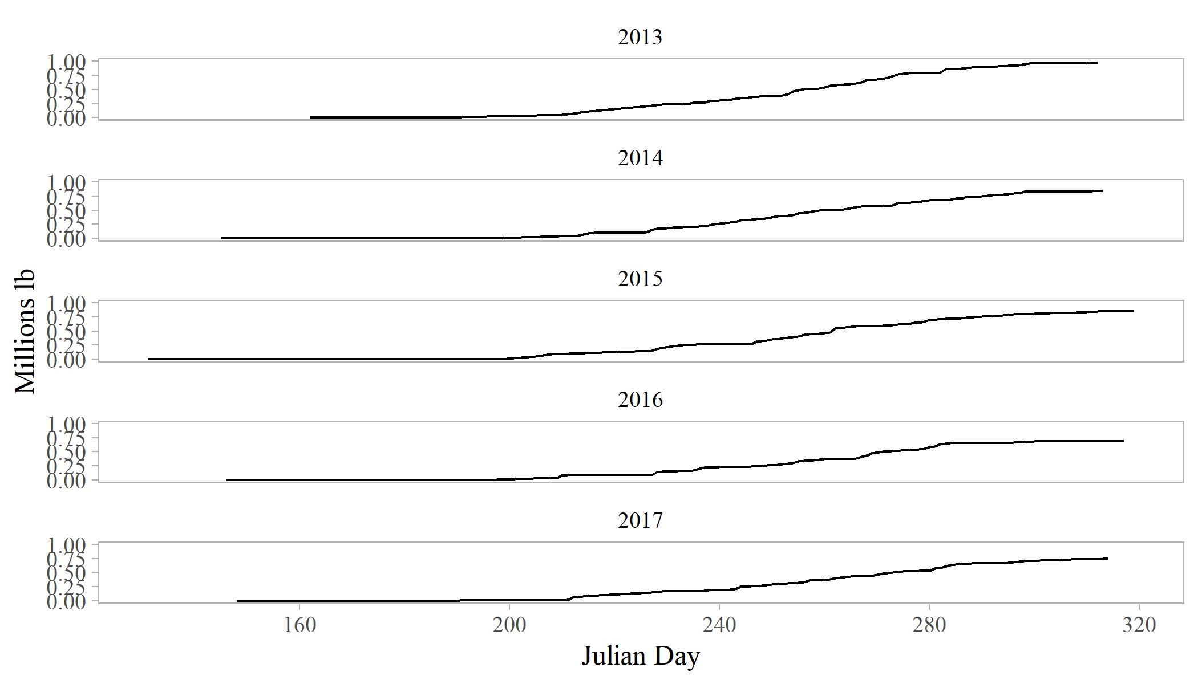

Figure 1. Fishery harvest in Chatham Strait from 1985-2018. The vertical dashed line marks the transition of the fishery from limited entry to equal quota share in 1994.

##### Forecast numbers-at-age

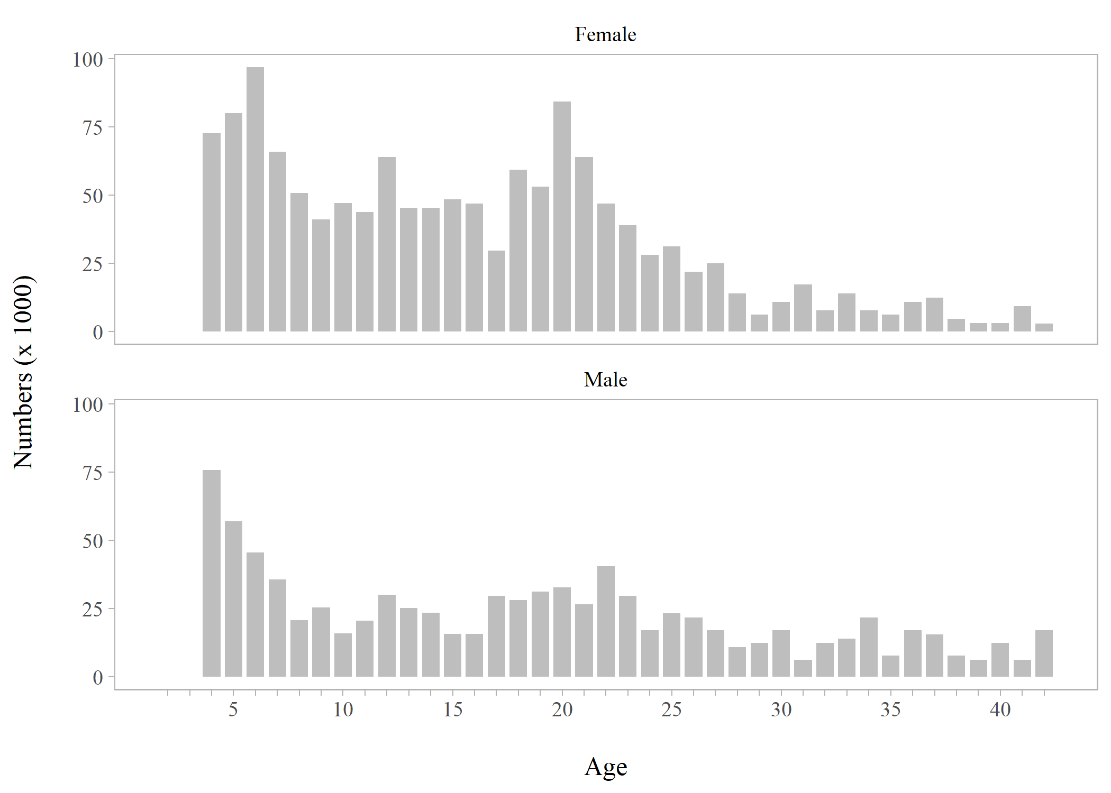

Figure 3. Forecasted numbers-at-age by sex for 2019 using the author-recommended abundance estimate.

##### Abundance over time restrospective

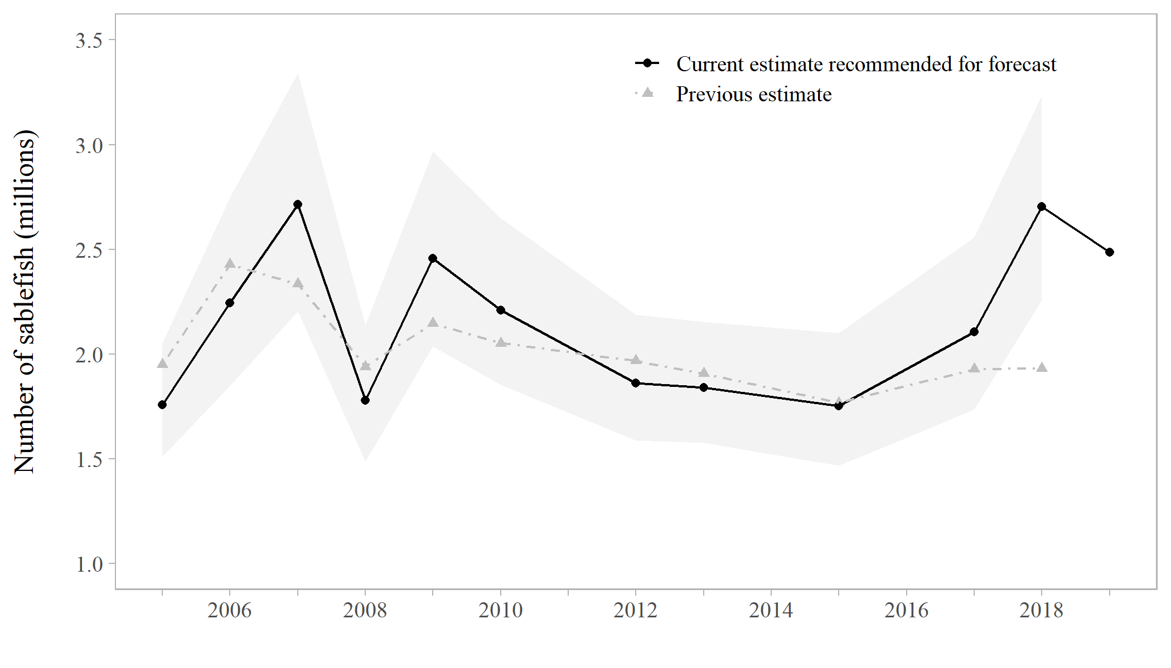

Figure 2. Abundance estimates from the current model (black points) and previous estimates of abundance that were used for management in a given year (grey triangles) from 2005-2018. Shaded areas are 95% credible intervals from the current estimates’ posterior distributions. The grey triangle in 2018 is the forecasted abundance from 2017.

##### Proportion female at age and by year

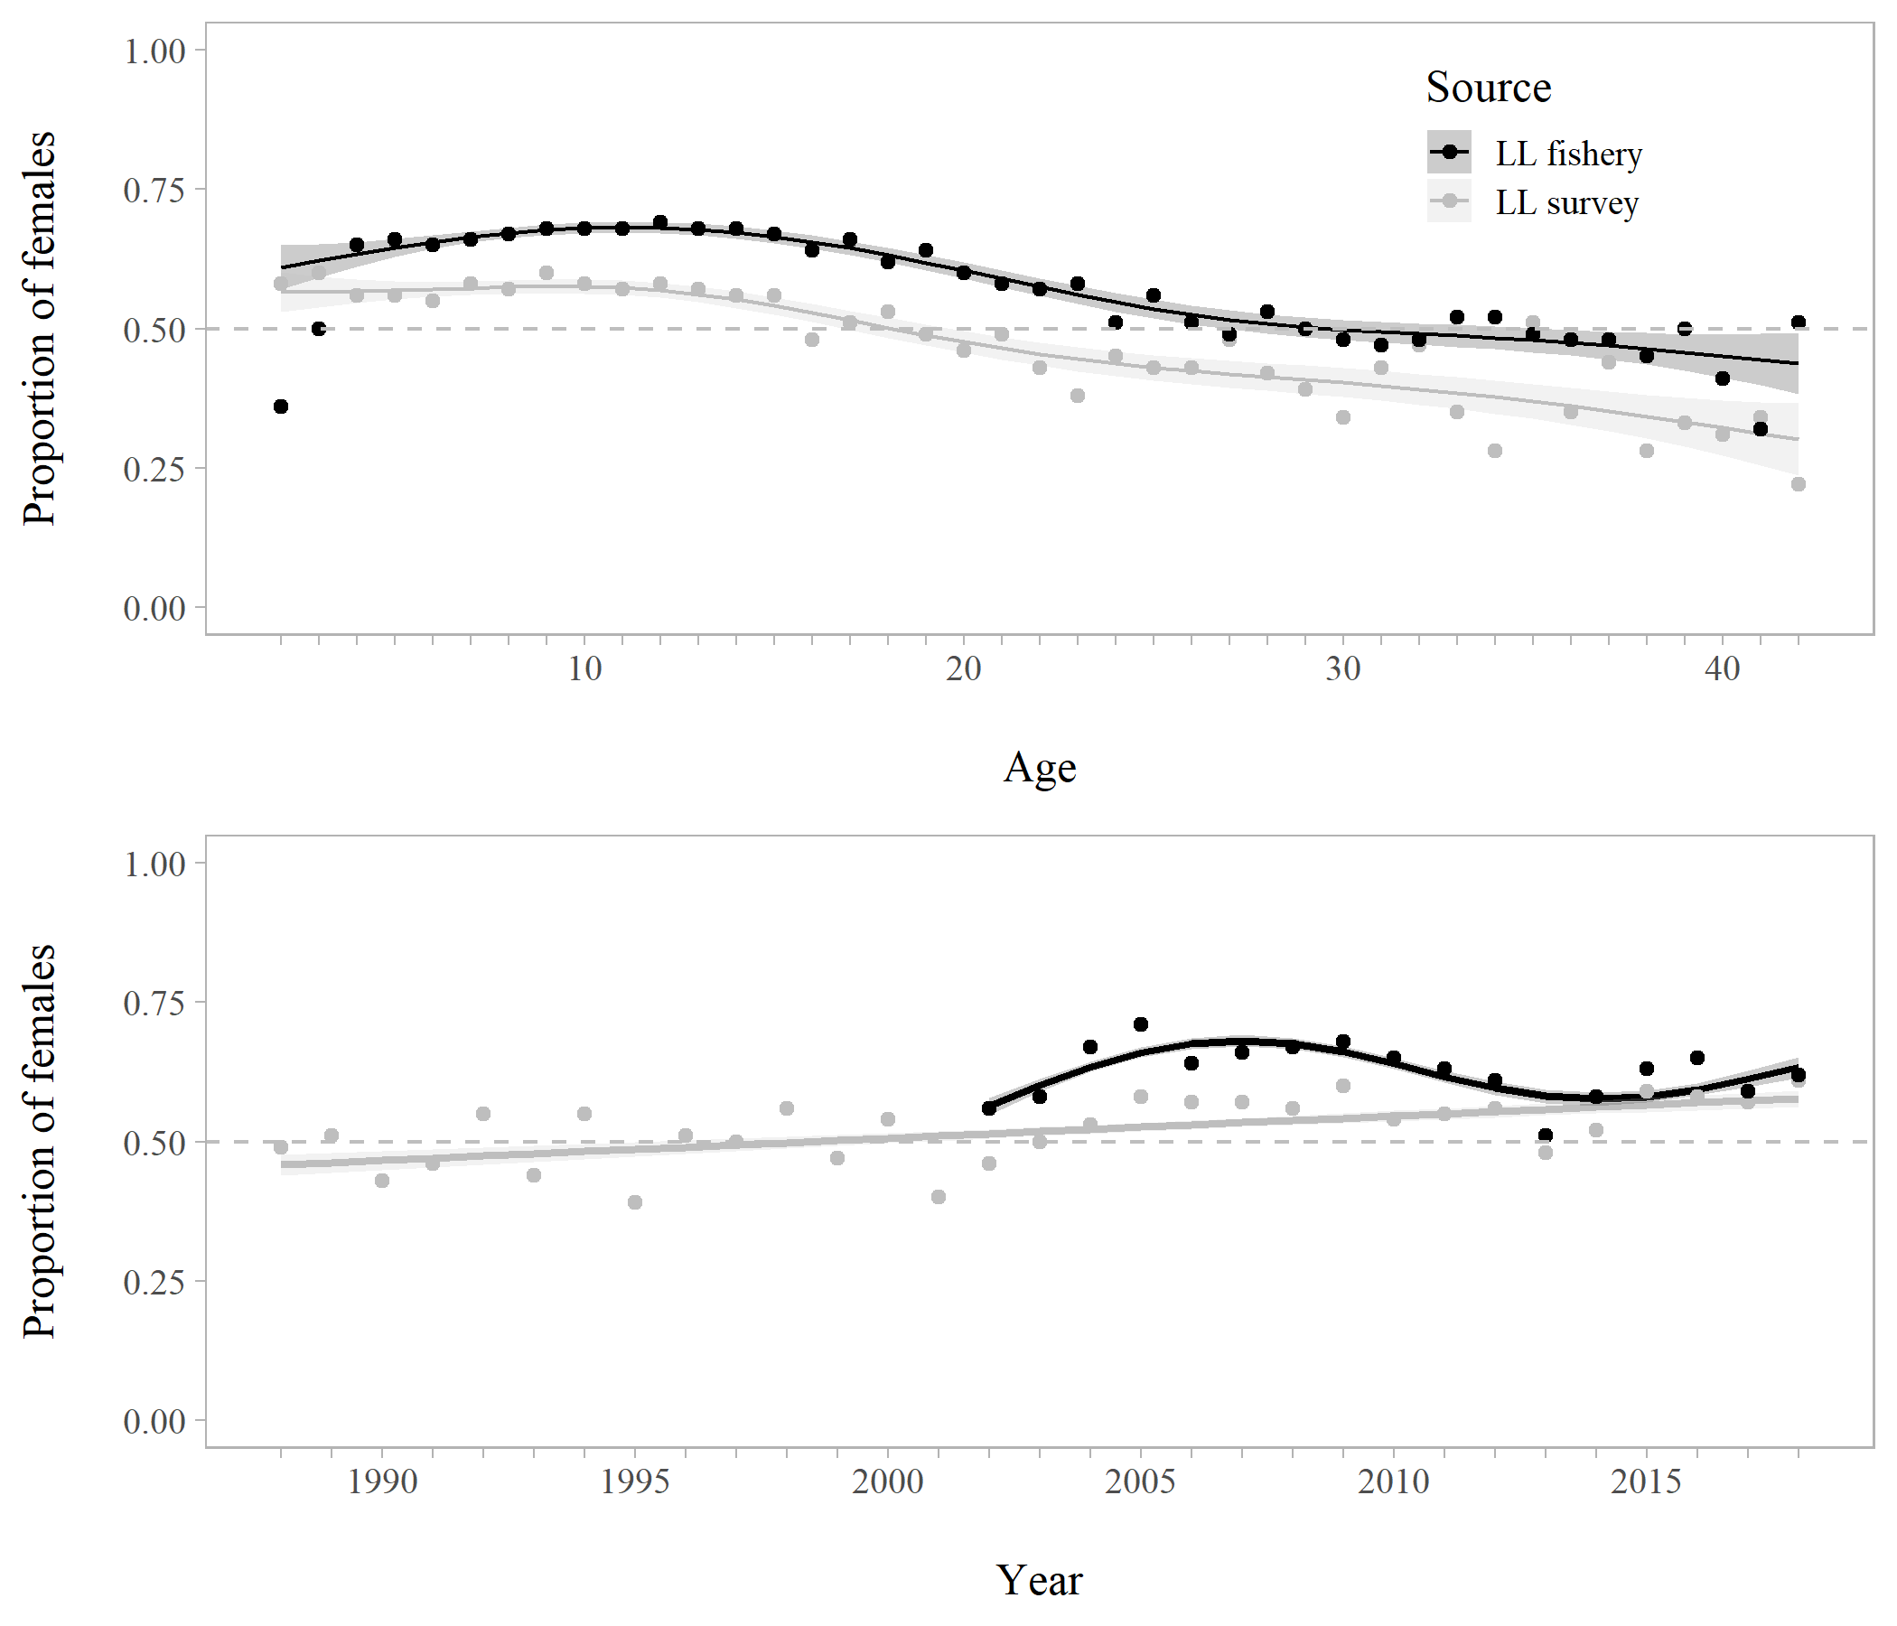

Figure 4. Proportion of females at age in the commercial longline fishery (black) 2002-2018 and longline survey (grey) 1988-2018 (top panel). Proportion of females by year (all ages combined) in the fishery (black) and survey (grey) are presented for the same years (bottom panel). Shaded areas and smoothed curves are the predicted values and standard errors from a generalized additive model.

##### Survey CPUE

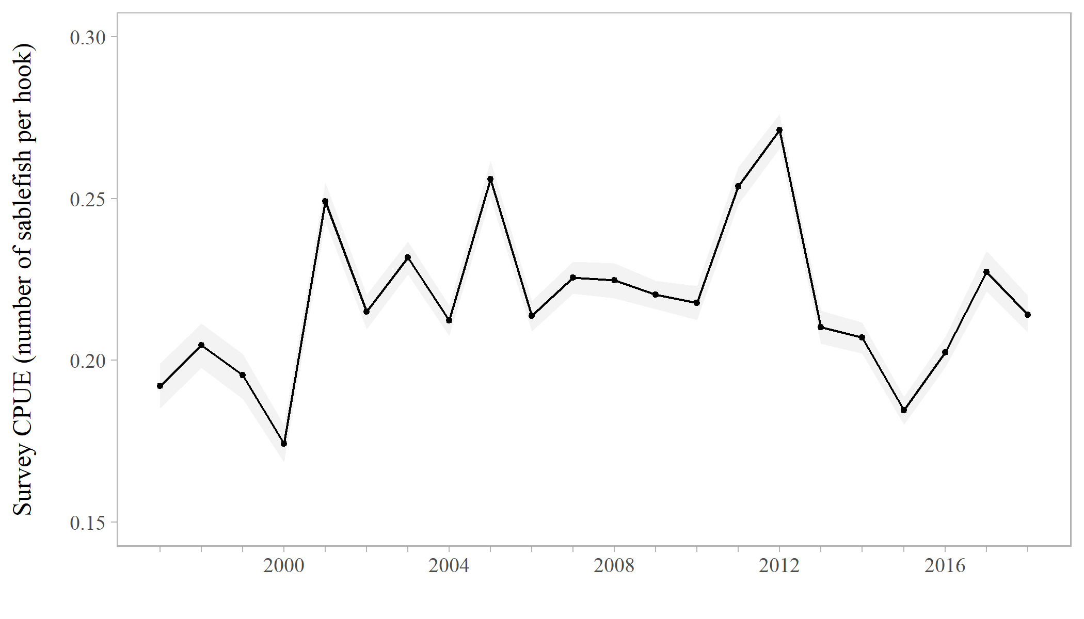

Figure 5. Longline survey CPUE in sablefish per hook with simple bootstrap 95% confidence intervals, 1997-2018.

##### Fishery CPUE

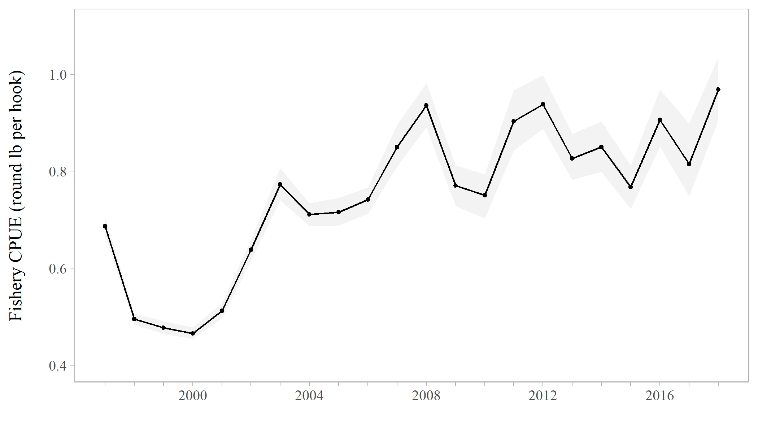

Figure 6. Commercial longline fishery CPUE in round lb per hook with simple bootstrap 95% confidence intervals, 1997-2018.

##### Survey age compositions

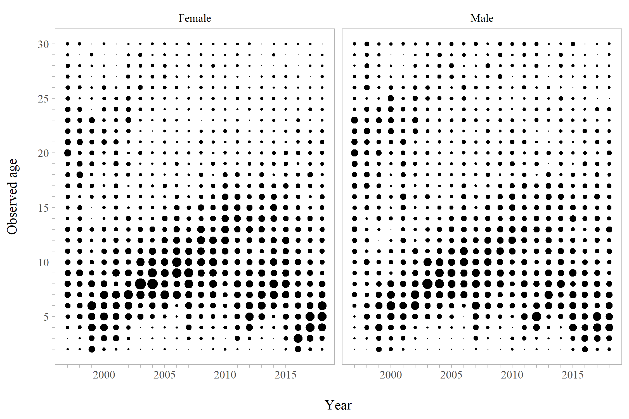

Figure 7. Proportions-at-age for males and females in the ADF&G longline survey, 1997-2018.

##### Fishery age compositions

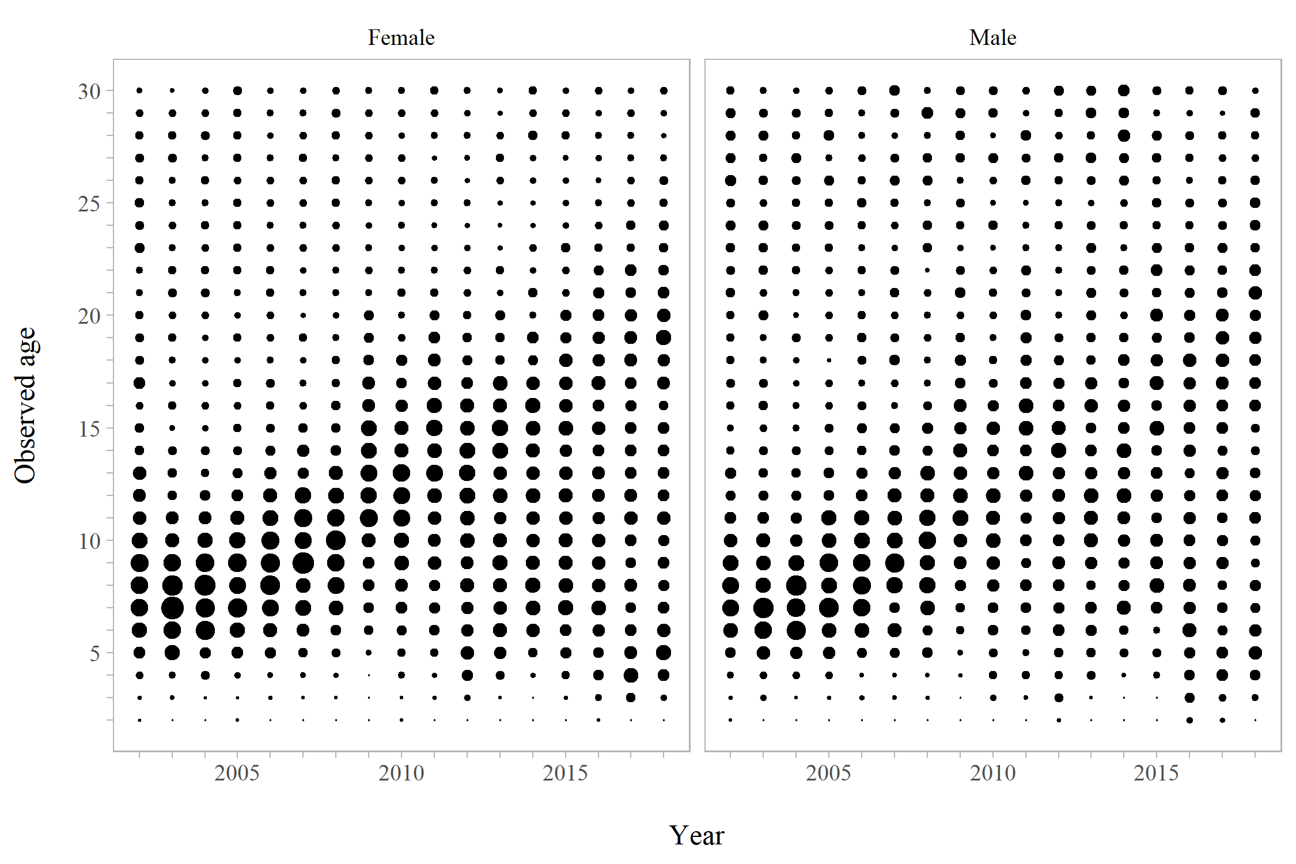

Figure 8. Proportions-at-age for males and females in the longline fishery, 2002-2018.

##### YPR inputs: weight-at-age and maturity

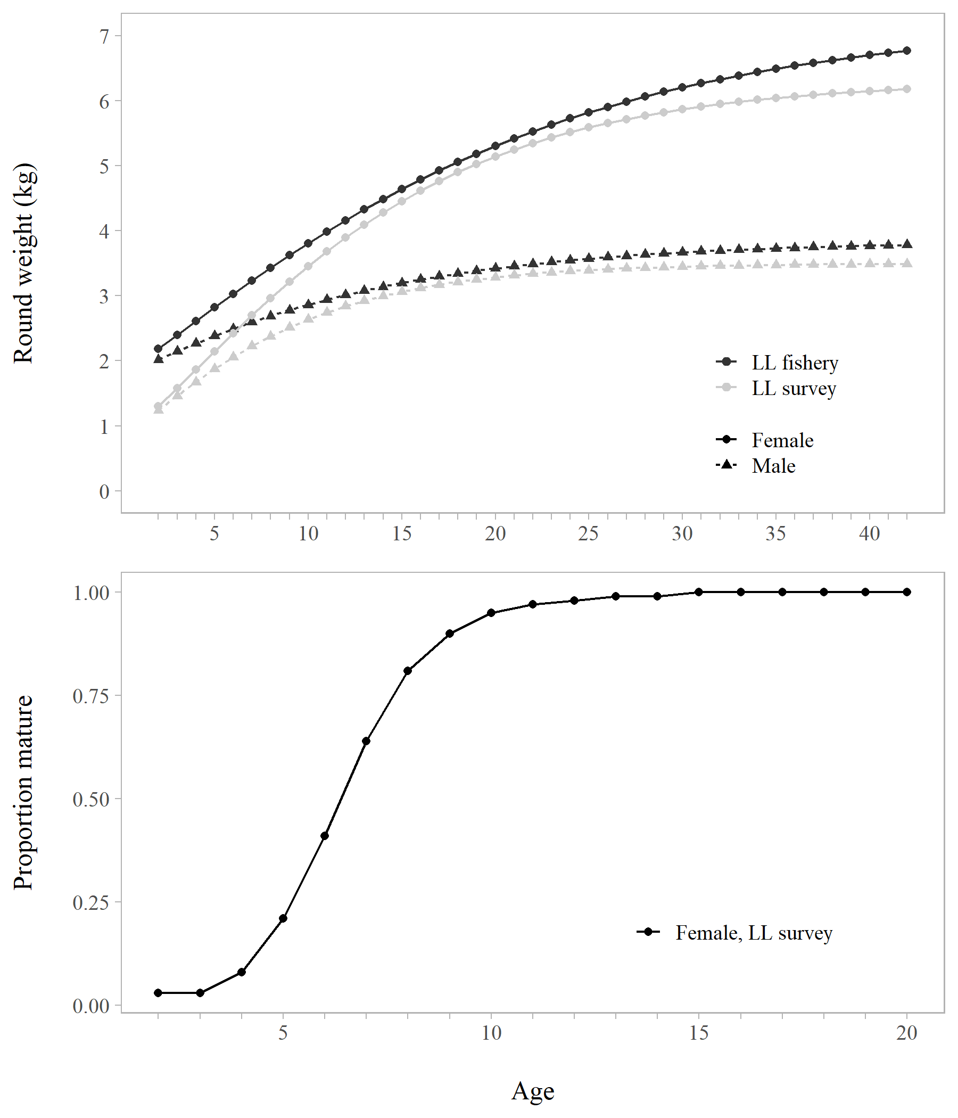

Figure 11. Sex-specific weight-at-age (kg) from the longline fishery and survey (top panel), and proportion mature-at-age for females estimated from the longline survey (bottom panel). These values are used as inputs to the yield per recruit model and $ABC$ calculation.

##### Retention probability at age

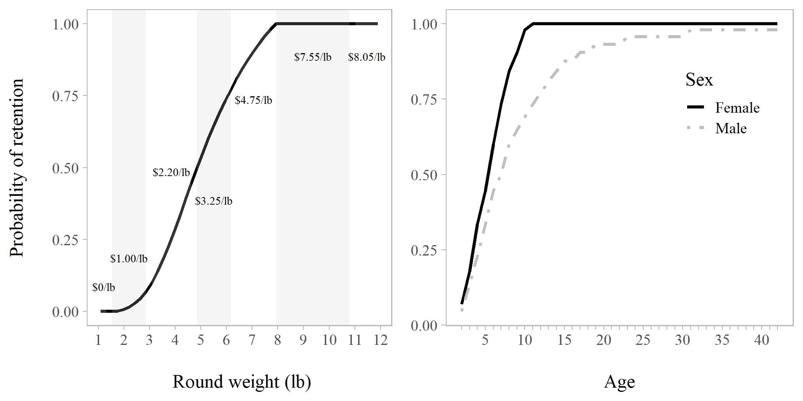

Figure 9. The probability of retaining a fish as a function of weight (left panel), sex, and age (right panel).

##### Fishing mortality at age with discards

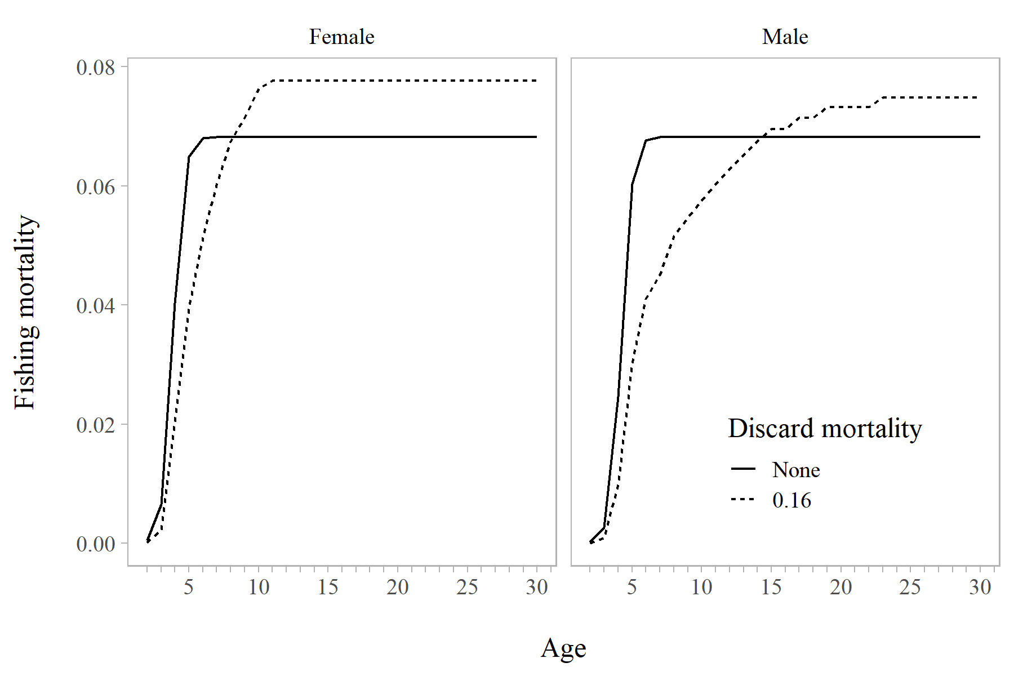

Figure 10. A comparison of equivalent fishing mortality rates by age and sex when discard mortality is assumed to be zero (solid line) and when it assumed to be 0.16 (dashed line).

##### Release/recapture cumulative proportion at length

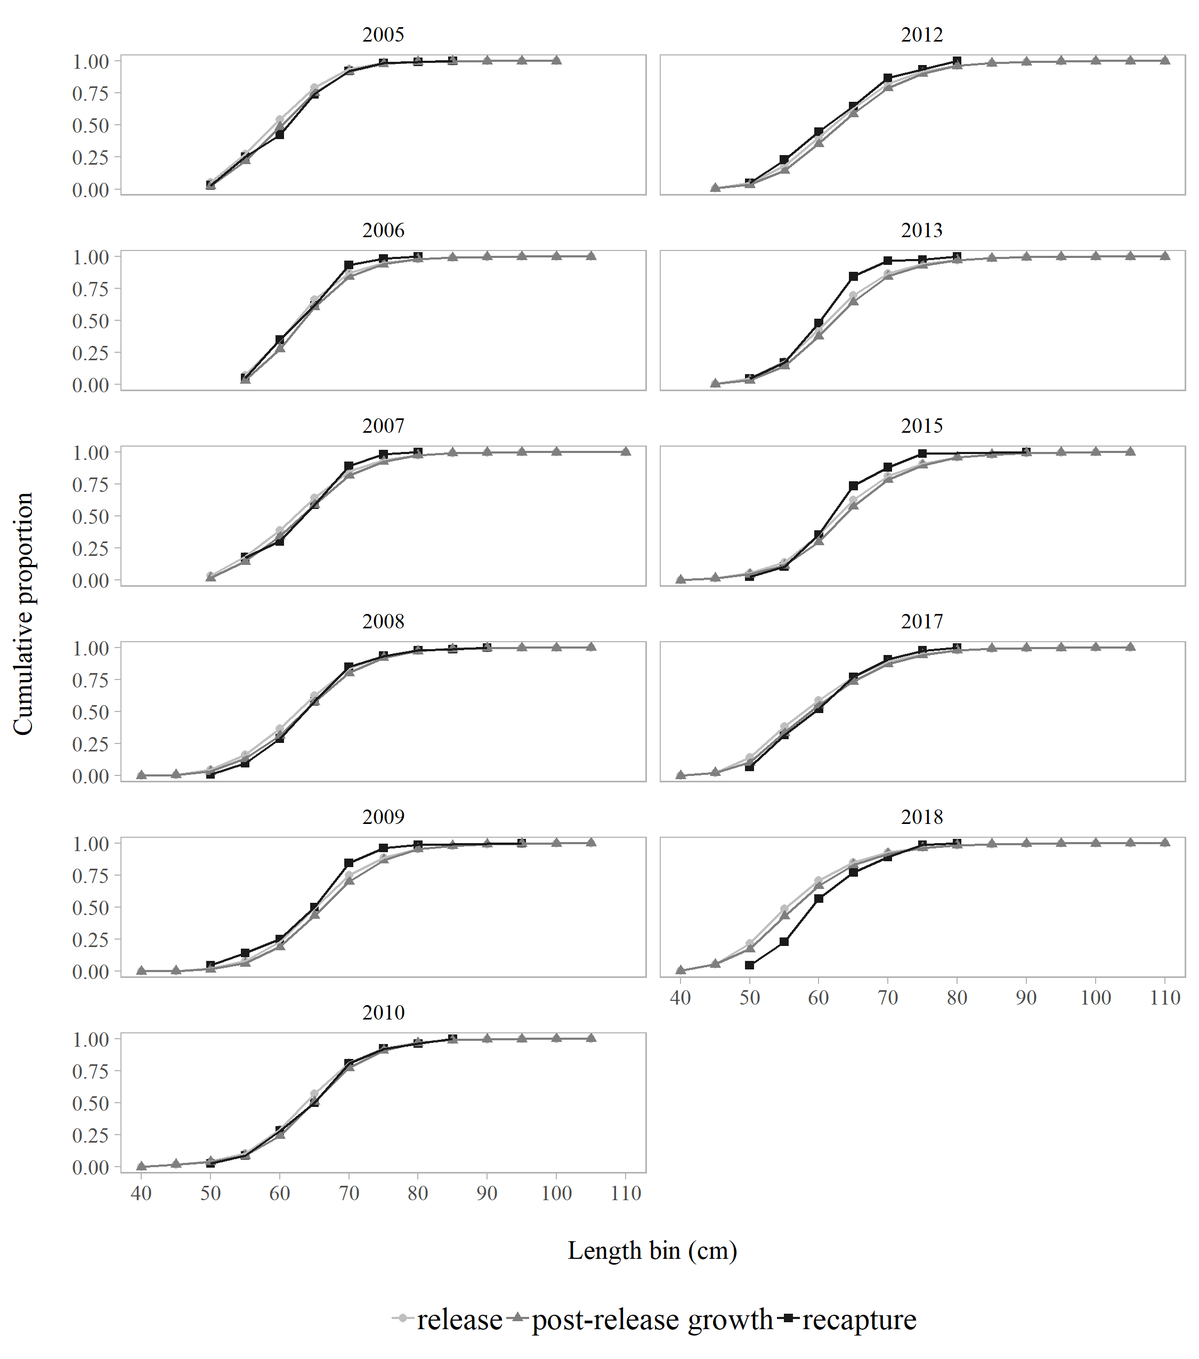

Figure 12. The cumulative proportion at length released (light grey), predicted growth after release (dark grey), and recaptured (black) in Chatham Strait by 5-cm length bins, 2005-2018.

##### Movement inside Chatham

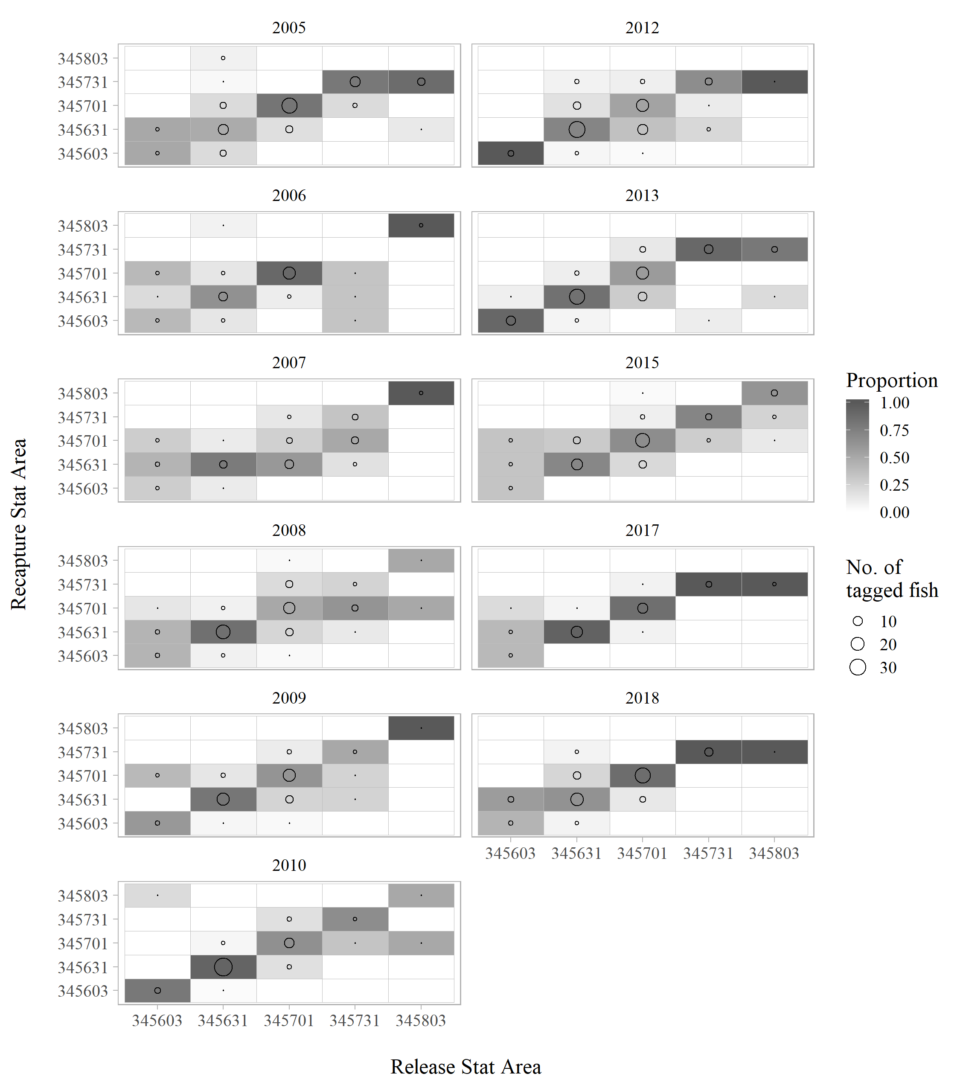

Figure 13. The probability of being recaptured in a statistical area given release area, 2005-2018. The relative size of the circle represents the number of tagged fish recaptured in each area. Statistical areas are arranged roughly north to south along each axis.

##### Annual migration estimates

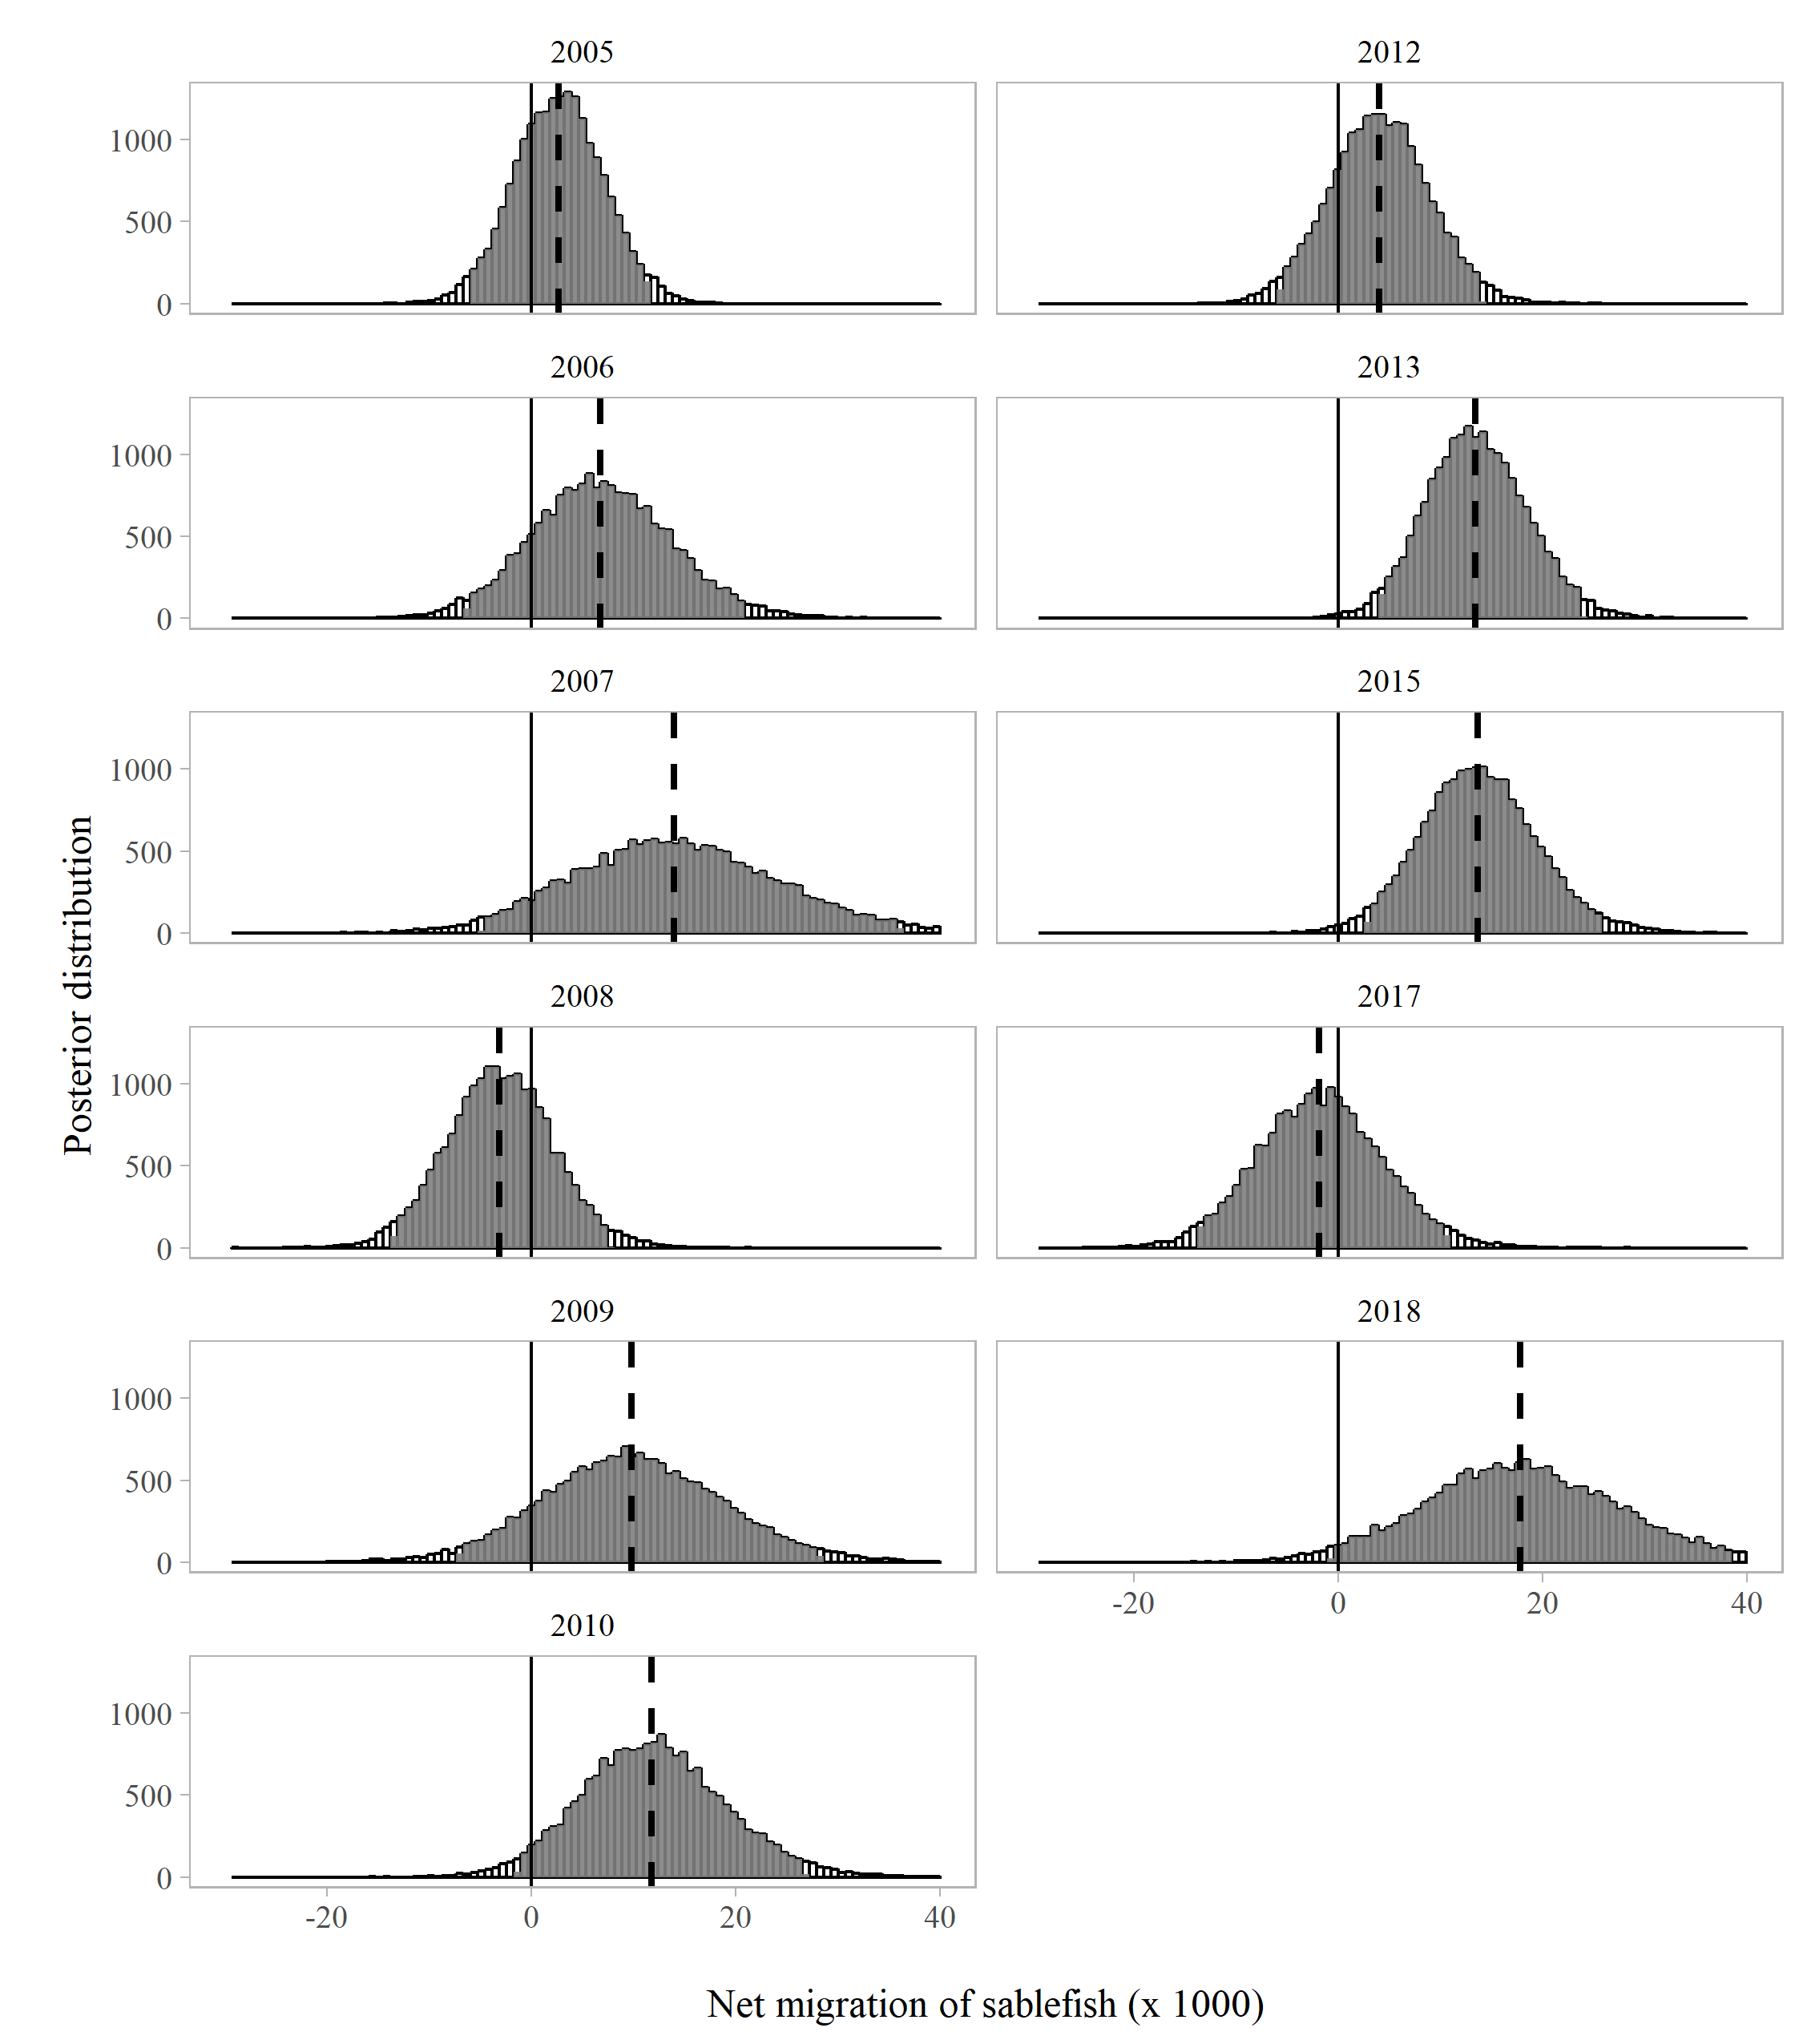

Figure 14. Posterior distribution of net migration into Chatham Strait with 95% credible intervals shaded (Model 2, P=6). The median is denoted by the dashed vertical line. The solid horizontal line at net 0 migration aids in visualization of results across years with a tagging survey, 2005-2018.

##### NPUE predicted from mark-recapture models

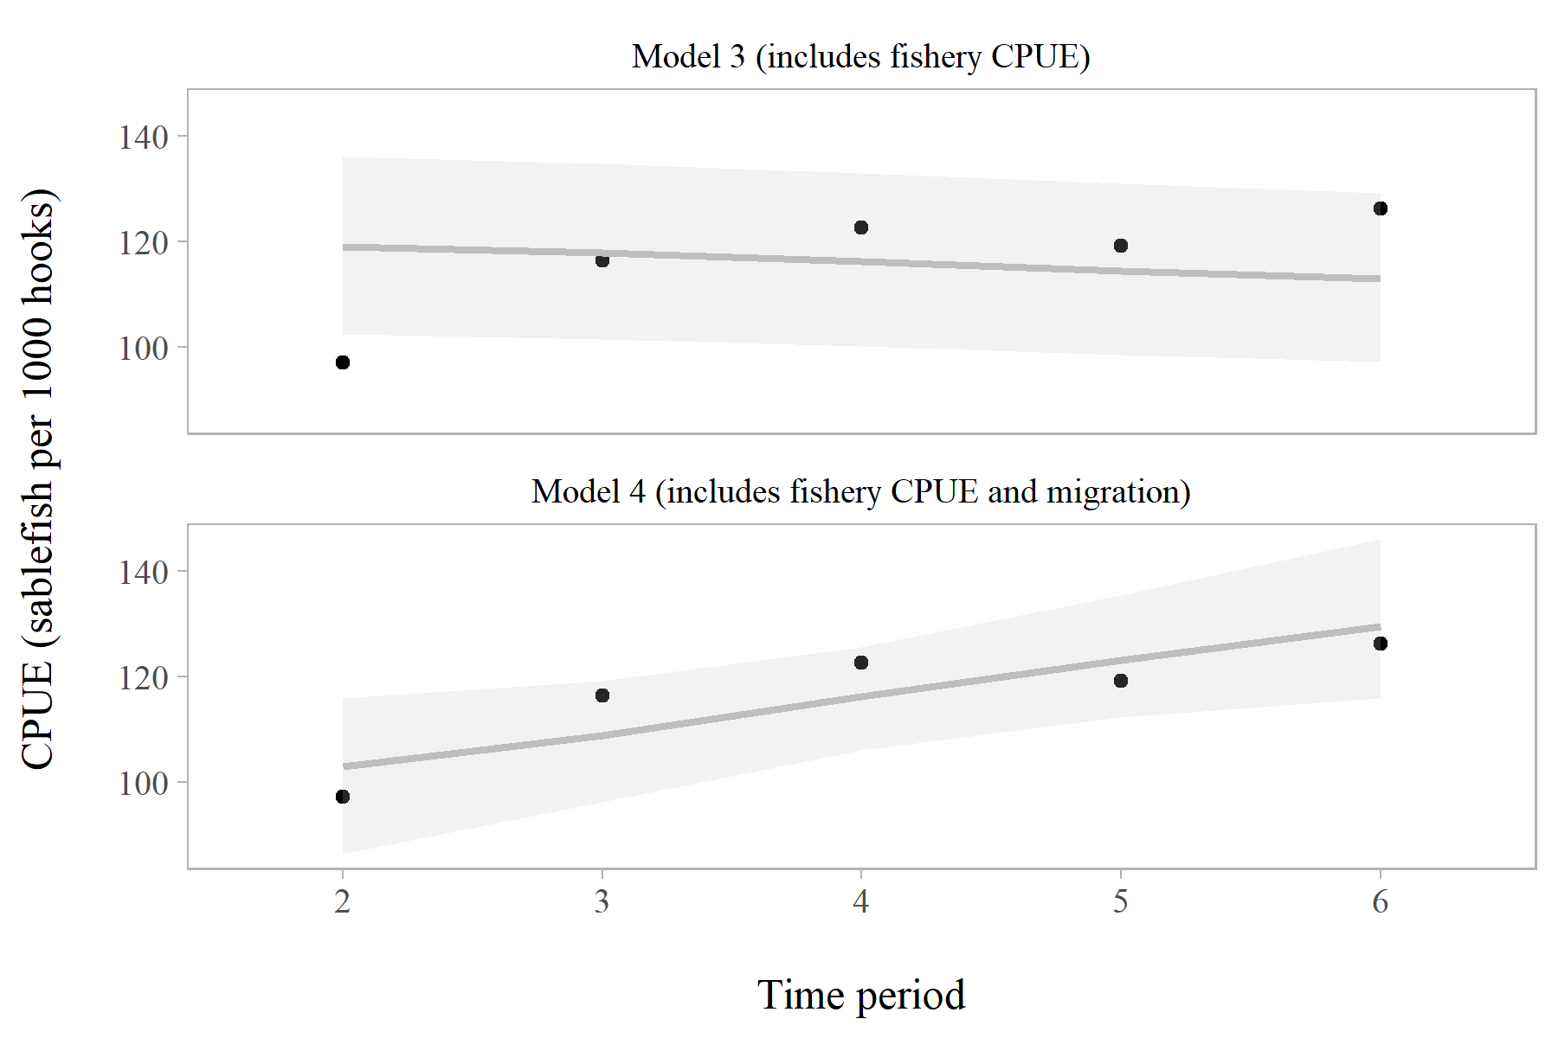

Figure 15. Observed (black) and model-estimated (grey) CPUE (sablefish / 1000 hooks) in the 2018 longline fishery in for Model 3 (top panel), which included CPUE, and Model 4 (bottom panel), which included CPUE and allowed for migration. Grey shaded areas show 95% credible intervals from the posterior distribution. Models 0, 1, and 2 are not included in this comparison because they do not estimate CPUE.