2021 Preseason Pink Salmon Forecast

Sara Miller, Rich Brenner, and Jim Murphy

October 9, 2020--draft

# Objective

To forecast the Southeast Alaska (SEAK) pink salmon harvest in 2021.

# Executive Summary

Forecasts were developed using an approach described in Murphy et al. 2019. A multiple regression model was developed using monthly peak juvenile pink salmon CPUE (standardized catch based on 20 minute trawl set) for the June and July surveys and associated environmental parameters. The model used was:

$$E(y)=α+β_{1}X_{1}+β_{2}X_{2}+β_{3}X_{1}X_{2}+ϵ,$$

where $y$ is ln(harvest), $β_{1}$ is the coefficient for ln(CPUE+1), $β_{2}$ is the coefficient for the environmental covariate water temperature (i.e., May through July average temperature 'ISTI' in the upper 20 m at eight stations in Icy Strait or the natural logarithm of 'ISTI'), $β_{3}$ is the interaction term, and $ϵ$ represents the normal error term that is lognormal.

Leave-one-out cross validation (hindcast) and model performance metrics such as Mean and Median Absolute Percentage Error (MAPE, MEAPE), and mean absolute scaled error (MASE) (Hyndman and Kohler 2006) were then used to evaluate forecast accuracy of alternative models. Statistical analyses were performed with the R Project for Statistical computing version 3.6.3 (R Core Team 2020).

Based on an additive model with CPUE and temperature, the SEAK pink salmon harvest in 2021 is predicted to be in the strong range with a point estimate of 31.4 million fish (80% prediction interval: 21.0 to 47.0 million fish).

# Analysis

Five hierarchical models were investigated. The full model was:

$$E(y)=α+β_{1}X_{1}+β_{2}X_{2}+β_{3}X_{1}X_{2},$$

where $X_{1}$ was ln(CPUE+1) and $X_{2}$ was either the average temperature in Icy Strait in May, June, and July or the natural logarithm of the average temperature in Icy Strait in May, June, and July, and $β_{3}$ is the interaction term between CPUE and one of the temperature indices.

The regression coefficients CPUE and temperature (ISTI, ISTI_log) were significant in the first three models (m1, m2, m3). The interaction term was not significant in either model m4 or m5 (Table 1). Therefore, only the first three models will be considered further.

Parameter estimates for the five potential models.

|  |  |  |  |  |  |
| --- | --- | --- | --- | --- | --- |
| model | term | estimate | std.error | statistic | p.value |
| m1 | (Intercept) | 2.264 | 0.206 | 10.984 | 0.000 |
| m1 | CPUE | 0.465 | 0.073 | 6.325 | 0.000 |
| m2 | (Intercept) | 6.683 | 0.992 | 6.740 | 0.000 |
| m2 | CPUE | 0.521 | 0.054 | 9.568 | 0.000 |
| m2 | ISTI | -0.502 | 0.111 | -4.508 | 0.000 |
| m3 | (Intercept) | 12.044 | 2.253 | 5.345 | 0.000 |
| m3 | CPUE | 0.521 | 0.055 | 9.386 | 0.000 |
| m3 | ISTI_log | -4.498 | 1.034 | -4.350 | 0.000 |
| m4 | (Intercept) | 4.172 | 2.702 | 1.544 | 0.139 |
| m4 | CPUE | 1.533 | 1.014 | 1.512 | 0.147 |
| m4 | ISTI | -0.227 | 0.296 | -0.767 | 0.453 |
| m4 | CPUE:ISTI | -0.110 | 0.110 | -0.999 | 0.330 |
| m5 | (Intercept) | 6.070 | 6.141 | 0.988 | 0.335 |
| m5 | CPUE | 2.926 | 2.301 | 1.271 | 0.219 |
| m5 | ISTI_log | -1.798 | 2.782 | -0.646 | 0.526 |
| m5 | CPUE:ISTI_log | -1.084 | 1.037 | -1.045 | 0.309 |

The model summary results using the metrics AICc, MAPE, MEAPE, and MASE (Hyndman and Kohler 2006) are shown in Table 2. For all of these metrics, the smallest value is the preferred model. The difference ($Δ_{i}$) between a given model and the model with the lowest AICc value and the metric MASE were the primary statistics for choosing appropriate models in this analysis. Models with AICc $Δ_{i}$ $≤$ 2 have substantial support, those in which 4 $≤$ AICc $Δ_{i}$ $≤$ 7 have considerably less support, and models with AICc $Δ_{i}$ > 10 have essentially no support (Burnham and Anderson 2004). These two metrics (AICc, MASE) suggest that models m2 and m3 are the preferred models.

Based on the AICc metrics, both models m2 and m3 have substantial support. If temperature is actually altering how CPUE is related to abundance it makes sense to restrict the temperature data to the CPUE months in the forecast model (June and July). The month of May is included as there are important migratory dynamics prior to the time juveniles are actually sampled in Icy Strait. Model m2 (based on average temperature in May through July) was used to forecast the 2021 pink salmon harvest. *Why was ISTI_log not used as the best model???*

Summary of model outputs and forecast error measures

|  |  |  |  |  |  |
| --- | --- | --- | --- | --- | --- |
| model | AdjR2 | AICc | MAPE | MEAPE | MASE |
| CPUE | 0.639 | 29 | 0.110 | 0.088 | 0.375 |
| CPUE+ISTI | 0.812 | 16 | 0.079 | 0.060 | 0.261 |
| CPUE+ISTI_log | 0.805 | 17 | 0.081 | 0.062 | 0.269 |

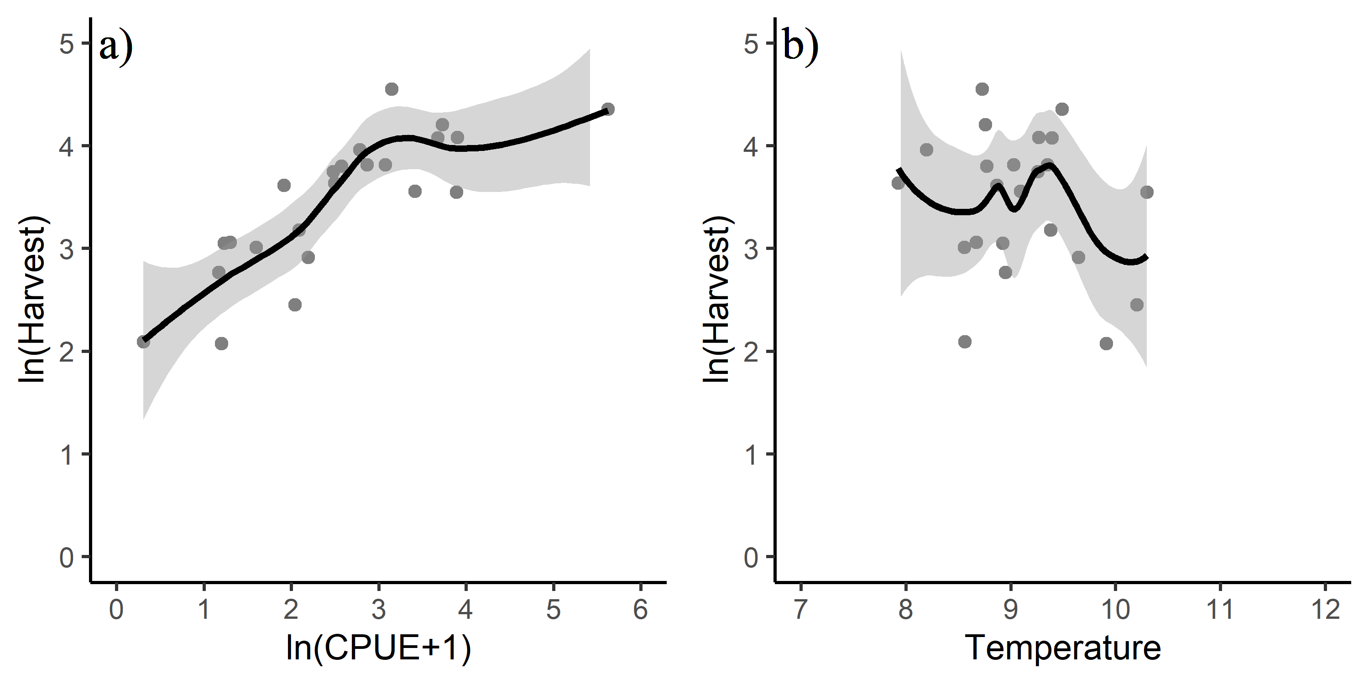

Figure 1: Relationship between a) ln(CPUE+1) and ln(harvest) and b) temperature in May through July (ISTI) and ln(harvest).

# Model Diagnostics

Model diagnostics for model m2 included residual plots, the curvature test, and influential observation diagnostics using Cook's distance (Cook 1977), the Bonferroni outlier test, and leverage plots. Model diagnostics were used to identify observations that were potential outliers, had high leverage, or were influential (Zhang 2016). These observations may have significant impact on model fitting and may need to be excluded.

## Cook's Distance

Cook's distance is a measure of influence, or the product of both leverage and outlier. Cook's distance,

$$D_{i}= \frac{e_{PSi}^{2}}{k+1}*\frac{h_{i}}{1−h_{i}},$$

where $e_{PSi}^{2}$ is the standardized Pearson residuals, $h_{i}$ are the hat values (measure of leverage), and $k$ is the number of predictor variables in the model, is a measure of overall influence of the $i_{th}$ data point on all $n$ fitted values (Fox and Weisburg 2019). A large value of Cook's distance indicates that the data point is an influential observation. Cook's distance values greater than $4/(n−k−1)$, where $n$ is the number of observations (i.e., 23), was used as a benchmark for identifying the subset of influential observations (Ren et al. 2016). Therefore, a Cook's distance cut-off of 0.20 was used; observations with a Cook's distance greater than 0.20 were investigated further.

## Leverage

An observation that is distant from the average covariate pattern is considered to have high leverage. If an individual observation has a leverage value $h_{i}$ greater than 2 or 3 times $p/n$ (Ren et al. 2016), it may be a concern (where $p$ is the number of parameters in the model including the intercept (i.e., 3), and $n$ is the number of observations in the model (i.e., 23); $p/n$ = 3/23 = 0.13 for this study). Therefore, a leverage cut-off of 0.26 was used; observations with a leverage value greater than 0.26 were investigated further.

## Residuals vs. Fitted Plot

The characteristics of an unbiased residual vs. fitted plot and what they suggest about the appropriateness of the simple linear regression model include: 1) The residuals "bounce randomly" around the 0 line. This suggests that the assumption that the relationship is linear is reasonable. 2) The residuals roughly form a "horizontal band" around the 0 line. This suggests that the variances of the error terms are equal. 3) No one residual "stands out" from the basic random pattern of residuals. This suggests that there are no outliers. The above paragraph was taken almost directly from the source: <https://newonlinecourses.science.psu.edu/stat462/node/117/>. To determine if a variable has a relationship with residuals, a lack-of fit curvature test was performed. In this test, terms that are non-significant suggest a properly specified model.

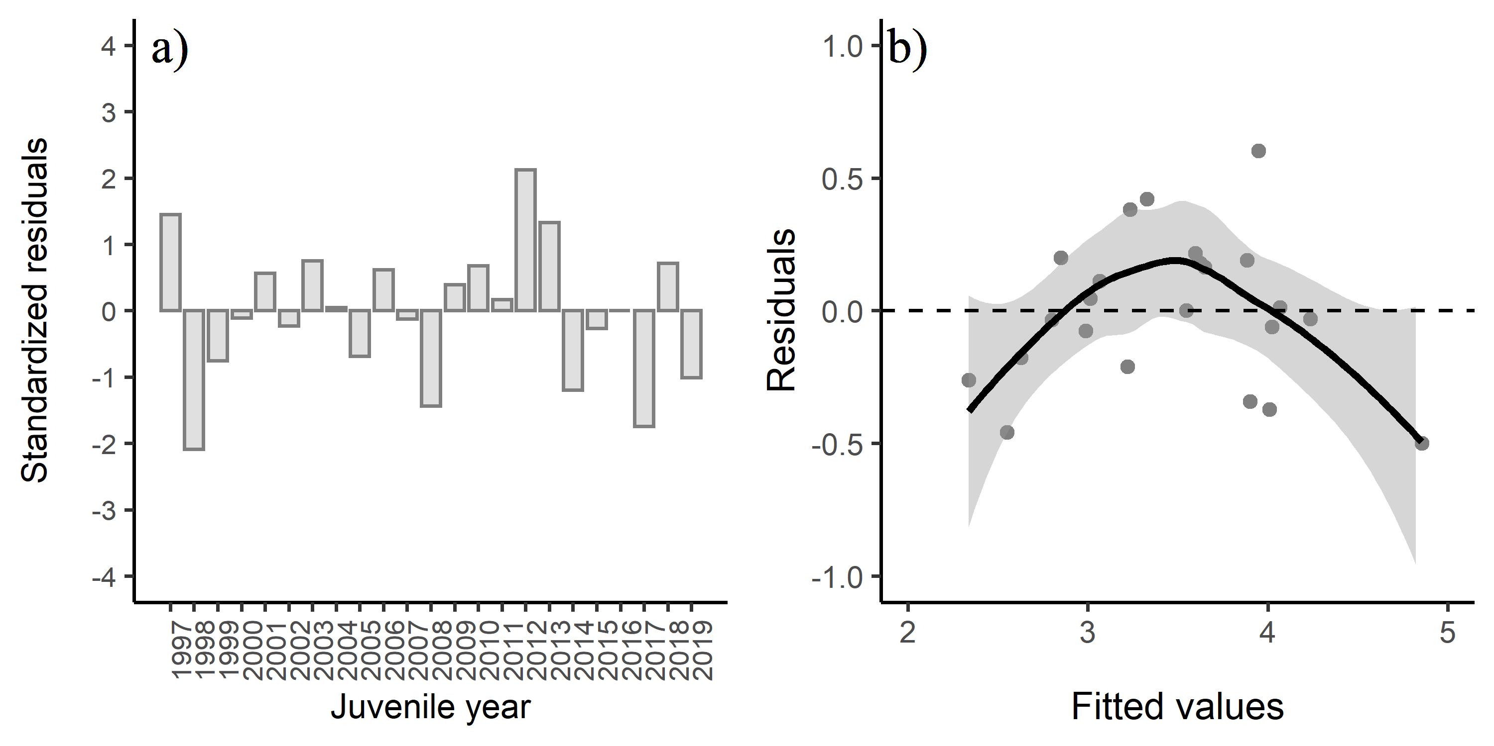

Figure 2: a) Standardized residuals versus juvenile year and b) residuals versus fitted values for model m2. Positive residuals indicate that the observed harvest was larger than predicted by the model.

## Residuals vs. Predictor Plots

The interpretation of a "residuals vs. predictor plot" is identical to that for a "residuals vs. fits plot." That is, a well-behaved plot will bounce randomly and form a roughly horizontal band around the residual = 0 line. In addition, no data points will stand out from the basic random pattern of the other residuals. The above paragraph was taken directly from the source: <https://newonlinecourses.science.psu.edu/stat462/node/117/>.

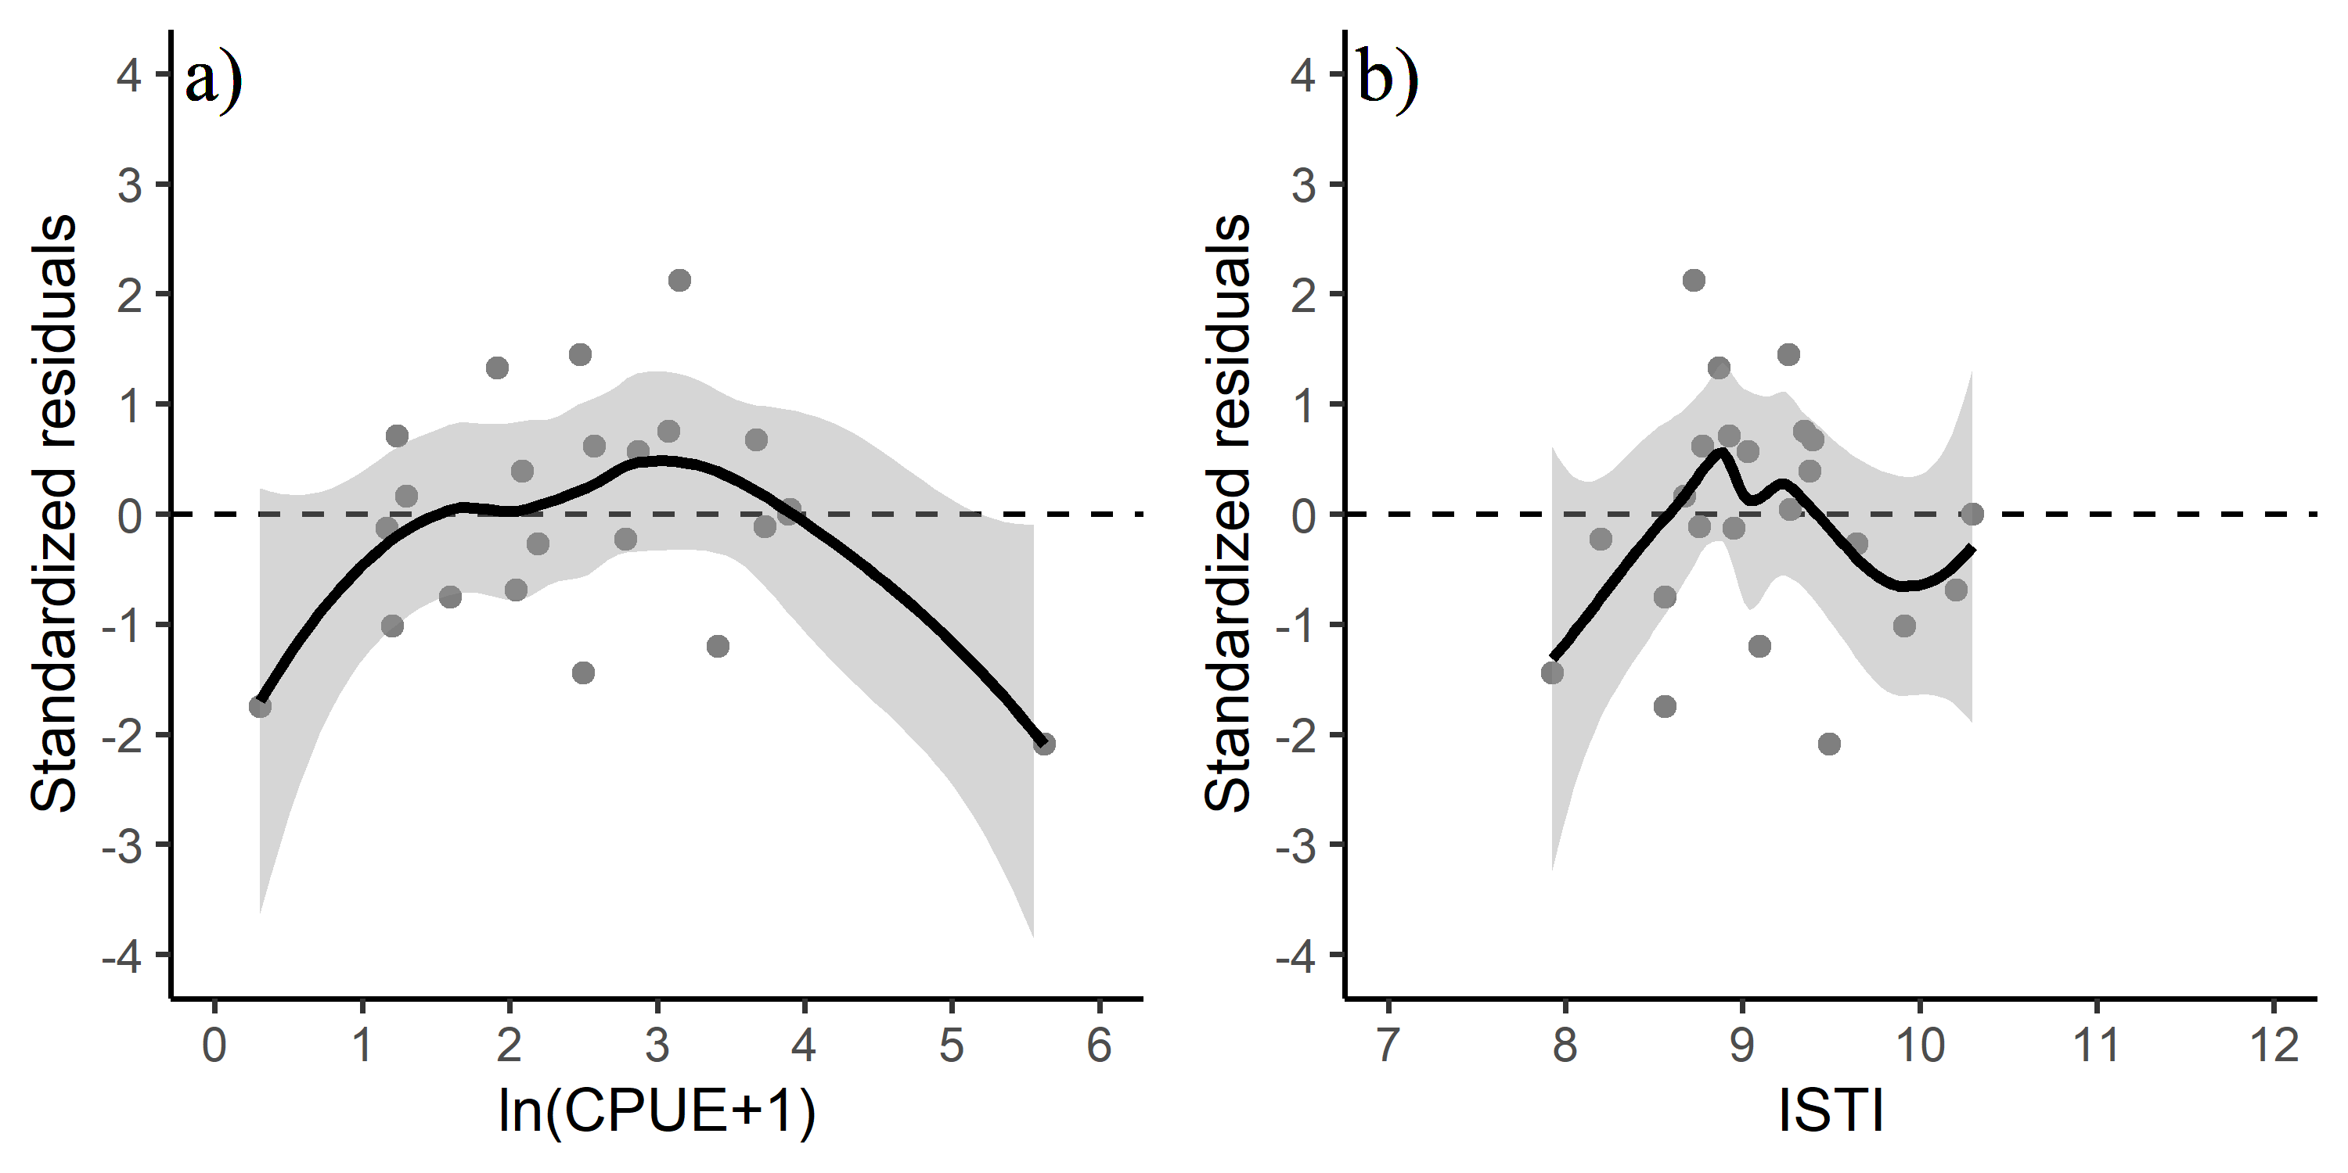

Figure 3: Standardized residuals versus predicted plots for a) CPUE and b) temperature.

## Influential Datapoints

The Bonferroni outlier test for model m2 suggested that there were no outliers, although observation 16 was the most extreme (juvenile year 2012; year 2013) based on standardized residuals (Table 3). The CPUE term was significant in the lack-of-fit curvature test ($P$ <0.05), suggesting some lack of fit for this term.

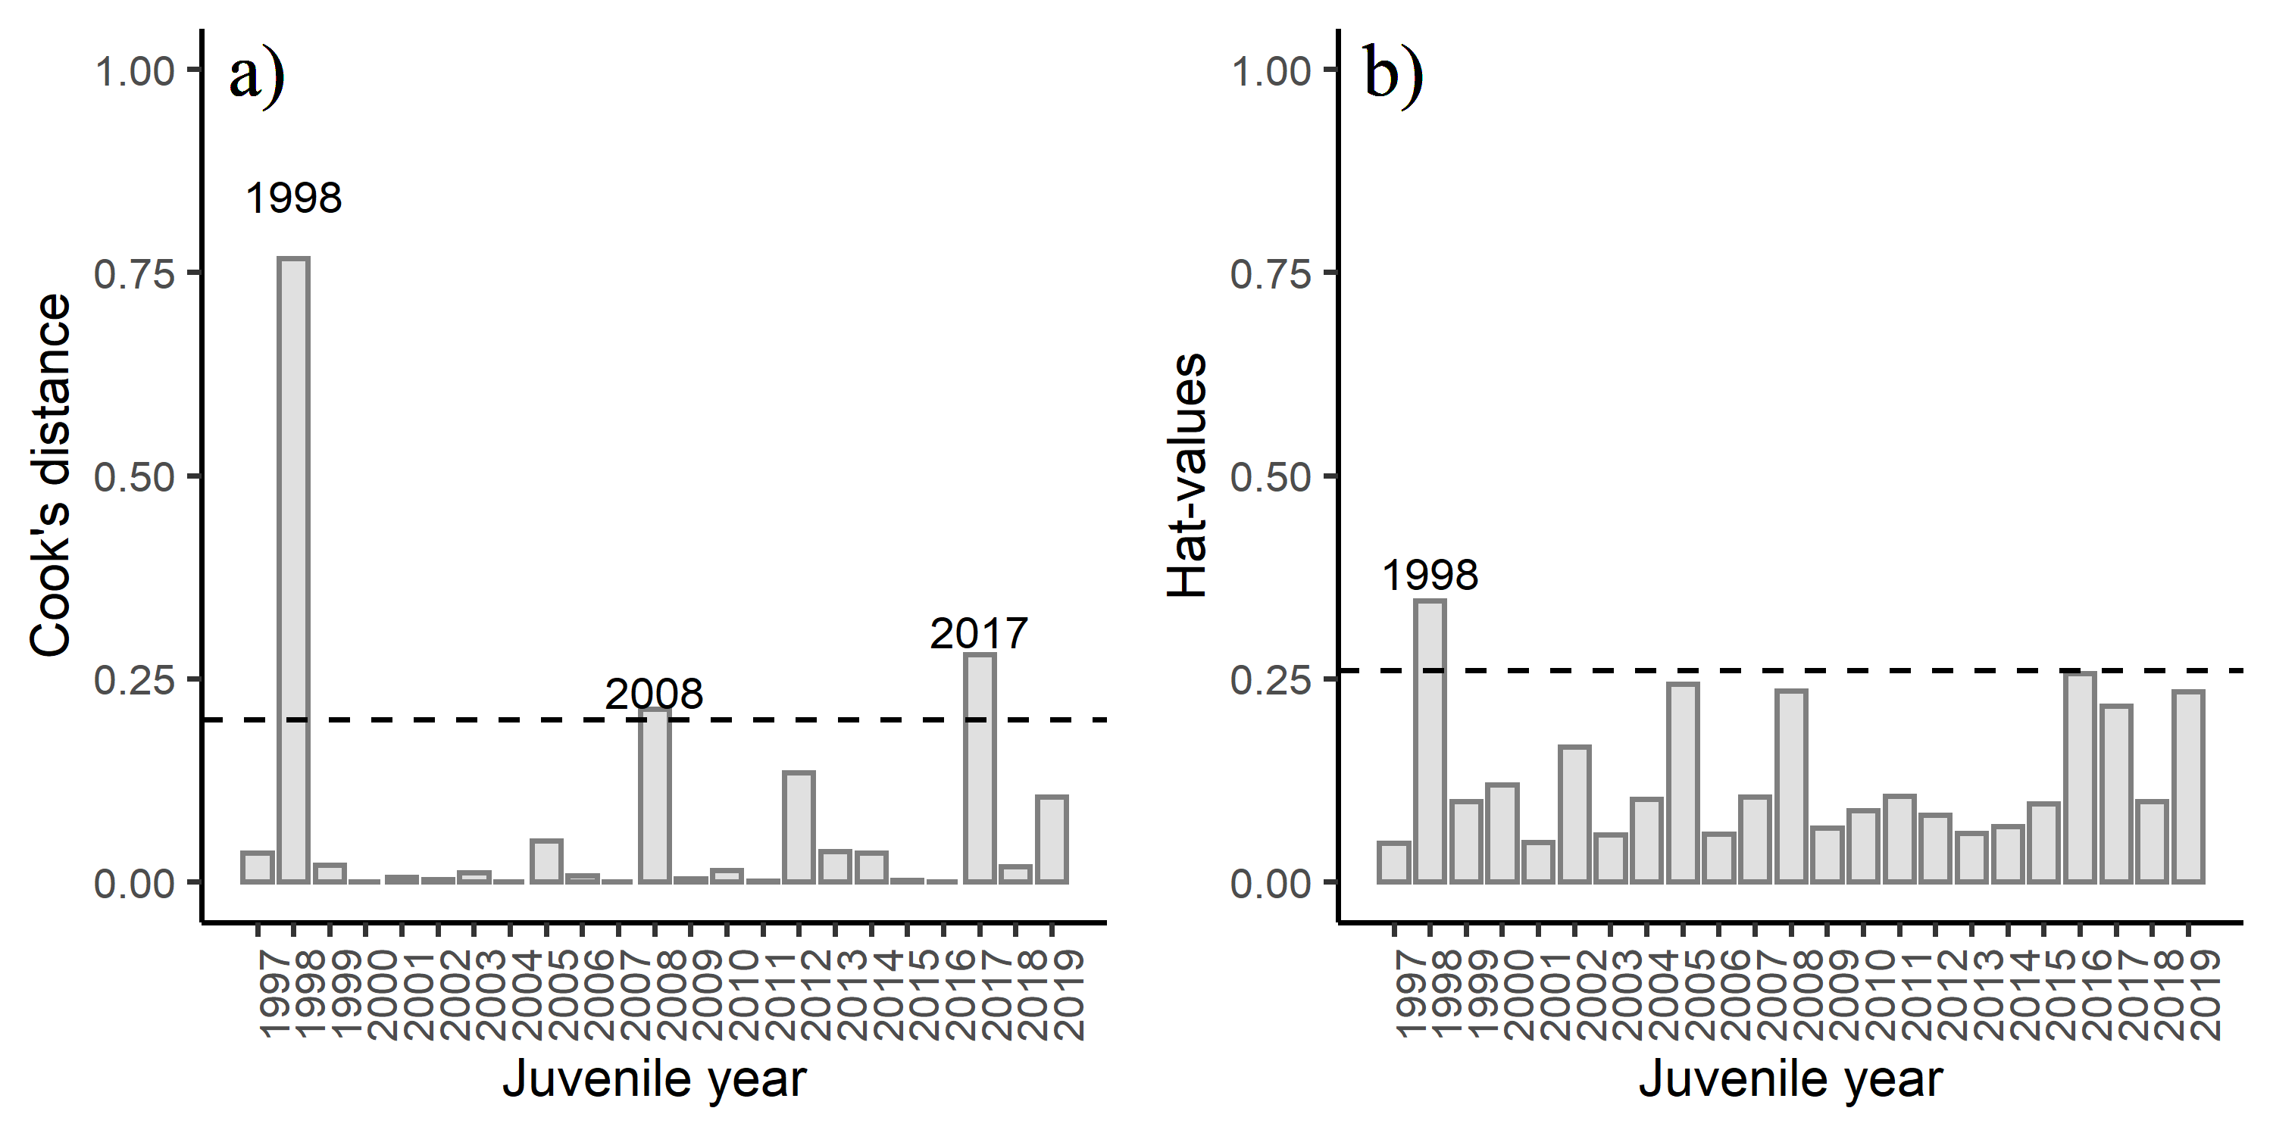

Figure 4: Diagnostics plots of influential observations including a) Cook's Distance (with a cut-off value of 0.20), and b) leverage values (with a cut-off value of 0.26) from model m2.

# Results

The best regression model based on AICc, the MASE metric, significant coefficients in the models, and the argument for restricting temperature to the months when CPUE is sampled was model m2 (i.e. the model containing CPUE, and a May through July temperature variable). Diagnostics indicated some observations had high leverage values (Figure 4b), but none of the observations affected model fitting and overall the model showed some lack of fit. A few of the data points were above the cut-off value for the Cook's distance (Figure 4a). Based on the Bonferroni outlier test, none of the data points had a studentized residual with a significant Bonferroni $P$-value suggesting that none of the data points impacted the model fitting. The conditional mean function in the residual plots should be constant across the plot in a "correct" model. Based on the results of the curvature test, and the slightly curved fitted lines in the residual versus fitted plot (Figure 2b), the fitted plot shows some lack of fit of the model. The adjusted $R^{2}$ value for model m2 was 0.81 indicating overall a good model fit.

# Conclusion

The SEAK pink salmon harvest in 2021 is predicted to be in the strong range with a point estimate of 31.4 million fish (80% prediction interval: 21.0 to 47.0 million fish).

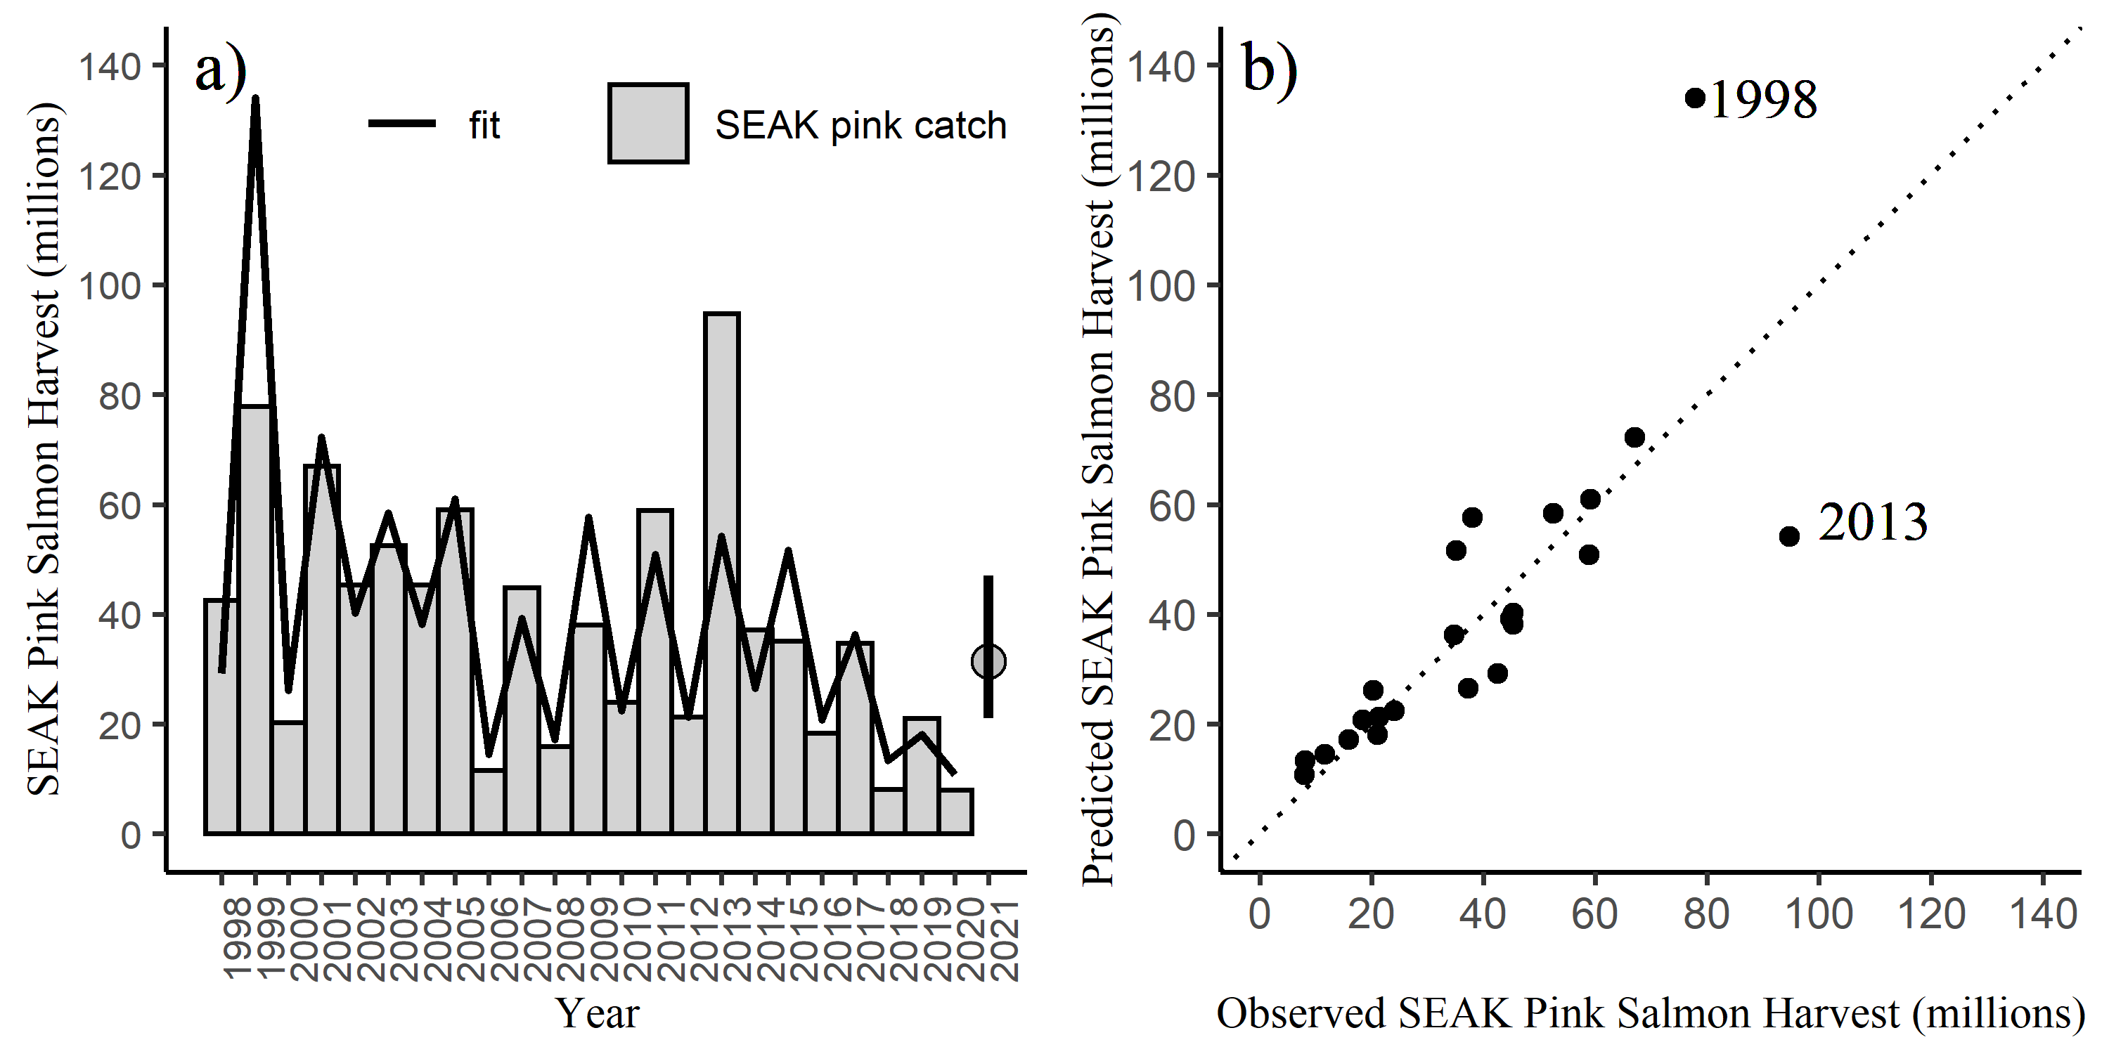

Figure 5: SEAK harvest (millions) a) by year and b) by the fitted values from model m2. The line in figure b is a one to one line. The predicted 2021 forecast is symbolized as a grey circle with an 80% prediction interval (21.0 to 47.0 million fish) in figure a.

Detailed output for model m2. Juvenile year 2012 (year 2013) shows the largest standardized residual.

|  |  |  |  |  |  |  |
| --- | --- | --- | --- | --- | --- | --- |
| year | SEAKCatch_log | resid | hat_values | Cooks_distance | std_resid | fitted |
| 1998 | 3.750 | 0.420 | 0.048 | 0.035 | 1.452 | 3.330 |
| 1999 | 4.354 | -0.500 | 0.346 | 0.767 | -2.087 | 4.854 |
| 2000 | 3.011 | -0.211 | 0.099 | 0.021 | -0.751 | 3.222 |
| 2001 | 4.205 | -0.031 | 0.120 | 0.001 | -0.110 | 4.235 |
| 2002 | 3.813 | 0.163 | 0.048 | 0.005 | 0.566 | 3.650 |
| 2003 | 3.961 | -0.062 | 0.166 | 0.003 | -0.228 | 4.022 |
| 2004 | 3.813 | 0.216 | 0.058 | 0.011 | 0.751 | 3.597 |
| 2005 | 4.079 | 0.013 | 0.102 | 0.000 | 0.046 | 4.066 |
| 2006 | 2.451 | -0.177 | 0.243 | 0.051 | -0.687 | 2.628 |
| 2007 | 3.802 | 0.178 | 0.059 | 0.008 | 0.620 | 3.624 |
| 2008 | 2.766 | -0.035 | 0.105 | 0.001 | -0.125 | 2.801 |
| 2009 | 3.638 | -0.373 | 0.236 | 0.212 | -1.438 | 4.010 |
| 2010 | 3.178 | 0.112 | 0.066 | 0.004 | 0.392 | 3.066 |
| 2011 | 4.076 | 0.191 | 0.088 | 0.015 | 0.674 | 3.885 |
| 2012 | 3.059 | 0.047 | 0.105 | 0.001 | 0.167 | 3.012 |
| 2013 | 4.551 | 0.603 | 0.082 | 0.135 | 2.125 | 3.948 |
| 2014 | 3.616 | 0.382 | 0.060 | 0.038 | 1.330 | 3.234 |
| 2015 | 3.558 | -0.343 | 0.069 | 0.035 | -1.199 | 3.901 |
| 2016 | 2.912 | -0.075 | 0.097 | 0.003 | -0.267 | 2.988 |
| 2017 | 3.547 | 0.001 | 0.256 | 0.000 | 0.004 | 3.546 |
| 2018 | 2.092 | -0.458 | 0.216 | 0.280 | -1.746 | 2.550 |
| 2019 | 3.049 | 0.200 | 0.099 | 0.019 | 0.713 | 2.849 |
| 2020 | 2.075 | -0.262 | 0.234 | 0.104 | -1.012 | 2.338 |

# References

Burnham, K. P., and Anderson, D. R. 2004. Multimodel inference: Understanding AIC and BIC in model selection. Sociological Methods and Research 33: 261-304.

Cook, R. D. 1977. Detection of influential observations in linear regression. Technometrics 19: 15-18.

Fox, J. and S. Weisburg. 2019. An R Companion to Applied Regression, Third Edition. Thousand Oaks CA: Sage Publications, Inc.

Hyndman, R. J. and A. B. Koehler. 2006. Another look at measures of forecast accuracy. International Journal of Forecasting 22: 679-688.

Murphy, J. M., E. A. Fergusson, A. Piston, A. Gray, and E. Farley. 2019. Southeast Alaska pink salmon growth and harvest forecast models. North Pacific Anadromous Fish Commisson Technical Report No. 15: 75-81.

Ren, Y. Y., L. C. Zhou, L. Yang, P. Y. Liu, B. W. Zhao, and H. X. Liu. 2016. Predicting the aquatic toxicity mode of action using logistic regression and linear discriminant analysis. SAR and QSAR in Environmental Research 27(9). DOI: 10.1080/1062936X.2016.1229691

R Core Team. 2020. R: A language and environment for statistical computing. R Foundation for Statistical Computing, Vienna, Austria. URL: <http://www.r-project.org/index.html>

Zhang, Z. 2016. Residuals and regression diagnostics: focusing on logistic regression. Annals of Translational Medicine 4: 195.