Environmental variables for the  
2022 SEAK Pink Salmon Preseason Forecast

Sara Miller

October 4, 2021

# Objective

The overall objective is to test a variety of temperature variables, using satellite sea surface temperature (SST) data or Southeast Alaska Coastal Monitoring project (SECM) data, within the forecasting model framework to forecast the 2022 pink salmon harvest in southeast Alaska (SEAK). This write-up is a summary of available SST variables based on satellite data (i.e., average of May (May), the average over the months of May through July (MJJ), the average over the months of April through June (AMJ), or the average over the months of April through July (AMJJ) from 1997 through 2021) over four regions of SEAK; Icy Strait, Icy and Chatham Straits, northern southeast Alaska (NSEAK), and SEAK. This write-up also includes a summary of SECM survey data from various months (i.e., the average over the months of May, June, and July (MJJ)) at 20 m depths of the SECM transects (i.e., Icy Strait and Upper Chatham transects stations ISA, ISB, ISC, ISD, UCA, UCB, UCC, UCD) from 1997 through 2021.

# Methods

## Satellite-derived SST data

Satellite-derived sea surface temperature (SST) data from April 1997 through June 2021 were pulled from the ‘SST and SST Anomaly, NOAA Global Coral Bleaching Monitoring, 5km, V.3.1, Monthly, 1985-Present’ time series (<https://coastwatch.pfeg.noaa.gov/erddap/griddap/NOAA_DHW_monthly.html>; full citation in references). The monthly data for July 2021 from the site <https://coastwatch.pfeg.noaa.gov/erddap/griddap/NOAA_DHW_monthly.html> was not available at the time of the assessment, so the daily data (<https://coastwatch.pfeg.noaa.gov/erddap/griddap/NOAA_DHW.html>; full citation in references) was summarized by month and region, and then combined with the monthly data from April 1997 through June 2021 to create the SST dataset (April 1997 through July 2021). This satellite-derived SST data set was then matched to pre-determined coordinates from four spatial regions that corresponded with sixteen variables of interest (four regions; four temporal variables per region).

### Satellite-derived SST variables

**Icy_Strait_SST_May**: The Icy Strait region encompasses waters of Icy Strait from the east end of Lemesurier Island to a line from Point Couverden south to Point Augusta. This variable is the average SST in May (Table 1; Figure 1; Figure 5a).

**Icy_Strait_SST_MJJ**: The Icy Strait region encompasses waters of Icy Strait from the east end of Lemesurier Island to a line from Point Couverden south to Point Augusta. This variable is the average SST in May through July (Table 1; Figure 1; Figure 5b).

**Icy_Strait_SST_AMJ**: The Icy Strait region encompasses waters of Icy Strait from the east end of Lemesurier Island to a line from Point Couverden south to Point Augusta. This variable is the average SST in April through June (Table 1; Figure 1; Figure 5c).

**Icy_Strait_SST_AMJJ**: The Icy Strait region encompasses waters of Icy Strait from the east end of Lemesurier Island to a line from Point Couverden south to Point Augusta. This variable is the average SST in April through July (Table 1; Figure 1; Figure 5d).

**Chatham_SST_May**: The Chatham and Icy Straits region encompasses waters of Chatham and Icy Straits east of Lemesurier Island to Point Couverden, and south to the approximate latitude of 56.025 degrees north (roughly Cape Decision off Kuiu Island) (Figure 2 and Figure 5a; Table 2). This variable is the average SST in May.

**Chatham_SST_MJJ**: The Chatham and Icy Straits region encompasses waters of Chatham and Icy Straits east of Lemesurier Island to Point Couverden, south to the approximate latitude of 56.025 degrees north (roughly Cape Decision off Kuiu Island) (Figure 2 and Figure 5b; Table 2). This variable is the average SST in May through July.

**Chatham_SST_AMJ**: The Chatham and Icy Straits region encompasses waters of Chatham and Icy Straits east of Lemesurier Island to Point Couverden, south to the approximate latitude of 56.025 degrees north (roughly Cape Decision off Kuiu Island) (Figure 2 and Figure 5c; Table 2). This variable is the average SST in April through June.

**Chatham_SST_AMJJ**: The Chatham and Icy Straits region encompasses waters of Chatham and Icy Straits east of Lemesurier Island to Point Couverden, south to the approximate latitude of 56.025 degrees north (roughly Cape Decision off Kuiu Island) (Figure 2 and Figure 5d; Table 2). This variable is the average SST in April through July.

**NSEAK_SST_May**: The NSEAK region encompasses northern Southeast Alaska from 59.475 to 56.075 degrees north latitude (approximately Districts 9 through 15, and District 13 inside area only; northern Southeast Inside subregion for Southeast Alaska (NSEI); Figure 3 and Figure 5a; Table 3). This variable is the average SST in May.

**NSEAK_SST_MJJ**: The NSEAK region encompasses northern Southeast Alaska from 59.475 to 56.075 degrees north latitude (approximately Districts 9 through 15, and District 13 inside area only; northern Southeast Inside subregion for Southeast Alaska (NSEI); Figure 3 and Figure 5b; Table 3). This variable is the average SST in May through July.

**NSEAK_SST_AMJ**: The NSEAK region encompasses northern Southeast Alaska from 59.475 to 56.075 degrees north latitude (approximately Districts 9 through 15, and District 13 inside area only; northern Southeast Inside subregion for Southeast Alaska (NSEI); Figure 3 and Figure 5c; Table 3). This variable is the average SST in April through June.

**NSEAK_SST_AMJJ**: The NSEAK region encompasses northern Southeast Alaska from 59.475 to 56.075 degrees north latitude (approximately Districts 9 through 15, and District 13 inside area only; northern Southeast Inside subregion for Southeast Alaska (NSEI); Figure 3 and Figure 5d; Table 3). This variable is the average SST in April through July.

**SEAK_SST_May**: The SEAK region encompasses Southeast Alaska from 59.475 to 54.725 degrees north latitude (Figure 4 and Figure 5a; Table 4). This variable is the average SST in May.

**SEAK_SST_MJJ**: The SEAK region encompasses northern Southeast Alaska from 59.475 to 54.725 degrees north latitude (Figure 4 and Figure 5b; Table 4). This variable is the average SST in May through July.

**SEAK_SST_AMJ**: The SEAK region encompasses Southeast Alaska from 59.475 to 54.725 degrees north latitude (Figure 4 and Figure 5c; Table 4). This variable is the average SST in April through June.

**SEAK_SST_AMJJ**: The SEAK region encompasses Southeast Alaska from 59.475 to 54.725 degrees north latitude (Figure 4 and Figure 5d; Table 4). This variable is the average SST in April through July.

## SECM survey temperature data

SECM survey temperature data were summarized by year (1997 to 2021), month (average over the months of May, June, and July) at 20m depths for the Icy Strait and Upper Chatham transects combined.

### SECM survey temperature variables

**ISTI20_MJJ**: Average temperature in the upper 20m during May through July at 8 stations in Icy Strait (Icy Strait and Upper Chatham transects; Figure 1; Figure 6; Table 5).

# Results

## Satellite-derived SST data

Satellite sea surface temperature data were summarized by region and year (i.e., average of May (May), the average over the months of May, June, and July (MJJ), the average over the months of April through June (AMJ), or the average over the months of April through July (AMJJ)) from 1997 to 2021 (Tables 1 through 4).

Satellite sea temperature data from the Icy Strait region from 1997 to 2021 for the month of May (May), May through July (MJJ), April through June (AMJ), and April through July (AMJJ). There are 70 satellite stations (latitude/longitude combinations) in the Icy Strait region.

|  |  |  |  |  |
| --- | --- | --- | --- | --- |
| year | Icy_Strait_SST_MJJ | Icy_Strait_SST_May | Icy_Strait_SST_AMJJ | Icy_Strait_SST_AMJ |
| 1997 | 10.30 | 7.01 | 8.83 | 7.30 |
| 1998 | 9.97 | 7.34 | 8.85 | 7.56 |
| 1999 | 9.08 | 6.17 | 8.02 | 6.78 |
| 2000 | 9.94 | 7.02 | 8.67 | 7.35 |
| 2001 | 9.57 | 6.48 | 8.40 | 7.08 |
| 2002 | 9.34 | 6.26 | 8.02 | 6.60 |
| 2003 | 10.08 | 7.29 | 8.88 | 7.53 |
| 2004 | 10.68 | 7.53 | 9.25 | 7.69 |
| 2005 | 11.16 | 8.40 | 9.64 | 8.26 |
| 2006 | 10.19 | 6.84 | 8.86 | 7.49 |
| 2007 | 9.49 | 6.55 | 8.16 | 6.87 |
| 2008 | 8.85 | 6.43 | 7.72 | 6.68 |
| 2009 | 9.94 | 7.19 | 8.47 | 7.22 |
| 2010 | 9.87 | 7.71 | 8.68 | 7.81 |
| 2011 | 9.84 | 6.81 | 8.47 | 7.18 |
| 2012 | 9.23 | 6.92 | 8.10 | 7.07 |
| 2013 | 9.88 | 6.37 | 8.45 | 6.97 |
| 2014 | 10.23 | 7.90 | 8.81 | 7.62 |
| 2015 | 10.73 | 8.34 | 9.43 | 8.29 |
| 2016 | 11.65 | 8.81 | 10.37 | 9.14 |
| 2017 | 9.82 | 7.22 | 8.66 | 7.51 |
| 2018 | 9.99 | 6.92 | 8.74 | 7.43 |
| 2019 | 10.74 | 7.79 | 9.51 | 8.10 |
| 2020 | 10.40 | 7.83 | 9.05 | 7.86 |
| 2021 | 10.26 | 6.91 | 8.91 | 7.47 |

Satellite sea temperature data from the Chatham and Icy Straits region from 1997 to 2021 for the month of May (May), May through July (MJJ), April through June (AMJ), and April through July (AMJJ). There are 313 satellite stations (latitude/longitude combinations) in the Chatham and Icy Straits region.

|  |  |  |  |  |
| --- | --- | --- | --- | --- |
| year | Chatham_SST_MJJ | Chatham_SST_May | Chatham_SST_AMJJ | Chatham_SST_AMJ |
| 1997 | 10.08 | 7.48 | 8.83 | 7.59 |
| 1998 | 9.85 | 7.83 | 8.91 | 7.88 |
| 1999 | 8.90 | 6.84 | 8.05 | 7.12 |
| 2000 | 9.70 | 7.34 | 8.62 | 7.52 |
| 2001 | 9.15 | 6.74 | 8.18 | 7.12 |
| 2002 | 8.97 | 6.39 | 7.85 | 6.64 |
| 2003 | 9.92 | 7.71 | 8.90 | 7.85 |
| 2004 | 10.43 | 7.94 | 9.22 | 7.96 |
| 2005 | 10.67 | 8.51 | 9.48 | 8.44 |
| 2006 | 9.78 | 7.16 | 8.68 | 7.58 |
| 2007 | 9.52 | 7.04 | 8.41 | 7.27 |
| 2008 | 8.65 | 6.77 | 7.69 | 6.83 |
| 2009 | 9.75 | 7.30 | 8.46 | 7.35 |
| 2010 | 9.65 | 7.97 | 8.66 | 7.93 |
| 2011 | 9.59 | 7.31 | 8.49 | 7.55 |
| 2012 | 9.17 | 7.07 | 8.18 | 7.22 |
| 2013 | 9.66 | 6.74 | 8.44 | 7.21 |
| 2014 | 9.98 | 8.17 | 8.76 | 7.77 |
| 2015 | 10.62 | 8.87 | 9.55 | 8.73 |
| 2016 | 11.04 | 8.92 | 10.03 | 9.07 |
| 2017 | 9.65 | 7.65 | 8.70 | 7.76 |
| 2018 | 9.87 | 7.40 | 8.75 | 7.61 |
| 2019 | 10.47 | 8.24 | 9.46 | 8.35 |
| 2020 | 9.99 | 8.09 | 8.84 | 7.86 |
| 2021 | 10.06 | 7.25 | 8.90 | 7.63 |

Satellite sea temperature from the northern Southeast Alaska (NSEAK) region from 1997 to 2021 for the month of May (May), May through July (MJJ), April through June (AMJ), and April through July (AMJJ). There are 1,344 satellite stations (latitude/longitude combinations) in the NSEAK region.

|  |  |  |  |  |
| --- | --- | --- | --- | --- |
| year | NSEAK_SST_MJJ | NSEAK_SST_May | NSEAK_SST_AMJJ | NSEAK_SST_AMJ |
| 1997 | 10.02 | 7.35 | 8.71 | 7.40 |
| 1998 | 9.89 | 7.65 | 8.85 | 7.71 |
| 1999 | 8.93 | 6.70 | 7.98 | 6.95 |
| 2000 | 9.70 | 7.23 | 8.57 | 7.39 |
| 2001 | 9.22 | 6.66 | 8.17 | 7.01 |
| 2002 | 9.05 | 6.39 | 7.88 | 6.61 |
| 2003 | 9.86 | 7.57 | 8.76 | 7.60 |
| 2004 | 10.38 | 7.89 | 9.09 | 7.79 |
| 2005 | 10.63 | 8.42 | 9.35 | 8.26 |
| 2006 | 9.72 | 6.98 | 8.55 | 7.36 |
| 2007 | 9.44 | 6.90 | 8.24 | 7.03 |
| 2008 | 8.65 | 6.64 | 7.63 | 6.74 |
| 2009 | 9.77 | 7.32 | 8.40 | 7.24 |
| 2010 | 9.62 | 7.76 | 8.54 | 7.72 |
| 2011 | 9.67 | 7.25 | 8.44 | 7.44 |
| 2012 | 9.14 | 6.95 | 8.09 | 7.10 |
| 2013 | 9.67 | 6.59 | 8.36 | 7.04 |
| 2014 | 10.03 | 8.15 | 8.70 | 7.64 |
| 2015 | 10.81 | 8.92 | 9.56 | 8.65 |
| 2016 | 11.18 | 8.92 | 10.05 | 9.00 |
| 2017 | 9.82 | 7.75 | 8.77 | 7.78 |
| 2018 | 10.11 | 7.53 | 8.86 | 7.63 |
| 2019 | 10.87 | 8.42 | 9.65 | 8.44 |
| 2020 | 10.23 | 8.26 | 8.98 | 7.94 |
| 2021 | 10.23 | 7.29 | 8.96 | 7.65 |

Satellite sea temperature from the Southeast Alaska (SEAK) region from 1997 to 2021 for the month of May (May), May through July (MJJ), April through June (AMJ), and April through July (AMJJ). There are 2,663 satellite stations (latitude/longitude combinations) in the SEAK region.

|  |  |  |  |  |
| --- | --- | --- | --- | --- |
| year | SEAK_SST_MJJ | SEAK_SST_May | SEAK_SST_AMJJ | SEAK_SST_AMJ |
| 1997 | 10.47 | 8.00 | 9.20 | 7.99 |
| 1998 | 10.36 | 8.37 | 9.38 | 8.37 |
| 1999 | 9.30 | 7.23 | 8.40 | 7.43 |
| 2000 | 10.02 | 7.71 | 8.95 | 7.86 |
| 2001 | 9.51 | 7.10 | 8.52 | 7.45 |
| 2002 | 9.44 | 6.92 | 8.33 | 7.14 |
| 2003 | 10.32 | 8.17 | 9.25 | 8.16 |
| 2004 | 10.98 | 8.58 | 9.74 | 8.51 |
| 2005 | 11.06 | 8.92 | 9.83 | 8.82 |
| 2006 | 10.19 | 7.63 | 9.07 | 7.96 |
| 2007 | 9.99 | 7.51 | 8.82 | 7.64 |
| 2008 | 9.18 | 7.22 | 8.17 | 7.28 |
| 2009 | 10.20 | 7.76 | 8.85 | 7.73 |
| 2010 | 10.09 | 8.28 | 9.05 | 8.23 |
| 2011 | 10.05 | 7.74 | 8.88 | 7.92 |
| 2012 | 9.68 | 7.47 | 8.63 | 7.61 |
| 2013 | 10.39 | 7.51 | 9.10 | 7.85 |
| 2014 | 10.57 | 8.62 | 9.26 | 8.17 |
| 2015 | 11.43 | 9.64 | 10.21 | 9.32 |
| 2016 | 11.67 | 9.61 | 10.59 | 9.59 |
| 2017 | 10.31 | 8.25 | 9.28 | 8.29 |
| 2018 | 10.79 | 8.28 | 9.54 | 8.30 |
| 2019 | 11.46 | 9.01 | 10.25 | 9.05 |
| 2020 | 10.70 | 8.90 | 9.52 | 8.53 |
| 2021 | 10.82 | 7.97 | 9.58 | 8.31 |

## SECM survey temperature data

SECM survey temperature data were summarized by year (1997 to 2021), month (average over the months of May, June, and July) at 20m depths; Table 5).

The SECM survey temperature data were summarized by year (1997 to 2021), month (the months of May, June, and July; MJJ) at 20m depths for the Icy Strait and Upper Chatham transects (stations ISA, ISB, ISC, ISD, UCA, UCB, UCC, UCD).

|  |  |
| --- | --- |
| year | ISTI20_MJJ |
| 1997 | 9.275320 |
| 1998 | 9.397513 |
| 1999 | 8.559749 |
| 2000 | 8.770015 |
| 2001 | 9.025533 |
| 2002 | 8.199539 |
| 2003 | 9.307691 |
| 2004 | 9.333084 |
| 2005 | 10.206372 |
| 2006 | 8.750817 |
| 2007 | 8.936006 |
| 2008 | 7.911832 |
| 2009 | 9.356667 |
| 2010 | 9.353333 |
| 2011 | 8.653333 |
| 2012 | 8.476667 |
| 2013 | 8.834667 |
| 2014 | 9.120000 |
| 2015 | 9.606667 |
| 2016 | 10.198500 |
| 2017 | 8.560533 |
| 2018 | 8.924952 |
| 2019 | 9.911211 |
| 2020 | 8.888253 |
| 2021 | 8.885510 |

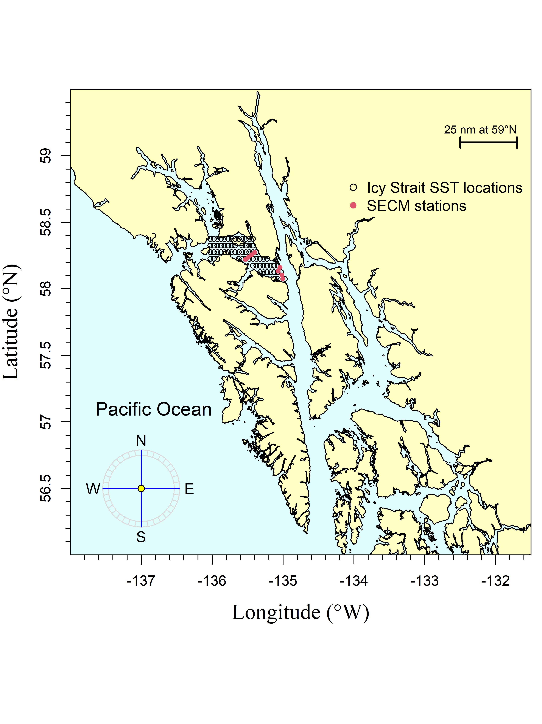

The Icy Strait region encompasses waters of Icy Strait from the east end of Lemesurier Island to a line from Point Couverden south to Point Augusta. The Southeast Coastal Monitoring (SECM) project transects (Upper Chatham Strait and Icy Strait) are shown as red points for comparison to the satellite stations (i.e., data points; black circles).

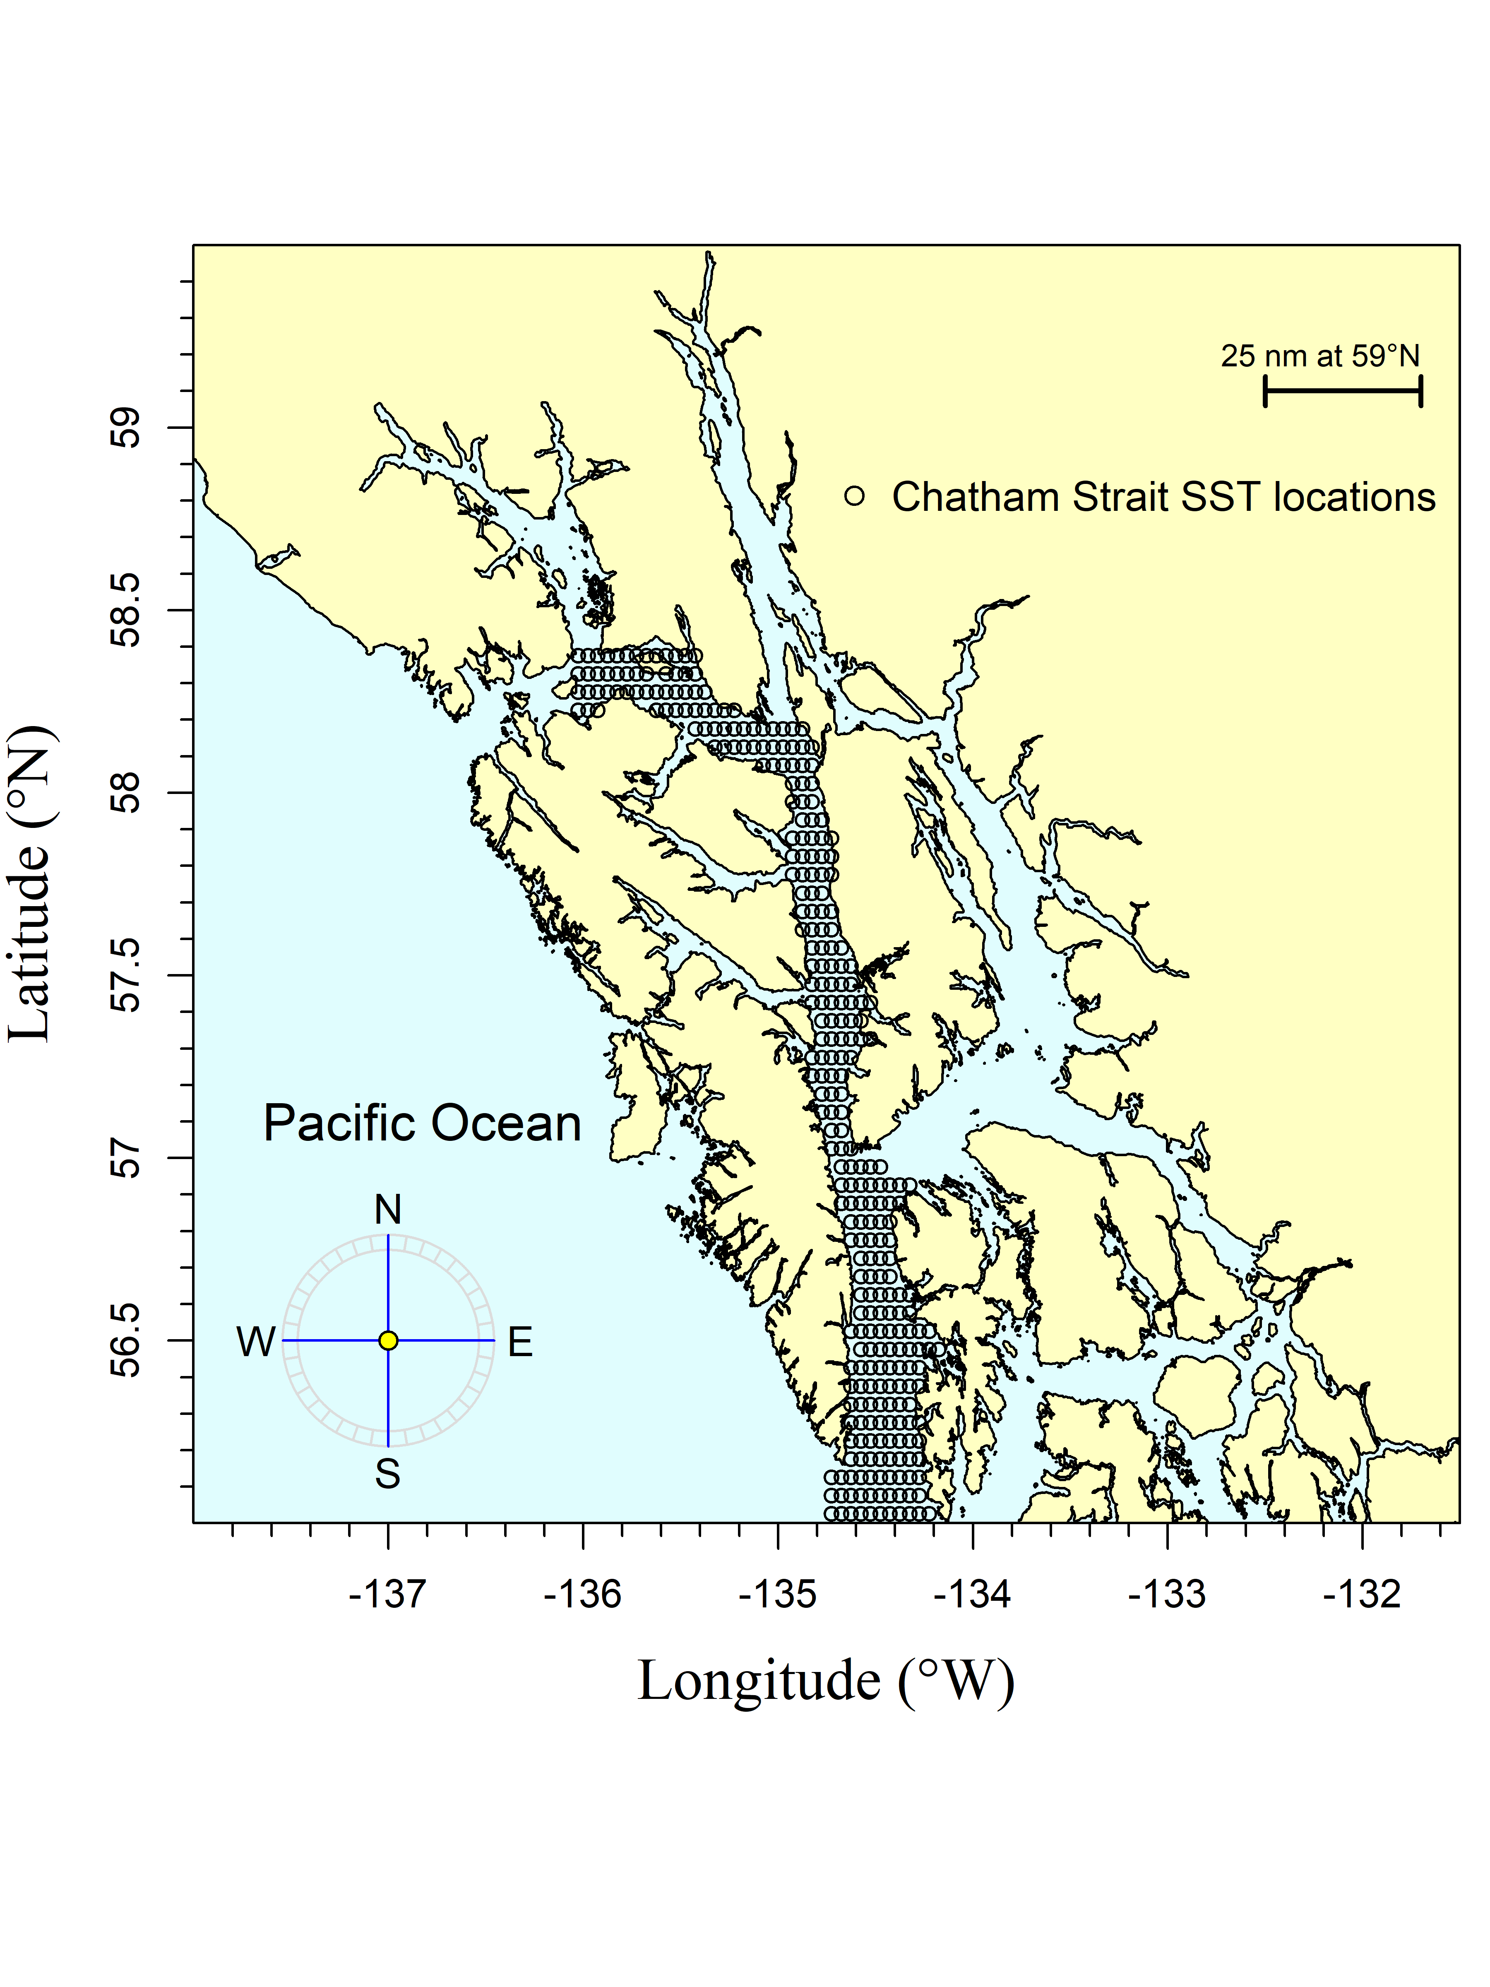

The Chatham and Icy Straits region encompasses waters of Chatham and Icy Straits east of Lemesurier Island to Point Couverden, south to the approximate latitude of 56.025 degrees north (roughly Cape Decision off Kuiu Island). The black circles are the satellite stations (i.e., data points).

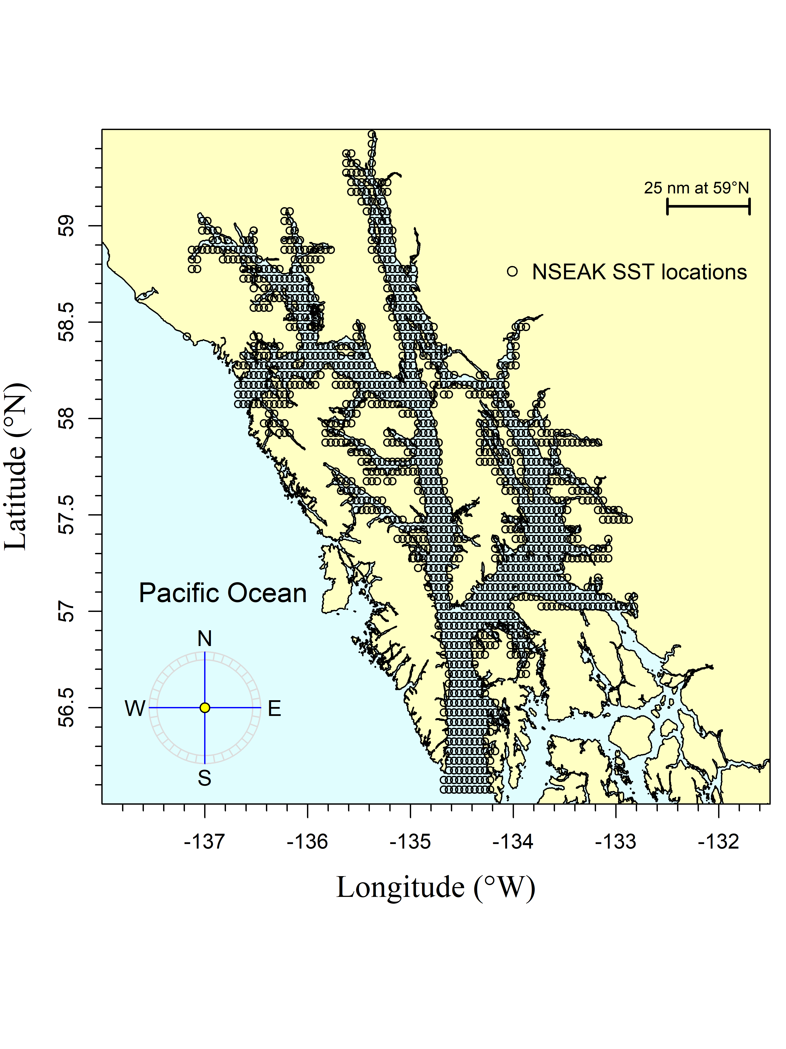

The northern Southeast Alaska (NSEAK) region encompasses northern Southeast Alaska from 59.475 to 56.075 degrees north latitude and from -137.175 to -132.825 degrees west longitude. The black circles are the satellite stations (i.e., data points).

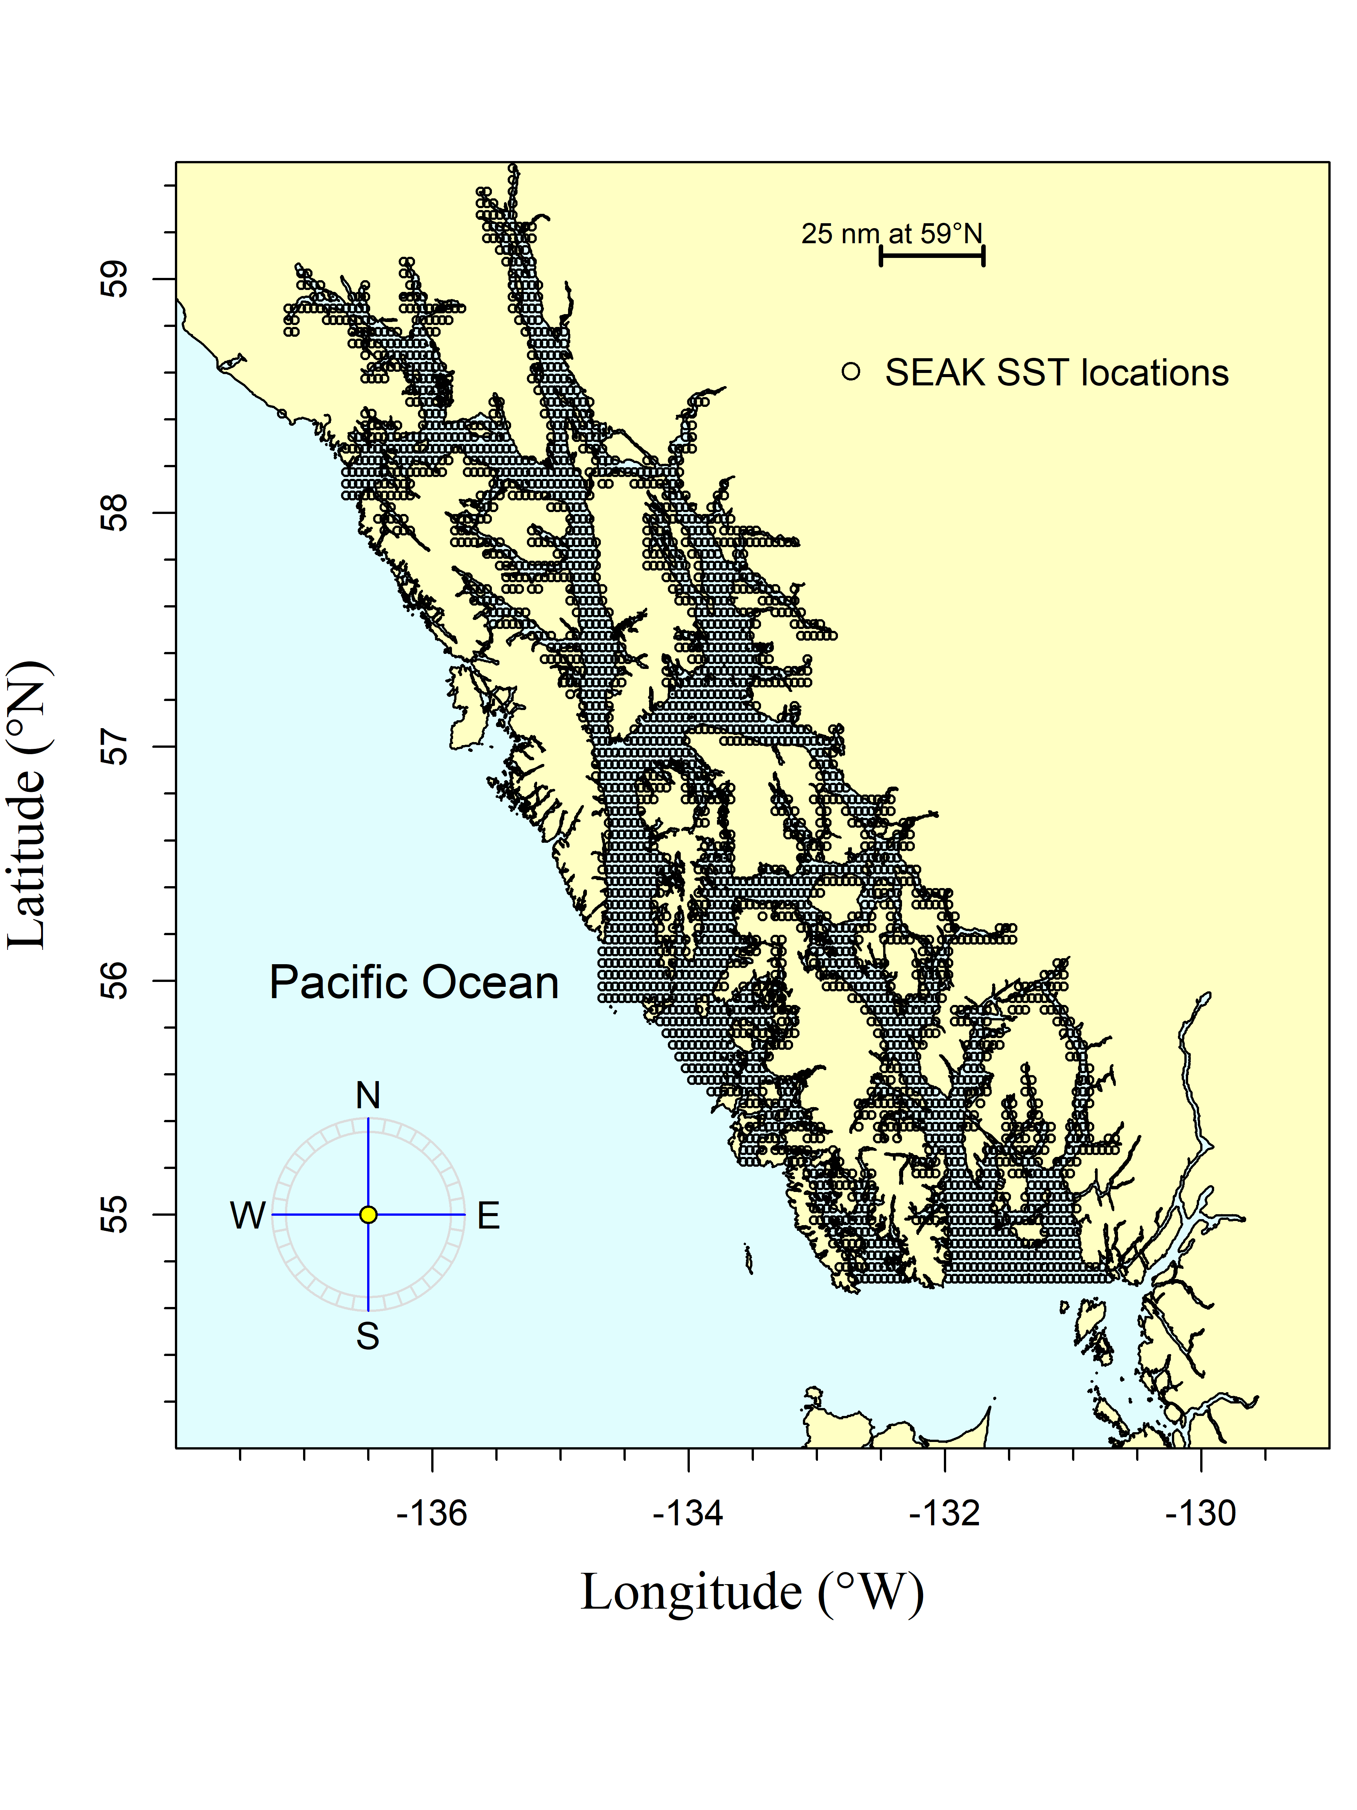

The Southeast Alaska (SEAK) region encompasses Southeast Alaska from 59.475 to 54.725 degrees north latitude and from -137.175 to -130.675 degrees west longitude. The black circles are the satellite stations (i.e., data points).

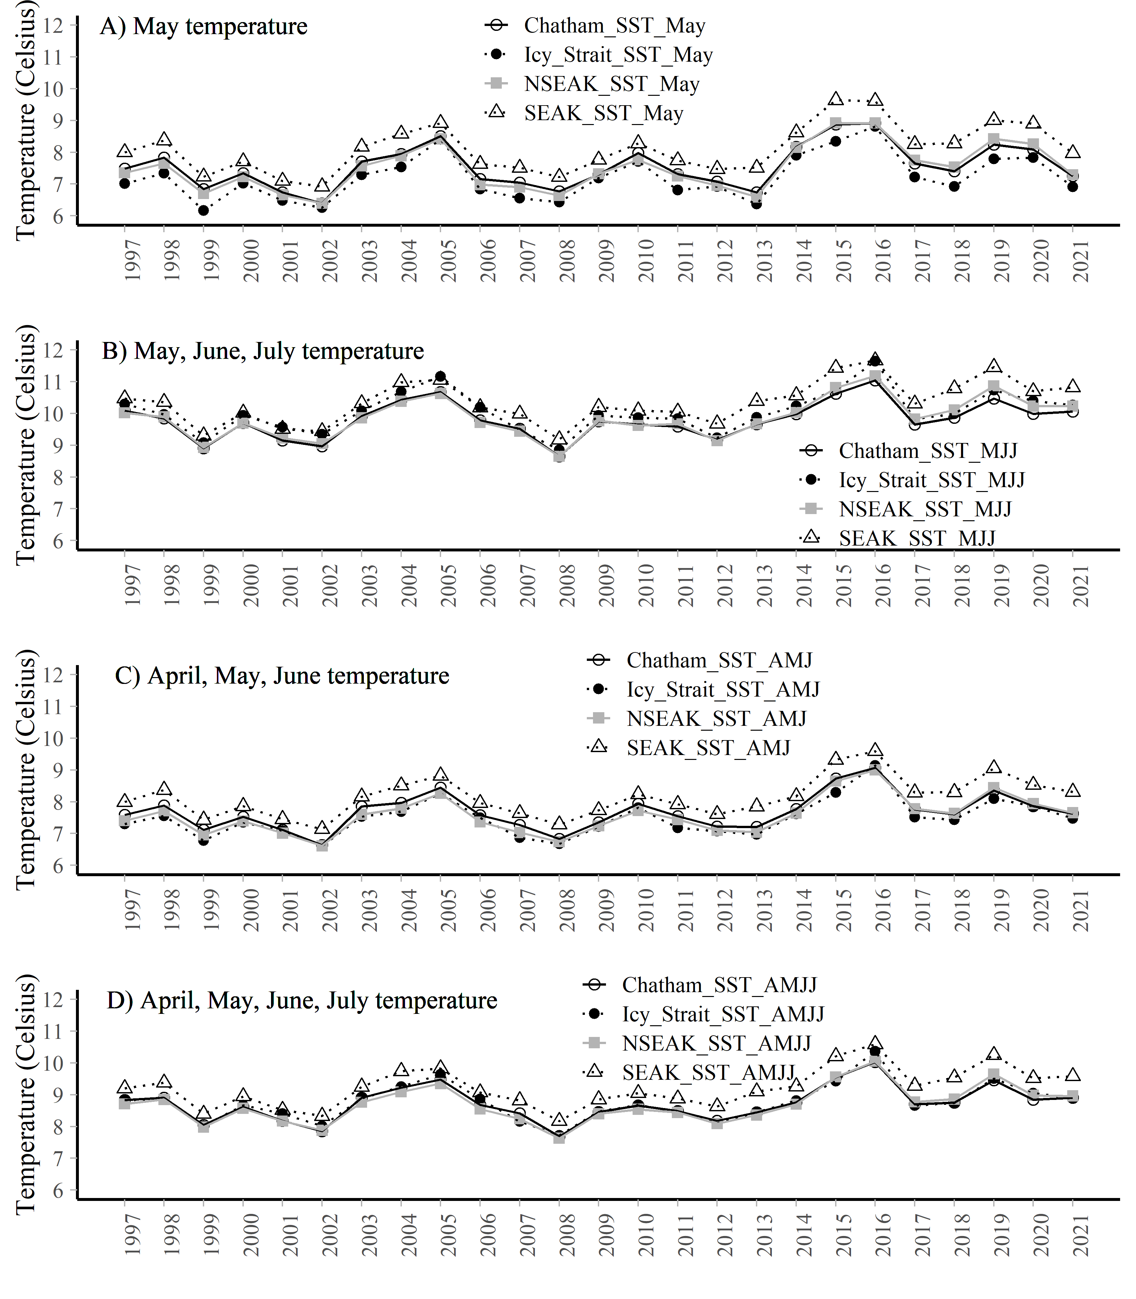

A. The May temperature averaged over each region (Chatham and Icy Straits, Icy Strait, NSEAK, SEAK) from 1997 through 2021. B. The May, June, and July temperature averaged over each region (Chatham and Icy Straits, Icy Strait, NSEAK, SEAK) from 1997 through 2021. C. The April through June temperature averaged over each region (Chatham and Icy Straits, Icy Strait, NSEAK, SEAK) from 1997 through 2021. D. The April through July temperature averaged over each region (Chatham and Icy Straits, Icy Strait, NSEAK, SEAK) from 1997 through 2021.

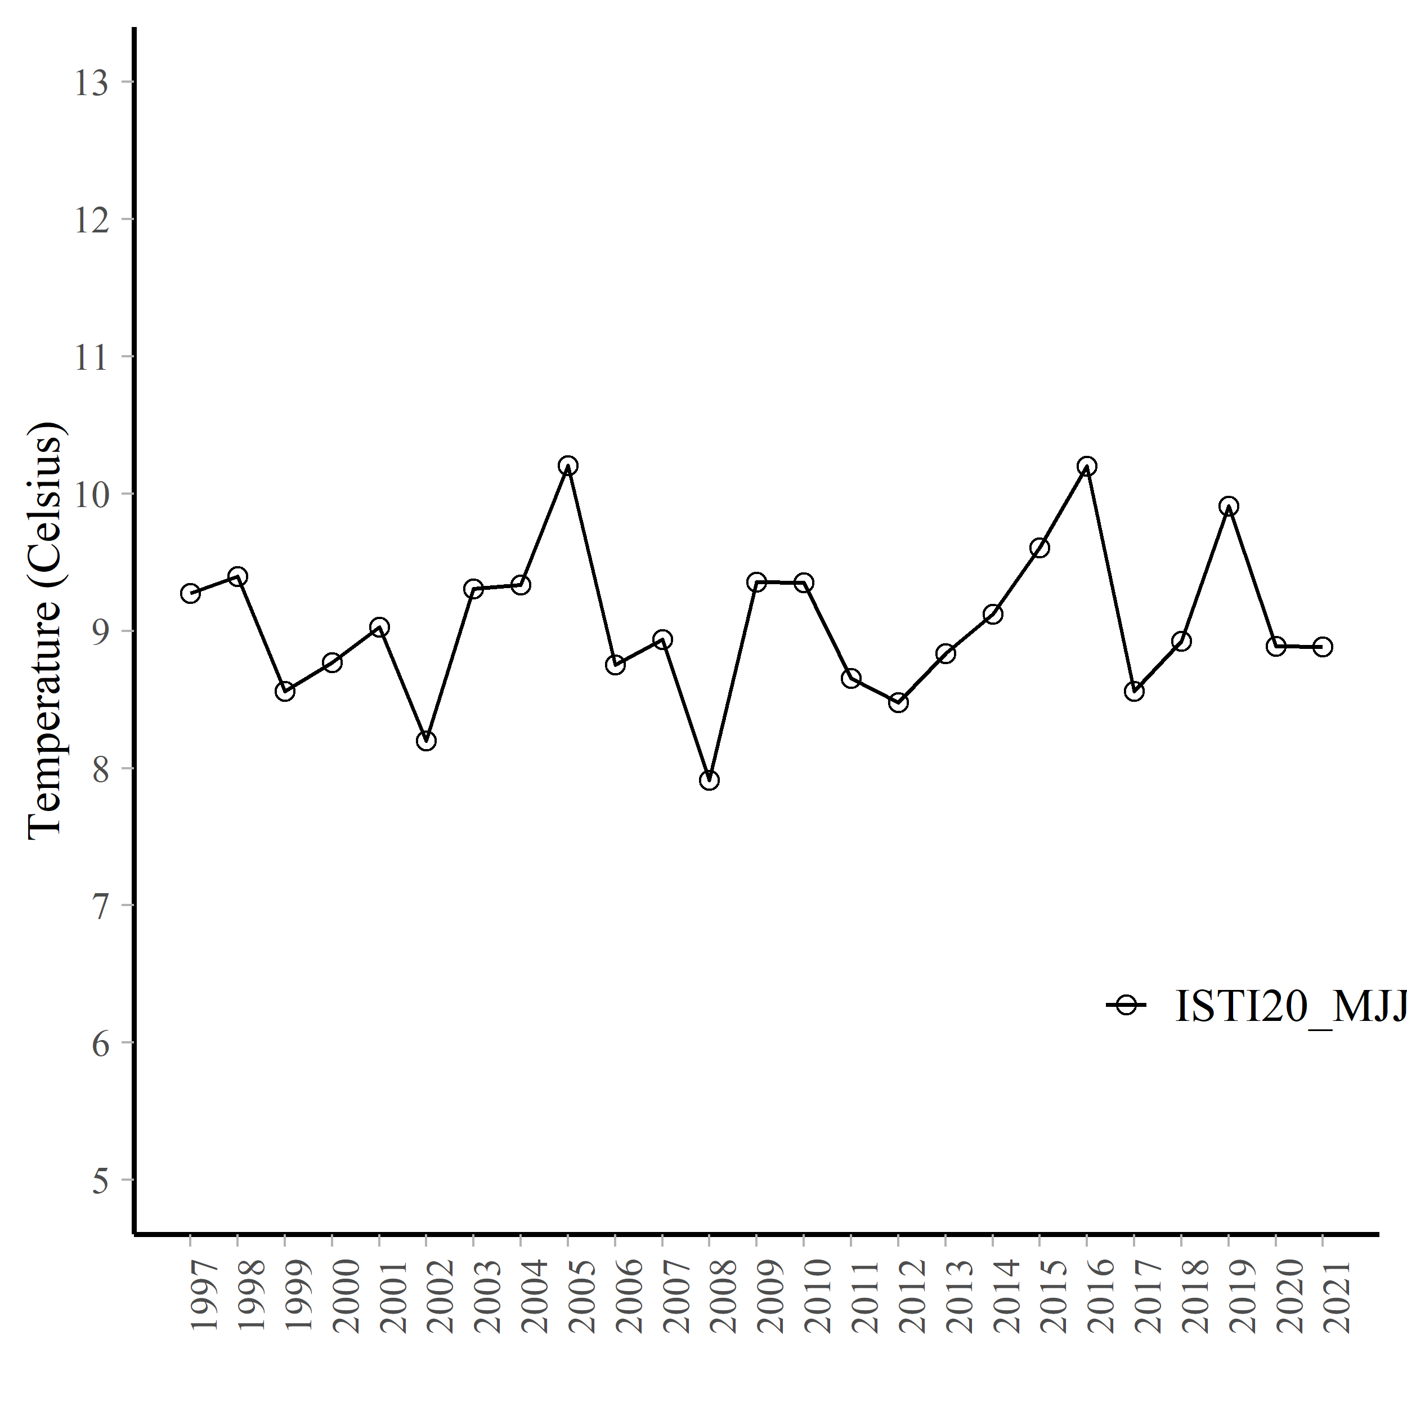

Average temperature (degrees Celsius) at 20m during May, June, and July at 8 stations in Icy Strait (Icy Strait and Upper Chatham transects; ISTI) from 1997 through 2021.

# Acknowledgements

Jordan Watson (NOAA) helped with the code to process the satellite data into a usable format. The data was accessed through NOAA’s Coral Reef Watch (<https://coastwatch.pfeg.noaa.gov/erddap/griddap/NOAA_DHW_monthly.html> and <https://coastwatch.pfeg.noaa.gov/erddap/griddap/NOAA_DHW.html>). Emily Fergusson summarized the SECM survey data by year, month, and depth. All code and associated data are located here: <https://github.com/commfish/southeast_pink_salmon_preseason> in the 2022_forecast folder.

# References

NOAA Coral Reef Watch (NOAA_DHW_monthly dataset). 2021, updated daily. NOAA Coral Reef Watch Version 3.1 Monthly 5km SST and SST Anomaly, NOAA Global Coral Bleaching Monitoring Time Series Data, May 1997-June 2021. College Park, Maryland, USA: NOAA/NESDIS/STAR Coral Reef Watch program. Data set accessed 2021-10-01 at <https://coastwatch.pfeg.noaa.gov/erddap/griddap/NOAA_DHW_monthly.html>.

NOAA Coral Reef Watch (NOAA_DHW dataset). 2021, updated daily. NOAA Coral Reef Watch Daily Near-real-Time Global 5km SST and SST Anomaly, NOAA Global Coral Bleaching Monitoring Time Series Data, July 2021. College Park, Maryland, USA: NOAA/NESDIS/STAR Coral Reef Watch program. Data set accessed 2021-10-01 at <https://coastwatch.pfeg.noaa.gov/erddap/griddap/NOAA_DHW.html>.

Piston, A. W., J. Murphy, J. Moss, W. Strasburger, S. C. Heinl, E. Fergusson, S. Miller, A. Gray, and C. Waters. 2021. Operational Plan: Southeast coastal monitoring, 2021. ADF&G, Regional Operational Plan No. ROP.CF.1J.2021.02, Douglas.