Untitled

Ben Williams

9/26/2019

This is figure 1.

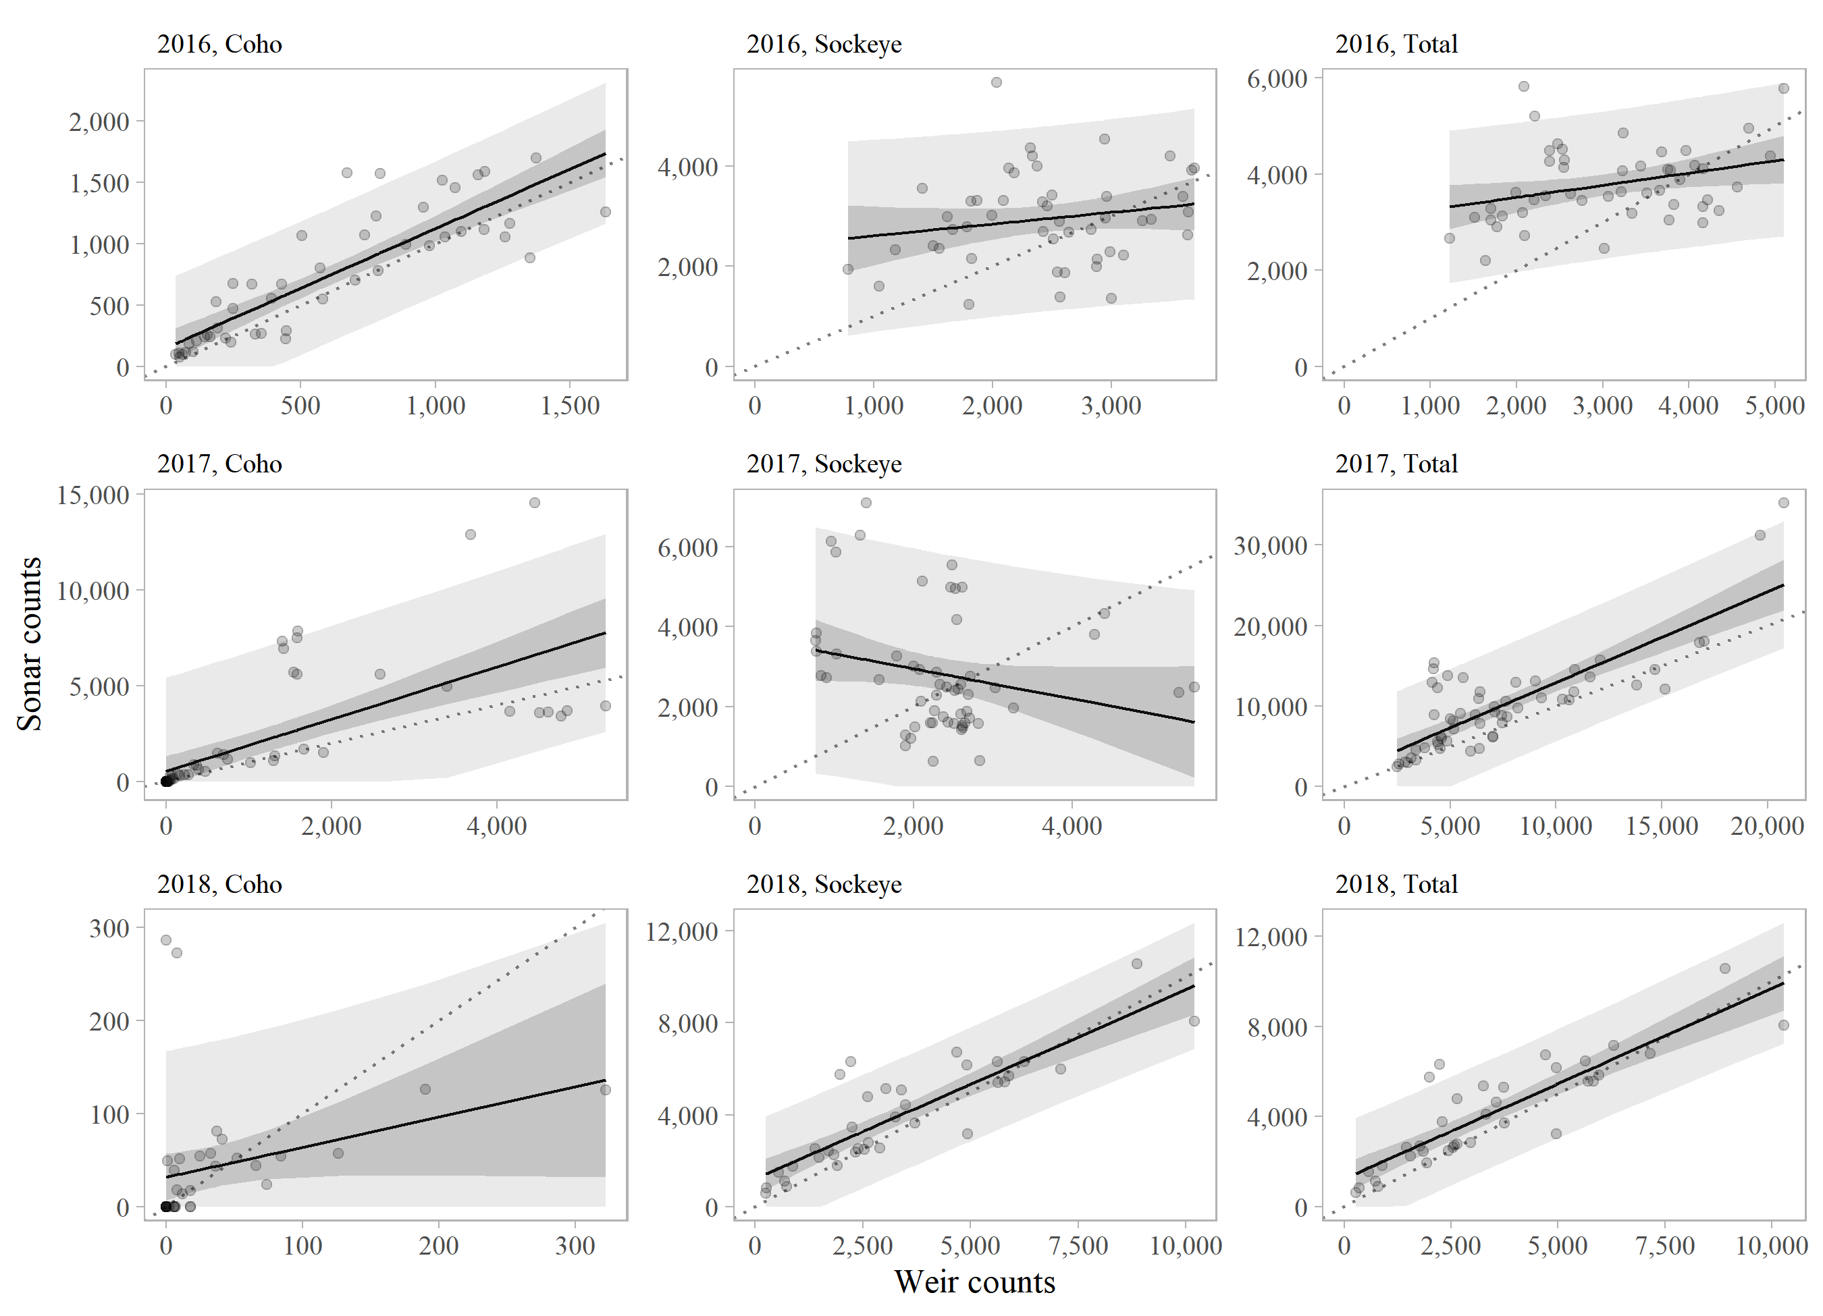

Figure 1: Estimates of scallop bed abundance based on statewide scallop dredge survey data. Error bars represent approximate 95 confidence intervals. Large scallops are those with shell height 100 mm