- Objective
- Audience
- Architecture
- API-Connect TMF APIS
  - Trouble tickting use case
  - Billing Use Case
- Creating an IBM Cloud Account
Step (1)
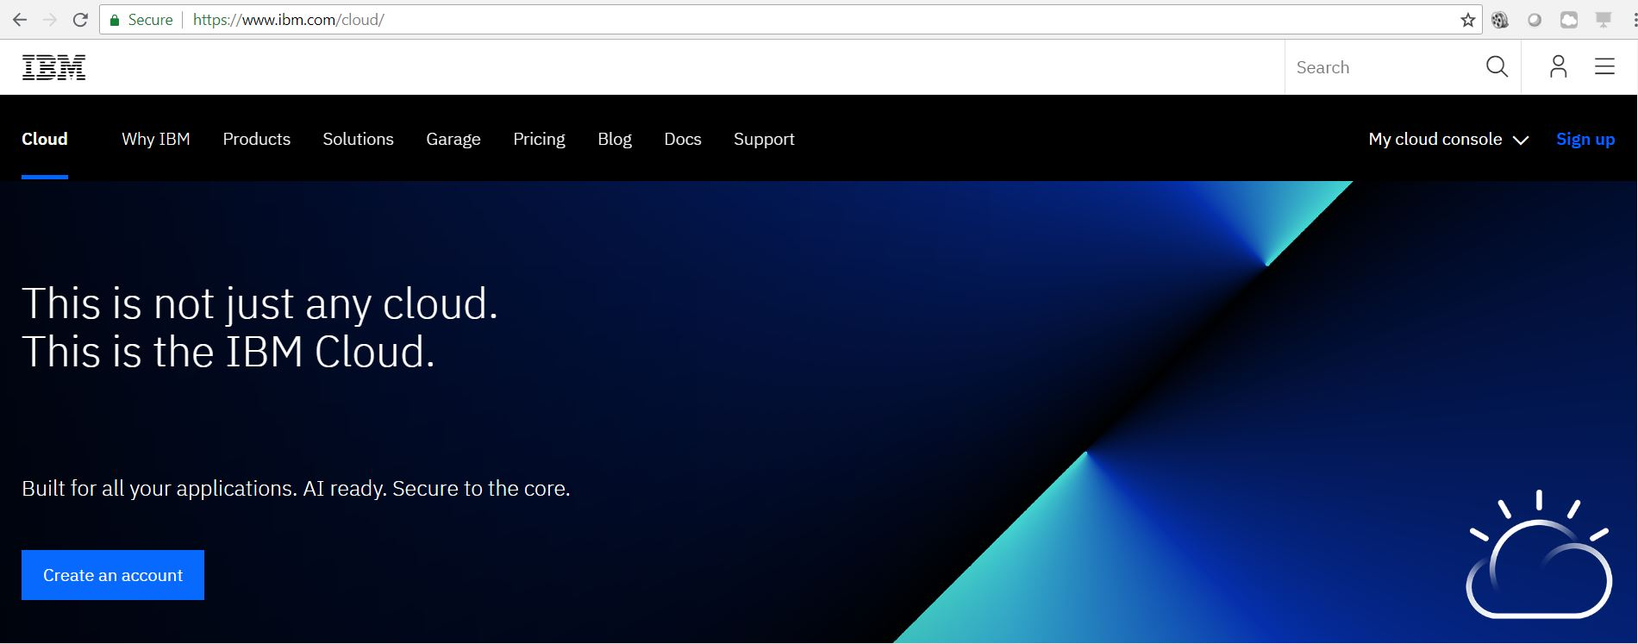
Navigate to www.ibm.com/cloud, Click the Blue “Create Account” Button

Step (2)
Create your account details and password
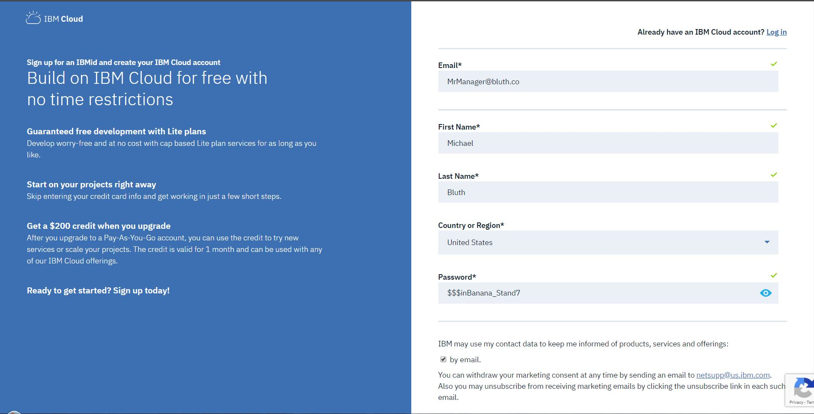

Step (3)
You will receive an Account Confirmation Email at the address you provided. Click the blue “Confirm Account” button within the email

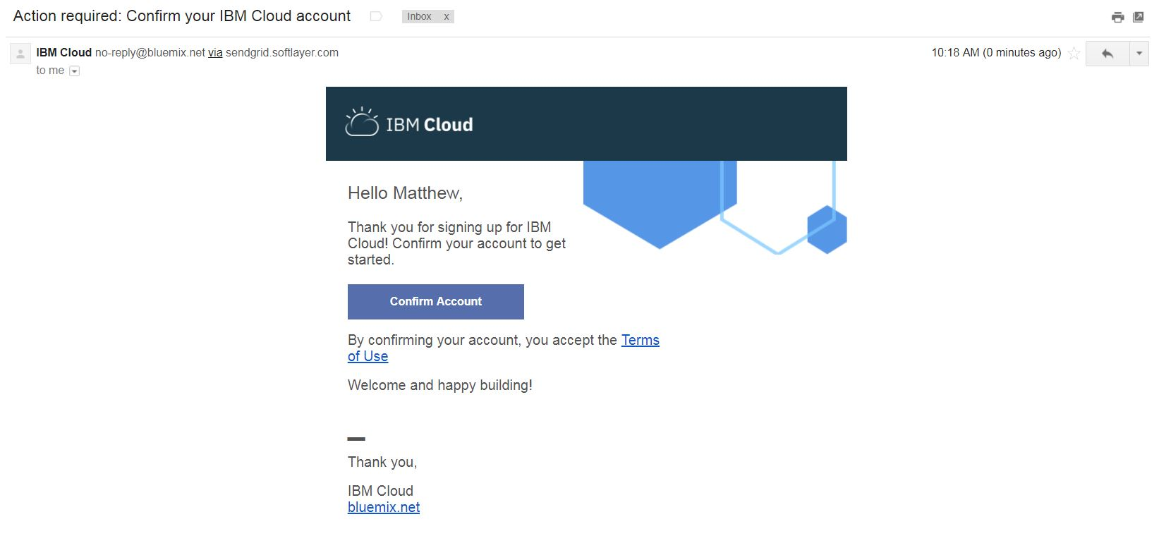
You will immediately be provided with a copy of the IBMid Privacy Policy. Read the policy, then click “Proceed”
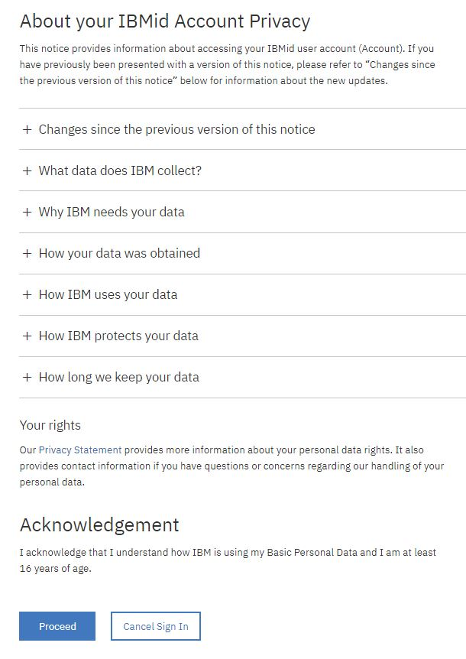
- Creating a Node-RED Starter Instance
Introduction of the service

Step (1)
Within the IBM Cloud Dashboard, navigate to the Catalog using the “Catalog” Button in the upper toolbar
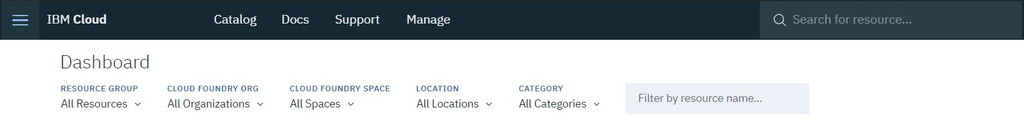
Step (2)
Once in the Catalog, Search for “Node-RED Starter” and click the Description Card. Alternatively, click the “Starter Kits” Category in the Left-hand filter menu as shown.

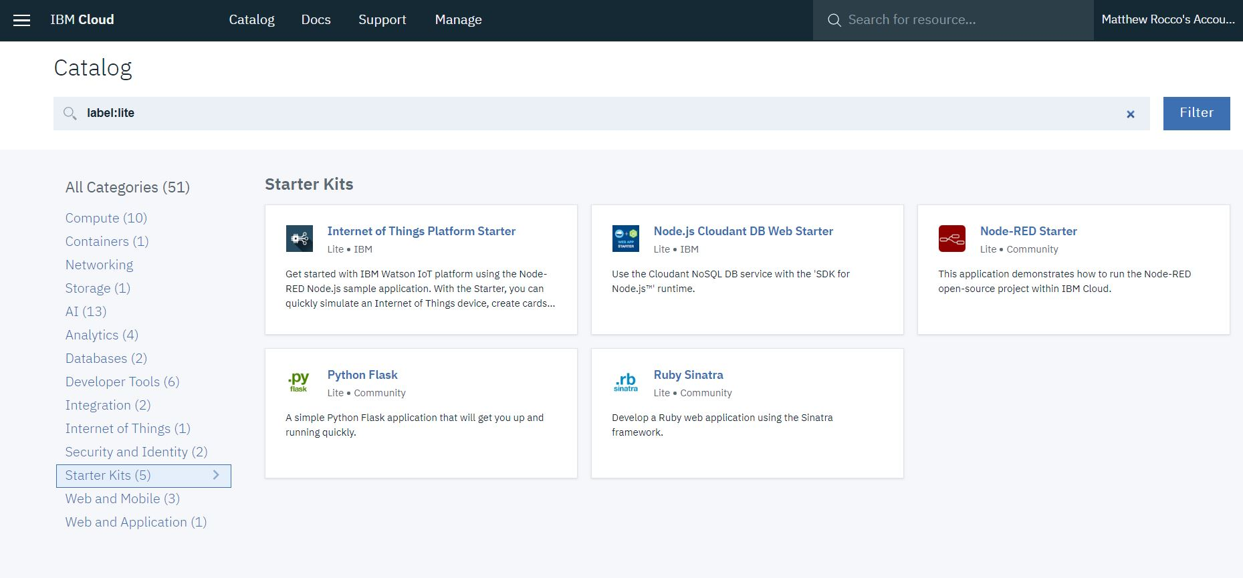
Step (3)
Give your Node-RED Service an App Name and then Create the Service.

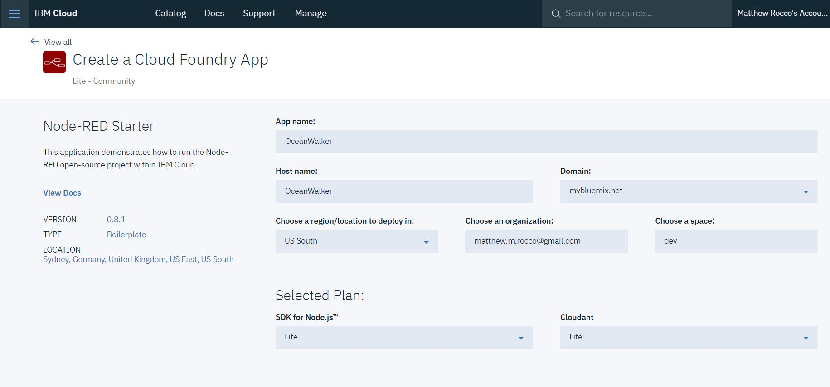

You will then be redirected to the IBM Cloud Dashboard. Your Node-RED Service will appear under the “Cloud Foundry Applications” Header. Click It.
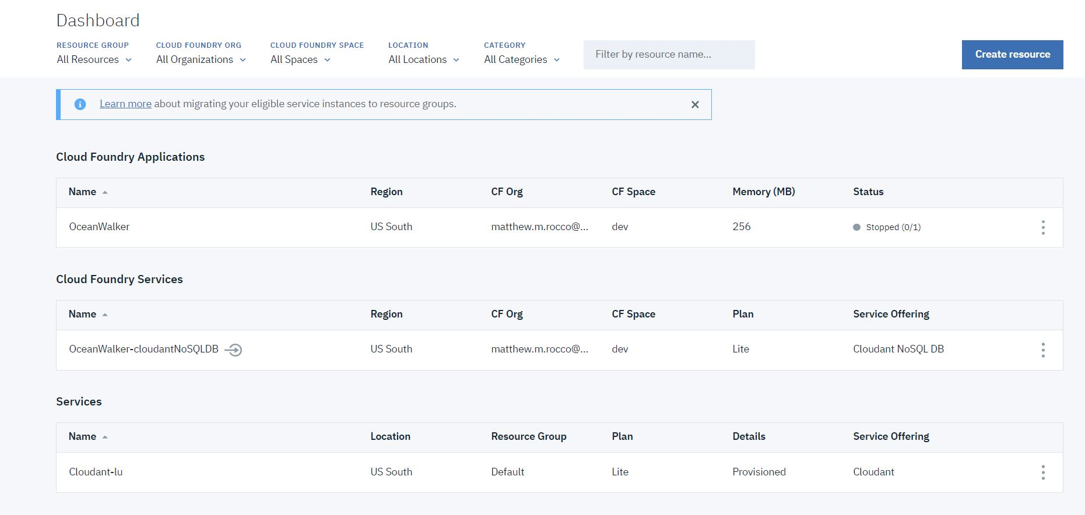
Step (3)
In the Node-RED Service Menu, navigate to the “Overview” Tab in the Left-hand menu, then select the “Menu” in the upper-right, as shown. Start the Service.

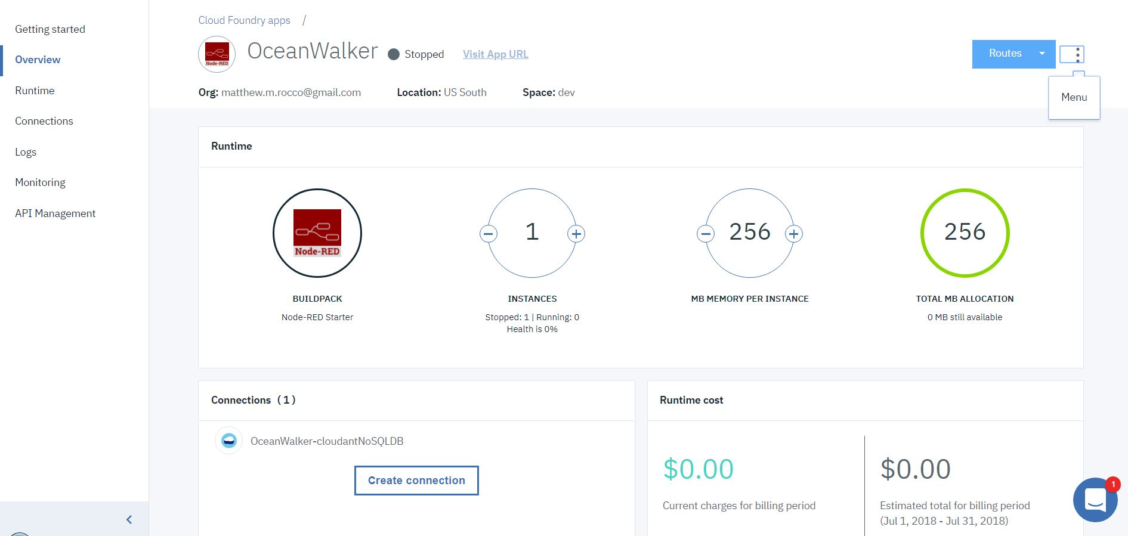

Wait roughly One Minute. The page should refresh and show a “This app is awake” status. Refresh the page manually, if necessary. Once the Status message is displayed, click the “Visit App URL” link, as shown

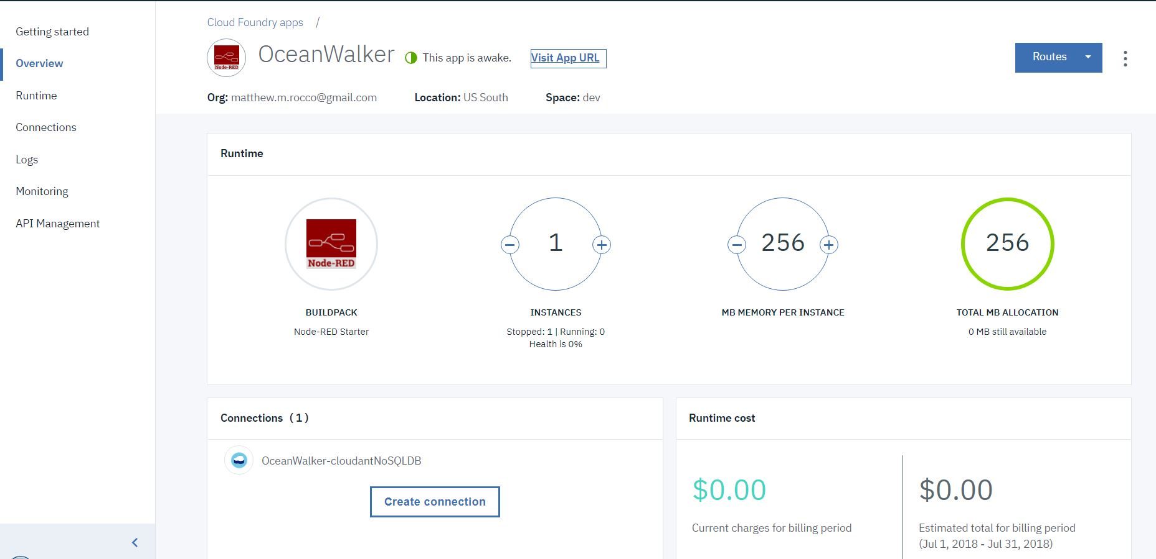
Step (4)
You will be taken to a Node-RED Startup Wizard. Click “Next”

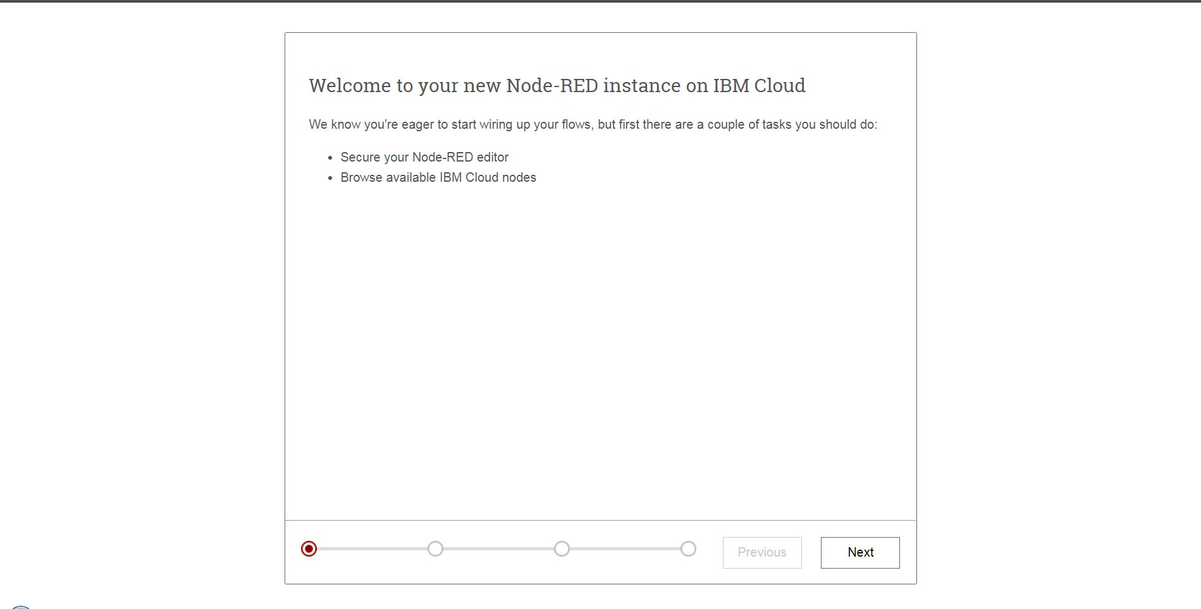

Choose to “Secure your Node-RED editor” using the Radio Button. Create a Username and Password. Leave “Allow anyone to view the editor” unchecked. Then Click “Next.”
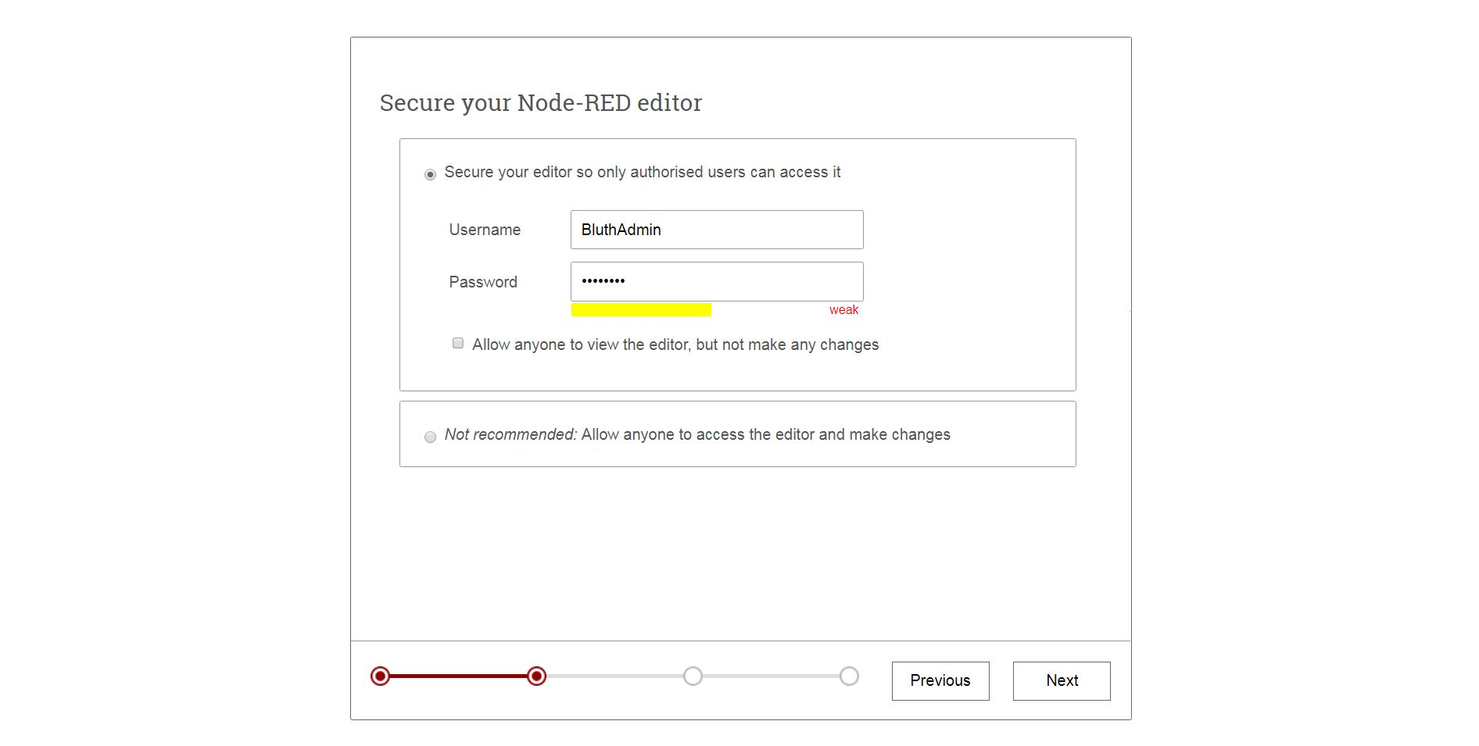
Click “Next” again.

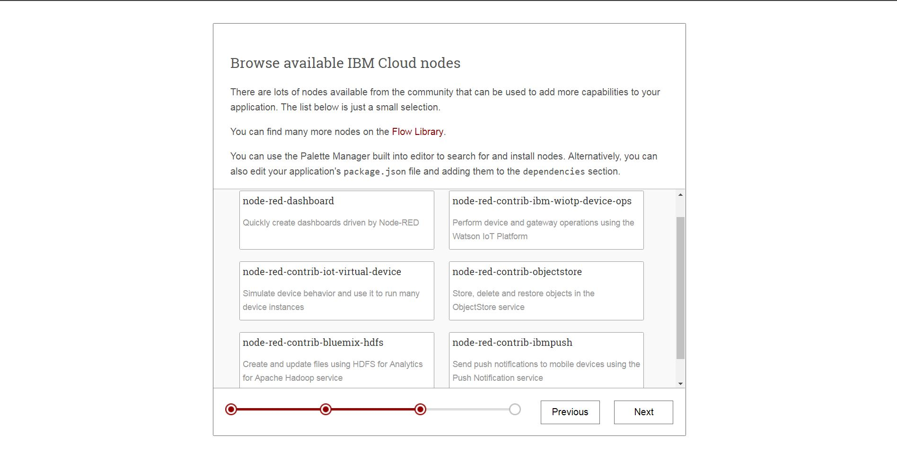
Finish the Install by Clicking “Finish”
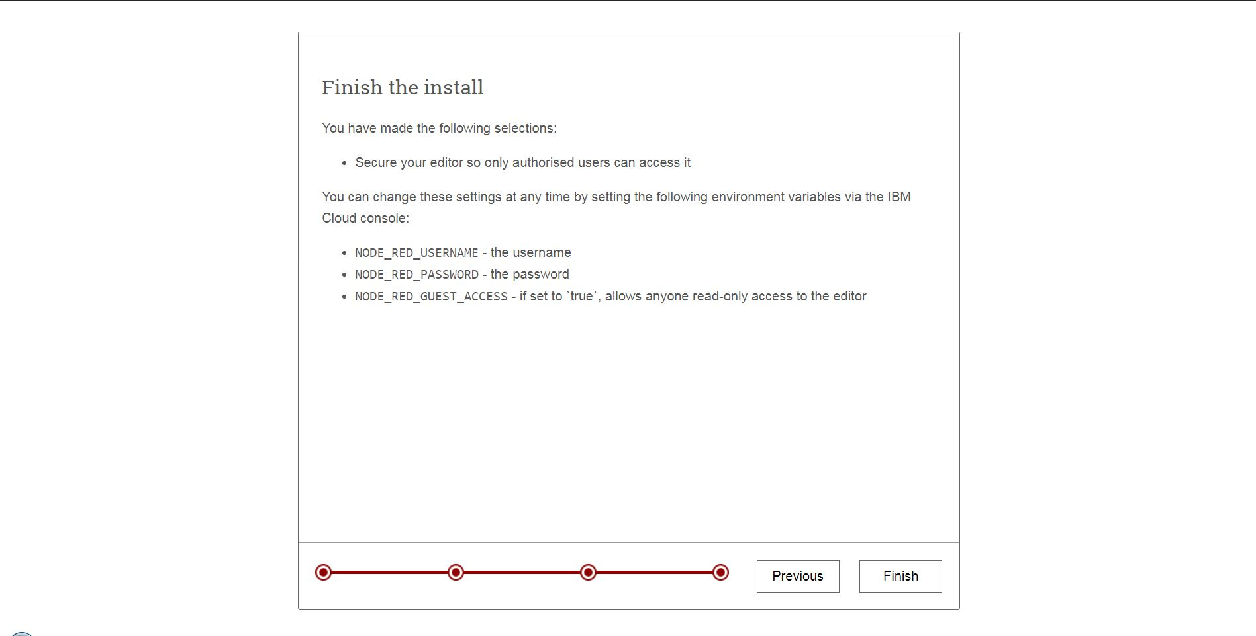

Step (5)
Your Node-RED Instance is now live. You can begin working with the Flow Editor at any time by clicking the “Go to Your Node-RED flow editor” button in the center of the page.

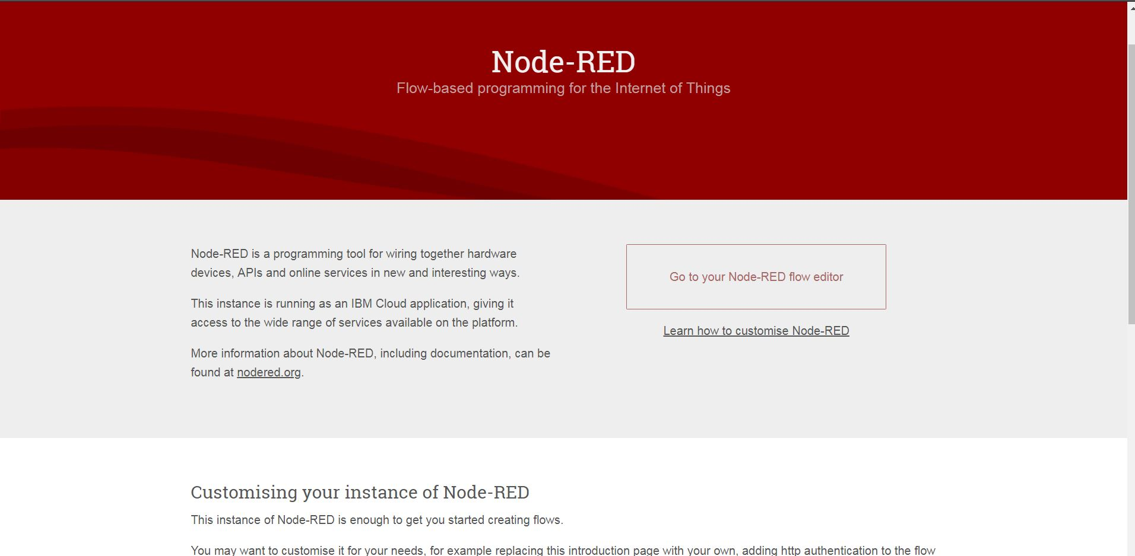

You will then be brought to the Flow Editor, as shown below
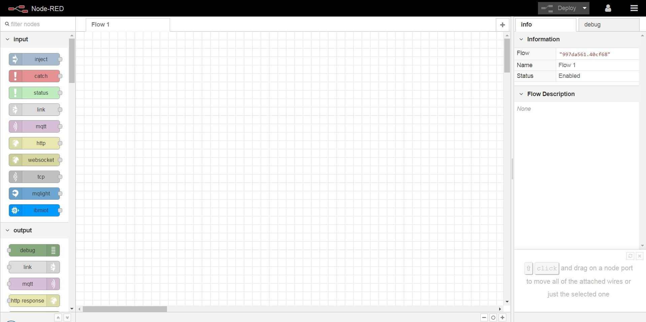

- Create a sample conversation using Watson Assistant
Introduction of the service
Step (1)
Navigate to ‘Catalog’ section in IBM Cloud.
Select ‘Watson Assistant’ in ‘AI’ Category (as shown in image below).

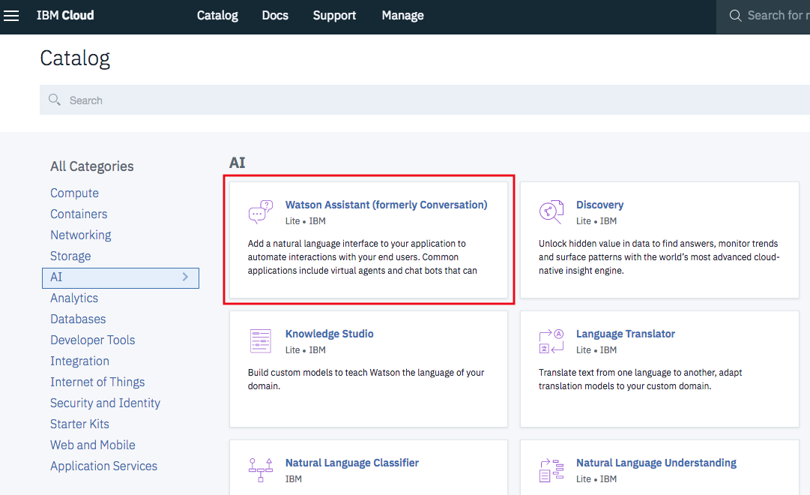

Click ‘Create’
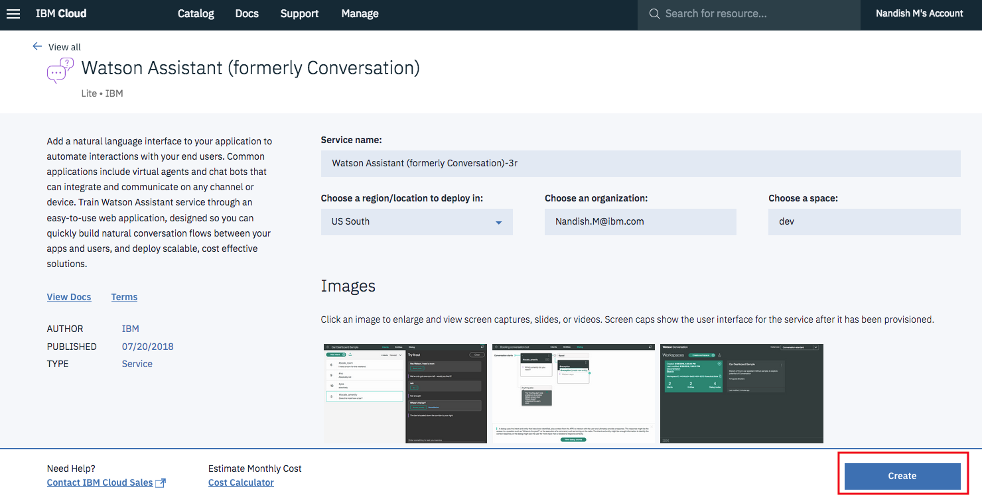

Step (2)
Create workspace with Name and Description.
Name: WA_TMF_Sample
Description: Watson Assistant sample for TM Forum Lab

Creation of ‘Intents’
Choose ‘Intents’ then select ‘Add intent’

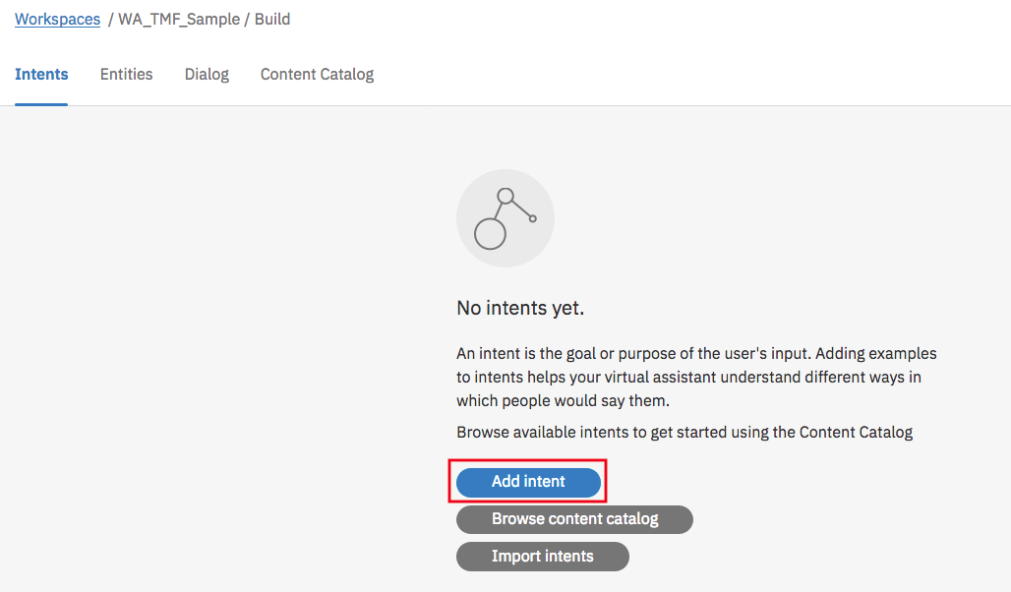

Provide ‘Intent name’ and ‘Add example’.

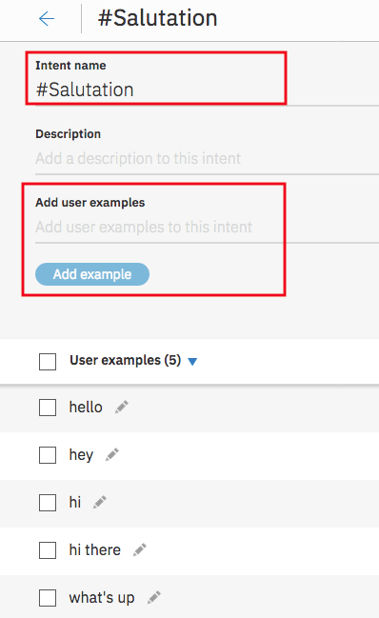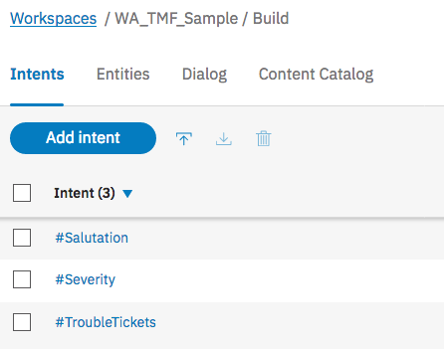

Please follow similar steps for ‘Severity’ and ‘TroubleTickets’ Intents as well using examples provided below

#Severity
How many trouble tickets are of high severity
How many tickets are marked as low
How many high Severity tickets are there?
High Severity tickets

#TroubleTickets
Trouble Tickets
Tickets
need info about tt
I want to query about trouble tickets
I want to discuss a trouble ticket

Creation of ‘Entities’

Choose Entities -> My entities -> Add entity

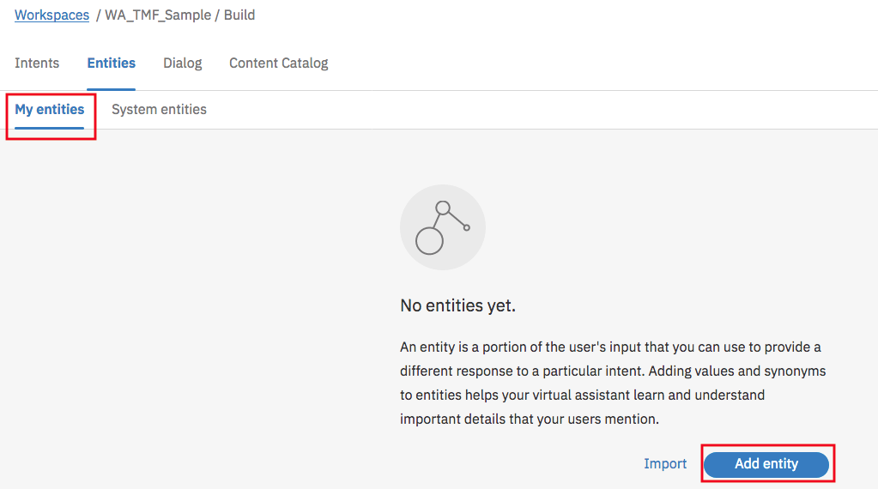

Provide Entity name, Value and Synonyms
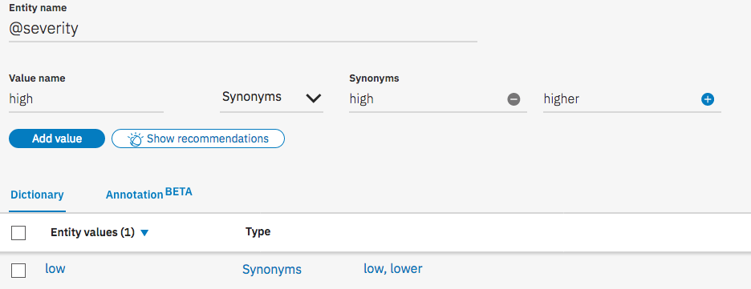

Creation of ‘Dialog’

Choose Dialog -> Create

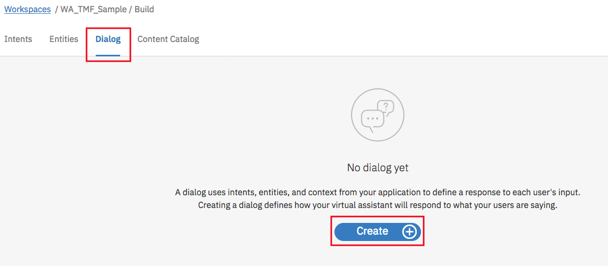

If bot recognizes: Provide Intent name
Then respond with: Provide Watson response

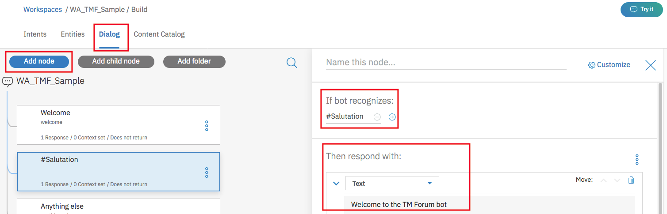

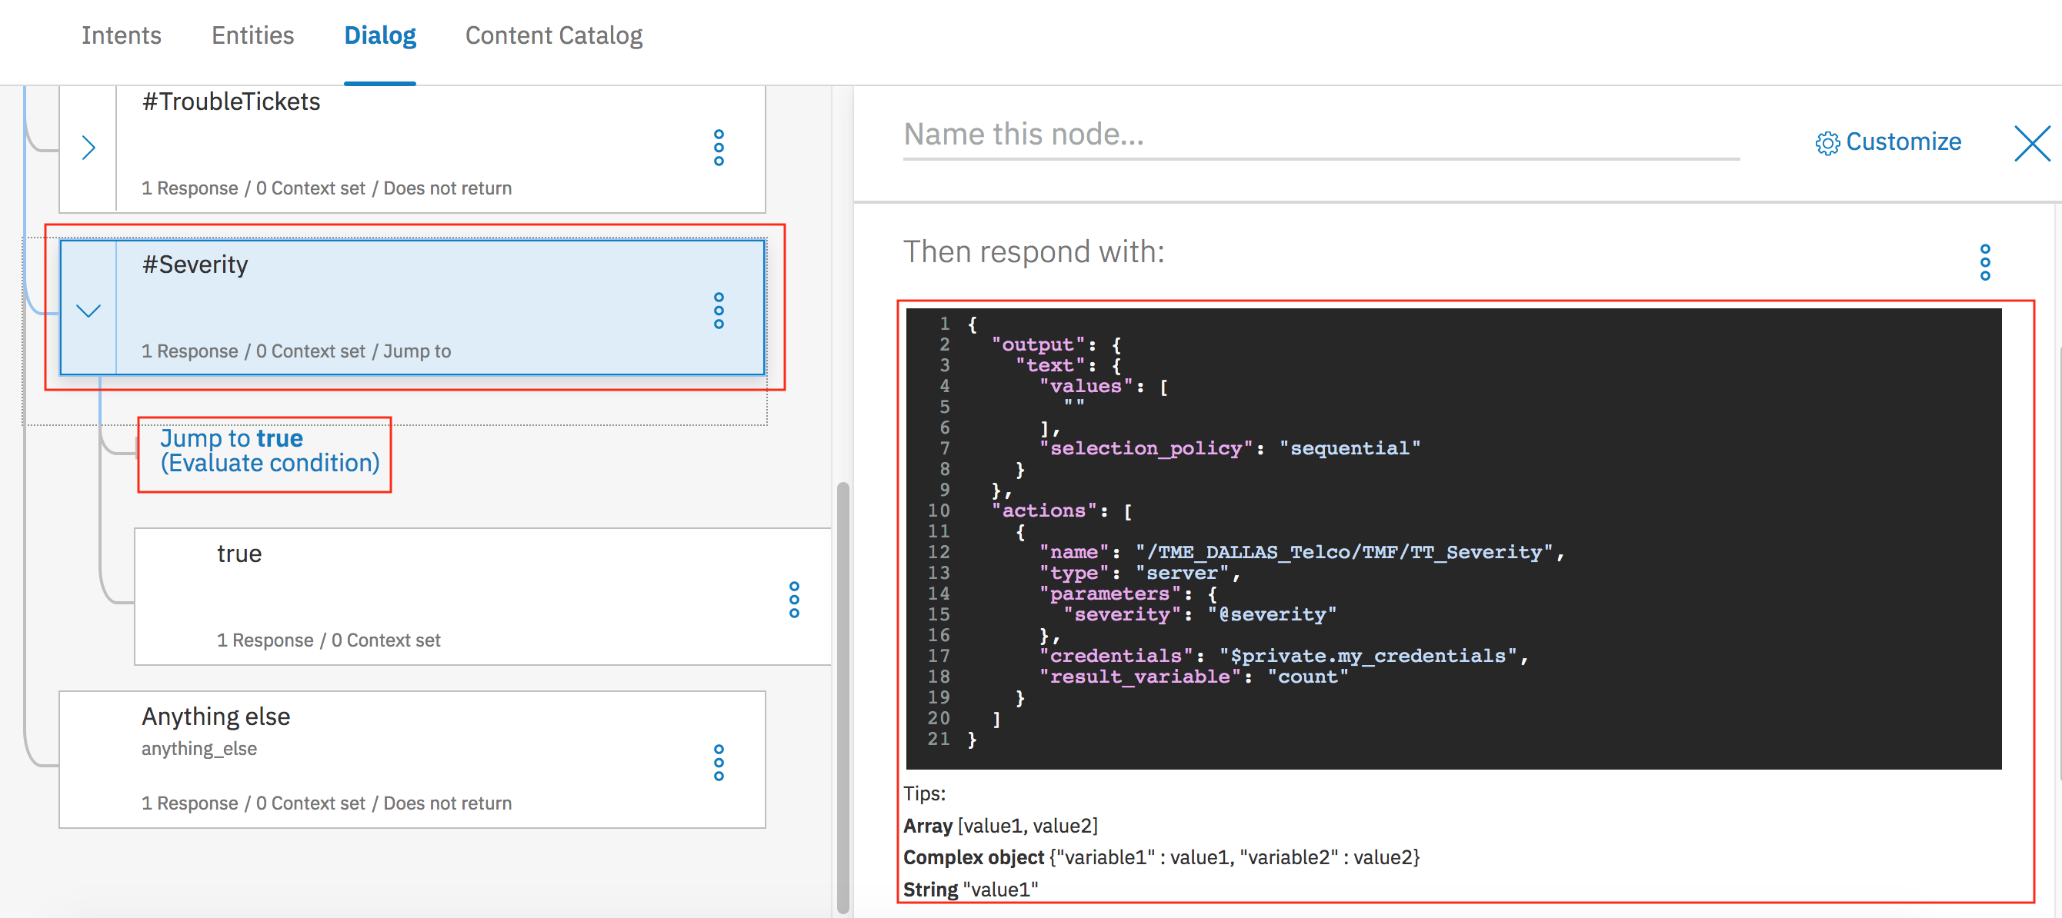

For ‘Severity’ include details provided below. Also include ‘Jump to’.

{
"output": {
"text": {
"values": [
""
],
"selection_policy": "sequential"
}
},
"actions": [
{
"name": "/TME_DALLAS_Telco/TMF/TT_Severity",
"type": "server",
"parameters": {
"severity": "@severity"
},
"credentials": "$private.my_credentials",
"result_variable": "count"
}
]
}

Step (*) (Alternate approach – Import using JSON file)
Create ‘Workspace’ with Name and Description

Import ‘TMF_Sample_Conversation_WA.json’ file which is available within ‘Watson_Assistant’ folder.
Github link: https://github.com/commgsc/tmf_sample_app.git

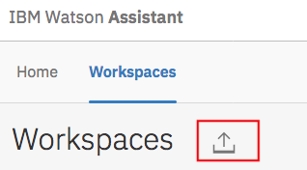

Once json file has been imported, you could view ‘Intents’, ‘Entities’ and ‘Dialog’.

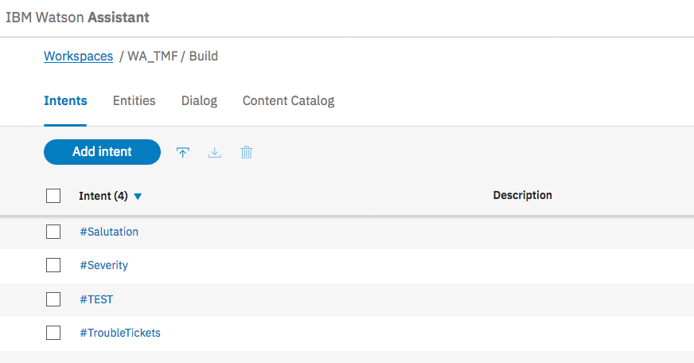

Step (3)
Try out the conversation, you just created!

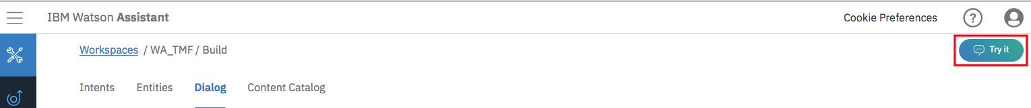

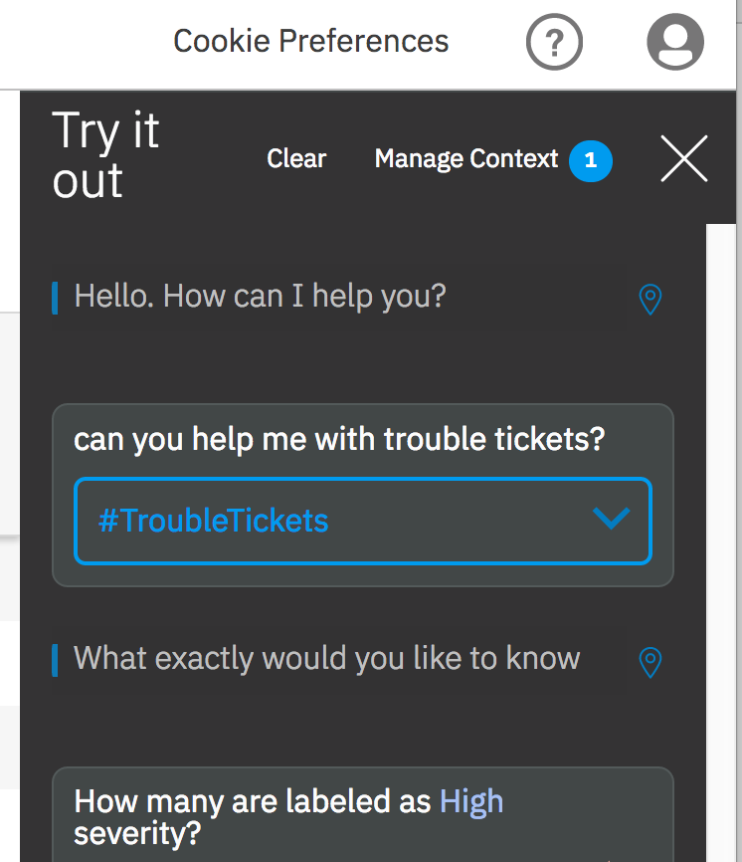

- Creating and configuring the IBM Functions Service
Introduction of the service

Step (1)
Navigate to catalog.mybluemix.net to reach the IBM Cloud Catalog.
Search “Functions” to find IBM Functions Service

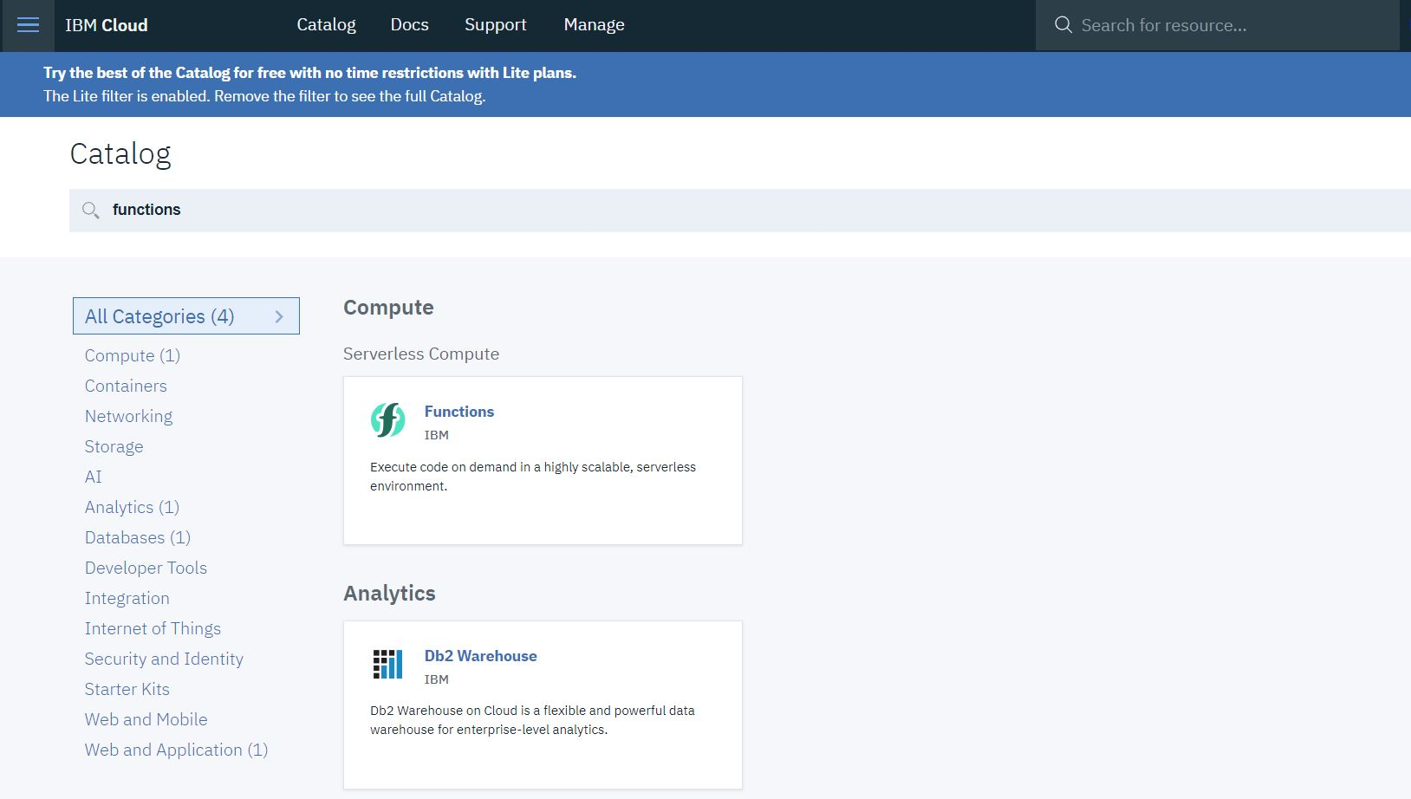
Step (2)
Navigate to “Actions” in the Left-hand menu. Click the Blue “Create” Button on the right-hand side

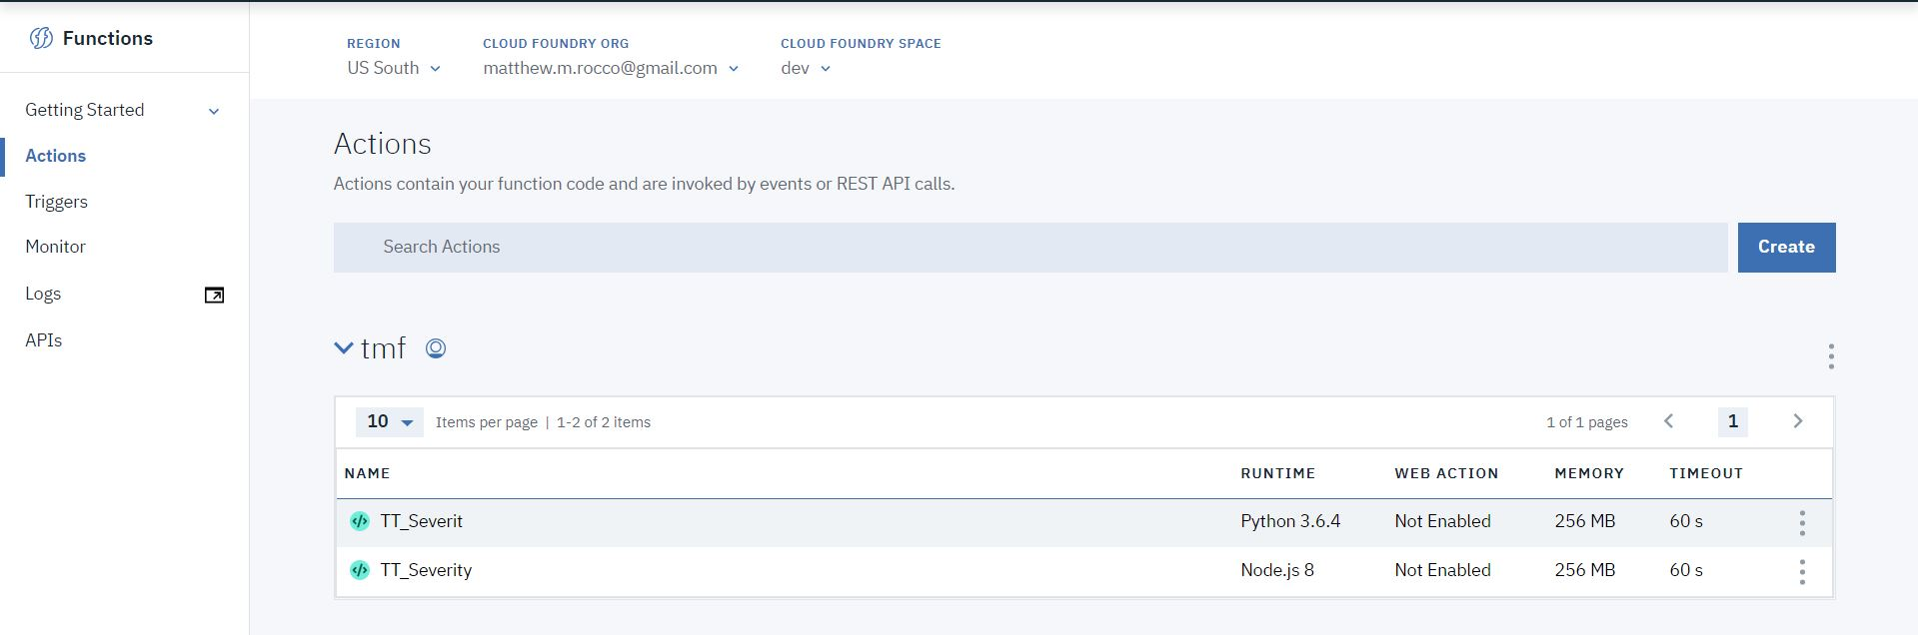
Enter “TT-Severity” as the Action Name. Use the “Create Package” button to create a Package. Name it tmf. Select Python 3 as your Runtime in the Dropdown Menu. Then click the blue “Create” Button in the lower right corner.

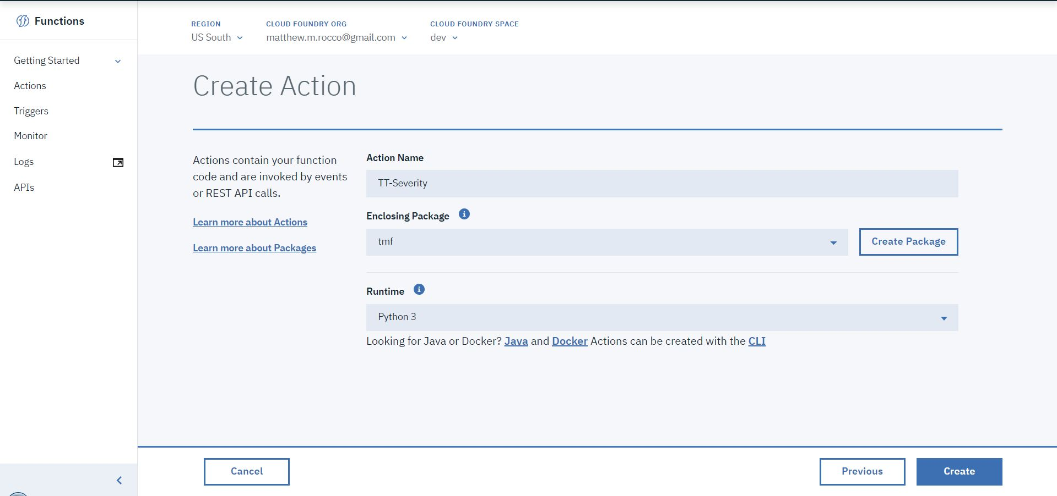

Step (3)
In a separate browser tab, navigate to: Within the Git repository, navigate to tmf_sample_app/actions/queryTroubleTickets.js. Copy the code that you find there.

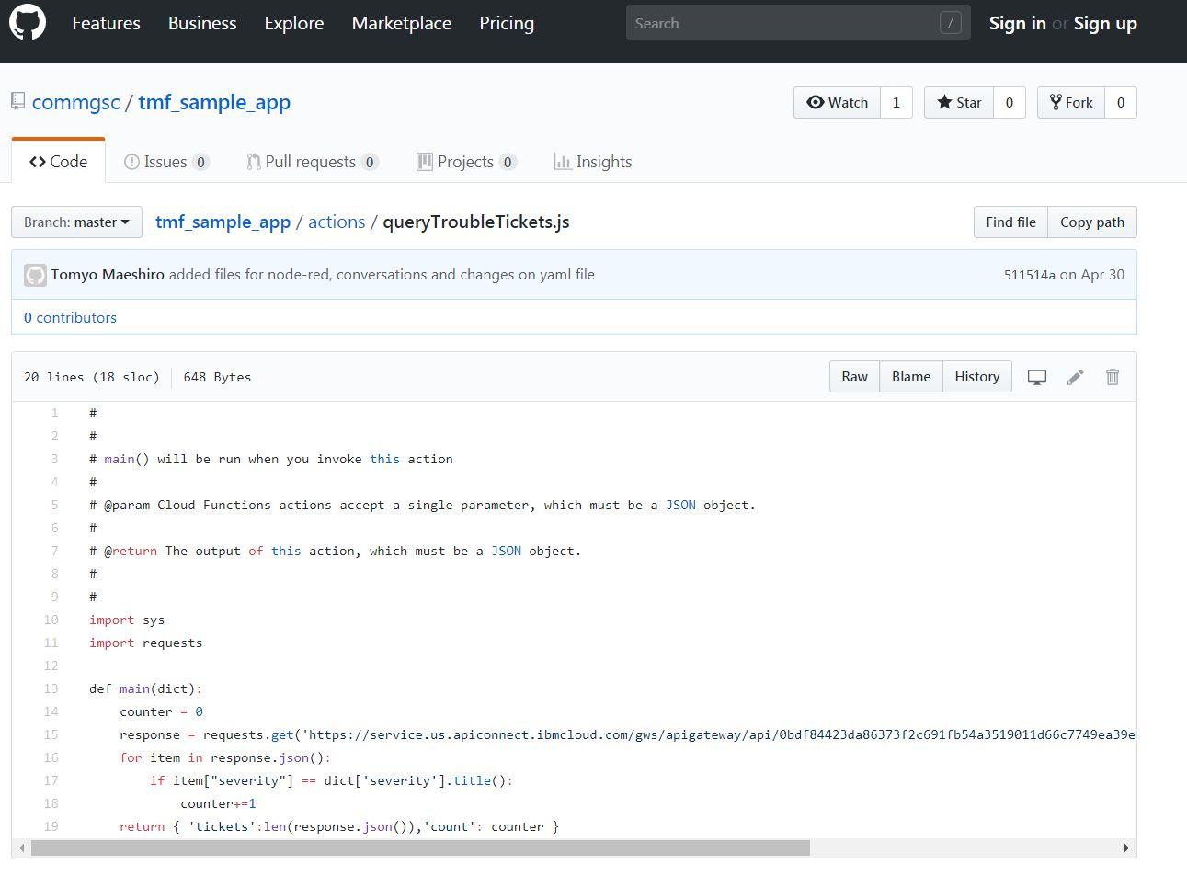

Back in your IBM Functions Tab, paste the code from the Git Repository in the “code” editor in the center of the page. Once pasted, Click the “Change Input” icon above the code editor.

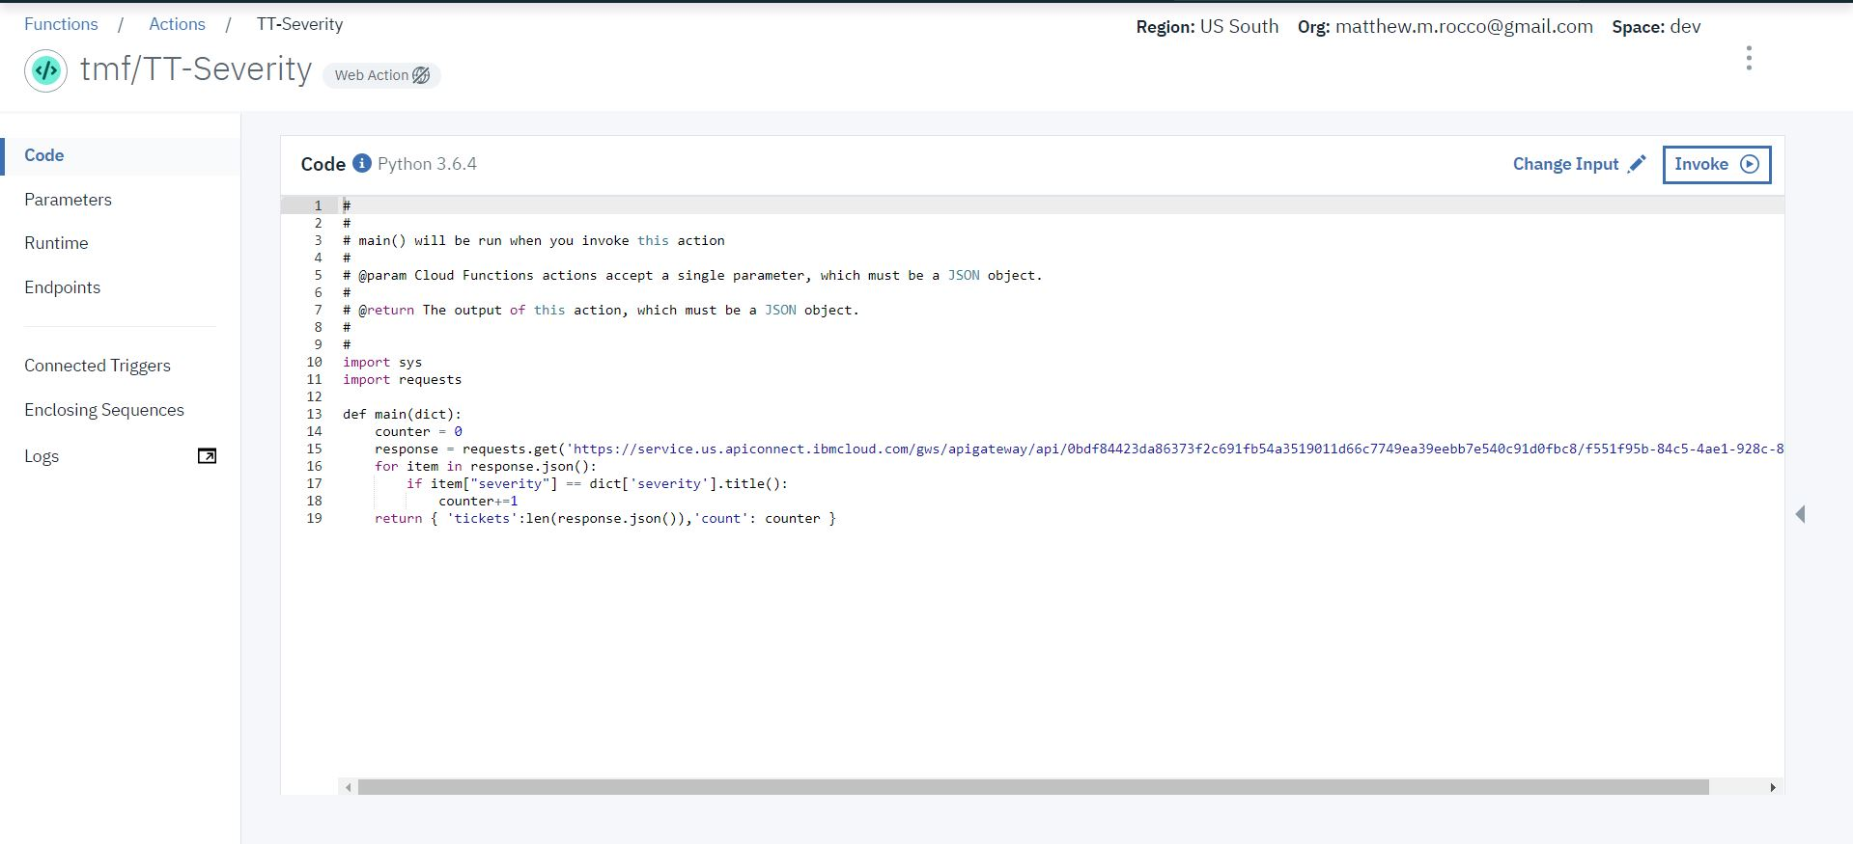
Change the Action Input to {“severity”:”High”}, as shown. Then Click the Blue “Apply” button

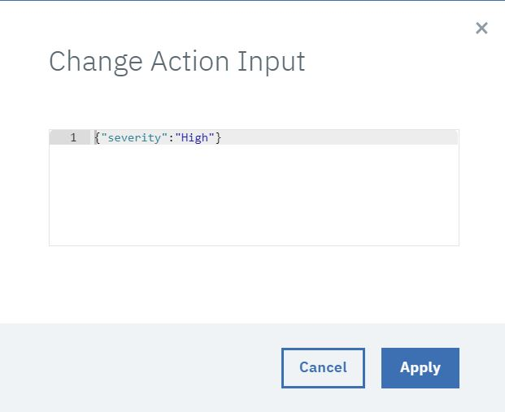
Back on the main page, Click the “Invoke” Button above the code editor in the center of the page. You can see the results of your test in the “Activations” Window shown at right in the image below:

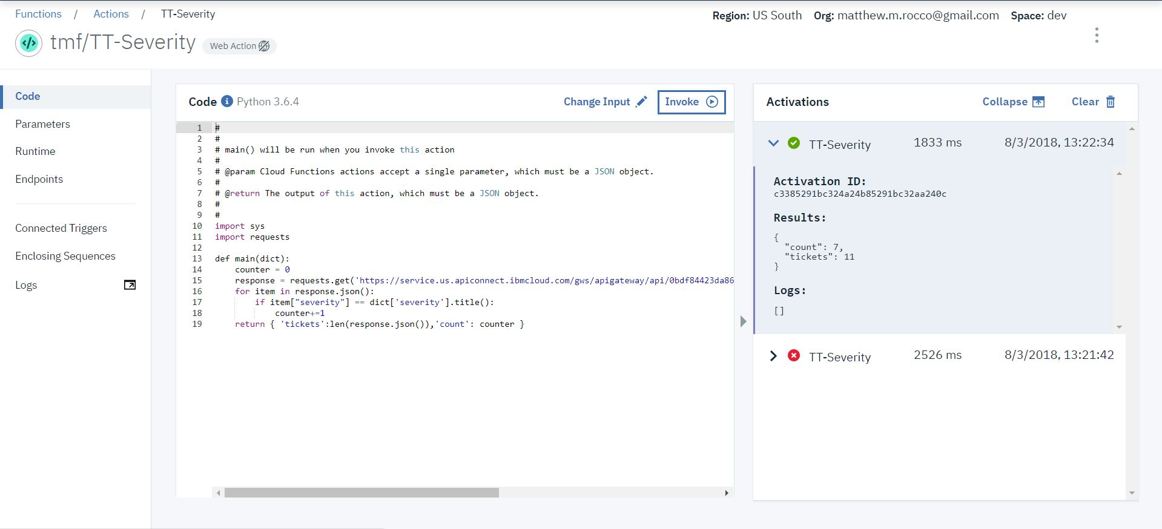

- Creating the node-red flow
- Creating and configuring the Nodejs App (Optional)
- Conclusions

