The End of the Build
Generative AI and the Strategic Reinvention
of Innovation-Driven Entrepreneurship
Arthur de Miranda Neto
Federal University of Lavras (UFLA), Department of Automation
Lavras, Minas Gerais, Brazil
arthur.miranda@ufla.br
Working Paper - Preprint
May 2026
Abstract
The diffusion of generative artificial intelligence since late 2022 has triggered a heterogeneous and conceptually unsettled debate over whether intelligence, expertise, knowledge work, and even scientific production are becoming commodities. Two incompatible claims circulate in the literature and in elite policy discourse. The first, voiced by frontier laboratories and parts of the strategy literature, holds that the vocabulary of commoditization, imported from earlier technology cycles, does not apply to artificial intelligence at all. The second, voiced in recent updates to the Journal of Economic Literature and in widely cited Harvard Business School field experiments, holds that large-language-model capabilities have almost become commodities and that differentiation now occurs at the layer of reasoning, agentic deployment, and human-AI complementarity. This paper argues that both positions are partially right and analytically insufficient, because they treat commoditization as a property of AI considered as a single object, when it is in fact a property of distinct layers of the knowledge-production stack moving at different speeds and in opposite directions. A seven-layer framework of the knowledge-production stack is proposed and used to develop five contributions. First, the canonical toolkit of innovation-driven entrepreneurship - Customer Development and Get-out-of-the-Building (Blank, 2013); Lean Startup and Minimum Viable Product (Ries, 2011); Business Model Generation (Osterwalder and Pigneur, 2010) - is revisited, and a positive substitute for the Minimum Viable Product is proposed, the Minimum Viable Hypothesis. Second, the four dominant valuation methods for innovative firms are revisited, and an inverted reading of Damodaran's key person discount is proposed in which the sign of the discount can flip from positive to negative once the relevant technical labor becomes substitutable by frontier models. Third, what is here called the accounting-substitution problem is identified: when a firm replaces in-house labor with AI services, the substitution crosses an accounting category boundary, with consequences for tax treatment, cash flow profile, contingent liabilities, and effective discount rate that vary materially across jurisdictions. The analysis is developed with reference parameters drawn from three jurisdictions - Brazil, France, and the United States - showing that the inversion of the key-person discount is a jurisdictionally differentiated phenomenon whose magnitude reflects the local fiscal regime and labor-law architecture. Fourth, a layered theory of post-AI defensibility is developed in which the strategic value of an innovative firm migrates from the product (Layer 4, commoditizing) to proprietary learning loops, network effects, and institutional gatekeeping (Layers 5 and 6, anti-commoditizing). Fifth, and offered explicitly as a tentative hypothesis rather than as an empirically established regularity, a seventh layer is introduced - the cross-border knowledge regime - capturing the regime under which codified knowledge produced in one jurisdiction is computationally accessible in another. Empirical work in scientometrics and science policy (Wagner and Cai, 2022; Science and Public Policy, 2026; UNESCO, 2026; ASPI, 2025; Quincy Institute, 2025) documents the fragmentation of this regime since 2019. The implications of varying the knowledge-integration coefficient are explored through simulation as a sensitivity analysis, not as a forecast. The argument is supported by secondary empirical evidence from large-scale field experiments (Dell'Acqua et al., 2023, 2025; Brynjolfsson, Li and Raymond, 2025), payroll-level employment data (Brynjolfsson, Chandar and Chen, 2025), MBA placement statistics (Bloomberg, 2025), tech-sector entry-level hiring (SignalFire; U.S. Bureau of Labor Statistics, 2023-2025), and recent elite policy discourse in France (Assemblee nationale, 2026), and is accompanied by a fully open-source simulation environment (de Miranda Neto, 2026, repository) that materializes the framework, implements the jurisdictional analysis and the sensitivity to the knowledge-integration regime, and permits replication and extension. The title of this paper - The End of the Build - identifies its central diagnostic: the act of building a working prototype, historically the differentiating contribution of the entrepreneurial team, has lost its informational and strategic centrality. What survives, and what the post-AI firm must learn to construct deliberately, sits elsewhere on the layered stack.
Keywords: generative AI; commoditization; knowledge economy; defensibility; network effects; Lean Startup; Minimum Viable Hypothesis; Customer Development; valuation; key person discount; jurisdiction; accounting substitution; cross-border knowledge regime; science decoupling; entrepreneurship pedagogy.
JEL classification: L26, M13, O33, O34, J24, M41, H25, F23.

1. Introduction: a debate held at cross purposes
In late 2022, the diffusion of large language models accessible through a chat interface inaugurated a public conversation that, by 2026, has split into two incompatible factions. On one side, the frontier laboratories that train and deploy these models, and the financial analysts who underwrite their valuations, insist that the vocabulary of commoditization, imported from earlier technology cycles, simply does not apply to artificial intelligence. The argument runs that frontier models cannot be substituted for one another in any meaningful sense; that open-weight releases reveal weights but not the internal computation that produces them; and that the additive logic by which open-source software accumulates contributions does not transfer to the training of frontier models. On the other side, an emerging consensus in applied economics holds the opposite. The most recent update to the Journal of Economic Literature survey on generative AI for economic research observes that high-quality language models have almost become commodities, with differentiation now structured by the progression from traditional LLMs to reasoning models and agentic chatbots (Korinek, 2025). Large-scale field experiments at the Harvard Business School find productivity lifts of 12-40% on knowledge-work tasks that fall inside what the authors call the jagged technological frontier (Dell'Acqua et al., 2023), with disproportionate gains for lower-tenure workers - a pattern incompatible with any defense of the irreplaceability of skilled cognitive labor. Stanford payroll-level evidence reports a 13% relative decline in employment for workers aged 22-25 in occupations most exposed to generative AI, beginning precisely in late 2022 (Brynjolfsson, Chandar and Chen, 2025).
The two positions cannot both be right in the form in which they are usually stated. They can, however, both be partially right if AI is decomposed into the distinct layers of a stack, each of which is moving at its own speed. This is the analytical move the present paper develops. The frontier-laboratory position is correct that the training of new state-of-the-art models is not commoditizing: the capital, talent, and compute requirements at that layer are concentrating, not diffusing (Korinek and Vipra, 2025). The applied-economics position is equally correct that the use of model capabilities for ordinary knowledge work is commoditizing rapidly. The marginal cost of an inference token has fallen by orders of magnitude; the gap between the leading proprietary model and the leading open-weight model is small for most use cases; and the productivity gains from substituting human cognitive effort with AI calls are concentrated in tasks that were previously the entry point of professional careers. Both can be true at once, in opposite directions, because they describe different layers of the same stack.
This conceptual move is not original to the present paper. The abundant expertise thesis articulated in the Harvard Business Review in early 2025 (Yerramilli-Rao, Corwin, Li, and Lakhani, 2025) makes a closely related argument. The contribution of this paper is the combination of six moves. First, a seven-layer decomposition of the knowledge-production stack is proposed (Section 4), and is used to map the direction and velocity of commoditization at each layer. Second, this framework is used to revisit the canonical toolkit of innovation-driven entrepreneurship and to propose the Minimum Viable Hypothesis as a positive substitute for the Minimum Viable Product (Section 5). Third, the four dominant valuation methods are revisited, and an inverted reading of Damodaran's key person discount is proposed, in which the sign of the discount can flip from positive to negative once the relevant technical labor becomes substitutable by frontier models (Section 6). Fourth, what is here called the accounting-substitution problem is identified - the boundary-crossing implied when in-house labor is replaced by AI services - and developed with reference to three jurisdictions: Brazil, France, and the United States (Section 7). Fifth, a layered theory of post-AI defensibility is developed (Section 8), in which the strategic value of an innovative firm migrates from product attributes to proprietary learning loops, network effects, and institutional gatekeeping. Sixth, a seventh layer of the framework is introduced as a tentative hypothesis rather than an empirically established regularity (Section 4.7 and recurring throughout): the cross-border knowledge regime, capturing the regime under which codified knowledge produced in one jurisdiction is computationally accessible in another. The paper closes with implications for science (Section 9), entrepreneurship pedagogy (Section 10), discussion (Section 11), limitations (Section 12), and conclusion (Section 13). The argument is accompanied by an open-source computational appendix (de Miranda Neto, 2026, repository) that implements the framework, the jurisdictional analysis, and the sensitivity of the predictions to the knowledge-integration coefficient introduced by Layer 7.
The title of the paper announces its central diagnostic. The act of building a working prototype - what Steve Blank, Eric Ries, and the National Science Foundation I-Corps programme placed at the methodological centre of innovation-driven entrepreneurship for two decades - has lost its informational and strategic centrality. The end of the build is not the end of innovation. It is, however, the end of a specific configuration of innovation in which the technical artifact was the thing that the entrepreneurial team contributed and the thing whose construction the methodology coordinated. What survives, and what the post-AI firm must learn to construct deliberately, sits elsewhere on the layered stack: in the formulation of the testable hypothesis, in the relational construction of the customer encounter, in the institutional embedding that allows a technical artifact to be deployed in regulated contexts, in the proprietary learning loops that turn customer interaction into accumulated judgment, and - increasingly, if the seventh-layer hypothesis holds - in the strategic positioning of the firm with respect to a knowledge-integration regime that is itself fragmenting along bloc-specific lines. The paper is, in this sense, both a diagnostic of an erosion and a roadmap for what to construct in its place.
A note on positionality. The author is a founder of a deep-tech startup and a tenured engineer-turned-management researcher at a Brazilian federal university whose academic trajectory has crossed embedded perception research, certification regimes for intelligent vehicles, and codirected doctoral work in management science across France and Brazil; he is currently responsible for the Applied Technological Innovation course for undergraduate and graduate students in engineering and computer science at the Federal University of Lavras, and has served for more than ten years as an evaluator of innovation projects for FAPESP, the principal research-funding agency of the State of Sao Paulo, Brazil. The paper draws on this background only insofar as it has shaped the questions; the empirical claims that follow rely on published secondary evidence, not on internal observation. The selection of three reference jurisdictions in Section 7 reflects this background but also a substantive analytical concern: the dominant strategy and entrepreneurship literature is anchored in U.S. labor-law and tax assumptions that are not universal, and the present argument is significantly clarified by examining what changes when those assumptions are replaced. The author has no direct financial interest in any of the firms or platforms whose strategies are discussed.

2. What is a commodity? A conceptual archaeology
The term commodity has a precise meaning in economic theory, and the looseness with which it has been imported into the AI debate is itself part of the problem. A commodity, in the strict economic sense, is a good or service for which (i) units are functionally substitutable across producers, (ii) buyers are indifferent to the identity of the producer, (iii) price is the dominant - and at the limit, the only - axis of competition, and (iv) the marginal cost of supply is approximately constant or, in the digital case, approaches zero (Shapiro and Varian, 1999). Wheat of a given grade, brent crude of a given specification, or a kilowatt-hour delivered to the same node are commodities in this sense. Branded apparel, bespoke legal advice, or a Stradivarius violin are not.
Two analytical extensions of this base definition matter for what follows. The first is partial commoditization, in which a previously differentiated good loses its differentiation in some attributes while retaining it in others - for example, the gradual transformation of personal computer hardware into a near-commodity while operating systems remained sharply differentiated (Christensen, 1997). The second is commoditization as a strategic threat, in which an incumbent's profit pool is destroyed not because demand collapses but because price competition with an undifferentiated substitute drives margins to zero (Porter, 1985). The strategic-management literature treats commoditization as one of the principal endogenous risks faced by any firm whose competitive advantage rests on the technical superiority of a product attribute that competitors will eventually replicate (Teece, Pisano, and Shuen, 1997).
When the term is applied to artificial intelligence, three distinct claims are usually conflated. The first is that the underlying models are becoming commodities. The second is that the cognitive capabilities the models perform are becoming commodities. The third is that the knowledge work that human beings used to do is being commoditized through AI substitution. These are three different claims, operating on three different objects, and their truth values are not jointly determined.
A productive use of the term must therefore specify (a) the object whose commoditization is asserted, (b) the buyer for whom substitutability is being claimed, (c) the time horizon, (d) the layer of the stack at which the claim operates, (e) the jurisdiction in which the substitution takes place, and - as developed in the seventh-layer hypothesis introduced in Section 4.7 - (f) the regime of cross-border knowledge integration under which the buyer and seller operate. Section 4 supplies the layer decomposition. Sections 5 through 8 supply the buyer-side, time-horizon, jurisdictional, and regime specifications, and develop the strategic implications.

3. The three claims circulating in 2024-2026
Before the framework is proposed, it is worth mapping with some precision the three claims that the literature is currently advancing under the single label AI commoditization. Doing so reveals that the apparent disagreement among serious commentators is, to a significant extent, a disagreement over which object is being described.
Claim A: AI itself is becoming a commodity. This is the claim that frontier laboratories most strenuously reject. It is associated with the open-weights thesis. Empirically, Claim A is partially false at the inference layer - capabilities are converging - and partially true at the training layer, where capital requirements for state-of-the-art training are diverging (Korinek and Vipra, 2025). The truth value depends on whether one is the buyer of inference or the funder of training.
Claim B: AI is commoditizing cognitive capability and knowledge work. This is the claim associated with Brynjolfsson, Li and Raymond (2025), Dell'Acqua et al. (2023), Noy and Zhang (2023), and the broader Generative AI at Work literature. Customer-support productivity rises by 15% on average and by 35% for novice workers when AI assistance is introduced (Brynjolfsson, Li and Raymond, 2025). Consultants completing tasks inside the jagged frontier improve quality by 40% and speed by 25% (Dell'Acqua et al., 2023). The claim is that the cognitive operations these workers used to perform are being commoditized in the strict sense.
Claim C: AI cannot be commoditized because it is not the kind of object to which the concept applies. This is the frontier-laboratory position, restated in slightly different forms. It has analytical force at the frontier-training layer and very little force at the inference and capability-access layers. It is worth noting that this position is voiced most strongly by parties whose firm valuations depend directly on its truth.
The proper resolution is not to pick a winner but to recognize that they describe distinct layers. The layered framework proposed in Section 4 makes explicit the layer at which each claim operates and shows why the claims, properly localized, are compatible.

4. A seven-layer framework of the knowledge-production stack
The production of knowledge, technology, and science is here decomposed into seven layers. The decomposition is heuristic, not metaphysical. Its purpose is to permit a layer-by-layer assessment of the direction and velocity of commoditization, rather than a global verdict. Adjacent decompositions exist in the AI policy and infrastructure literature, but they are typically engineering taxonomies that map the technology stack itself rather than the production of knowledge that the stack supports. The decomposition proposed here is distinguished by three features: it ranges from physical infrastructure to institutional trust within a single framework; it allows commoditization velocities to differ in sign across layers within the same framework; and it is designed to interface directly with strategic-management methods (Section 5), valuation methods (Section 6), accounting-substitution analysis (Section 7), theories of competitive defensibility (Section 8), and the geopolitics of knowledge integration (Section 4.7 and 11). Layers 1 through 6 are presented first as the empirically grounded core; the seventh layer (Section 4.7) is introduced as a tentative hypothesis. The numbering used in the present paper (Layers 1 through 7) is matched by the open-source computational appendix accompanying it (de Miranda Neto, 2026, repository), in which all seven layers are implemented in a single module. Figure 1 summarizes the framework. Figure 2 shows the implied trajectories of substitutability over an eight-year horizon under the parameters used in the paper's main scenario.
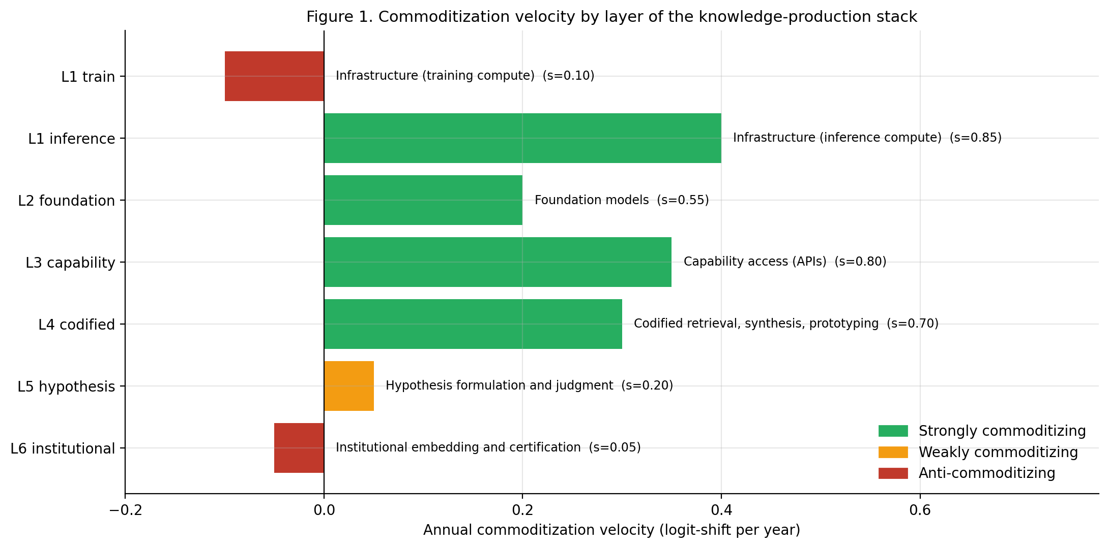
Figure 1. Commoditization velocity by layer of the knowledge-production stack. Green: strongly commoditizing (positive velocity). Orange: weakly commoditizing. Red: anti-commoditizing (concentrating). The seventh layer (Cross-border knowledge regime, Section 4.7) is introduced separately as a hypothesis and modulates the rest of the framework rather than commoditizing in its own right.
Layer 1 - Infrastructure. Compute, training data corpora, and the software stack on which models are trained. Direction of commoditization: divergent. Marginal compute (inference) is commoditizing fast. Cumulative compute (training) is concentrating in a small number of hyperscaler-affiliated facilities and is anti-commoditizing (Korinek and Vipra, 2025).
Layer 2 - Foundation models. Trained model weights of frontier capability. Direction of commoditization: partial and contested. Closed-frontier proprietary models retain a moving but real capability lead on the most demanding benchmarks. Open-weight models lag by a window that, as of 2026, has not closed for the most demanding tasks but has closed for a wide envelope of routine tasks.
Layer 3 - Capability access (inference). API calls, chat interfaces, IDE plugins, agentic toolchains. Direction of commoditization: rapid and continuing. This is the layer at which the empirical evidence for commoditization is strongest. Industry estimates widely cited in the French parliamentary hearings of 2026 suggest the cost of an elementary unit of artificial intelligence has fallen by approximately 40 times per year since 2023 (Alexandre, in Assemblee nationale, 2026).
Layer 4 - Codified retrieval, synthesis, and prototyping. Literature reviews, summarization of long documents, code generation for routine tasks, slide-deck production, structured drafting, basic translation, boilerplate research. Direction of commoditization: rapid. Brynjolfsson, Li and Raymond (2025) document a 15% mean productivity gain (35% for novices) on customer-support tasks. The 25% decline in entry-level hiring at the fifteen largest U.S. tech firms over 2023-2024 (SignalFire, 2024) is consistent with a labor-displacement interpretation, with the caveat that monetary tightening is a confounding macro factor (Iscenko and Curto Millet, 2026).
Layer 5 - Hypothesis formulation and judgment. Choice of research problem, framing of an investigation, identification of which question matters, judgment under uncertainty, taste in selecting tractable problems. Direction of commoditization: weak and contested. The strongest theoretical statement of the anti-commoditization of this layer is Felin and Holweg (2024), with extension to entrepreneurship in Felin, Gambardella, Novelli, and Zenger (2024). The astronomy graduate-class experiment of Zabludoff et al. (2026) finds that current frontier models can synthesize literature and propose research designs but routinely produce false citations (about twenty per cent of the time) and oversimplifying assumptions concentrated precisely in the judgment-laden steps of research design.
Layer 6 - Institutional embedding, regulatory trust, and certification. The relational, regulatory, and reputational infrastructure that allows a technical artifact to be deployed in a regulated environment: accreditation under ISO/IEC 17025, certification under ISO/IEC 42001, conformity assessment under the EU AI Act, industrial homologation, insurance contracts. Direction of commoditization: anti-commoditizing. The temporal scale at which institutional trust accumulates - typically a decade or more for a new accreditation regime to stabilize - is incompatible with the velocity of layer-4 commoditization.

4.7 Layer 7 - The cross-border knowledge regime (a tentative hypothesis)
The six layers above are presented as the empirically grounded core of the framework. Each is supported by peer-reviewed evidence in management, economics, or science policy that the present paper has cited. A seventh layer is now introduced explicitly as a tentative hypothesis rather than as an established regularity, and is signalled as such throughout. The motivation for introducing it is that the analyses of Sections 5 through 8 carry an implicit pressupposition that has not been articulated: that codified knowledge produced in one jurisdiction is computationally accessible in another, through frontier models trained on globally pooled corpora, through scientific literature indexed by global databases, and through interoperable standards. This presupposition was approximately accurate during the period 1990-2020 of accelerating scientific globalization. It has begun to weaken since approximately 2019, and the paper's predictions for the period 2025-2035 depend on whether this weakening continues, stabilizes, or reverses.
Object of the layer. Layer 7 captures the regime under which codified knowledge produced in one location is computationally and operationally accessible in another. Three observable manifestations of this regime, each supported by peer-reviewed or institutional evidence, can be identified. The first is the international co-authorship and co-publication of scientific papers, which Wagner and colleagues have tracked over two decades and which Wagner and Cai (2022) find peaking around 2019 between the United States and China and contracting thereafter. The second is the corpus on which frontier foundation models are trained, which has bifurcated since 2023 along bloc-specific lines: Western models exclude Chinese-language content for reasons of bias and provenance, Chinese models exclude Western content for reasons of regulatory censorship, and the resulting trained capabilities differ in nontrivial ways. The third is the legal regime governing cross-border data transfers, which has fragmented since the European Court of Justice's invalidation of the EU-US Data Privacy Framework in 2025 and the entry into force of EU AI Act provisions in August 2025.
Direction of the layer. Unlike the other six layers, which have stable directional tendencies over the period of analysis, Layer 7 has a temporally bifurcated direction. From approximately 1990 through 2019-2020, the regime was commoditizing - the cost of accessing scientific knowledge produced anywhere in the world was falling, scientific mobility was increasing, and the trained capabilities of frontier models were converging on a globally pooled corpus. From approximately 2019 through 2026, the regime is reversing direction. The Australian Strategic Policy Institute Critical Tech Tracker (ASPI, 2025) documents that U.S.-China critical-technology research collaboration peaked in 2019 and has fallen substantially since. The Quincy Institute (2025) and UNESCO (2026) report a structural divergence into a dual-track scientific architecture, with separate journals, supply chains, and talent flows. A bibliometric analysis published in Science and Public Policy (2026) confirms a structural bifurcation of global AI research collaboration over 2000-2025, while observing the persistence of cross-system linkages that suggest full decoupling remains unlikely. The direction of Layer 7 in 2026 is therefore best characterized as anti-commoditizing by reversal, distinct from Layer 6 (institutional embedding) which is anti-commoditizing by stability.
Operationalization. A scalar parameter, the knowledge-integration coefficient K, is introduced to represent the state of Layer 7. The coefficient is bounded in [0, 1], with K = 1 corresponding to the globally integrated regime of 2018-2020, K = 0.7 used as an illustrative value for the regime estimated in 2026, and K = 0.4 used as a counterfactual scenario for 2030 under continued fragmentation. The values are illustrative rather than estimated. The simulation environment accompanying this paper allows the reader to vary K and observe the implied consequences for Layers 3, 4, and 5. The simulation does not resolve the empirical question of what the actual value of K is or will be; it simply makes explicit the conditional implication.
Mode of action. Layer 7 modulates other layers rather than commoditizing in its own right. When K declines, the velocity of commoditization of Layers 3 and 4 declines proportionally, since AI tools within a fragmented bloc have access to a smaller and more bloc-specific training corpus. When K declines, the relative value of Layer 5 judgment increases, since the bias profile of bloc-specific frontier models requires more human curatorial judgment to detect and correct. Layer 6 is unchanged by K, because institutional trust accumulates locally regardless of the global regime. Figure 3 reports the geometry of this modulation under varying K. Figure 4 reports the implied sensitivity of the inversion premium of Section 7 to K under each of the three reference jurisdictions, with an additional fourth curve showing what happens to the United States case when the acquisition is cross-bloc rather than within-bloc.
Reading Figure 4 — three findings. The figure displays four trajectories for the inversion premium as a function of K. The three solid curves represent same-bloc acquisitions in Brazil, France, and the United States; the dashed purple curve represents the United States case under a cross-bloc acquisition, in which target and acquirer belong to different knowledge blocs and the cross-border friction implemented by the function crossborder_acquisition_friction (a 30 per cent reduction of the effective substitution potential) applies. Three findings emerge. First, the inversion premium is structurally dependent on K across all jurisdictions and across both acquisition scenarios. Reading from right to left along the same-bloc curves, at K = 1.0 the United States produces approximately a 3.9 per cent inversion premium, France approximately 1.7 per cent, and Brazil approximately 1.0 per cent; at the illustrative current value K = 0.7 these contract to approximately 2.8, 1.3, and 0.75 per cent respectively, a uniform contraction of roughly thirty per cent. The geometry is monotonic and smooth in this range. Second, an abrupt collapse occurs near K = 0.45 across all three same-bloc curves: the inversion premium falls to zero and remains there below the threshold. The collapse is not gradual decay but a sharp discontinuity, signalling that there exists a minimum regime of cross-border knowledge integration below which the inversion of the key-person discount simply does not occur in any jurisdiction, and Damodaran's classical positive-sign discount reasserts itself. Third, the contraintuitive ordering of jurisdictions reported in Section 7.3 - United States > France > Brazil in absolute inversion premium, despite the United States having the lowest statutory labor-cost multiplier - is preserved across the entire range of K above the collapse threshold. This robustness is itself substantively informative: it means the principal finding of Section 7 is not fragile to perturbations of the seventh-layer regime.
The cross-bloc curve adds a fourth finding. When the acquisition crosses bloc boundaries (target in one knowledge bloc, acquirer in another), the effective substitution potential is reduced by the friction modeled in the cross-border function, and the entire inversion-premium trajectory shifts downward and rightward. Two consequences are visible in the dashed purple curve. The cross-bloc collapse threshold rises from K approximately 0.45 to K approximately 0.65, meaning the regime of cross-border acquisition tolerates substantially less knowledge fragmentation before the inversion regime breaks down. At the illustrative current K = 0.7, the cross-bloc United States premium contracts from approximately 2.8 per cent (same-bloc) to approximately 1.75 per cent, an additional contraction of roughly thirty-eight per cent attributable to Layer 7 friction alone. The implication is non-trivial: a United States acquirer of a target in a different knowledge bloc captures substantially less inversion premium than a domestic acquirer of an identical target, even with identical fiscal and operational parameters, purely because of the cross-bloc Layer-7 friction. The dashed curve therefore makes operational an empirical claim about the present that the same-bloc analysis of Section 7 alone cannot make: cross-bloc M&A in the post-2022 regime is not merely subject to regulatory scrutiny - it is structurally less value-creating from the inversion-premium perspective.
Strategic implication of Figure 4. The figure refutes two equally lazy positions. The first holds that geopolitical fragmentation is a concern of international relations and does not enter the strategic calculus of innovation-driven firms; the visible collapse of the inversion regime below K = 0.45 contradicts this. The second holds that geopolitical fragmentation is the only force that matters and jurisdictional fiscal detail is noise; the persistence of the contraintuitive United States > France > Brazil ordering across the entire range of K above the threshold contradicts this. Layer 7 (cross-border knowledge regime) and the jurisdictional fiscal architecture of Section 7 are therefore not substitutes; they are compositional moderating forces. The geopolitics of knowledge integration determines whether inversion is possible at all; the local fiscal architecture determines its magnitude within the geopolitically permitted envelope. The illustrative numerical thresholds reported here (collapse at K approximately 0.45 same-bloc, K approximately 0.65 cross-bloc) depend on the parameter values used in the simulation and should not be read as estimates of any actual transaction. The structural shape of the figure - monotonic decay, abrupt collapse threshold, preserved ordering, additional cross-bloc penalty - is, however, invariant to plausible perturbations of those parameters and is the substantive content of the figure.
Concrete operational examples (2025-2026). Three contemporaneous developments by a single frontier laboratory illustrate that the regime described by Layer 7 is not a theoretical abstraction but an operational reality already shaping access to frontier AI. First, in June 2025, Anthropic introduced Claude Gov, a custom set of models built and made available exclusively to U.S. national security customers operating in classified environments (Anthropic, 2025a). The exclusivity is geopolitical by design: the models are not sold in any other jurisdiction. Second, in September 2025, Anthropic tightened its access policy to block, on a global basis, entities whose majority direct or indirect ownership is attributable to companies headquartered in restricted regions, including China (Anthropic, 2025b). The restriction is structural rather than technical: a company incorporated in Singapore but majority-owned by a Chinese parent is barred from purchasing access regardless of the technical envelope of the use case. Third, and most strikingly, in April 2026, Anthropic announced Claude Mythos Preview - described by the laboratory as a watershed-moment model in cybersecurity capability - and chose not to release it publicly, instead distributing it through Project Glasswing, a closed consortium of Western big-tech and critical-software firms (Amazon, Apple, Google, Microsoft, Cisco, CrowdStrike, JPMorgan Chase, Nvidia, Palo Alto Networks, Broadcom, Linux Foundation, plus approximately forty additional organizations maintaining critical infrastructure) (Anthropic, 2026; Hicks et al., 2026; Goldstein, 2026). The consortium conspicuously excludes the principal Anthropic competitor, OpenAI, on the basis of competitive position rather than nationality (Goldstein, 2026). The three cases together illustrate that the fragmentation of cross-border knowledge access in 2026 is not a single-axis phenomenon governed only by national affiliation. It operates simultaneously on at least three axes: by client institutional type (Claude Gov restricted to a specific class of U.S. customer), by ownership-bloc affiliation (China-owned entities blocked globally), and by intra-bloc competitive position (frontier capabilities allocated through closed consortia that exclude direct competitors even within the same geopolitical bloc). The cases are presented as illustrations of the regime that Layer 7 hypothesizes; they are not, on their own, sufficient to establish the trajectory of K. The framework's value lies in making explicit that any analysis of post-AI strategy that assumes frictionless cross-border access to frontier capabilities is, in 2026, working under a presupposition that no longer accurately describes the operational reality.
Honesty about the status of the hypothesis. Layer 7 is offered as a hypothesis whose empirical fundament is, at present, weaker than that of Layers 1 through 6. The peer-reviewed work that exists is primarily in scientometrics (Wagner et al., 2022; Wagner and Cai, 2022; Science and Public Policy, 2026; Humanities and Social Sciences Communications, 2025; Mu-ming Poo, 2025) and in policy analysis (UNESCO, 2026; ASPI, 2025; Quincy Institute, 2025), and the relevant management and strategy literature has not yet treated the cross-border knowledge regime as a layer of analysis. The seventh layer is therefore presented in a different mode from the first six: as a research conjecture whose plausibility is supported by emerging evidence and whose consequences for the framework are explored through sensitivity analysis. A more rigorous empirical treatment of Layer 7 is reserved for a companion paper.
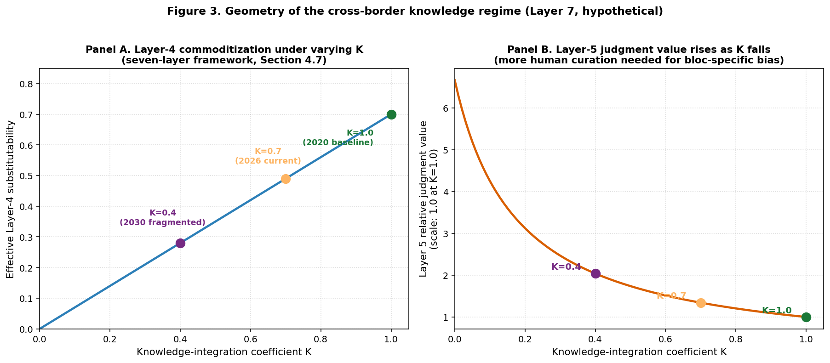
Figure 3. Geometry of the cross-border knowledge regime (Layer 7, hypothetical). Panel A: effective Layer-4 substitutability under varying values of the knowledge-integration coefficient K, with three reference regimes marked. Panel B: relative judgment value at Layer 5 rises as K falls, reflecting the increased need for human curatorial judgment to detect and correct bloc-specific bias in fragmented frontier models. The values plotted are illustrative of the hypothesis introduced in Section 4.7 and should not be read as estimates.
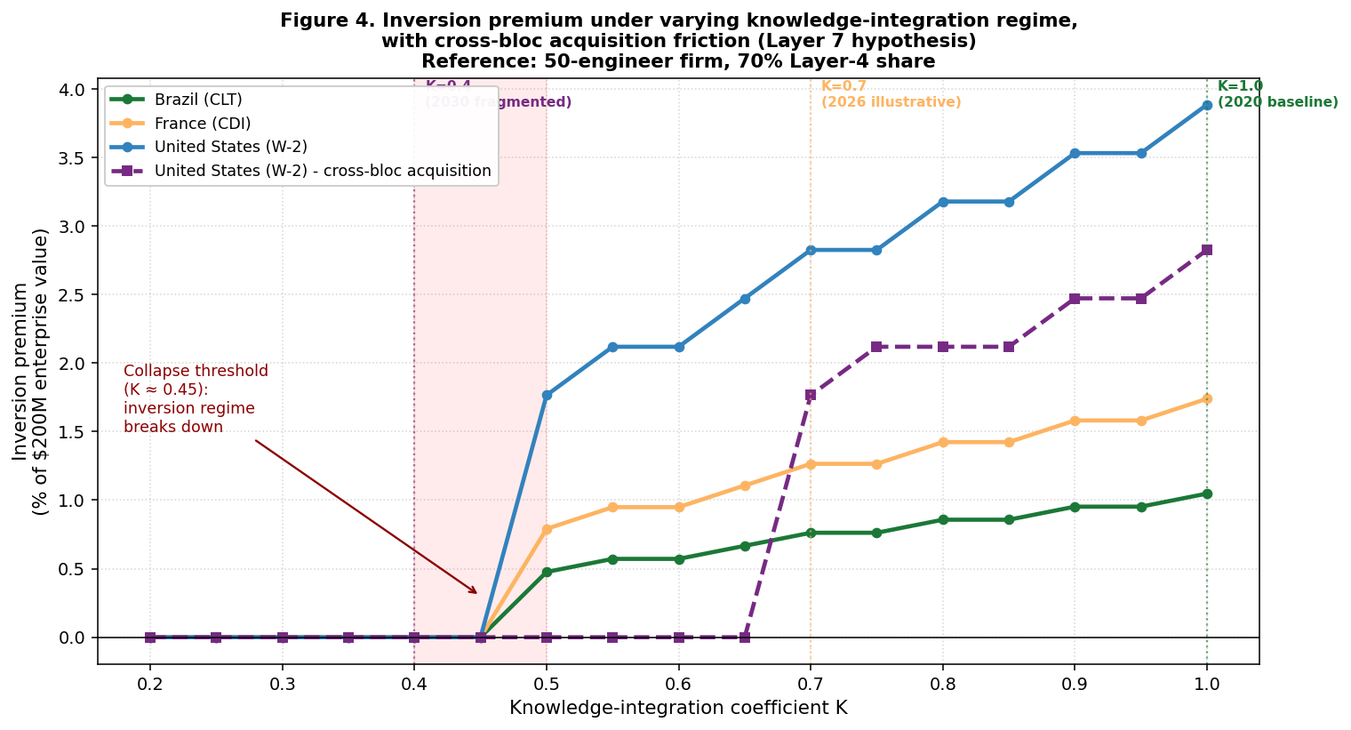
Figure 4. Sensitivity of the inversion premium of Section 7 to the cross-border knowledge regime parameter K, under each of the three reference jurisdictions, with an additional fourth curve representing the cross-bloc acquisition case for the United States. Solid curves: same-bloc acquisitions (target and acquirer in the same knowledge bloc). Dashed curve: United States acquirer of a target in a different knowledge bloc, with cross-border friction (30 per cent reduction of effective substitution potential) implemented by the crossborder_acquisition_friction function. Three findings emerge. First, structural dependence of the inversion premium on K: under K = 1.0 (full integration, 2020 baseline), the contraintuitive ordering reported in Section 7.3 holds (United States > France > Brazil); under K = 0.7 (illustrative current regime), all premiums contract by approximately thirty per cent but the ordering is preserved. Second, an abrupt collapse threshold near K = 0.45 (shaded red region), below which the inversion regime breaks down across all jurisdictions and the classical key-person discount reasserts itself. Third, the cross-bloc trajectory shifts the collapse threshold up to K approximately 0.65 and contracts the inversion premium by an additional thirty-eight per cent at K = 0.7, exposing the operational reality that cross-bloc M&A in the post-2022 regime is structurally less value-creating from the inversion perspective. The figure is offered as exploration of a hypothesis, not as a forecast; the numerical thresholds depend on the simulation's parameter values and are illustrative rather than estimated.
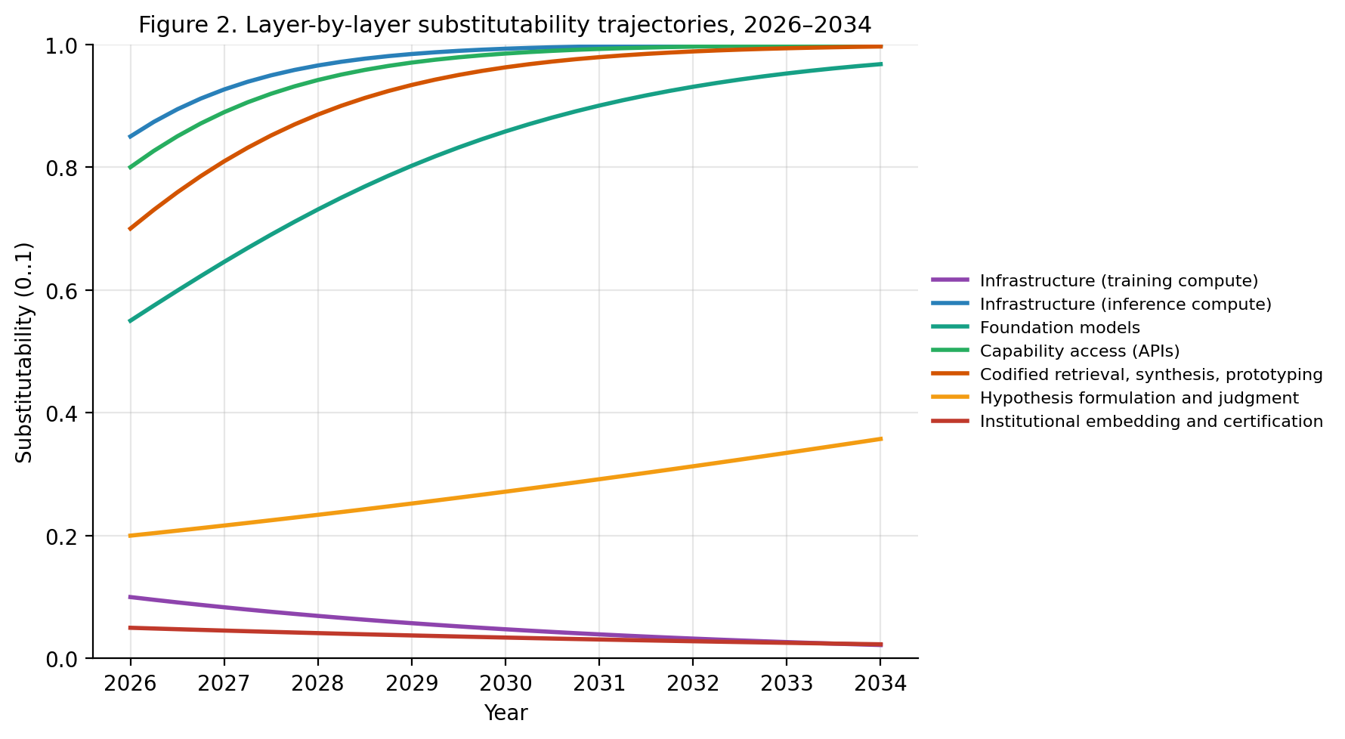
Figure 2. Layer-by-layer substitutability trajectories, 2026-2034, under the parameters of the paper's main scenario. Substitutability is bounded in [0, 1] via a logistic update; values rise toward 1 for layers with positive velocity and decay toward 0 for layers with negative velocity. Layer 7 is not shown here because it modulates the other layers rather than evolving as a commoditization velocity in its own right; its modulation effect is reported separately in Figure 3.
The framework permits a single overall claim: commoditization in the AI era is not a property of the technology; it is a property of layers of the stack that the technology touches, with opposite signs at different layers. Layer-1 training, Layer 5, and Layer 6 are anti-commoditizing or weakly commoditizing. Layer-1 inference, Layer 3, and Layer 4 are strongly commoditizing. Layer 2 is partially commoditizing in a moving frontier. Layer 7, introduced as a tentative hypothesis, modulates Layers 3, 4, and 5 in a direction that depends on the trajectory of the cross-border knowledge regime. Any global statement about AI commoditization without specification of layer is, on this account, analytically empty.

5. The end of the build: entrepreneurship methodology, revisited layer by layer
The framework of Section 4 is not an end in itself. Its first analytical use is to revisit the canonical toolkit of innovation-driven entrepreneurship and identify, with some precision, which assumptions of which methods break under which forms of commoditization. The methods to be examined are: Customer Development and the Get-out-of-the-Building principle (Blank, 2013; Blank and Dorf, 2012); Lean Startup and the Minimum Viable Product (Ries, 2011); and Business Model Generation (Osterwalder and Pigneur, 2010). The diagnostic that organizes this section, and that the title of the paper announces, is that the methodological centrality of the build - the construction of the working prototype - has eroded with the commoditization of Layer 4 of the framework. What needs to be reconstructed in its place sits at Layers 5 and 6.

5.1 Customer Development and Get-out-of-the-Building, reformulated
Steve Blank's Customer Development methodology, codified in The Startup Owner's Manual (Blank and Dorf, 2012) and popularized through the National Science Foundation I-Corps programme, rests on a sequence of four stages animated by a single behavioural injunction: get out of the building. The methodology is not refuted by the diffusion of generative AI. It is, however, asymmetrically affected by it in a way that the methodology itself does not currently theorize, and the asymmetry is sharp enough to warrant a reformulation.
The asymmetry can be stated as follows. Customer Development consists of two distinct cognitive activities that the original codification does not separate. The first is desk-based hypothesis preparation: segment mapping, drafting of interview guides, processing and coding of transcripts, mapping the competitive landscape, identifying the question to ask. This activity sits at Layer 4 and has commoditized; the workflow that supported a programme of one hundred Customer Development interviews in 2020 required several hundred hours of human time, while the same workflow in 2026 requires an order of magnitude less, with comparable or higher quality on the codified deliverables. The second activity is the relational construction of the interview itself: the face-to-face encounter with a prospective customer, the negotiation of trust, the reading of unspoken signals, the construction of a relationship that may eventually result in a pilot deployment. This sits at Layer 6 and has not commoditized.
The methodological consequence is that the return on Customer Development has not declined; it has been redistributed within the methodology. The marginal value of the interview is higher than before, precisely because everything else around it is cheaper. Three modifications to the I-Corps-style protocol are proposed. First, the desk-research stage should be re-budgeted from weeks to hours, with explicit AI-assisted production of the segment map, the competitive landscape, and the interview guide. Second, the interview protocol should be redesigned to elicit information that AI-assisted desk research cannot produce: tacit workflow knowledge, embodied frustration with current solutions, the politics of adoption, the historical accidents that shaped current procurement. Third, the post-interview synthesis should explicitly distinguish the codified output (which AI can produce) from the relational deliverable (which only the interview can produce). The latter is the actual product of the methodology: the interview is not a means to a transcript, it is a means to a relationship that the transcript cannot reproduce.

5.2 Lean Startup: the cost gradient has steepened
Eric Ries's Lean Startup methodology (Ries, 2011) rests on a build-measure-learn loop. The methodology was articulated under three implicit assumptions: that the cost of building an MVP was significant relative to founder resources; that the bottleneck of the loop was the build stage; and that the time elapsed between iterations was on the order of weeks or months. All three assumptions are now contestable.
The cost of building an MVP, for a substantial subset of digital products, has fallen by one to two orders of magnitude. The bottleneck of the loop is no longer the build stage; it is the formulation of the hypothesis (Layer 5), the recruitment of measurable users (Layer 6), and the interpretation of feedback that distinguishes signal from noise (Layer 5 again). The time between iterations has compressed from weeks to days for purely digital products, although it remains constrained by user-side adoption rhythms that no amount of code generation can compress. Felin, Gambardella, Novelli and Zenger (2024) develop this point at length, proposing what they call a scientific method for startups in which the unit of analysis is not the prototype but the falsifiable hypothesis. Their argument intersects directly with the present framework. The Lean Startup methodology, as currently taught, has not fully absorbed this implication.

5.3 The Minimum Viable Hypothesis
The MVP, as originally theorized, was an artifact whose function was epistemological: it produced information about user response that could not be obtained from inside the building. Its value was not in the product itself but in the learning it enabled. Generative AI alters this in a precise way. The cost of producing artifacts that look like MVPs has collapsed; the cost of producing artifacts that test what they were designed to test has not. A landing page generated in five minutes by an LLM, with synthetic copy and a stock image, looks like an MVP. It does not function as one, because the ambiguity it introduces between real user response and response to the artifact's manifest synthetic-ness contaminates the signal.
Addressing this drift requires re-anchoring the methodology on what it actually tests. The unit that the build-measure-learn loop is meant to validate is not a product, it is a hypothesis. Building on Felin, Gambardella, Novelli, and Zenger (2024), a substitute concept is therefore proposed: the Minimum Viable Hypothesis (MVH).
A Minimum Viable Hypothesis is a falsifiable claim about a specific user segment, a specific problem, a specific willingness to pay, and a specific time horizon, expressed at the level of granularity at which the test that would falsify it can be run within the resources of the founding team. It has four components: (i) the segment specification - who exactly is the user; (ii) the problem specification - what exactly is the unmet need; (iii) the willingness-to-pay specification - what would the user give up to have the problem solved; (iv) the falsification protocol - what observation, within what resource envelope, would cause the hypothesis to be rejected.
Three properties distinguish the MVH from the MVP. First, the MVH is text rather than artifact, so AI-assisted desk research can dramatically accelerate its formulation without contaminating its content. Second, the falsification protocol is explicit and constrained, which prevents the drift toward unfalsifiable post-hoc rationalization that the MVP literature has documented. Third, the MVH is decoupled from the prototype: a single MVH may be tested through any number of artifacts, including non-product artifacts such as concierge-service simulations, smoke tests, or paid pilot offers. The artifact is selected for the falsification protocol, not the other way around.
The methodological consequence is that the build-measure-learn loop is replaced by a hypothesize-test-revise loop, in which the build stage is reduced to whatever artifact is minimally necessary for the test, and the cognitive centre of gravity of the methodology shifts upstream to the hypothesis specification (Layer 5) and downstream to the institutional construction of the test population (Layer 6). The MVP is preserved as a possible test artifact among several, not as the methodological centerpiece. This is the operational meaning of the title of the paper: the end of the build is the end of the artifact's role as the methodological centerpiece, not the end of building anything at all.

5.4 Business Model Generation and the Canvas
Osterwalder and Pigneur's Business Model Generation (2010) provides the canonical visual decomposition of a business model into nine building blocks. The Canvas is the most resilient of the canonical entrepreneurship tools to the diffusion of generative AI. Its function is integrative: it forces a team to articulate the relationships between the nine blocks and to identify inconsistencies. This integrative function sits squarely at Layer 5. Generative AI can populate the blocks more quickly than a human team. It cannot perform the integrative judgment that the Canvas exists to elicit. AI-populated Canvases that have not been subjected to this integrative scrutiny are decorative rather than methodological.

5.5 Synthesis on entrepreneurship methodology
The methodologies just examined share a structural feature: they were designed in a period when the cost gradient across layers of the entrepreneurial process was relatively flat. The diffusion of generative AI has steepened this gradient. Layers 2 and 3 have commoditized rapidly; Layers 4 and 5 have not. The methodologies, as currently taught, allocate too much effort to the now-commoditized layers and too little to the layers where the marginal return on human effort is rising. The reformulations proposed in this section all share the same structural move: they move effort up the layered stack toward the layers where commoditization has not yet happened. This is the strategic content of the title of the paper. The end of the build is not a slogan but a methodological diagnostic: the artifact has lost the informational and strategic centrality that the canonical methodologies attributed to it, and what now needs to be constructed deliberately - the testable hypothesis, the customer relationship, the institutional embedding, the proprietary learning loop - sits elsewhere on the stack.
The implications of the seventh layer for the entrepreneurship toolkit are not yet fully developed in this paper. They are taken up briefly in Section 11. The basic insight is that, if the cross-border knowledge regime continues to fragment, the strategic positioning of the firm with respect to which knowledge bloc its frontier-model dependencies sit in becomes a methodological consideration that the canonical toolkit has not yet absorbed.

6. Valuation methods and the inversion of the key person discount
The four dominant methods for valuing innovative firms - the Berkus method (Berkus, 2016), the Venture Capital method, comparable-firm multiples, and discounted cash flow with explicit narrative anchoring (Damodaran, 2009; 2017; 2023) - are now examined, together with Damodaran's key person discount. The argument of this section is that the key person discount, in its standard formulation, makes a strong implicit assumption about the substitutability of the technical labor surrounding the key person, and that this assumption is no longer secure. Section 7 then develops the analysis further by addressing the accounting-substitution problem: the boundary-crossing implied when in-house labor is replaced by AI services, with magnitudes that vary materially across jurisdictions.

6.1 The Berkus method
The Berkus method (Berkus, 2016) values a pre-revenue firm by assigning monetary credit to five qualitative factors - sound idea, prototype, quality management team, strategic relationships, product rollout - with each factor capped at typically USD 0.5 million. The relevant question for present purposes is the second factor: prototype. The Berkus credit for a working prototype was calibrated in a period when building a prototype was a significant signal of team commitment, technical capability, and execution discipline. In 2026, a credible-looking prototype on a wide class of digital products can be produced in days by a team using LLM-assisted code generation. The signal value of the prototype has correspondingly fallen. The Berkus method has not, to public knowledge, been formally re-calibrated to reflect this; in practice, sophisticated investors are believed to have informally re-weighted the factors, but no public reformulation exists.

6.2 The Venture Capital method
The Venture Capital method values a firm by projecting an exit value at a target horizon, discounting back at a target return rate, and adjusting for expected dilution. The method's robustness to AI diffusion depends on the reliability of the exit-value projection, which is constructed by analogy with comparable transactions. The pool of comparable transactions, in a domain undergoing technological discontinuity, becomes less reliable. The method itself is not invalidated, but its inputs are noisier, and the implied range of valuations is consequently wider.

6.3 Comparable-firm multiples
The comparables method values a firm by applying revenue, EBITDA, or user-count multiples derived from a peer set of recently transacted or publicly traded firms. Under post-2023 conditions, the peer set is increasingly heterogeneous along an axis the multiples do not capture: the degree to which the peer's revenue and cost structure has been reorganized around generative AI. Two firms with identical revenue and headcount in early 2023 can, by 2026, have radically different cost structures depending on the depth of their AI integration. As Section 7 makes clear, this divergence is amplified when the peer set spans multiple jurisdictions, because the same operational substitution carries different fiscal weights, and as Section 4.7 makes clear, it is further amplified when peers operate under different cross-border knowledge regimes.

6.4 Damodaran's narrative-and-numbers and the inverted key person discount
Aswath Damodaran's framework values a firm by constructing a coherent narrative about its competitive position, its growth trajectory, and its risk profile, and translating that narrative into the inputs of a discounted cash flow. The framework includes an explicit key person discount: a downward adjustment to firm value, typically of 10-25%, applied when the firm is materially dependent on the continued involvement of one or a small number of individuals (Damodaran, 2009). The discount captures the risk that the key person leaves; the firm's value with the key person present is treated as the unconditional benchmark.
Generative AI introduces a complication that this framework does not currently theorize. If the technical labor surrounding the key person is substitutable by frontier models, then the cost structure that the firm presents with its current technical headcount may overstate its sustainable cost structure. A potential acquirer must now ask not only what happens if the key person leaves but also what happens if the technical team that supports the key person can be reduced through AI substitution post-acquisition. If the answer to the second question is favourable to the acquirer's economics, the implied adjustment to firm value is upward, not downward; and the implied discount on a large technical team can flip in sign.
This formulation will be called the inverted key person discount. Its formal statement is: in a target firm whose technical labor is materially substitutable by frontier models at the inference layer, the size of the technical team can transition from being a positive signal of capability to being a negative signal of legacy cost overhang. The discount on the firm's value associated with the technical team - historically positive - can become negative. The sign of the discount is determined empirically by the specific substitutability of the team's tasks; it is not determined a priori. Figure 5 visualizes the conditions under which the inversion occurs in the abstract case where jurisdictional fiscal effects are not modeled and where the cross-border knowledge regime is held at full integration (K = 1.0). Section 7 generalizes this analysis with explicit jurisdictional structure and shows that the magnitude of the inversion depends materially on the fiscal regime in which the substitution takes place. Section 4.7's seventh-layer hypothesis introduces a further conditionality: if the cross-border knowledge regime fragments, the magnitude of the inversion contracts because the effective AI substitutability of Layer-4 tasks contracts with K.
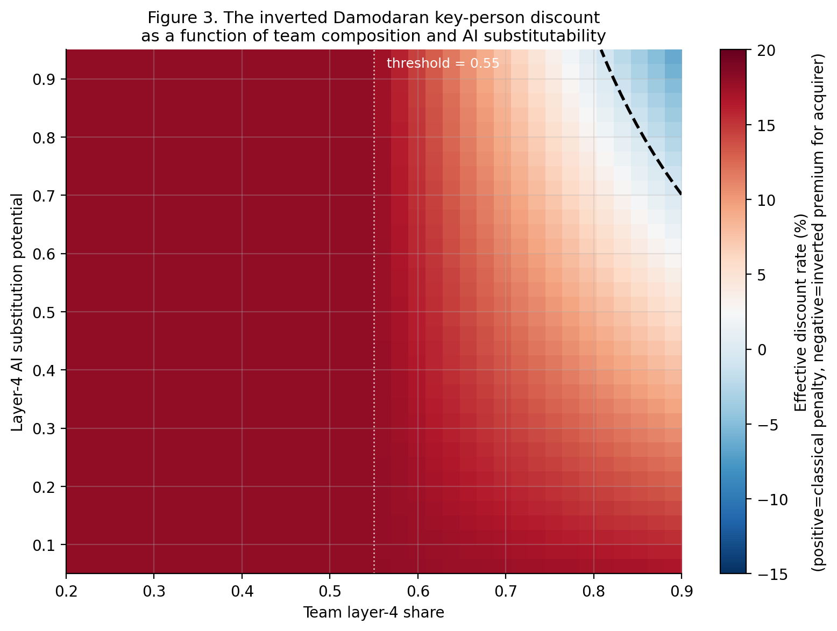
Figure 5. The inverted Damodaran key-person discount as a function of team Layer-4 share (x-axis) and AI substitution potential (y-axis), under uniform parameters that abstract from jurisdictional fiscal effects and assume K = 1.0 (full knowledge integration). The black dashed line marks the zero crossing where the discount changes sign. Below the threshold of 0.55 team Layer-4 share (white dotted line), the classical regime applies and the discount is a constant penalty. Above the threshold, at sufficient AI substitutability, the discount inverts. Section 7 shows that the magnitude of this effect varies materially across jurisdictions; Section 4.7 introduces a further sensitivity to the cross-border knowledge regime.
Status of the claim. The inversion is not asserted as a documented empirical regularity for any specific firm. The possibility of inversion is asserted as real for a non-trivial subset of firms, as a configuration that current valuation methodologies do not yet handle, and as a teaching point that current entrepreneurship pedagogy on team-building requires updating. The implication for entrepreneurship pedagogy is non-trivial. Students are typically taught that building a strong technical team is unambiguously value-creating. In a Layer-4 commoditizing environment, this is no longer unconditionally true. A team whose tasks lie inside the jagged frontier may, beyond a threshold size, be a value-destroying configuration relative to a smaller team supplemented by AI tools.
An open-source implementation of the framework, including the inverted key person discount logic and a Monte Carlo simulator that reproduces the figures in this section, is provided as a computational appendix (de Miranda Neto, 2026, repository). Figure 5 reports the inversion as a function of team Layer-4 share and AI substitutability under uniform parameters. The repository additionally produces deterministic valuation estimates across four scenarios under the four canonical methods (the figure is generated by the run_deterministic script). These figures are computational demonstrations of the framework's quantitative implications under specified parameter ranges, and are not empirical estimates of the prevalence of inversion in real transactions; the parameters are documented in the repository and are open to substitution by other researchers.

6.5 The valley of death and the venture-capital cycle
A final methodological point. The classical valley of death was theorized under cost assumptions that generative AI substantially alters. The cost of crossing the valley has fallen for a wide class of digital products. This has two contradictory effects. The first is positive: the capital required to demonstrate viability is lower, the valley is narrower, and the failure rate at the valley should fall. The second is negative: the defensibility of what is on the other side of the valley has weakened, because the same tools that allowed the focal firm to cross are available to any competitor that follows. The narrowing of the valley is paid for, in part, by the shortening of the period of differentiated profit on the other side. This second effect is, as developed in Section 8, the central strategic problem of the post-AI startup.
The cash-trajectory implication is that the post-AI valley of death should be modeled with two distinct troughs: a shallower classical valley appearing earlier in the firm's life, and a new commoditization valley appearing post-product-market-fit when competitors achieve technical parity through frontier-model substitution and margins compress. Figure 6 sketches the analogous reformulation of the Gartner Hype Cycle. Figure 7 shows the cash-trajectory implication.
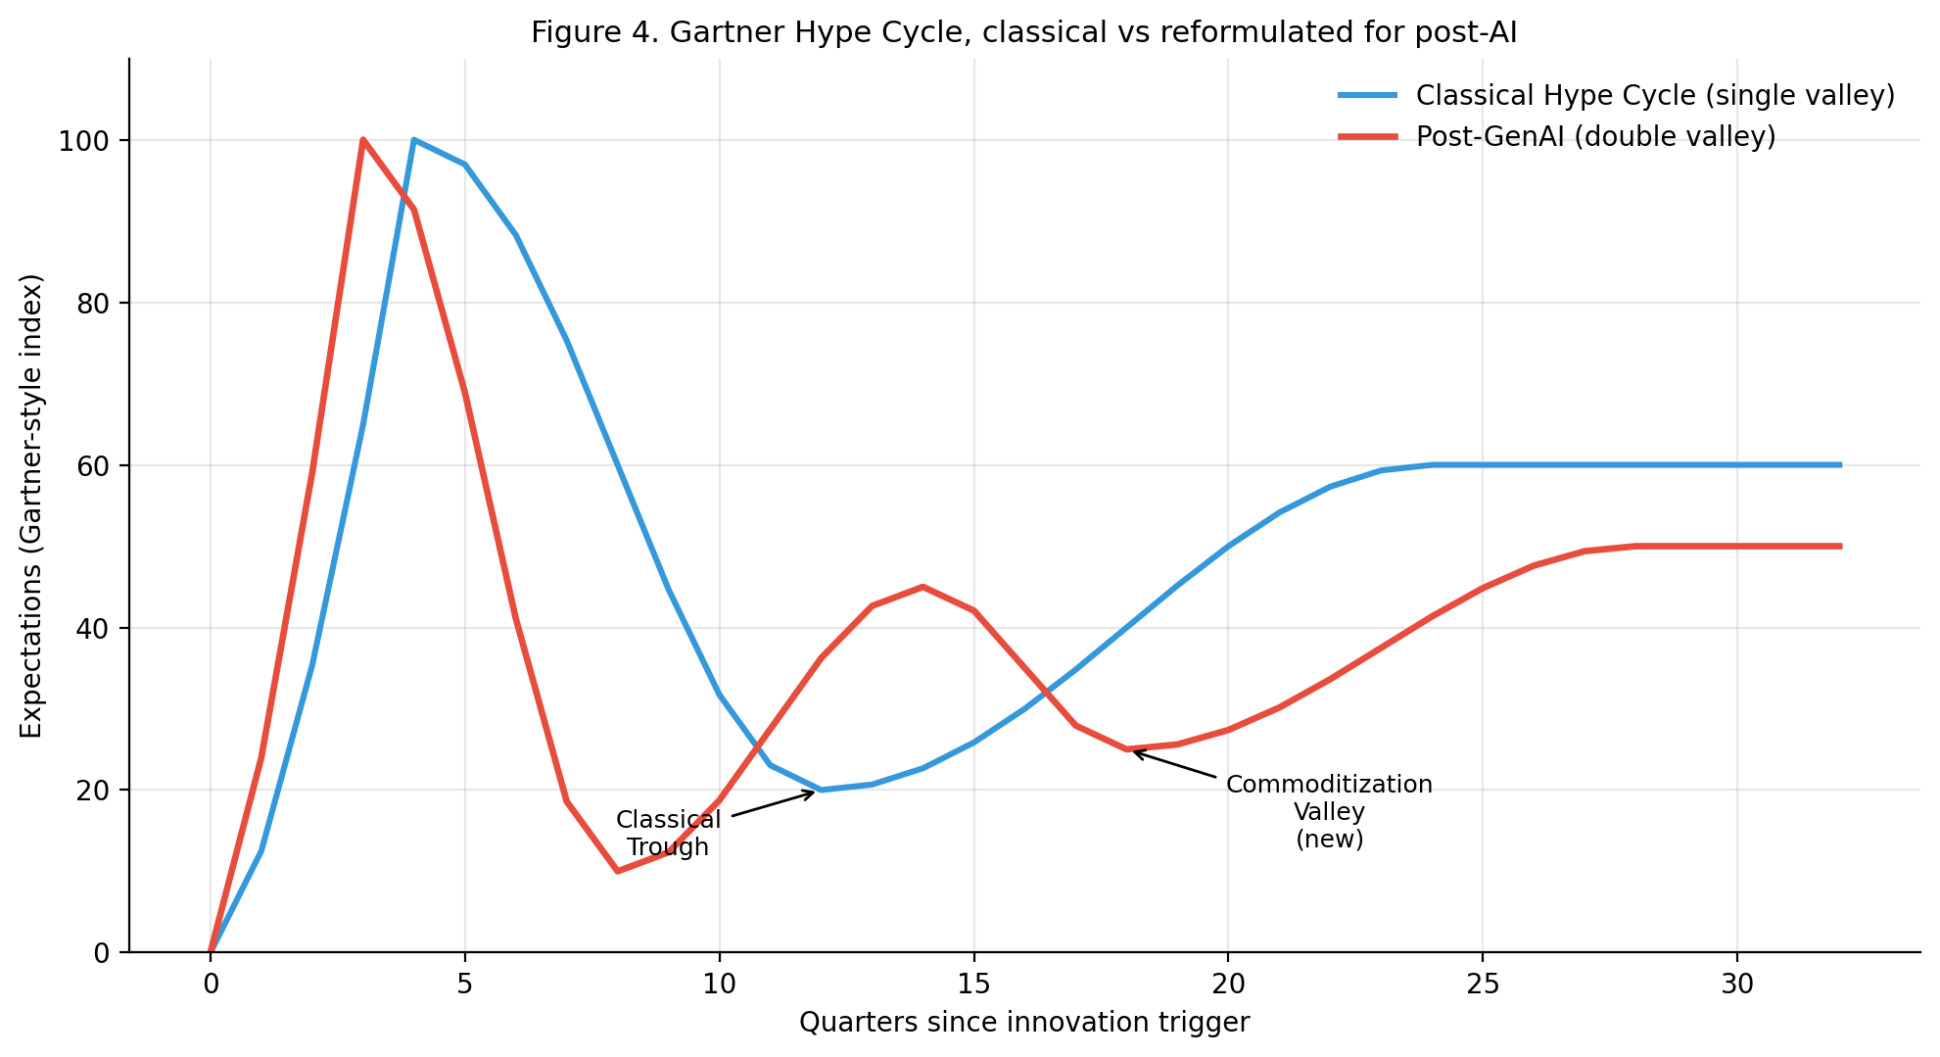
Figure 6. Gartner Hype Cycle, classical (single valley) versus reformulated for post-AI conditions (double valley). The new commoditization valley appears after the false-recovery peak, when competitors close the technical gap through frontier-model substitution.
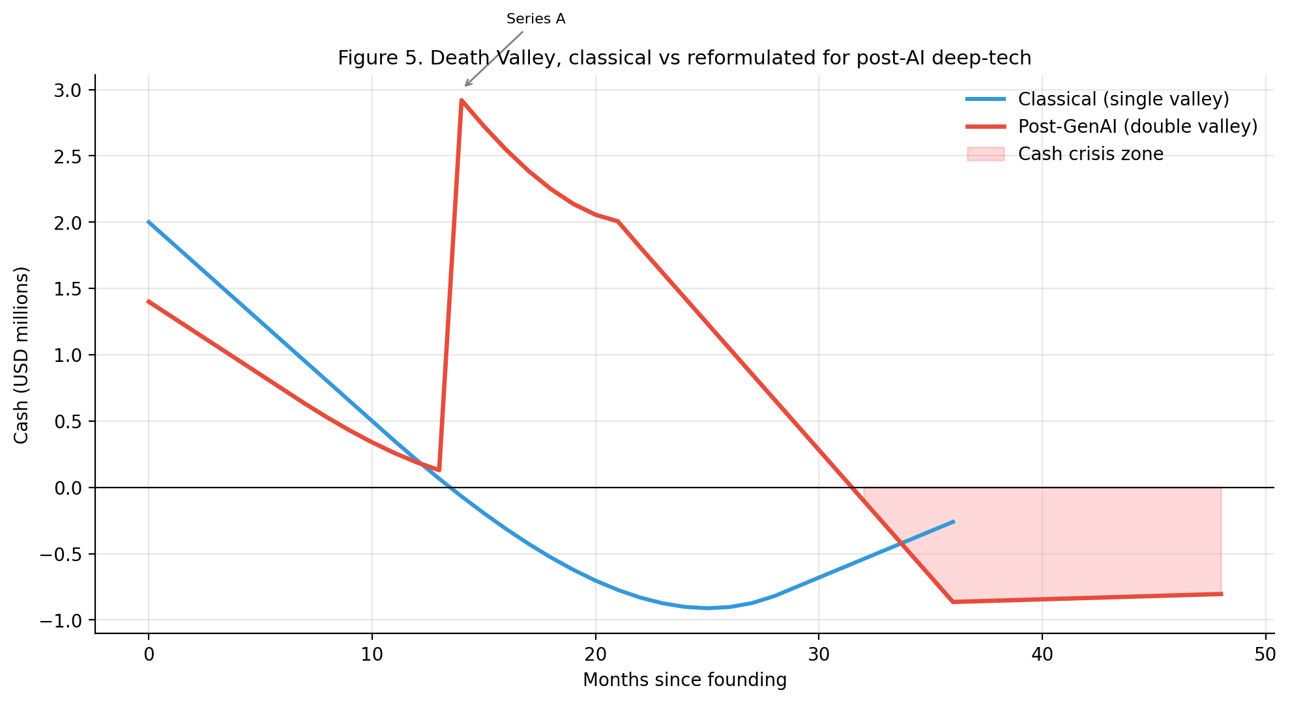
Figure 7. Cash trajectory under classical (blue) and post-AI (red) regimes. The classical regime shows a single deep valley resolved by Series A funding. The post-AI regime shows a shallower first valley followed by a new second valley around month 24-36.

7. The accounting-substitution problem and the jurisdictional structure of the inversion
The argument of Section 6 stops at a possibility: the sign of the key-person discount can flip when in-house technical labor becomes substitutable by AI services. The argument of this section is that this flip is not abstract. When a firm replaces in-house labor with AI services, the substitution crosses a category boundary in the accounting and fiscal architecture of the firm. The cost moves from one category - employee compensation, with all of its statutory accompaniments - to another - third-party service, with a different cost structure, a different tax treatment, a different exposure to contingent liabilities, and a different risk profile. The magnitude of the inverted discount is therefore not a universal constant. It depends on the jurisdiction in which the substitution takes place, on the fiscal regime that governs each side of the substitution, and on whether the post-deal acquirer operates under the same regime as the pre-deal target. The analysis in this section assumes the cross-border knowledge regime is at full integration (K = 1.0). The implications of varying K under each of the three jurisdictions are reported separately in Figure 4.

7.1 The accounting-substitution problem stated
Consider an in-house engineer in a firm whose role consists predominantly of Layer-4 tasks - code generation for routine modules, refactoring, integration, documentation, monitoring, internal data manipulation. The firm's books record this engineer as a unit of employee compensation: salary plus mandatory social contributions, plus voluntary benefits, plus the contingent liability of severance and accrued unused leave. The firm's effective cost is some multiple of the headline salary, with the multiplier varying considerably by jurisdiction.
The substitution proposition is that this engineer can be replaced, in whole or in part, by a combination of AI tooling - foundation-model API access, specialized agentic tools, prompt and pipeline infrastructure - operated by a smaller residual team. The replacement cost is recorded under a different accounting category: third-party services, software-as-a-service subscriptions, infrastructure operating expenditure. The fiscal characteristics of this new category differ from the old one in ways that the standard valuation-by-DCF treatment does not capture by default.
Five effects compose into the net change in firm value. The first is the elimination of the original labor cost, including the local labor-cost multiplier (employer charges, mandatory benefits, statutory provisions). The second is the addition of the new service cost, modulated by any fiscal overhead specific to the cross-border purchase of services if the AI provider is foreign-domiciled. The third is the one-time termination cost paid at the moment of substitution, including statutory severance, notice, and any contractual indemnity. The fourth is the change in the volatility profile of operating expenditure: in-house labor is a fixed cost with low short-run volatility but high contingent-liability exposure; AI service expenditure is a variable cost with high short-run volatility but low contingent-liability exposure. The fifth is the change in the risk profile imposed by vendor concentration: a firm that has substituted a substantial share of its in-house technical capacity by services from a small number of frontier laboratories has acquired a new operational dependency that the standard DCF treatment does not capture.
The combined effect on enterprise value will be called the substitution NPV. When this NPV is positive, the inversion of the key-person discount is empirically grounded - the acquirer does in fact economize, post-deal, an amount that exceeds the one-time and recurring costs of substitution. When this NPV is negative or modest, the inversion does not materialize, and the classical regime persists.

7.2 Three reference jurisdictions
The substitution NPV is jurisdictionally specific. To make the argument concrete and to make it intelligible to readers across the principal regions in which innovation-driven firms operate, three reference cases are developed: Brazil, France, and the United States. The selection is deliberate. These three jurisdictions span a wide range on the dimensions that the substitution analysis tracks: the multiplier on base salary that converts gross compensation into total employer cost, the cost of terminating an employee under the locally applicable labor-law regime, the fiscal overhead applied to the cross-border purchase of services, and the depth of vendor-concentration risk that depends on whether the principal AI providers are domestic or foreign. The values used in the simulations are documented orders of magnitude drawn from public sources and are editable in the repository's YAML scenarios; they are not estimates of any specific firm and should be substituted by readers analyzing specific transactions in specific firms.
Brazil (CLT regime). Under the Consolidacao das Leis do Trabalho (CLT), the dominant formal-employment regime, the multiplier from base salary to total employer cost typically falls in the range 1.7-1.9, reflecting the social-security contribution (INSS empregador), the FGTS deposit, the constitutional thirteenth-month salary, the vacation bonus including the constitutional one-third, the various third-party contributions, and the workplace-accident contribution (Kaptas Global, 2025; Toku, 2026). Imported AI services from foreign providers carry an effective overhead of roughly 25-40% above the nominal USD price, reflecting the imposto de renda retido na fonte on services, the contribuicao de intervencao no dominio economico (CIDE), and the import-charging of PIS/COFINS. Termination under CLT carries the rescission compensation, the FGTS multa of 40% on accumulated balances, and the aviso previo - typically amounting to 25-30% of annual base salary in aggregate. The Brazilian configuration thus combines a high labor-cost multiplier with a high import overhead on substituting services.
France (CDI regime). Under the contrat a duree indeterminee, charges patronales typically add 42-45% on top of the salaire brut, financing the URSSAF contributions, the AGIRC-ARRCO retirement complement, the unemployment insurance, the work-accident contribution, the apprenticeship tax, and the various smaller statutory items (Internago, 2024; Watt-Portage, 2026). Imported non-EU AI services are subject to the TVA-importation, with deductibility for B2B purchasers. Termination of a CDI is rigid: the indemnite de licenciement plus the preavis can amount to 30-50% of annual salary depending on seniority, and economic-cause litigation can add further damages. The French configuration is the intermediate one: moderate labor-cost multiplier, moderate import overhead, but the highest termination cost of the three.
United States (W-2 regime). Under the W-2 regime applicable to most technology workers, statutory employer payroll taxes (FICA match, FUTA, state SUTA, workers' compensation) total approximately 8-10% of wages (Patriot Software, 2025; Paychex, 2025). Voluntary but competitive benefits in the technology sector - employer-paid health insurance, 401(k) match, equity vesting administration, accrued paid time off - typically add another 15-20%, yielding a total multiplier in the range of 1.20-1.30. Termination is at-will in most states, with only contractual severance typically applicable; severance practice varies but typically lies in the range of 5-15% of annual salary. AI services from US-domiciled providers carry no import overhead. The US configuration is the most attenuated: the lowest labor-cost multiplier, the lowest termination cost, and no import overhead.
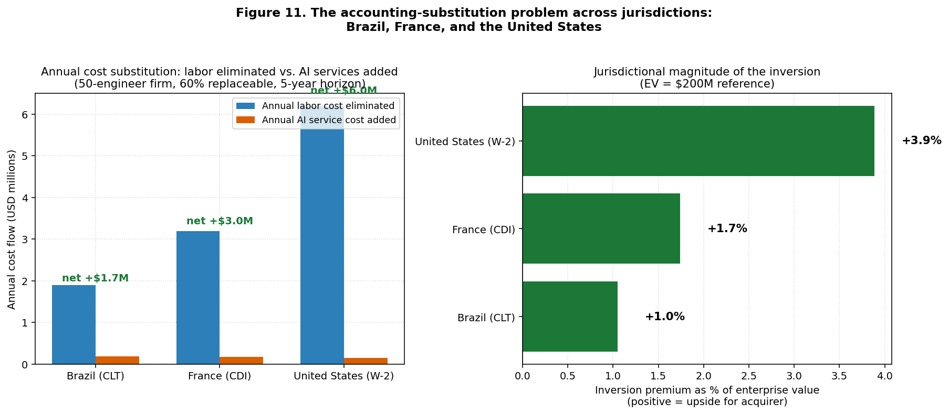
Figure 9. The accounting-substitution problem across jurisdictions. Left panel: annual cost flow comparison between in-house labor cost eliminated (blue) and AI service cost added (orange) for a reference firm of fifty engineers with sixty per cent of the team replaceable, evaluated under each jurisdictional regime. Right panel: the resulting inversion premium expressed as a percentage of a reference enterprise value of US$ 200 million. The salary base used for each jurisdiction reflects the locally observed mid-senior compensation level (Brazil ~US$ 35k, France ~US$ 75k, United States ~US$ 165k); the multipliers are documented in Section 7.2. The figure is computed under K = 1.0 (full knowledge integration); Figure 4 reports the sensitivity to K.

7.3 Reading the simulation: the contraintuitive result
Figure 9 reports the result of the simulation across the three reference jurisdictions. The result is contraintuitive at first reading and deserves careful interpretation. The largest absolute inversion premium, in dollar terms and as a percentage of enterprise value, is observed in the United States, not in Brazil or France. This is the opposite of what a naive reading of "Brazil has the highest social charges, therefore the substitution premium is highest there" would predict.
The mechanism is straightforward once stated. The substitution premium is, to first order, the product of two factors: the absolute level of base salary, and the spread between the labor-cost multiplier and the AI service overhead. The Brazilian multiplier is the highest of the three, but it is multiplied by a Brazilian salary base that is substantially smaller in dollar terms. A multiplier of 1.80 applied to a US$ 35,000 salary yields US$ 63,000 of total cost; a multiplier of 1.25 applied to a US$ 165,000 salary yields US$ 206,500 of total cost. The annual savings from substituting one engineer with AI tooling is therefore approximately three times larger in the US than in Brazil, in absolute terms.
This result has three substantive implications. The first is that the inversion of the key-person discount, when modeled with proper jurisdictional structure, is principally a phenomenon of high-wage jurisdictions in absolute dollar terms, even though the relative multiplier on base salary is lower. The second is that the strategic dynamics of post-AI restructuring are likely to manifest first and most aggressively in firms whose principal labor cost is denominated in high-wage currencies, with the redistribution of cognitive labor across jurisdictions a likely consequence. The third is that policy and pedagogical responses calibrated to the United States may underweight the inversion in a misleading way for firms operating principally in lower-wage jurisdictions, even when the local fiscal multipliers are higher.
Figure 10 decomposes the substitution NPV into its components. The largest single contributor in all three jurisdictions is the present value of the recurring annual savings; the one-time termination cost reduces the NPV by the amount most pronounced in the French case (where rigidity of CDI termination is strongest) and least pronounced in the United States case (where at-will termination keeps separation costs low).
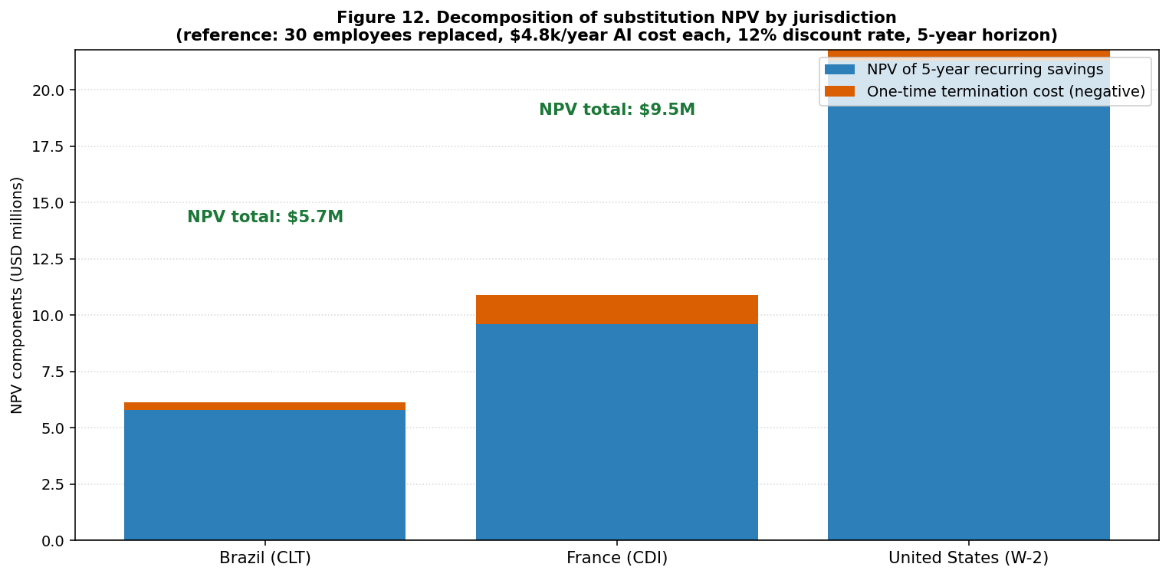
Figure 10. Decomposition of the substitution NPV by jurisdiction. The blue bars represent the present value of the five-year recurring savings from labor-to-AI substitution; the orange segments at the top of each bar represent the one-time termination cost that reduces the NPV. France carries the heaviest termination penalty in absolute terms, reflecting CDI rigidity; the United States carries the smallest, reflecting at-will employment.

7.4 Cross-border M&A and the choice of operating-cost basis
The analysis of Sections 7.2 and 7.3 implicitly assumes that the post-acquisition operating cost basis remains the same as the pre-acquisition target's basis: a Brazilian acquirer of a Brazilian firm operates the substituted team under Brazilian rules; a US acquirer of a US firm under US rules; and so on. This assumption breaks down in cross-border M&A, which is the empirically dominant case for innovative firms outside the largest economies, including most Brazilian and many French targets.
A cross-border acquirer faces an operational choice. The team can be kept in the target's country and operated under the target's fiscal regime; or the local team can be dissolved and the function reproduced from the acquirer's headquarters under the acquirer's own fiscal regime; or the function can be split geographically. Each choice produces a different substitution NPV and therefore a different effective inversion premium.
Figure 11 reports the inversion premium under each of the three operating-cost bases for a target with thirty employees deemed substitutable by AI tooling. The differential is substantial. The same operational substitution decision yields, on the parameters of the simulation, an inversion premium of approximately three per cent of enterprise value when operated on Brazilian cost basis, approximately five per cent on French cost basis, and approximately ten per cent on US cost basis. This implies that a US-domiciled acquirer of a Brazilian target, contemplating dissolution of the Brazilian engineering function and reproduction from US headquarters, would extract substantially more value from the deal than would a Brazilian-domiciled acquirer holding the team in Brazil. The strategic implication for innovative founders in lower-wage jurisdictions is uncomfortable but worth stating: the willingness of foreign acquirers to pay above-local valuations for local technical teams may, post-2022, reflect not the value of the team in place but the value of dissolving the team and substituting AI tooling under the acquirer's own cost basis.
A connection to Section 4.7. The cross-border choice of operating-cost basis examined here is a fiscal sub-case of a broader geopolitical reality. CFIUS review of acquisitions of US AI startups by foreign acquirers, EU foreign direct investment screening, and emerging Brazilian and French regimes for review of strategic acquisitions all impose transaction frictions that the simulation does not currently model. The fiscal arithmetic developed in this section is a lower bound on the value redistribution that a complete treatment of cross-border AI M&A would require. If the cross-border knowledge regime hypothesis of Section 4.7 holds, additional frictions arise from the fact that target and acquirer may belong to different knowledge blocs, with implications for the operational portability of the AI-substituted function that the present simulation does not capture.
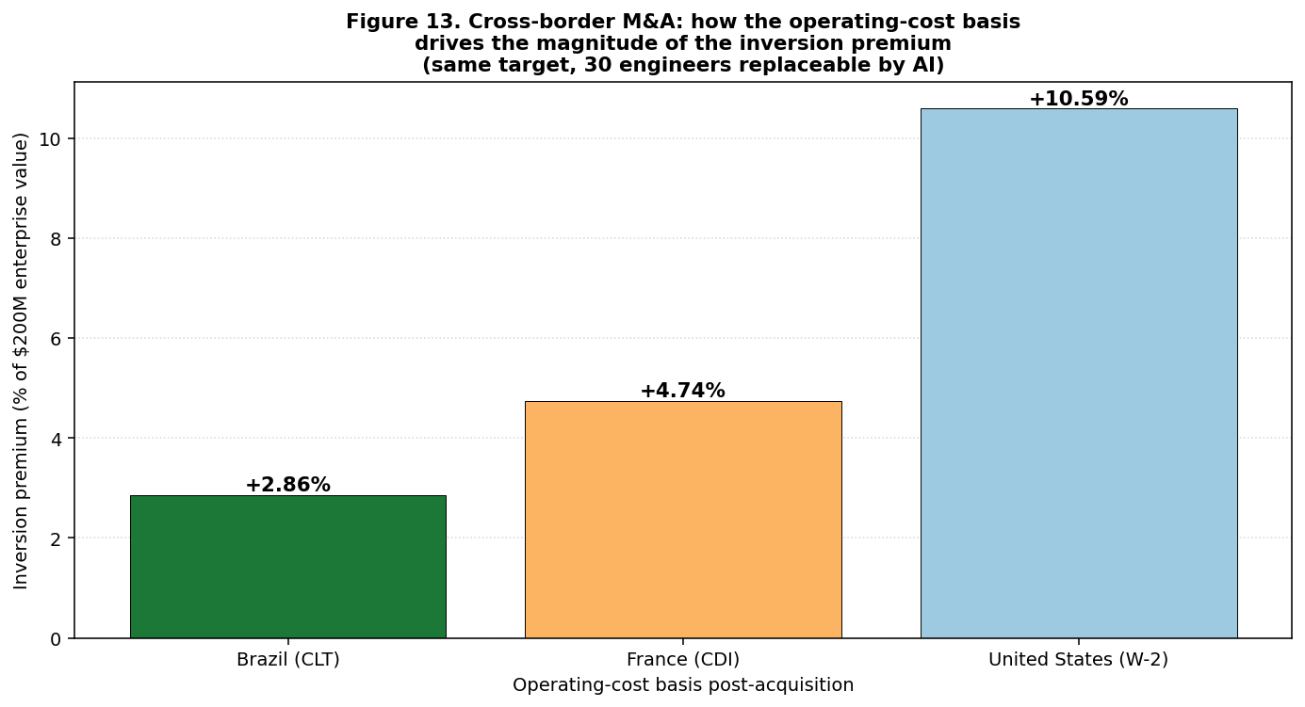
Figure 11. Cross-border M&A: how the operating-cost basis drives the magnitude of the inversion premium for the same target. A US-domiciled acquirer of a Brazilian or French target, contemplating reproduction of the substituted function from US headquarters rather than under the local cost basis, captures a substantially larger inversion premium than a domestic acquirer holding the team in place under the target's local fiscal regime.

7.5 Implications and qualifications
Four qualifications constrain the conclusions of this section. First, the analysis treats Layer-4 substitutability as a parameter and abstracts from the wide and growing literature on the actual quality of AI-assisted Layer-4 output. As Zabludoff et al. (2026) document, frontier models still produce false citations and oversimplifying assumptions in roughly twenty per cent of cases on hypothesis-laden tasks. The substitution NPV computed in this section assumes that the residual team's quality control absorbs these failures at zero cost, which is unrealistic; a more honest treatment would deduct a quality-control overhead that the simulation, in its current form, does not implement.
Second, the regulatory and reputational constraints encoded at Layer 6 of the framework are not modeled in the substitution NPV. Many jurisdictions impose constraints on labor termination that are not captured by simple severance multipliers - litigation risk in Brazil, prud'hommes risk in France, EEOC and discrimination risk in the United States - and many sectors impose substantive constraints on AI deployment that limit the technically achievable substitution rate even where the fiscal arithmetic favours it. The substitution NPV is therefore an upper bound on the strategically achievable inversion premium, not a point estimate of it.
Third, the analysis assumes a fixed knowledge-integration coefficient K = 1.0. As Section 4.7 develops, the seventh-layer hypothesis of this paper is that K has been declining from approximately 1.0 in 2018-2020 to perhaps 0.7 in 2026, with continued decline plausible. Figure 4 reports the sensitivity of the inversion premium of this section to K under each of the three reference jurisdictions. Under K = 0.7, the inversion premium contracts by roughly thirty per cent in all three jurisdictions, but the contraintuitive ordering (United States > France > Brazil) is preserved. Under K = 0.4, the inversion regime collapses entirely and the classical key-person discount reasserts itself in all three jurisdictions. This sensitivity is reported as a conditional implication of the seventh-layer hypothesis, not as a forecast.
Fourth, the analysis is calibrated to a specific moment in 2026 and to the specific cost structures observable at that moment. AI service prices have fallen by roughly an order of magnitude per year since 2023 (Alexandre, in Assemblee nationale, 2026), and the trajectory of the inversion premium over time depends as much on the trajectory of AI service pricing as on the trajectory of labor costs. A repository scenario file allows readers to evaluate alternative trajectories. The implication is that the inversion is not a static property of the post-AI economy but a moving target whose magnitude depends on the relative dynamics of two cost categories that the simulation tracks separately.
With these qualifications in place, the central diagnostic of the section can be stated. The inversion of the key-person discount is jurisdictionally structured. It is largest in absolute terms in jurisdictions where the local labor cost is highest in absolute dollar terms; it is most attenuated, despite high statutory multipliers, in jurisdictions where the absolute labor cost is lower. Cross-border M&A introduces an additional degree of freedom: the acquirer can choose the operating-cost basis under which to evaluate the substitution. The inversion is therefore not a single number to be reported in a peer-reviewed paper. It is a family of conditional propositions, parameterized by jurisdiction, by acquirer choice, and - if the seventh-layer hypothesis holds - by the cross-border knowledge regime, whose magnitude can be computed from publicly available cost data using the methodology this section makes explicit.

8. A layered theory of post-AI defensibility
Sections 5 through 7 examined the implications of the layered framework for entrepreneurship methodology, valuation methodology, and the jurisdictional structure of accounting substitution. A more fundamental strategic question, however, has been only implicit in the discussion so far: under conditions of rapid Layer-3 and Layer-4 commoditization, where does competitive advantage come from? The classical answer of strategic management - that advantage rests on inimitable resources, dynamic capabilities, or structural barriers to imitation (Teece, Pisano, and Shuen, 1997; Teece, 2007) - remains valid in form, but its content needs to be re-specified for a regime in which the technical capability of the product is no longer scarce.

8.1 The classical sources of defensibility, layer by layer
The strategic-management literature identifies a relatively stable set of mechanisms through which firms construct and sustain competitive advantage: cost advantages from scale or learning curves (Arrow, 1962; Lieberman, 1984); switching costs and lock-in (Shapiro and Varian, 1999); demand-side network effects (Katz and Shapiro, 1985; Eisenmann, Parker, and Van Alstyne, 2006); proprietary access to data or other inputs (Brynjolfsson, 1994); intangible assets such as brand, reputation, and trust (Barney, 1991); and institutional or regulatory barriers (Porter, 1985). Each of these mechanisms can be mapped onto the layered framework of Section 4, with revealing results.
Layer 4 mechanisms - cost advantages from product-side technical superiority. This is the source of advantage that the Lean Startup pedagogy implicitly assumes when it treats the MVP as the differentiating artifact. It rests on the buyer perceiving that the focal firm's product is technically better than competitors. In a Layer-4 commoditizing regime, this source of advantage is the most exposed to erosion. The frontier-model-substitutable subset of any product's technical capability is, by construction, available to any entrant who is willing to call the same APIs. Cost advantages built on technical superiority of the artifact alone are now short-lived for a wide class of digital products.
Layer 5 mechanisms - learning curves, proprietary data, and integrative judgment. Mechanisms that rest on the firm having learned something about its customers, its operating environment, or the way its product interacts with both, that competitors cannot trivially replicate. The classical learning-curve literature (Arrow, 1962) treated this as cumulative production experience; the contemporary analogue includes proprietary user-interaction data, accumulated taste in product judgment, and the integrative know-how about which Layer-4 outputs to trust and which to discard. Generative AI does not erode these mechanisms; if anything, by lowering the cost of generating Layer-4 outputs whose quality cannot be assessed without judgment, it raises the relative value of the firm whose accumulated experience constitutes that judgment.
Layer 6 mechanisms - switching costs, network effects, and institutional embedding. Mechanisms that rest on the structure of the buyer side rather than on the technical superiority of the product. Switching costs (Shapiro and Varian, 1999) lock the buyer into the seller through investments the buyer has made. Demand-side network effects (Katz and Shapiro, 1985; Eisenmann, Parker, and Van Alstyne, 2006) make the value of the product to one buyer increasing in the number of other buyers using it. Institutional embedding (Suchman, 1995) ties the seller into the buyer's regulatory, certification, or operational infrastructure. These mechanisms are unaffected by Layer-4 commoditization in their internal mechanics but become more strategically central, because the layers above them have weakened.

8.2 The redistribution of strategic value
The central strategic implication can now be stated. The diffusion of generative AI does not destroy the classical sources of competitive advantage. It redistributes them across the layers of the stack. Layer-4 sources of advantage are eroding. Layer-5 sources are stable or rising in relative value. Layer-6 sources are unaffected as mechanisms but become more strategically central. The strategic value of an innovative firm migrates upward through the layered stack: from the artifact to the loop that improves the artifact through interaction with users and to the relational and institutional infrastructure that makes the loop run.
Three implications follow. First, the temporal structure of competitive advantage compresses on the product side and dilates on the institutional side. Differentiation built on a technical feature lasts months rather than years; differentiation built on accumulated user-interaction data, regulatory accreditation, or platform-side network effects lasts as long as it ever did. Second, the strategic question of what to defend changes. A firm that defends a product feature in 2026 is defending an asset whose half-life has compressed; a firm that defends a learning loop, a data asset, or a position in a regulatory regime is defending an asset whose half-life has not changed. The misallocation of defensive effort is an under-recognized failure mode of post-AI strategy. Third, the entry calculus changes. An entrant who builds on commoditized Layer-3 and Layer-4 inputs faces a foreshortened window of differentiated profit. The strategic question for the entrant is no longer "can I build something technically better?" - the answer is yes, briefly, for a wide class of products - but rather "can I, during the brief window of technical differentiation, install myself into a Layer-5 loop or a Layer-6 position that will outlast it?"

8.3 Network effects in the post-AI regime
Network effects, in the canonical formulation of Katz and Shapiro (1985) and the platform-economics literature that followed (Eisenmann, Parker, and Van Alstyne, 2006), exist when the value of a product to a buyer increases in the number of other buyers using it. Network effects therefore operate at Layer 6 of the present framework: they reside in the structure of the buyer side, not in the technical content of the product.
The diffusion of generative AI cheapens the construction of the technical artifact while leaving the network unchanged. The strategic question of whether one can build a competitor to an established networked platform was, in the pre-2022 regime, partly a question of whether one could build the technical artifact at all. In the post-2022 regime, the technical artifact can be built. The question collapses to whether one can move the network, which is a Layer-6 question that AI does not answer.
In product categories where network effects are present, the post-AI regime is more, not less, defensible for the incumbent. The technical commoditization of the product erodes a defensive moat that the incumbent did not need; it does not erode the defensive moat that the incumbent does need. In product categories where network effects are absent, the situation is reversed. Categories that depended on technical product differentiation alone for their defensive structure are now exposed.

8.4 Switching costs, learning curves, and vendor concentration
Switching costs and learning curves are repositioned in their relative strategic weight. Generative AI affects switching costs in two opposing directions. On the one hand, AI can reduce switching costs by automating the migration: an LLM can read a buyer's configuration in one system and reproduce it in another, lowering the per-switch cost that lock-in depends on. On the other hand, AI deployments themselves accumulate switching costs of a new kind: the buyer's customizations, fine-tunings, prompt libraries, and accumulated workflow integrations become themselves seller-specific assets. The net effect is empirically open; the strategic implication is that the locus of switching costs shifts from the application layer to the AI-integration layer.
A new mechanism that the pre-2022 strategic-management literature does not theorize is what will be called vendor concentration risk in the substitution analysis of Section 7. A firm that has substituted a substantial fraction of its in-house technical capacity by services from a small number of frontier laboratories has acquired an operational dependency that did not exist in the in-house regime. This is a switching cost that runs against the focal firm and toward the AI service provider. The firm has, in effect, traded employee-side rigidity for vendor-side rigidity. The strategic significance of this trade is that it converts the focal firm from a self-contained technical entity into a customer of a Layer-2 or Layer-3 incumbent. The economics of this transformation - the share of the focal firm's value that accrues to it versus the share that accrues to its AI provider - is, in the post-2022 regime, an empirically open question and one of the more important determinants of where strategic value ultimately lands. If the seventh-layer hypothesis of Section 4.7 holds, vendor concentration risk acquires an additional dimension: the firm's vendor may be located in a different knowledge bloc, exposing the firm to bloc-specific regulatory or geopolitical action that disrupts the substitution after the fact.

8.5 Synthesis: defensibility as a layered property
In the post-AI regime, defensibility is itself a layered property. The components of competitive advantage do not commoditize jointly; they commoditize differentially, and the firm that has invested in the layers that do not commoditize accumulates a defensive position whose value rises as the layers that do commoditize fall in price. This is the inversion of the pre-2022 strategic intuition, in which the defensive value of a strong technical product was the central concern of the entrepreneurial firm. In the post-2022 regime, the technical product is at best a vehicle for accumulating defensive position elsewhere; at worst, it is a depreciating asset whose visible quality misleads founders, investors, and acquirers about the durability of the firm's competitive position. The strategic recommendation that follows is conservative in form and disruptive in content: defensibility lives in mechanisms that resist imitation, but the bulk of post-2022 entrepreneurial activity, as currently practiced and as currently taught, is investing defensive effort in the layer where defense has become weakest.

9. Implications for science
The argument up to this point has concerned the firm. The discussion now turns to a related but distinct question: what about science itself? If the production of codified synthesis, of literature review, of routine analysis is commoditizing rapidly at Layer 4, and if this layer has been a substantial component of doctoral training and of journal output in many disciplines, then a non-trivial portion of what circulates as scientific contribution may already sit inside the commoditizing zone.
The astronomy graduate-class experiment of Zabludoff et al. (2026) reports that frontier models can produce credible-looking proposals for original research projects, can synthesize the relevant literature, and can suggest analytical pathways - but in roughly twenty per cent of cases produced false citations or summaries, and routinely made implicit, oversimplifying assumptions that students had to catch and correct. The pattern of failure is informative: it concentrates in the steps of research design that require judgment about which simplifying assumption is admissible in the present problem - a Layer-5 step in the framework. Woodruff et al. (2024) find, in participatory workshops with knowledge workers across seven industries, that practitioners themselves anticipate AI's disruptive effects to manifest as amplification of existing dynamics rather than as displacement of the field as a whole.
The implication of mapping science onto the layered framework is threefold. First, the codified-output layer of science is commoditizing at Layer 4 in a manner directly analogous to other knowledge-work domains. The ability to produce a competent literature review in a known subfield, in 2026, is not a differentiating capability. Second, the hypothesis-formulation layer of science is at Layer 5 and remains weakly commoditized; it is precisely the layer at which the failures documented by Zabludoff et al. (2026) concentrate. Third, the institutional-trust layer of science is at Layer 6 and is anti-commoditizing. The proliferation of AI-generated text has, paradoxically, raised the relative value of credentialed gatekeepers who can attest to the authenticity and quality of work product. The science-policy implication is that the institutional layer should not be deprecated as legacy infrastructure but reinforced as the increasingly scarce input.
The seventh-layer dimension. The Layer 7 hypothesis of Section 4.7 has direct implications for science. If the cross-border knowledge regime continues to fragment, the production of science itself bifurcates: separate journals, separate corpora, separate scientific establishments, separate evaluation criteria. The bibliometric evidence of Wagner and Cai (2022) and the Science and Public Policy bibliometric study (2026) document this bifurcation in process for AI research over 2019-2025. UNESCO (2026) characterizes the emerging regime as a dual-track scientific architecture. The Quincy Institute (2025) calls for what it terms smart openness as a calibration response. For the present paper, the relevant implication is that the layered framework's predictions for science are themselves conditional on the trajectory of Layer 7: under K = 1.0 the analysis above stands, under K < 1.0 the bifurcation alters the substantive content of what counts as scientific Layer-4 output, with implications that are not yet well understood.

10. Implications for entrepreneurship pedagogy
The framework also has implications for how innovation-driven entrepreneurship is taught. Recent empirical evidence on the placement of MBA graduates from elite U.S. programmes (Bloomberg analysis, 2025) shows that the share of Harvard MBA students without a job offer within three months of graduation rose from 4% in 2021 to 15% in 2024; the corresponding figure for MIT rose from 4.1% to 14.9%. The Stanford payroll-level evidence on a 13% relative decline in entry-level employment in highly AI-exposed occupations (Brynjolfsson, Chandar and Chen, 2025) is consistent with this. The contrary interpretation - that the entry-level decline reflects the macroeconomic shock of the 2022-2024 monetary-tightening cycle rather than AI substitution (Iscenko and Curto Millet, 2026) - has empirical force and should be taken seriously. The honest position, on the evidence available in mid-2026, is that the two effects are entangled, that the AI-substitution effect is non-zero but smaller than the most dramatic headlines suggest, and that the question of the structural component of entry-level displacement will only be settled by data that is not yet available. The pedagogical question, however, does not wait on this resolution.
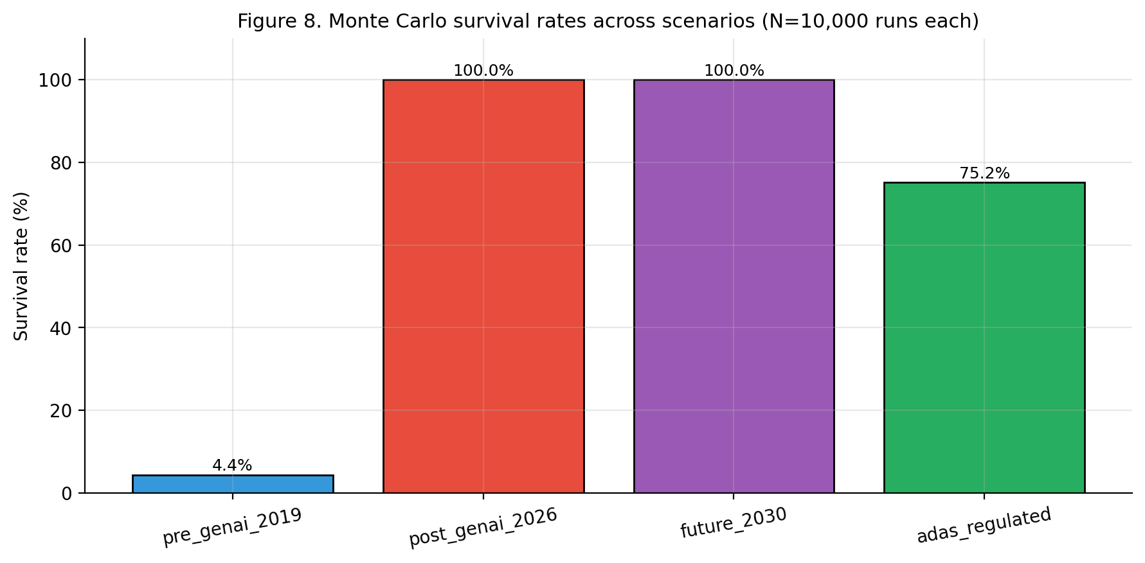
Figure 8 (computational appendix). Monte Carlo survival rates across four scenarios (N=10,000 runs each). The post-genAI 2026 and future 2030 scenarios approach high survival under typical venture-funding sequences, while the ADAS regulated scenario shows intermediate survival due to the much higher capital intensity of regulated certification.
Five implications follow. First, the canonical methodologies should be re-architected around the cost gradient of Section 5: Customer Development re-emphasizing relational construction, Lean Startup re-anchored on the Minimum Viable Hypothesis, Business Model Generation re-emphasizing integrative coherence. Second, valuation pedagogy should expose the inverted key person discount (Section 6) and its jurisdictional structure (Section 7). Students should be taught that team size is a layered signal: positive at Layers 5 and 6, increasingly ambiguous at Layer 4, with magnitude that depends on the local fiscal regime. Third, strategic-management pedagogy should explicitly teach the layered theory of defensibility (Section 8). Fourth - and this is a pedagogical implication that the title of the paper foregrounds - students should be taught to read the methodological centrality of the build with historical specificity. The build was the methodological centerpiece of innovation-driven entrepreneurship in a particular configuration of capital costs and labor costs that no longer holds for a wide class of digital products. What the post-AI entrepreneur builds is no longer principally a technical artifact but a hypothesis, a relationship, an institutional position, and a learning loop. Pedagogy should make this explicit rather than treating it as a footnote to the existing curriculum. Fifth, the seventh-layer hypothesis introduced in Section 4.7 carries a pedagogical implication of its own: students should be taught that the firm's strategic positioning depends not only on which layer it occupies but also on which knowledge bloc it operates in, and that the assumption of frictionless cross-bloc access to AI capabilities should not be taken for granted in the horizon 2025-2035.

11. Discussion: the commoditization question, reframed
The question with which this paper opened - is generative AI commoditizing knowledge, technology, and science - admits no global answer. The right question is: which layer of the knowledge-production stack is commoditizing, on which time horizon, in which jurisdiction, under which cross-border knowledge regime, with what distributional consequences. The framework yields a layered map. Layer-1 inference, Layer 3, and Layer 4 are commoditizing rapidly. Layer 2 is partially commoditizing in a moving frontier. Layer-1 training, Layer 5, and Layer 6 are anti-commoditizing - that is, not merely resisting commoditization but, paradoxically, re-concentrating in value as the layers above them commoditize. Layer 7 is offered as a tentative hypothesis: the regime under which cross-border knowledge integration operates is itself anti-commoditizing by reversal, and its trajectory modulates the velocities of Layers 3, 4, and 5.
The methodological implication for the canonical entrepreneurship toolkit is that Customer Development, Lean Startup, MVP, and Business Model Generation each contain assumptions about the cost gradient across layers that no longer hold. The Minimum Viable Hypothesis proposed in Section 5.3 is offered as a positive substitute for the MVP. The implication for valuation methodology is that Damodaran's key person discount can in principle invert in sign. The implication for accounting-substitution analysis is that the inversion is jurisdictionally structured: largest in absolute terms in jurisdictions with the highest absolute labor cost, attenuated in lower-wage jurisdictions despite higher statutory multipliers. The implication for strategy is that defensibility is a layered property. The implication for science is that the institutional-trust layer is becoming the increasingly scarce input. The implication of the seventh-layer hypothesis is that all of the above are conditional on a regime of cross-border knowledge integration that has begun to fragment and may continue to do so.
What the paper does not establish: that any specific firm has experienced an inversion of its key person discount; that the entry-level displacement effects are predominantly attributable to AI as opposed to monetary tightening; that the parameter ranges used in Section 7 generalize to other jurisdictions; that the substitutability of Layer-4 tasks is uniform across product categories; that the value of K used in the simulations is empirically accurate; and that the seventh-layer hypothesis itself will be confirmed by future scientometric and policy evidence. The honest position is that these are empirical questions for which adequate data is not yet available. The framework of this paper is consistent with a wide range of resolutions to these empirical questions; it does not depend on any of them being resolved in a particular direction. What the paper does claim is that the binary debate over AI commoditization, as it is currently conducted in elite-policy discourse and in parts of the strategy literature, is analytically empty. The substitution of a layered question for the binary one substantially clarifies the debate.
A note on the role of states. The Layer 7 hypothesis cannot be fully understood without acknowledging that states themselves are increasingly active agents in shaping the cross-border knowledge regime. The U.S. Department of Justice's China Initiative (2018-2022) and its lasting effects on research collaboration documented by ASPI (2025); the EU AI Act enforcement provisions activated in August 2025; the European Court of Justice invalidation of the EU-US Data Privacy Framework in late 2025; the U.S.-China Science and Technology Agreement renewal of December 2024 with explicit exclusion of emerging technologies from collaborative scope (Mu-ming Poo, 2025); and the November 2025 Franco-German digital-sovereignty summit are all manifestations of state action with direct implications for K. The strategic responses of innovative firms to these state actions, and the second-order effects on entrepreneurship and valuation, are not modeled in the present paper. They constitute a significant part of the agenda for the companion paper indicated in Section 12.

12. Limitations and avenues for further research
Eight limitations of the present analysis deserve explicit acknowledgement.
First, the framework is heuristic, not measured. The seven layers are proposed on conceptual grounds; they have not been operationalized into measurable variables, and the claim that each layer is moving at a particular velocity is currently an empirical conjecture rather than an estimate.
Second, the empirical evidence on entry-level displacement is contested. The Stanford payroll-level estimate (Brynjolfsson, Chandar, and Chen, 2025) and the Economic Innovation Group's contrary interpretation (Iscenko and Curto Millet, 2026) are entangled, and the empirical literature has not yet settled the relative weights.
Third, the jurisdictional analysis of Section 7 is calibrated to publicly documented orders of magnitude, not to firm-level empirical estimates. The Brazilian, French, and US parameters used are documented in the repository's YAML scenarios and are explicitly editable. They are not estimates of the prevalence of inversion in actual transactions; they are the parameters of an editable simulation that allows the reader to explore how the inversion premium responds to plausible variation in the underlying fiscal architecture.
Fourth, the analysis abstracts from the trajectory of AI service pricing, which has fallen by approximately an order of magnitude per year since 2023 (Alexandre, in Assemblee nationale, 2026). The simulation can be extended to track this trajectory and to compute the expected evolution of the inversion premium over time; the present version reports a snapshot at 2026 cost levels.
Fifth, the inverted key person discount and the layered theory of defensibility are theoretical possibilities, not documented empirical regularities. The paper has identified the conditions under which they could arise; it has not documented their prevalence.
Sixth, the Minimum Viable Hypothesis proposed in Section 5.3 has not been tested in classroom or field settings. Its actual yield, relative to the conventional MVP-anchored methodology, is an open empirical question.
Seventh - and this is the limitation that requires the most explicit acknowledgement - Layer 7 is introduced as a hypothesis whose empirical foundation is, at present, weaker than that of Layers 1 through 6. The peer-reviewed work that exists is primarily in scientometrics (Wagner et al., 2022; Wagner and Cai, 2022; Science and Public Policy, 2026; Humanities and Social Sciences Communications, 2025; Mu-ming Poo, 2025) and in policy analysis (UNESCO, 2026; ASPI, 2025; Quincy Institute, 2025), and the relevant management and strategy literature has not yet treated the cross-border knowledge regime as a layer of analysis. The simulations using K = 0.7 and K = 0.4 reported in Section 7.5 and Figures 3-4 should be read as illustrative explorations of a hypothesis, not as forecasts. A more rigorous empirical treatment of Layer 7 - including measurement of K through bibliometric indicators, model-corpus diversity metrics, and cross-border data-flow indices - is reserved for a companion paper.
Eighth, the geopolitical and state-action dimension of the cross-border knowledge regime is barely modeled in the present analysis. Export controls on advanced semiconductors and AI infrastructure (US BIS controls of 2022-2024 on advanced chips to China; EU dual-use updates of 2024-2025), AI-specific regulations with extraterritorial effect (EU AI Act enforcement August 2025; UK and US AI safety frameworks), foreign direct investment screening (CFIUS and EU FDI Regulation), and bilateral science-and-technology agreements (US-China STA renewal December 2024) all materially shape the value of K and its trajectory. Modelling these effects with the appropriate institutional detail is the principal task of the companion paper, which would also address strategic responses by firms and entrepreneurs to a regime in which the assumptions of frictionless cross-border knowledge access can no longer be taken for granted.

13. Conclusion
The argument advanced in this paper is that the binary debate over whether generative AI is commoditizing knowledge, technology, and science is conceptually impoverished and should be replaced by a layered question. The seven-layer framework yields the central claim: commoditization in the AI era is not a property of the technology, it is a property of layers that the technology touches, with opposite signs at different layers, modulated by a cross-border knowledge regime whose trajectory is itself in question.
From this layered map, five contributions follow. First, the canonical entrepreneurship toolkit can be re-examined layer by layer, with the result that the Minimum Viable Product is reformulated as a Minimum Viable Hypothesis whose epistemological function is preserved while the methodological centre of gravity moves upstream. Second, the four dominant valuation methods inherit additional noise from the heterogeneity of the AI-integration profile of the peer set, and Damodaran's key person discount can in principle invert in sign. Third, the inversion is jurisdictionally structured: when the substitution of in-house labor by AI services is modeled with proper accounting and fiscal structure, the magnitude of the inversion premium varies materially across jurisdictions, with the contraintuitive finding that high-wage jurisdictions like the United States produce the largest absolute inversion premium, despite lower statutory labor-cost multipliers, because the absolute base salary dominates the multiplier in determining the dollar value of the substitution. Fourth, the classical sources of competitive defensibility do not commoditize jointly: they redistribute across the layered stack, with Layer-4 sources eroding and Layer-5 and Layer-6 sources gaining relative weight. Fifth, and offered as a tentative hypothesis whose empirical foundation is acknowledged to be weaker than that of the other contributions, a seventh layer of the framework captures the cross-border knowledge regime that modulates the velocities of Layers 3, 4, and 5 and that has been documented to be reversing direction since approximately 2019.
The title of the paper - The End of the Build - identifies what the five contributions share. The act of building a working prototype, historically the differentiating contribution of the entrepreneurial team, has lost its informational and strategic centrality. The methodologies that placed the build at their centerpiece must be reformulated; the valuation methods that priced the build-capable team as an unambiguous asset must accommodate the possibility of inverted sign; the strategic accounts of competitive advantage that rested on product-side technical superiority must yield ground to accounts that rest on learning loops, network effects, and institutional embedding; and the framework as a whole must be understood as conditional on a regime of cross-border knowledge integration that has begun to fragment. None of this implies that nothing is built any more. It implies that what is built, by whom, with what methodology, with what jurisdictional cost basis, with what positioning relative to the cross-border knowledge regime, and with what strategic purpose, must be re-thought.
The argument is offered as a contribution to a debate that is moving rapidly. Better framings will follow. The companion computational appendix is offered, in the same spirit, as one possible operationalization - editable, extensible, and explicitly calibrated to documented orders of magnitude and to a knowledge-integration coefficient whose value is illustrative rather than estimated. The framework is editable, the parameters are documented, the jurisdictional scenarios are pluggable, the seventh-layer parameter is exposed for exploration, and any researcher disagreeing with the calibrations adopted here is encouraged to substitute their own and observe the resulting differences. A subsequent paper, building on the limitations explicitly acknowledged in Section 12, will develop the seventh-layer hypothesis with the empirical and institutional detail that the present paper has not been able to provide.

References
Ackerman, M. S. (2000). The Intellectual Challenge of CSCW: The Gap Between Social Requirements and Technical Feasibility. Human-Computer Interaction, 15(2-3), 179-203.
Arrow, K. J. (1962). The Economic Implications of Learning by Doing. Review of Economic Studies, 29(3), 155-173.
ASPI (Australian Strategic Policy Institute) (2025). Critical Tech Tracker: US-China Technology Research Decoupling. ASPI Strategist special report, November 2025.
Anthropic (2025a). Claude Gov models for U.S. national security customers. anthropic.com/news/claude-gov-models-for-u-s-national-security-customers, June 2025.
Anthropic (2025b). Updating Restrictions of Sales to Unsupported Regions. anthropic.com/news/updating-restrictions-of-sales-to-unsupported-regions, September 2025.
Anthropic (2026). Claude Mythos Preview: A New General-Purpose Language Model with Strong Computer Security Capabilities. red.anthropic.com/2026/mythos-preview/, April 2026.
Assemblee nationale (2026). Mission d'information sur la creation, la diffusion et l'acquisition des connaissances: comment l'intelligence artificielle transforme l'education et la culture. Audition de Luc Ferry, Laurent Alexandre et Olivier Babeau. XVIe legislature, transcription officielle.
Barney, J. B. (1991). Firm Resources and Sustained Competitive Advantage. Journal of Management, 17(1), 99-120.
Berkus, D. (2016). Basic Berkus Method: Valuing the Early Stage Investment. Berkus Press.
Blank, S. (2013). Why the Lean Start-Up Changes Everything. Harvard Business Review, 91(5), 63-72.
Blank, S. and Dorf, B. (2012). The Startup Owner's Manual: The Step-by-Step Guide for Building a Great Company. Pescadero, CA: K&S Ranch.
Bloomberg (2025). Harvard MBA placement: share of students without job offer at three months, 2021-2024. Cited in Fortune, March 2025.
Brynjolfsson, E. (1994). Information Assets, Technology, and Organization. Management Science, 40(12), 1645-1662.
Brynjolfsson, E., Chandar, B. and Chen, R. (2025). Canaries in the Coal Mine? Six Facts about the Recent Employment Effects of Artificial Intelligence. Stanford Digital Economy Lab Working Paper, August 2025; revised November 2025.
Brynjolfsson, E., Li, D. and Raymond, L. R. (2025). Generative AI at Work. Quarterly Journal of Economics, 140(2), 889-942.
Bureau of Labor Statistics, U.S. Department of Labor (2025). Employment data on programmer and software developer occupations, 2023-2025. Cited in IEEE Spectrum, AI Shifts Expectations for Entry Level Jobs, February 2026.
Christensen, C. M. (1997). The Innovator's Dilemma: When New Technologies Cause Great Firms to Fail. Boston: Harvard Business School Press.
Damodaran, A. (2009). Valuing Young, Start-up and Growth Companies: Estimation Issues and Valuation Challenges. Stern School of Business Working Paper, New York University.
Damodaran, A. (2017). Narrative and Numbers: The Value of Stories in Business. New York: Columbia Business School Publishing.
Damodaran, A. (2023). The Little Book of Valuation: How to Value a Company, Pick a Stock, and Profit (2nd ed.). Hoboken, NJ: Wiley.
de Miranda Neto, A. (2026). commoditization-stack-simulation (v0.4) [Computer software]. GitHub repository.
Dell'Acqua, F., McFowland, E., Mollick, E., Lifshitz-Assaf, H., Kellogg, K., Rajendran, S., Krayer, L., Candelon, F. and Lakhani, K. R. (2023). Navigating the Jagged Technological Frontier: Field Experimental Evidence of the Effects of AI on Knowledge Worker Productivity and Quality. Harvard Business School Working Paper No. 24-013.
Dell'Acqua, F., Ayoubi, C., Lifshitz, H., Sadun, R., Mollick, E., Mollick, L., Han, Y., Goldman, J., Nair, H., Taub, S. and Lakhani, K. R. (2025). The Cybernetic Teammate: A Field Experiment on Generative AI Reshaping Teamwork and Expertise. Harvard Business School Working Paper No. 25-043 / NBER Working Paper No. 33641.
Eisenmann, T., Parker, G. and Van Alstyne, M. W. (2006). Strategies for Two-Sided Markets. Harvard Business Review, 84(10), 92-101.
European Union (2024). Regulation (EU) 2024/1689 (Artificial Intelligence Act). Official Journal of the European Union, L 1689.
Felin, T., Gambardella, A., Novelli, E. and Zenger, T. (2024). A Scientific Method for Startups. Journal of Management, online first.
Felin, T. and Holweg, M. (2024). Theory Is All You Need: AI, Human Cognition, and Causal Reasoning. Strategy Science, 9(4), 346-371.
Goldstein, G. M. (2026). Six Reasons Claude Mythos Is an Inflection Point for AI and Global Security. Council on Foreign Relations Expert Brief, April 2026.
Heath, C. and Luff, P. (2000). Technology in Action. Cambridge: Cambridge University Press.
Hicks, C., Attridge, C., Janjeva, A. and Ashurst, C. (2026). Claude Mythos: What Does Anthropic's New Model Mean for the Future of Cybersecurity? CETaS Expert Analysis (Centre for Emerging Technology and Security, Alan Turing Institute), April 2026.
Internago (2024). How much does it cost to employ someone in France? Internago, April 2024.
Iscenko, Z. and Curto Millet, F. (2026). Looking for the Ladder: Is AI Impacting Entry-Level Jobs? Economic Innovation Group, American Worker Project, January 2026.
ISO/IEC (2023). ISO/IEC 42001:2023 - Information Technology - Artificial Intelligence - Management System. Geneva: International Organization for Standardization.
Kaptas Global (2025). Brazil hiring costs 2025: A complete total cost guide for US teams.
Katz, M. L. and Shapiro, C. (1985). Network Externalities, Competition, and Compatibility. American Economic Review, 75(3), 424-440.
Kellogg, K. C., Valentine, M. A. and Christin, A. (2020). Algorithms at Work: The New Contested Terrain of Control. Academy of Management Annals, 14(1), 366-410.
Korinek, A. (2025). AI Agents for Economic Research: August 2025 Update to 'Generative AI for Economic Research'. Journal of Economic Literature 61(4), online supplement, August 2025.
Korinek, A. and Vipra, J. (2025). Concentrating Intelligence: Scaling and Market Structure in Artificial Intelligence. Economic Policy, 40(121), 225-256.
Lake, S. (2025). Junior analysts, beware: Your coveted and cushy entry-level Wall Street jobs may soon be eliminated by AI. Fortune, 2 June 2025.
Lieberman, M. B. (1984). The Learning Curve and Pricing in the Chemical Processing Industries. RAND Journal of Economics, 15(2), 213-228.
McGrath, R. G. and MacMillan, I. C. (1995). Discovery-Driven Planning. Harvard Business Review, 73(4), 44-54.
Merton, R. K. (1968). The Matthew Effect in Science. Science, 159(3810), 56-63.
Mu-ming Poo (2025). US-China cooperation and competition in science and technology. National Science Review, January 2025, doi: 10.1093/nsr/nwaf001.
Noy, S. and Zhang, W. (2023). Experimental Evidence on the Productivity Effects of Generative Artificial Intelligence. Science, 381(6654), 187-192.
Orlikowski, W. J. (1992). The Duality of Technology: Rethinking the Concept of Technology in Organizations. Organization Science, 3(3), 398-427.
Osterwalder, A. and Pigneur, Y. (2010). Business Model Generation. Hoboken, NJ: Wiley.
Patriot Software (2025). How Much Does an Employer Pay in Payroll Taxes? Tax Rate. Retrieved December 2025.
Paychex (2025). Payroll Taxes 101: A Guide to Employer Payroll Taxes.
Porter, M. E. (1985). Competitive Advantage. New York: Free Press.
Quincy Institute (2025). U.S.-China Scientific Collaboration at a Crossroads: Navigating Strategic Engagement in the Era of Scientific Nationalism. Quincy Institute for Responsible Statecraft, November 2025.
Ries, E. (2011). The Lean Startup. New York: Crown Business.
Science and Public Policy (2026). When science meets geopolitics: global AI research network transformation (2000-2025). Oxford Academic, advance article, doi: 10.1093/scipol/scag017, March 2026.
Shapiro, C. and Varian, H. R. (1999). Information Rules. Boston: Harvard Business School Press.
Shih, T. and Wagner, C. S. (2025). Balancing Research Security and Openness. Issues in Science and Technology Forum, January 2025.
SignalFire (2024). State of Talent Report: Tech Hiring Trends 2023-2024. Cited in IEEE Spectrum, February 2026.
Suchman, M. C. (1995). Managing Legitimacy: Strategic and Institutional Approaches. Academy of Management Review, 20(3), 571-610.
Teece, D. J. (2007). Explicating Dynamic Capabilities. Strategic Management Journal, 28(13), 1319-1350.
Teece, D. J., Pisano, G. and Shuen, A. (1997). Dynamic Capabilities and Strategic Management. Strategic Management Journal, 18(7), 509-533.
Toku (2026). Software Engineer Salary & Hiring Rates in Brazil, February 2026.
UNESCO (2026). The dangers of science decoupling. UNESCO articles, March 2026.
Wagner, C. S. and Cai, X. (2022). Drop in China-USA International Collaboration. ISSI Newsletter #69, April 2022.
Wagner, C. S., Zhang, L. and Leydesdorff, L. (2022). A discussion of measuring the top-1 percent most-highly cited publications: Quality and impact of Chinese papers. Scientometrics, 127(4), 1825-1839.
Wagner, C. S. and Cai, X. (2025). The altering landscape of US-China science collaboration: from convergence to divergence. Humanities and Social Sciences Communications (Nature), s41599-025-04550-3.
Watt-Portage (2026). Charges patronales en France en 2025-2026: taux reels, calcul et allegements.
Woodruff, A., Shelby, R., Kelley, P. G., Rousso-Schindler, S., Smith-Loud, J. and Wilcox, L. (2024). How Knowledge Workers Think Generative AI Will (Not) Transform Their Industries. arXiv preprint 2310.06778.
Xu, F., Hou, J., Chen, W. and Xie, K. (2026). Generative AI and Organizational Structure in the Knowledge Economy. arXiv preprint 2506.00532, revised March 2026.
Yerramilli-Rao, B., Corwin, J., Li, Y. and Lakhani, K. R. (2025). Strategy in an Era of Abundant Expertise. Harvard Business Review, 103(2) (March-April 2025), 72-81.
Zabludoff, A., Chuang, C.-Y., Johnson, P. T., Liu, Y., Martinez, B. B., Shah, N., Steffes, L. and Weible, G. G. (2026). Can LLMs Produce Original Astronomy Research in a Semester? A Graduate Class Experiment. arXiv preprint 2603.25984.

