Thank you for using EventSpot Constant Contact Plugin.

Installation
Go to Api Key settings page and fill the Api Keys click here
As shown in the below image fill the settings
Constant Contact Api Key
Constant Contact Secret Key
Constant Contact Api Access Token

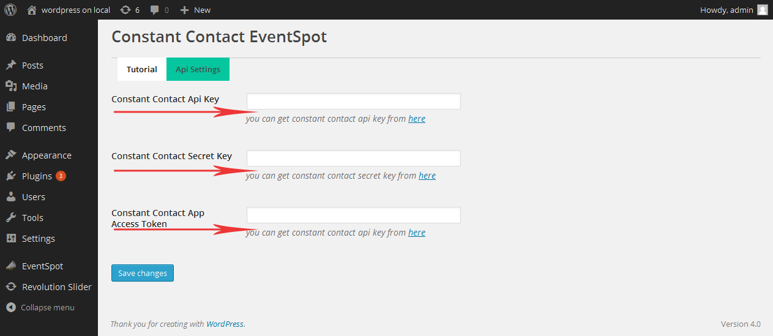

To show upcoming Events in side bar of the website , Drag the EventSpot widget to the Side Bar Area as shown in below figure.

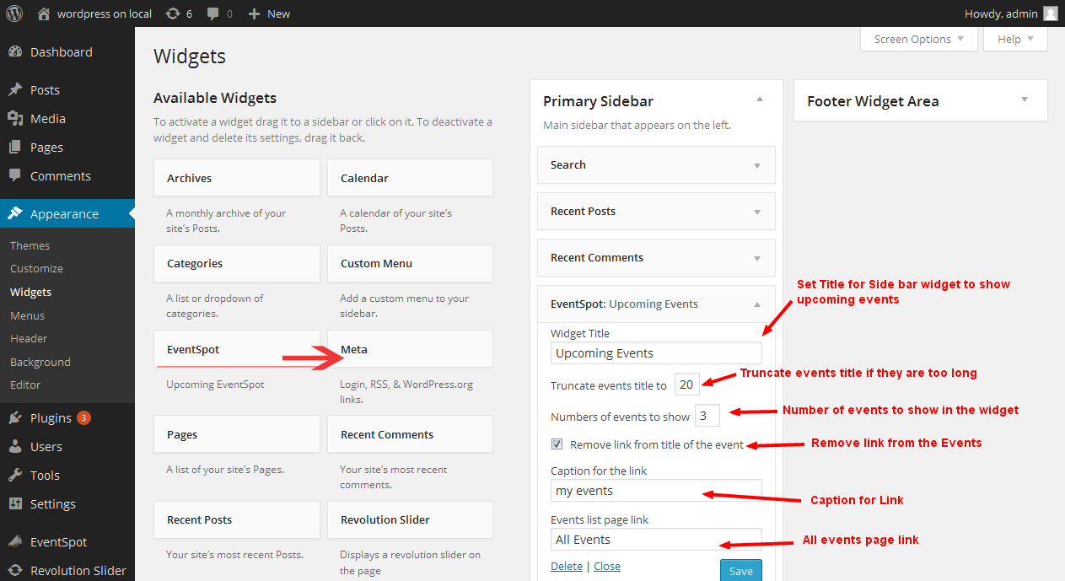

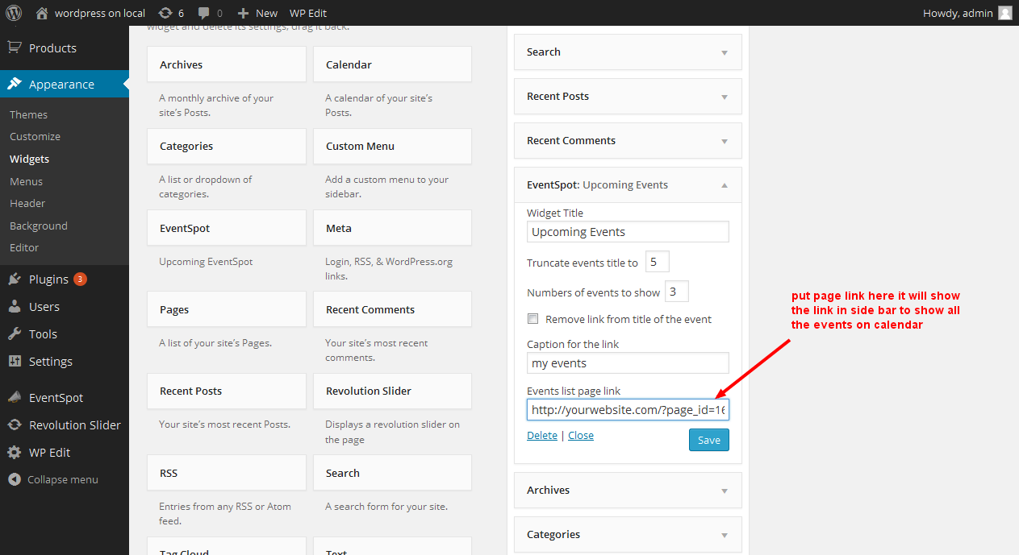

After completing above two steps here is the short code that you need to put in your
wordpress page WSYG Editor is
[es_calendar]
or if you want to show calendar in theme you can call the short code as in your theme file.

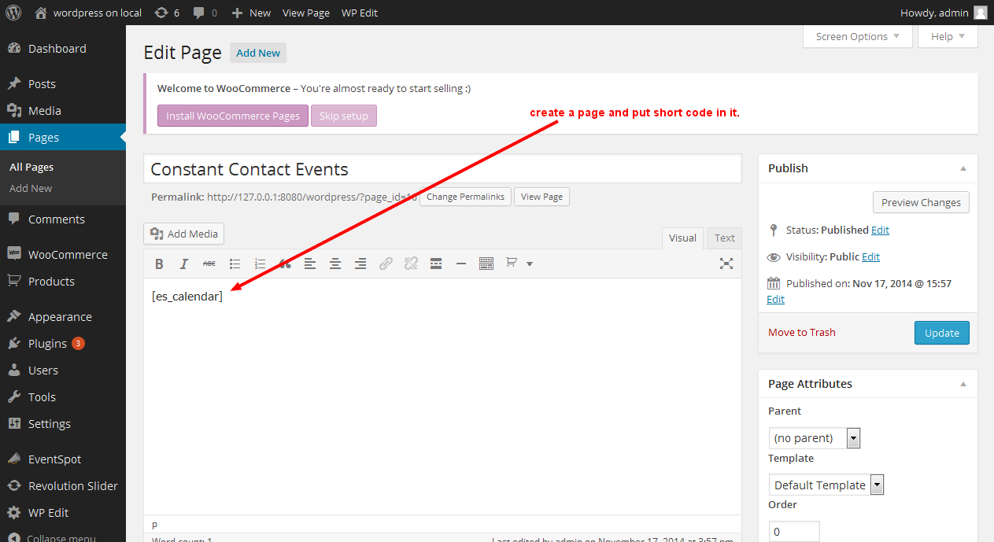

Manage Events

Create events
Go to manage tab in the plugin click on create event button and there will be a form to create an event like shown in below screen.

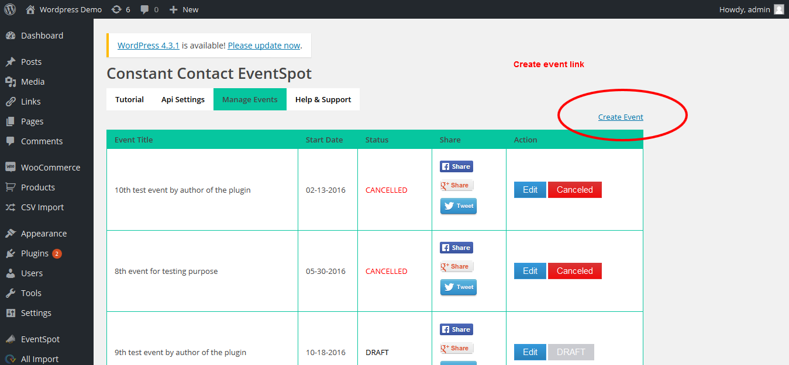
Default event status will be DRAFT
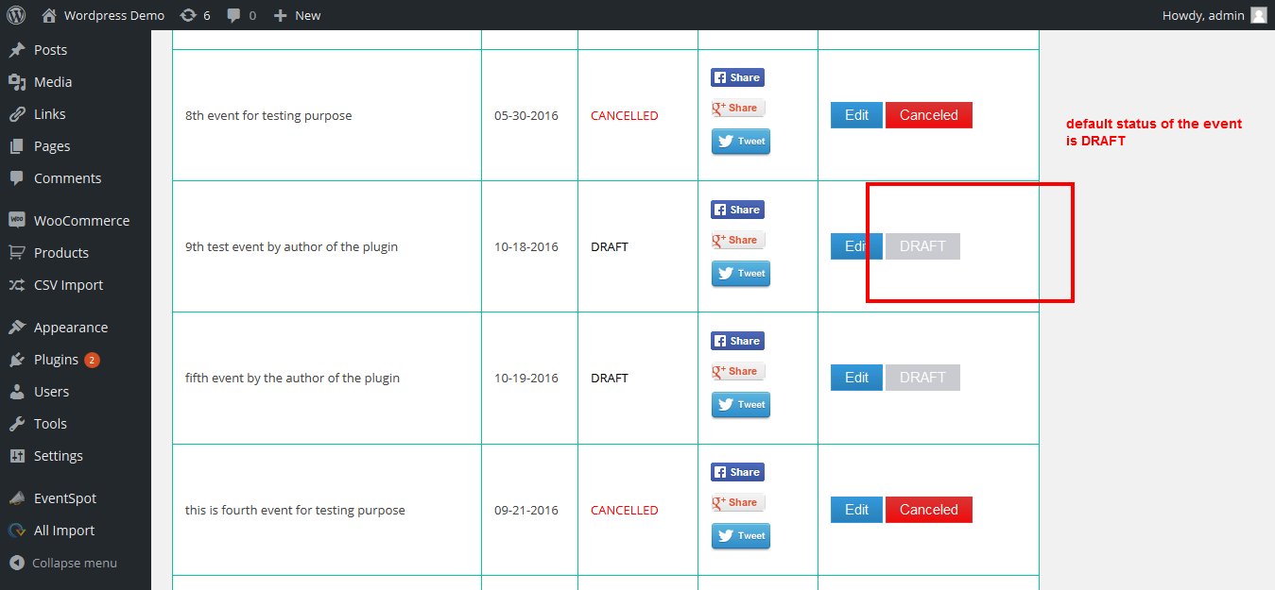

Click on DRAFT button to make it PUBLISH
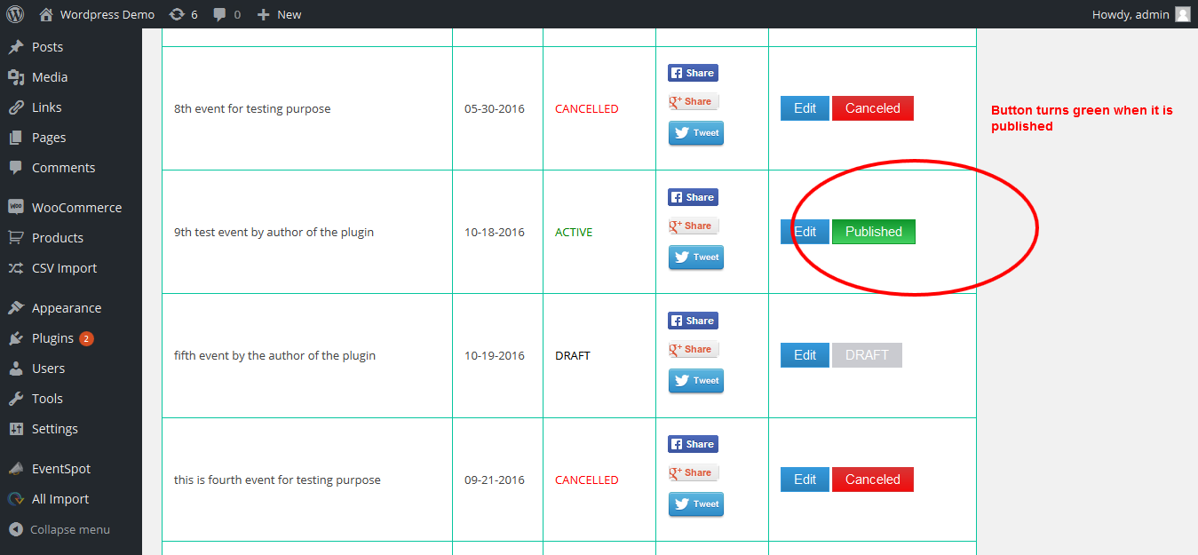

If you click on publish button it will ask you to make this event CANCEL once an event is canceld it can not be re published

