**Like Gate Documentation**

## What is Like Gate

Like Gate allows you to reveal some hidden/secret content when the user likes a piece of content. Therefore increasing the likeness of your articles. The likes will appear on your user's Facebook status wall/timeline which can be seen by their friends.

There are 2 versions of the plugin

* Lite (Free) - <http://wordpress.org/extend/plugins/like-gate/> from WordPress.org
* Pro (Paid) - <http://club.orbisius.com/products/>

## How it works

1. You to install the plugin (lite or pro)
   1. For Lite: search for ***like gate*** within WordPress' (Plugins > Add New)
   2. For Pro: visit the site mentioned above and download the ZIP file
2. Then you need to edit existing or add a new post/page
3. Surround the hidden content with like-gate shortcodes
4. Visit the page to see if the like button will show on the page

Note: You can read more on shortcodes on this site:

<http://codex.wordpress.org/Shortcode_API>

### Like Gate Lite Options

This will generate the Like button for the current post or page. Works in both Like Gate and Like Gate Pro.

|  |
| --- |
| [like-gate][/like-gate] |

Like Gate Pro Options  
Like Gate Pro - send likes to a site/fan page of their choice not just a blog post.

|  |
| --- |
| [like-gate url="yahoo.com"][/like-gate] |

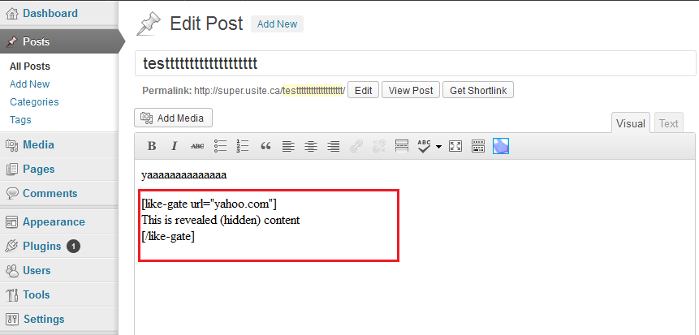

Like Gate Pro allows you to include other shortcodes within the like-gate shortcodes.

|  |
| --- |
| [like-gate]  [another-short-code]  .....  [/another-short-code]  [/like-gate] |

Sometimes after people like your piece of content Facebook will show a comment box which can obstruct the view of the hidden content. To hide the comment box insert "hide\_comment="1" parameter.

|  |
| --- |
| [like-gate hide\_comment="1"]  [/like-gate] |

## Installation Steps

* Log into WordPress Administration ( yourdomain.com/wp-login.php )
* Go to Plugins > Add New
* Click on Upload, Select the .ZIP file that you've downloaded and click on upload
* Activate the plugin

## Mailing List

Get the latest news and updates about this and future cool plugins we develop.

[Subscribe to our newsletter](http://orbisius.us2.list-manage.com/subscribe?u=005070a78d0e52a7b567e96df&id=1b83cd2093&MERGE3=Orb+Like+Gate&MERGE4=doc)

## Support

Support is handled on our site: <http://club.orbisius.com/support/>

Please do **NOT** use the WordPress forums or other places to seek support as we don't monitor them regularly.

About OrbisiusOrbisius in a fresh and innovative company based in Niagara area, Ontario, Canada.

It was founded by Svetoslav Marinov (Slavi) [<http://linkedin.com/in/svetoslavmarinov>] and provides various IT services including custom programming, mobile app development and more. For more information, visit: http://orbisius.com

Phones (Canada): Toronto: (647) 478 6512, (US): (716) 514 8880 Fax:  (647) 694 1524

Follow us on:

|  |  |
| --- | --- |
| C:\Users\User\Documents\Business\Products\Info_Products\Website_Creation_Course\References\elegantmediaicons\PNG\twitter.png | Twitter: <http://twitter.com/orbisius> |
| C:\Users\User\Documents\Business\Products\Info_Products\Website_Creation_Course\References\elegantmediaicons\PNG\youtube.png | YouTube: <http://youtube.com/user/orbisius> |
| C:\Users\User\Documents\Business\Products\Info_Products\Website_Creation_Course\References\elegantmediaicons\PNG\linkedin.png | Linked In: <http://www.linkedin.com/company/orbisius/> |
| C:\Users\User\Documents\Business\Products\Info_Products\Website_Creation_Course\References\elegantmediaicons\PNG\facebook.png | Like us on Facebook: <http://www.facebook.com/orbisius> |