MapNavigator Documentation

Overview

This is the documentation for MapNavigator. If you need additional help, please try posting to the forums or contact me directly.

Compatibility

MapNavigator is compatible with WordPress 3.0 and higher. It requires PHP version 5.0 or higher.

Installation

MapNavigator installation like any other Wordpress plugin installation.
- Download the .zip file
- Unzip the file to your wp-content/plugins directory. You should now have a directory like:
wp-content/plugins/map-navigator
- Go to the WordPress ‘plugins’ menu and activate the MapNavigator plugin
- After you activate you should see the MapNavigator ‘tool’ menu in your WordPress administration menu

Tools Screen

The tools screen provides options that affect the creation of the map navigation posts and the MapPress maps and markers.

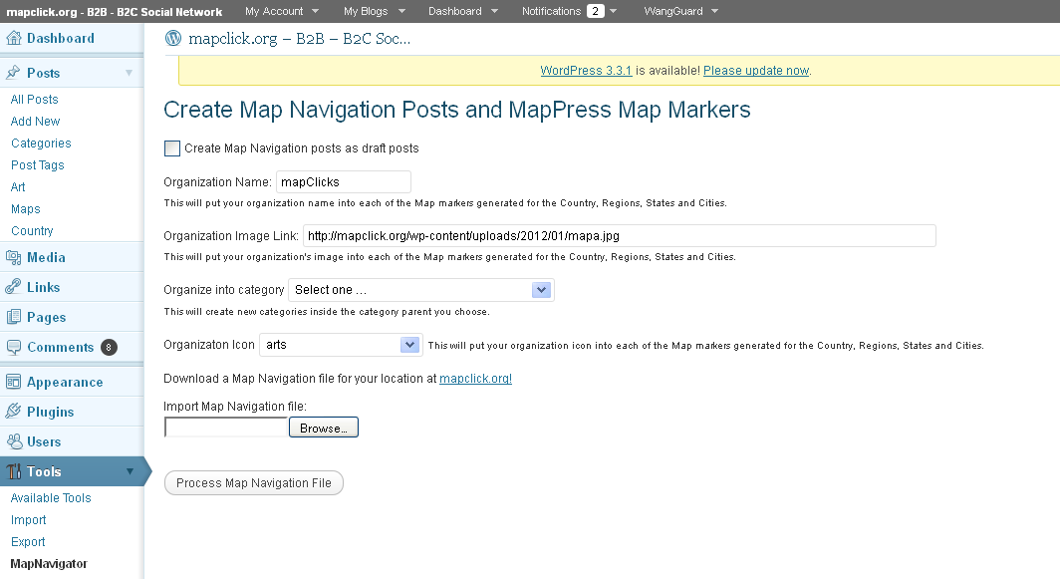

The available options are listed below.

Option | Description
Create Map Navigation Posts as Drafts | Assigns the status of ‘Draft’ to each post that is created. This provides a method of performing quality control before accepting the posts onto your site.
Organization Name | Assigns your Organization name to the map navigation post and to the post excerpt which appears on the map markers that provide navigation within your chosen geography.
Organization Image Link | Assigns your image as specified by the link to be included in each map marker within your chosen geography.
Organize into Category | This will create the Maps categories under the parent category you specify.
Organization icon | Assigns an icon as specified for each map marker within your chosen geography.
Import Map Navigation file | This provides a browse on your local file system to assign a map navigation file to process. See ‘Creating a Map Navigation File” later in this document, or download a standard Map Definition File for your geography at mapclick.org.
Process Map Navigation file | Press this button to build your Map Navigation Posts hierarchy of Continent, Country, Region, State and City Posts, Maps and Map Markers

Using The Plugin

- Fill out the Tool options and select a map Navigation file to process. This can be the ‘Test Map-Navigator-USA.csv’ file in the examples directory, a standard Map Navigation file downloaded from mapclick.org, or a custom file created using the example and the instructions found in ‘Creating a Map Navigation File” later in this document.
- Press the ‘Process map Navigation File’ button; a message will appear at the top of the screen with the number of map Navigation Posts created successfully.
- Select the ‘Maps’ function under the ‘Posts’ label on the upper left of the WordPress theme. You will see all the Map Navigation Post categories listed here: Continent, Country, Region, State and City.

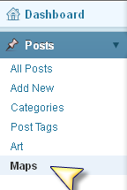

- Select the ‘Continent’ Posts and find the Post that is for the ‘Regions’ such as ‘United States Regions’.

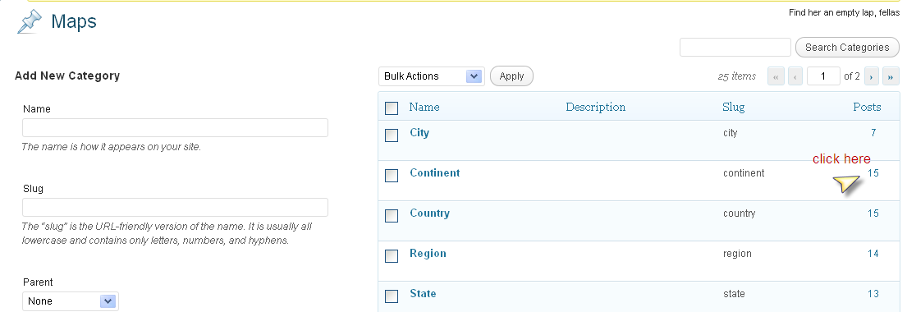

- View the ‘Regions’ post and follow the Map Navigation hierarchy using the links that are displayed when you select a Map Marker . The ‘Regions’ post will have markers that link to ‘States’ posts. The ‘States’ posts will have markers the link to the ‘City’ posts.

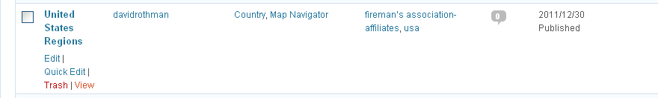

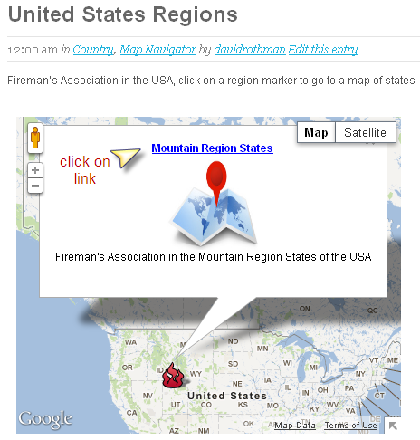

- Follow the directions in the section labeled ‘Adding New posts into your Map Navigation hierarchy’.

Creating a Map Navigation File

The Map Definition file is in CSV format that consists of rows and columns. Each row in a CSV file represents a post; each column identifies a piece of information that comprises a post. Each Post is assigned to a level in the Map Taxonomy which provides the Map Navigational Hierarchy as follows:

Posts in the Maps Taxonomy are members of one or more of the following hierarchical categories:
- Continent
- Country (child of Continent)
- Region (child of Country)
- State (child of Region)
- City (child of State)

The following Column header must be present in the Map Navigation file:

nav_post_title - title of the post. The name should reflect the category of the taxonomy level. For instance : 'United States Regions’ or 'Mountain Region States' or 'California Map'

nav_post_post - body of the post. This will hold the MapPress command to create a 'mashup' or to display a map in this post

nav_post_excerpt - post excerpt. This will contain the title that will appear in the Map Marker. The word 'mapClicks' will be replaced with your organization's name entered on the Map Navigator Tool dialog in Wordpress.

nav_post_categories - a comma separated list of category names or ids. This will be the taxonomy level associated with this post; for instance : Maps > Continent > Country > Region

nav_post_tags`- a comma separated list of tags. Tags are used in the nav_post_post column to specify the post map markers that will be included in the mashup post. See the Examples directory for a sample file. Pay close attention to the tags defined in this column and the references in the nav_post_post column.

nav_post_date - about any English textual description of a date and time. For example, `11/16/2009 `1999-12-31 23:55:00`. For technical details, consult PHP's `strtotime()` function [documentation][strtotime].

nav_ctax_maps - See the Examples directory for a sample file (Test Map-Navigator-USA.csv). This column is used to specify the Post's taxonomy tags and thus what the post will appear as in the 'Maps' taxonomy (Continent, Country, Region, State or City)

map_address- holds the address of the MapPress map marker that will appear on the map for this post. This must be defined as a Custom field and specified in the MapPress setup as the field used to create maps automatically from when a post is updated. See the MapPress Pro documentation for a more complete description of the possible contents of this field. The sample file Map-Navigator-USA.csv shows the format needed by the MapNavigator to build a hierarchy of navigation maps.

Adding New posts into your Map Navigation Hierarchy
There are two ways o add posts into the map Navigator Hierarchy.

If the post is for a new City in a geography that is in the hierarchy already, you just need to use the ‘Maps’ category to specify that this post is for a particular country, region and state:

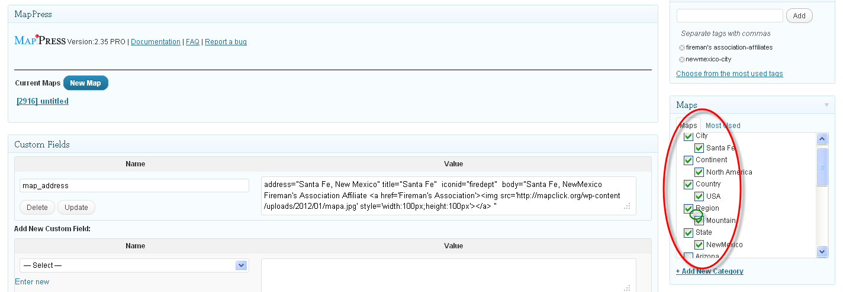

Then you must add a new category which will be the new City Name for the country, region and state that you have chosen:
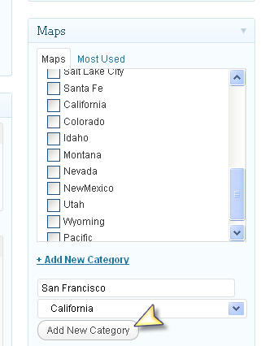

Now go to another City post and copy the text from the ‘map_address’ custom field:

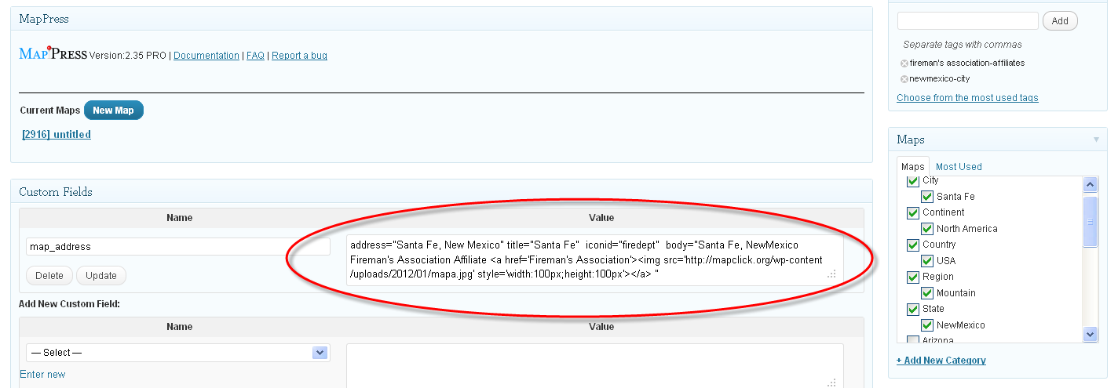

Now create the ‘map_address’ Custom field in your new Post and paste in the map_address text you copied. Change the address m title and body text and save the new filed.

Now Update the Post and the new Map and marker will be created on the page.
