**Office Visits Logbook Plugin for WordPress**

Version 1.0 – last updated 2020-05-07

Your company is still using paper log sheets for office visitors? Everything is digital and paperless now. Being paperless can also save trees and protect the environment. We provide you an efficient plugin for your company office visitors to sign in and sign out. Data is saved in the same MySQL database for your WordPress website.

This office visits logbook plugin is for the sign-in and sign-out of office interview, business, meeting, etc. You can add any new visit type categories and new visit types if you want.

**By default, this plugin uses Bootstrap (https://getbootstrap.com/) for the formatting. But sometimes you already have your own formatting css files. So you may need to remove these Bootstrap css and JavaScript files when you use this plugin. If this is the case, you can choose not to use Bootstrap’s css and JavaScript files by changing the values of USE_BOOTSTRAP_JS and USE_BOOTSTRAP_CSS to no (0) in the constant table.**

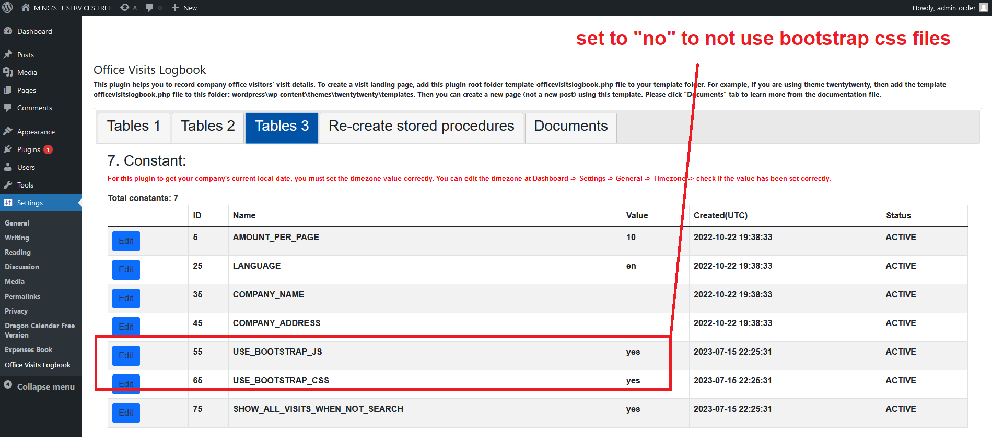

**If you did not find USE_BOOTSTRAP_JS and USE_BOOTSTRAP_CSS in your constant table, please deactivate this plugin and activate it again. Then USE_BOOTSTRAP_JS and USE_BOOTSTRAP_CSS will be automatically added to your constant table.**

If you find out that the search result is not showing all the fields' data, you can try to re-create stored procedures in the admin plugin page. Go to admin page, click "Settings", and then click "Office Visits Logbook". Then click tab "Re-create stored procedures", and press the button to re-create all the stored procedures again.

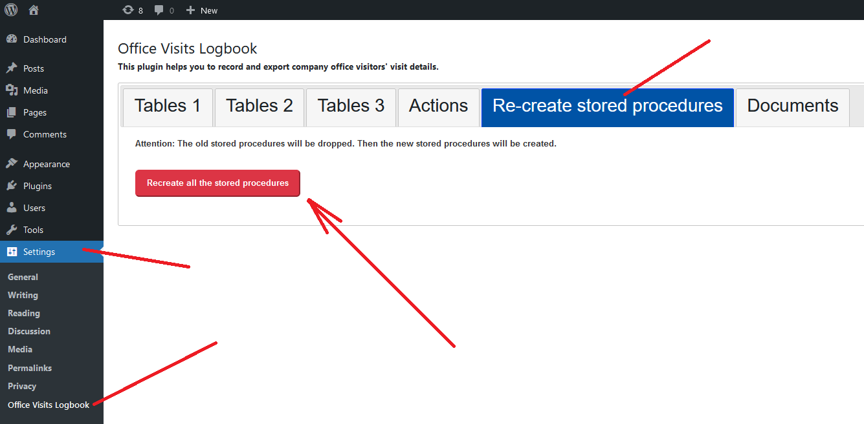

This plugin has the **web accessibility** feature for the disabled people to listen to the screen reader. The disabled people just need to press the tab key to access the elements on the page. Then use keyboard to input. Then press the enter key for submit, reset and cancel. To use this feature, you can download and use any screen reader software such as NVDA (for Windows), VoiceOver (for Apple), etc. Most of this kind of software is free to download and use.

**By default, the landing page shows all the visits. But sometimes you want to protect other visitors' privacy and hide other visits' details when a new visitor is using this landing page. To do this, just set the value of SHOW_ALL_VISITS_WHEN_NOT_SEARCH in your constant table to no (0).**

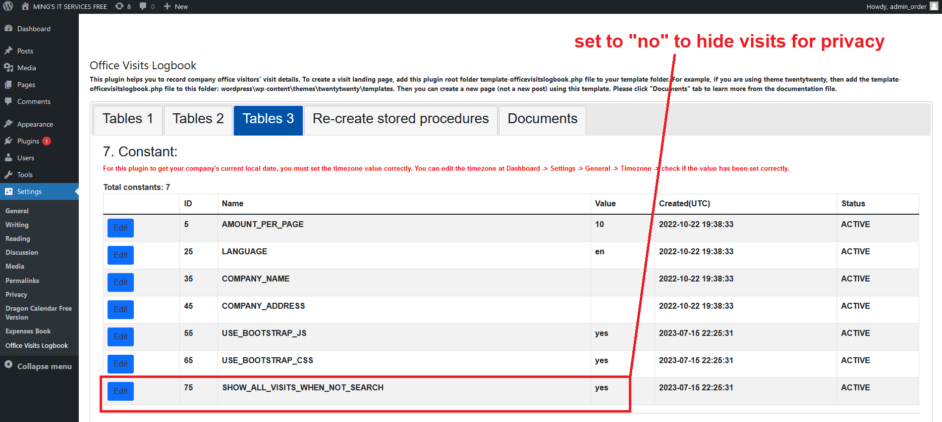

**If you did not find SHOW_ALL_VISITS_WHEN_NOT_SEARCH in your constant table, please deactivate this plugin and activate it again. Then SHOW_ALL_VISITS_WHEN_NOT_SEARCH will be automatically added to your constant table.**

A visit record can be updated only when it is active and timeout is empty. Deleted visits and finished visits are not available for editing.

This plugin has an access restriction feature. You can give a user access to the visit landing page by adding the user to the wp_dragonvisitzyx987_users table. You must log in WordPress website to access this plugin’s landing page.

This plugin uses a responsive design. You can use it from your cellphone, tablet, laptop, and PC. Then the layout will change accordingly.

For example, here is an example of a tablet browser:

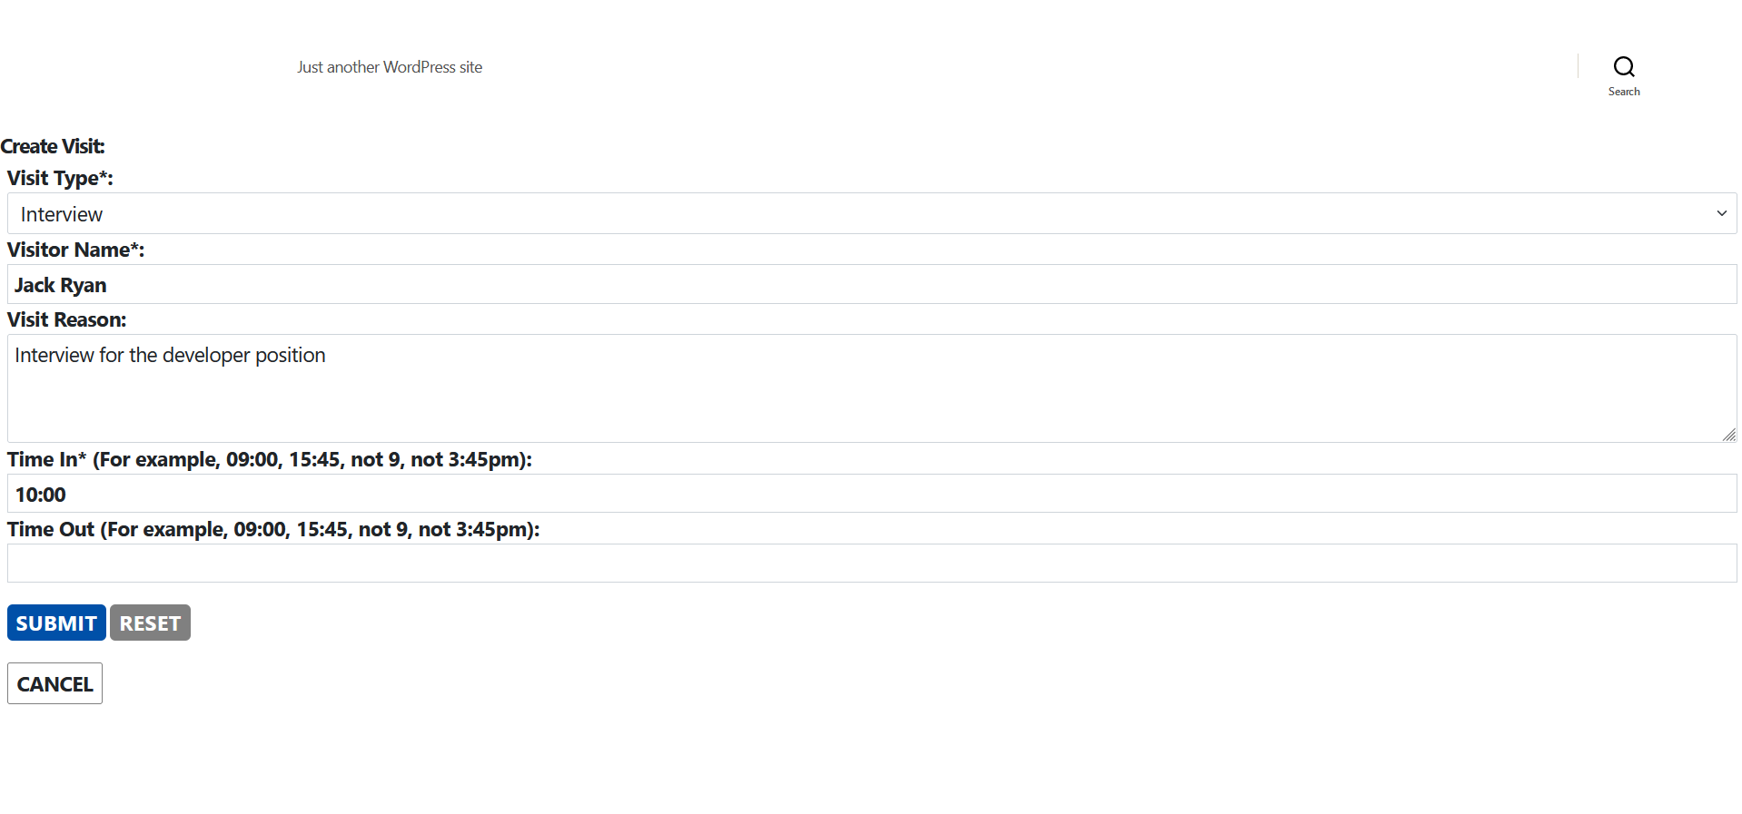

Here is an example of a cellphone browser:

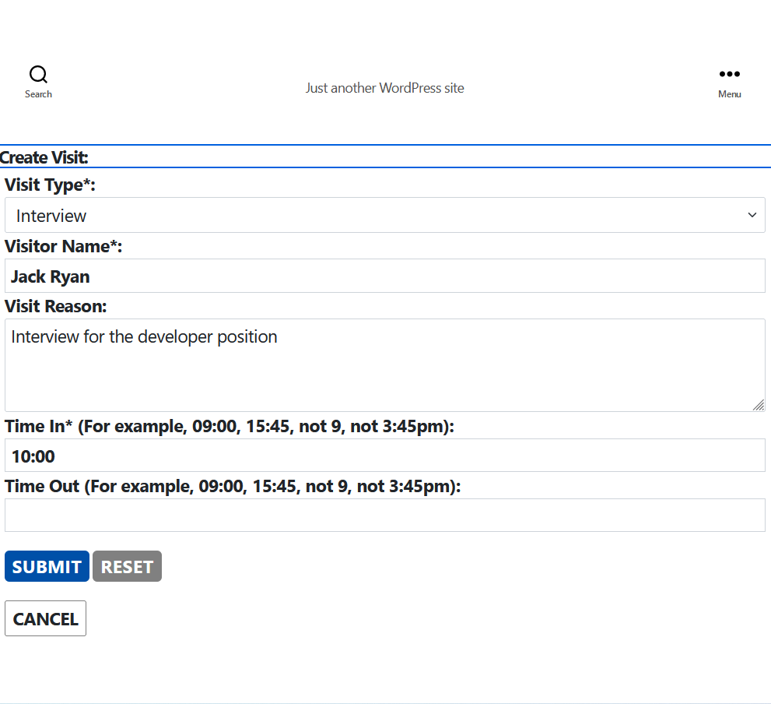

For the best user experience, we recommend you to use this plugin in a desktop computer with three monitors. Two monitors share the same content. The visitor uses one monitor, keyboard and mouse. The receptionist uses another monitor to watch the visitor’s input and behavior. The receptionist also uses a third monitor showing the dashboard’s plugin setting page. The third monitor is for the receptionist to verify visitor’s input after visitor finishes input. See the image below:

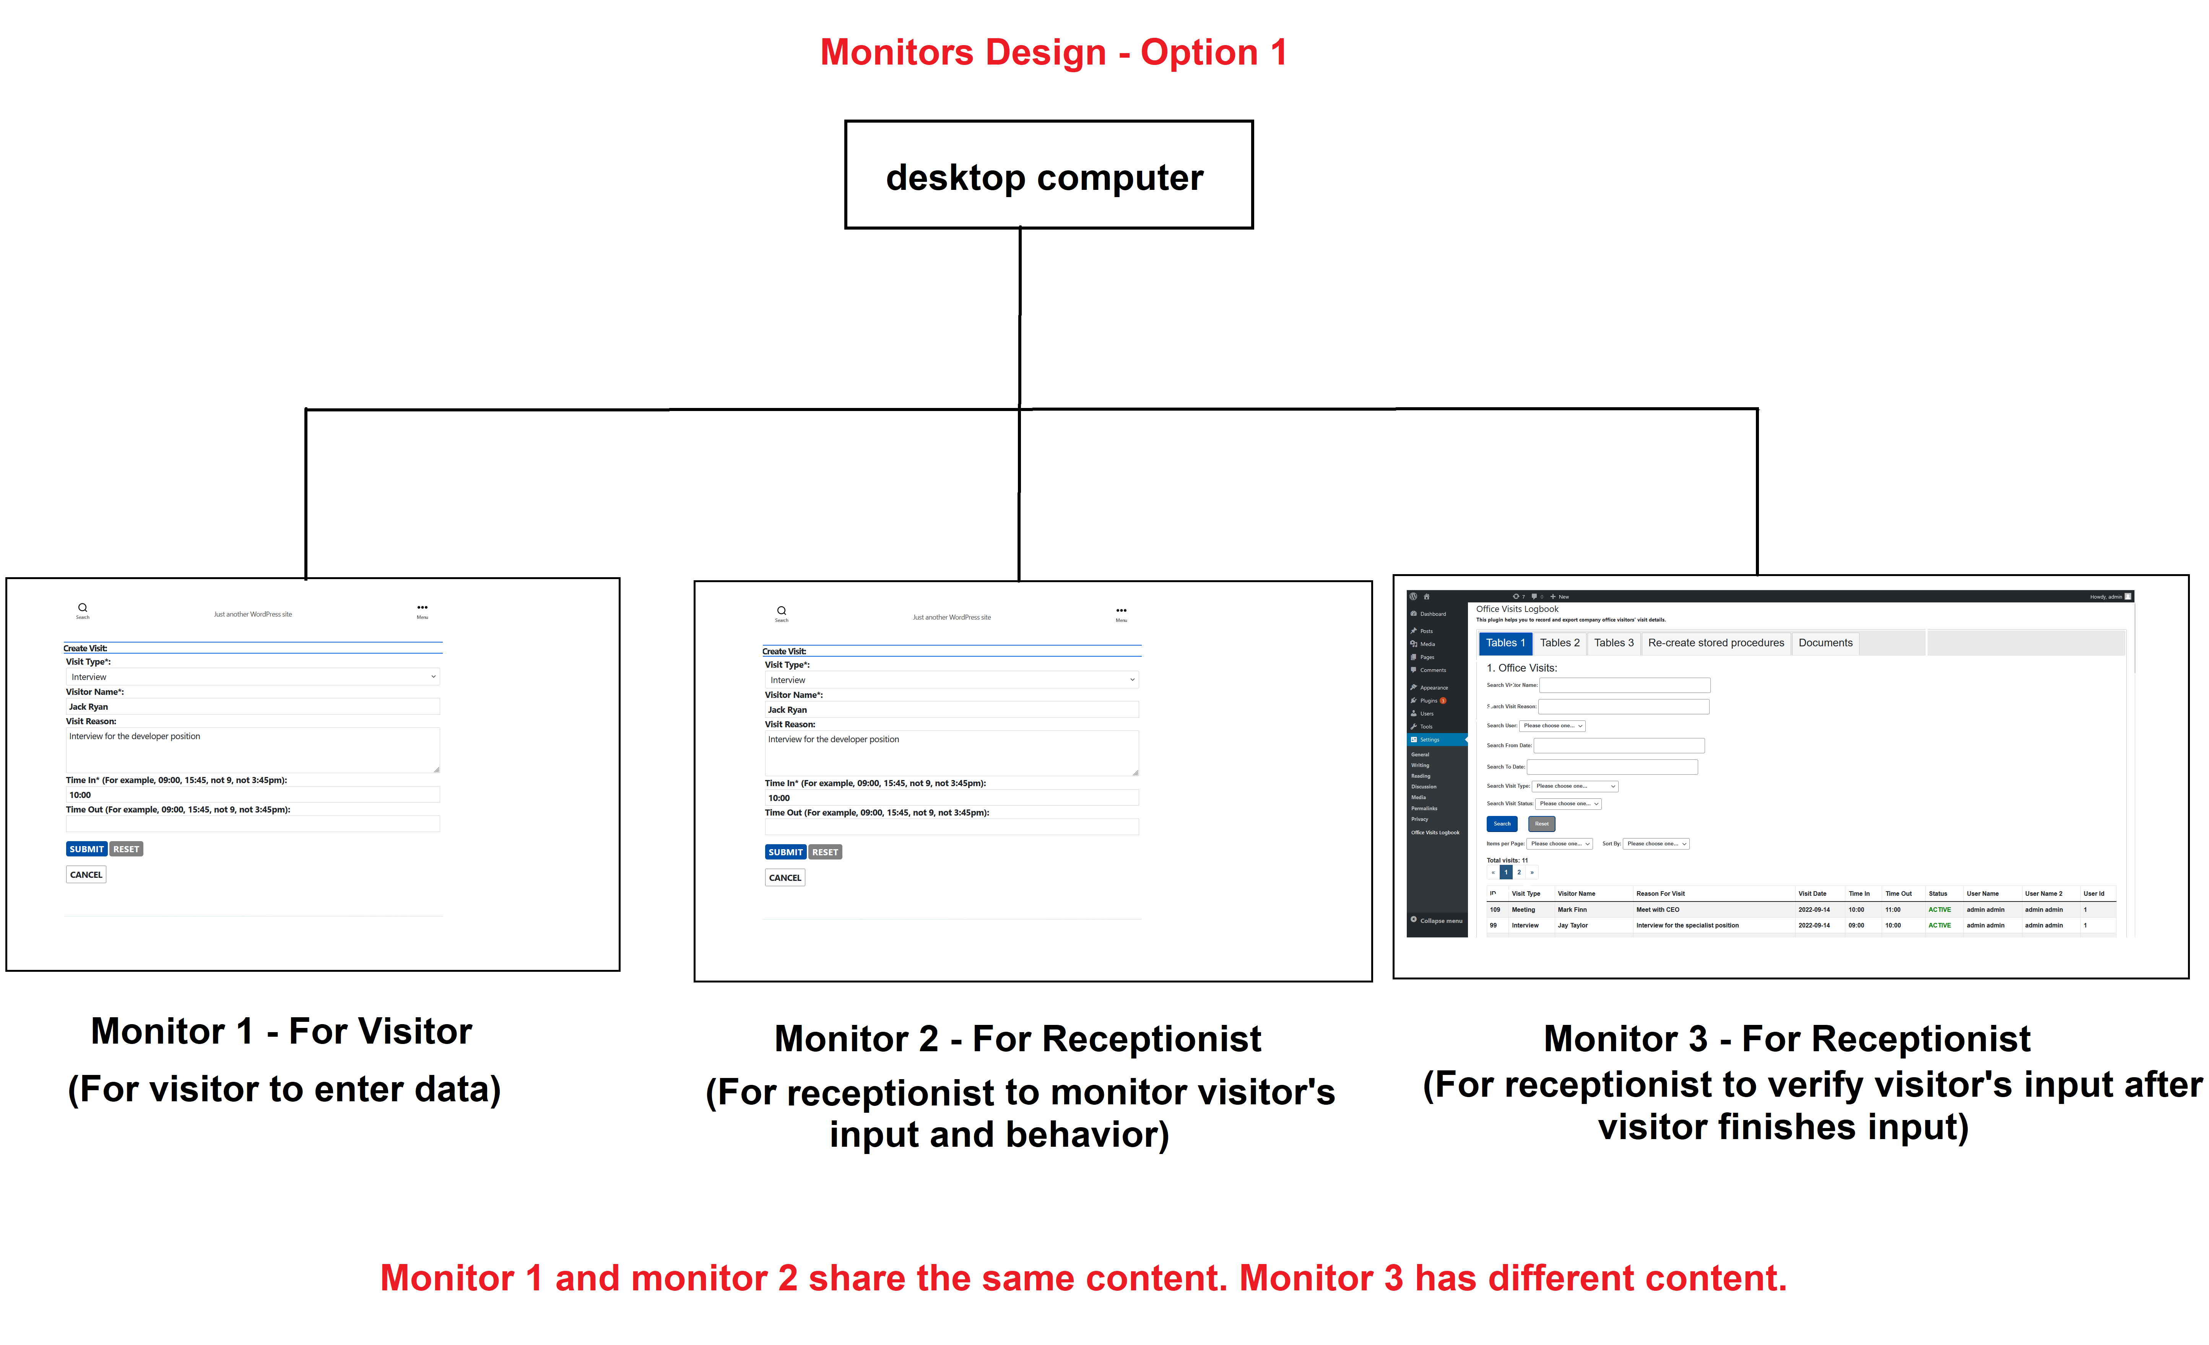

Here is the admin page:

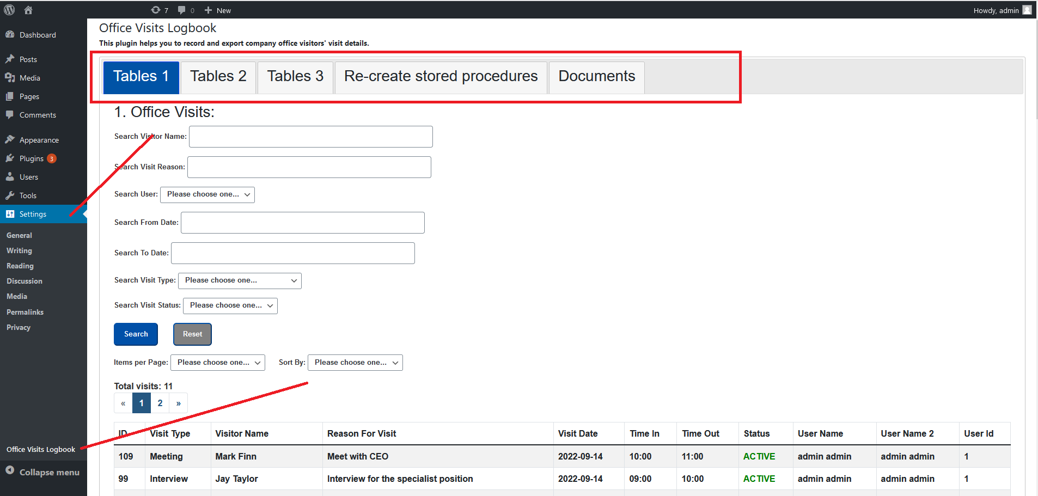

**IMPORTANT!**

**For this plugin to get your company's current local date, you must set the timezone value correctly. You can edit the timezone at Dashboard -> Settings -> General -> Timezone -> check if the value has been set correctly.**

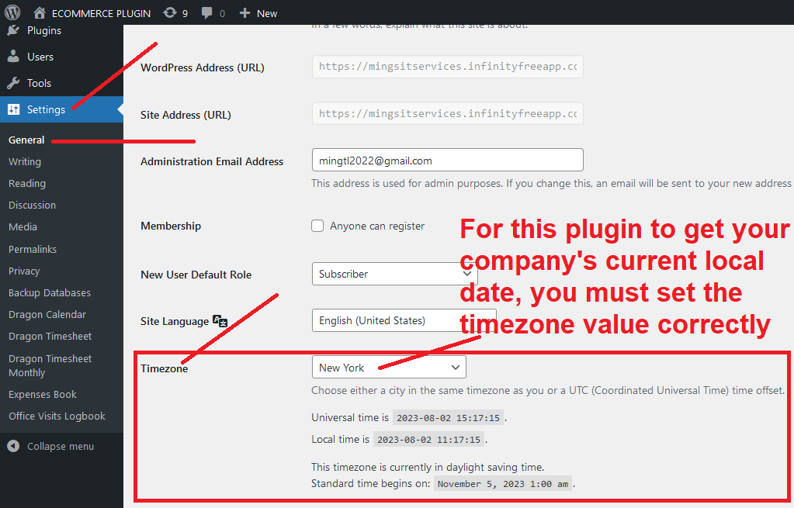

1. Your office visitors can use this office visits logbook WordPress plugin to create/edit/delete visits. These visits can be interview, meeting, business, etc. You can add any new type categories and types if you want. You can do that in the admin page. **A visit record can be updated only when it is active and timeout is empty. Deleted visits and finished visits are not available for edit.**

2. When creating/editing visits, office visitors can choose different kinds of visit types from the drop down list. For example, types can be “meeting”, “interview”, “business”, etc. See the image below:

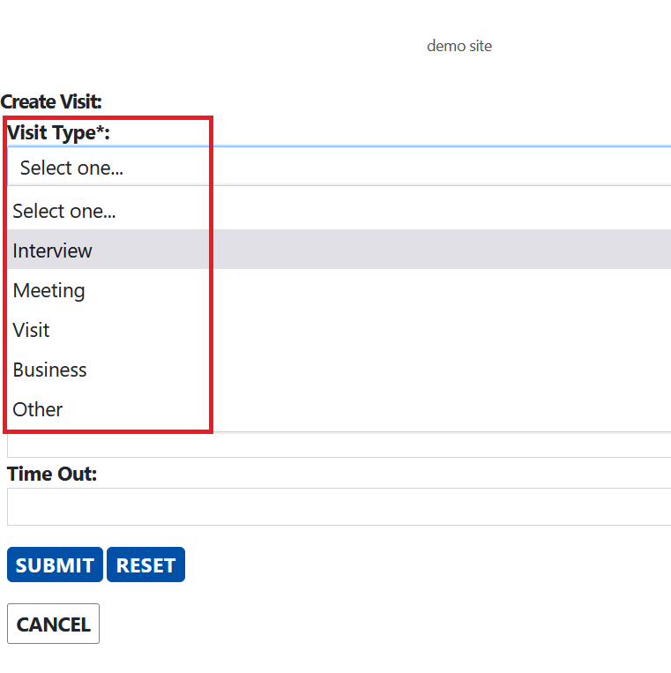

3. This plugin uses a lot of stored procedures. This makes it fast to process database queries.

4. This plugin uses Mysqli for database query. It can prevent SQL injection.

5. Visitors can create/edit visits. They can also delete the visit if it is not correct. On the landing page, if there is no search input, there will be no visit list showing on the  
page. This is for protecting other visitors' privacy. A visit record can be updated only  
when it is active and timeout is empty. Deleted visits and finished visits are not available  
for edit. See the image below:

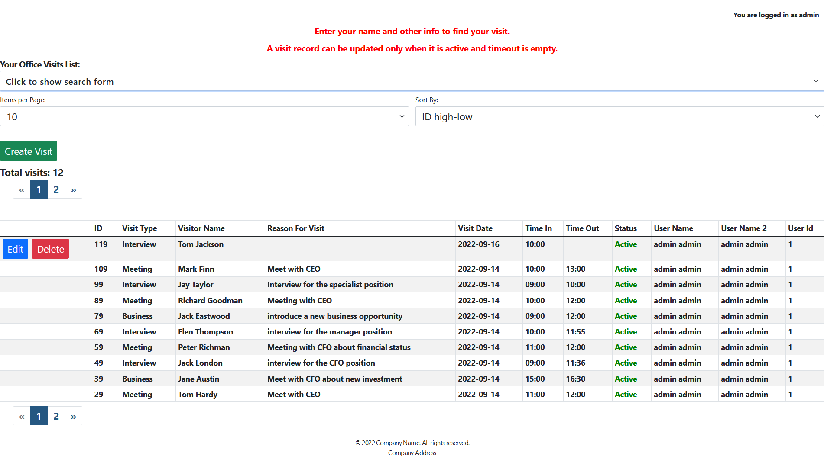

6. You can create/edit a type. See the image below:

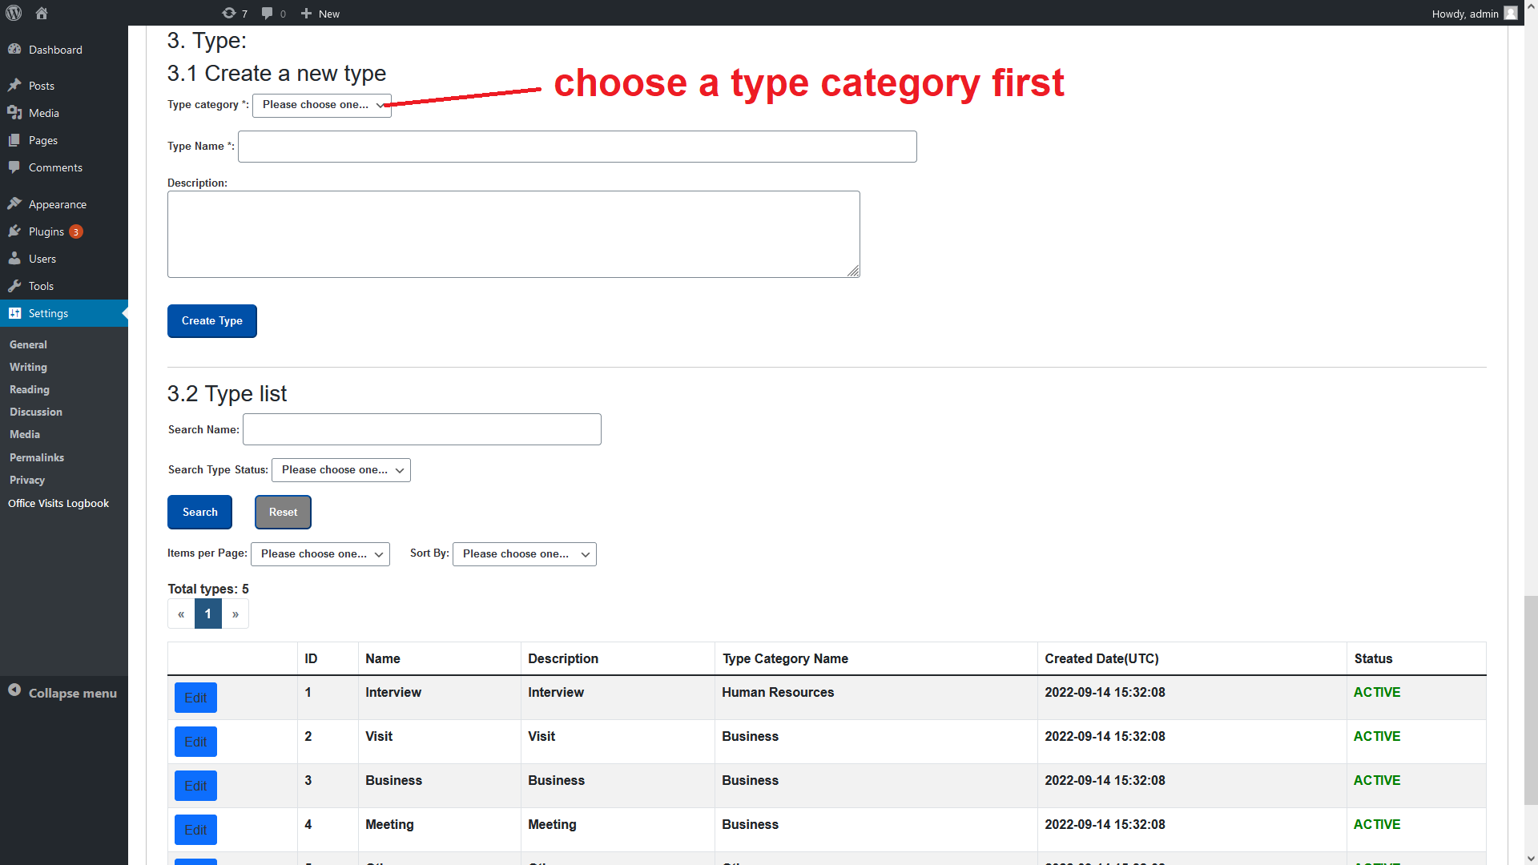

7. Mobile responsive. Visitors can create/edit/delete visits from desktop, laptop, tablets and cellphones by accessing your website. The typical company usage is from a tablet.

8. It can be used for any WordPress themes. It has its own menu and CSS file. It only needs one single URL to show a website to users. So it can be perfectly integrated into your existing WordPress website.

9. Single page is used for this plugin’s webpage. Parameters are added in the URL for a HTTP GET request. When do HTTP POST, the parameter values will be added into PHP and JavaScript code.

10. Since it's a single page design, you do not need to worry about if other plugin's URLs will have the same URLs as our plugin. For example, you do not need to worry if other plugins will have the same visit URL as our plugin: https://www.yourwebsite/index.php/visit

11. Easy set up. You can edit every table from the plugin admin setting page.

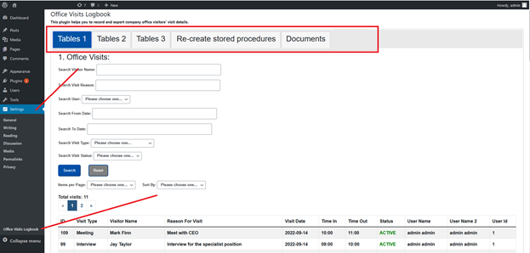

12. To use this visit plugin’s webpage, you must log in from the WordPress login page.

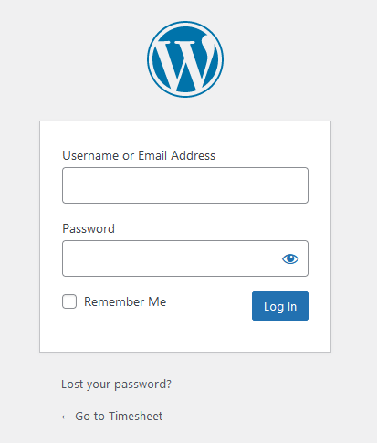

13. To prevent hackers, use https for your website. Do not use http for your website because hackers can get your website activity information. Plus, remove the username "admin" because it can be easily hacked by hackers. Use a difficult to guess username and password to log in your WordPress admin page. For example, username is b7v1P3T5y9W4C8Q2xk31u0, password is Z3u1T$9e5N2w3!L8S6X7!a9P0q7V3. Save username and password separately to different email address. You can also take two pictures of the username and password separately and save to your computer and cellphone. Here is an example about how to create a new administrator user. https://www.inmotionhosting.com/support/edu/wordpress/change-wordpress-admin-username-for-security/

14. For this plugin's programmers: if possible, cookies should be set as HTTPonly and samesite=strict. This can prevent CSRF attack. Each form has its own different WordPress nonce. Backend will validate if the nonce is correct. This can prevent hacks.

15. **Only admin users in the table wp_dragonvisitzyx987_users can access the admin setting page. After install and activate this plugin, admin will be automatically added to the wp_dragonvisitzyx987_users table.** If the user is not in the table, ask the website admin to add this user into the table. If the user is not admin role, the user can not access the admin setting page for this plugin. Here is an example for admin:

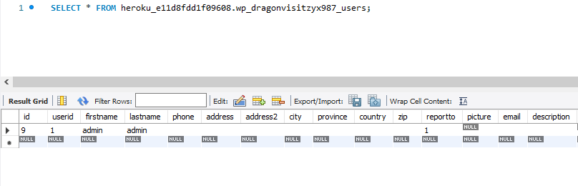

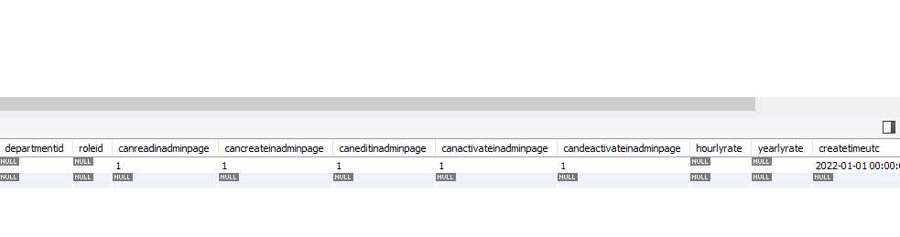

Userid is the ID in the WordPress table wp_users.

16. **You need to check the constant table, double check all the names and values if they are correct.**

AMOUNT_PER_PAGE

COMPANY_NAME

COMPANY_ADDRESS

USE_BOOTSTRAP_JS

USE_BOOTSTRAP_CSS

SHOW_ALL_VISITS_WHEN_NOT_SEARCH

17. One type category can have many types. A visit can have one visit type. For example, type category can be “Human Resources”, “Business”, “Other”. Types for “Human Resources” could be “interview”.

**18. After plugin activation, go to the "Settings" menu to find the plugin admin page. By default, when you activate this plugin, it will automatically create a visit landing page for you. For some themes, if it does not automatically create a visit landing page for you, add this plugin root folder template-officevisitslogbook.php file to your template folder. For example, if you are using theme twentytwenty, then add the template-officevisitslogbook.php file to this folder: wordpress\wp-content\themes\twentytwenty\templates. Then you can create a new page (not a new post) using this template. See the image below:**

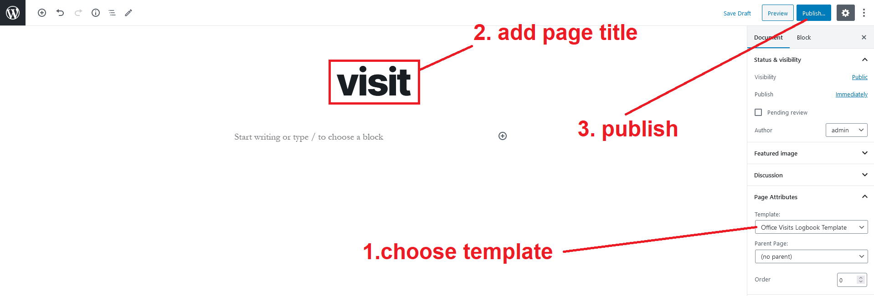

**When you use the template method to create a new visit page, do not set the page title to "officevisitslogbook". If you set the page title to "officevisitslogbook", it could conflict with the page automatically created when you activate this plugin.**

**Basic configurations and steps:**

1. **When you activate this plugin, if you are the plugin installer and have the administrator role, and the wp_dragonvisitzyx987_users table does not have an admin user yet, this plugin will add you to the wp_dragonvisitzyx987_users table automatically.**
2. Go to WordPress admin page. In your **constant table**, you need to set each item’s value. Some values are already automatically set for you. You need to double check if these values are correct.

**COMPANY_NAME**

This is your company name. It will show up on the footer area of the landing page.

**COMPANY_ADDRESS**

This is your company address. It will show up on the footer area of the landing page.

**AMOUNT_PER_PAGE**

The above one is to set the amount of visit for each page on the visit web page. Default is 10. You can change it if you want.

**USE_BOOTSTRAP_JS**

The above one is to set if you want to use Bootstrap’s formatting javascript files. “yes” means you want to use. “no” means you do not want to use. Default value is “yes”. You can find Bootstrap info from this URL: https://getbootstrap.com/.

**USE_BOOTSTRAP_CSS**

The above one is to set if you want to use Bootstrap’s formatting css files. “yes” means you want to use. “no” means you do not want to use. Default value is “yes”. You can find Bootstrap info from this URL: <https://getbootstrap.com/>.

**SHOW_ALL_VISITS_WHEN_NOT_SEARCH**

The above one is to set if you want to protect other visitors' privacy and hide other visits' details when a new visitor is using the landing page. “yes” means you want to show all visits when the user is not searching the visits. “no” means you do not want to show all visits when the user is not searching the visits. Default value is “yes”.

1. Create type categories.

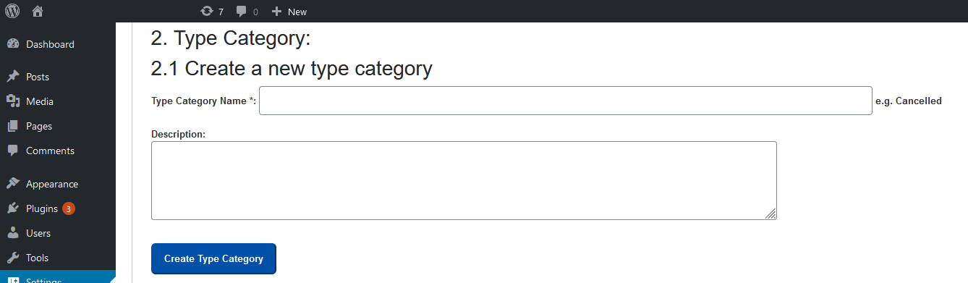

1. Create types:

Choose the type category from the drop down list, and then enter name, and description.



1. Role:

You do not need to create any new roles.

1. Create departments:

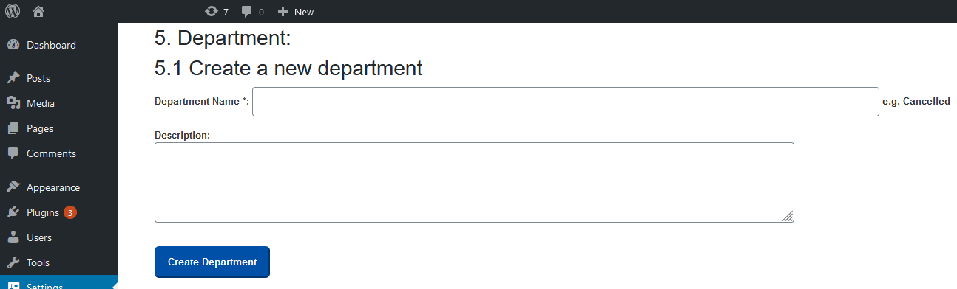

1. **Create new users:**

This step is very important. You need to add the employees who have WordPress user names into this table wp_dragonvisitzyx987_users.

If the employee is not in this wp_dragonvisitzyx987_users table, the employee cannot access this plugin’s webpage. And this employee cannot see the admin setting page. **Only admin role users can access the plugin’s admin setting page.**

When creating a new user, you need to enter that user’s WordPress user ID, which can be found in the wp_users table. You also need to enter the user’s first name, last name, and createtimeutc (e.g. ‘2022-01-01’). You also need to set canreadinadminpage, cancreateinadminpage, caneditinadminpage, canactivateinadminpage, candeactivateinadminpage to 1. You can also set reportto to the user’s supervisor’s ID in the wp_users table. Then add this record to wp_dragonvisitzyx987_users table. **canreadinadminpage, cancreateinadminpage, caneditinadminpage are used to control each user’s ability to read, create new record, and edit records in the admin setting page for this plugin. Be careful about setting these values for each user.** Go to tab Tables 2, 6 User to create a new user.See the image below for the create user page:

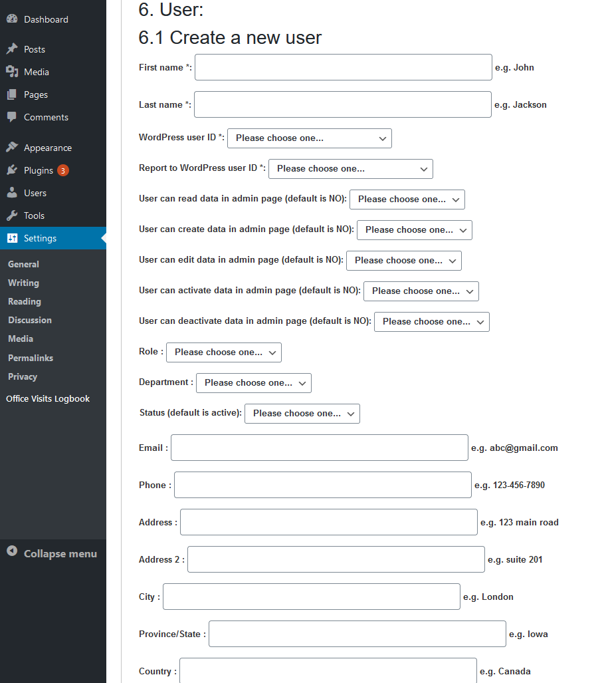

Here is an example for this wp_dragonvisitzyx987_users table list:

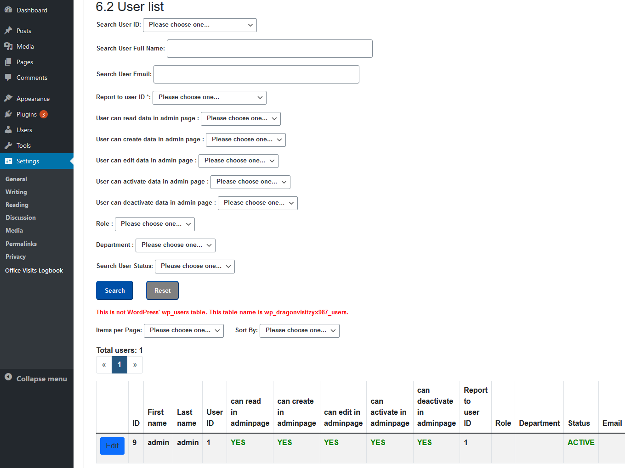

1. Re-create stored procedures:

When you have some issues with stored procedures, you can drop them and create them again. See the image below:

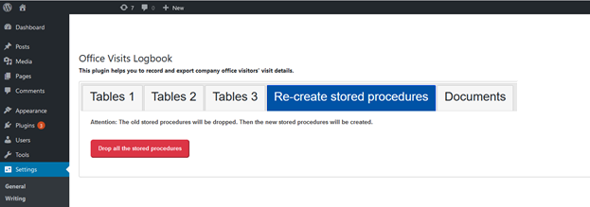

1. Log table:

You can track big issues from the log table. You can search it, drop the table and create a new one when the log table is too big. It’s in tab Tables 3, Log table. See the image blow:

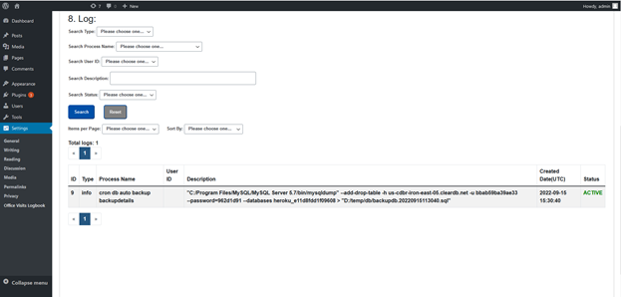

To drop and create a new log table, you need to use MySQL Workbench or other software to access the database and manually drop and create a new log table.

**Instruction:**

After plugin activation, go to the "Settings" menu to find the plugin admin page. **By default, when you activate this plugin, it will automatically create a visit landing page for you.** For some themes, if it does not automatically create a visit landing page for you, add this plugin root folder template-officevisitslogbook.php file to your template folder. For example, if you are using theme twentytwenty, then add the template-officevisitslogbook.php file to this folder: wordpress\wp-content\themes\twentytwenty\templates. Then you can create a new page (not a new post) using this template. 

Then this visit landing page is created. You can edit the template file in the admin page:

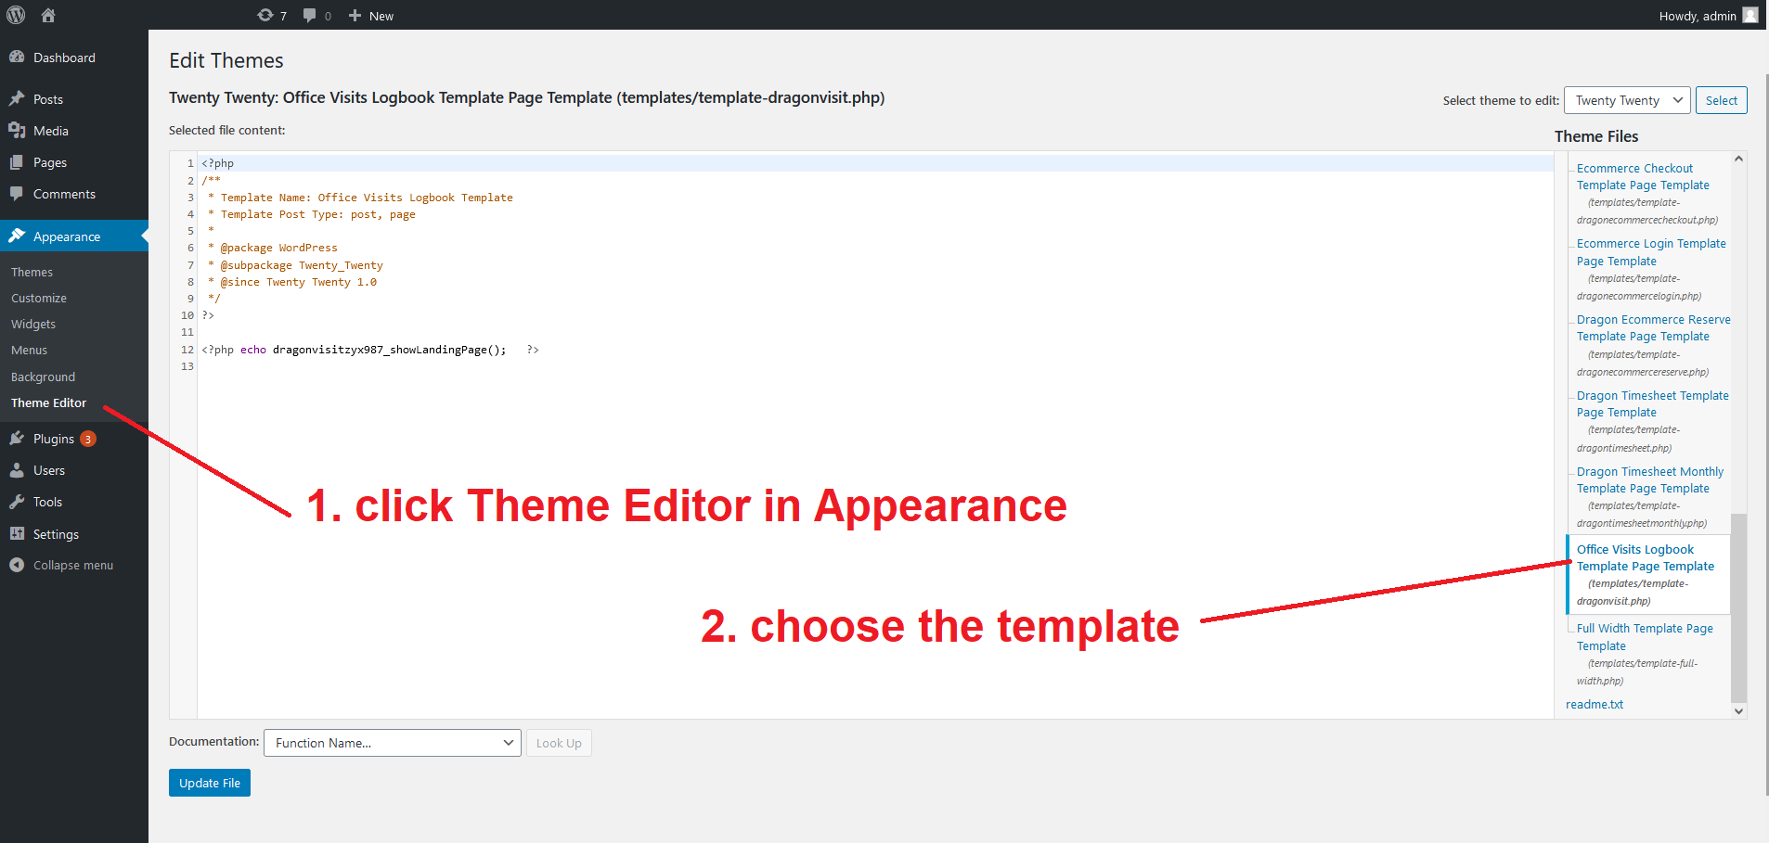

**When you use the template method to create a new visit page, do not set the page title to "officevisitslogbook". If you set the page title to "officevisitslogbook", it could conflict with the page automatically created when you activate this plugin.**

1. Done. Now you can enter some data to test it.
2. You can custom set this plugin’s style. Our custom css file is at:

/wordpress/wp-content/plugins/officevisitslogbook/css/dragonvisit.css

**demo website:**

<https://mingsitservicesfree.infinityfreeapp.com/officevisitslogbook/>

**admin page:**

<https://mingsitservicesfree.infinityfreeapp.com/wp-admin/>

Log in WordPress admin page using

username:

admin_order

password:

m8Yl*KWKq4nEa5JUDk

Then, go to

<https://mingsitservicesfree.infinityfreeapp.com/wp-admin/options-general.php?page=Office+Visits+Logbook>

to set up the admin page.

Then, you can test visits create/edit/delete.

**Documentation:**

<https://mingsitservicesfree.infinityfreeapp.com> log in as admin, then go to setting > Office Visits Logbook, click tab “Documents”, “Manual pdf”.

<https://mingsitservicesfree.infinityfreeapp.com/wp-content/plugins/office-visits-logbook/documentation_officevisitslogbook.pdf>

**Platform and Database:**

You can run it on any platform: Windows, Mac, Linux.

Database is MySQL. It’s free.

PHP version: PHP 5 >= 5.5.0

**Attention: PHP version and WordPress version may have compatibility issues. For example, WordPress 5.4 may not match PHP 8. Check this website for details:** [**https://make.wordpress.org/core/handbook/references/php-compatibility-and-wordpress-versions/**](https://make.wordpress.org/core/handbook/references/php-compatibility-and-wordpress-versions/)

1. PHP has support for the mysqli extension (to be used for prepared statement)

2. Must use HTTPS, not http. If website use HTTP, tell the website admin - cannot use this plugin.

3. Since PHP 5.4 there are constants which can be used by json_encode() to format the json response how you want. To remove backslashes use: JSON_UNESCAPED_SLASHES. Like so: json_encode($response, JSON_UNESCAPED_SLASHES);

**The visitor management system market is increasing fast.** According to this website https://www.globenewswire.com/news-release/2023/06/27/2695465/0/en/Global-Visitor-Management-System-Market-Size-To-Grow-USD-2-7-Billion-By-2032-CAGR-of-18-4.html**,** Spherical Insights & Consulting published a report saying **the global visitor management system market size was valued at USD 1.5 billion in 2022 and the worldwide visitor management system market size is expected to reach USD 2.7 billion by 2032.**