How to create a Twitter Application for Tweet Old Custom Post
This article shows you how to create a Twitter app for Tweet Old Custom Post plugin.
1- Go to https://developer.twitter.com/en/apps and sign into your account.
2- Select the following Use cases for your app:
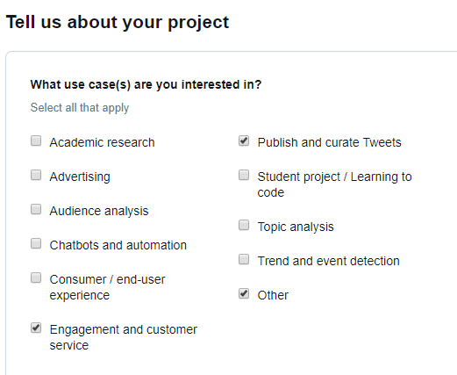
3- In the text area where you're asked to explain more about your app enter the following text:
What is the purpose of your product or service?

A plugin which shares content from my website to my Twitter account.
--
What will you deliver to your users/customers?

I'm not delivering anything to users/customers currently, just sharing content from my website to my Twitter account.
--
How do you intend to analyze Tweets, Twitter users, or their content?

I don't intend to analyze any tweets from Twitter users or their content. I do not need such permissions/functionality, I'll just be sharing content from my website to my Twitter acount.
--
How is Twitter data displayed to users of your end product or service (e.g. will Tweets and content be displayed at row level or in aggregate)?

Tweets will be displayed as normal individual tweets and Twitter cards
4- In the area below check the option No:
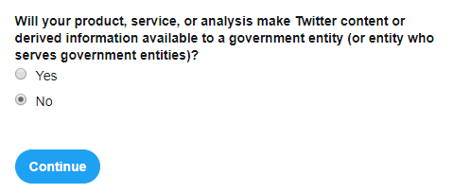
Wait for the approval process by Twitter, it might take a few days.
5- Once approved head back to https://developer.twitter.com/en/apps and click Create an app
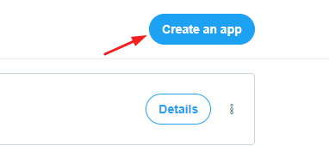
6- Enter your App name, a short Application description such as "shares posts to Twitter" and in the Website URL area add your website.
7- Leave the option for Enable sign in with Twitter unchecked and add to Callback URLs text field like https://yourwebsite.com/wp-admin/admin.php (be sure to change your URL accordingly if it's http or has www.)
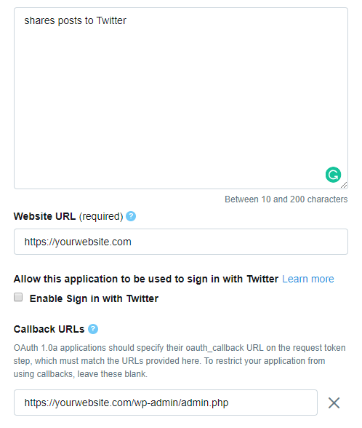
P.S: If you plan to use Tweet Old Custom Post on more websites, make sure you do the same thing for each website.
8- You need to add a note on how the app is used, enter the following text and click create:
This app is for internal use not public use. It allows my website to share posts to my Twitter account so my followers can engage with.

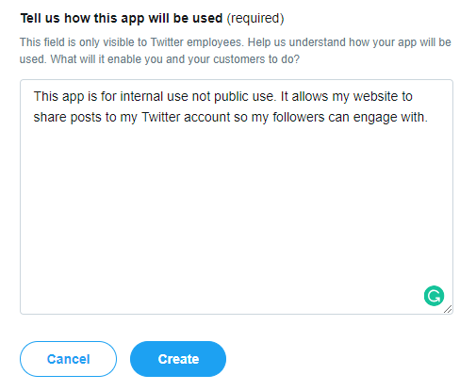
9- Click Create once again when the modal shows
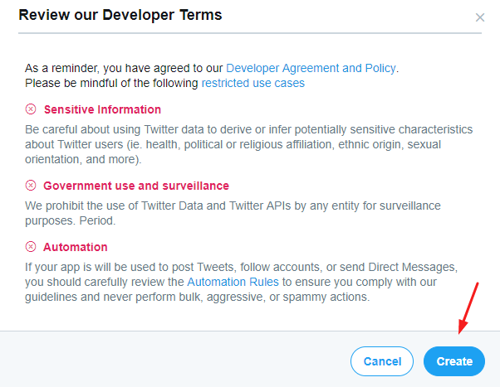
NOTE: If this is your first time creating a developer account and app you will have to wait for the review process before being able to create new apps.
10- Now you can copy the Consumer Key and Consumer Secret from Keys and tokens tab and paste it into the login modal for adding Tweet Old Custom Post account.
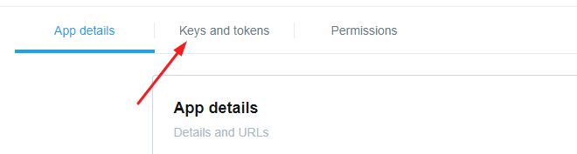
11- Go to the Tweet Old Custom Post settings from the WordPress Dashboard > Tweet Old Custom Post> Add API Keys.
12- Now you can paste the API key and API Secret Key from your previously created app.
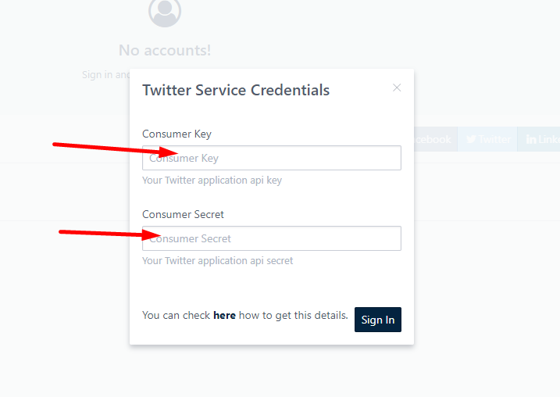
13- Click to login with Twitter and authorize the application.

