**Objectives :**

1.To know about a digital clock properly and its mechanism.

2.To make a digital clock where a particular pulse (56) is skipped in seconds and minutes.

3.To know the overall idea about the asynchronous counter and flipflops.

4.To use the T flipflop and making the equations required.

5.To learn how to use the seven segments display in the clock.

6.To design the skipped digital clock in the Logisim.

**Introduction :**

Building a digital clock using logic gates and counters involves designing a circuit that can accurately measure and display time. The foundation of this project relies on logic gates to create clock pulse signals, control the flow of data, and drive seven-segment displays to show the time. Additionally, counters play a crucial role in keeping track of the time by incrementing seconds, minutes, and hours. By utilizing counters, the clock circuit can accurately count the passage of time and update the display accordingly. These counters are essentially digital storage devices that increment their values at regular intervals, and their outputs are decoded to generate the appropriate signals to display hours and minutes on the seven-segment displays. Combining logic gates and counters enables the creation of a functional digital clock that is both informative and educational in showcasing the principles of digital electronics.

**Required Components :**

1. NOT Gate(06)

2. AND Gate(19)

3. OR Gate(09)

4. NOR Gate(03)

5. XOR Gate(01)

6. XNOR Gate(02)

7. T Flipflop (07)

8. Clock

9. 7 Segment Display(06)

**0 to 9 Counter :**

A 0 to 9 counter was build using the T Flipflop . 4 T flipflop needed here to hold the recquired

4 bits.

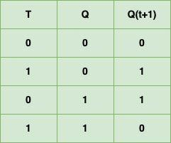

Functions for T flipflop:

MSB, T0 = T1T2T3 + T0T3

T1 = T2T3

T2 = T0’T3 T Flipflop Truth Table

T3 = 1

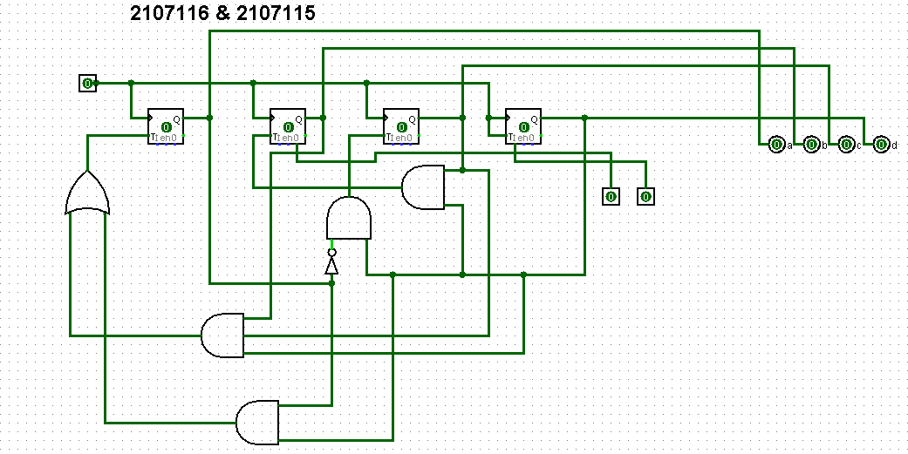

**0 to 5 Counter :**

This counter was also designed using T flipflop .3 flipflop was required here.The recquired functions for this counters are :

MSB , T0 = T0T2 + T1T2

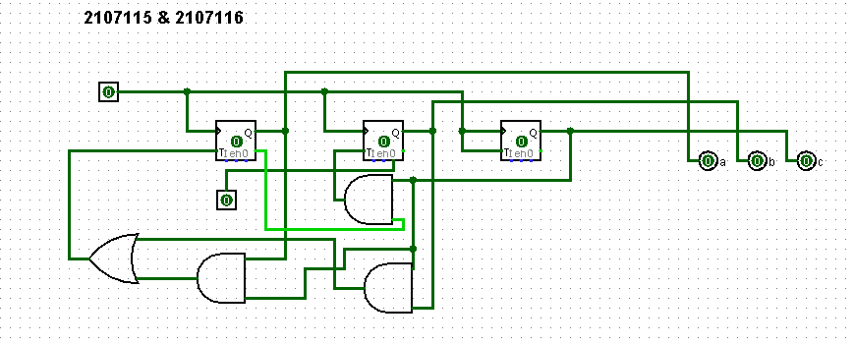

T1 = T0’T2

T2 = 1

**BCD to 7 Segment :**

To convert the Binary numbers into decimal numbers , BCD to 7 segment decoder circuit was built.The output is shown in the 7 Segment Display.

Expressions for the 7 segment decoder :

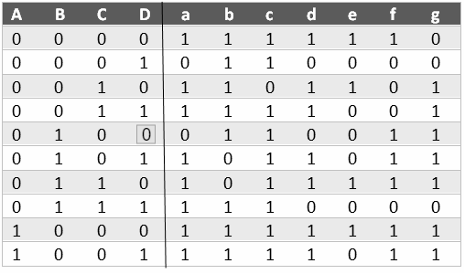

X= b’d’ + c + bd + a

Y= b’d’ + c + bd + a

Z= c’+ d + b

U= b’d’ + b’c + cd’ + bc’d + a

V= bd’ + cd’

W= c’d’ + bc’ + bd’ + a

S = b‘c + bc’ + bd’ + a

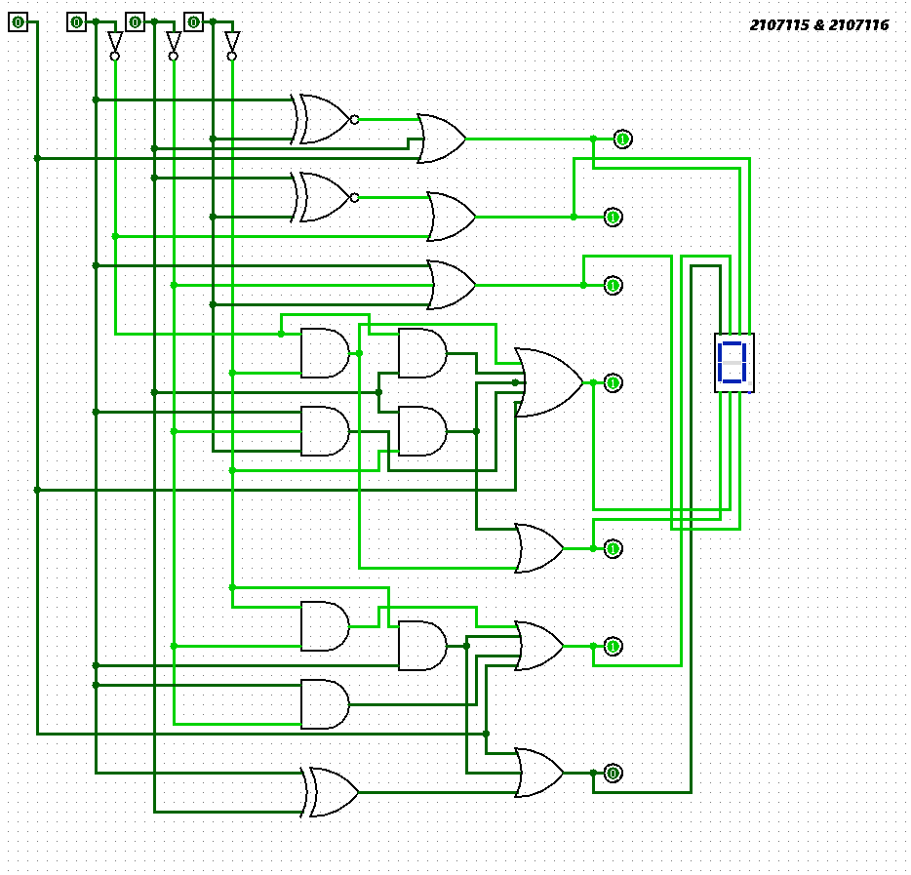

**56 Skip in Seconds and Minutes :**

To skip 56 , the combination was checked whether it is simultaneously 6 on 0-9 counter and 5 on 0-5 counter or not.If the required combination was found ,the Preset input in the last Flipflop was invoked.

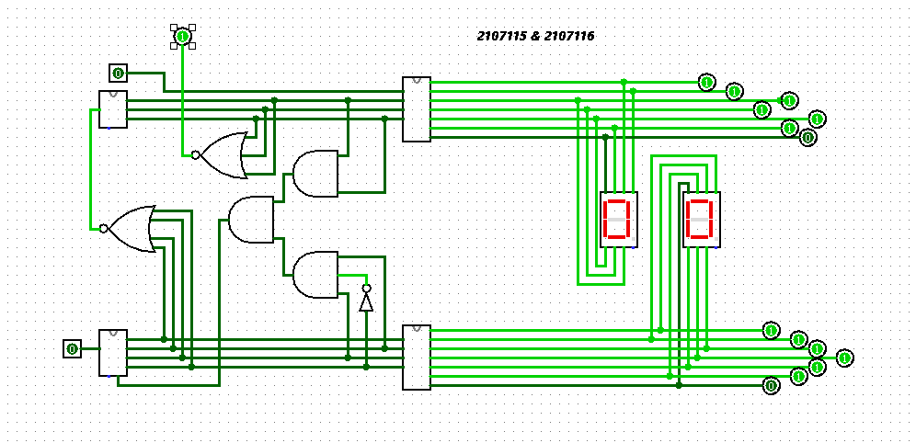

**Hour :**

To count hour from 1 to 24 ,the same 0 to 9 and 0 to 5 counter was used.When the hour is 24 ,it was preset to 01 using the present pin used in the counters.

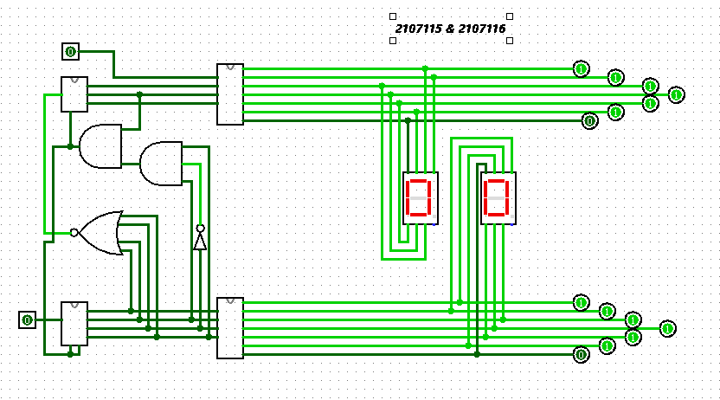

**Combining the Parts :**

Later a IC was build for Second ,which was also used to represent Minute.Then a another combinational circuit was build to represent hour which was used here.

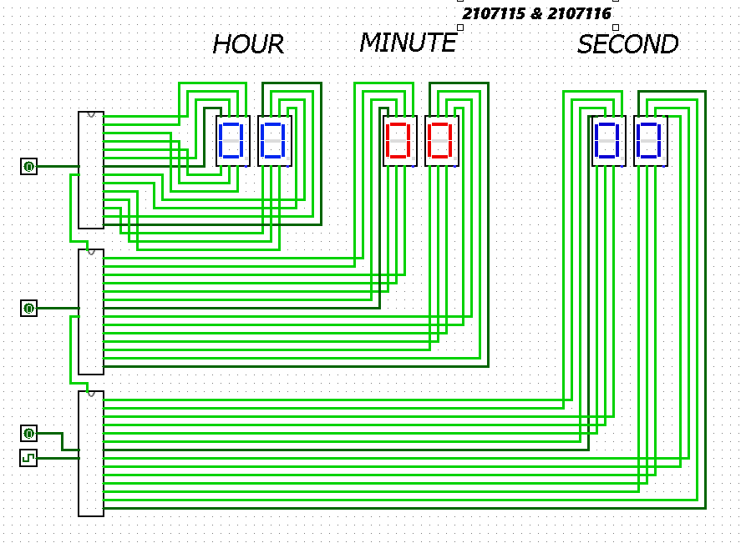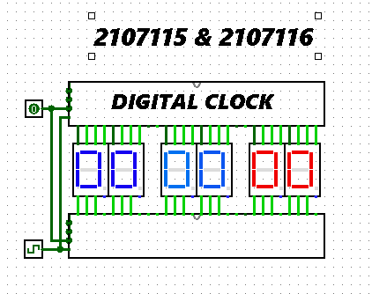

**Conclusion :**

Taking on the challenge of integrating T flip-flops and custom logic circuits in Logisim can be tough but rewarding. It involves understanding basic digital electronics principles and using advanced logic design techniques. This task helps people learn important skills in digital logic design and problem-solving while getting good at simulating electronic circuits. It also emphasizes the importance of keeping detailed documentation and the value of hands-on learning experiences. To wrap up this project, it's important to recognize that creating a digital clock with skip functionality using synchronous counters is a great starting point for exploring and innovating in the vast field of digital electronics. Whether you're doing it for learning, personal growth, or practical purposes, the knowledge and skills gained from this project open up many possibilities in the ever-evolving world of digital technology.