The Gazpacho recipe

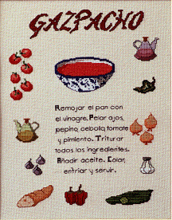

Simple instructions on basic usage of gazpacho

Preface
This document describes briefly the basics of graphical user interface designing with the Gazpacho designer. It is intended as an introduction to Gazpacho form the designers point-of-view rather than going to the developers side of things (assigning signal handlers and so on).

Gazpacho
Here's the main window:

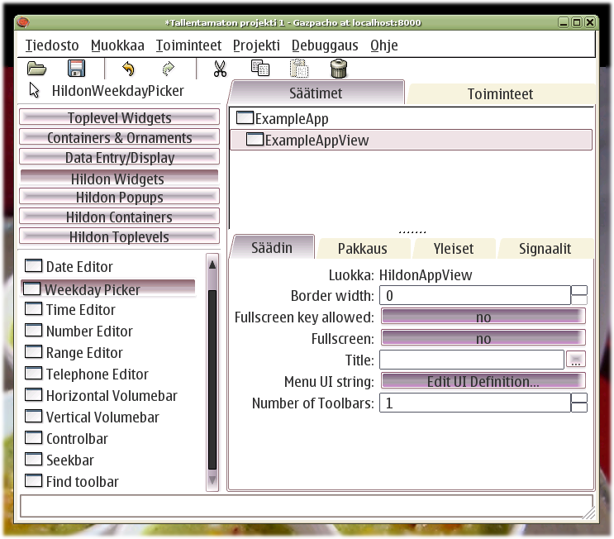
At left, the widget palette. At right, the widget tree and below it the properties area

Adding widgets is done with the palette on the left. Working with widgets is done by selecting them in the widget tree. The property area will then be updated with the appropriate properties to edit. You can copy, cut and paste widgets (useful to moving them around).

Note: Ctrl-c,x and v are used to copy, cut and paste the currently selected widgets in Gazpacho

The Actions

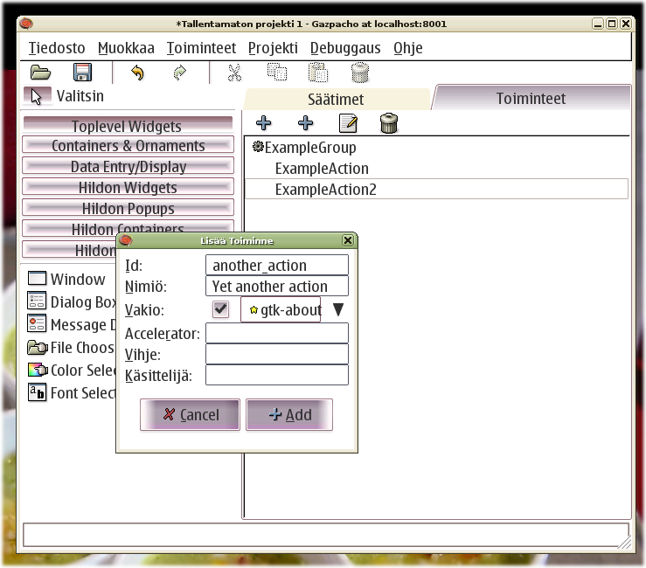
At right, the actions tree, the dialog is the "Add action" dialog

Gtk+ layout
Knowing some details on how the Gtk+ lays out its widgets (interface elements) is most valuable in the usage of Gazpacho, otherwise the behavior of the layout will surprise you and perhaps even be frustrating.

Types of widgets
There are three general types of widget behavior, toplevel widgets, container widgets and child widgets.

Toplevel widgets are the only ones that can be used without putting them into container widgets. This means basically windows (and widgets derived from them like dialogs). Toplevel widgets are usually also container widgets. In Gazpacho, they are created by simply clicking the appropriate button in the palette.

Container widgets are the backbone of Gtk+ user interfaces, they define how all the widgets are laid out in the application window. A container widget can have one or more child widgets in them, depending on the type of container. Places for child widgets in Gazpacho are denoted with a gray mesh background, with a narrow border between "slots" if the container allows multiple child widgets. Adding a widget to a container is done by selecting them in the palette, and then clicking in the desired place you want the widget to go to. Container widgets can have their own visual representation (like the frame widget), but not necessarily (like most of the box-type containers).

All widgets are child widgets with the exception of toplevel widgets. A child widget can be put inside a container, and can also be a container. Usually the ones that user interacts with the most are child widgets that are not containers, but display and allow editing of some information.

Boxes and packing
Boxes are the most used type of container in Gtk+ layouts. Boxes have no visual representation of their own, but allocate space for their child widgets according to packing properties. In addition to padding around individual widgets and spacing between child widgets in a box, there are two packing properties for the boxes. These are expand and fill. Even though these are properties that belong to the container, they are set in the "Packing" tab of each child widget inside the container. That's why they are also called child properties.

- Expand means that the child widget will get as much space as is available allocated to it. If there are multiple children with expand set, the available space will be divided between them. If the expand is not set, the child will get allocated only as much space as is necessary for it, and no more.
- Fill means that the widget will occupy all the space that the container has given to it. If not set, it will occupy only the amount of space it needs. This can be observed with buttons for example, they stretch to accommodate the space available when fill is set.

Note: The child properties need to be implemented in the widget, so some widgets may ignore the settings in their rendering.

The most common types of boxes used are the HBox and VBox. H stands for horizontal and V for vertical. These are simple containers that take one or more child widgets. The orientation affects the way the children are aligned, and also the spacing you can apply to child widgets.
For horizontal box, you can only define how much space you leave between the items horizontally and individual padding for the children (also only horizontally). Vertically the child widgets will not have any padding, unless you specify a border width for the container. This however affects all the sides of the container, which may not be what you wanted. This limitation allows the containers to be simple and robust, but will feel awkward at first. If you need to have both vertical and horizontal padding or alignment, you will need to have a HBox inside a VBox (or the other way round). Fortunately, this is usually the case anyway.

If the desired alignment for a widget differs radically from the surroundings and/or needs to be precise, there is the Alignment widget that works as a "proxy" between the allocated space and the widget and allows the placement of the widget to be determined more freely within the allocated space than without the Alignment. The Alignment widget has no actual visual representation of its own.

Usually, you don't want to use Tables. They are somewhat inflexible on resizing when comparing to just using nested VBoxes and HBoxes. If you need table-like alignment, usually it's better to use SizeGroups for the aligned widgets.

Note: SizeGroups do not have support in Gazpacho at the time of writing this, but will in the future.

When an area of the layout will need more space than is suspected to be available, one uses the ScrolledWindow widget to create scrollbars for that area. Some widgets have inherent scrolling, but most widgets don't and for those a Viewport must be used. Gazpacho creates automatically a Viewport for a ScrolledWindow, and detect widgets that do not require a Viewport and remove it from the ScrolledWindow so the Viewport that is visible in the widget tree can safely be ignored.

One widget that needs a special mention here is the Fixed widget. It allows the child widget to be placed within it by pixel measures, and the child will not be affected by any packing properties, resizing or other dynamic changes to the UI. That's why you should never use it.

Menus, toolbars and UIManager
The grand idea behind the UIManager is to allow designers to recycle common tasks between menus, toolbars and other UI-manageable widgets. The designer can specify an Action that can be activated through several different places in the application. This allows the specification for that action, as well as the implementation, to be done exactly once.

It also allows the UI to be modified dynamically. For example, you can have one menu visible at all times, and additional items to be "merged" on them when needed, and removed
after the context changes again to the original state.

Actions in Gazpacho are managed separately of the widgets, in the Actions tab. You must always first create a ActionGroup (or several) before you can create actions. ActionGroups are mostly just for structure in the designing phase. After you have created an ActionGroup, you can add Actions to it. Note that the selection in the action tree will determine to which group the Action will be placed. Actions can not be moved between groups currently.

After you have some Actions, you can create a UI definition to a UI-managed widget. This can be done from the widgets properties, with the "Edit UI definition" button. It shows you a dialog with a treeview and some buttons to add and remove Actions to the definition. There are some differences how the UI-managed widgets allow editing of their UI-definition, detailed below. Note that showing a submenu is considered an Action, and thus must have an Action associated with it.

MenuBars allow only menus as toplevel items.

Toolbars allow only toplevel items, no submenus

HildonAppView allows both toplevel items and submenus. All Actions are created as menuitems initially. If you add an Action while a menuitem is active, it is converted to a submenu item. It cannot be converted back to menuitem currently, to revert you must remove the item and add it again.or it.

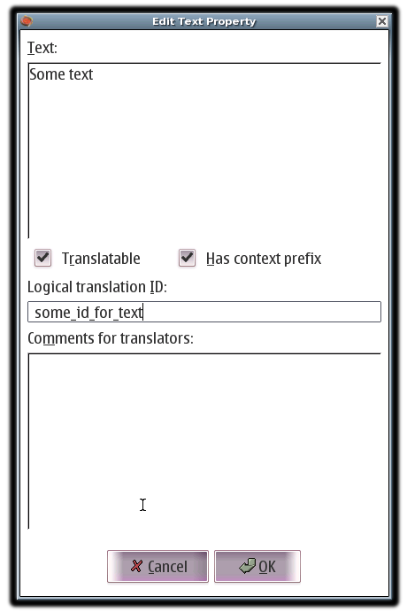
L10N features

In addition to normal way of using gettext (inserting english text as the ids that the translations are based on), Gazpacho now includes support for using "logical ids" or "UI strings" in the designs. They can be inserted in the normal dialog, which has an additional field for it.

Note: The translation changes prohibit the normal style of translations currently

You can also insert helpful comments for translators in the "Comments" area.

The "Translatable" check box controls whether the string in question will be used for translations or not.

The "Context prefix" feature is has no effect currently.

Action labels are not currently translatable with Gazpacho.

The L10N menu

There is a new menu added to the Gazpachos menu bar. It contains the following items:
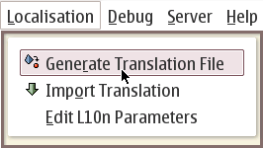
- Generate translation file
  - Creates a po file (aka. master po) with the UI strings and engineering english.

- Import translation
  - Imports a po file to the current project

- Edit l10n parameters
  - Opens the L10N dialog (described later)

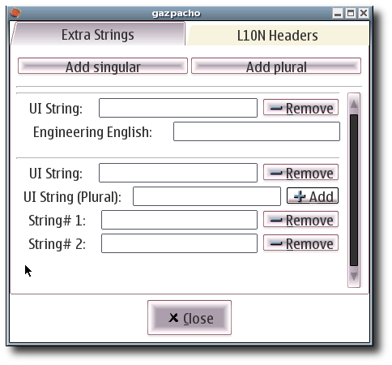
The L10N dialog

The L10N dialog has two tabs.

In the first one, you can input extra strings. Sometimes applications need strings that are not permanently attached to any widget (notifications, simple dialogs etc.) but should still be translatable. For this, there is the extra strings feature that allows you to input UI string / Engineering english pairs that will be saved in the UI definition and in any exported po files.

You can add singular or plural forms of strings with the buttons at the top. Removing the strings happens with the "Remove" button beside each item.

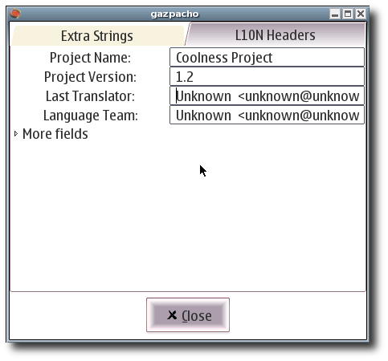
The second one lists common information that is stored in the exported po file, like project name and version. The "More fields" expander hides some rarely changed fields, normally you shouldn't have a reason to change them.

