- Introduction
The purpose of the project is to develop a graphic user interface (GUI) for ModelJUnit, which is a model based testing tool implemented by program language java. The test designer needs to design states and actions based the behavior of system under test (SUT) to make a model. ModelJUnit could automatically generate test sequences and run test according to the model.

The GUI could provide a friendly user interface to user to generate code to connect user defined model with ModelJUnit. Beside from that the GUI also provides two ways to run generated test. They are automatically by ModelJUnit and generate test manual by user respectively. The details of those two methods are in section 3.

  - Extended finite state
The backbone of model based testing is extended finite state machine (EMSM).A finite state machine will contains states connected by transitions. Transitions are associated with a set of input Boolean conditions and a set of output Boolean functions. The transition cannot be performed without conditions are satisfied. Once conditions satisfied, the correspond transition will be fired, changing the machine from the current state to the next state and performing the relevant data operations.

  - Background of model based testing

- GUI architecture
  - Basic components in GUI
The GUI contains 4 panels; they are test design panel, code view panel, test result panel and manual test execution panel.
    - Test design panel
The test design panel includes components that allow user load model, select algorithm and set parameters for ModelJUnit to run test.
    - Code view panel
Once import model and set all parameters for ModelJUnit, application will generate java code and display in this panel, user can also export the code to java file here.
    - Test result view panel
User could run test and observe test result.
    - Manual test execution (animation) panel
If user wants to run test step by step, function by function, here is the right place. All transition list in this panel, user could select particular transition and execute the transaction. The output of the execution also contains machine’s state.
  - Diagram of design
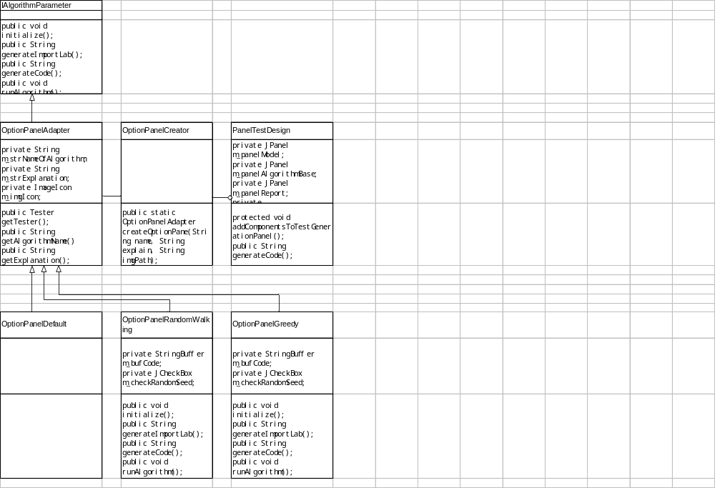

- Tests generation

3.1 Automatically tests generation and Manual tests generation
3.1.1 Automatically tests generation
3.1.2 Manual tests generation

3.2 Simple use case

    - Auto generated test
Select class path
Import LargeSet.class from examples folder
Switch to code view panel
Click run button

    - Manual generated test
Select class path
Import LargeSet.class from examples folder
Switch to execute actions panel
Select an action user wants to run
Double click the action

- References
http://www.geocities.com/harry_robinson_testing/robinson.pdf
http://en.wikipedia.org/wiki/Extended_finite_state_machine

