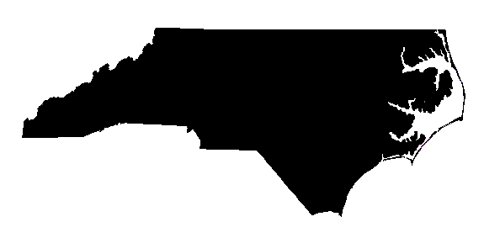
VOCATIONAL
REHABILITATION
V
R

North Carolina Division of Vocational Rehabilitation Services
Employer Satisfaction Survey
The North Carolina Division of Vocational Rehabilitation Services (NC DVRS) is interested in your ratings for the services we provide to you as an employer. Please take a few moments to complete the survey below. When you are finished, please return the survey to Stephanie Vinson, Employer Networks Specialist, via email at Stephanie.vinson@ncmail.net.

1. Are you familiar with the services offered to employers through NC DVRS?
 | Yes | No | Have Used This Service | Would use this service in the future
a. Recruitment Assistance
b. Training Assistance for New Hires
c. On the Job Training Reimbursements
d. Financial Incentives/ Tax Credits and Incentive
e. Rehab. Technology/Workplace Modification/Accommodations
f. Retaining existing employees with disabilities
g. Training and Consultation on disability Etiquette/Awareness/ADA

2. Have you hired an applicant who received services from NC DVRS? Yes___ No___

3. What is your level of satisfaction with the following services provided by NC DVRS?
 | Poor | Fair | Average | Good | Excellent
a. Recruitment Assistance
b. Training Assistance for New Hires
c. On the Job Training Reimbursements
d. Financial Incentives/Tax Credits and Incentive
e. Rehab. Technology/ Workplace Modification/Accommodations
f. Retaining existing employees with disabilities
g. Training and Consultation on disability Etiquette/Awareness/ ADA

4. What is your level of satisfaction with NC DVRS staff in regard to the following:
 | Poor | Fair | Average | Good | Excellent
a. Courtesy of Staff
b. Competence of Staff
c. Responsiveness of Staff
d. Staff’s Understanding of Your Business Needs

5. What is your overall level of satisfaction with the services your company has received from NC DVRS?
Very Unsatisfied | Unsatisfied | Neutral | Satisfied | Very Satisfied

6. Is there anything that we can do to improve the services that we provide to you as an employer?

Company Name: _____________________________________________________________

Job Title of the Person Completing the Survey: ___________________________________

Thank You for Completing the Survey!

