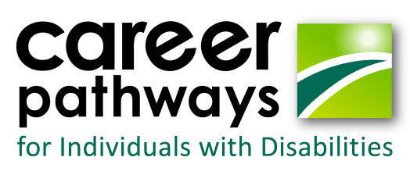

**2017 Dream It. Do it. Academies**

|  |  |  |  |
| --- | --- | --- | --- |
| **Date** | **Camp** | **Location** | **Number of Students** |
| June 12-16 | 3-D Imaging | Lake County Advanced Learning Center | 12-14 |
| June 26-30 | Welding | Lake County Advanced Learning Center | 12 |
| June 26-30 | Robotics/Cyber* | Richmond- DBVI campus | 26 |
| July 2-7 | Production/Water filtration* | Wilson Workforce and Rehabilitation Center | 14-16 |
| July 10-14 | Gaming | SSVCC Daniel Campus | 12 |
| July 10-14 | CNC-Machining* | Valley Career and Technical Center | 10-14 |
| Sept 15-17  (weekend) | 3 D Printing  Adult Academy | Dabney S Lancaster Community College | 12 |

*Denotes a residential academy with dormitory housing available for attendees

Assistive technology provided at all CPID academies

**Need more information?** Email:

Tish Harris, DBVI: [Tish.Harris@DBVI.Virginia.Gov](mailto:Tish.Harris@DBVI.Virginia.Gov)

Kate Kaegi, DARS: [Kate.Kaegi@DARS.Virginia.Gov](mailto:Kate.Kaegi@DARS.Virginia.Gov)

For a listing of all Dream it. Do it. camps: https://www.dreamitdoitvirginia.com/

Virginia’s Career Pathways for Individuals with Disabilities (CPID) grant is a federally-funded grant project (CFDA #84.235N) through the Department of Education.