Adding Links to Raggedsky.com

NOTE: The site edit functions will not work in the Safari browser. If you are working on a Mac, download and use the Firefox browser.

1) To edit pages, you must log in. Go to one of the pages with a login box at the bottom (like "About Us") and log in.
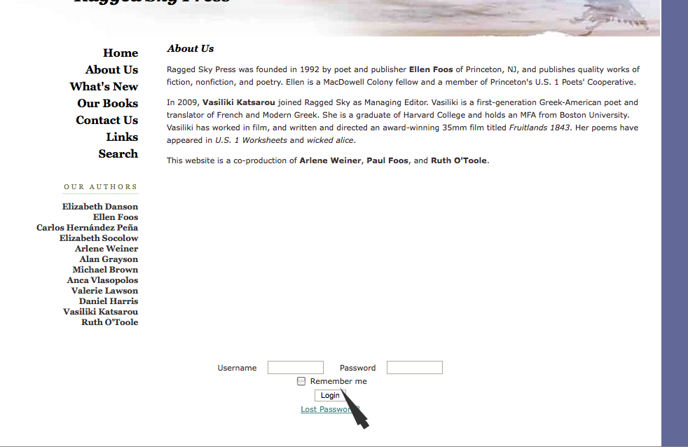
2) Navigate to the Links page. If logged in you will see a little pencil and paper symbol at upper left. Click on it.

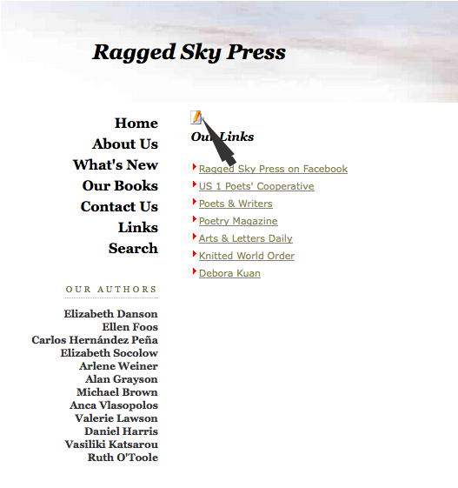
3) The links page is an unordered list of links; you do not need to insert any paragraphs, or other formatting. Just put your cursor at the end of one of the list items, press return and a new list item will be created:
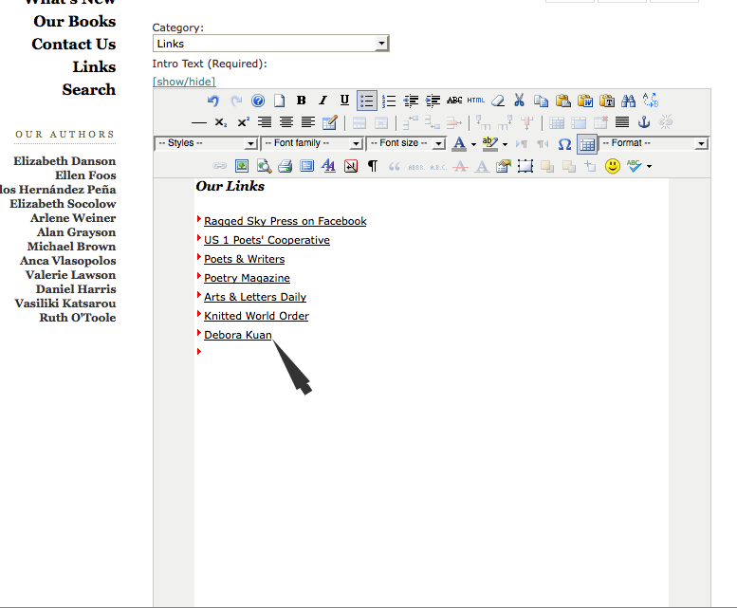

4) Write the link text in the empty list item (not the URL) and select it, as shown:

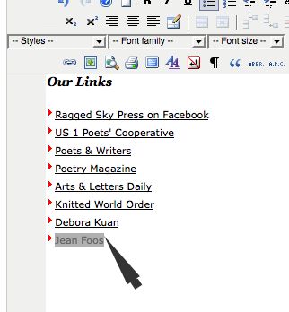
5) With the link STILL SELECTED, click on the chain link symbol in the top of the editor.
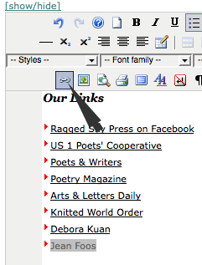
6) This will open a dialogue box. Enter the URL in the "URL" box. Include the "http://" prefix or the link won't work. In the "Target" box, select "Open in new window" as shown. This is best practice for a link going off your site. Finally, click "Insert" at lower left.

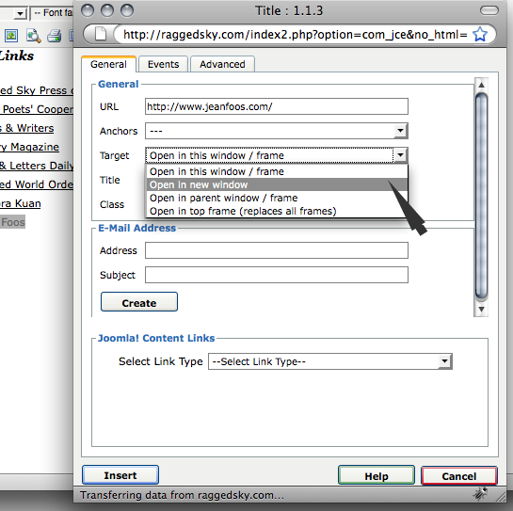
7) The linked text should now look the same as the other items in the list. Click the "Save" icon (computer disk) at upper right to save your work and close the editor. Click the red "X" to cancel if you don't like what you have done. The blue check mark, or "Apply" button saves your changes but leaves the editor open.

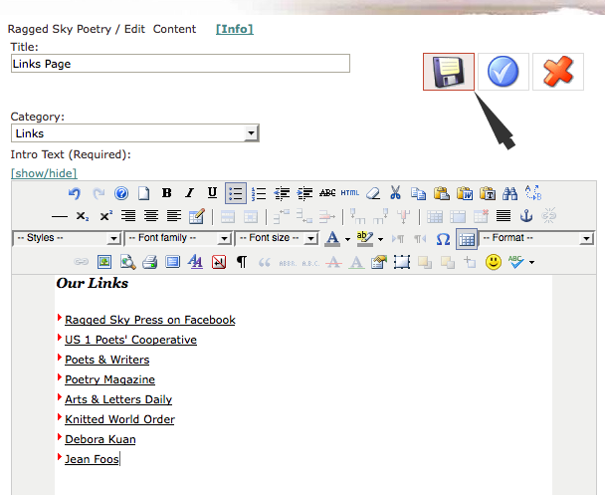
Once you have closed your editor, check to see if the link works. If not, reopen the editor and try again.

