
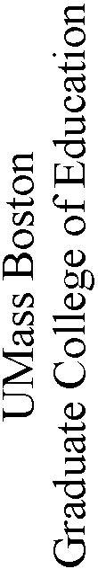
Teacher of Students with Visual Impairments Program

Practicum Handbook

Revised Fall 2009
Janice Barron and Marybeth Dean

Contents List

Introduction
Letter from Office of Student Services and Licensure ……………….. 3
UMass Boston Professional Education Unit Mission………………….. 4
Professional Education Program Goals…………………………………5
Conceptual Framework for the Professional Education Program
Performance Expectations for Candidates………………….....6-8
TVI Course of Study…………………………………………………….. 9

Massachusetts Test for Educator Licensure (MTEL)………………………… 10

Roles and Responsibilities
Expectations of the Student Teacher………………………………….. 11
Student Teacher’s Responsibilities…………………………………….12-13
Expectations of the Supervising Practitioner………………………… 14
Addendum to Expectations of the Supervising Practitioner…………. 15
Expectations of the Program Supervisor………………………………. 16

TVI Summer Practicum Dates 2008………………………………. ………….. 17
Forms-SP…and PS……………………………………………………………… 18

Glossary of Terms…………………………………………………………….. 19-22

Mass DOE TVI License Specific Questions………………………………… 23-24

Lesson Plan Format…………………………………………………………… 25

Massachusetts Curriculum Frameworks………………………………………..26

Introduction

Dear Student Teacher, Supervising Practitioner or Program Supervisor,

The student teaching experience is a vital component of Teacher Preparation at UMass Boston. With the support of the supervising practitioner and the program supervisor, the student teacher must integrate the academic work that has preceded it with the practical experiences of the classroom. To make the student teaching experience successful for both the student teachers and for the students in the classrooms in which they teach, it is important that all the participants in the student teaching experience are actively involved and supported.

We, at the University, take our responsibility very seriously and see ourselves as advocates for our students and for the schools which accept them. It is important that we know how the experience is going and that you know we are always available to provide assistance. We also want your input as to how we can improve the way we prepare future educators.

Congratulations to the student teachers for being successful in their program thus far. We encourage you to continue your exemplary work during your student teacher experience. We would also like to thank the cooperating teachers for mentoring, guiding and sharing their rich experiences with these future teachers. We gratefully acknowledge the university supervisors as skilled and experienced teachers, who act both as liaisons in this enterprise as well as onsite faculty.

We understand, respect and admire classroom teachers for the knowledge, skills and dispositions they bring to the children they teach. Teaching remains a most important job occupied by caring professionals who can make a difference in the lives of children and their families. We appreciate your efforts on their behalf.

Office of Student Services and Professional Licensure

Elaine Bauer, Director 617-287-7625 Elaine.Bauer@umb.edu

Other Contact Information

UMass Boston’s website: www.umb.edu

Career Center: www.careers.umb.edu Kathy Larson-617-287-5519

MA Department of Education http://www.doe.mass.edu

University of Massachusetts Boston
Professional Education Unit Mission

The Professional Education Unit (PEU) Mission is to prepare and provide professional development for thoughtful and responsive teachers and educational leaders, counselors, and school psychologists, to work effectively in urban schools and communities.

The Professional Education Unit is committed to fostering and enhancing the abilities of educational professionals to address the needs of children, adults, and families with a diversity of cultural, linguistic, and ethnic backgrounds, race, socioeconomic status, sexual orientation, and ability.

Through courses, clinical experiences, research projects, and multi-faceted partnerships, the Professional Education Unit offers intellectually stimulating, richly inclusive programs, in which the study of theory, research, and professional knowledge is integrated with practice and considerations of the ethical issues faced by educators. PEU's goal is to provide contexts and opportunities for the strengthening of reflective and critical thinking, and for the acquisition of valuable insights into nature of learning, thinking, personal and social development, and ways to support growth of individuals and groups.

The Professional Education Unit seeks to promote collaboration among educational professionals, stressing the ways in which teachers, administrators, counselors, schools, adult education centers, families, and communities to create social environments that promote the realization by all children and adults of their full potential.

The Professional Education Unit views education as central to all efforts to address the challenges of urban communities, and see ourselves as contributing to those efforts through our preparation and support of the continuing development of caring, principled, and respectful educational personnel.

The Professional Education Unit seeks to impart professional values and ethical behavior to its candidates, and to encourage them to be creative members of school and community teams and leaders in the introduction of innovations that will result in greater equity for children, schools, and families in urban communities.

Professional Education Program Goals

Through targeted commitments and collective resources, we seek to support thoughtful and responsive educators, to develop values and competencies to meet the educational needs of all students, and to work collaboratively in schools and communities, particularly in urban environments.

As such, the program seeks students whom:

♦ Make a commitment to and feel responsible for anti–biased practice and anti–racist practice;

♦ Take action toward greater social and economic justice;

♦ Place a particular emphasis on the central place of families and communities in children’s lives;

♦ Make schools work for all children – especially those from subordinated backgrounds;

♦ Understand practice/praxis;

♦ Have a strong belief in the power of education and the potential of all children; and

♦ Take responsibility for high standards.

Conceptual Framework for the Professional Education Program

Performance Expectations for Candidates

The knowledge base for the professional education program learning outcomes is influenced by various sources: the Commonwealth of Massachusetts Standards for Licensure Teachers, INTASC Standards, National Board Standards, and the curricula guidelines from Learned Societies for the various disciplines. Following the program expectations for candidates is a matrix that illustrates how the professional education program conceptual framework “The Thoughtful and Responsive Educator” learning outcomes have been aligned with the various standards. In addition, the knowledge base for program outcomes is influenced by the professional literature on teacher education and on educating other school personnel. Upon program completion, graduates are thoughtful and responsive educators who demonstrate commitments, understandings, and practices. The knowledge, skills and dispositions are noted below.

- COMMITMENTS (by upholding ethical behaviors, pursuing life long learning, dedicating oneself to serve others, and by acknowledging human resiliency and capability to learn)

- UNDERSTANDINGS (by possessing breadth and depth in content and pedagogical knowledge, assessment practices, and the use of technology in practice)

- PRACTICES (by demonstrating caring behavior and by collaborating productively with others, reflecting on how to improve professional practices, and promoting social justice as a social change agent)

To demonstrate Commitments the thoughtful and responsive educator acquires and maintains:
Ethical behavior
- Knowledge of professional practices and ethical boundaries of profession
- Skills to work within codes of behavior
- Dispositions to recognize responsibility for engaging in and supporting appropriate professional practices for self and colleagues

Life Long Learning
- Knowledge of resources available for ongoing professional development
- Skills of participating in and taking advantages of professional growth activities
- Dispositions of willingness to give to and receive help from administrators, colleagues, students and communities
- Problem solving strategies

Dedication
- Knowledge that professional educators have made a pledge to service their constituency
- Skills to maintain an ideal of service
- Dispositions to a belief that a professional can positively learn from others and has enthusiasm for professional work

Modeling and Mentoring
- Knowledge of the various interpersonal and social models responsible for positive changes in different people
- Skills in facilitating observational learning and in developing interpersonal strategies as tools for learning
- Dispositions to recognize the potential of all people to learn and to acknowledge the people’s capacity to be resiliency

To demonstrate Understandings the thoughtful and responsive educator acquires and maintains:
Content
- Knowledge of central organizing concepts, theories and factual information and of current research in the field and its implications for practice
- Skills to create disciplinary and interdisciplinary learning experiences that promote growth
- Skills to understand and apply multiple perspectives to a range of experiences and situations
- Dispositions to realize knowledge is not a fixed body of knowledge but is ever evolving

Pedagogy
- Knowledge about theory and research of effective practice
- Skills for applying theory and research of effective practice to promote growth and learning of individuals from diverse cultural and linguistic backgrounds and with special needs
- Skills for creating a safe learning environment that encourages positive social interaction, active engagement in learning and self motivation
- Dispositions for affirming the belief that all individuals can achieve success

Assessment
- Knowledge about performance assessments
- Skills for applying assessment practices to promote the growth and learning of all individuals including those with cultural and linguistic diversity and with special needs
- Skills for gathering and using data for program improvement
- Dispositions to value ongoing assessment as essential to the instructional process and to recognize that many different assessment strategies are necessary for promoting student learning

Technology
- Knowledge about appropriate technology in effective practice
- Skills to model the use of technology for disseminating information, for communicating, for research and organizational management
- Skills for integrating technology into instructional activities as a means for enabling all students to learn, including those with cultural and linguistic diversity and with special needs
- Dispositions that can promote procedures that will ensure equitable access to technology.

The thoughtful and responsive educator acquires and maintains the following Practices:

Caring
- Knowledge of practices that reflect a nurturing, safe and healthy environment where all individuals can grow and prosper
- Skills to be attentive to listeners and willing to listen and withhold judgment
- Dispositions that acknowledge the uniqueness of individuals, yet respects their loyalty to their own community and culture

Collaborative
- Knowledge of how individuals work in groups productively
- Skills for working with students, administrators, parents, community members and colleagues
- Dispositions for valuing and appreciating the importance of working with others to create a community

Reflective
- Knowledge of methods of inquiry that provide a variety of ways to look at and improve practices
- Skills for evaluating critically his or her own teaching practices, beliefs and assumptions
- Dispositions to value critical and creative thinking as habits of mind to refine practices

Social Justice
- Knowledge that society exists with economic, social, educational inequities and has either positive or negative impact on students
- Skills for reducing social injustices and for promoting all dimensions of diversity, including exceptionalities
- Dispositions for becoming a social change agent in order to increase the accessibility to an excellent education for children and youth
 Teacher of Students with Visual Impairment Program

Personal Program of Study Tracking Form
(Two Year Program)
NAME: Ed Leveling: □Required □Not required

Anticipated Date Date Completed Credits
Education Leveling Courses
EDCG 668 Mathematics for Elementary Teachers ___________ ___________ 3.0
EDCG 646 Understanding Reading: ___________ ___________ 3.0 Principles and Practices
MTELS
Communication and Literacy ___________ ___________
Foundations of Reading ___________ ___________
General Curriculum ___________ ___________

TVI Core Courses (37 credits required)
Year 1
SPE 620 Ed. of Students with VI Summer ___________ 3.0
SPE 621 Intro to Disabilities Summer ___________ 3.0

SPE 614 Visual Functioning Fall ___________ 3.0
SPE 615 Braille I Fall ___________ 3.0

SPE 616 Implications of Low Vision Spring ___________ 3.0
SPE 619 Braille Communications II Spring ___________ 3.0

Year 2
SPE 641 O&M and Indep Living Summer ___________ 4.0
SPE 622 Technology and VI Summer ___________ 3.0

SPE 642 Assessment and Instr. Strat. VI Fall ___________ 4.0

SPE 643 Assessing and Tchg Mult. Dis. Spring ___________ 4.0

SPE 698 Practicum VI (300 clock hrs.) ___________ ___________ 4.0

Total Credits Received ________

STUDENT: ADVISOR:

DATE:
Massachusetts Test for Educator Licensure (MTEL)

If you are currently Student Teaching or Interning, then you must have completed your required MTEL exams.

All Educator and Practitioner Licensure Programs of UMass Boston require that you pass required MTEL exams, as prescribed for the particular program, prior to APPLYING to Practicum. The Massachusetts Department of Education (DOE) requires all Candidates for initial certification in the Commonwealth of Massachusetts to have passed the state-approved test appropriate to the license sought. UMass Boston has incorporated the DOE requirement into the University’s Educator programs.

Information for the MTEL exams in posted on the MTEL website (www.mtel.nesinc.com), the Doe website (www.doe.mass.edu) and the GCE website (www.gcoe.umb.edu). The Teaching Advising Office and respective program departments provide information regarding dates and exams required per program.

Please schedule your exams accordingly.

Semester intended for
Student Teacher Practicum Application for STP Due

Spring Semester October 1st
Summer Semester February 15th
Fall Semester March 1st

Substitute Teaching

Candidates may not act as substitute teachers in the school while they are completing the practicum.

Employment and Student Teaching

If you are hired on waiver as a Teacher of Students with Visual Impairments, you may complete the practicum at the same time.

Roles & Responsibilities

EXPECTATIONS OF THE STUDENT TEACHER

A student teacher is confronted by a range of complex and varied responsibilities. Therefore, it is impossible to detail each precise responsibility for each student teacher because this varies according to the individual situation. To give some guidance and help to the student teacher, the Supervising Practitioner, and the Program Supervisor, we offer these guidelines.

  - The Practicum is the final class in UMB's Educators’ Preparation Programs. Experience in the classroom and attendance in the practicum seminar is required.

  - As is required by state law, each student must submit a copy of a recent (within two years) tuberculin test to the principal or Supervising Practitioner.

  - Many school districts also require that a Criminal Offender Record Inquiry (CORI) be completed before beginning student teaching. Please address the requirement with your placement site’s administrators. (This usually is addressed prior to the Principal or appropriate parties signing the Letter of Agreement.)

  - The Candidate should also submit a resume to the Supervising Practitioner.

  - Candidate will follow the public school calendar, taking vacations when the school, not the University is on vacation.

  - The Candidate is expected to conform to the same professional standards as the regular staff members of the school. S/he should arrive at the school at the same time as other staff and expect to spend the full school day and any additional planning time as the Supervising Practitioner requests. If some unforeseen circumstance should cause the Candidate to be late, the school and the Supervising Practitioner should be notified. If an illness causes an absence, the Candidate should afford the same consideration to the Supervising Practitioner that a regular teacher would give a substitute teacher. That is, notifying the Supervising Practitioner the night before or as early as possible and providing plans and other materials necessary to teach in the areas for which the Candidate is responsible. The Candidate should also notify the Program Supervisor of the absence.

  - Absences from student teaching of more than three days a semester must be made up or a grade of Incomplete will be given. Serious illness or unusual circumstances will be handled on an individual basis by the Program Supervisor. Religious holidays will not be counted as part of the three days.

  - Each Candidate will be supervised by a Supervising Practitioner. The Supervising Practitioner works with the Candidate each day and can provide the most immediate assistance in planning, teaching and evaluating.

- Each Candidate will have a Program Supervisor who will assist him/her in achieving the greatest professional growth. Each Program Supervisor will bring an individual perspective to this work. The Program Supervisor makes at least five supervisory visits for each Candidate placement. When arranging for the visits, the Candidate should plan for a time when it will be possible for the Program Supervisor to confer with the Candidate immediately following the observation and to confer with the Supervising Practitioner after that.

- When the Program Supervisor visits the classroom, the Candidate should provide the Program Supervisor with the daily lesson plans.

Student Teacher’s Responsibilities

During the Practicum, each Candidate should encounter the following experiences:

- Observe the classroom teacher.
- Instruct on a one-on-one basis individual students who may need help in a particular skill area.
- Lead a small group in the development of a new concept or skill.
- Instruct the total class in the development of a new concept or skill, which might involve a sequence of several lessons.
- Instruct in all areas of the classroom curriculum as handles by the classroom teacher.
- Plan for and teach at least one unit.
- Plan for and instruct several groups simultaneously.
- Assume the responsibility for the supervision of students who are engaged in completing independent work.
- Diagnose individual student’s progress in various areas of the curriculum.
- Plan and design appropriate instructional materials to provide for student needs.
- Plan and write in-depth lesson plans for the first several lessons as each new area in the curriculum is added to the teaching load.
- Develop appropriate curriculum materials and teaching aids for students.
- Develop skill in selection and utilization of educational technology in classroom instruction.
- Give evidence of the ability to evaluate student progress and develop curriculum accordingly.
- Adapt the use of curriculum materials to the individual learning levels.
- Demonstrate the knowledge of appropriate questioning techniques in individual, small group and total classroom situations.
- Discuss lessons on a daily basis with the classroom teacher.
- Handle the entire instructional program of the classroom for a substantial period.
- Assist the classroom teacher in performing routine tasks in the classroom – checking attendance, housekeeping, clerical tasks, etc.
- Assist the classroom teacher in maintaining adequate physical arrangements of the classroom for varying instructional modes during the day.
- Assist the classroom teacher in the supervisory responsibility in the classroom, building, cafeteria, gym, library, etc.
- Design (at the elementary level) several bulletin board projects and child learning center arrangements.
- Participate in faculty meetings, PTA meetings, and special school functions.
- Become familiar with all classroom, school, and community policy relative to the education of students.
- The Practicum is the final class in the Teacher Education Program. Experience in the classroom and attendance in the seminar are required.
- As is required by state law, each student must submit a copy of a recent (within two years) tuberculin test to the principal or Supervising Practitioner.

- The Candidate should also submit a resume to the Supervising Practitioner.

- Candidates will follow the public school calendar, taking vacations when the school, not the University is on vacation.

- The student teacher is expected to conform to the same professional standards as the regular staff members of the school. S/he should arrive at the school at the same time as other staff and expect to spend the full school day and any additional planning time as the Supervising Practitioner requests. If some unforeseen circumstance should cause the student teacher to be late, the school and the Supervising Practitioner should be notified. If an illness causes an absence, the student teacher should afford the same consideration to the Supervising Practitioner that a regular teacher would give a substitute teacher. That is, notifying the Supervising Practitioner the night before or as early as possible and providing plans and other materials necessary to teach in the areas for which the student teacher is responsible. The student teacher should also notify the Program Supervisor of the absence.

- Absences from student teaching of more than three days a semester must be made up or a grade of Incomplete will be given. Serious illness or unusual circumstances will be handled on an individual basis by the University supervisor. Religious holidays will not be counted as part of the three days.

- Each Candidate will be supervised by a classroom or Supervising Practitioner. The Supervising Practitioner works with the Candidate each day and can provide the most immediate assistance in planning, teaching and evaluating.

- Each Candidate will have a Program Supervisor who will assist him/her in achieving the greatest professional growth. Each Program Supervisor will bring an individual perspective to this work.

- The Program Supervisors make at least five supervisory visits for each student teaching placement. When arranging for the visits, the Candidate should plan for a time when it will be possible for the Program Supervisor to confer with the Candidate immediately following the observation and to confer with the Supervising Practitioner after that.

- When the Program Supervisor visits the classroom, the Candidate should provide the Program Supervisor with the daily lesson plans.
EXPECTATIONS OF THE SUPERVISING PRACTITIONER

The Supervising Practitioner is the person most directly involved with the Candidate on a daily basis. Her/His function is to serve as a mentor who guides the Candidate's development as a practicing teacher. To this end, the Supervising Practitioner is expected to:

➢ Hold an appropriate teaching license.

➢ Accept the Candidate as a professional and convey this acceptance to the class and co-workers. Introductions to the administrative staff and other faculty members can assist in this matter.

➢ Provide a model of teaching for the Candidate to observe and adapt to her/his own use. Give the Candidate a list of directed observations to make during the initial days of the experience.

➢ Explain school policies, regulations and facilities.

➢ Provide access to curriculum guides. Share written lesson plans and provide the Candidate with a sample format for daily, weekly and long-range plans.

➢ Assist the Candidate in developing communication with students and establishing effective classroom management appropriate to individual, small group, and whole class situations.

➢ Help the Candidate develop techniques for evaluating and grading pupil work.

➢ Discuss how to formulate long-range goals and plans for an entire semester or school year focusing on curriculum areas and skill development.

➢ Discuss how to provide for a variety of learning styles when planning for instruction. Show how to modify plans to provide for ALL students and revise as appropriate.

➢ Encourage the Candidate to improve classroom performance by discussing any limitations candidly and objectively. Criticism needs to be constructive and during private supervision time. Flexibility should be allowed in both methods and styles of teaching.

➢ Maintain frequent communication with the Candidate and provide continuous feedback through conferences after lessons have been taught.

➢ Work with the Program Supervisor in helping the Candidate resolve problems and evaluate her or his readiness to enter the teaching profession.

➢ Complete the mid-term and final evaluation by the due date. Discuss them with the Candidate prior to formally submitting them to the Program Supervisor.
ADDENDUM TO EXPECTATIONS OF THE SUPERVISING PRACTITIONER FOR THE TEACHER OF STUDENTS WITH VISUAL IMPAIRMENTS PROGRAM

- Explain confidentiality protocol required by the school

- Provide opportunities to review files, IEPs and other important information about students on the caseload at the beginning of the internship

- Offer suggestions on how to apply the information learned from these documents to planning and teaching

- Help the student teacher develop techniques for conducting assessments i.e. functional vision assessment and Learning Media Assessment.

- Stress the importance and value of careful observations of student in all settings

- In discussing how to provide for a variety of learning styles, talk about instructional strategies that are unique to students with visual impairments including use of adapted technology and specialized learning tools

- Gradually release teaching to the student teacher

- Discuss caseload management issues and practices and how to create an effective schedule

- Maintain record keeping and logs for each student

- How to select and use specialized equipment, technology and learning materials and methods to modify and produce materials in all media including Braille, enlarged print and tactile graphics

- Discuss roles and utilization of paraprofessional working with your students

EXPECTATIONS OF THE PROGRAM SUPERVISOR

The role of the Program Supervisor is a critical ingredient in the student teaching process. The Program Supervisor includes mentoring the Candidate, supporting the Supervising Practitioner, and building the team within the community of practice. The Program Supervisor is expected to:

➢ Visit the Candidate at least five times during the semester, including an initial contact during the first or second week to verify placement and discuss student teaching expectations.

➢ Participate in at least three conferences with both the Candidate and Supervising Practitioner.

➢ Follow-up all observations of the Candidate with an on-site or telephone conference and a written report detailing the observation which can also be shared with the Supervising Practitioner.

➢ Teach the practicum seminar for Candidates and guide them in their preparation of capstone portfolios.

➢ Attend the Student Teacher Orientation and monthly Program Supervisor's meetings (as scheduled per Chair of Curriculum and Instruction. See “Contact Information” and “Important Dates”.

➢ Review and assist the Candidate with lesson plans and long-range teaching plans.

➢ Monitor the extent and balance of Candidate involvement in the classroom. When needed, the Program Supervisor will work with the Supervising Practitioner and Candidate to make appropriate modifications in the type and/or level of involvement.

➢ Maintain open communication with both the Supervising Practitioner and the Candidate.

➢ Help Candidates develop a sense of confidence and purposefulness as they assume the role of teacher.

➢ Serve as a resource person when questions arise on the part of the student or Supervising Practitioner.

➢ Devise a plan to help the Candidate, in consultation with the Supervising Practitioner, when appropriate progress is not being made.

- Collect all forms required for endorsement: DOE PPA, DOE PPA final evaluation, NCATE midterm and NCATE final evaluations, student disposition forms, site data forms, collaborative assessment forms, observation forms. (See “Forms”)

- Collect Supervising Practitioner’s voucher forms, Supervising Practitioner’s Data forms, and Student Data verification forms, and submit them to FEL by posted deadline.

  - Collect, read and score the Candidate’s capstone portfolio, and participate in reading and scoring the capstone portfolios as prescribed and arranged per program departments. (See “Important Dates” and “Contacts.”)

  - Responsible for awarding the final grade for Practicum and Seminar.

Important TVI Practicum Dates

Fall 2009

September 8th– First day of Fall Semester
You may not begin accruing Fall Practicum hours prior to this date!

November 3rd- Graduation Declaration form due for December 2009 graduation

December 7th – Capstone Portfolios Due for
December 2009 Graduates
This due date is for students who will have finished all 300 clock hours and will be graduating in December 2009

December 14th – Fall semester classes end. Last day to complete fall practicum hours.
Forms to be Completed by Program Supervisor

CEC Evaluation Form
- To be filled out during three-way meetings or online
- Three way meetings consist of ST, SP and PS

DOE Preservice Performance Assessment Form
- To be filled out during three-way meetings
- Three way meetings consist of ST, SP and PS

Collaborative Action Plans
- To be completed by ST, SP and PS during three-way meetings

Observation Form and Feedback
- Completed by PS each visit

Candidate Disposition Survey
- PS fills out form midway through practicum online

DOE Preservice Performance Assessment Form -page 1 (3-ply)
- To be completed for each placement during three-way meetings

Forms to be filled out by Supervising Practitioner

In addition to the forms above which are filled out during three-way meetings

Candidate Disposition Survey
- Fill out form midway through the practicum online

Supervising Practitioner Data Verification Form
- Complete at beginning of practicum online

ST- student teacher; SP- supervising practitioner; PS- program supervisor

GLOSSARY OF TERMS
7.02: Definitions
As used in 603 CMR 7.00, the following terms shall have the following meanings:
Apprenticeship: A paid or unpaid field-based experience of at least one semester in the role and at the level of the license sought, in a classroom with a supervising classroom teacher who holds a Professional license.
Approved Program; A program approved by the Commissioner to prepare individuals for educator licensure.
Bachelor's Degree; For an undergraduate student seeking a first teaching license, a Bachelor of Science or Bachelor of Arts degree from an accredited college or university resulting from the completion of an undergraduate program in which the student has satisfactorily met the requirements for a major in one or more academic subjects in the arts or sciences or for a major appropriate to the instructional field of the license sought. For a post-baccalaureate student, a Bachelor of Science or Bachelor of Arts degree resulting from the completion of an undergraduate program in which the student has satisfactorily met its requirements.
Board; The Massachusetts Board of Education.
Communication and Literacy Skills Test: The test of communication and literacy skills included in the Massachusetts Tests for Educator Licensure.
Competency Review; The process for determining whether the subject matter knowledge requirements for a license have been met in a field for which there is no subject matter knowledge test, using Department guidelines.
Core Academic Subjects: English, reading or language arts, mathematics, science, foreign languages, civics and government, economics, arts, history, and geography.
Department: The Massachusetts Department of Education.
Educator; Any person employed by a school or school district in a position requiring a license.
Field: The subject, population, or professional role specified in the title of a license issued by the Department.
Field-Based Experience: Experiences such as observation of a variety of classrooms, pre-practicum, practicum/practicum equivalent, internship, apprenticeship, or administrative internship that are integral components of any program for the preparation of educators.
Inclusive General Education Classroom Experience; A practicum that takes place in a classroom that serves both students with and without disabilities. The students with disabilities must be receiving some of their Individualized Education Program services in the

classroom setting. The teacher candidate must address the individual and group needs of all of the students (with and without disabilities) who are assigned to the classroom and receive supervision from both a special educator and a general educator during the practicum.
Induction Program: A planned program of professional support for new teachers and administrators provided by the school district, including orientation, opportunities for classroom observation and conferencing, and peer group meetings. An induction program should be an integral part of a school district's professional development plan.
Initial License; An educator license issued to a person who has completed a bachelor's degree, passed the Massachusetts Tests for Educator Licensure, completed an educator preparation program approved by the Commissioner, and met other eligibility requirements established by the Board. The Initial license is valid for five years of employment and may be renewed at the discretion of the Commissioner for an additional five years. This license is equivalent to a provisional educator certificate with advanced standing as defined in M. G. L. c. 71,§38G.
Internship; A paid or unpaid, supervised, and mentored field-based experience, outside of an approved program, in the role and at the level of the license sought. Interns must be evaluated through a Performance Assessment for Initial License, using Department guidelines.
Level; The range of grades within which a given license is valid.
License: Any credential issued to an educator under 603 CMR 7.00. The terms "license" and "licensure" as used in 603 CMR 7.00 are equivalent to the terms "certificate" and "certification" as used in M. G. L. c. 71, § 38G.
Massachusetts Tests for Educator Licensure (MTEL): Examinations required of all candidates for Preliminary or Initial license. The MTEL examines communication and literacy skills, and subject matter knowledge appropriate to the license sought.
Mentor; An educator who has at least three full years of experience under an Initial or Professional license and who has been trained to assist a beginning educator in the same professional role with his or her professional responsibilities and general school/district procedures. In addition, a mentor may assist an experienced educator who is new to a school, subject area, or grade level. A mentor may also assist an educator who is participating in a performance assessment or a district-based program for licensure.
NASDTEC Interstate Contract; The contract sponsored by the National Association of State Directors of Teacher Education and Certification (NASDTEC) concerning reciprocal licensing of educational personnel among participating jurisdictions.
Panel Review: The process used by the Department for reviewing and recommending candidates for Initial licensure who have substantial experience and formal education relevant to the license sought but have not met the specific license requirements.

Performance Assessment for Initial License; Assessment of educator performance for Initial licensure using Department guidelines.
Performance Assessment Program: A Department-sponsored Performance Assessment Program for the Professional license that includes a series of seminars and a performance assessment.
Performance Review Program for Initial Licensure (PRPIL): A performance review that satisfies the requirements for a practicum/practicum equivalent based on eligibility requirements, portfolio review, supervision and mentoring during an internship, and the completion of a Performance Assessment for Initial License.
Practicum/Practicum Equivalent: A field-based experience within an approved program in the role and at the level of the license sought, during which a candidate's performance is supervised jointly by the sponsoring organization and the supervising practitioner and evaluated in a Performance Assessment for Initial License. See 603 CMR 7.04 (4) for practicum hours. The duration of any equivalent to a practicum shall be no fewer hours than provided for the practicum in 603 CMR 7.04 (4). An equivalent to a practicum may include an apprenticeship, the initial five-month period of service as teacher or administrator of record under a Preliminary license, or others approved by the Department.
Preliminary License: A license issued to a person who holds a bachelor's degree and has passed the Massachusetts Tests for Educator Licensure (MTEL) and met other eligibility requirements established by the Board in 603 CMR 7.04 (2) and 7.09 (1). The Preliminary license is valid for five years of employment. This license is equivalent to a provisional educator certificate as defined in M. G. L. c. 71 § 38G.
Pre-practicum: Early field-based experiences in a variety of educational settings, integrated into courses or seminars that address either the Professional Standards for Teachers as set forth in 603 CMR 7.08 or the Professional Standards for Administrators as set forth in 603 CMR 7.10. For candidates serving an apprenticeship or employed as educator of record, these experiences may occur simultaneously with the practicum or practicum equivalent.
Professional License; An educator's license issued to a person who has met the requirements for an Initial license in that field and met requirements established by the Board set forth in 603 CMR 7.04 (c), 7.09, or 7.11. The Professional license is valid for five years and renewable for additional five-year terms as set forth in 603 CMR 44.00. This license is equivalent to a standard educator certificate as defined in M. G. L. c. 71, § 38G.
Program Approval; State authorization of an educator preparation program or its sponsoring organization to endorse and recommend program completers for educator licensure. Also, the process through which a program or sponsoring organization may receive state approval.
Program Completer; An individual who has completed all the requirements of a state-approved preparation program (i.e., instruction/course work and practicum), regardless of whether that person has taken and passed state tests or assessments for licensure or has been endorsed or recommended for licensure by the program or its sponsoring organization.

Program Supervisor; The supervisor from the sponsoring organization, under whose immediate supervision the candidate for licensure practices during a practicum.

[Provisional License: See “PreliminaryLicense”]
Sponsoring Organization: College, university, school district, professional association, or other organization that provides, or seeks to provide, approved preparation programs.
Subject Matter Knowledge Requirements: Topics from the content of a discipline or field. These topics do not necessarily coincide with academic courses or imply a specific number of credit hours.
Supervising Practitioner; The educator who has at least three full years of experience under an appropriate Initial or Professional license, under whose immediate supervision the candidate for licensure practices during a practicum. For the educator of record, a comparably qualified educator will function as the supervising practitioner during the practicum equivalent.
Teacher; Any person employed in a school or school district under a license listed in 603 CMR 7.04 (3) (a).
[Teacher of Record: Any candidate who is also serving as Teacher, and for whom UMB arranges to conduct Practicum within the context of the place of employment.]
Temporary License: An educator license issued to a person who holds a valid license or certificate of a type comparable to at least an Initial license in Massachusetts from another state or jurisdiction, and who has been employed under such license for a minimum of three years and has met the requirements set forth in 603 CMR 7.04 (2) (d). It is valid for one year and is nonrenewable. Service under a Temporary license shall be counted as service in acquiring professional teacher status, contingent upon the educator passing the applicable licensure tests.

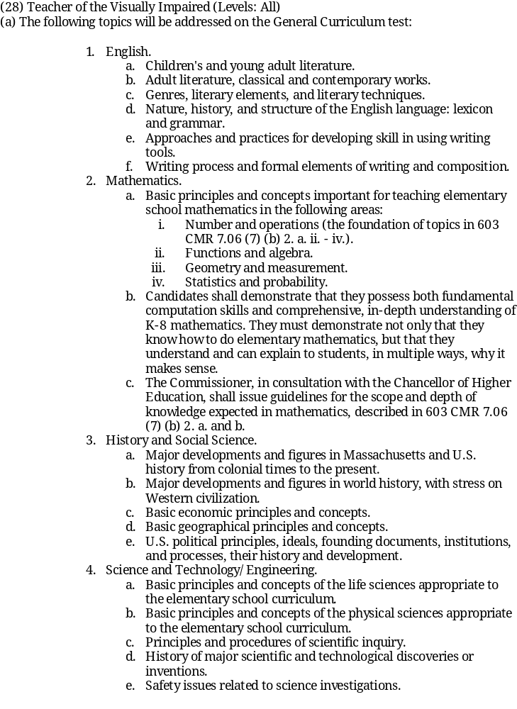

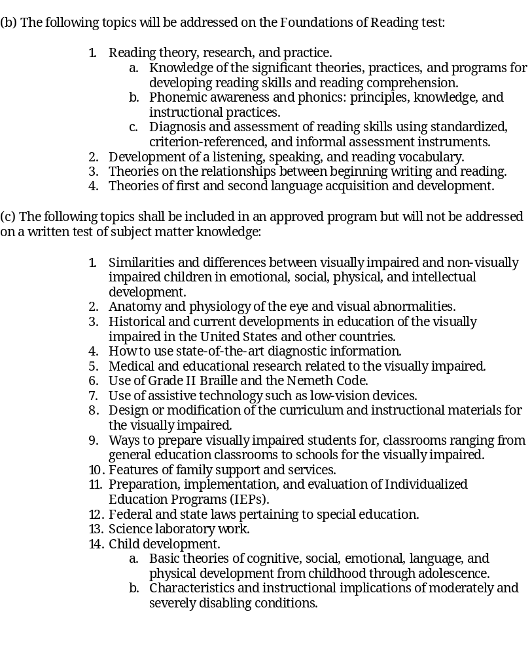

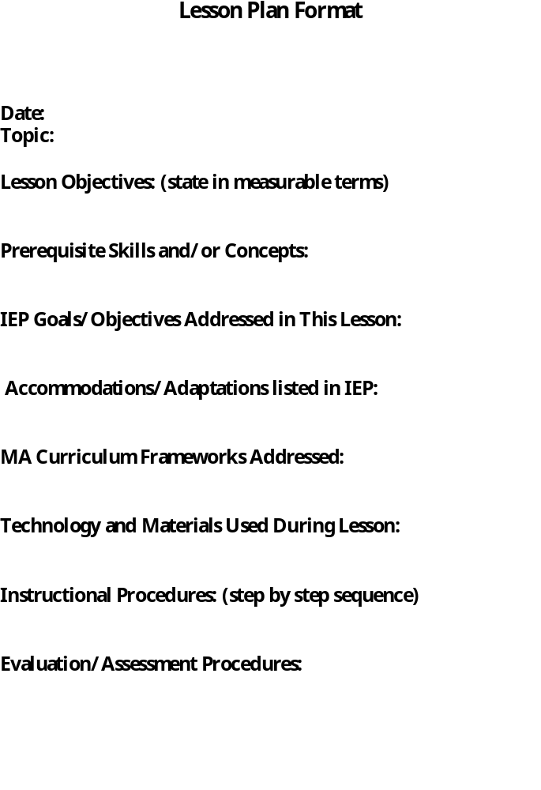

Educator Services Teaching & Learning Curriculum Resources
Massachusetts Curriculum Frameworks

Current Curriculum Frameworks
Subject | Release Date | Format(s)
Arts | October 1999
English Language Arts | June 2001  May 2004 | SUPPLEMENT*
Foreign Languages | August 1999
Comprehensive Health | October 1999
Mathematics | November 2000  May 2004 | INTERACTIVE VERSION  SUPPLEMENT*
History and Social Science | August 2003
Science and  Technology/Engineering | May 2001
English Language Proficiency  Benchmarks and Outcomes | June 2003
FRAMEWORKS ARCHIVE

Massachusetts Comprehensive Assessment System Test Items

Resource Guide to the Massachusetts Curriculum Frameworks for MCAS Alternate Assessment

Guidelines for Preschool Learning Experiences

Recommended Instructional Technology Standards
* Supplement to the Massachusetts English Language Arts Curriculum Framework Grades 3, 5, and 7 Grade-Level Standards for Vocabulary, Reading, and Literature, May 2004
* Supplement to the Massachusetts Mathematics Curriculum Framework Grades 3, 5, and 7 Grade-Level Standards, May 2004

