NodeMCU-32S , Node32s Pinout
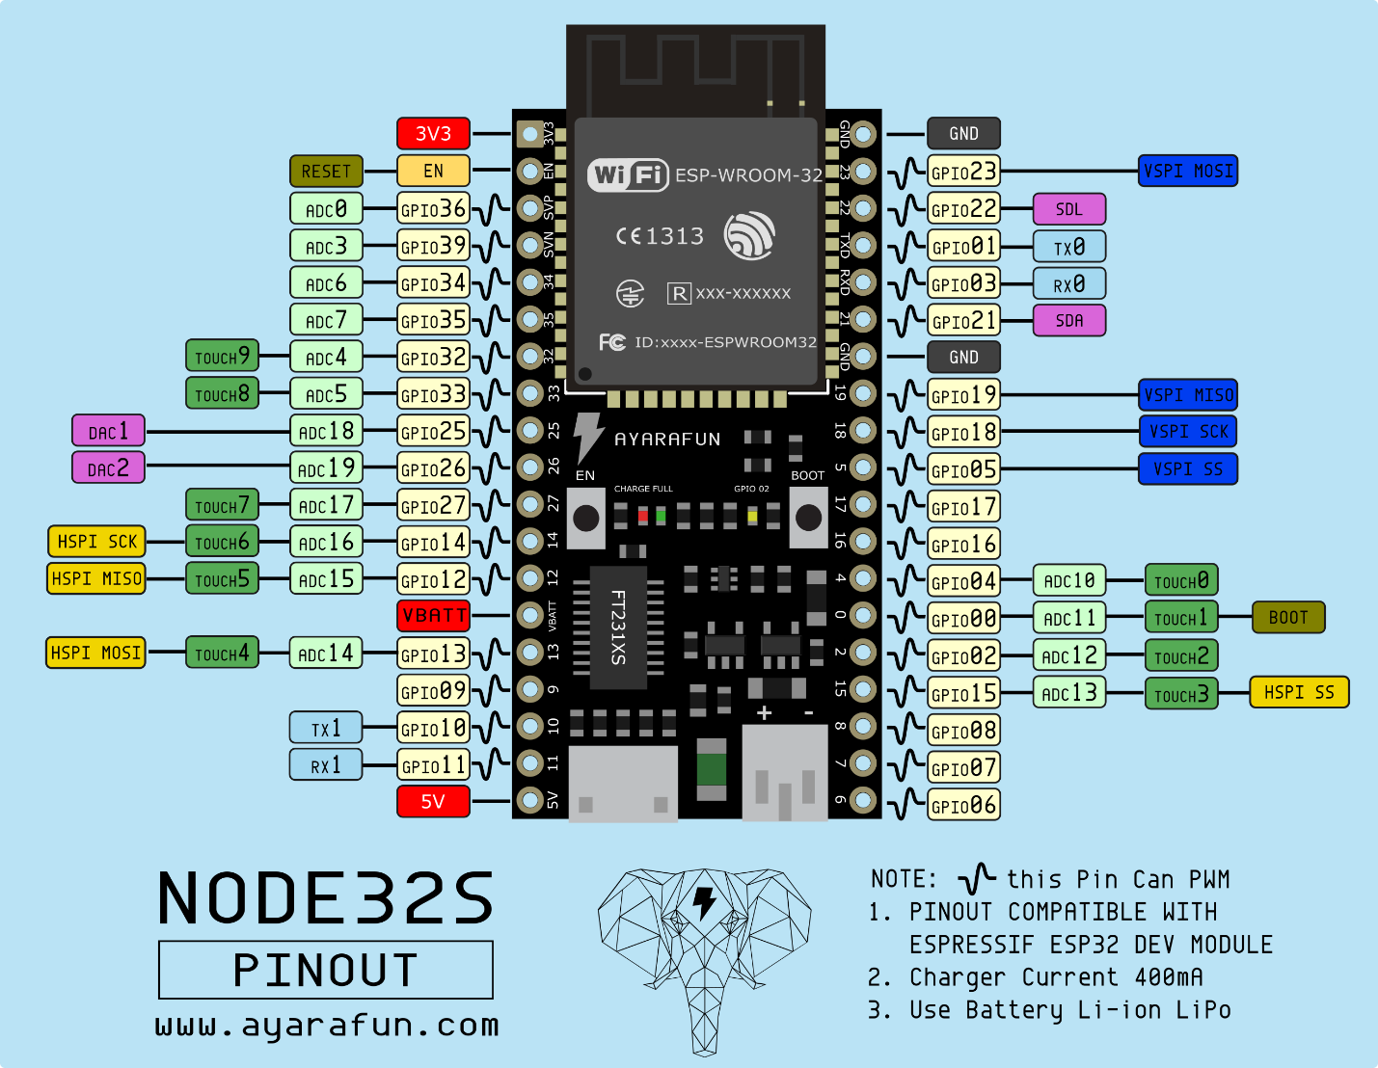
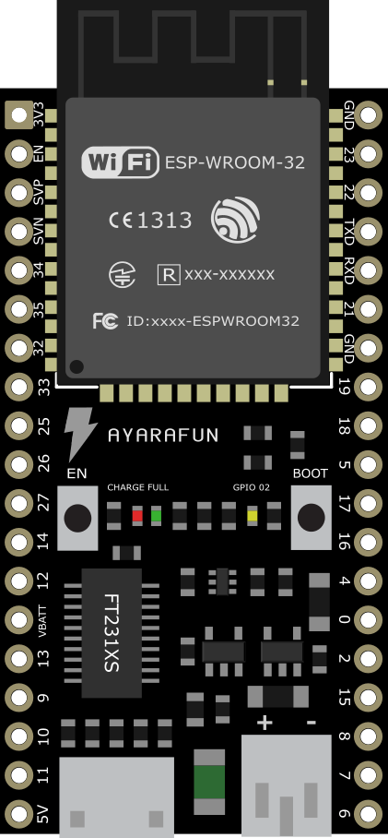

http://www.ayarafun.com/2016/11/esp32-node32s-pinout/

