* Vehicle
- Added deposit amount

It was linked with the vehicle when boolean field is true it will consider the deposit amount from the vehicle object.

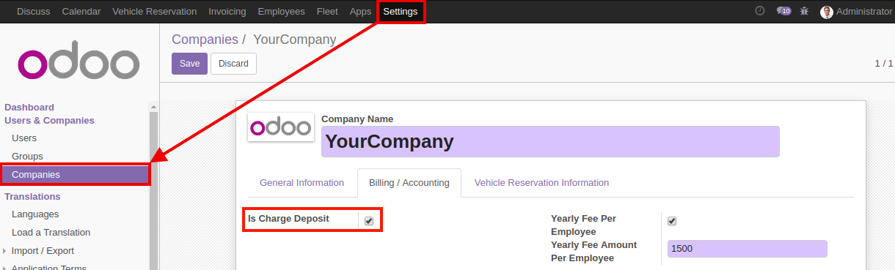

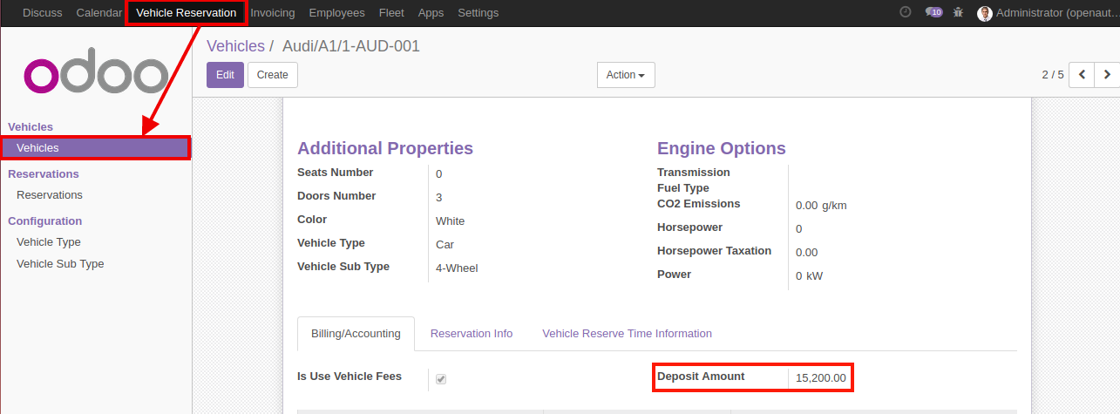

- Added vehicle smart button on vehicle type and vehicle sub-type
This Buttnos Are use for the Open related vehicles.

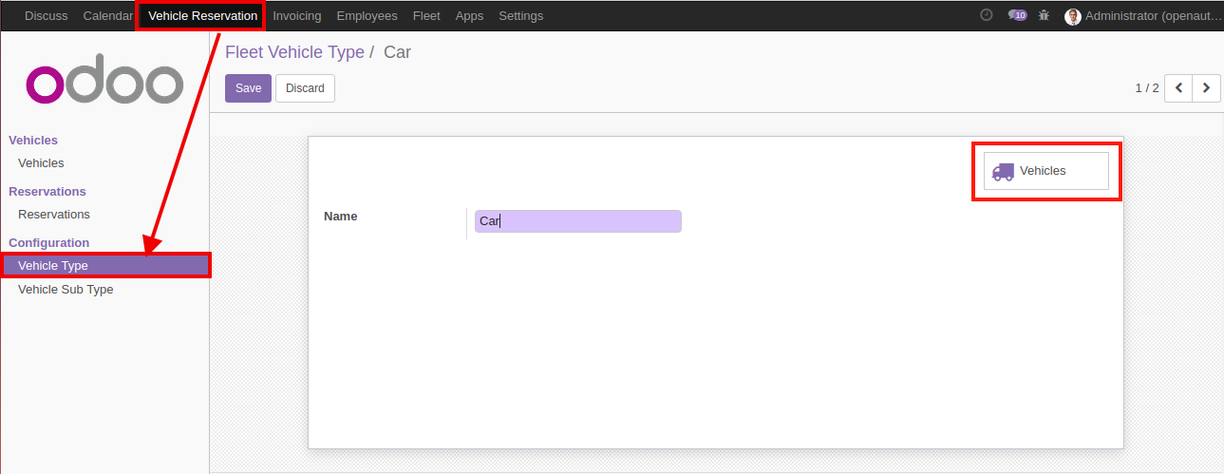

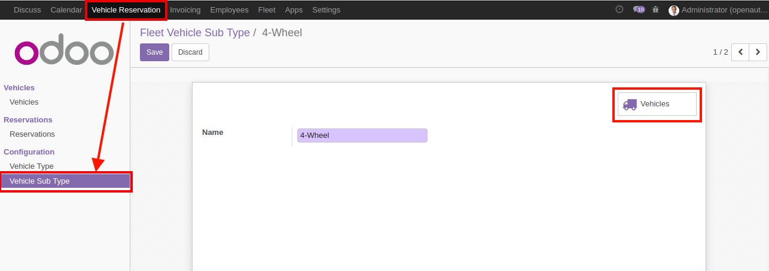

- Added vehicle not available time

It will be open two fields not available from , not available to it's consider this vehicle are not avail in b/w time.

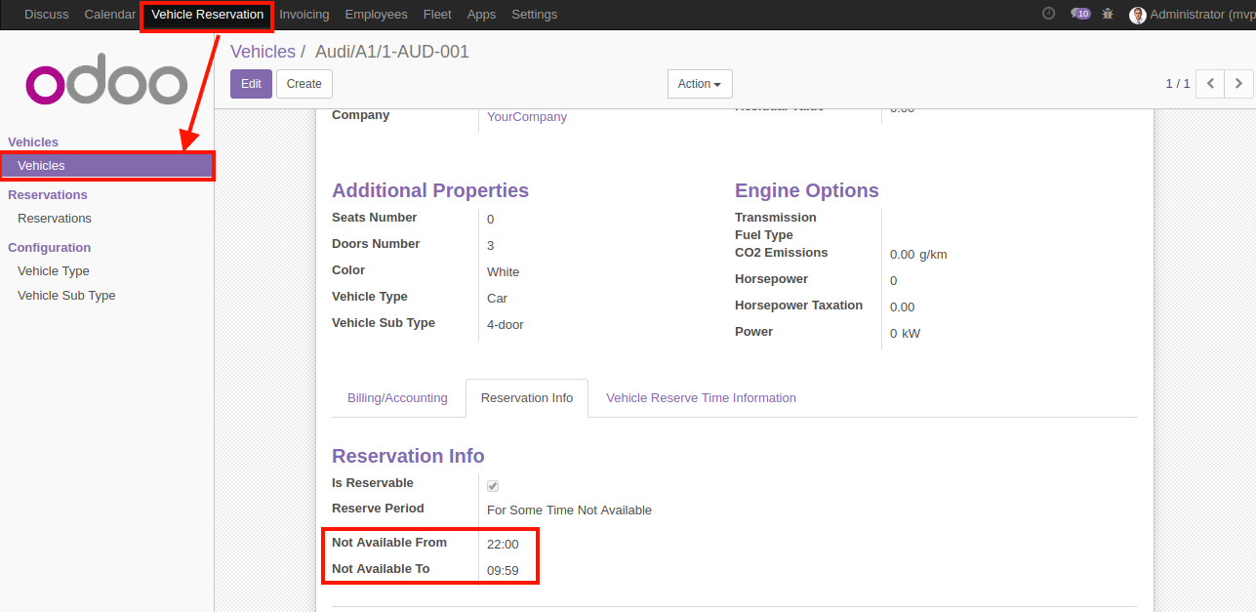

* Company
- Added invoice Amount.min

- Added graceInvoice.period
This will consider when it will be block a new reservation for the employee.
* Reservation:
- Added vehicle time availability validation from vehicle
It's generate validation error when employee will try to create reservation at out of reservation from ,available to from at vehicle .

- Added Note on reservation and pass to calendar event
Add new note on reservation schedule it will passed to the invoice and calendar event
- Do not create invoice for vehicle goes for service
Which reservation is for the service it wi;; not able to generate the invoice.
- Pass all the information to calendar event
* Employee
- Added Reservation details
Add reservation details to the employee form.

*ACL Fixed

