*Vehicle:-
Add Product for the Vehicle to add account in invoice.

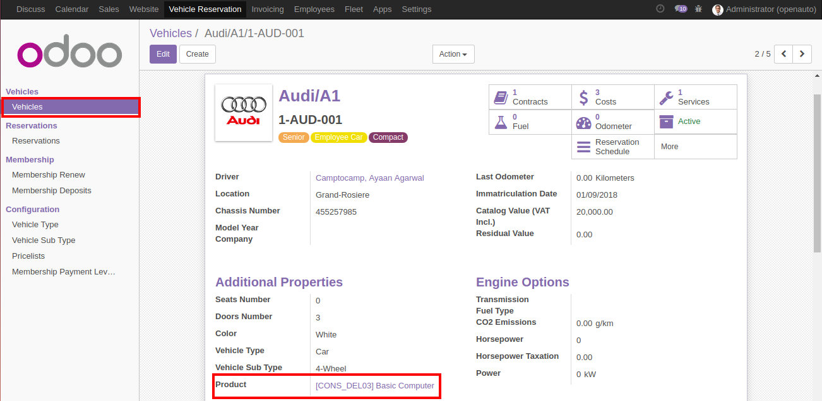

*Vehicle Reservations:-
Add New fields to the reservations for the information. And Also Add Price list of the emplyee it will used to create invoice.

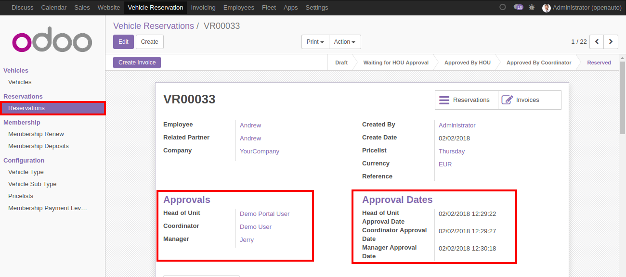

*Membership Renew :-
Membership renew is used to create membership of employee.

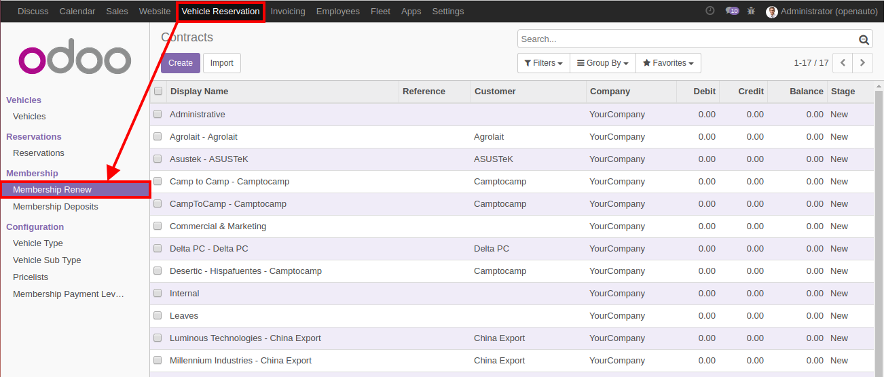

*Membership Deposit :-
Add Membership Deposit and Create Invoice from Create Invoice Button after Approved

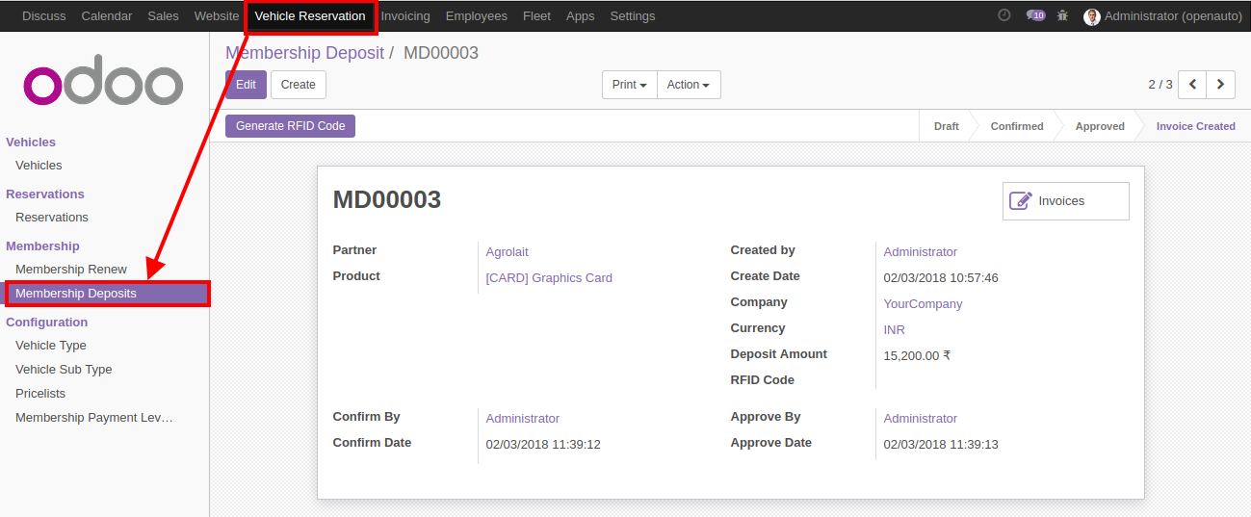

*Pricelist :-
Add Price list for the calculate the amount of the reservation invoice if it's startdate enddate was metch with lines.

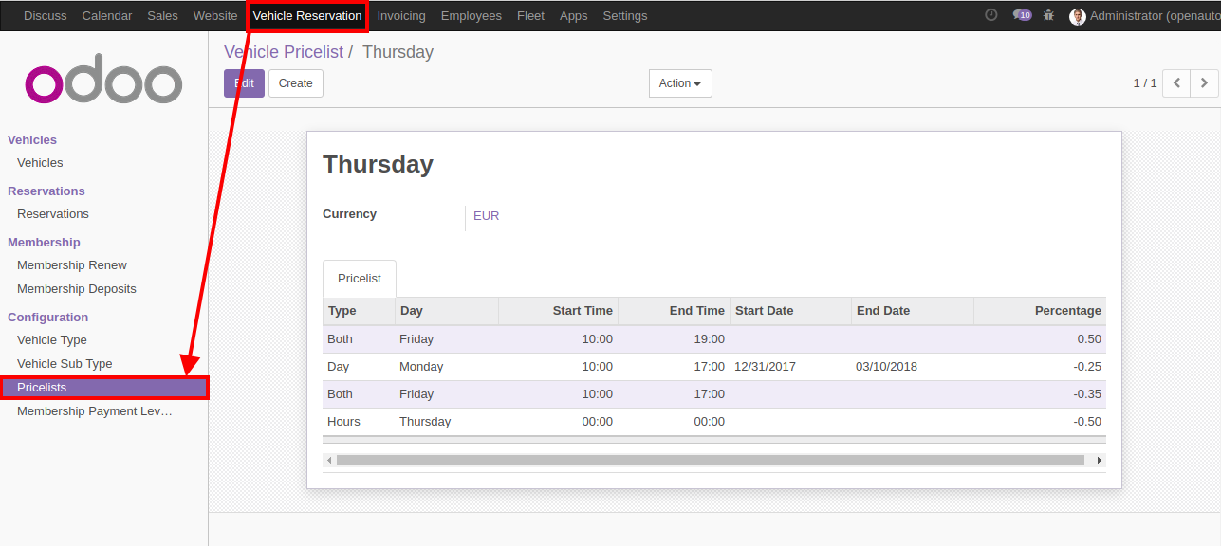

*Membership Payment Level :-
Payment level for the company advance payment level.

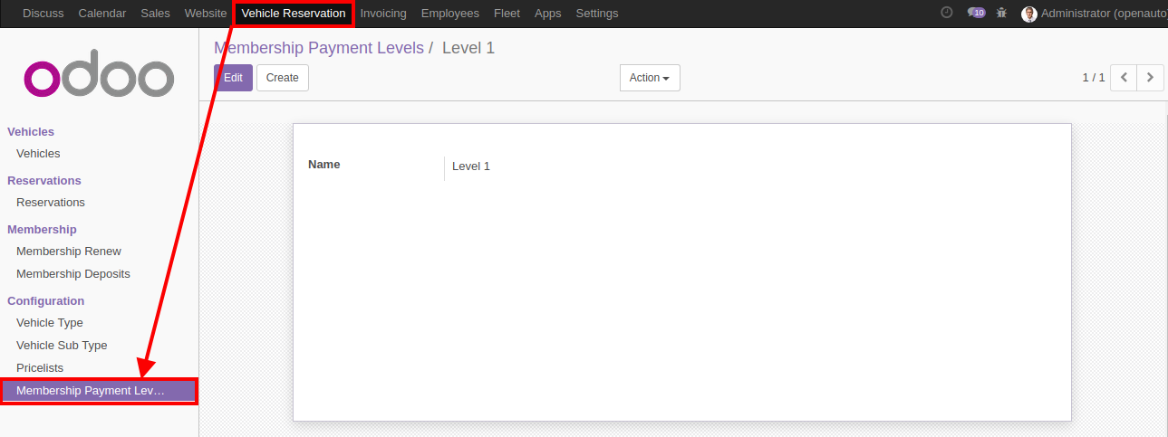

*Check in Wizard:-
Check in wizard is used for the get entry for the checkin time duartion from event.

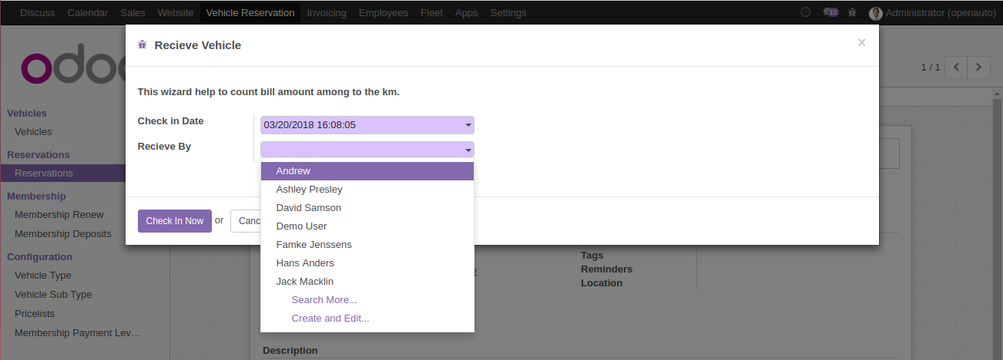
*Return Wizard
Return wizard will used for the get entry for the return vehicle.

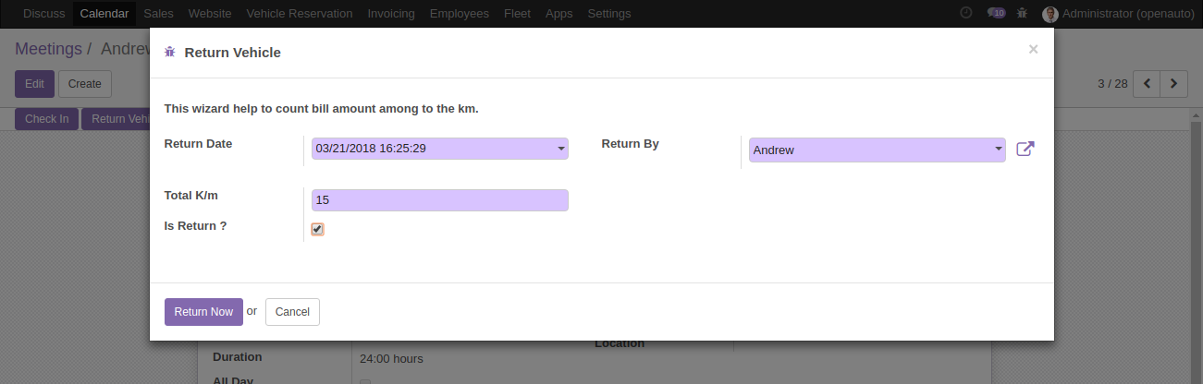
*Check in Return Info :-

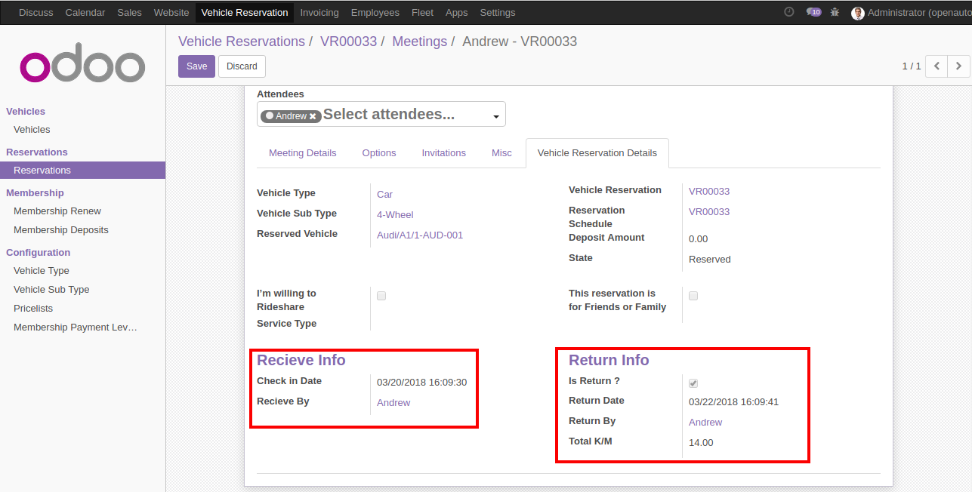

*Vehicle Reservation lines on invoice:-
You can create single invoice for single partner

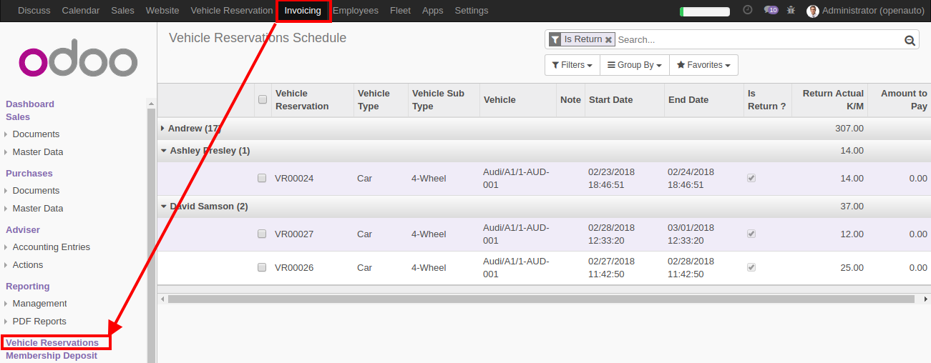

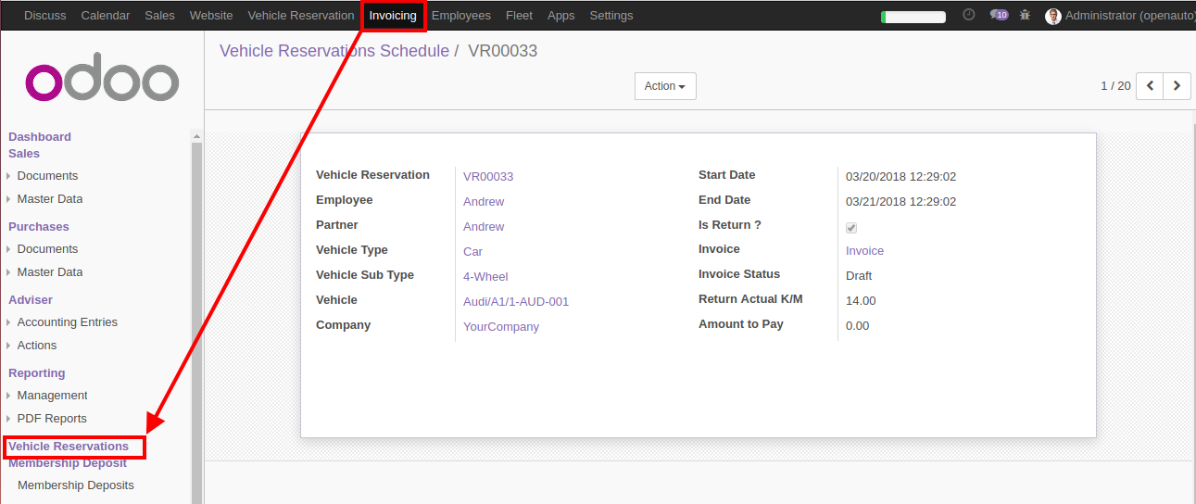

*Create Single invoice :-
Create Invoice Menu to open wizard.

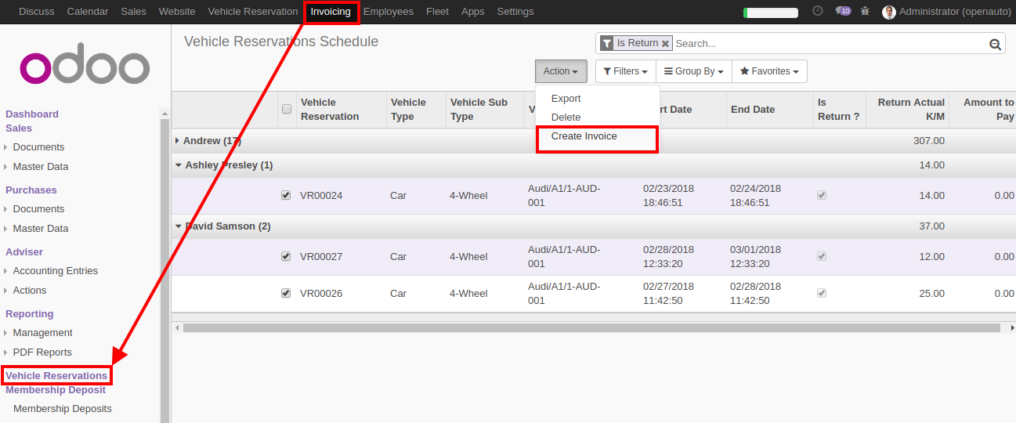

Create Single invoice of multiple reservations for each partner from wizard.

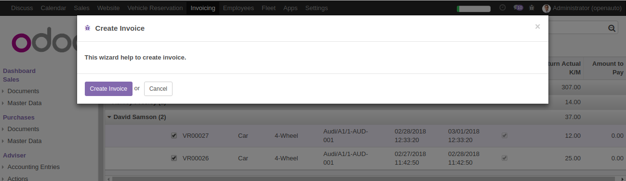

Create single invoice for each Partner

