* Vehicle
- Added deposit amount

It was linked with the vehicle when boolean field is true it will consider the deposit amount from the vehicle object.This deposit amount will be set on reservation schedule related to the selected vehicle.

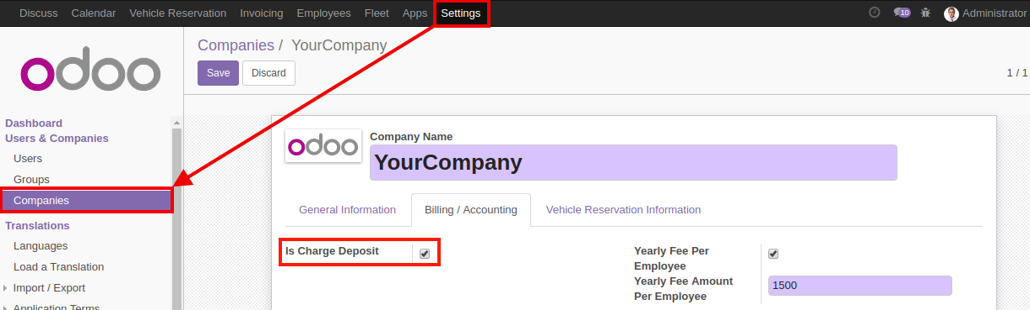

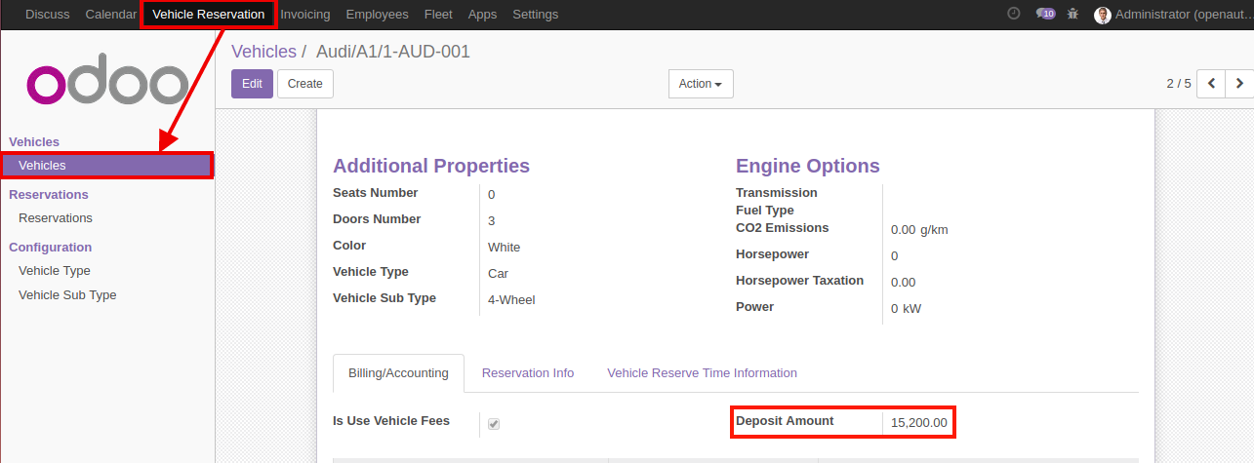

- Added vehicle smart button on vehicle type and vehicle sub-type
This Buttons Are use for the Open related vehicles.

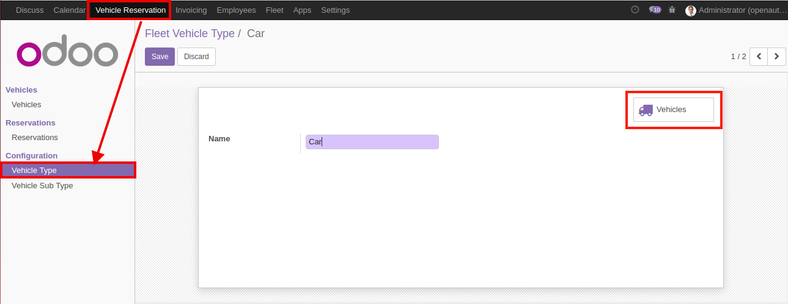

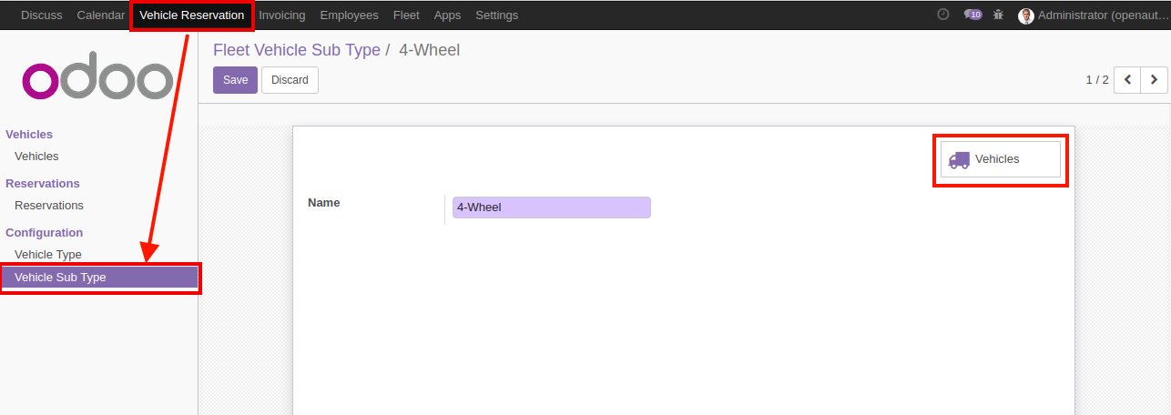

- Added vehicle not available time
It will be open two fields not available from , not available to it's consider this vehicle are not avail in between time.

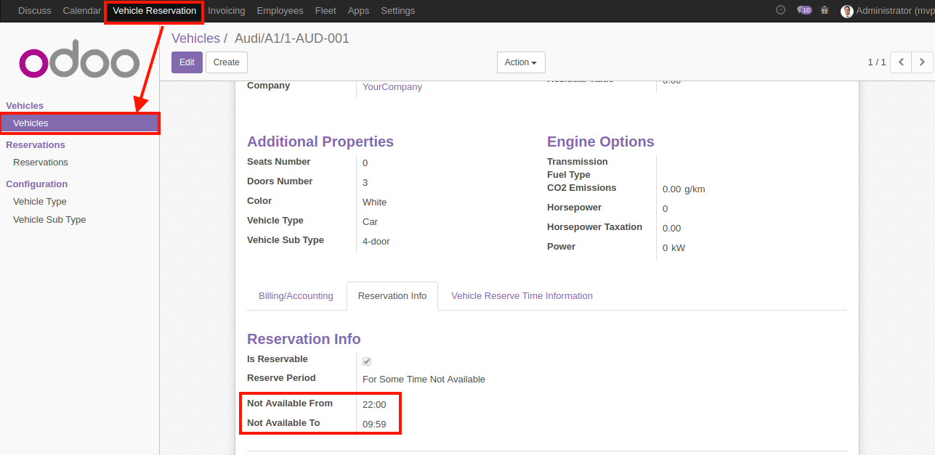

* Company
- Added invoice Amount.min

- Added graceInvoice.period
This will consider when it will be block a new reservation for the employee for perticular days.

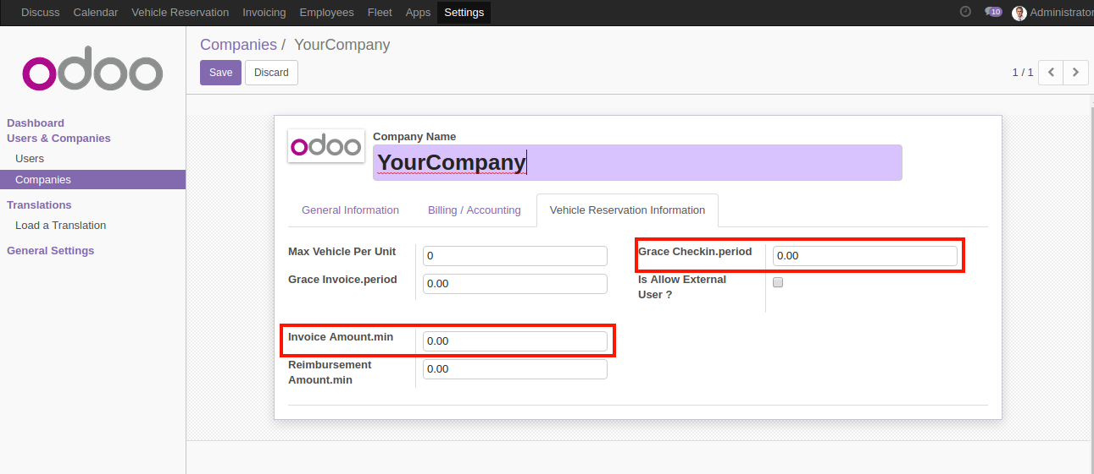
* Reservation:
- Added vehicle time availability validation from vehicle
It's generate validation error when employee will try to create reservation at out of reservation from ,available to at vehicle .

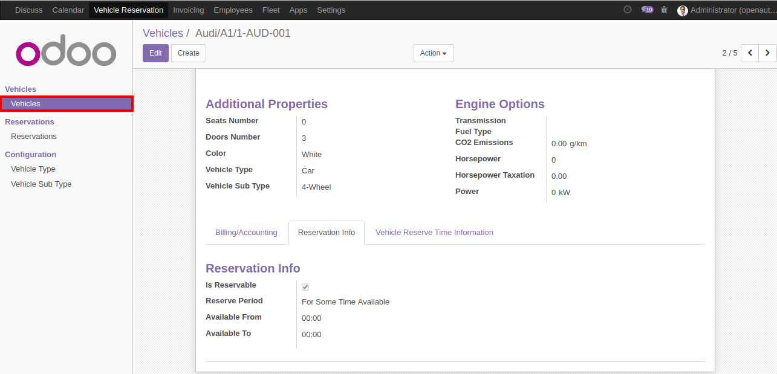

- Added Note on reservation and pass to calendar event
Add new note on reservation schedule it will passed to the invoice and calendar event

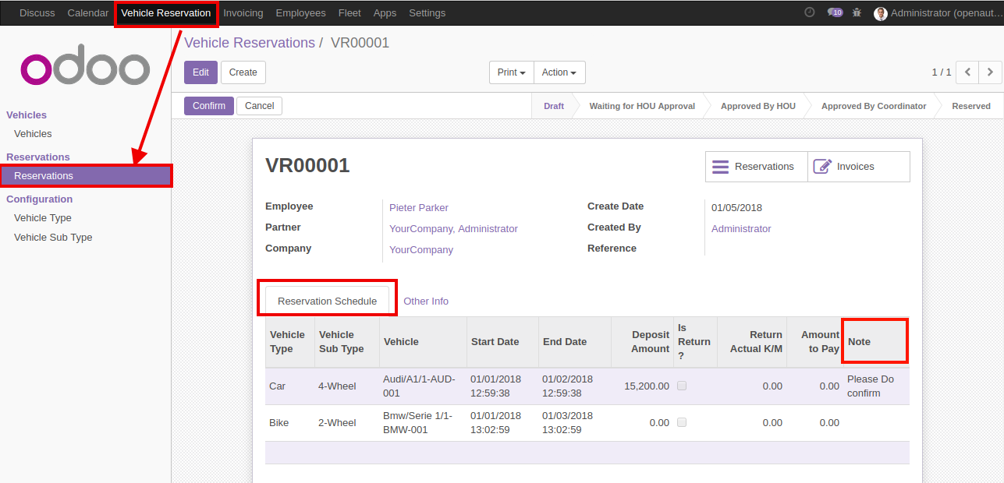
- Do not create invoice for vehicle goes for service
Which reservation is for the service it will not allowed to create invoice.
- Pass all the information to calendar event

* Employee
- Added Reservation details
Add reservation details to the employee form.

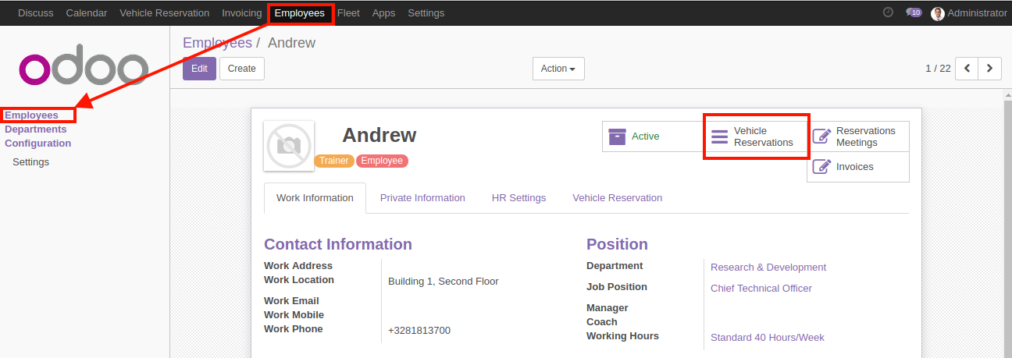

*ACL Fixed

