**Installing Linux OS UBUNTU on Windows 10**

Inspired by “How to Run Linux/Bash on Windows 10 Using the Built-In…” by Corey Schafer, YouTube

Search on “Features” and select “Turn Windows features on or off”. Scroll to bottom of features, select “Windows Subsystem for Linux”, and click ok.

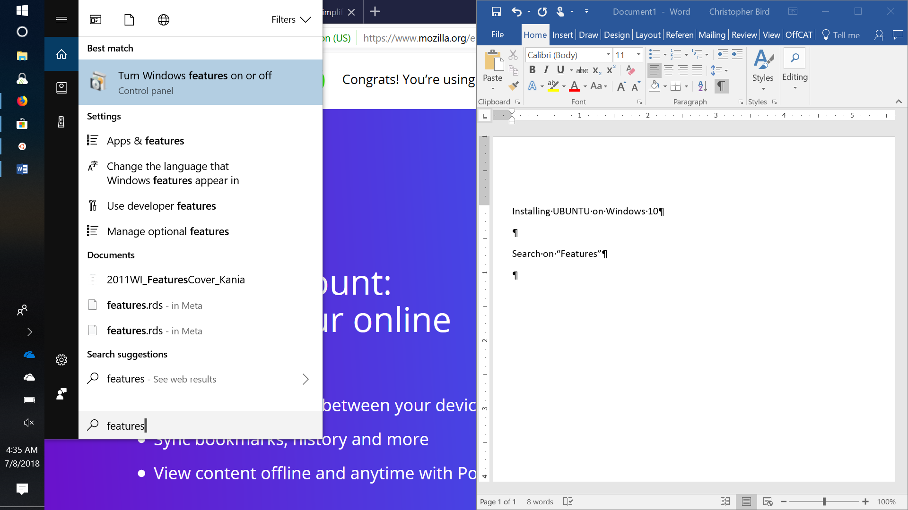 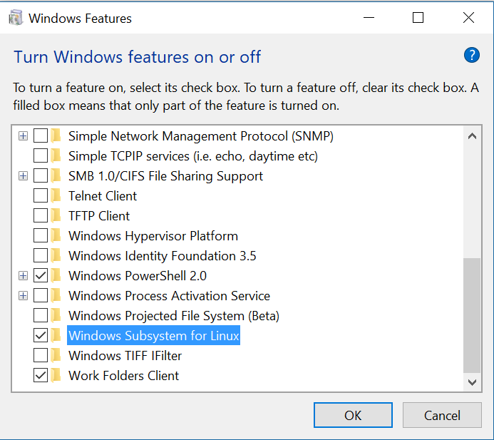

Your computer will restart.

Goto the Microsoft Store and search on “Linux”. Select “Get the apps” button

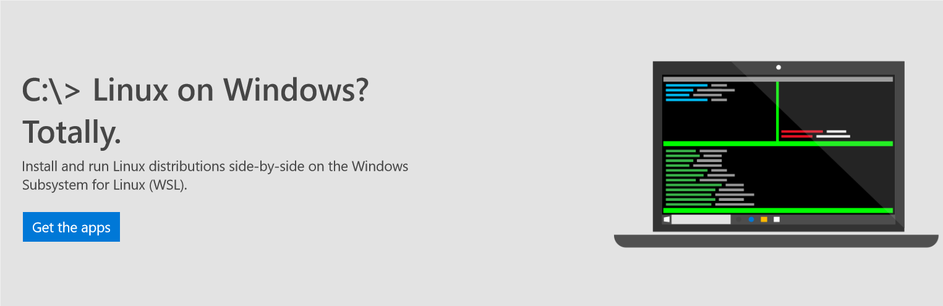

Select the UBUNTU installer and click “Install” button. When complete select “Launch”

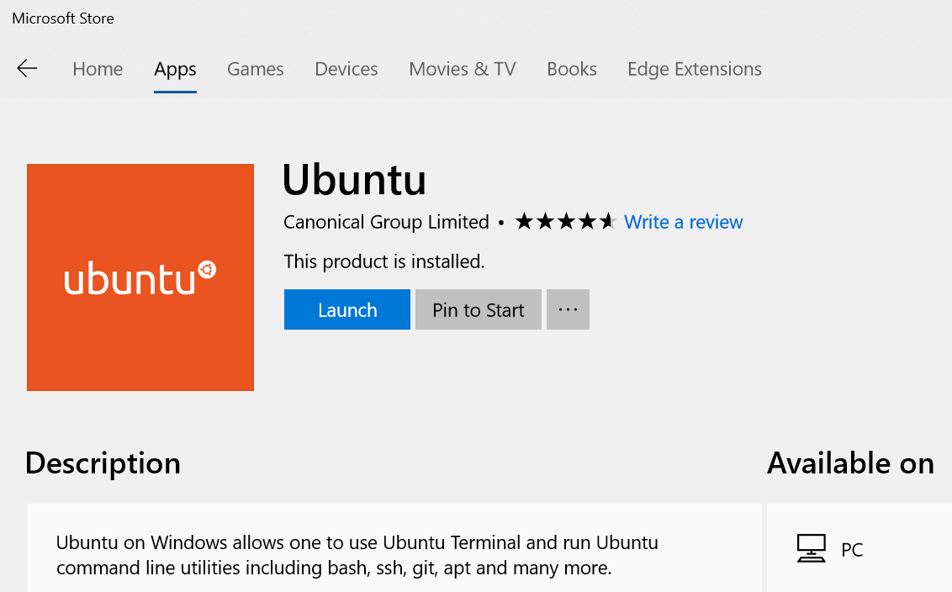

When prompted, type in your username and a password for UBUNTU.

Modify the .bashrc file to add a shortcut to your windows home directory, set the DISPLAY so gui apps will run, set the TERM so that nano will work correctly, and run the initialize.bash script fix the domain name bug, then save the changes (ctrl x) .

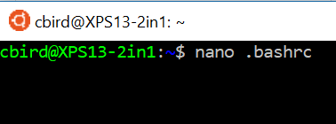

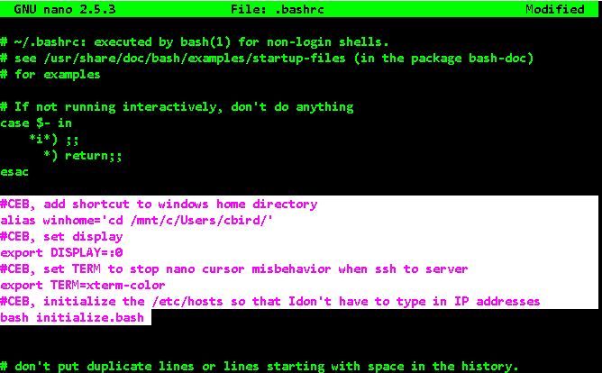

Make a script called initialize.bash in your home directory that will allow you to ssh to domain names rather than just ip addresses

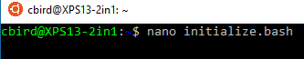

#!/bin/bash

#this script initializes my custom settings in UBUNTU on WINDOWS

sudo chmod 777 /etc/hosts

cp ~/hosts /etc

sudo chmod 555 /etc/hosts

Copy the file /etc/hosts to your home directory, then add to it the domain names and IP addresses that you will use.



sudo chmod 777 hosts



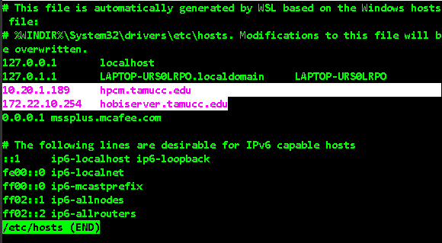

sudo chmod 555 hosts

Load the .bashrc settings

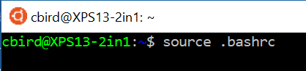

Update and upgrade UBUNTU. If prompted, enter a “y” for yes.

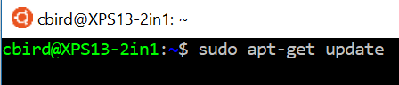

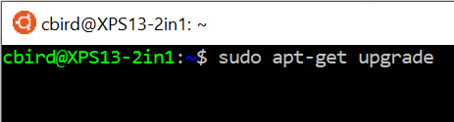

You need to install xming x server on windows and run it to run gui apps from UBUNTU

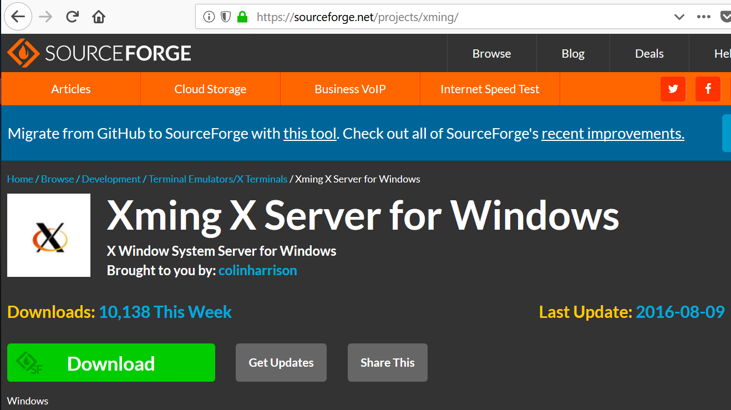

If you want to run gui programs through ssh within UBUNTU on Windows, then you need to create a ~/.ssh/config file as follows:

mkdir .ssh



Type the following

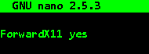

Close the file

Lastly, to make nano behave properly on a remote server, open ~/.profile with nano and add the following to the end of the file:

# This ssh alias function resolves an issue running nano within an ssh session

function ssh(){

/usr/bin/ssh -t ${@:1} "stty sane; export TERM=linux; bash"

}

