**Installing Software in UBUNTU on Windows**

You can install your favorite linux software using apt-get. For example, here’s how to install parallel, r, bwa, samtools, igv, vcftools

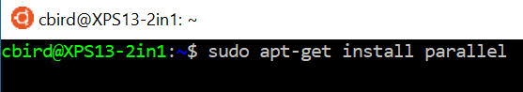

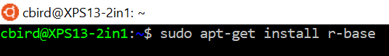

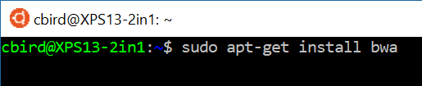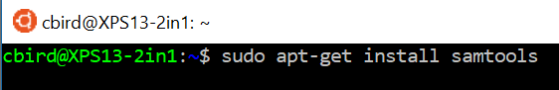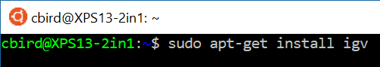



To run a graphical program from UBUNTU, like IGV, just type the name of the app (make sure that xming is running on windows and that you modified the .bashrc to export the DISPLAY).

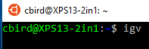

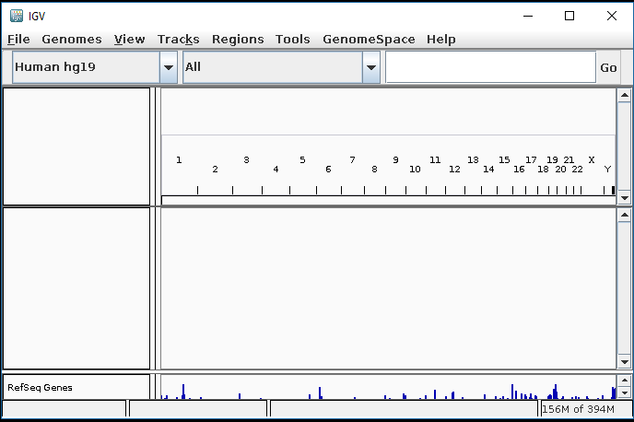

Not all programs are available through apt-get, and many that are available with apt-get are dated.

Download vcflib from github.com into your downloads directory using git, then compile it. Here’s a tutorial on installing software from github <https://www.lifewire.com/installing-software-using-git-3993572> . Note that I also read the README file after cloning vcflib. You will want to refer to the Linux Cheat Sheet: Package Installation for information on compiling software



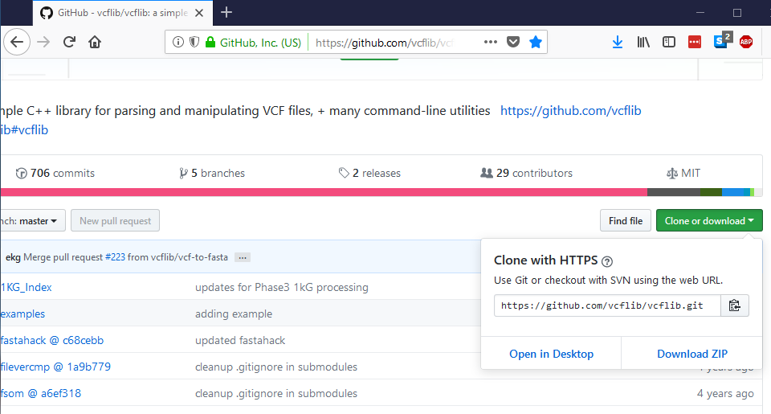



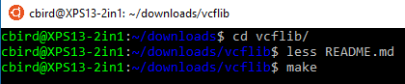

After compiling, you can copy the compiled vcflib software to the /usr/bin directory. For where to place files, consult the linux Filesystem Hierarchy Standard <https://en.wikipedia.org/wiki/Filesystem_Hierarchy_Standard>



Here’s an example of how to install a program from a website. We will install seaview <http://doua.prabi.fr/software/seaview> . Navigate to the website, copy the address of the 64-bit Linux seaview tar.gz file and wget it.

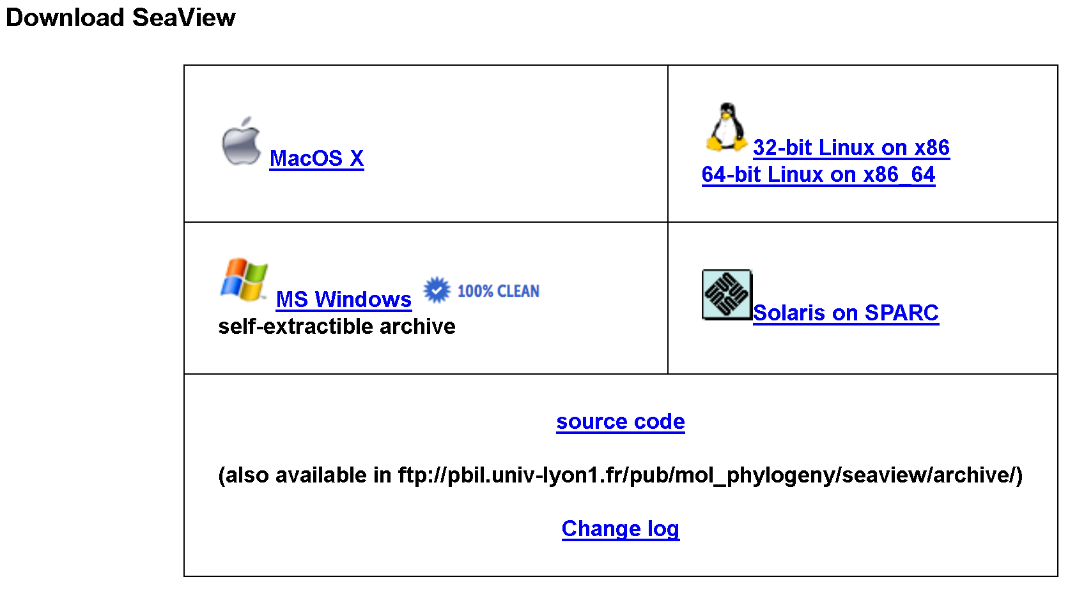



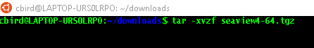

Now we move into the seaview directory and copy the compiled apps to the /usr/bin and try to run seaview. However, we find that a dependency is missing. I searched on the error message first, then just on the library that was missing. I then installed the missing library and tried to run seaview again

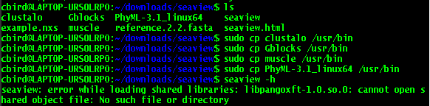

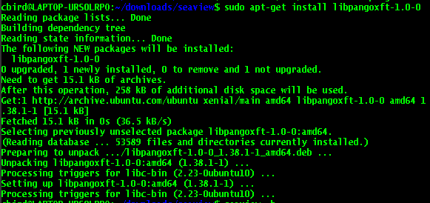

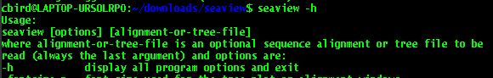

Success!

Finally, open a fasta file in seaview (if this doesn’t work, make sure that xming is turned on in windows and you have added the export DISPLAY line to the .bashrc)



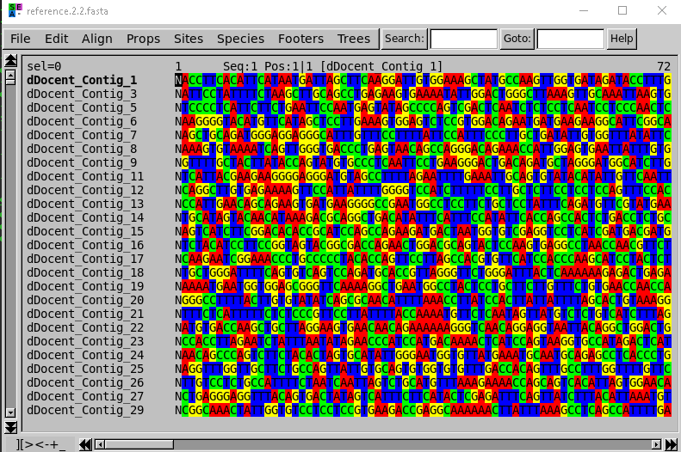

It’s worth noting that the seaview manual is an html doc, so you need a web browser to view it. You can use sudo apt-get install firefox to install firefox. When I did this, I subsequently had to update and upgrade then install firefox again to successfully complete installation:











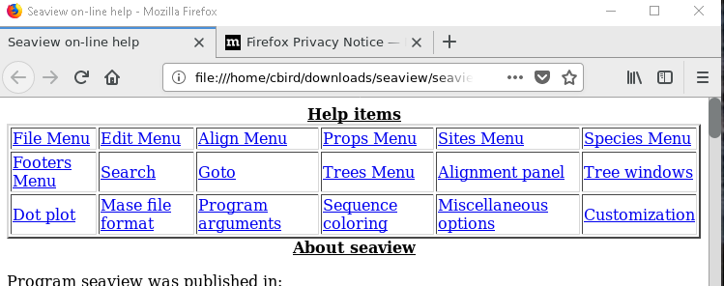

Seaview was pretty easy, for other programs, you may need to consult the Linux Cheat Sheat.