testSS_FC: Simple shear of gamma12=1.0; FC Taylor model
C:\Users\u0050438\Documents\svnserver\people\peyckens\tests_AlTaySub\VerifTests_bugfix_TRC\test_SimpleShear_beforeBugFix
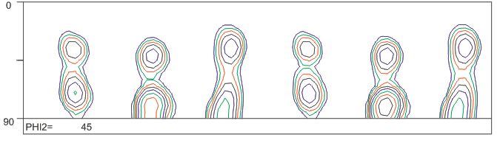
C:\Users\u0050438\Documents\svnserver\people\peyckens\tests_AlTaySub\VerifTests_bugfix_TRC\test_SimpleShear_beforeBugFix
