

**The SuchiVille Team**

**Developed by:**

Anthony Scinocco 200271982,

Alex Andriishyn 200296533,

Lyka Sunesara 200299883

Sam Parathuvayalil Sunny 200300762

**Table of Contents**

1. Logo 2
2. Web App Details 2
3. List of Pages 3
4. Version History 4
5. Color and Typography 4
6. Application Wireframes 4
7. Application Screenshots 4

**Description of the Web App:**

The online store SushiVille lets users to browse a huge catalog of sushi products, Filter the products based on the Sushi type. Users have the ability to Select items based on their preference and add them on to the shopping cart. And after they are done, they can view their shopping cart and modify the items in the cart. Once Users have confirmed their order, they can checkout. Users are also given the option to use an offer code to get discounts on their orders.

**Pages:**

**The Home Page** contains sample images of our products and also a link to the menu page.

**The Login Page** is where you log in to the website in order to add your address and other delivery information. Admins can also log in through this page in order to add or modify items in the catalog.

**The Register** **Page** is where you register yourself as a new user in order to add your address and other delivery information.

**The User Details Page** is a place wherea user can update their personal information on our website.

**Menu Item List Page** gives you a list of all the Sushi items based on the food type that the user chose.

**Item Details Page** shows the details of the selected food item. The Details include a name, a long description, the price and an image of the food item.

**Manage Items Page** provides an Administrator User with possibility to list, update or delete any item currently present in the catalog as well as create a new one.

**Add Item Page** allows an Administrator User to create a new item. You can enter the Name, the food type, the price, the description and the image URL of the new item.

**Edit Item Page.** Here, you can edit the details of existing item. You can edit the Name, the food type, the price, the description and the image URL of the item.

**The Delete Page** prompts the admin to confirm the deletion of the selected item.

**Version History**

<https://github.com/comp2086/comp2007f>

<Screenshot of Commit history goes here>

**Color and Typography**

<Fonts, colors and color codes used in the website goes here>

**Wireframes**

Home

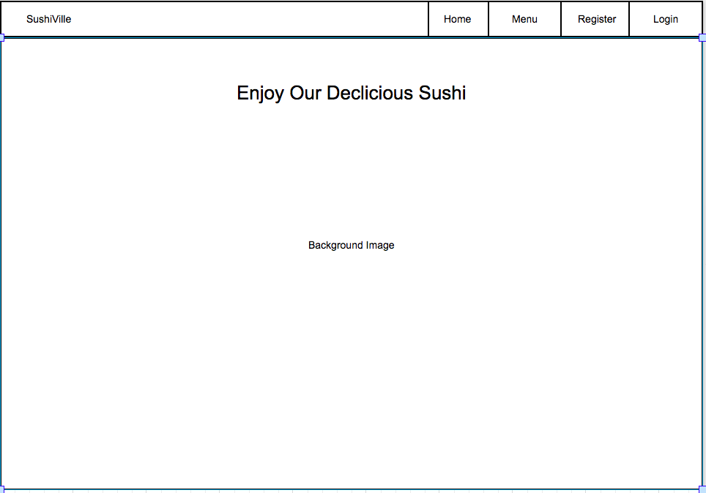

Menu

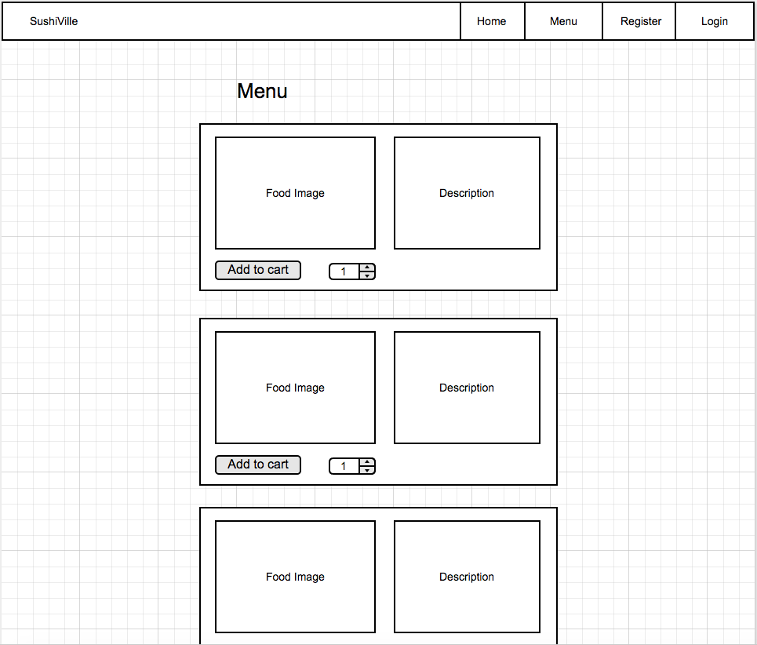

Login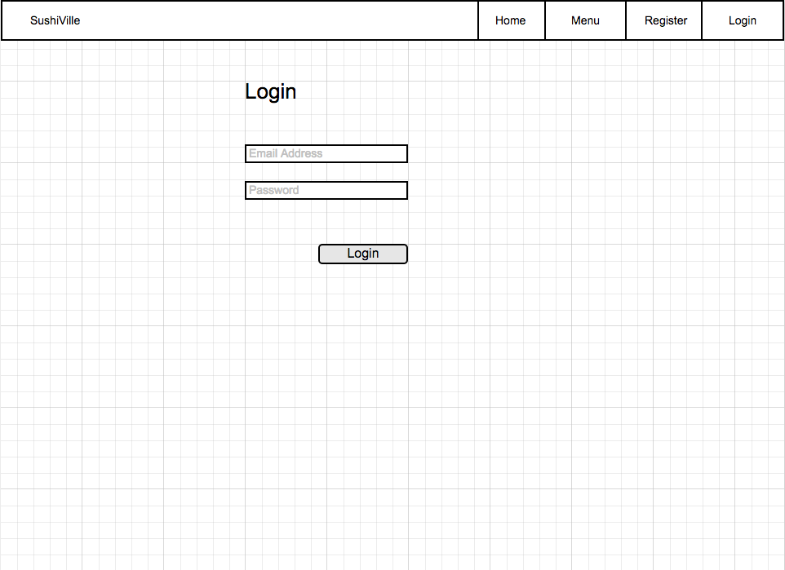

Register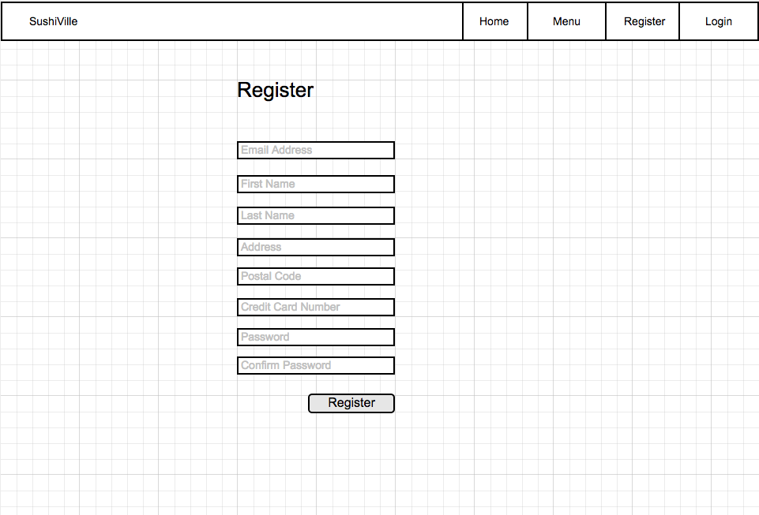

Cart

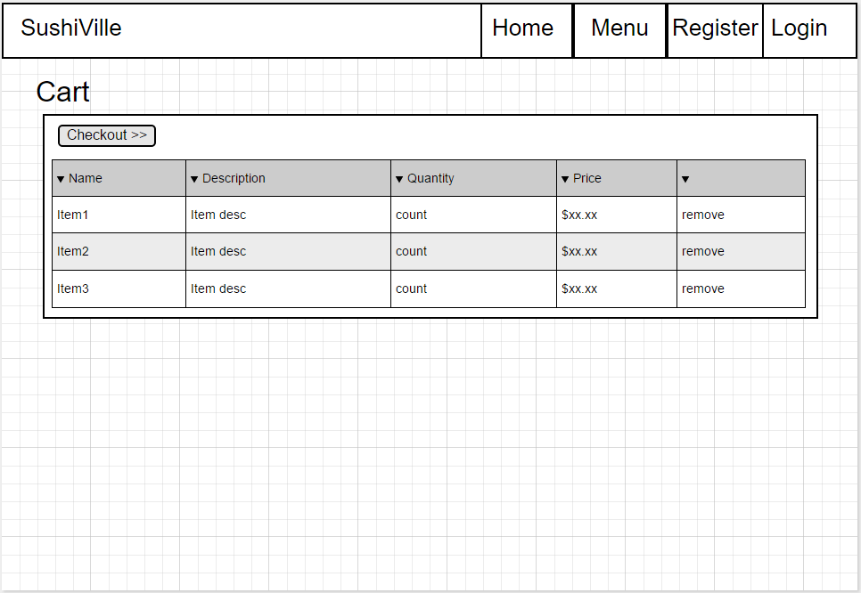

Address and Payment

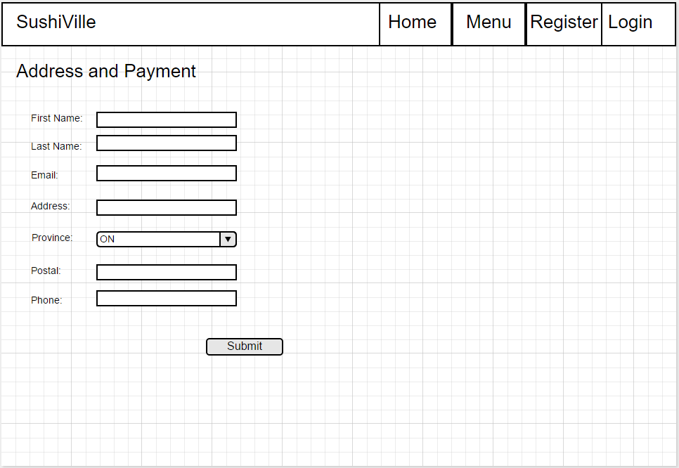

Order Confirmation

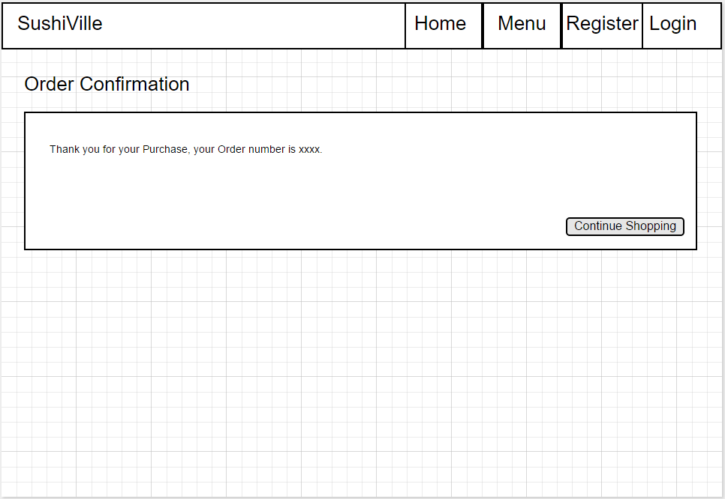

Manage Items

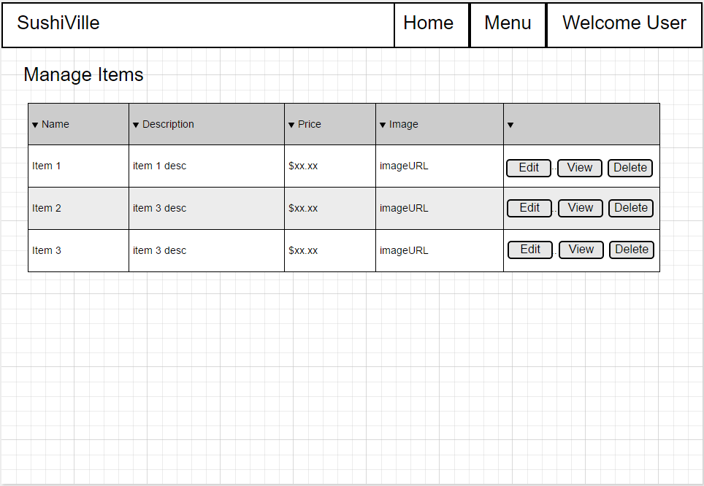

Add Item

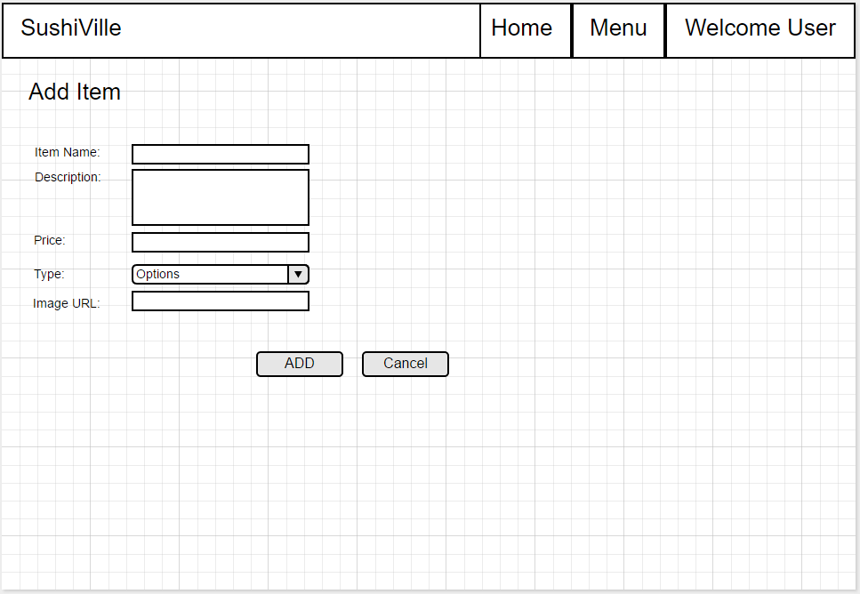

**Screen Shots**

<Website screenshots goes here>