APPENDIX C (END-USER & ADMINISTRATOR MANUALS)

User guide for administrator

This manual is for administrator

User guide for end user

This manual is helpful for normal user who’s using our application for the first time.

Home Page



When you run the application, this homepage will show up. In this screen, you can either 1) Your uploaded projects, 2) Explore more into various categories for search

The bottom tabs are used to navigate between

* Home
* equity calculator
* add posts
* search.

Navigation:



if you swipe to the right you will see the Drawer Menu in the left part of the screen

* Notifications: If user click  icon it will direct him to his notifications page.
* Payment: If user clicks on  icon it will direct him to his payment page.
* Support: If user clicks on  icon it will direct him to the support page where he can find help information about account, application problems.
* Log out: If user clicks on  icon he will log out from account.

Post details:

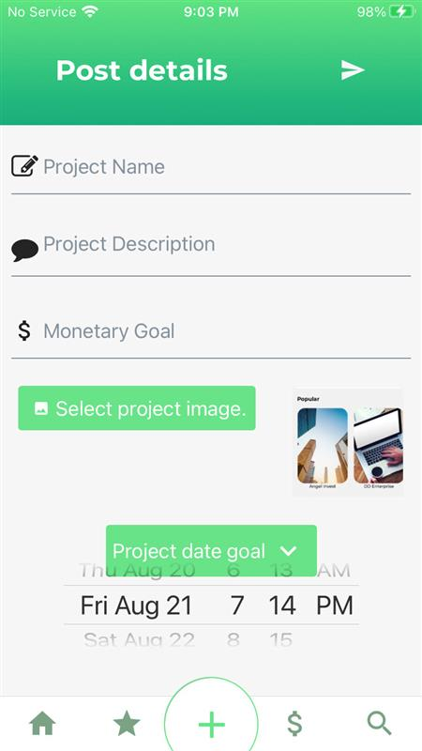

If the user clicks the "+" Icon they will go to the Post Screen, there you can input the

Project name

Project description

Money goal

Project image and

Date goal if any.

Posting Details and Review:

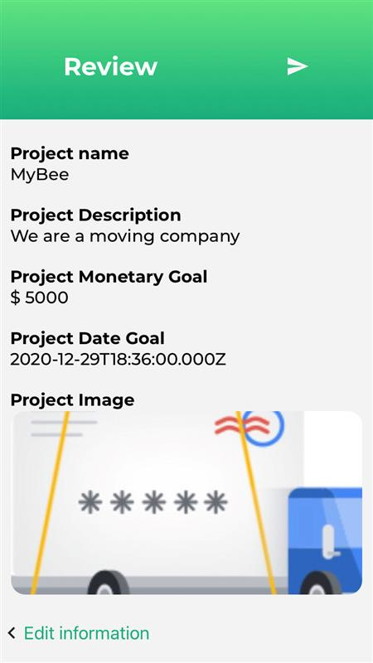

Once on filling the details you can review your edited values on the review project page

user can click the ">" Button and go to the review screen where they can review what they are about to submit. After that they can click the send Icon and submit the project

**Screens:**

Home Screen:

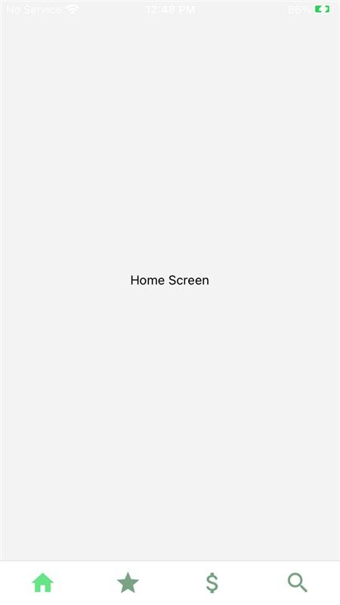

If the user clicks on icon, they will go to the Home Screen, where they see their overall information about their profile.

Favorite Screen:



If the user clicks on  icon, they will go to the Favorite Screen where they can find their favorite projects, investments etc.

Investments Screen:



If the user clicks on  icon, they will go to the Investments Screen where they can see their investments made on the application.

Search Screen:



If the user clicks on  icon, they will go the Search Screen where they can search and filter the post details regarding the category, price, ratings etc.