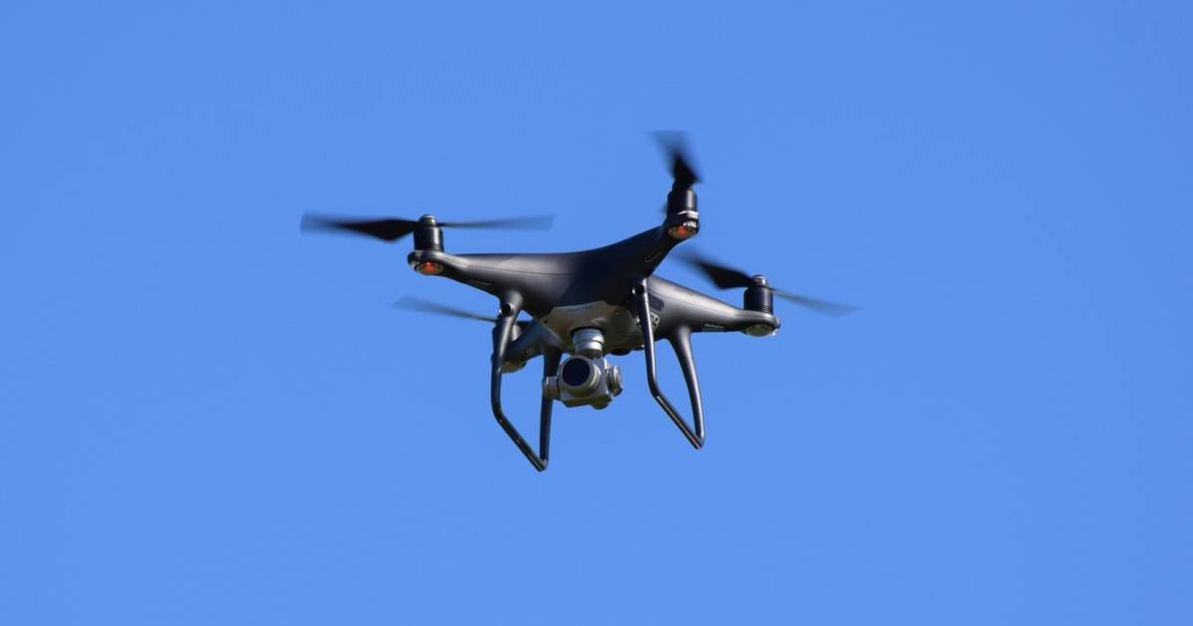

Pruned Intensity Graphs
Design Document

By: [Your Name Here]

Table of Contents
1. Introduction 3
1.1. Problem Overview 3
1.2. Problem Complexity 3
1.3. System Overview 3
2. Constructing the Intensity Graph 4
2.1. Understanding the Method Signature 4
2.2. Architecture 4
2.2.1. Building the Graph 4
2.2.2. Finding the intensityWeight 4
3. Constructing the Pruned Graph 6
3.1. Understanding the Method Signature 6
3.2. Architecture 6
3.2.1. Building the Graph 6
3.2.2. Pruning the Intensity Graph 6
3.2.3. Finding the prunedWeight 7
4. Test-Driven Development 8
4.1. Test Case Architecture 8
4.2. Building a Better Test Suite 8

Introduction

Problem Overview

[Restate the problem in your own words. Make sure to cover what the problem is you are trying to solve, what the inputs to the system are, and what the expected output is. Highlight how you plan to approach solving the problem in a high-level by outlining the remaining content in this document.]
[Should be at least ½ page in length. Remove all red instructional text for your final submission.]

Problem Complexity
[Answer/address all of the following: must be at least ½ a page:
- It is known at Seemo that the real solution to the salient object detection problem involves computing the shortest paths related to the intensity graph. State what algorithm from class you would use to find the shortest path from a vertex in the intensity graph to any other vertex in the intensity graph. Highlight why you would choose this algorithm and give its runtime.
- Explain why this algorithm is computationally expensive for the salient object detection problem, since we need to know the shortest path between each pair of pixels in the image.
  - Give examples with attributes a graph may have that would highlight how inefficient this can be.
  - Additionally, give the runtime of computing all the shortest paths needed for the salient object detection problem.
- Breadth-first search would be an efficient solution. Explain why BFS cannot be used to address the salient object detection problem.
]

System Overview
Method 1: constructIntensityGraph
[Answer the following: Why does this method exist? What problem does it address? [Must be at least 3 sentences] ]

Method 2: constructPrunedGraph
[Answer the following: Why does this method exist? What problem does it address? [Must be at least 3 sentences] ]

Helper methods and classes: [List what helper methods you think you should add and what additional classes you plan to add. For each, in a sentence, state what purpose it will serve. You should have at least 2 items here.]

Constructing the Intensity Graph

Understanding the Method Signature
[Fill in the following table: do not copy from the program handout.]

Method Structure | Purpose
constructIntensityGraph | [In 2 to 3 sentences, explain the purpose of this method.]
Parameter  (int [][] image) | [In 2 to 3 sentences, explain what data this parameter represents for the problem and why the int [][] is a good structure to pass that information to this method.]
Return value  (int intensityWeight) | [In a sentence, explain what the return value is for this method.]

Architecture

Building the Graph
[To correctly produce the right return value, you first need to translate the int [] [] image into an intensity graph, i.e. into a graph, which you can learn reason over. Fill in the following table, add rows as needed:]
Graph Object Oriented Construction

Object | Description
[Name] | Representation: [this object class captures what information]  Fields:  - [list the fields you’d create and state the purpose of each field.]

Adjacency List vs. Adjacency Matrix.
[Your outlined graph is either the adjacency list or the adjacency matrix representation of a graph. (Every runtime we’ve discussed in class assumes you set up an adjacency list but you do not have to. However, you’ll need to reason about the correct runtime for whichever representation you used.]
[Explain which representation you use and why you chose this representation. Must be at least 4 sentences].

Finding the intensityWeight
[The return value for this problem is the intensity weight. Once you have the intensity graph translated from a int [ ] [ ] array to a graph, you now need to find the intensity weight.]

Steps to find the intensity weight once the intensity graph is formed:

- [Give an algorithm that assumes you have a graph and calculate the intensity weight]

Runtime and Correctness.
[Give and justify the runtime of your algorithm to find the intensity weight. Remember: it’ll be different for the list representation vs matrix. Give a correctness argument for your algorithm. Must be at least 4 sentences.]

Constructing the Pruned Graph

Understanding the Method Signature
[Fill in the following table: do not copy from the program handout.]

Method Structure | Purpose
constructPrunedGraph | [In 2 to 3 sentences, explain the purpose of this method.]
Parameter (int [][] image) | [In 2 to 3 sentences, explain what data this parameter represents for the problem and why the int [][] is a good structure to pass that information to this method.]
Return value (int) | [In a sentence, explain what the return value is for this method.]

Architecture

Building the Graph
[To correctly produce the right return value, you first need to translate the int [] [] image into an intensity graph, i.e. into a graph, which you can then reason over to prune edges and make a pruned graph.]

[Explain why you will use the same process to build a graph for this method as you . Must be at least 5 sentences.]

Pruning the Intensity Graph
[What algorithm will you use to solve this problem? Justify why this algorithm should be used. Must be at least 5 sentences]

Steps to produce the pruned edges:

- [Give an algorithm that takes an intensity graph and produces a pruned version of the graph]

Data structure: [Name]
[The algorithm you chose requires a certain data structure in order to be efficient. Name the data structure and highlight how you will create this data structure within your code. It will require a helper method on the side and/or specific fields added to your graph you constructed. Make sure you convey all of these.]
Plans to create the data structure within the code base:
- [A]
- [B]
- [C]

Runtime and Correctness.
[Give and justify the runtime of your algorithm to find the pruned graph. Remember: it’ll be different for the list representation vs matrix. Your data structure also plays into your runtime. Give a correctness argument for your algorithm. Must be at least 6 sentences.]

Finding the prunedWeight
[The return value for this problem is the pruned weight. Once you have the intensity graph translated from a int [ ] [ ] array to a graph and you’ve pruned the edges, you now need to find the pruned weight.]

Steps to find the pruned weight once the pruned intensity graph is formed:

- [Give an algorithm that assumes you have a pruned graph and calculate the pruned weight]

Runtime and Correctness.
[Give and justify the runtime of your algorithm to find the pruned weight. Remember: it’ll be different for the list representation vs matrix. Give a correctness argument for your algorithm. Must be at least 4 sentences.]

Test-Driven Development

Test Case Architecture
Test Case Component | Description
Image input | [In 3 to 4 sentences, explain what the imageX [ ] [ ] portion of the test you create actually represents of the graph. Make sure to address: Why do we not need an additional test input that gives the name of vertices? How can this int [ ][ ] be all we need to render the graph?]
Expected output: intensity graph weight | [What is the expected output? It is possible for the actual output of your program to be correct but implementation is wrong. Explain why this can happen. What would be a more rigorous expected output to test the intensity graph?]
Expected output: pruned graph weight | [What is the expected output? It is possible for the actual output of your program to be correct but implementation is wrong. Explain why this can happen. What would be a more rigorous expected output to test the pruned intensity graph?]

Building a Better Test Suite
[For 3 test cases that you submitted as your interesting test cases, fill out the following:]
Test Case ID: [unique name]
- Motivation for test: [explain why this graph was an interesting test case]
- If this test fails, what will you learn: [explain how this test case would help you debug your program if it failed]
- If this test passes, what will you build confidence in: [explain how this test case would help you feel confident in specific aspects of your solution. You must be detailed here not vague/hand-wavy.]

Test Case ID: [unique name]
- Motivation for test: [explain why this graph was an interesting test case]
- If this test fails, what will you learn: [explain how this test case would help you debug your program if it failed]
- If this test passes, what will you build confidence in: [explain how this test case would help you feel confident in specific aspects of your solution. You must be detailed here not vague/hand-wavy.]

Test Case ID: [unique name]
- Motivation for test: [explain why this graph was an interesting test case]
- If this test fails, what will you learn: [explain how this test case would help you debug your program if it failed]
- If this test passes, what will you build confidence in: [explain how this test case would help you feel confident in specific aspects of your solution. You must be detailed here not vague/hand-wavy.]

