Architecture Design
for
Brew Day!
Version 1.0 approved
Prepared by
Guo Rui 1630013011
Ji Jia 1630003023
Xie Qizhou 1630003056
Chen Mingxuan 1630003002
Atanasoff
23:45 03/04/2019
Table of Contents
Table of Contents ii
Revision History ii
1. Overview 1
1.1 Project description 1
“Brew Day!” is an application that allows home brewers to maintain an organized database of their beer recipes. The application allows users to create, store and modify recipes, and later on delete them, if the user wishes to do so. And users can write note after using a specific recipe to brew beer. 1
1.2 References 1
1.3 Design purpose 1
2. Overall description 1
2.1 Use case diagram and class diagram 1
2
2.2 Design model 3
2.3 System architecture 3
3. System architecture 5
3.1 Recipe Subsystem 5
3.1.1 Description 5
3.1.2 Database 5
6
3.2 Equipment Subsystem 6
3.2.1 Description 7
3.2.2 Database 7
3.3 Note Subsystem 8
3.3.1 Description 8
3.3.2 Database 8
4. Assessment 9
4.1 Stability 9
4.2 Reusability 9
4.3 Scalability 9
5. Alternative design (optional) 9
6. More considerations 9
7. Appendix 9

Revision History
Name | Date | Reason For Changes | Version
Guo Rui, Ji Jia, Chen Mingxuan, Xie Qizhou. | 03/04/2019 | The first version. | Initial Version

Overview

Project description

“Brew Day!” is an application that allows home brewers to maintain an organized database of their beer recipes. The application allows users to create, store and modify recipes, and later on delete them, if the user wishes to do so. And users can write note after using a specific recipe to brew beer.

References
[1]. IEEE Software Engineering Standards Committee, “IEEE Std 830-1998, IEEE Recommended Practice for Software Requirements Specifications”, October 20, 1998.
[2]. Simon Bennett; Steve McRobb; Ray Farmer, “Object Oriented Systems Analysis and Design Using UML”, (4th Edition), McGraw Hill, 2010.
[3]. Guo Rui; Chen Mingxuan; Xie QiZhou; Ji Jia, “SRS_Atanasoff_v2.1”, Atanasoff Company, 2019.

Design purpose
The architecture design document is to divide the system into several parts and let users work together in a more efficient way.

Overall description

Use case diagram and class diagram
Use case diagram.

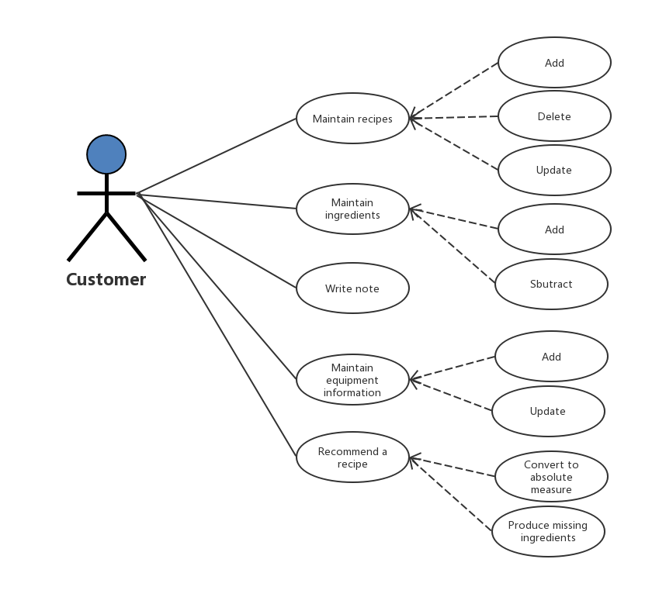

Class diagram.

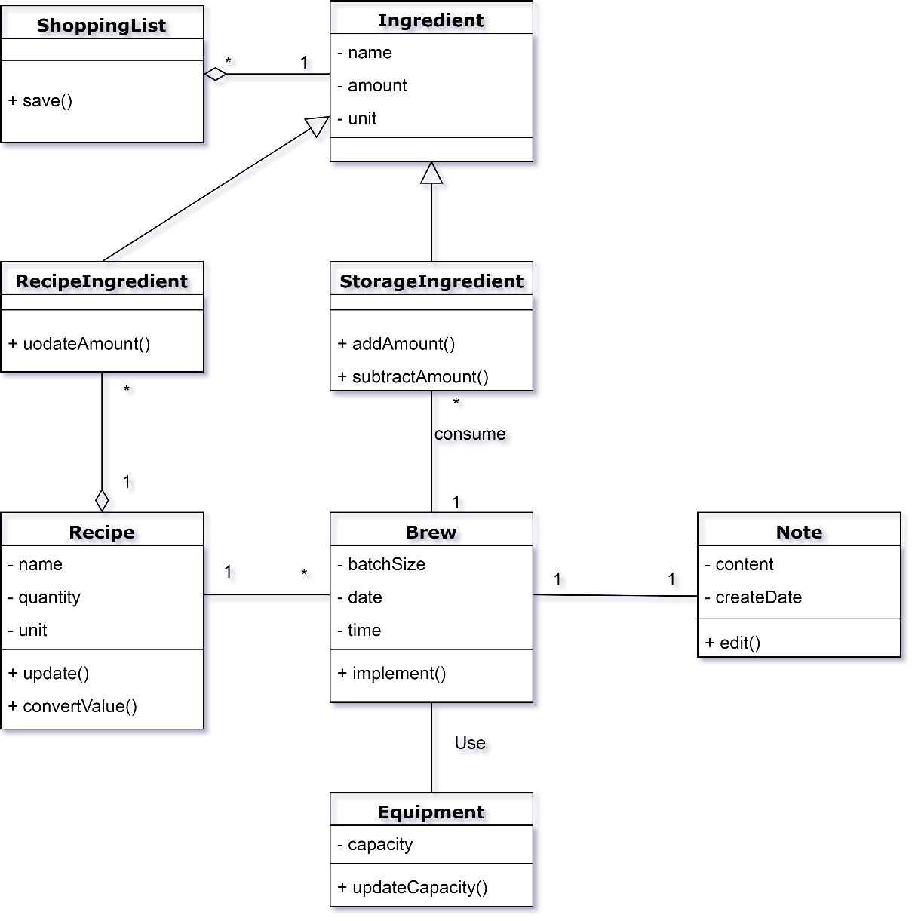

Design model
We built the architecture on MVC model. Because MVC can be developed simultaneously. And MVC enables logical grouping of related actions on a controller together. The views for a specific model are also grouped together, which has really high cohesion. It is easy to develop and modify in the future, because of the separation of responsibilities.

System architecture

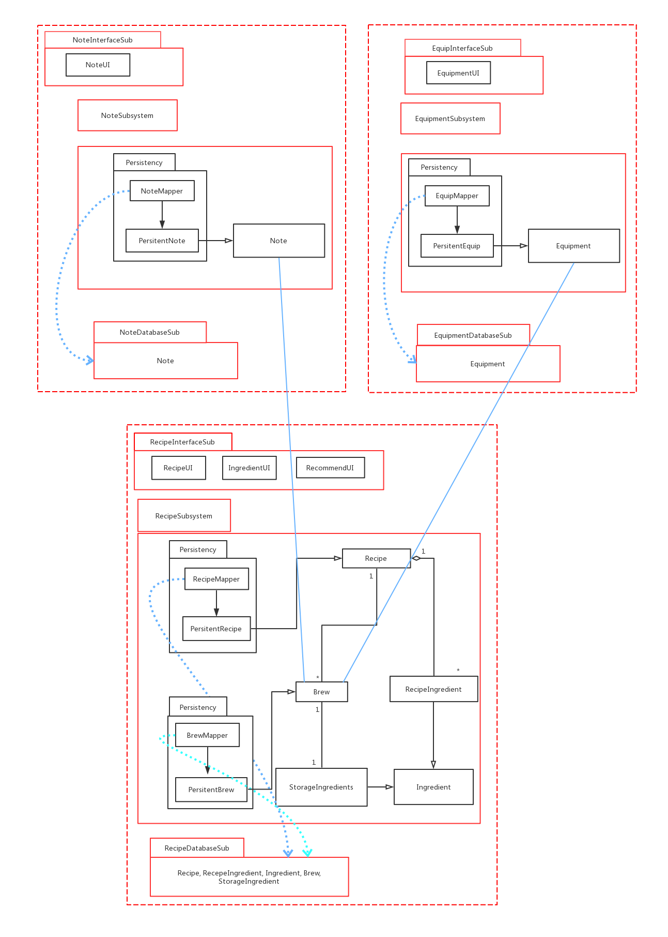

System architecture

Recipe Subsystem
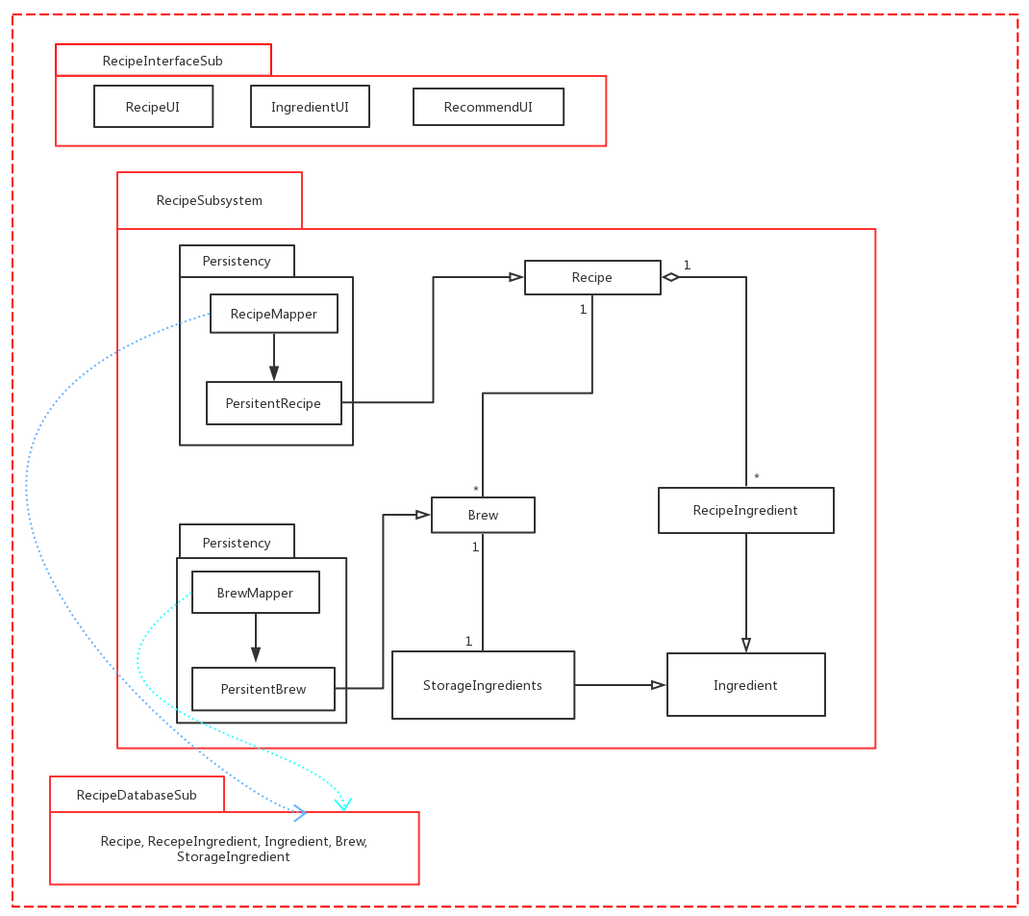

Description
In recipe subsystem, it contains recipes, ingredients and recommendations. The recipe mapper and brew mapper will stored as permanent data.

Database
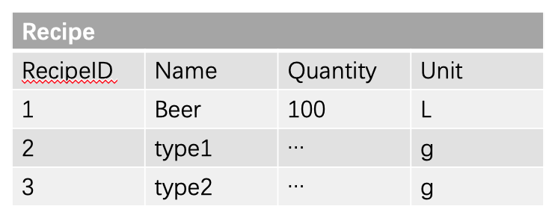

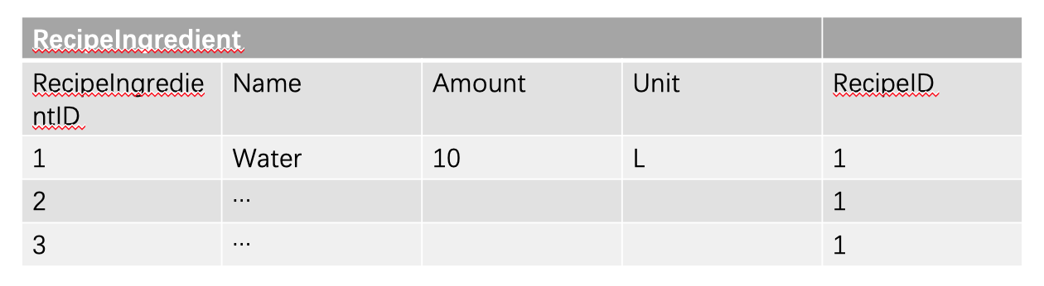

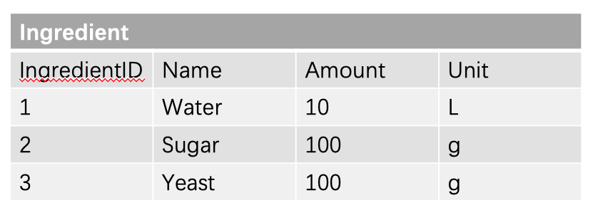

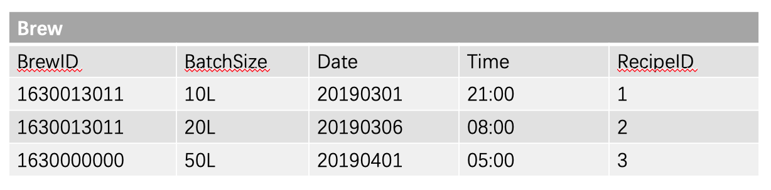

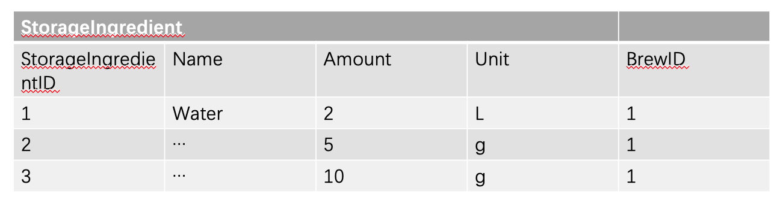

Equipment Subsystem

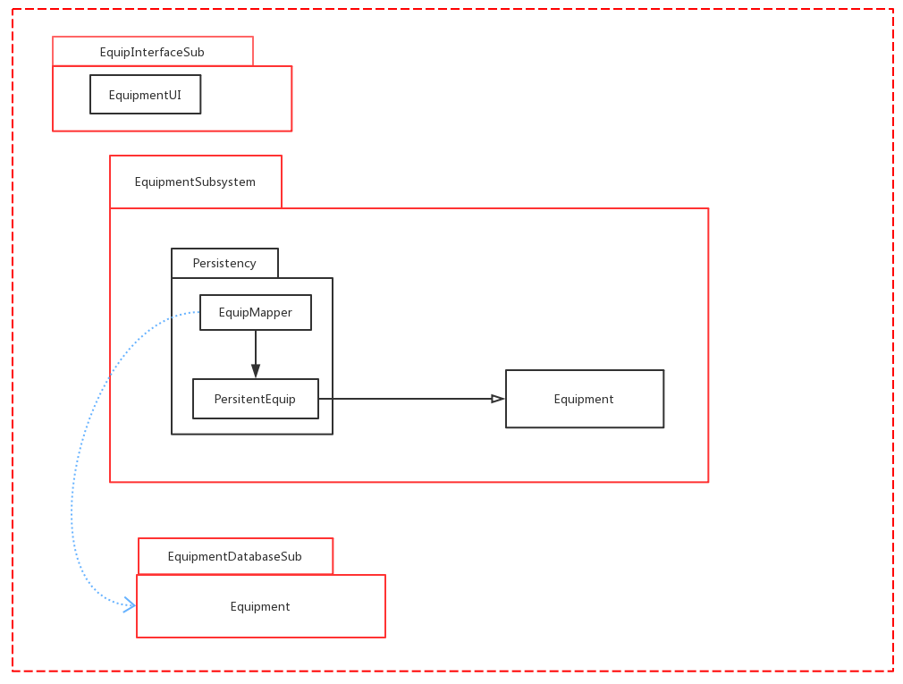

Description
In equipment subsystem, it is used to control the equipment. The equipment mapper will stored as permanent data.

Database
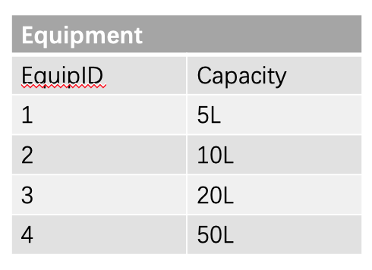

Note Subsystem

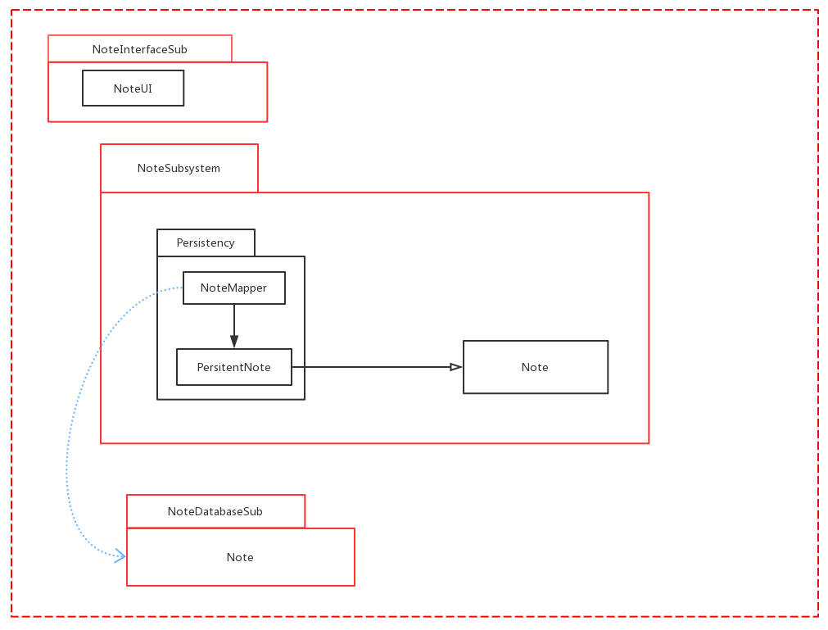

Description
In note subsystem, it is used to control the writing note part of the whole system. The note mapper will stored as permanent data.

Database
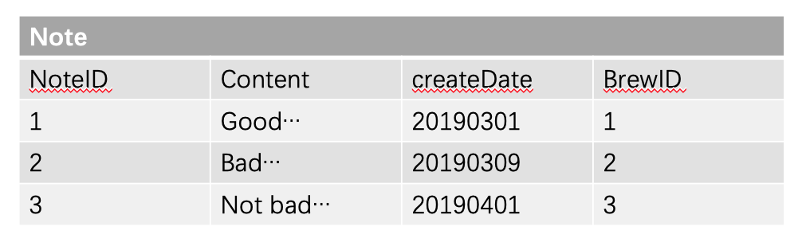

Assessment

Stability
This architecture that the system is based on is really stable. Because we design the system by MVC model. If some changes are made to certain components, there will not be influenced to other subsystems components.
In MVC model, controller can relate all the other parts together to have a high cohesion. And the coupling in controller, view and model in MVC model framework is low. Thus, the system is really stable.

Reusability
The components of the system can be used in other place without changes or with just a little change. For example, in the model component, all the data will connect to the database in the model. And MVC model allows access to the same controller with a variety of different styles of view, because multiple views can share a single model.

Scalability
It is easy for the system to extend the architecture. Just like reusability, we can add component all based on the database in the model. And we can design different views, the UI, for the system. All the developers can easily extend with the architecture.

Alternative design (optional)

More considerations
We will use java language for this system.

Appendix

