Software Requirements Specification
for
Brew Day!
Version 1.0 approved
Prepared by ZHANG Zhiyi, LUO Zichen, WANG Yuan, LU Guangxing
Cerf
4 March 2019
Table of Contents
Table of Contents ii
Revision History ii
1. Introduction 1
1.1 Purpose 1
1.2 Document Conventions 1
1.3 Intended Audience and Reading Suggestions 1
1.4 Project Scope 1
1.5 References 1
2. Overall Description 2
2.1 Product Perspective 2
2.2 Product Features 2
2.3 User Classes and Characteristics 2
2.4 Operating Environment 2
2.5 Design and Implementation Constraints 2
2.6 User Documentation 3
2.7 Assumptions and Dependencies 3
3. System Features 3
3.1 System Feature 1 3
3.2 System Feature 2 (and so on) 4
4. External Interface Requirements 4
4.1 User Interfaces 4
4.2 Hardware Interfaces 4
4.3 Software Interfaces 4
4.4 Communications Interfaces 4
5. Other Nonfunctional Requirements 4
5.1 Performance Requirements 4
5.2 Safety Requirements 4
5.3 Security Requirements 5
5.4 Software Quality Attributes 5
6. Other Requirements 5
Appendix A: Glossary 5
Appendix B: Analysis Models 5
Appendix C: Issues List 5

Revision History
Name | Date | Reason For Changes | Version
ZHANG Zhiyi,  LUO Zichen,  LU Guangxing,  WANG Yuan | 3/4/2019 | Initialize the SRS Document | 1.0

Introduction (team work, everyone contributes every section)

Purpose
This document is going to describe the whole software named Brew Day!, which is now designing. And this is the first version of SRS regarding this software.

Document Conventions
In this document, we particular use these conventions for clarity and readability:
- Brew Day! is the name of the software/system we are developing. And for clarity in context, we describe it in an underline format.
- SRS document refers to the specific software requirements specification we write to describe our Brew Day! software, if not specifically pointed out.
- Software refers to the Brew Day! software, if not specifically pointed out.
- TBD for sections which we have not acquired enough information to fill in, and N/A for sections which are temporarily not applicable.

Intended Audience and Reading Suggestions
We suggest everyone who is related to this software read all parts, but if there will be some difficulty while reading, we suggest:

If you are developers, testers and documentation writers, please read all part of this document carefully.

If you are project managers and marketing staff, please focus on 2. Overall Description and 5. Other Nonfunctional Requirements.

If you are users, please read 1. Introduction.

Project Scope
This software is developed for home beer brewers, to give them some little help such as record recipes, keep track of ingredients, etc. This software will be desktop-based. A brief user manual will also be provided.

References
SCORE Project: Brew Day!: http://score-contest.org/2018/projects/brewday.php

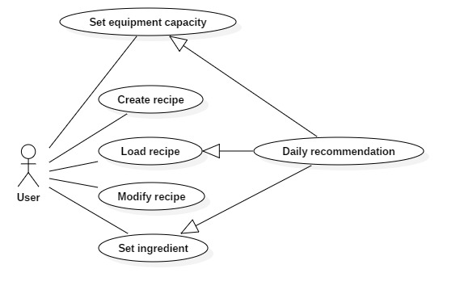
Overall Description (team work, everyone contributes every section)

Product Perspective
No context. This is a new independent software. It is the first version.

Product Features

User Classes and Characteristics
This software is developed mostly for home beer brewers. We prefer users with certain ability to use a computer and knowledge of beer brewing.

Operating Environment
This software will be operated on desktop

Design and Implementation Constraints
No constraints.

User Documentation
User manuals will be provided.

Assumptions and Dependencies
TBD

System Features
<This template illustrates organizing the functional requirements for the product by system features, the major services provided by the product. You may prefer to organize this section by use case, mode of operation, user class, object class, functional hierarchy, or combinations of these, whatever makes the most logical sense for your product.>

System Feature 1
<Don’t really say “System Feature 1.” State the feature name in just a few words.>
3.1.1 Description and Priority
<Provide a short description of the feature and indicate whether it is of High, Medium, or Low priority. You could also include specific priority component ratings, such as benefit, penalty, cost, and risk (each rated on a relative scale from a low of 1 to a high of 9).>
3.1.2 Stimulus/Response Sequences
<List the sequences of user actions and system responses that stimulate the behavior defined for this feature. These will correspond to the dialog elements associated with use cases.>
3.1.3 Functional Requirements
<Itemize the detailed functional requirements associated with this feature. These are the software capabilities that must be present in order for the user to carry out the services provided by the feature, or to execute the use case. Include how the product should respond to anticipated error conditions or invalid inputs. Requirements should be concise, complete, unambiguous, verifiable, and necessary. Use “TBD” as a placeholder to indicate when necessary information is not yet available.>

<Each requirement should be uniquely identified with a sequence number or a meaningful tag of some kind.>

REQ-1:
REQ-2:

System Feature 2 (and so on)

External Interface Requirements (team work, everyone contributes every section)

User Interfaces
<Describe the logical characteristics of each interface between the software product and the users. This may include sample screen images, any GUI standards or product family style guides that are to be followed, screen layout constraints, standard buttons and functions (e.g., help) that will appear on every screen, keyboard shortcuts, error message display standards, and so on. Define the software components for which a user interface is needed. Details of the user interface design should be documented in a separate user interface specification.>

Hardware Interfaces
This application is desktop-based and it has GUI displayed on the Monitor. User can use mouse and keyboard to input data.

Software Interfaces
This software needs to connect to local database to record and load recipes, which will be decided and developed in the furture.

Communications Interfaces
N/A

Other Nonfunctional Requirements (team work, everyone contributes every section)

Performance Requirements
TBD

Safety Requirements
This software only works as a method for users to store and display their recipes. The software has no ability to check whether the recipe could bring harms to human. User will be solely-responsible for the context of their recipe.

Security Requirements
The software will not share the recipe or any other user data without the permission of user. Data will be stored locally, so we will not provide any authentication methods for entering our software.

Software Quality Attributes
TBD

Other Requirements (team work, everyone contributes every section)
TBD
Appendix A: Glossary
N/A
Appendix B: Analysis Models
N/A
Appendix C: Issues List
TBD

