Architecture Design
for
Brew Day!
Version 2.0 approved
Prepared by Liu Tingxuan 1630003038
Chen Ruonan 1430017004
Guo Zhenyue 1630003017
Guan jinghong1630003016
<Church>
<4.2.2019>
Table of Contents
Table of Contents ii
Revision History ii
1. Overview 1
1.1 Project description 1
1.2 References 1
1.3 Design purpose 1
2. Overall description 1
2.1 Use case diagram and class diagram 1
2.2 Design model 3
2.3 System architecture 4
3. System architecture 4
3.1 Recipe Sub-system 5
3.1.1 Description 5
3.1.2 Database 6
3.2 Brew Sub-system 6
3.2.1 Description 7
3.2.2 Database (Tingxuan Liu 1630003038) 8
4. Assessment 8
4.1 Stability (Ruonan Chen 1430017004) 8
4.2 Reusability 8
4.3 Scalability (Ruonan Chen 1430017004) 8
5. Alternative design (optional) 9
6. More considerations 9
7. Appendix 9

Revision History
Name | Date | Reason For Changes | Version
Initial Version | 4/2/2019 | None | 1.0
Second Version | 4/9/2019 | Modify previous version basing on comments | 2.0

Overview（Chen ruonan 1430017004）
The Architecture Design is split into the following sections and an overview of what each section will contain is provided below:
Chapter One Introduction,
Chapter Two Overall description
Chapter Three System Architecture
Chapter Four Assessment
Chapter Five Alternative design
Chapter Six More considerations
Chapter Seven Appendix

Project description
“Brew Day!” is a system for home brewers which provide home brewers with easy to use functions to maintain recipes, ingredients, and equipment’s. It also offer recipe recommendation for brewers, and allows brewers to write notes for their brews.
This document provides a comprehensive architectural overview of the system, using a number of different architectural view to depict different features of the system. It is intended to capture and convey the significant architectural decisions which will be made on the system.

References

[1] | S. C. o. S. Engineering, "SCORE," 2018. [Online]. Available: http://score-contest.org/2018/index.php. [Accessed 9 4 2019].

Design purpose
This software requirement specification document describes the detailed information of a beer brewing software. The name of the software is “Brew Day!” The software is a stand-alone application, which provides home brewers with basic function while their brewing process.
The users can use this software we designed to record their brewing processes and needed ingredients during brewing. They can also make their own specific recipes and notes which can bring convenience to their future brewing.

Overall description

Use case diagram and class diagram

User case diagram:
Figure 1 User case diagram
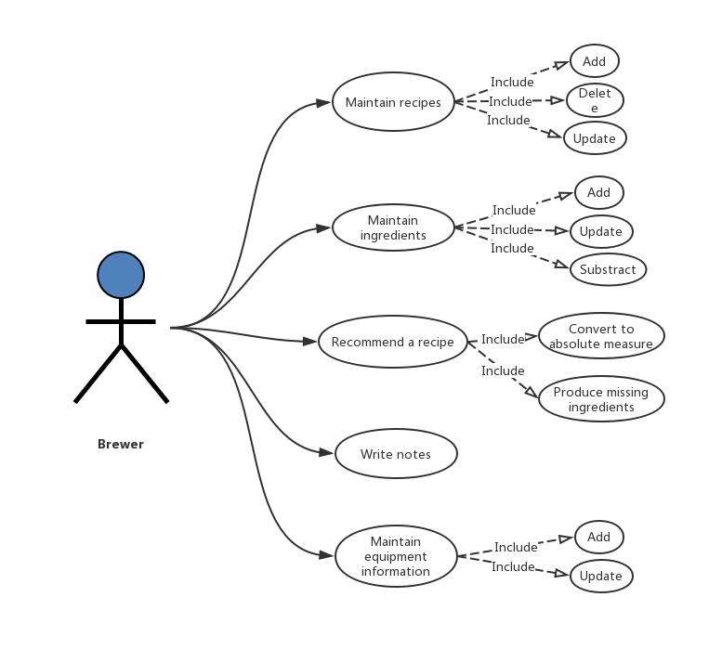

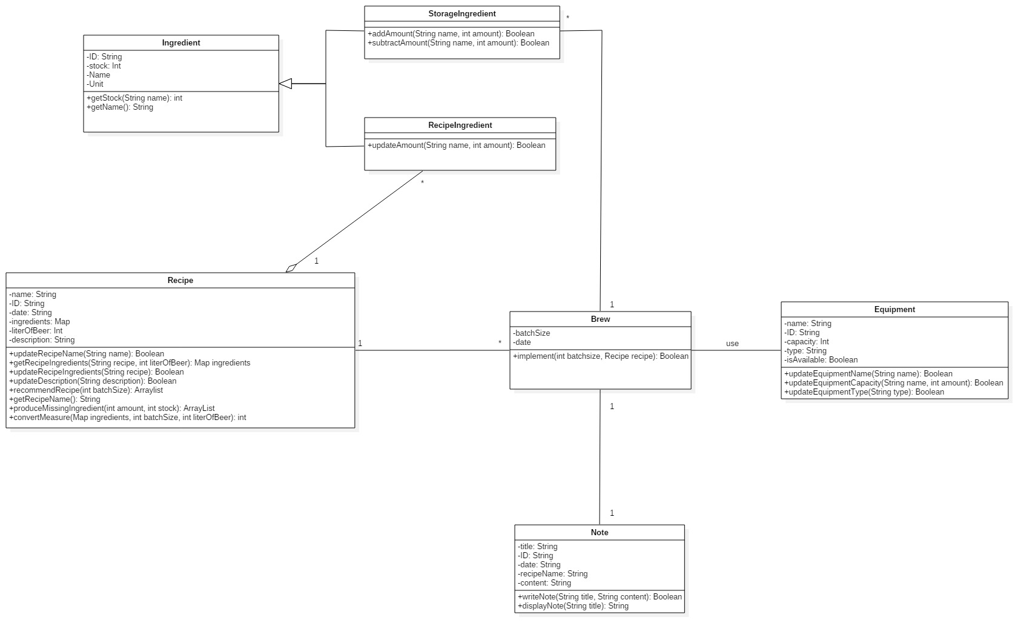
Class diagram:
Figure 2 Class diagram

Design model
The Model View Controller model will be applied for this system.
Model component manages the system data and corresponding operations on that data.
The view component manages how the data is displayed to the user.
The controller component is in charge of user interactions (e.g. key presses, mouse clicks)

Figure 3 MVC diagram

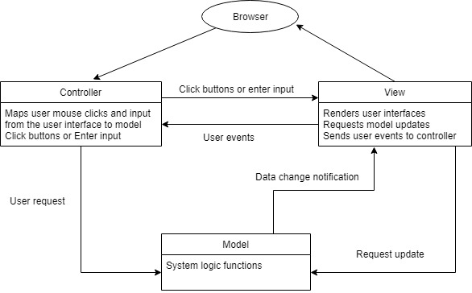
The current version of the system might only support viewing on computers, however, in our future work, we may develop this system to a mobile phone application as well. Because MVC allows multiple ways to view and interact with data, for the reuse favor, MVC is the model conducted on the system.

System architecture
There are two sub-systems in the design. One is recipe sub-system and another one is brew sub-system.
In recipe sub-system, classes are recipe class and recipe ingredients class. User interfaces are add recipe UI, delete recipe UI, update recipe UI, recommended recipe UI. There are also recipe ingredient and recipe databases.
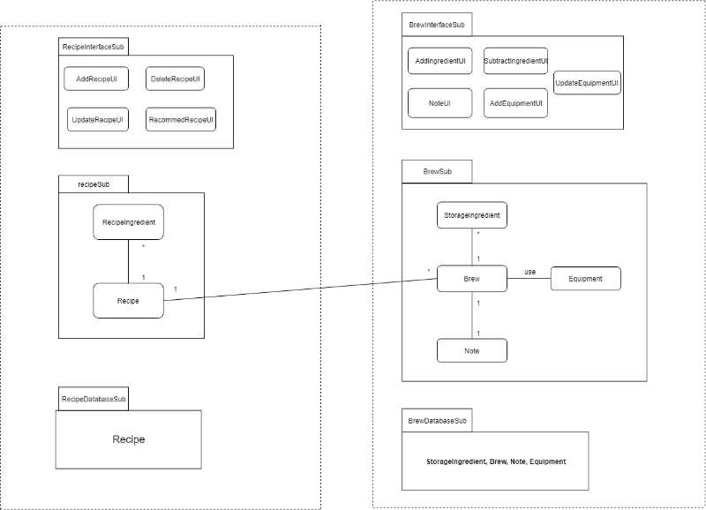
In brew sub-system, classes are storage class, brew class, note class, and equipment class. User interfaces are add ingredient UI, subtract ingredient UI, note UI, add equipment UI, update equipment UI. There are also storage ingredient, brew, note and equipment databases.

Figure 4 Sub-systems

System architecture (Tingxuan Liu 1630003038)
There are two sub-systems in the system architecture. One is recipe sub-system another one is brew sub-system. This chapter shows detailed description and information for each subsystem.

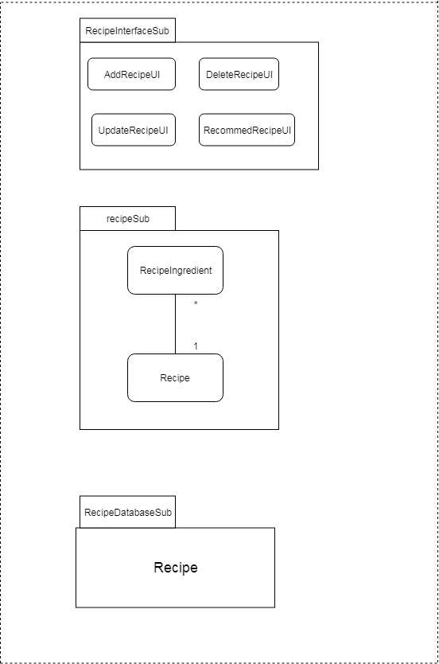
Recipe Sub-system
This Recipe subsystem contains some user interfaces, classes as well as databases relating to this recipe subsystem. The interfaces in this subsystem contain add recipe UI, delete recipe UI, update recipe UI, recommend recipe UI. The class also contain recipe ingredient and recipe. Besides, there are recipe ingredients’ database and recipes’ database.

Description

Figure 5 Recipe Sub-system

Add recipe UI: this is the user interface for adding recipes.
Delete recipe UI: this is the user interface for deleting recipes.
Update recipe UI: this is the user interface for updating recipes.
RecipeIngredient and Recipe in the middle block are classes in this subsystem.
Recipe database: contain some attributes of recipes and data of recipes.

Database
Recipe
ID | Name | date | Ingredients | literOfBeer | description
1. | Recipe1 | 2019/4/3 | **** | 200 | *****
2. | Recipe2 | 2019/4/2 | **** | 200 | *****

Brew Sub-system (Tingxuan Liu 1630003038)
This brew subsystem contains some user interfaces, classes as well as databases relating to this subsystem. The interfaces in this subsystem contain add ingredient UI, subtract ingredient UI, update equipment UI, write note UI add equipment UI. The class also contain brew, storage ingredients, equipment and note. Besides, there are databases of storage ingredients, brew, note and equipment.

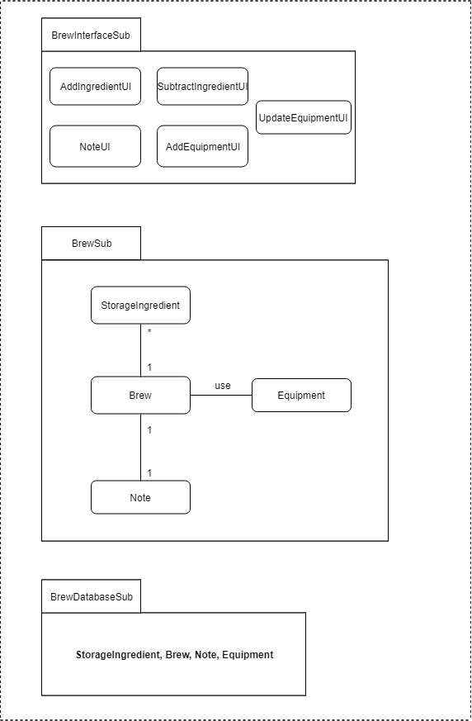
Description
Figure 6 Brew Sub-system

Add ingredient UI: the user interface for adding ingredients.
Subtract ingredient UI: the user interface for subtracting ingredients.
Add equipment UI: the user interface for adding equipment.
Update equipment UI: the user interface for updating equipment.
Write note UI: the user interface for writing notes.
storgeIngredient, Brew, Equipment, Note in the middle block of this subsystem are classes.
StorageIngredient, Brew, Note, Equipment in the last block of this subsystem are databases.

Database (Tingxuan Liu 1630003038)
Storage Ingredient
ID | Stock | Name | Unit
1 | 100 | Malts | g
2 | 200 | Hops | g
3 | 100 | yeasts | g

Brew
batchsize | date
50 | 2019/4/2
40 | 2019/4/3

Note
title | ID | date | recipeName | content
*** | 1 | 2019/4/2 | Recipe1 | ***
*** | 2 | 2019/4/3 | Recipe2 | ***

Equipment
ID | capacity | type | isAvailable
1 | 200 | Kettle | true
2 | 200 | fermenter | false

Assessment

Stability (Ruonan Chen 1430017004)
Basing on this architecture is stable, because the coupling between two sub-systems are minimized, and the cohesion are maximized. The connection between two sub-systems is the relationship between recipe class and brew class. Therefore there are few parameter need to pass among two sub-systems.
When modifications are needed, most components are involved only when modifications happen on brew and recipe classes. Otherwise, the involved components are minimized.

Reusability
Because the model we applied the MVC model. Therefore, controller part can be directly be used in other place.

Scalability (Ruonan Chen 1430017004)
We utilize the model-view-control model in the system and the current version of the system is a web-based system. Therefore, if in the future, the application is required to support IOS or android system, view and control section may need to be largely modified according to the operating system requirement. However the core application logics remain the same.

Alternative design (optional)
None

More considerations
None

Appendix
None

