Detailed Design
for
Brew Day!
Version 1.0 approved
Prepared by Liu Tingxuan 1630003038
Chen Ruonan 1430017004
Guo Zhenyue 1630003017
Guan jinghong1630003016
Church
4.10.2019
Table of Contents
Table of Contents ii
Revision History ii
1. Overview 1
1.1 Project description 1
1.2 References 1
1.3 Design purpose 1
2. Overall description 1
2.1 Class diagram 1
2.2 Refinements 2
3. Detailed design 3
3.1 Class diagram 3
3.2 Classes 4
3.2.1 Ingredient 4
3.2.2 StorageIngredient 4
3.2.3 RecipeIngredient 5
3.2.4 Brew 5
3.2.5 Recipe 5
3.2.6 Equipment 6
3.2.7 Note 7
4. Alternative detailed design (Optional) 7
5. More considerations 7

Revision History
Name | Date | Reason For Changes | Version
Initial Version | 4/9/2019 | None | 1.0
Second Version | 4/10/2019 | Update and finish the whole file | 1.1

Overview

Project description
“Brew Day!” is a system for home brewers which provide home brewers with easy to use functions to maintain recipes, ingredients, and equipment’s. It also offer recipe recommendation for brewers, and allows brewers to write notes for their brews.
This document provides a comprehensive architectural overview of the system, using a number of different architectural view to depict different features of the system. It is intended to capture and convey the significant architectural decisions which will be made on the system.

References
[1] | Church, "Software Requirements Specification for Brew Day!," 2019.
[2] | S. C. o. S. Engineering, "Brew Day!" 2018. [Online]. Available: http://score-contest.org/2018/index.php. [Accessed 9 4 2019].
[3] | Church, "Architecture Design," 2019.

Design purpose
This software requirement specification document describes the detailed information of a beer brewing software. The name of the software is “Brew Day!” The software is a stand-alone application, which provides home brewers with basic function while their brewing process.
The users can use this software we designed to record their brewing processes and needed ingredients during brewing. They can also make their own specific recipes and notes which can bring convenience to their future brewing.

Overall description

Class diagram
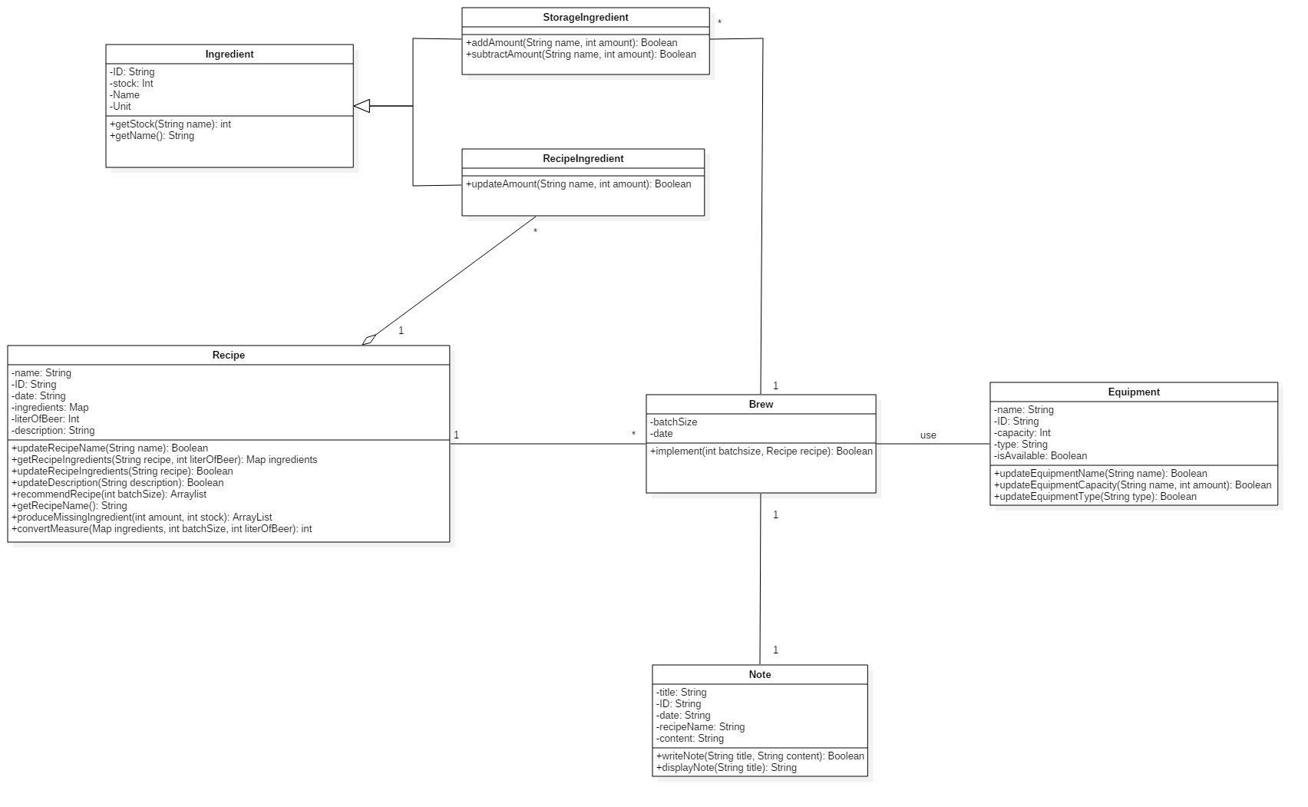

Refinements

Add constructor and destructor for each class
Consider the range of some attributes
Modify the modifiers (public, private, and protected)
Use quantifier to reduce the multiplicity between “Brew” and “Equipment”
Change the relationship between “Recipe” and “RecipeIngredient” from aggregation to composition
The relationship between “Brew” and “StorageIngredient” is composition

Detailed design

Class diagram
Use quantifier to reduce the multiplicity between “Brew” and “Equipment”
Change the relationship between “Recipe” and “RecipeIngredient” from aggregation to composition
The relationship between “Brew” and “StorageIngredient” is composition
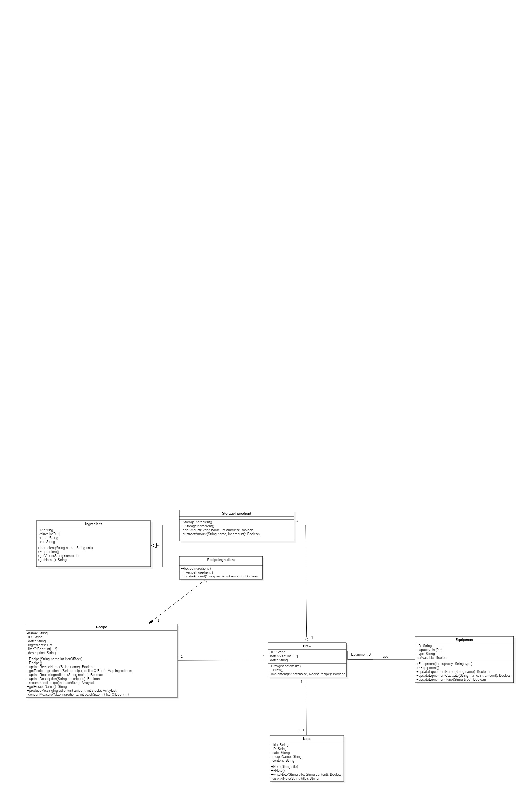

Classes

Ingredient
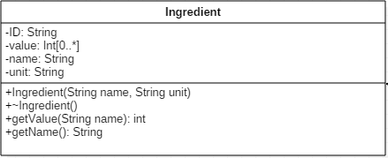

Explanations

Add constructor “Ingredient (String name, String unit)” and destructor “~Ingredient ()”
Declare data type of “name”, and “unit”
Rename “stock” as “value” and declare the data type
Add the range of “value”

Constraints (optional)

None

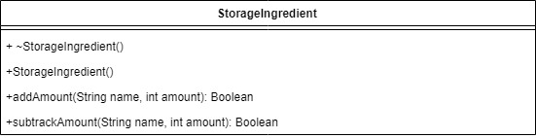
StorageIngredient

Explanations

Add constructor “StorageIngredient()” and destructor “~StorageIngredient()”

Constraints (optional)

None

RecipeIngredient
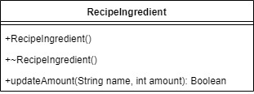
Explanations

Add constructor “RecipeIngredient ()” and destructor “~RecipeIngredient ()”.

Constraints (optional)

None

Brew
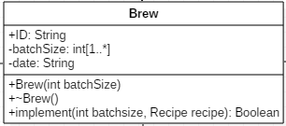

Explanations

Add constructor “Brew (int batchSize)” and destructor “~Brew ()”.
Add attribute “ID” and the value of “batchSize” should be more than 1.

Constraints (optional)

None

Recipe
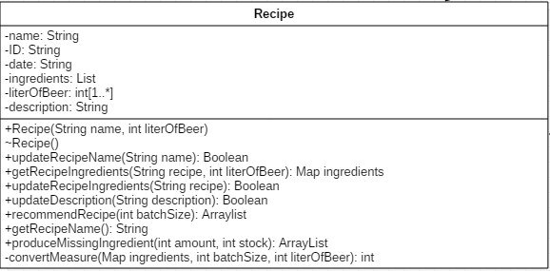
Explanations

Add constructor “Recipe (String name, int literOfBeer)” and destructor “~Recipe ()”.
Add the value of “literOfBeer” should be more than 1
Modify the type of “ingredients” from “Map” to “List”
Modify the type of operation “convertMeasure” from “public” to “private”.

Constraints (optional)

None

Equipment
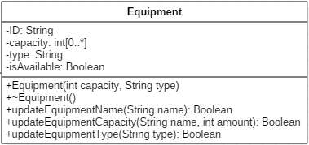
Explanations

Delete attribute "name"
Add the value of capacity should be 0 or positive
Add a constructor and destructor "Equipment (int capacity, String type)" and "~Equipment ()"

Constraints (optional)

None

Note
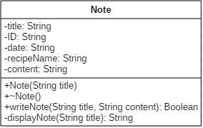
Explanations

Add a constructor, destructor: “Note (String title)” and “~Note ()”.

Constraints (optional)

None

Alternative detailed design (Optional)
None

More considerations
With the development of the production, the brewer may have new demand of system (e.g. customer rating, cost of production). We need to leave some interface to adapt new classes or systems which make work more convenient and clear.

