Detailed Design
for
Brew Day!
Version 3.0 approved
Prepared by Liu Tingxuan 1630003038
Chen Ruonan 1430017004
Guo Zhenyue 1630003017
Church
5.23.2019
Table of Contents
Table of Contents ii
Revision History ii
1. Overview 1
1.1 Project description 1
1.2 References 1
1.3 Design purpose 1
2. Overall description 1
2.1 Class diagram 1
2.2 Refinements 2
3. Detailed design 3
3.1 Class diagram 3
3.2 Classes 4
3.2.1 Ingredient 4
3.2.2 StorageIngredient 4
3.2.3 RecipeIngredient 5
3.2.4 Brew 5
3.2.5 Recipe 5
3.2.6 Equipment 6
3.2.7 Note 7
4. Alternative detailed design (Optional) 7
5. More considerations 7

Revision History
Name | Date | Reason For Changes | Version
Initial Version | 4/9/2019 | None | 1.0
Second Version | 4/10/2019 | Update and finish the whole file | 2.0
Final Version | 5/23/2019 | Update the class diagram | 3.0

Overview

Project description
“Brew Day!” is a system for home brewers which provide home brewers with easy to use functions to maintain recipes, ingredients, and equipment’s. It also offer recipe recommendation for brewers, and allows brewers to write notes for their brews.
This document provides a comprehensive architectural overview of the system, using a number of different architectural view to depict different features of the system. It is intended to capture and convey the significant architectural decisions which will be made on the system.

References
[1] | Church, "Software Requirements Specification for Brew Day!," 2019.
[2] | S. C. o. S. Engineering, "Brew Day!" 2018. [Online]. Available: http://score-contest.org/2018/index.php. [Accessed 9 4 2019].
[3] | Church, "Architecture Design," 2019.

Design purpose
This software requirement specification document describes the detailed information of a beer brewing software. The name of the software is “Brew Day!” The software is a stand-alone application, which provides home brewers with basic function while their brewing process.
The users can use this software we designed to record their brewing processes and needed ingredients during brewing. They can also make their own specific recipes and notes which can bring convenience to their future brewing.

Overall description

Class diagram
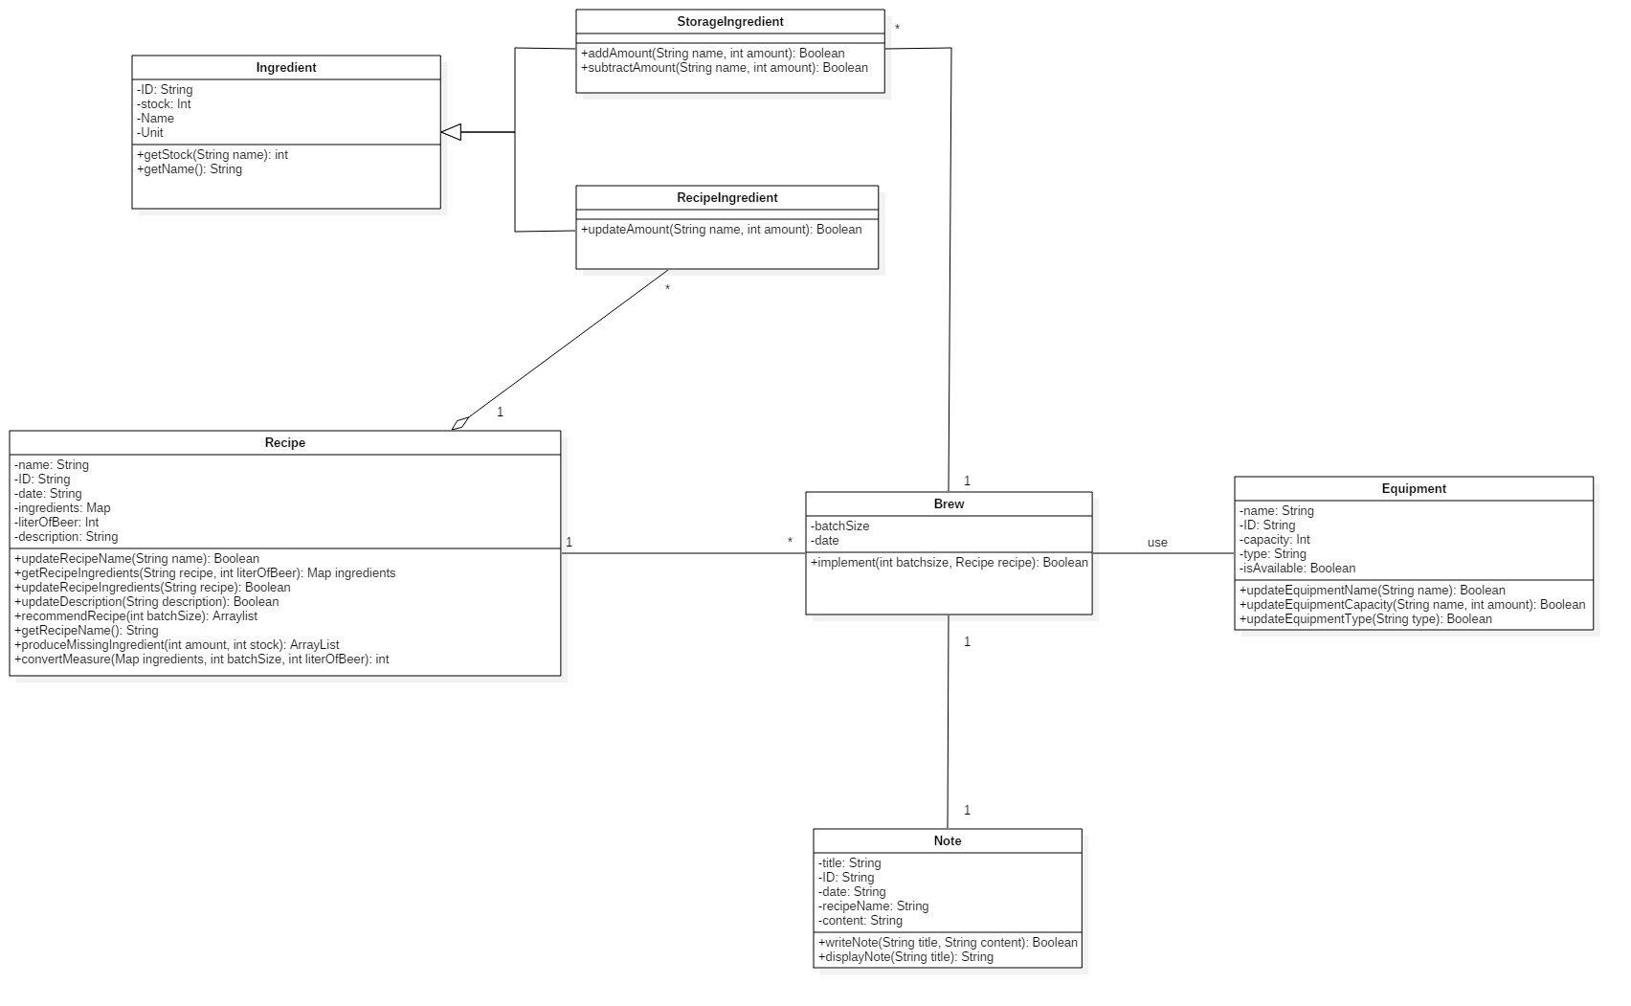

Refinements

Add constructor and destructor for each class
Consider the range of some attributes
Modify the modifiers (public, private, and protected)
Use quantifier to reduce the multiplicity between “Brew” and “Equipment”
Change the relationship between “Recipe” and “RecipeIngredient” from aggregation to composition
The relationship between “Brew” and “StorageIngredient” is composition

Detailed design

Class diagram
Use quantifier to reduce the multiplicity between “Brew” and “Equipment”
Change the relationship between “Recipe” and “RecipeIngredient” from aggregation to composition
The relationship between “Brew” and “StorageIngredient” is composition

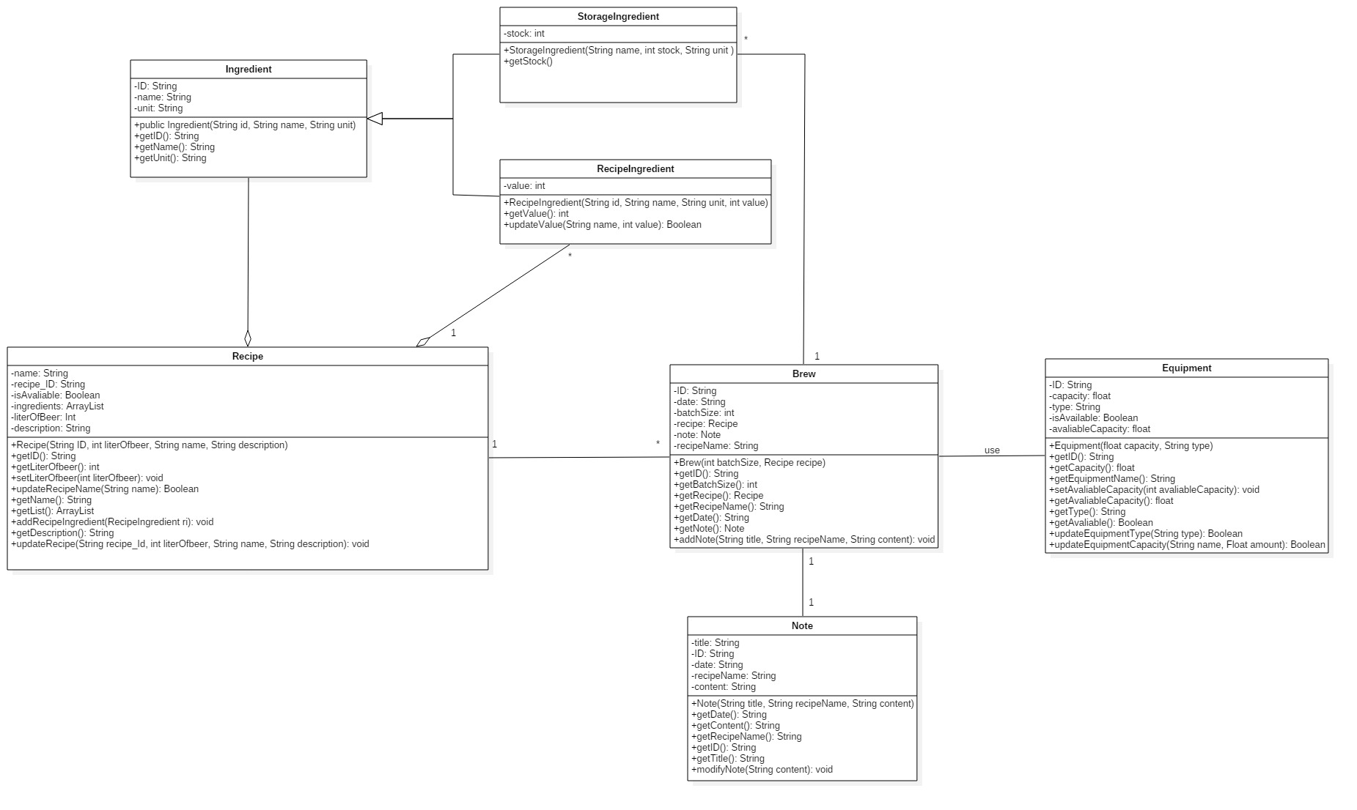

Classes

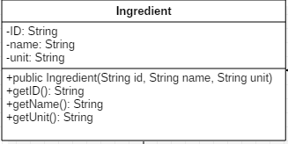
Ingredient

Explanations

Add constructor “Ingredient (String id, String name, String unit)”
Delete some attributes: date, ingredients, literOfBeer, description
Delete some operations

Constraints (optional)

None

StorageIngredient
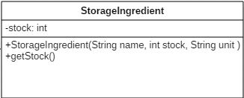

Explanations

Add constructor “StorageIngredient()” and destructor “~StorageIngredient()”
Add one attribute stock
Change the operation into addAmount() and subtractAmount()

Constraints (optional)

None

RecipeIngredient

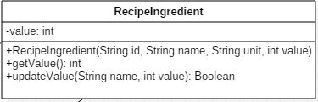

Explanations

Add constructor “RecipeIngredient ()” and destructor “~RecipeIngredient ()”.
Add one attribute value
Add operations RecipeIngredient() and getValue()

Constraints (optional)

None

Brew
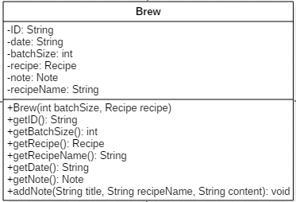

Explanations

Add constructor “Brew (int batchSize, Recipe recipe)”
Add attribute “ID”, “recipe”, “note”, “recipeName”
Update all the operations into above operations

Constraints (optional)

None

Recipe

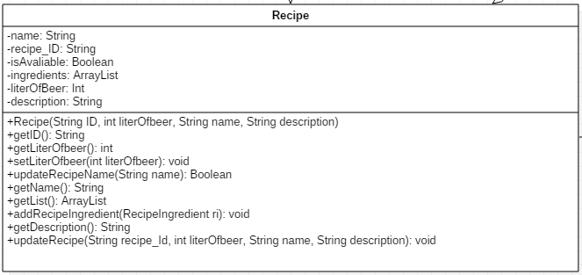

Explanations

Add constructor “Recipe (String ID, int literOfBeer, String name, String description)”
Change attribute “ID” into “recipe_ID” and add attribute “isAvaliable”
Delete attribute “date”
Update operations into above operations

Constraints (optional)

None

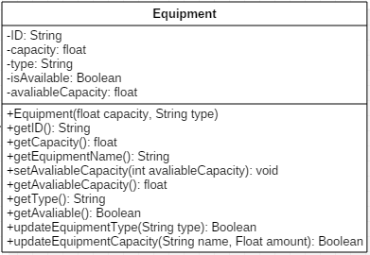
Equipment

Explanations

Delete attribute "name"
Add attribute “availableCapacity”
Add a constructor and destructor "Equipment (int capacity, String type)"
Update the other operations into above operations

Constraints (optional)

None

Note

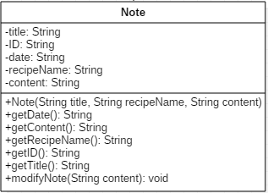

Explanations

Add a constructor, destructor: “Note (String title, String recipeName, String content)”
Update the operations into above operations
Constraints (optional)

None

Alternative detailed design (Optional)
None

More considerations
With the development of the production, the brewer may have new demand of system (e.g. customer rating, cost of production). We need to leave some interface to adapt new classes or systems which make work more convenient and clear.

