Software Requirements Specification

for

Brew Day!

Version 6.0 approved

Prepared by Liu Tingxuan 1630003038

Chen Ruonan 1430017004

Guo Zhenyue 1630003017

Church

2019.5.23

Table of Contents

Table of Contents ii

Revision History ii

1. Introduction (Chen ruonan 1430017004) 3

1.1 Purpose 3

1.2 Document Conventions 3

1.3 Intended Audience and Reading Suggestions 3

1.4 Project Scope 3

1.5 References 4

2. Overall Description (Liu tingxuan 1630003038) 4

2.1 Product Perspective 4

2.2 Product Features 4

2.3 User Classes and Characteristics 5

2.4 Operating Environment 6

2.5 Design and Implementation Constraints 6

2.6 User Documentation 6

2.7 Assumptions and Dependencies 6

3. System Features(Chen ruonan1430017004,Liu tingxuan1630003038) 6

3.1 Maintain Recipes 6

3.2 Maintain Ingredients 7

3.3 Recommend a Recipe 8

3.4 Write Notes 9

3.5 Maintain Equipment Information 10

4. External Interface Requirements (Guo zhenyue 1630003017) 12

4.1 User Interfaces 12

4.2 Hardware Interfaces 18

4.3 Software Interfaces 19

4.4 Communications Interfaces 19

5. Other Nonfunctional Requirements (Guo zhenyue 16300030317) 19

5.1 Performance Requirements 19

5.2 Safety Requirements 19

5.3 Security Requirements 19

5.4 Software Quality Attributes 19

6. Other Requirements (Guo zhenyue 1630003017) 19

6.1 Appendix A: Glossary 20

6.2 Appendix B: Analysis Models 20

6.3 Appendix C: Issues List 21

Revision History

|  |  |  |  |
| --- | --- | --- | --- |
| **Name** | **Date** | **Reason For Changes** | **Version** |
| Initial Version | 3/05/2019 | None | 1.0 |
| Second Version | 3/13/2019 | Modify the previous version and add System Features | 2.0 |
| Third Version | 3/20/2019 | Add system features | 3.0 |
| Fourth Version | 3/26/2019 | Add class diagram and sequence diagram | 4.0 |
| Fifth Version | 4/2/2019 | Modify the previous version | 5.0 |
| Final Version | 5/23/2019 | Modify the user interfaces and class diagram, transition diagram | 6.0 |

# Introduction (Chen ruonan 1430017004)

## Purpose

This software requirement specification document describes the detailed information of a beer brewing software. The name of the software is “Brew Day!” The software is a stand-alone application, which provides home brewers with basic function while their brewing process.

There are six chapters in the document. The first chapter is a general introduction of the software requirement document. The second chapter is the overall description for the “Brew Day!” application. The third chapter describes the system features. The forth chapter indicates the external interface requirements of the application. The fifth chapter illustrates other non-functional requirements and finally there are other requirements in the last chapter.

## Document Conventions

None

## Intended Audience and Reading Suggestions

This document is intended for both software developers and users.

Suggested reading sequence:

For users:

Read 2.1, 2.2, 2.3, and 2.6 in chapter 2 to get general idea of the software.

Read chapter3 to know the features of the application

Read 4.1 in chapter 4 to see the user interface.

For developers:

Read the whole document in detailed to understand the specific requirement of the application.

## Project Scope

This application will be a beer brewing software for home brewers. This application will be designed to maintain and update lists of recipes and ingredients, log brewers’ recipes and notes, and provide a suggestion for brewers according to the their capacity of the batch and the available ingredients by maximize the use of the ingredients and the batch size. The software will meet home brewers’ needs and also provide easy to understand and use functions.

## References

Fong, J. (2019, 03 12). *Software Development Workshop III.* Retrieved from Ispace: https://ispace.uic.edu.hk/course/view.php?id=3041

# Overall Description (Liu tingxuan 1630003038)

## Product Perspective

As we know, brew beer is a complicated production and it includes a lot of ingredients and equipment. So we develop a program to control the program and make it clear to manage. It is a new, self-contained product that work for brewing.

## Product Features

1. The application can create, store and modify users’ recipes, as well as delete existing recipes.
2. The application can contain all of ingredients and specific quantities of every ingredients.
3. It can also update the ingredients at all times after users using some of them.
4. The application can create, store and modify notes for every brewing, as well as delete existing recipes if the users want. Besides, the application also contain a special notes: tasting notes.
5. The application can maintain a list of available ingredients. It can remind users to purchase ingredients which are about to be lacking.
6. The application has a big database which contains all of existing ingredients and quantities. It can generate a recipe using existing ingredients intelligently.
7. The application can store these ingredients in a specific grams or kilograms, it can convert these specific ingredients to recipe directly.

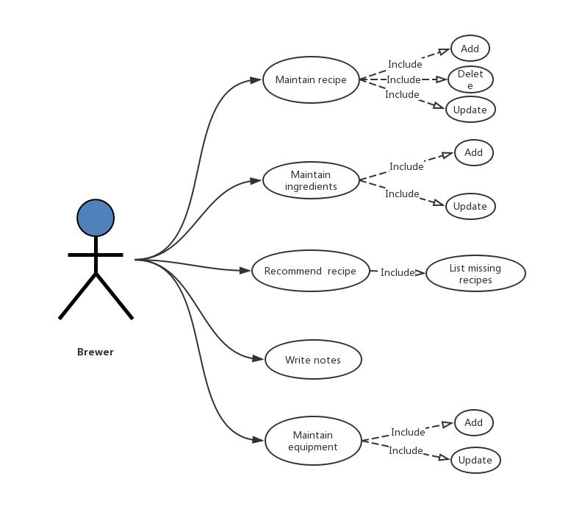

**Scenario** for sending notification when there is a lack of ingredients

Basic:

1. Check for the quantity of all of existing ingredients-

If the ingredients have been below the set quantity?

1. The application returns YES.
2. The application will send notification to remind users to purchase.

Alternative:

1. Check for the quantity of all of the existing ingredients-

If the ingredients have been below the set quantity?

1. The application returns NO.
2. Exit

## User Classes and Characteristics

The application service for different classes’ users:

Language: the application has multiple languages for users to use according users’ requirements.

Use different way to record notes: users has different way to record notes, such as text, pictures and voice.

User’s brewing level: user are master of brewing; user don’t know how to brew, but have interests.

## Operating Environment

Standalone Windows

## Design and Implementation Constraints

The application will use parallel operation to make sure different users can use this application at the same time. It also need communication and transport protocols to communicate with users all over the world to talk about brewing experience. Besides, this application has the aid of database to record all of data.

Developers will use JAVA to develop this application.

## User Documentation

There is a user manual to teach new users to use this application step by step. There is also an online website to introduce our application.

## Assumptions and Dependencies

The client may add the demand suddenly or require something special in an applied function.

# System Features(Chen ruonan1430017004,Liu tingxuan1630003038)

## Maintain Recipes

* + 1. Description and Priority

Maintain recipes ***:

This function is to maintain the recipe which include the function of add, delete and update. User can modify the recipe as they want. This function has the highest priority in feature system.

* + 1. Stimulus/Response Sequences

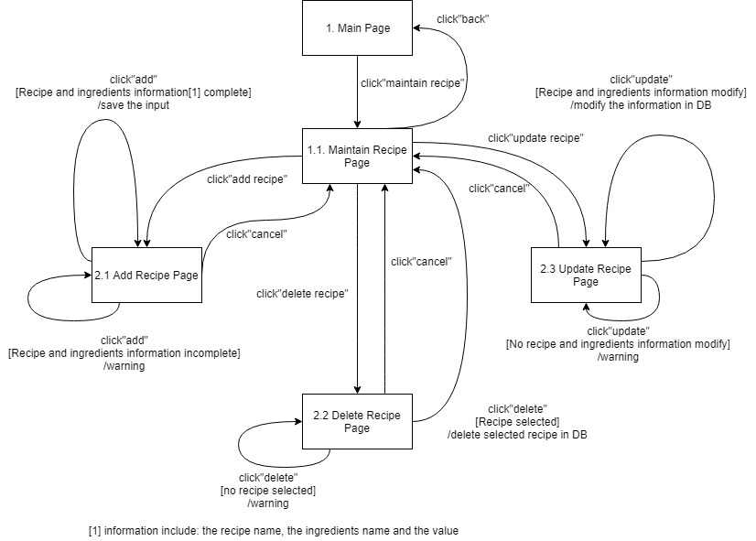

3.1.3 Functional Requirements

If the function meet errors, it will return back to option pages to try once again. For example, if ‘add’ function fail to add the items, it will return to the ‘add’ page to let users operate again and throw an exception window. And it also fit for other operations (delete, update).

For the ‘recommend a recipe’, we do as them. If the first operation fail, then we let user try it again.

## Maintain Ingredients

* + 1. Description and Priority

Maintain ingredients***

This function is to maintain the ingredients which includes the functions of adding and updating. Users can add the ingredients into the system as well as update the ingredients in the system whenever they want. This function has the highest priority in feature system.

* + 1. Stimulus/Response Sequences

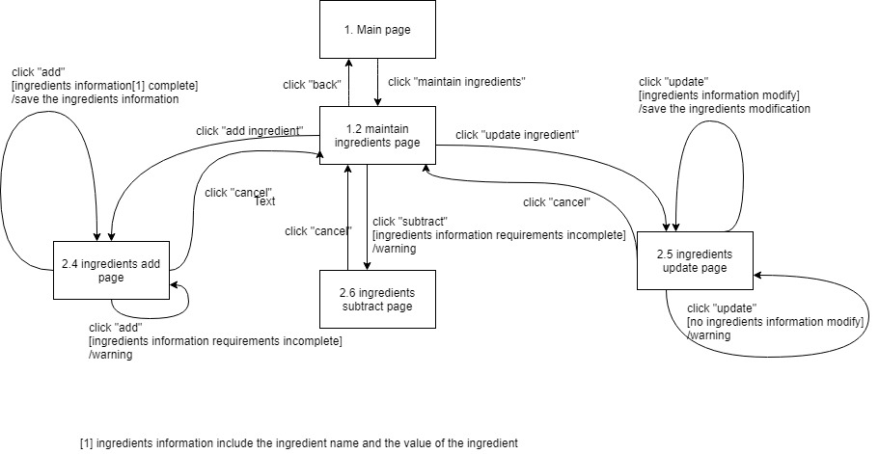

* + 1. Functional Requirement

When the users click the “add” button, but the ingredients information requirements are incomplete, the system will auto-pop-up a warning box as well as go back to the ingredients add page. When the users click the “update” button, but there is no ingredients information modified, the system will auto-pop-up a warning box as well as go back to the ingredients update page.

## Recommend a Recipe

* + 1. Description and Priority

Recommend a recipe ***

This function is to recommend a recipe to the brewer. It includes 2 functions: convert to absolute measure and produce missing ingredients.

We offer a list to show the option which contains the ingredients no matter enough or not. If the ingredient is not enough for produce, it will display the specific information.

* + 1. Stimulus/Response Sequences

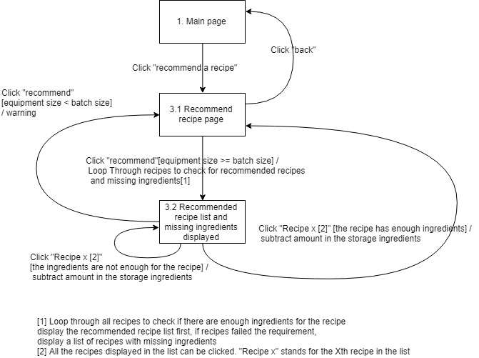

* + 1. Functional Requirements

First the user needs to enter the batch size. If the batch size is larger than the equipment available capacity, the system will notify the user the capacity is not enough and return to the recommend recipe page. If the batch size is less than the available capacity, then the system will loop through all recipes to check if there are enough ingredients for each recipe. If there are enough ingredients, show the recipe in the front of the list. The recipes with missing ingredients will display after recommended recipes.

When the user entering the interface meet errors, the system will go back to the previous interface and allow the user to enter again.

## Write Notes

* + 1. Description and Priority

Write Notes**

This function is for user to write notes during brewing period. The user can log all the information, and the any data they want to keep for example the date, tasting, and flavor.

* + 1. 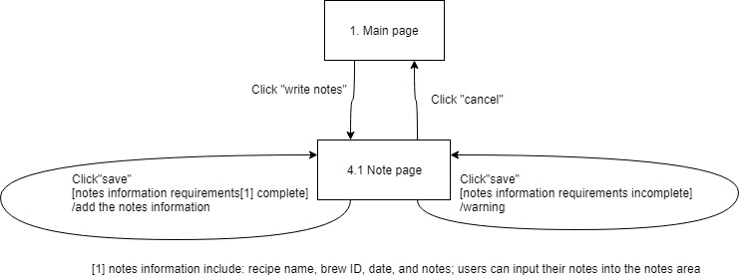Stimulus/Response Sequences
    2. Functional Requirement

The user needs to enter the current recipe name and the date, and the system will instantiate a brew ID for the recipe instance. If the contents are incomplete, the system will give a warning.

On the main page, user click “write notes” to enter the Note page to edit the note. If they finish editing, just click “save”. If error happens, it will reload and give a chance to reedit. When “cancel” clicked, the system will return back to the main page.

## Maintain Equipment Information

* + 1. Description and Priority

Maintain Equipment Information***

This function is to maintain the information of each equipment to let the user manage the equipment. User can update or add information in this section.

* + 1. Stimulus/Response Sequences

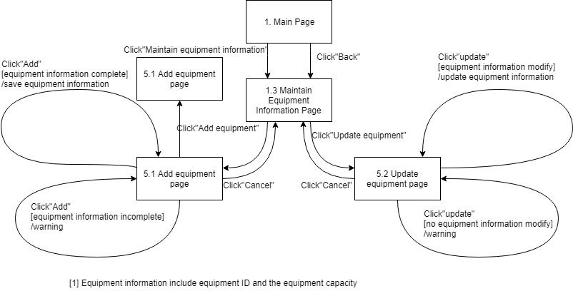

* + 1. Functional Requirement

When the users click the “add” button, but the equipment information requirements are incomplete, the system will auto-pop-up a warning box as well as go back to the add equipment page. When the users click the “update” button, but there is no equipment information modified, the system will auto-pop-up a warning box as well as go back to the update equipment page.

# External Interface Requirements (Guo zhenyue 1630003017)

## User Interfaces

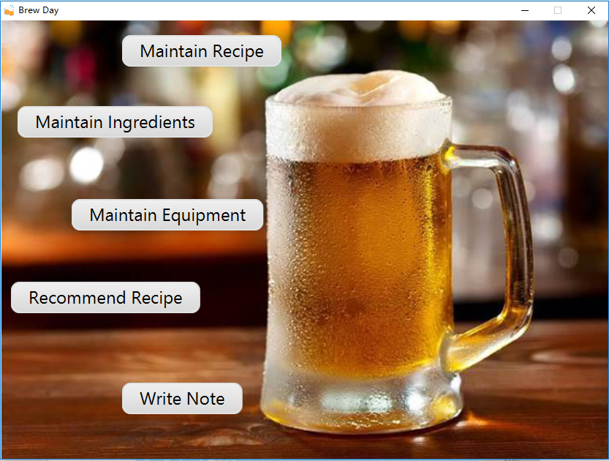

Figure 1 1. Main Page

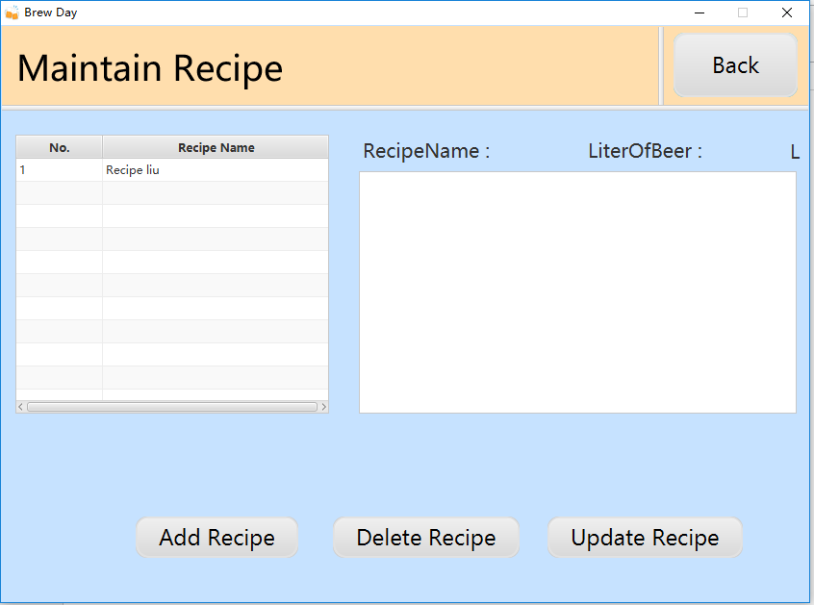

Figure 2 1.1 Maintain Recipes Page

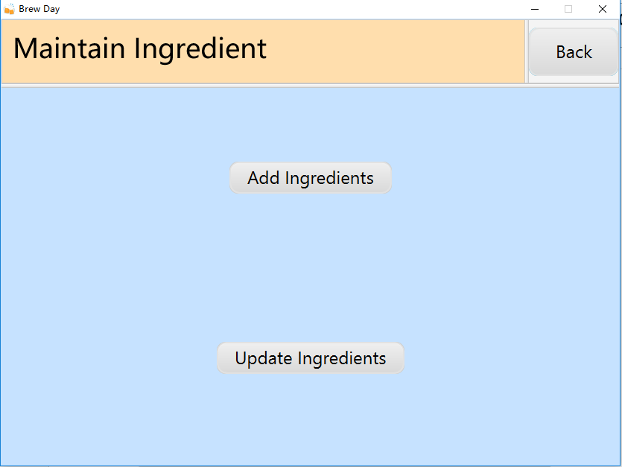

Figure 3 1.2 Maintain Ingredients Page

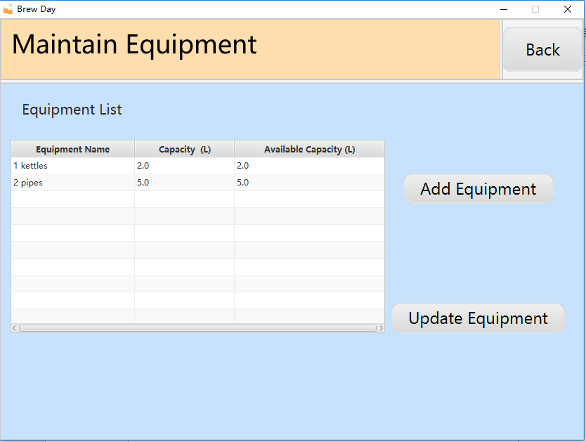

Figure 4 1.3 Maintain Equipment Page

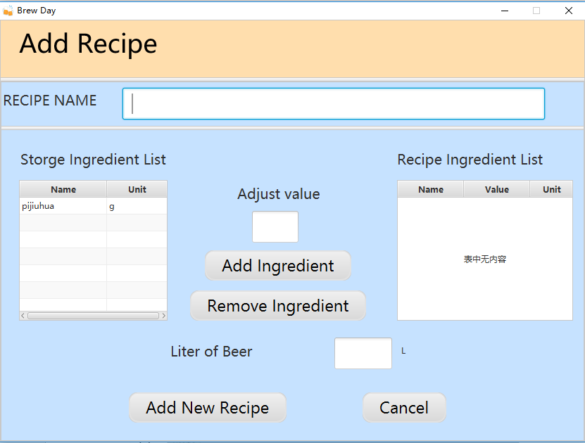

Figure 5 2.1 Add Recipe Page

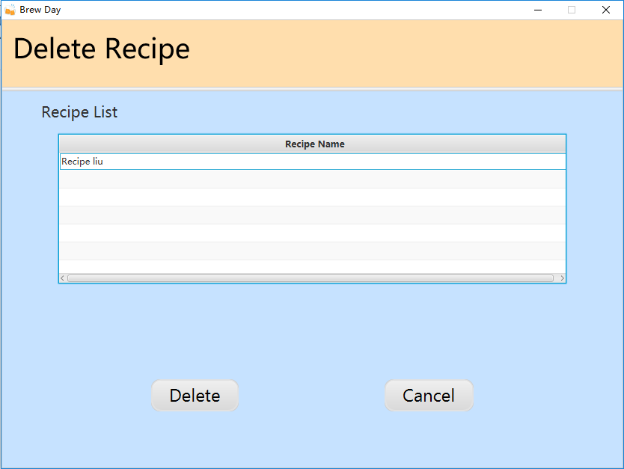

Figure 6 2.2 Delete Recipe Page

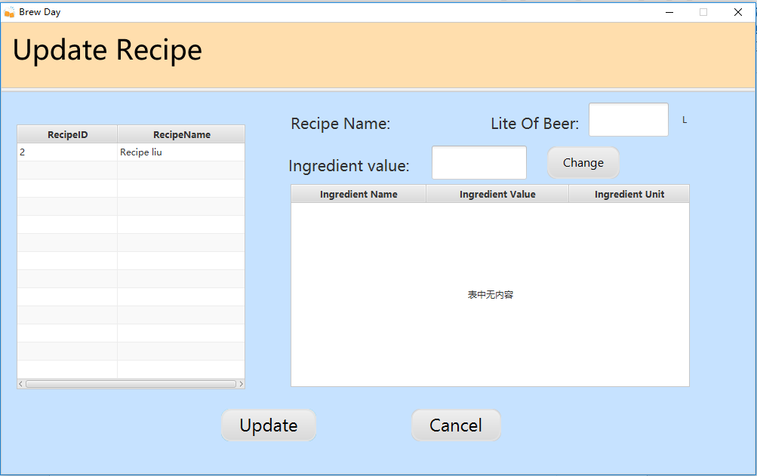

Figure 7 2.3 Update Recipe Page

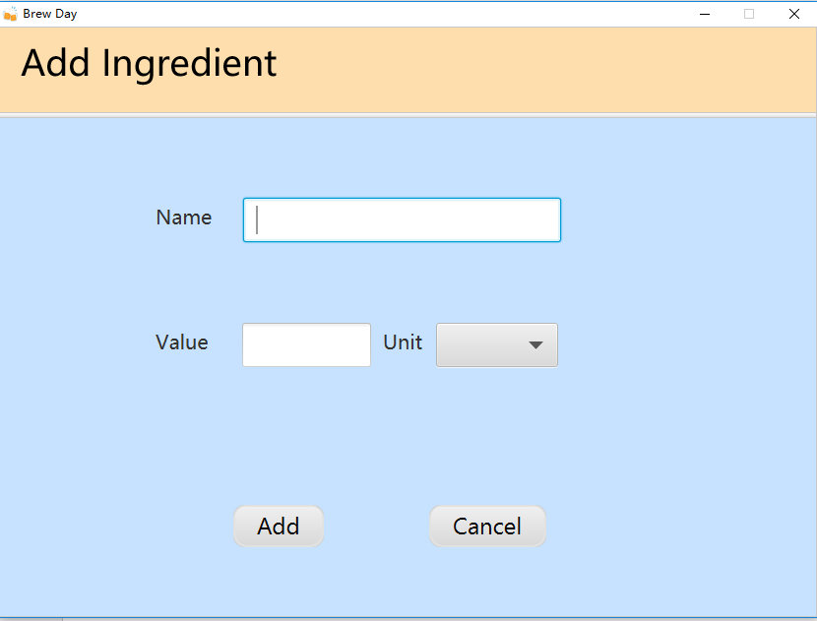

Figure 8 2.4 Add Ingredients Page

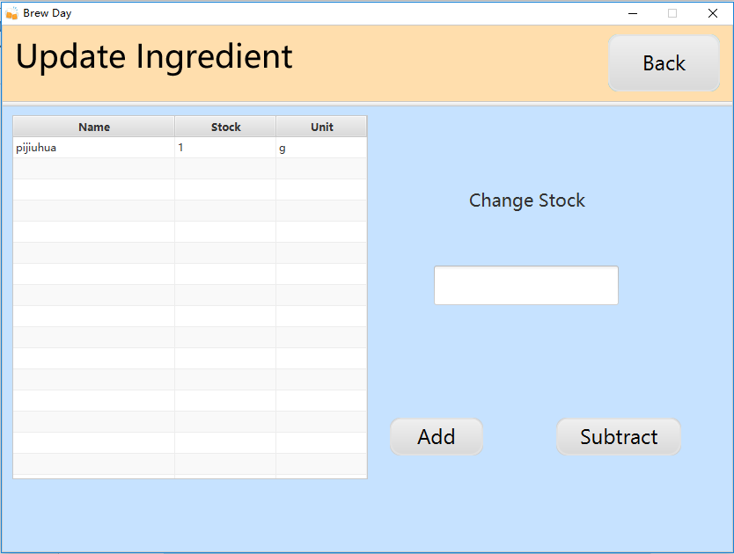

Figure 9 2.5 Update Ingredients Page

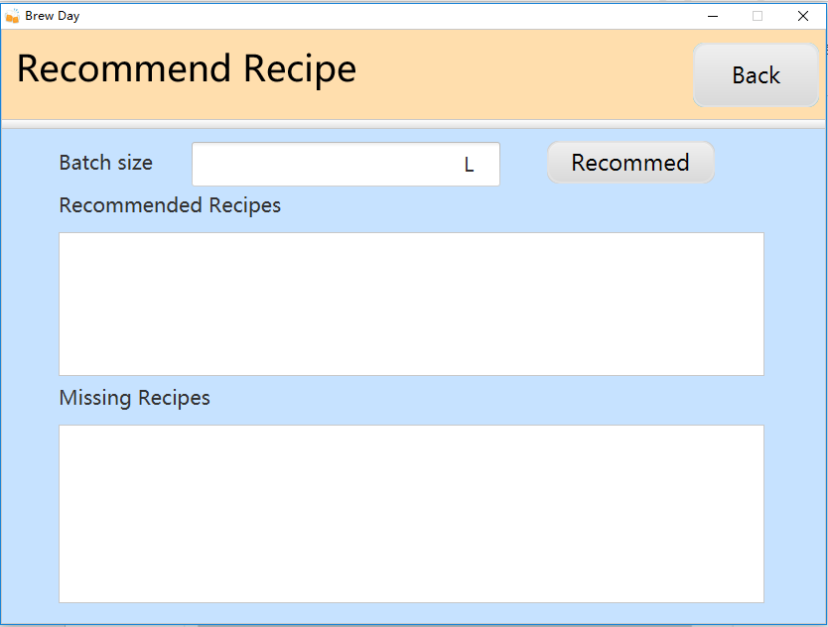

Figure 10 3.1 Recommend Page before batch size input

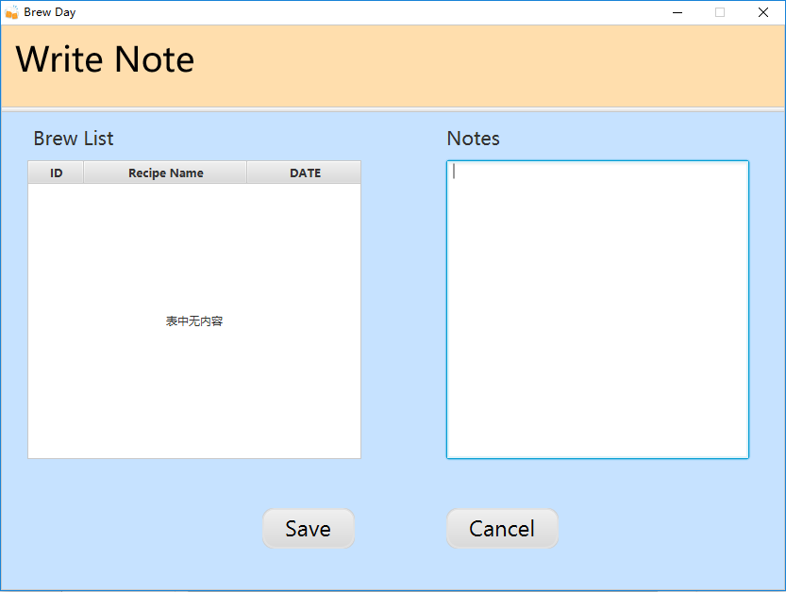

Figure 11 4.1 Write Note Page

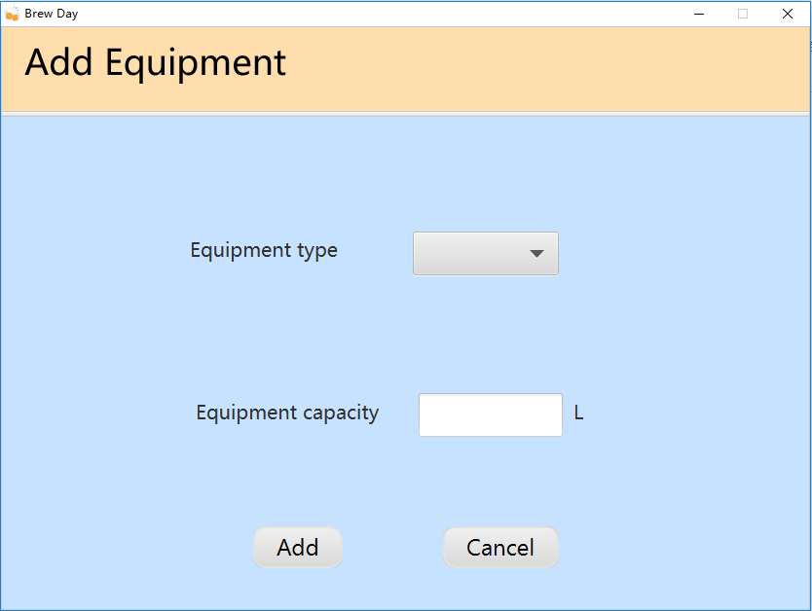

Figure 12 5.1 Add Equipment Page

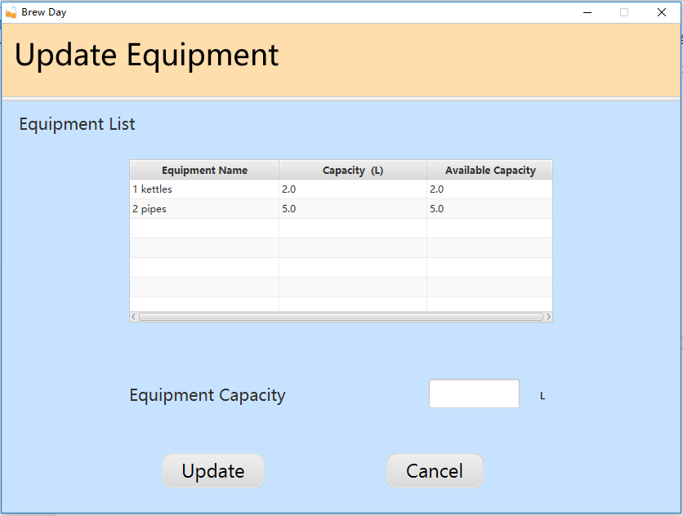

Figure 13 5.2 Update Equipment Information Page

## Hardware Interfaces

None

## Software Interfaces

None

## Communications Interfaces

None

# Other Nonfunctional Requirements (Guo zhenyue 16300030317)

## Performance Requirements

This project we hope to improve the reliability of transforming data. For example, when connecting data between App and server or database, we should guarantee that the data won’t lose. And we need to improve the efficiency in communication. Such as, control the response time in a second or faster.

## Safety Requirements

We don’t provide advice for the recipe. Customers should test them by themselves.

## Security Requirements

Authenticate users when they using the application. Because the material and variable are the major secret of the product, so we hope this can protect user’s information.

## Software Quality Attributes

We build an abstract/detail and object-oriented models to let the whole process of brewing into digital view and store the information into database. This would improve the adaptability maintainability, reusability, robustness, usability of the process.

# Other Requirements (Guo zhenyue 1630003017)

## Appendix A: Glossary

None

## Appendix B: Analysis Models

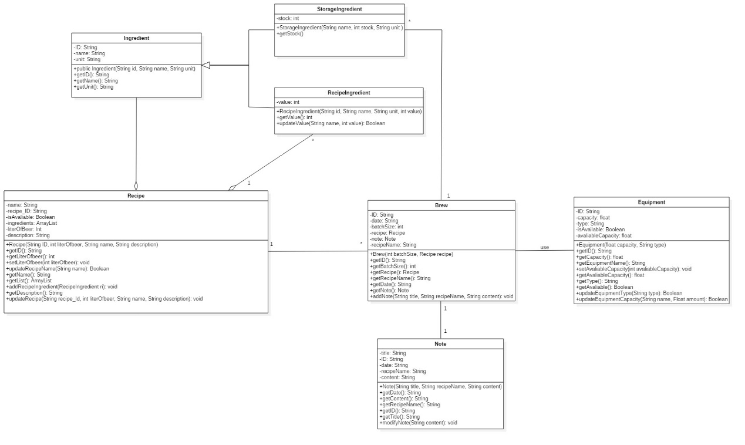

Figure 16 Class Diagram（Chen ruonan1430017004, Liu tingxuan1630003038）

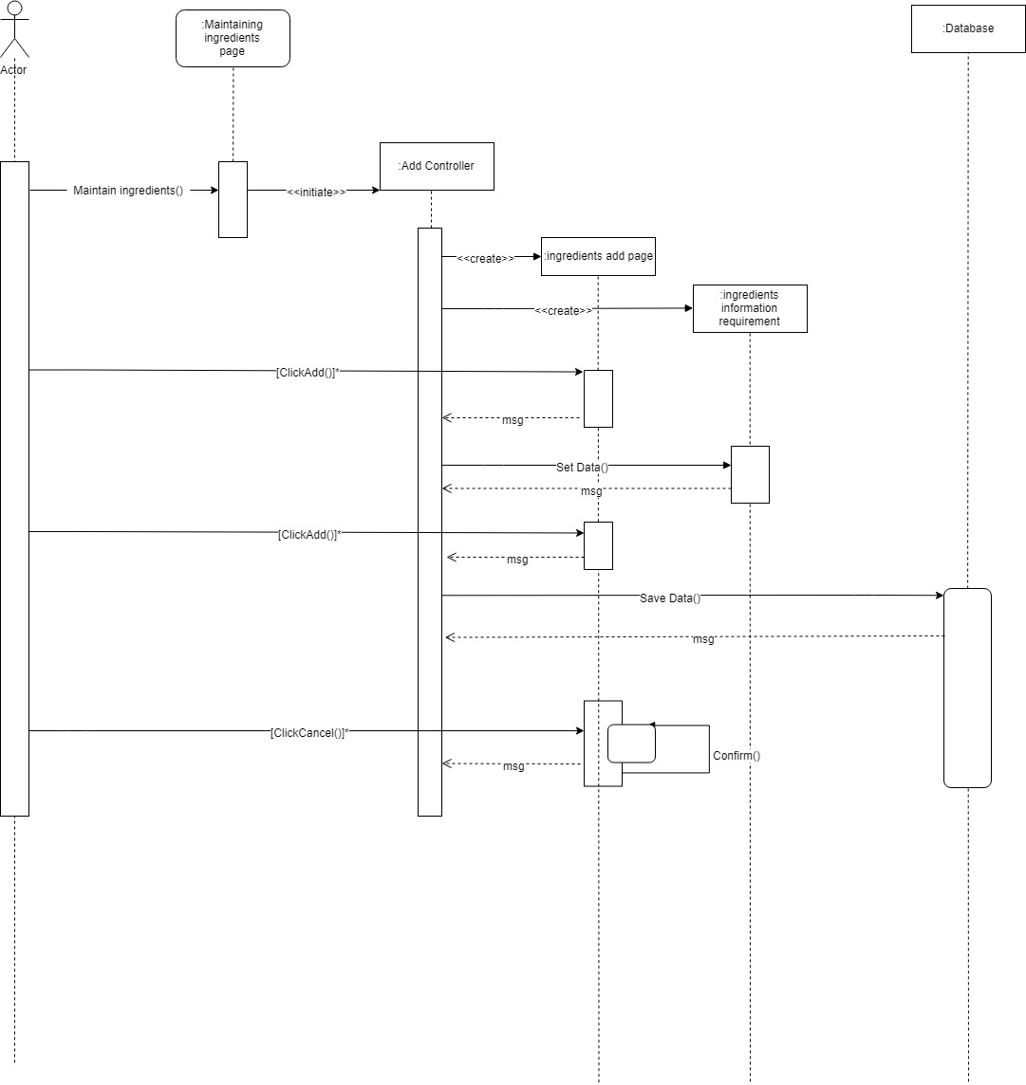

Figure 17 Sequence Diagram(Guo zhenyue1630003017)

## Appendix C: Issues List

None