Software Requirements Specification

for

< Brew Day!>

Version 1.2 approved

Prepared by <Kexin CAO>

<Changyu SHEN>

<Yuan ZHANG>

<Xianggao GU>

<Frege>

<3/5/2019>

Table of Contents

Table of Contents ii

Revision History ii

1. Introduction 1

1.1 Purpose ------Xianggao GU 1

1.2 Document Conventions------Xianggao GU 1

1.3 Intended Audience and Reading Suggestions------Xianggao GU 1

1.4 Project Scope------Xianggao GU 1

1.5 References------Xianggao GU 1

2. Overall Description 2

2.1 Product Perspective------Changyu SHEN 2

2.2 Product Features------Changyu SHEN 2

2.3 User Classes and Characteristics------Changyu SHEN 6

2.4 Operating Environment------Yuan ZHANG 6

2.5 Design and Implementation Constraints------Yuan ZHANG 6

2.6 User Documentation------Yuan ZHANG 6

2.7 Assumptions and Dependencies------Yuan ZHANG 6

3. System Features 6

3.1 Maintain Recipes – Gu Xianggao 6

3.2 Maintain Ingredients – Shen Changyu 8

3.3 Recommend a Recipe – Gu Xianggao 9

3.4 Write Note – Shen Changyu 10

3.5 Maintain Equipment Information – Shen Changyu 12

4. External Interface Requirements 13

4.1 User Interfaces 13

4.1.1 Maintain Recipes – Zhang Yuan 13

4.1.2 Maintain Ingredients – Cao Kexin 14

4.1.3 Recommend a Recipe – Zhang Yuan 14

4.1.4 Write Notes – Shen Changyu 15

4.1.5 Equipment Information – Cao Kexin 15

4.2 Hardware Interfaces------Yuan ZHANG 16

4.3 Software Interfaces------Yuan ZHANG 16

4.4 Communications Interfaces------Yuan ZHANG 16

5. Other Nonfunctional Requirements 16

5.1 Performance Requirements ------Kexin CAO 16

5.2 Safety Requirements ------Kexin CAO 16

5.3 Security Requirements ------Kexin CAO 17

5.4 Software Quality Attributes ------Kexin CAO 17

6. Other Requirements ------Kexin CAO 17

Appendix A: Glossary 17

Appendix B: Analysis Models 17

Appendix C: Issues List 17

Revision History

|  |  |  |  |
| --- | --- | --- | --- |
| **Name** | **Date** | **Reason For Changes** | **Version** |
| Frege (all) | 3/5/2019 | Preliminary manuscript of the project | 1.0 |
| Frege(all) | 3/12/2019 | Preliminary manuscript of the project | 1.1 |
| Frege(all) | 3/19/2019 | Preliminary manuscript of the project | 1.2 |

# Introduction

## Purpose ------Xianggao GU

This article is the version 1.0 SRS of an application called “Brew Day!” We will systematically introduce all the plans to help with programming the entire project, and also help customers better understand the features of this application and how testers test it. In this SRS, we will introduce the types of customers that this project applies to; the basic product characteristics, product design and its operating environment, dependencies; the requirements for product performance, safety and security; and the additional help for developers

## Document Conventions------Xianggao GU

In this SRS, all normal requirements are written in Times font, 12 font-size. For higher-level requirements, we will highlight them and use larger font-size.

## Intended Audience and Reading Suggestions------Xianggao GU

This SRS applies to developers, project managers and testers. The rest of the article consists of four important parts: Overall Description (Section 2), a brief introduction to the basic information of the project; System Features (Section 3), which detailing the features that the software needs to have; External Interface Requirements (Section 4), which detailing the various interfaces; and Other Nonfunctional Requirements (Section 5), which pointing out the performance that the software needs to achieve. For project managers, we recommend carefully reading 2.4, 2.7 and the entire section 3 (system features) to properly arrange the entire project before starting the program; for developers, we recommend reading the entire section 4 for better development; for testers, we recommend reading the entire section 5 so that they can know what requirement the software needs to accomplish.

## Project Scope------Xianggao GU

“Brew Day!” is an application which can make home brewers much easier to maintain their beer recipes with an organized database, which is benefit for them. Also, users are allowed to create, store and modify their recipes, even when they wish to delete them later, they can remove recipes conveniently. In addition, customers also need a special function “what should I brew today?” in which home brewers can choose the recipe that maximizes the use of the available ingredients, taking into account the equipment capacity. Optionally, developers may choose to allow ingredients availability manually, as opposed to do it automatically from brews information.

## References------Xianggao GU

Siebenthal, C. (2019). Learn the Step-by-Step Process Of Brewing

Beer, Explained in Animated GIFs. Retrieved from

https://firstwefeast.com/drink/learn-how-to-brew-beer-with-these-fun-animated-gifs

# Overall Description

## 图片5Product Perspective------Changyu SHEN

This product is a new, self-contained product.

The beer recipe database could save all the recipes. And the recipe management system could adjust the recipes including modify, create, delete. The ingredients database saves all the quantities of ingredients. And the ingredients could update the number of ingredients and each price of them. The recommendation system could look though the recipe database and according to the ingredient database to give a special recipe. Besides, the recoding system could record the recipe instances and notes after brewing beer saved in note database. Finally, it has a maintain system to make sure everything goes well.

## Product Features------Changyu SHEN

Manage the recipes: including save, modify, create, delete.

Update the quantity of ingredients.

Recommend recipes by quantities of ingredients.

Record the recipe instances.

Take notes after brewing beer.

Remind missing ingredients for the next brew.

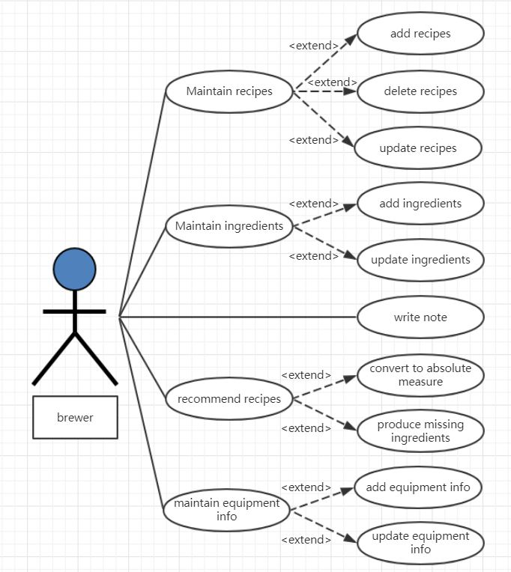

Basic scenario for “Update recipes”:

-The user chooses one recipe then click “Update”

-The Server displays the detail of recipe

-The user modifies the information and click “Save”

-The Server saves the information of recipes and displays it.

Alternative scenario – Repetitive recipes:

-The user chooses one recipe then click “Update”

-The Server displays the detail of recipe

-The user modifies the information and click “Save”

-The information is already saved

Basic scenario for “Add recipes”:

-The user clicks “Add” to create a new recipe

-The Server displays the information boxes of recipe

-The user fills in the information boxes and click “Save”

-The Server saves the information of recipes and displays it.

Alternative scenario – Repetitive recipes:

-The user clicks “Add” to create a new recipe

-The Server displays the information boxes of recipe

-The user fills in the information boxes and click “Save”

-The information is already saved

Basic scenario for “Delete recipes”:

-The user chooses one recipe then click “Delete”

-The Server displays the detail of recipe

-The user to be sure of deleting

-The Server delete the information of recipes and remind it successes.

Alternative scenario – Delete wrong recipes:

-The user chooses one recipe then click “Delete”

-The Server displays the detail of recipe

-The user to be not sure of deleting

-The deleting is canceled

Basic scenario for “write note”:

-The user chooses one recipe instance.

-The Server displays the boxes of the notes

-The user enters the notes of recipes instance then click “Save”

-The Server saves the notes of recipes and displays it.

Alternative scenario – Note is too long:

-The user chooses one recipe instance.

-The Server displays the boxes of the notes

-The user enters the notes of recipes instance then click “Save”

-The notes can’t be saved and remind “Note is too long”

Basic scenario for “Add ingredients”:

-The user chooses one recipe

-The Server displays the box quantities of the ingredients of the recipe

-The user add the number of ingredients

-The Server add ingredient amounts and displays the latest

Alternative scenario – Insufficient ingredients:

-The user chooses one recipe

-The Server displays the box quantities of the ingredients of the recipe

-The user add the number of ingredients

-The update fails because of insufficient ingredients

Basic scenario for “Update ingredients”:

-The user chooses one recipe

-The Server displays the quantities of the ingredients of the recipe

-The user clicks “Do it”

-The Server reduce the ingredient amounts and displays the latest

Alternative scenario – Insufficient ingredients:

-The user chooses one recipe

-The Server displays the quantities of the ingredients of the recipe

-The user clicks “Do it”

-The update fails because of insufficient ingredients

Basic scenario for “Record recipe instances”:

-The user chooses one recipe and click “Do it”

-The Server displays the boxes of the conditions

-The user enters the conditions of recipes instance then click “Save”

-The Server saves the conditions of recipes and displays it.

Alternative scenario – Incomplete information

-The user chooses one recipe and click “Do it”

-The Server displays the boxes of the conditions

-The user enters the conditions of recipes instance then click “Save”

-The information can’t be saved and remind “Incomplete”

Basic scenario for “Convert to absolute measure”:

-The user chooses “Recommend recipe”.

-The Server displays the recipe and its ingredients according to the ingredients and batch size

-The user clicks “OK”

-The Server convert to absolute measure and show the data

-The user checks the information and clicks “Do it”

-The Server save the information and start brewing.

Alternative scenario – Incomplete information

-The user chooses “Recommend recipe”.

-The Server displays the recipe and its ingredients according to the ingredients and batch size

-The user clicks “OK”

-The Server convert to absolute measure and show the data

-The user checks the information and clicks “Do it”

-The information can’t be saved and remind “Incomplete”

Basic scenario for “produce missing ingredients”:

-The user chooses one recipe.

-The Server displays the ingredients needs

-The user clicks “Missing”

-The Server remind the missing ingredients and their quantities

Alternative scenario – No missing ingredients

-The user chooses one recipe.

-The Server displays the ingredients needs

-The user clicks “Missing”

-No ingredient is missing

Basic scenario for “Add equipment info”:

-The user chooses the equipment info page.

-The Server displays the equipment info

-The user clicks “Add”

-The Server show the equipment info box

-The user fills in the box and clicks “Finish”

-The Server add the info, remind success and show the info

Alternative scenario – Wrong equipment info

-The user chooses the equipment info page.

-The Server displays the equipment info

-The user clicks “Add”

-The Server show the equipment info box

-The user fills in the box and clicks “Finish”

-The Server can’t add the info because it’s wrong equipment info

Basic scenario for “Update equipment info”:

-The user chooses one equipment info page.

-The Server displays the equipment info

-The user clicks “Modify”

-The Server show the equipment info box

-The user fills in the box and clicks “Finish”

-The Server add the info, remind success and show the info

Alternative scenario – Wrong equipment info

-The user chooses one equipment info page.

-The Server displays the equipment info

-The user clicks “Modify”

-The Server show the equipment info box

-The user fills in the box and clicks “Finish”

-The Server can’t add the info because it’s wrong equipment info

## User Classes and Characteristics------Changyu SHEN

For people who haven’t brewed beer before, we set up beginner guide steps for them to learn to how to start brewing by this software. And they may prefer the recommend recipe function.

For people who have brewing experience but don’t know how to use software, the guide steps will be more focus on how to use it rather than how to brew beer.

For people who often brew beer and like using applications, they can skip the beginner guide steps and the record function is more important for them. Because they need this software to take notes after brewing beer and want it to maintain the ingredients and the recipes.

## Operating Environment------Yuan ZHANG

The software will operate under the standalone Windows operating environment.

## Design and Implementation Constraints------Yuan ZHANG

The Internet connection is a constraint for the application. Since the application fetches data from the database over the Internet, it is crucial that there is an Internet connection for the application to function.

## User Documentation------Yuan ZHANG

For user documentation and information, please consult attached user manual, and on-line help.

## Assumptions and Dependencies------Yuan ZHANG

Assumption about the product is that it will always be used on Windows computers that have JRE. If the computer does not JRE, then user will install JRE for use this application.

# System Features

## Maintain Recipes – Gu Xianggao

3.1.1 Description and Priority

This is the main feature provided for customers to maintain the whole recipes. It has three functions, which are “add”, “delete” and “update”. This feature is the most important part (rank 9) which is the basic function for the whole project. It will greatly improve users’ satisfaction about this project.

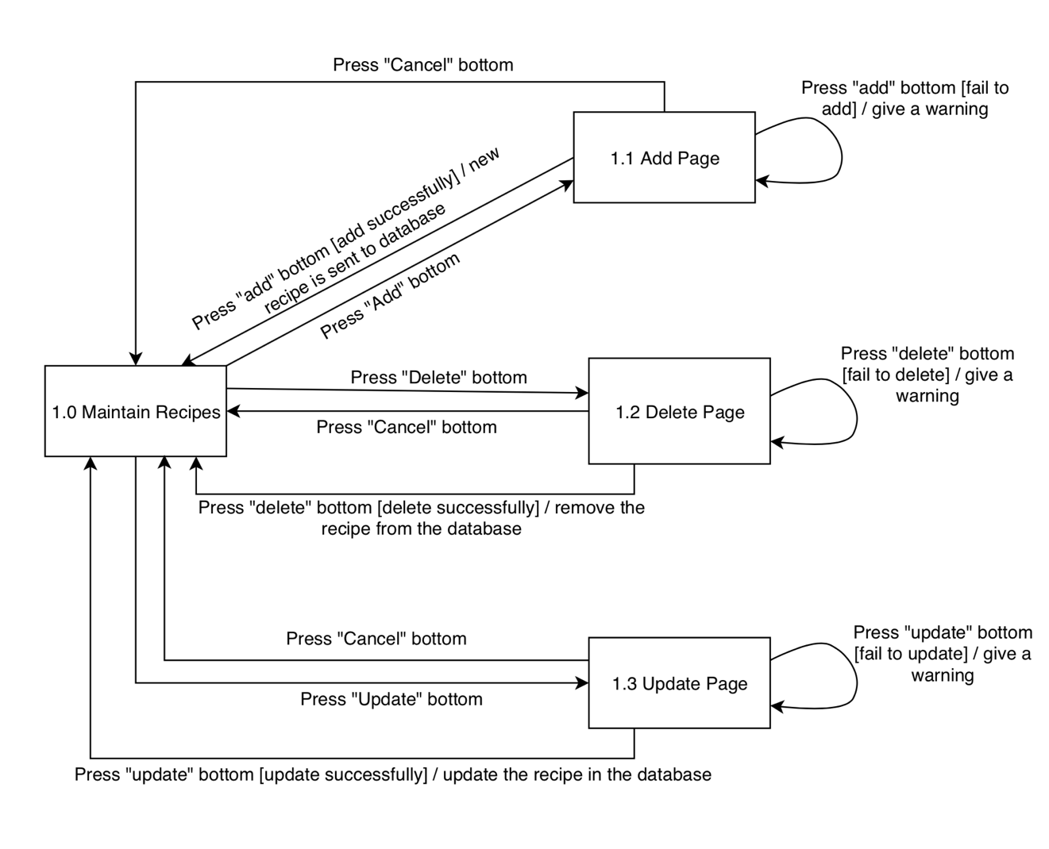3.1.2 Stimulus/Response Sequences

3.1.3 Functional Requirements

When user in the “Maintain Recipes” page, there are three bottoms in it. When user click “Add” bottom, it needs to jump into the “Add” page, and in the “Add” page, users can add any recipe they like, or click “ cancel” bottom to return the “Maintain Recipes” page; When users click “Delete” bottom, it needs to jump into the “Delete” page, where user can find the recipe they do not like to remove, or click “cancel” bottom to return back the maintain page. If there is any recipe, show all of them; If there is not any recipe, give a warning only; When users click “Update” bottom, it needs to jump into the “Update” page, where user can find the recipe they need to change to modify, or click “cancel” bottom to return back the maintain page. If there is any recipe, show all of them; If there is not any recipe, give a warning only; If the user now is in the maintain recipes page, they can click “home” bottom to go back to the homepage.

REQ-1: In the “Maintain Recipes” page, “Add”, “Delete” and “Update” bottoms in it. Click “home” bottom can return to the main page.

REQ-2: In the “Add” page, can add recipe or click “cancel” bottom to return the “Maintain Recipes” page.

REQ-3: In the “Delete” page, can remove the recipe, or click “cancel” bottom to return back the maintain page. If there is any recipe, show all of them; If there is not any recipe, give a warning only.

REQ-4: In the “Update” page, can update the recipe, or click “cancel” bottom to return back the maintain page. If there is any recipe, show all of them; If there is not any recipe, give a warning only.

## Maintain Ingredients – Shen Changyu

3.2.1 Description and Priority

This key feature provides customers with the ability to record all ingredients. It has two functions, "Add" and "Update". The priority of the feature is the highest (rank 9), and the sub-features, “Add” and “Update” are the second highest (rank 8). It is necessary for the complete user use and experiment.

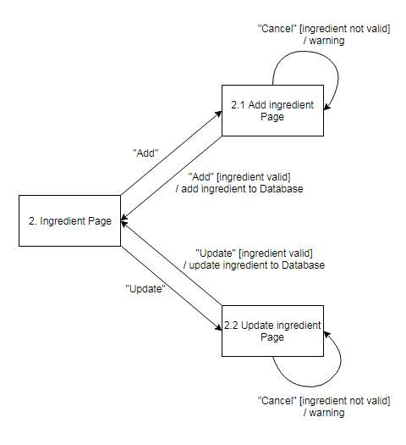3.2.2 Stimulus/Response Sequences

3.1.3 Functional Requirements

After clicking “Add” button in the Ingredient Page, it will jump to the Add Ingredient Page. Fill in the add box, click the “Add” button in the Add Ingredient Page, it will save the added information to the database, then it will jump back to Ingredient Page. If there is ingredient already existing, the add action will be failed, then it will give a warning and jump back to Add Ingredient Page. If click “Cancel” button, it will jump to the Ingredient Page and do not change anything.

After clicking “Update” button in the Ingredient Page, it will jump to the Update Ingredient Page. Change the number of ingredients, click the “Update” button in the Update Ingredient Page, it will update the information to the database, then it will jump back to Ingredient Page. If the amount of ingredients is less than 0, the update action will be failed, then it will give a warning and jump back to Update Ingredient Page. If click “Cancel” button, it will jump to the Ingredient Page and do not change anything.

REQ-1: In the Ingredient Page, “Add” and “Update” bottoms in it. Click “Home” bottom can return to the main page.

REQ-2: In the Add Page, can add ingredients or click “Cancel” bottom to return the Add Ingredient Page.

REQ-3: In the Update Page, can update the ingredients, or click “Cancel” bottom to return back the Add Ingredient Page.

## Recommend a Recipe – Gu Xianggao

3.3.1 Description and Priority

“Recommend Recipes” is a high priority features which is the customers’ compulsory request. This function can recommend many kinds of recipes to customers according to the batch size they enter. The more precise it recommends, the more satisfied customers will be.

3.3.2 Stimulus/Response Sequences

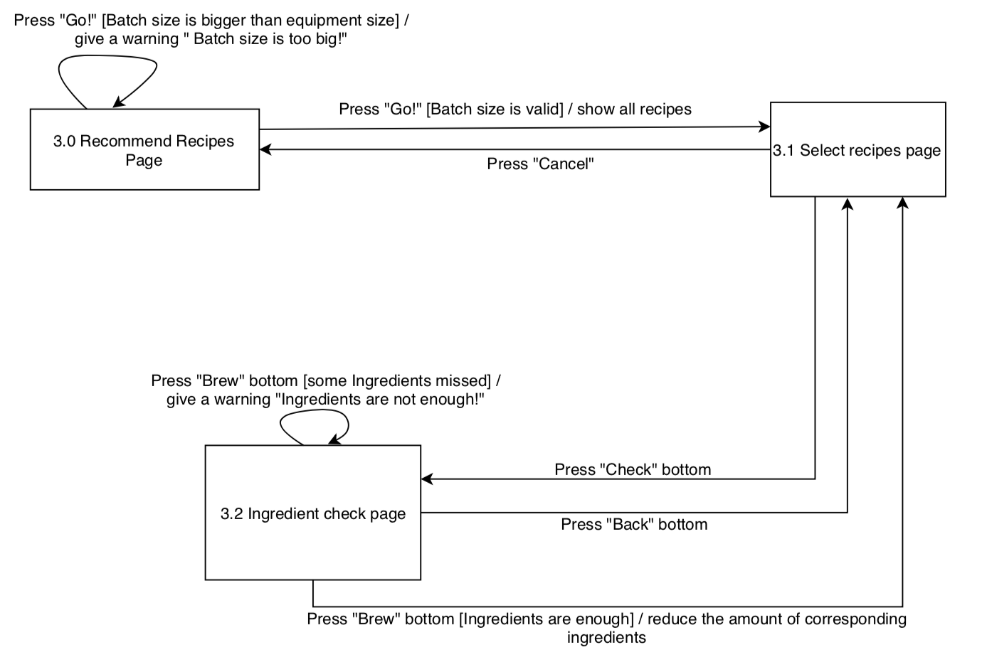

3.3.3 Functional Requirement

In the Recommend page, users are asked to input the batch size. After they enter the batch size, the system will check whether this batch size is smaller than the equipment size, if bigger, give warning, otherwise jump into the Select Recipes Page. In the Select Recipes Page, all the recipes will show in the list, but whose ingredients are enough already will show at the top while whose ingredients will show below them. After clicking “Check” bottom, the detail recipe information will appear and user can check the amount of all ingredients. When users click “Brew” bottom, if ingredients are not enough, a warning will pop out; if are enough, the corresponding ingredients will reduce automatically and system will go back to the Select Recipes Page.

REQ-1: In the Recommend page, users are asked to input the batch size.

REQ-2: System checks batch size. If bigger than equipment size, give warning, otherwise jump into the Select Recipes Page.

REQ-3: In the Select Recipes Page, show all the recipes.

REQ-4: When users click “Brew” bottom, system can do both giving a warning or reducing the corresponding ingredients and go back to the Select Recipes Page.

## Write Note – Shen Changyu

3.4.1 Description and Priority

Provide users with “Write Note” feature. The user creates a new note and adds it to the note library for easy viewing. This feature has a middle priority. “Write” function can create a new note (rank 8).

3.4.2 Stimulus/Response Sequences

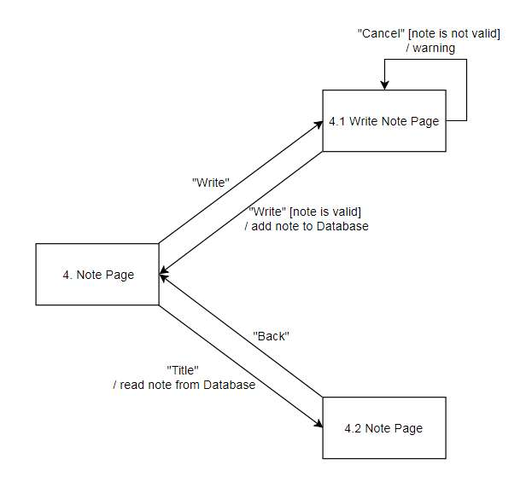

3.4.3 Functional Requirement

After click “Write” button in the Note Page, it will jump to the Write Note Page. Then fill in the title and content of note, click “Write” button in the Write Note Page. If the note is valid, it will save to the database and it will jump to the Note Page. If the note is not valid or click the “Cancel” button, it will give a warning and go back to the Write Note Page without doing anything.

After click any “Title” of these notes, it will go to the Note page and it will show the title, time and content of the note. If click “Back” button, it will go back to the Note Page.

REQ-1: In the Note page, user can see the titles of notes and could know when they created, “Write” button for create a new note and click title could read the specific one.

REQ-2: In the Write Note Page, can write a new note or click “Cancel” to jump to the Note Page.

REQ-3: In the Read Note Page, can read the content of note and know when it create, click “Back” button to jump to the Note Page.

## Maintain Equipment Information – Shen Changyu

3.5.1Description and Priority

“Maintain Equipment Information” is a high priority feature. This function can record the name, amount and capacity of the equipment for subsequent user production. It has two functions, “Add” and “Update”. The priority of the feature is the highest (rank 9), “Add” and “Update” are the second highest (rank 8).

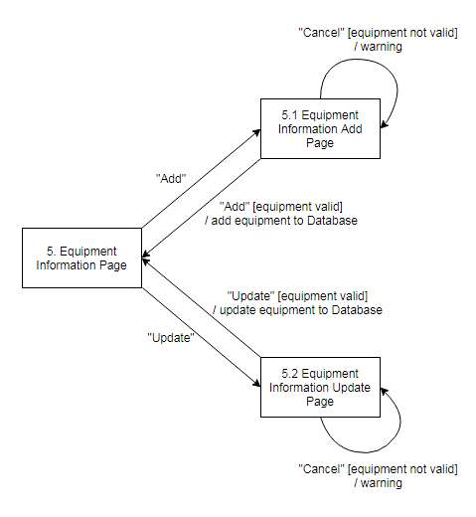3.5.2 Stimulus/Response Sequences

3.5.3 Functional Requirement

After clicking “Add” button in the Equipment Information Page, it will jump to the Equipment Information Add Page. Fill in the add box, click the “Add” button, it will save the added information to the database, then it will jump back to Equipment Information Page. If there is equipment already existing, the add action will be failed, then it will give a warning and jump back to Equipment Information Add Page. If click “Cancel” button, it will jump to the Equipment Information Page and do not change anything.

After clicking “Update” button in the Equipment Information Page, it will jump to the Equipment Information Update Page. Fill in the add box, click the “Update” button, it will save the updated information to the database, then it will jump back to Equipment Information Page. If there is equipment already existing, the add action will be failed, then it will give a warning and jump back to Equipment Information Update Page. If click “Cancel” button, it will jump to the Equipment Information Page and do not change anything.

REQ-1: In the Equipment Information Page, “Add” and “Update” bottoms in it. Click “Home” bottom can return to the main page.

REQ-2: In the Add Page, can add equipment or click “Cancel” bottom to return the Equipment Information Page.

REQ-3: In the Update Page, can update the equipment, or click “Cancel” bottom to return back the Equipment Information Page.

# External Interface Requirements

## User Interfaces

### Maintain Recipes – Zhang Yuan

### C:\Users\dell1\Desktop\图片2.pngC:\Users\dell1\Desktop\图片1.pngC:\Users\dell1\Desktop\图片3.pngMaintain Ingredients – Cao Kexin

### Screen%20Shot%202019-03-19%20at%2016.49.40.pngScreen%20Shot%202019-03-19%20at%2016.49.31.pngScreen%20Shot%202019-03-19%20at%2016.49.23.png Recommend a Recipe – Zhang Yuan

### C:\Users\dell1\Desktop\微信图片_20190319223134.jpgC:\Users\dell1\Desktop\微信图片_20190319223139.jpgC:\Users\dell1\Desktop\微信图片_20190319223147.pngWrite Notes – Shen Changyu

### C:\Users\dell1\Desktop\微信图片_20190319223011.jpgC:\Users\dell1\Desktop\fsfsd.jpgC:\Users\dell1\Desktop\微信图片_20190319223006.jpgEquipment Information – Cao Kexin

## Hardware Interfaces------Yuan ZHANG

None.

## Software Interfaces------Yuan ZHANG

1. The Howe Brewing System shall communication with the beer recipe database to store and to collect users’ beer recipe on cloud.

2. The Howe Brewing System shall communication with the ingredient database to record every user’s remaining ingredients.

3. The Howe Brewing System shall communication with the maintenance system to maintain the recipe instances.

4. The Howe Brewing System shall communication with the ingredient management system for handling the modification of user’s ingredient database each time users consume their ingredients.

5. The Howe Brewing System shall communication with the recipe management system to enable users to change their recipes.

6. The Howe Brewing System shall communication with the recording system to allow users to write some notes for each time they brew beer.

7. The Howe Brewing System shall communication with the note database to record every note written by users.

8. The Howe Brewing System shall communication with the recommendation system to select and give the user the best recipe, which can be brewed with the available ingredients, maximizing the use of the ingredients, and the batch size.

## Communications Interfaces------Yuan ZHANG

None.

# Other Nonfunctional Requirements

## Performance Requirements ------Kexin CAO

The customer of this product is family-based, which means that an application has a private database. Not a large-scale software. In order to provide a good user experience, the system response time should be within 1 seconds. In case of opening databases, sorting questions and computing there are no delays and the operation is performed in less than 1 second for opening, sorting, computing > 95% of the files. UI elements that do not involve outside connections to social media resources will respond to user input immediately with no noticeable lag.

## Safety Requirements ------Kexin CAO

The software background will have backup data. Once the program crashes, opening the software again will call the backup data to protect the user's operation and modification.

## Security Requirements ------Kexin CAO

This application involves personal privacy and property security. The user's material inventory will not be easily leaked. User names and passwords for access to our application (Brew Day!) should be stored (encrypted) securely. Account login is performed account API’s following the specification given by the API documentation to maintain account security. Our application will not monitor or collect data on user information.

## Software Quality Attributes ------Kexin CAO

What is the purpose of abstract/detail and object-oriented models? <TBD>

**Adaptability**: Checking that the application always has something to function and always pop up error messages in case of component failure. In this case, the error messages appear when something goes wrong so to prevail availability problems.

**Maintainability**: This application code is detailed in detail, clearly defined, easy to find problems, and convenient to maintain and modify.

**Reusability**: The code for its inventory system can be applied to all other inventory management applications.

**Robustness**: If the application is unresponsive, it will automatically close, automatically retain the user state before the shutdown, and the information edited by the user is automatically saved as a draft file. If the application is interrupted while increasing/decreasing the material inventory, this operation will not be saved, and the accuracy of the inventory quantity is guaranteed.

**Usability**: The interface is simple and beautiful, and the user manual is detailed. The operation is simple and easy to use.

# Other Requirements ------Kexin CAO

<Define any other requirements not covered elsewhere in the SRS. This might include database requirements, internationalization requirements, legal requirements, reuse objectives for the project, and so on. Add any new sections that are pertinent to the project.>

<TBD>

Appendix A: Glossary

<Define all the terms necessary to properly interpret the SRS, including acronyms and abbreviations. You may wish to build a separate glossary that spans multiple projects or the entire organization, and just include terms specific to a single project in each SRS.>

<TBD>

Appendix B: Analysis Models

<Optionally, include any pertinent analysis models, such as data flow diagrams, class diagrams, state-transition diagrams, or entity-relationship diagrams.>

<TBD>

Appendix C: Issues List

< This is a dynamic list of the open requirements issues that remain to be resolved, including TBDs, pending decisions, information that is needed, conflicts awaiting resolution, and the like.>

<TBD>