Frege
Meeting Minutes
2019.2.26
- Call to order
Kexin CAO called to order the regular meeting of the Frege at 15:30 on 2/26/2019 in T8-301.
- Roll call
Changyu SHEN conducted a roll call. The following persons were present: Kexin CAO, Yuan ZHANG, Xianggao GU, Changyu SHEN.
- Approval of minutes from last meeting
Changyu SHEN read the minutes from the last meeting. The minutes were approved as read.
- Open issues
- Discuss ways to improve the meeting minutes.
Solution: Should indicate who was chosen to be our team leader and secretary.
Team leader: Kexin CAO
Secretary: Changyu SHEN
- New business
- A new project, An Application for Home Brewers.
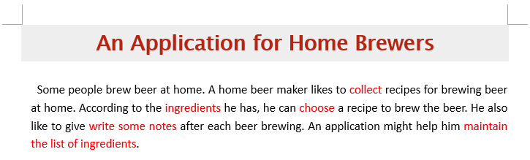
- Meeting to discuss some questions to ask customers:
- Which kinds of information contained in the recipe?
- Which kinds of information need to be record in every brewing process?
- Need to modify in the already recorded recipe, or create a new one?
- Does beer need to be classified?
- Should the application run on a computer or a smart phone?
- Which type of notes will be recorded?
- Does the quantity of ingredients need to be recorded?
- Should we record the source of recipes?
- Know some details of the requirements from the customer.
- The application should run on a smart phone.
- Write down the notes on paper. Will submit the txt and jpg.
- Language: English and Chinese.
- Need user manual (step-by-step).
- The notes generally are for himself, but if he likes, he can share with others.
- The recipes can be modified in the already recorded recipe, and create a new one.
- It may be necessary to record the price of the ingredients.
- According to the SRS templet, ask some new questions:
- Is this app for just one person; or for public, and the recipes can be shared by a group of people? (SRS 2.3)
- Do the users need the on-line help or manuals or both? (SRS 2.6)
- Should the app account be associated with your email? (SRS 4.4)
- Do you want to hide all your information, that nobody can find you or see your profiles? (SRS 5.2)
- Do you need this application can be used in both computer and mobile devices? (SRS 5.4)
- Can this application can be used off-line? (SRS 5.4)
- Determine our main features.
- Adjournment
Kexin CAO adjourned the meeting at 16:30.
Minutes submitted by: Kexin CAO
Minutes approved by: Kexin CAO

