Test Report
for
<BrewDay!>
Prepared by <Xianggao Gu>
<Frege>
<2019.5.12>
Contents
1. Brief description 1
2. Test date and performer 1
3. References 1
4. Error report 1
5. Appendix 1

Brief description
On May.12 2019, we conducted this test. We mainly test the recommend recipes feature, and everything is going right as expected.

Test date and performer
Tester: Xianggao Gu.
Date: May.12 2019

References
Test Plan for <BrewDay!>. (2019.). 1st ed.

Error report
There isn’t any unexpected result.

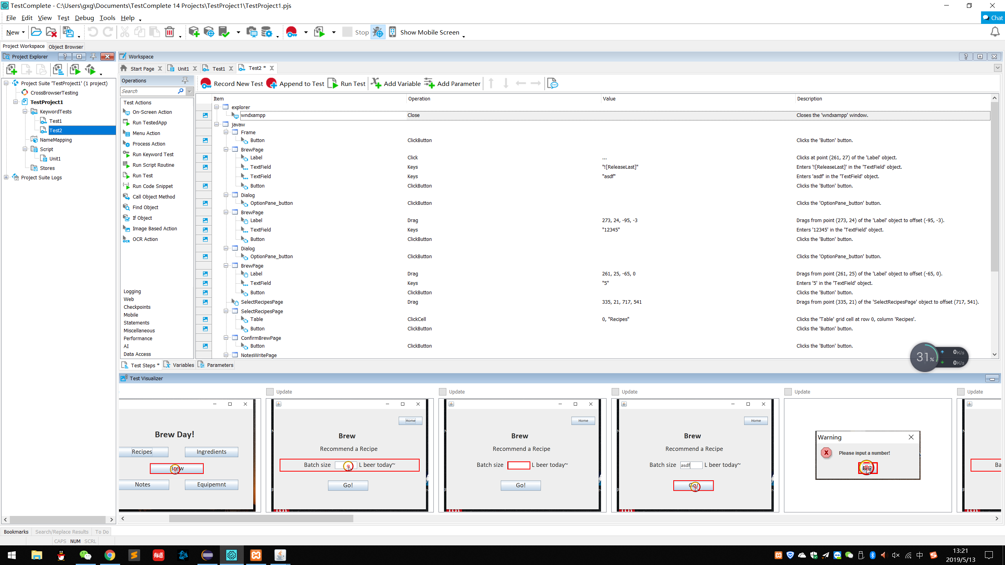
Appendix
After recording, all operations will be showed in Workspace, and some screenshots will showed in Test Visualizer.
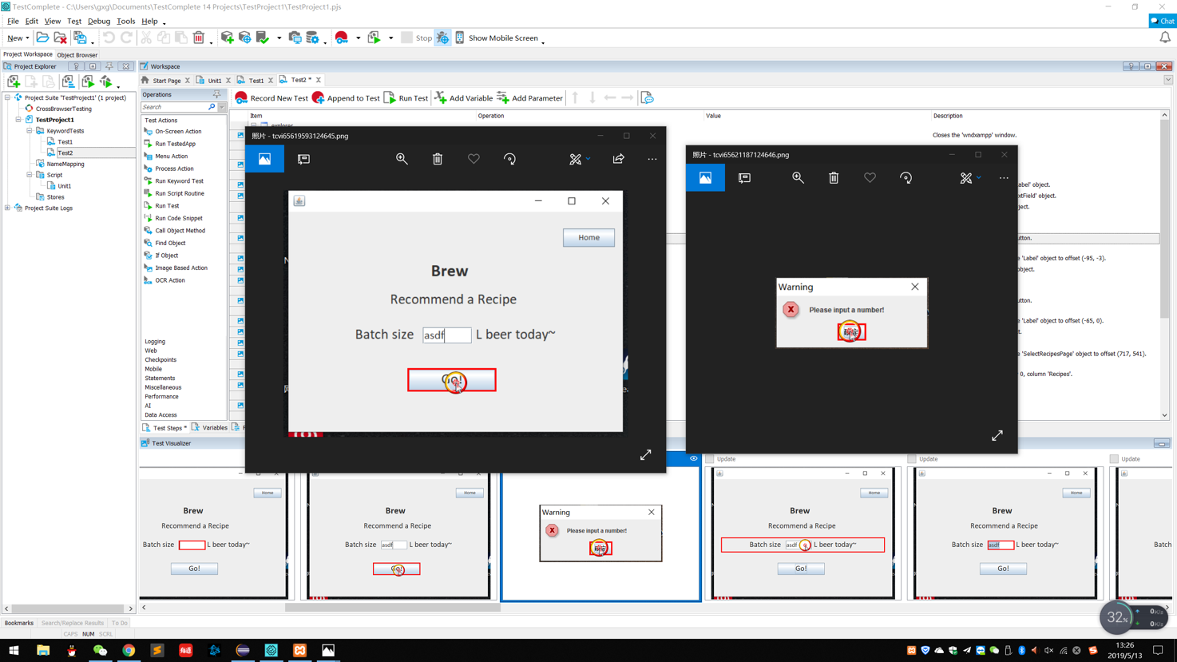
When user's input is not number, pop out a warning "Please input a number!"

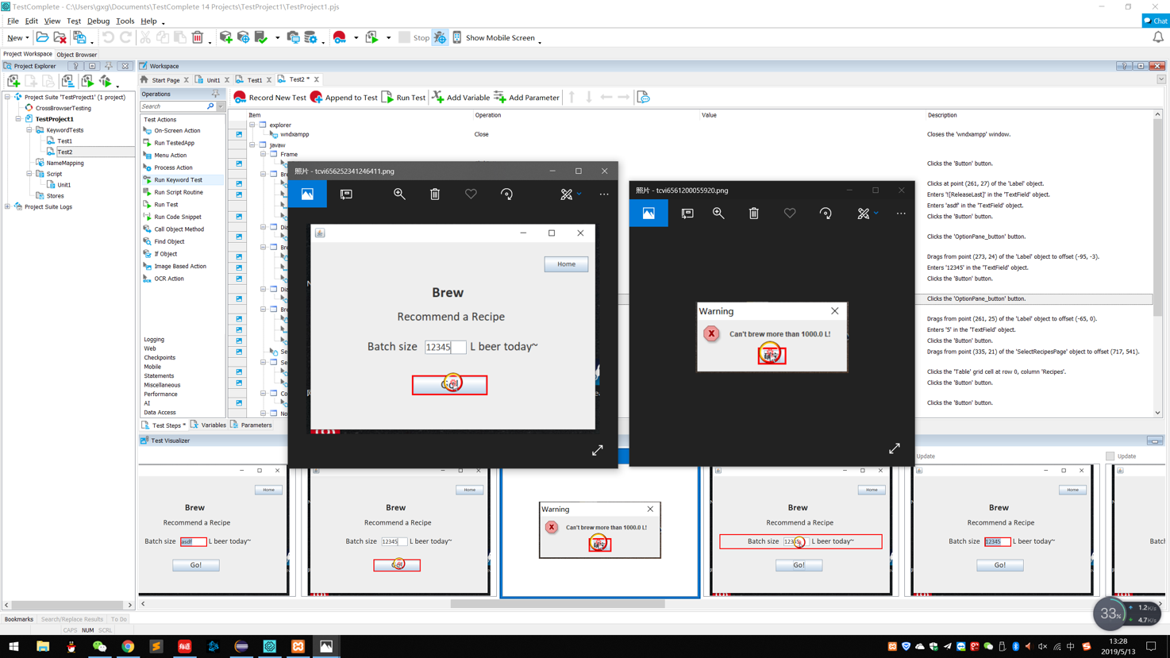
When user enter a batch size which is larger than capacity, pop out a warning "Can't brew more than X L" where X is depend on your capacity.

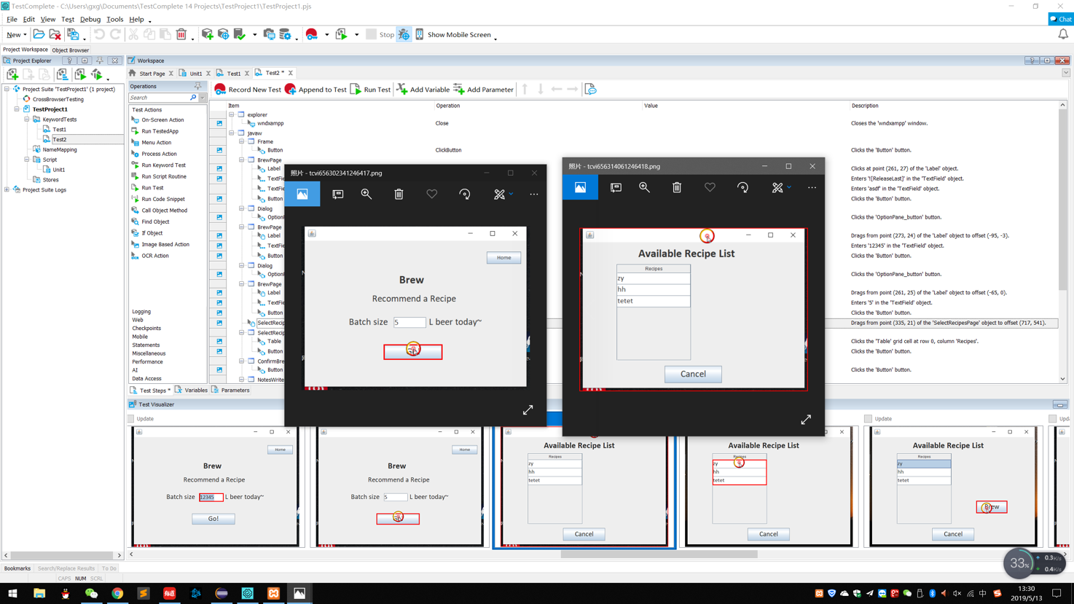
When user enter a batch size which is smaller than capacity, and there is at least one recipe that can be brewed, show the satisfied recipes.
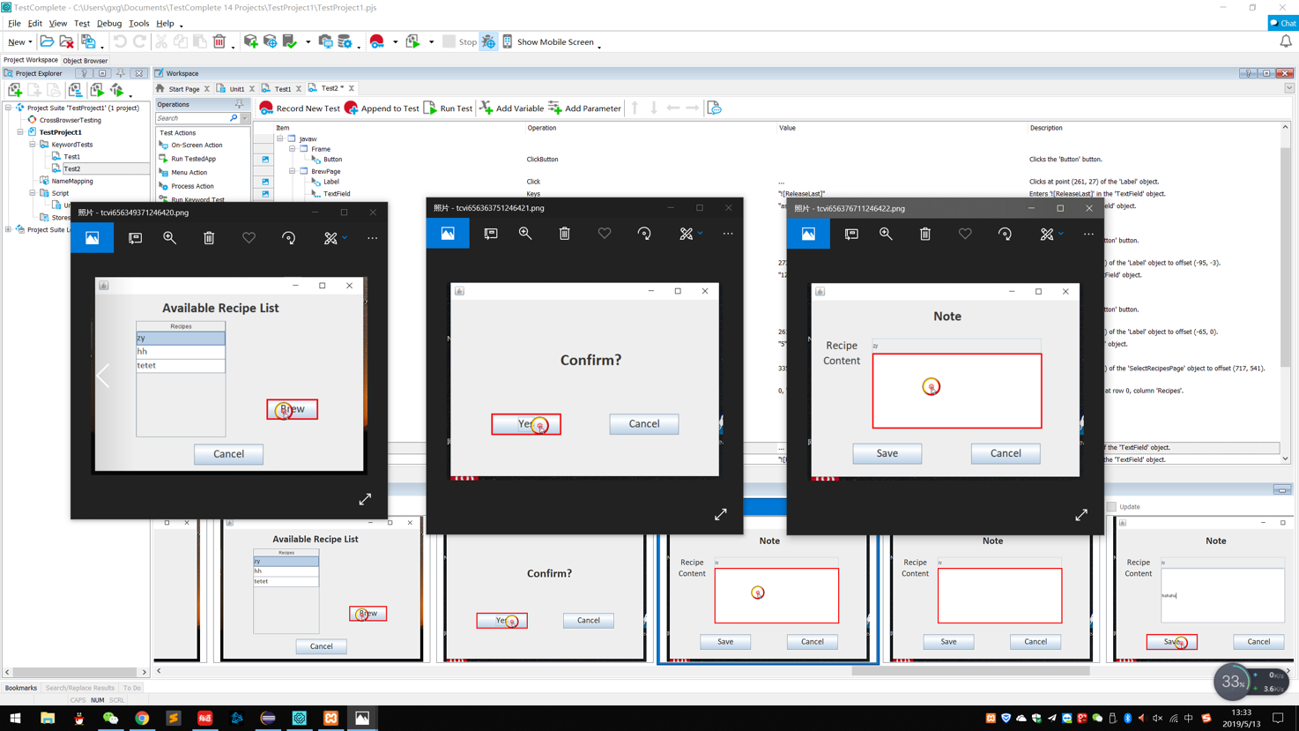

When user choose one recipe to brew, after clicking "yes", Writing note page will show and recipe name will show in the blank, user can enter content.

