Software Requirements Specification
for
<Project>
Version 1.0 approved
Prepared by <author>
<organization>
<date created>
Table of Contents
Table of Contents ii
Revision History ii
1. Introduction 1
1.1 Purpose 1
1.2 Document Conventions 1
1.3 Intended Audience and Reading Suggestions 1
1.4 Project Scope 1
1.5 References 1
2. Overall Description 2
2.1 Product Perspective 2
2.2 Product Features 2
2.3 User Classes and Characteristics 2
2.4 Operating Environment 2
2.5 Design and Implementation Constraints 2
2.6 User Documentation 2
2.7 Assumptions and Dependencies 3
3. System Features 3
3.1 System Feature 1 3
3.2 System Feature 2 (and so on) 4
4. External Interface Requirements 4
4.1 User Interfaces 4
4.2 Hardware Interfaces 4
4.3 Software Interfaces 4
4.4 Communications Interfaces 4
5. Other Nonfunctional Requirements 5
5.1 Performance Requirements 5
5.2 Safety Requirements 5
5.3 Security Requirements 5
5.4 Software Quality Attributes 5
6. Other Requirements 5
Appendix A: Glossary 5
Appendix B: Analysis Models 6
Appendix C: Issues List 6

Revision History
Name | Date | Reason For Changes | Version

Introduction

Purpose
<Identify the product whose software requirements are specified in this document, including the revision or release number. Describe the scope of the product that is covered by this SRS, particularly if this SRS describes only part of the system or a single subsystem.>

Document Conventions
<Describe any standards or typographical conventions that were followed when writing this SRS, such as fonts or highlighting that have special significance. For example, state whether priorities for higher-level requirements are assumed to be inherited by detailed requirements, or whether every requirement statement is to have its own priority.>

Intended Audience and Reading Suggestions
<Describe the different types of reader that the document is intended for, such as developers, project managers, marketing staff, users, testers, and documentation writers. Describe what the rest of this SRS contains and how it is organized. Suggest a sequence for reading the document, beginning with the overview sections and proceeding through the sections that are most pertinent to each reader type.>

Project Scope
<Provide a short description of the software being specified and its purpose, including relevant benefits, objectives, and goals. Relate the software to corporate goals or business strategies. If a separate vision and scope document is available, refer to it rather than duplicating its contents here. An SRS that specifies the next release of an evolving product should contain its own scope statement as a subset of the long-term strategic product vision.>

References
<List any other documents or Web addresses to which this SRS refers. These may include user interface style guides, contracts, standards, system requirements specifications, use case documents, or a vision and scope document. Provide enough information so that the reader could access a copy of each reference, including title, author, version number, date, and source or location.>

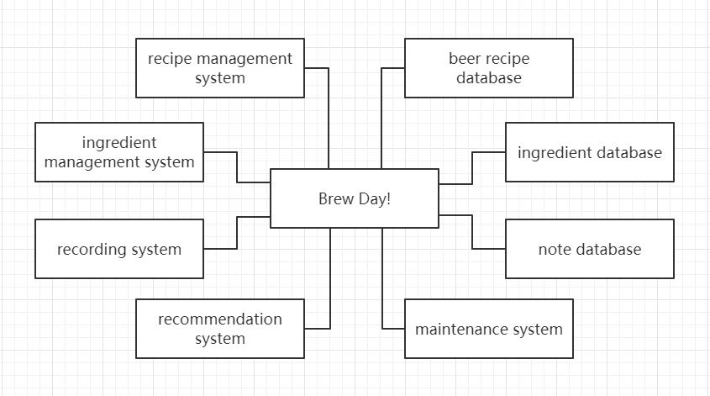
Overall Description

Product Perspective
This product is a new, self-contained product.

The beer recipe database could save all the recipes. And the recipe management system could adjust the recipes including modify, create, delete. The ingredients database saves all the quantities of ingredients. And the ingredients could update the number of ingredients and each price of them. The recommendation system could look though the recipe database and according to the ingredient database to give a special recipe. Besides, the recoding system could record the recipe instances and notes after brewing beer saved in note database. Finally, it has a maintain system to make sure everything goes well.

Product Features
Manage the recipes: including save, modify, create, delete.
Update the quantity of ingredients.
Recommend recipes by quantities of ingredients.
Record the recipe instances.
Take notes after brewing beer.
Remind missing ingredients for the next brew.
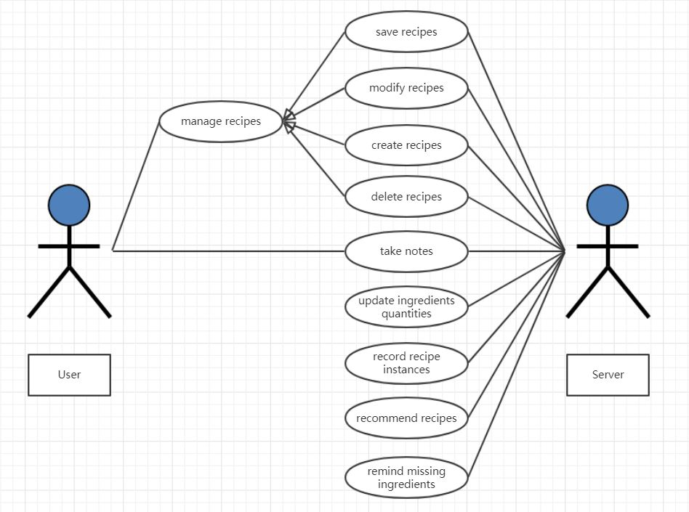

Basic scenario for “Save recipes”:
-The user enters the detail of recipes then click “Save”
-The Server displays the boxes of the name
-The user enters the name of new recipes
-The Server saves the information of recipes and displays it.
Alternative scenario – Repetitive recipes:
-The user enters the detail of recipes then click “Save”
-The Server displays the boxes of the name
-The user enters the name of new recipes
-The information is already saved

Basic scenario for “Modify recipes”:
-The user chooses one recipe then click “Modify”
-The Server displays the detail of recipe
-The user modifies the information and click “Save”
-The Server saves the information of recipes and displays it.
Alternative scenario – Repetitive recipes:
-The user chooses one recipe then click “Modify”
-The Server displays the detail of recipe
-The user modifies the information and click “Save”
-The information is already saved

Basic scenario for “Create recipes”:
-The user clicks “Create” to create a new recipe
-The Server displays the information boxes of recipe
-The user fills in the information boxes and click “Save”
-The Server saves the information of recipes and displays it.
Alternative scenario – Repetitive recipes:
-The user clicks “Create” to create a new recipe
-The Server displays the information boxes of recipe
-The user fills in the information boxes and click “Save”
-The information is already saved

Basic scenario for “Delete recipes”:
-The user chooses one recipe then click “Delete”
-The Server displays the detail of recipe
-The user to be sure of deleting
-The Server delete the information of recipes and remind it successes.
Alternative scenario – Delete wrong recipes:
-The user chooses one recipe then click “Delete”
-The Server displays the detail of recipe
-The user to be not sure of deleting
-The deleting is canceled

Basic scenario for “Take notes”:
-The user chooses one recipe instance.
-The Server displays the boxes of the notes
-The user enters the notes of recipes instance then click “Save”
-The Server saves the notes of recipes and displays it.
Alternative scenario – Note is too long:
-The user chooses one recipe instance.
-The Server displays the boxes of the notes
-The user enters the notes of recipes instance then click “Save”
-The notes can’t be saved and remind “Note is too long”

Basic scenario for “Update ingredients quantities”:
-The user chooses one recipe
-The Server displays the quantities of the ingredients of the recipe
-The user clicks “Do it”
-The Server reduce the ingredient amounts and displays the latest
Alternative scenario – Insufficient ingredients:
-The user chooses one recipe
-The Server displays the quantities of the ingredients of the recipe
-The user clicks “Do it”
-The update fails because of insufficient ingredients

Basic scenario for “Record recipe instances”:
-The user chooses one recipe and click “Do it”
-The Server displays the boxes of the conditions
-The user enters the conditions of recipes instance then click “Save”
-The Server saves the conditions of recipes and displays it.
Alternative scenario – Incomplete information
-The user chooses one recipe and click “Do it”
-The Server displays the boxes of the conditions
-The user enters the conditions of recipes instance then click “Save”
-The information can’t be saved and remind “Incomplete”

Basic scenario for “Recommend recipes”:
-The user chooses “Recommend recipe”.
-The Server displays the recipe and its ingredients according to the ingredients and batch size
-The user clicks “Do it”
-The Server saves all information
Alternative scenario – Incomplete information
-The user chooses “Recommend recipe”.
-The Server displays the recipe and its ingredients according to the ingredients and batch size
-The user clicks “Do it”
-The information can’t be saved and remind “Incomplete”

Basic scenario for “Remind missing ingredients”:
-The user chooses one recipe.
-The Server displays the ingredients needs
-The user clicks “Missing”
-The Server remind the missing ingredients and their quantities
Alternative scenario – No missing ingredients
-The user chooses one recipe.
-The Server displays the ingredients needs
-The user clicks “Missing”
-No ingredient is missing

User Classes and Characteristics
For people who haven’t brewed beer before, we set up beginner guide steps for them to learn to how to start brewing by this software. And they may prefer the recommend recipe function.
For people who have brewing experience but don’t know how to use software, the guide steps will be more focus on how to use it rather than how to brew beer.
For people who often brew beer and like using applications, they can skip the beginner guide steps and the record function is more important for them. Because they need this software to take notes after brewing beer and want it to maintain the ingredients and the recipes.

Operating Environment
<Describe the environment in which the software will operate, including the hardware platform, operating system and versions, and any other software components or applications with which it must peacefully coexist.>

Design and Implementation Constraints
<Describe any items or issues that will limit the options available to the developers. These might include: corporate or regulatory policies; hardware limitations (timing requirements, memory requirements); interfaces to other applications; specific technologies, tools, and databases to be used; parallel operations; language requirements; communications protocols; security considerations; design conventions or programming standards (for example, if the customer’s organization will be responsible for maintaining the delivered software).>

User Documentation
<List the user documentation components (such as user manuals, on-line help, and tutorials) that will be delivered along with the software. Identify any known user documentation delivery formats or standards.>

Assumptions and Dependencies
<List any assumed factors (as opposed to known facts) that could affect the requirements stated in the SRS. These could include third-party or commercial components that you plan to use, issues around the development or operating environment, or constraints. The project could be affected if these assumptions are incorrect, are not shared, or change. Also identify any dependencies the project has on external factors, such as software components that you intend to reuse from another project, unless they are already documented elsewhere (for example, in the vision and scope document or the project plan).>

System Features
<This template illustrates organizing the functional requirements for the product by system features, the major services provided by the product. You may prefer to organize this section by use case, mode of operation, user class, object class, functional hierarchy, or combinations of these, whatever makes the most logical sense for your product.>

System Feature 1
<Don’t really say “System Feature 1.” State the feature name in just a few words.>
3.1.1 Description and Priority
<Provide a short description of the feature and indicate whether it is of High, Medium, or Low priority. You could also include specific priority component ratings, such as benefit, penalty, cost, and risk (each rated on a relative scale from a low of 1 to a high of 9).>
3.1.2 Stimulus/Response Sequences
<List the sequences of user actions and system responses that stimulate the behavior defined for this feature. These will correspond to the dialog elements associated with use cases.>
3.1.3 Functional Requirements
<Itemize the detailed functional requirements associated with this feature. These are the software capabilities that must be present in order for the user to carry out the services provided by the feature, or to execute the use case. Include how the product should respond to anticipated error conditions or invalid inputs. Requirements should be concise, complete, unambiguous, verifiable, and necessary. Use “TBD” as a placeholder to indicate when necessary information is not yet available.>

<Each requirement should be uniquely identified with a sequence number or a meaningful tag of some kind.>

REQ-1:
REQ-2:

System Feature 2 (and so on)

External Interface Requirements

User Interfaces
<Describe the logical characteristics of each interface between the software product and the users. This may include sample screen images, any GUI standards or product family style guides that are to be followed, screen layout constraints, standard buttons and functions (e.g., help) that will appear on every screen, keyboard shortcuts, error message display standards, and so on. Define the software components for which a user interface is needed. Details of the user interface design should be documented in a separate user interface specification.>

Hardware Interfaces
<Describe the logical and physical characteristics of each interface between the software product and the hardware components of the system. This may include the supported device types, the nature of the data and control interactions between the software and the hardware, and communication protocols to be used.>

Software Interfaces
<Describe the connections between this product and other specific software components (name and version), including databases, operating systems, tools, libraries, and integrated commercial components. Identify the data items or messages coming into the system and going out and describe the purpose of each. Describe the services needed and the nature of communications. Refer to documents that describe detailed application programming interface protocols. Identify data that will be shared across software components. If the data sharing mechanism must be implemented in a specific way (for example, use of a global data area in a multitasking operating system), specify this as an implementation constraint.>

Communications Interfaces
<Describe the requirements associated with any communications functions required by this product, including e-mail, web browser, network server communications protocols, electronic forms, and so on. Define any pertinent message formatting. Identify any communication standards that will be used, such as FTP or HTTP. Specify any communication security or encryption issues, data transfer rates, and synchronization mechanisms.>

Other Nonfunctional Requirements

Performance Requirements
<If there are performance requirements for the product under various circumstances, state them here and explain their rationale, to help the developers understand the intent and make suitable design choices. Specify the timing relationships for real time systems. Make such requirements as specific as possible. You may need to state performance requirements for individual functional requirements or features.>

Safety Requirements
<Specify those requirements that are concerned with possible loss, damage, or harm that could result from the use of the product. Define any safeguards or actions that must be taken, as well as actions that must be prevented. Refer to any external policies or regulations that state safety issues that affect the product’s design or use. Define any safety certifications that must be satisfied.>

Security Requirements
<Specify any requirements regarding security or privacy issues surrounding use of the product or protection of the data used or created by the product. Define any user identity authentication requirements. Refer to any external policies or regulations containing security issues that affect the product. Define any security or privacy certifications that must be satisfied.>

Software Quality Attributes
<Specify any additional quality characteristics for the product that will be important to either the customers or the developers. Some to consider are: adaptability, availability, correctness, flexibility, interoperability, maintainability, portability, reliability, reusability, robustness, testability, and usability. Write these to be specific, quantitative, and verifiable when possible. At the least, clarify the relative preferences for various attributes, such as ease of use over ease of learning.>

Other Requirements
<Define any other requirements not covered elsewhere in the SRS. This might include database requirements, internationalization requirements, legal requirements, reuse objectives for the project, and so on. Add any new sections that are pertinent to the project.>
Appendix A: Glossary
<Define all the terms necessary to properly interpret the SRS, including acronyms and abbreviations. You may wish to build a separate glossary that spans multiple projects or the entire organization, and just include terms specific to a single project in each SRS.>
Appendix B: Analysis Models
<Optionally, include any pertinent analysis models, such as data flow diagrams, class diagrams, state-transition diagrams, or entity-relationship diagrams.>
Appendix C: Issues List
< This is a dynamic list of the open requirements issues that remain to be resolved, including TBDs, pending decisions, information that is needed, conflicts awaiting resolution, and the like.>

