Software Requirements Specification
for
< Brew Day>
Version 1.0 approved
Prepared by < Leremy Lin
Xu Xiaochen
Zhiqi Wang
Weifeng Huang >
<Gray>
<2019/03/05>
Table of Contents
Table of Contents ii
Revision History ii
1. Introduction 1
1.1 Purpose 1
1.2 Document Conventions 1
1.3 Intended Audience and Reading Suggestions 1
1.4 Project Scope 1
1.5 References 1
2. Overall Description 2
2.1 Product Perspective 2
2.2 Product Features 2
2.3 User Classes and Characteristics 2
2.4 Operating Environment 2
2.5 Design and Implementation Constraints 2
2.6 User Documentation 2
2.7 Assumptions and Dependencies 3
3. System Features 3
3.1 System Feature 1 3
3.2 System Feature 2 (and so on) 4
4. External Interface Requirements 4
4.1 User Interfaces 4
4.2 Hardware Interfaces 4
4.3 Software Interfaces 4
4.4 Communications Interfaces 4
5. Other Nonfunctional Requirements 5
5.1 Performance Requirements 5
5.2 Safety Requirements 5
5.3 Security Requirements 5
5.4 Software Quality Attributes 5
6. Other Requirements 5
Appendix A: Glossary 5
Appendix B: Analysis Models 6
Appendix C: Issues List 6

Revision History
Name | Date | Reason For Changes | Version

Introduction (Xu Xiaochen-l630003060)

Purpose
The purpose of this document is to give a detailed description for the requirements of “Brew Day” software. It will illustrate the purpose of this software, the design and implementation of the system. It will contain product features, system constraints, interface, and intended readers. The security problems and other requirements will also be included.

Document Conventions
The main body of this document will be written in font Times, size 12. The title will be in Times, font size 14 or 18 in bold. Priorities for higher-level requirements are not assumed to be inherited by detailed requirements, every requirement statement have its own priority.

Intended Audience and Reading Suggestions
The rest of this document will describe features of the software, classes of different users, environment while implementation and some constrains in Section 2. The details of user features are illustrated in Section 3; external interface and security problems are shown in Section 4 and 5. Section 6 includes some complementary requirements. The appendixes are listed at the last of this document.
The intended audiences for this document are people who design the software: software developers, client engineers, and system architects. And also for people who do not need to know much details about the design: Project manager, End-users, Client, and Contractor, who are recommended only to read Section 1, 3, 5 of this documentation.

Project Scope
The purpose of this software “Brew Day” is to develop an application for home brewers that allows them to maintain a list of recipes, and adapt existing ones. The beer enthusiasts or people who interested in brewing beer will be able to log their notes about brewing, maintain an updated list of available ingredients, and do other activities. The details of the features will be included in section 2.2 and 3 of this document.

References
TBD

Overall Description (Leremy Lin – l630003034)

Product Perspective
This is a new product, so there is nothing to be referred.

Product Features

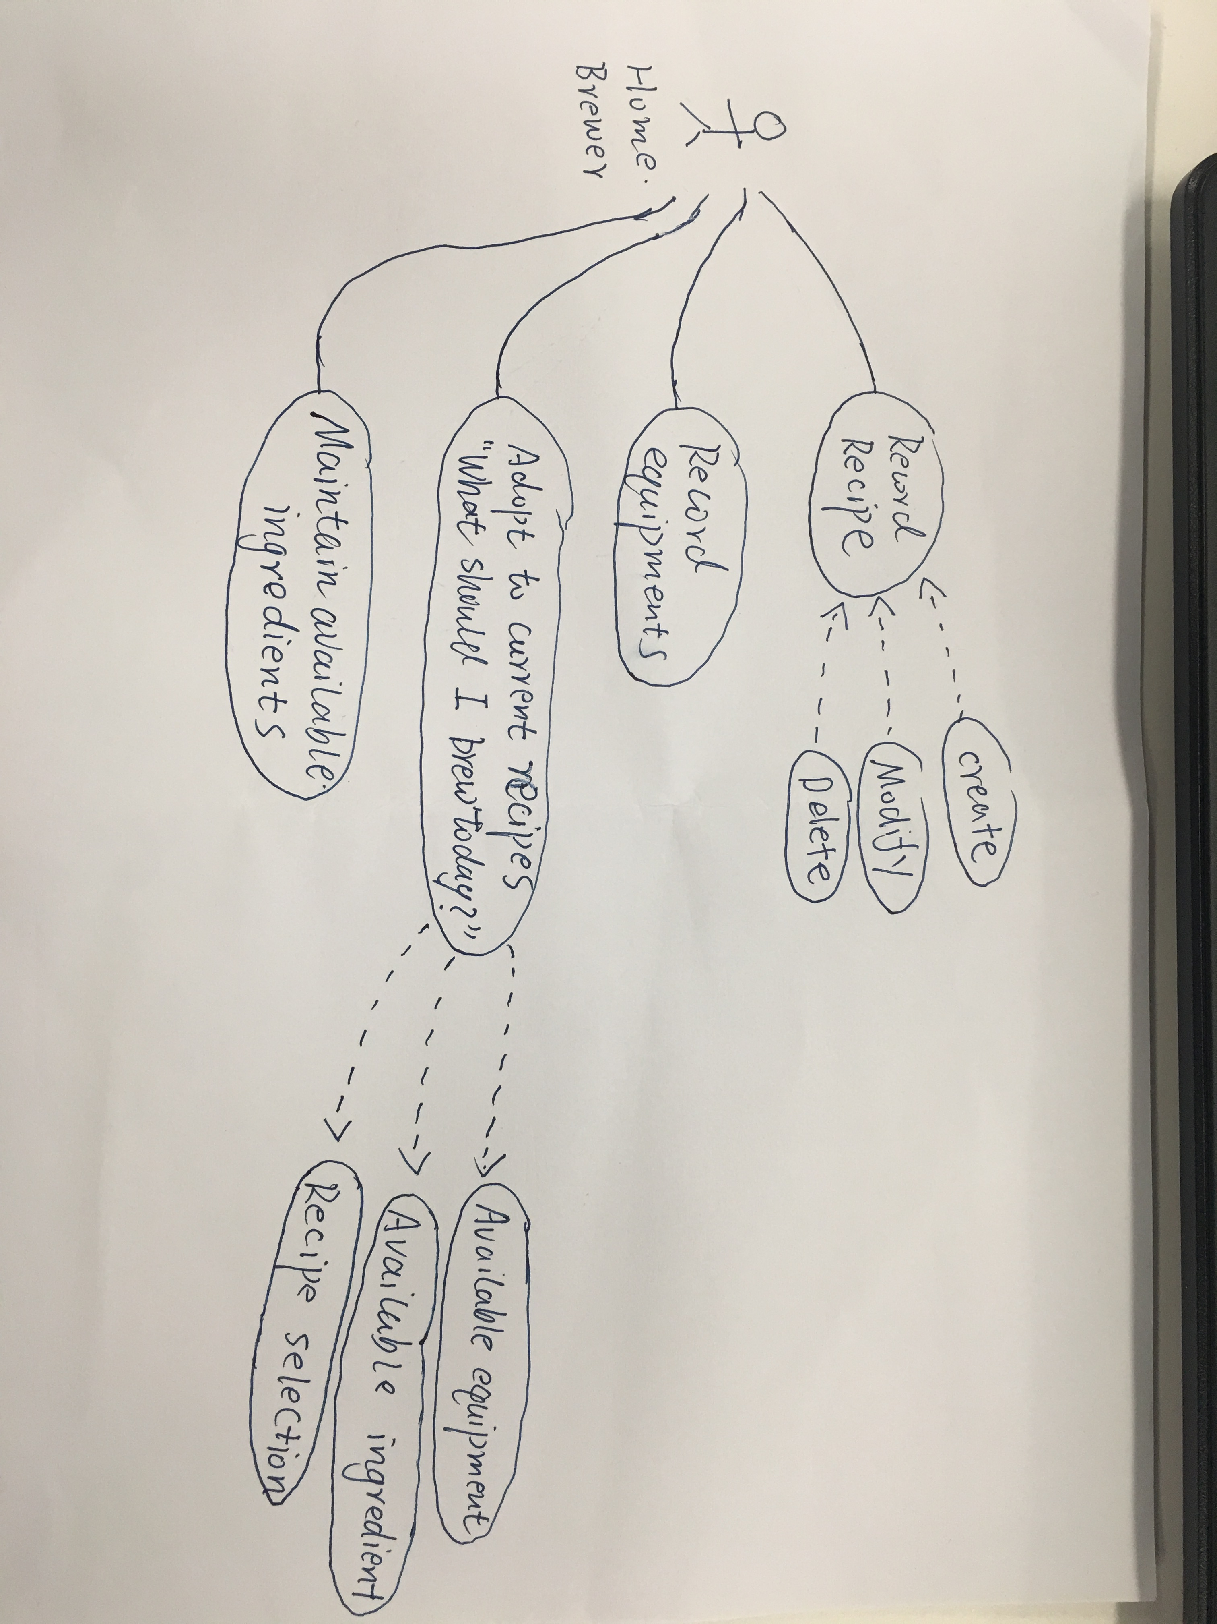

User Classes and Characteristics
The main user classes for this product is the home brewers, who prefer to brew at home and produce beer on a small scale for personal purposes. As a home brewer, they often owns a brewing equipment and brewing capacity as well as the required ingredients for brewing at home. Thus, the product will provide the function to help the users to maintain a list of recipes, adapt existing ones and update list of available ingredients according to their corresponding resources.

Operating Environment
The software is operated under the standalone Windows operating system.

Design and Implementation Constraints

This is a desktop-based application.

JAVA language is used.

User Documentation
TBD.

Assumptions and Dependencies
The software will use JAVA JDK for development.

System Features
<This template illustrates organizing the functional requirements for the product by system features, the major services provided by the product. You may prefer to organize this section by use case, mode of operation, user class, object class, functional hierarchy, or combinations of these, whatever makes the most logical sense for your product.>

System Feature 1
<Don’t really say “System Feature 1.” State the feature name in just a few words.>
3.1.1 Description and Priority
<Provide a short description of the feature and indicate whether it is of High, Medium, or Low priority. You could also include specific priority component ratings, such as benefit, penalty, cost, and risk (each rated on a relative scale from a low of 1 to a high of 9).>
3.1.2 Stimulus/Response Sequences
<List the sequences of user actions and system responses that stimulate the behavior defined for this feature. These will correspond to the dialog elements associated with use cases.>
3.1.3 Functional Requirements
<Itemize the detailed functional requirements associated with this feature. These are the software capabilities that must be present in order for the user to carry out the services provided by the feature, or to execute the use case. Include how the product should respond to anticipated error conditions or invalid inputs. Requirements should be concise, complete, unambiguous, verifiable, and necessary. Use “TBD” as a placeholder to indicate when necessary information is not yet available.>

<Each requirement should be uniquely identified with a sequence number or a meaningful tag of some kind.>

REQ-1:
REQ-2:

System Feature 2 (and so on)

External Interface Requirements (Zhiqi Wang- 1630003052)

User Interfaces
<Describe the logical characteristics of each interface between the software product and the users. This may include sample screen images, any GUI standards or product family style guides that are to be followed, screen layout constraints, standard buttons and functions (e.g., help) that will appear on every screen, keyboard shortcuts, error message display standards, and so on. Define the software components for which a user interface is needed. Details of the user interface design should be documented in a separate user interface specification.>

Hardware Interfaces
NONE

Software Interfaces
The application allows home brewers to maintain an organized database of their beer recipes. The application allows users to create, store and modify recipes, and later on delete them, if the user wishes to do so. If user want use the feature of "what should I brew today?” the application can go through the recipes database to search.

Communications Interfaces
TBD

Other Nonfunctional Requirements (Weifeng Huang- 1630003022)

Performance Requirements
This application need to transfer the data, for example when we use login our account, the application would transfer the data to the database and compare the data. In this case we require the application have a well performance in the data transfer. Make sure the data will not lose any things during the transfer. If there are miss some things during the transfer we should send the data again. Which also apply in updating the data.
It also require this application haves 1 sec response time form ask the data from the database.

Safety Requirements
This application require a warning label to the each recipes, it will tell the brewers all the announcements about this beer or wines, such as alcoholicity, and unsuitable for what people. Which can prevent some people who can’t drink, such as the people who have alcohol allergy, to drink those beers or wines.
This application also require an alarm clock to tell the user when they should stop brewing and the expiration date.

Security Requirements
This application require every user should have a user account to identification. The users can’t see other users’ recipes, except they share it to others.
And this application may require more user’s information, such as the location and phone number, those information should be keep in the database of sever, can’t use in any others way.

Software Quality Attributes

This application was required to object-oriented models. Then it can have the quality attributes of adaptability, maintainability, reusability, robustness and usability.

Other Requirements
TBD

Appendix A: Glossary
<Define all the terms necessary to properly interpret the SRS, including acronyms and abbreviations. You may wish to build a separate glossary that spans multiple projects or the entire organization, and just include terms specific to a single project in each SRS.>
Appendix B: Analysis Models
<Optionally, include any pertinent analysis models, such as data flow diagrams, class diagrams, state-transition diagrams, or entity-relationship diagrams.>
Appendix C: Issues List
< This is a dynamic list of the open requirements issues that remain to be resolved, including TBDs, pending decisions, information that is needed, conflicts awaiting resolution, and the like.>

