Test Report
for
Brew day
Prepared by Yuanzhen Lin, Weifeng Huang, Xiaochen Xu, Ziqi Wang
Gray
2019/05/13
Contents
1. Brief description 1
2. Test date and performer 1
3. References 1
4. Error report 1
5. Appendix 1

Brief description
The test begins from 2019/5/12.
Some unconsidered cases happened. The test tool is difficult to download.

Test date and performer
Testing date is 2019/5/13, tested by Yuanzhen Lin and Weifeng Huang.

References
Brew-day-test-plan.doc

Error report
Test case ID | Expected result | Actual result
006 (without click an item to do the selection recipe button) | Waring message | Nothing happened
009 (click two recipes at the same time) | Warning message | Nothing happened

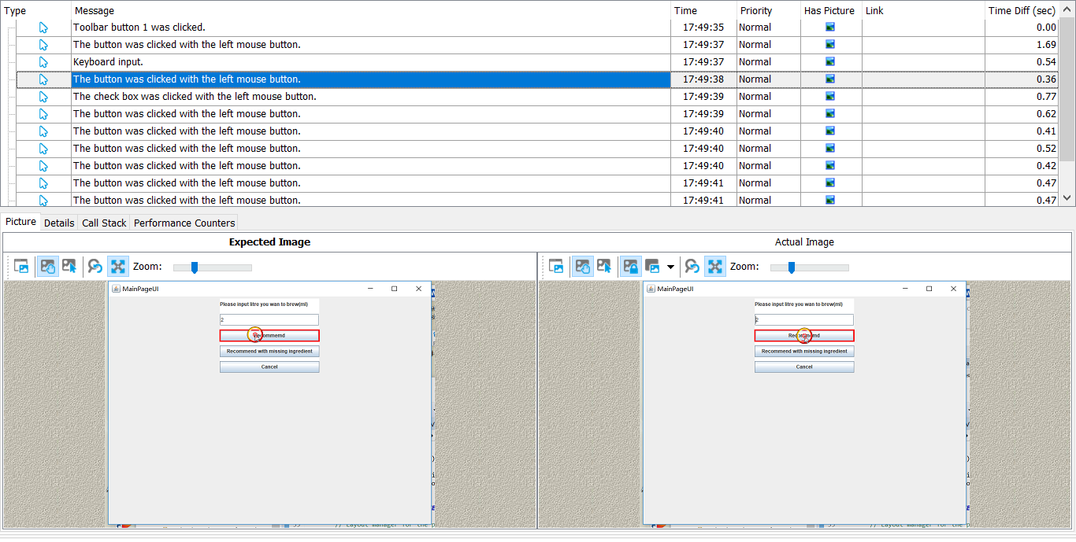
Appendix

1. Check for the normal input for the number checking

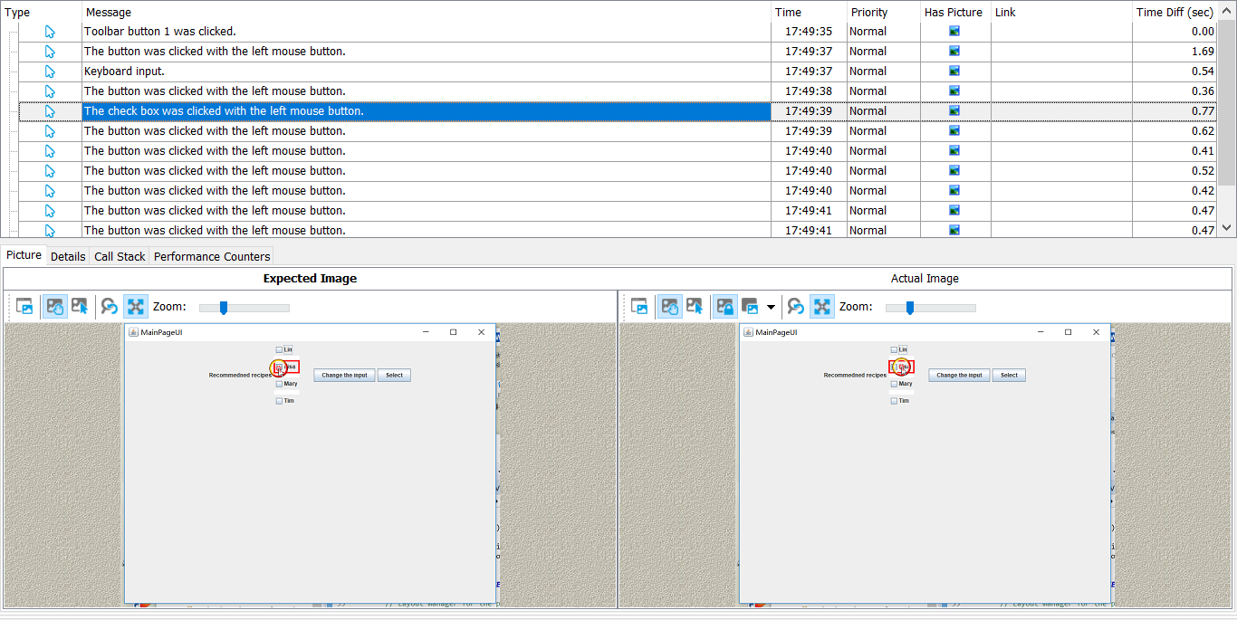

2. Check whether the recommended recipes were shows correctly according to the input number

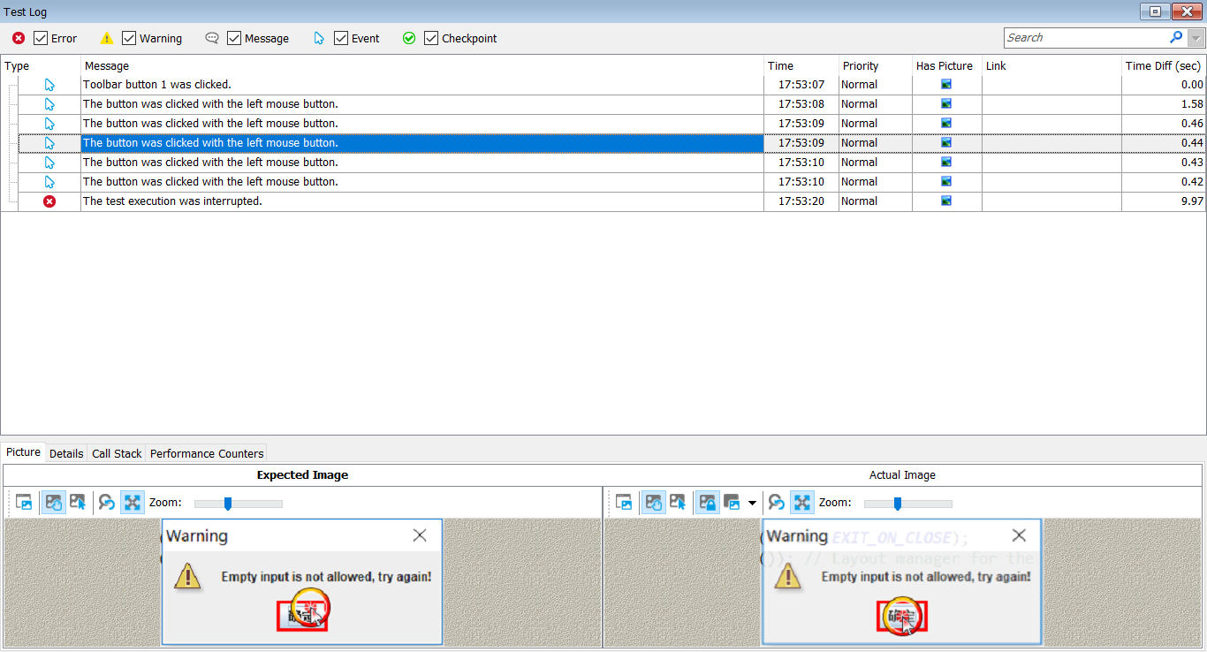

3. Check whether the empty input will arouse the warning message

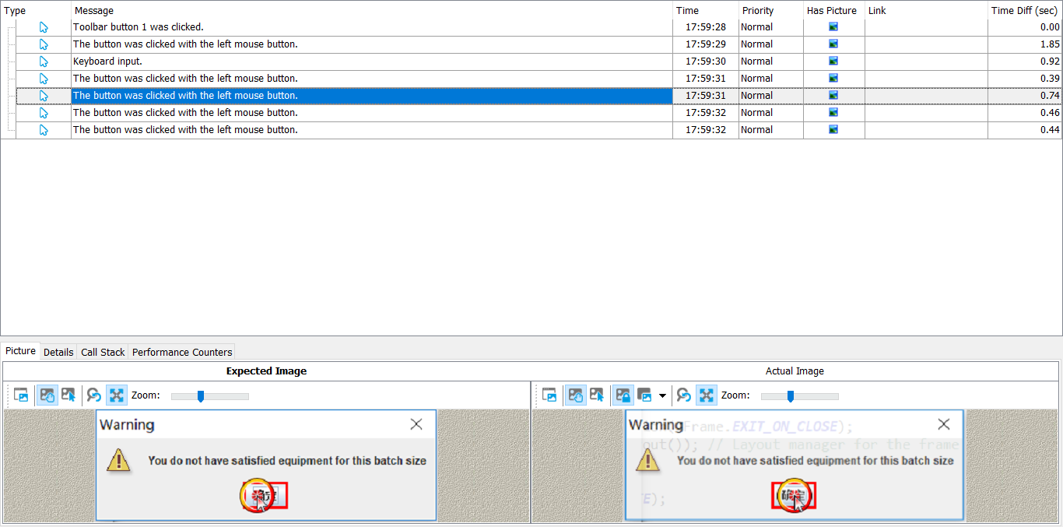

4. Testing whether the batch size larger than the maximum equipment size will cause the waring message

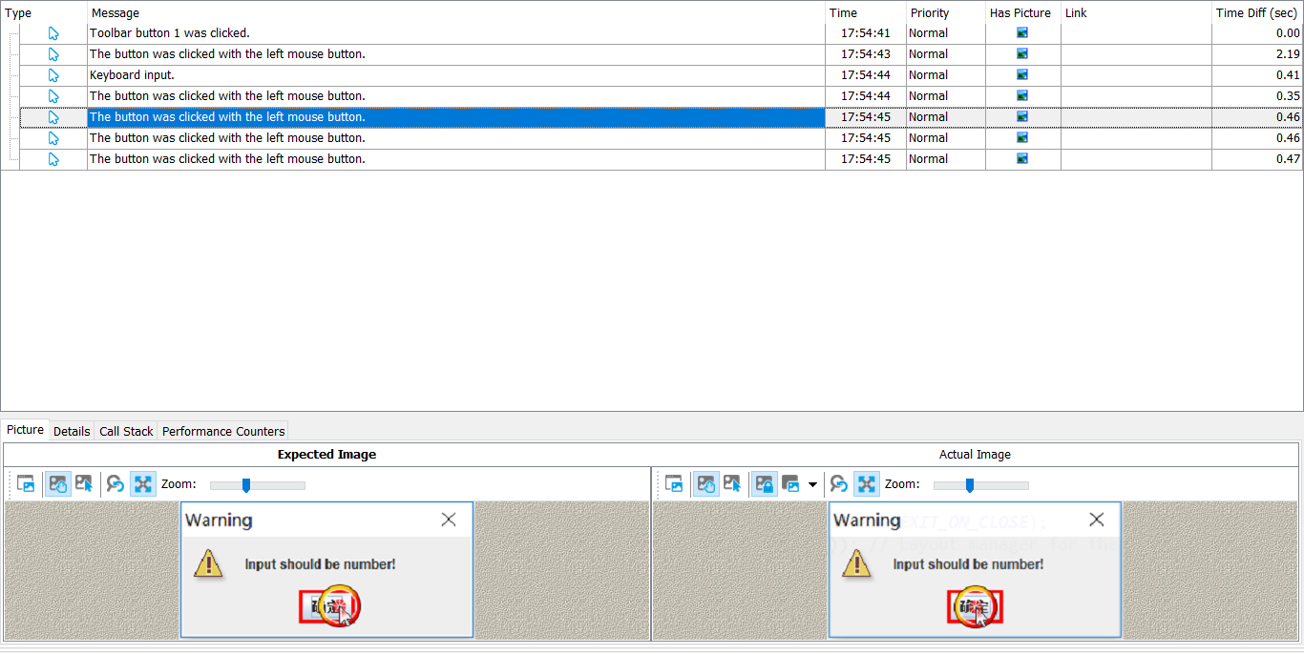

5. Test whether the non-number input will cause the waring message.

