# Solve the following questions using Python (scipy module)

# Normal Distribution

Q1: Calculate the filled-up area under each normal/gaussian curve below:

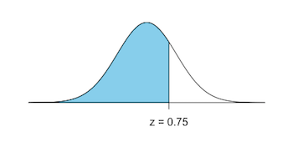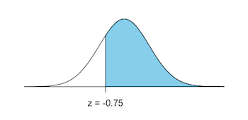

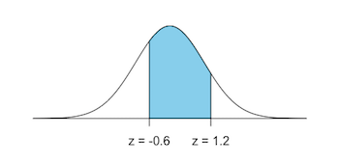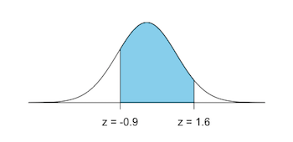

Q2: Assume that temperatures are distributed according to the standard normal distribution. Find the probability that a random temp measurement complies with the following requirements:

* less than −5.5∘
* less than 4.44
* greater than 29.99
* greater than −15.5
* between 15∘ and 40∘
* between −23.00∘ and −2.00∘
* greater than 0∘

Q3: Find z-scores corresponding to the filled-up area below:

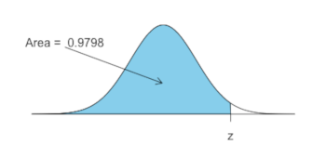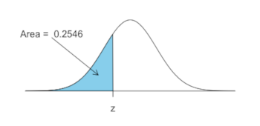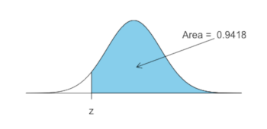

Q4: Estimate the following probabilities:

* P(z>3.30)
* P(−0.43<z<1.54)
* P(z>−3.1)
* P(z<−4.5)

Q5: Estimate the value of m:

* P(z<m)=0.9664
* P(z<m)=0.3050
* P(z>m)=0.0078

Q6: The following normal have mean 100 and sd 15, find x:

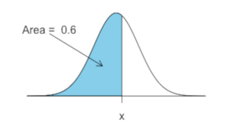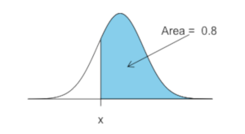

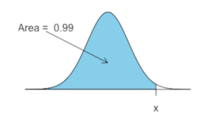

Q7: The average salary for freshmen professors is PKR 50,000. Assume normal distribution with standard deviation 2140.

* What is the probability that a randomly selected first-year teacher makes between 15,000 and 35,000 each year?
* What is the probability that a randomly selected freshman prof has a salary less than 22,000?
* What is the probability that a randomly selected freshman prof has a salary at least 12,000?
* What is 90th percentile salary?

# Confidence Interval

Q1: Construct a 95% confidence interval for the mean height of male Pakistanis. Forty-nine male Pakistanis are surveyed. The sample mean is 71 inches. The sample standard deviation is 2.8 inches.

* State the CI interval
* Draw the graph
* Calculate the error bound
* What will happen to the level of confidence obtained if 2,000 male Pakistanis are surveyed instead of 49? Why?

Q2: We do a survey to estimate the time needed to complete one person’s tax forms. We randomly survey 1000 people. The mean is 33.8 hours with sd of 6.5 hours. Assume normality

* State the CI interval
* Draw the graph
* Calculate the error bound

Q3: The average height of children has a normal distribution with standard deviation of 3.4 inches. We are interested in estimating the mean height of children at school to within two inches with 93% confidence. How many children must you measure?

# Central Limit Theorem

Q1: Model any problem from the agricultural domain in Python and demonstrate the central limit theorem (like dice roll and coin toss example).

# Other Probability Distributions

Q1: Create a notebook which clearly demonstrates the basic concepts and hands-on of Logistic, Log-Logistic, Logit-Normal distributions along with the logit function. You need to add comments in your own words. (Similarly to how I have done in the notebook)