**Group Members:**

* Omer Abid - 14922
* Syed Huzaifa Ejaz - 14905

**Topic**: Smart Home Analytics

**Background**

We assumed that there are two primary type of devices: sensors to send input to our system and the smart devices like light bulbs and thermostats etc which take command from our system

We assumed that there is a central control application that takes input from the sensors and then decide based on that input to turn on, or turn off or change the configuration of a smart device.

Whenever a device changes its configuration (like a thermostats working on a lower temperature), it records that change at the timestamp at which that change occurred.

Also, every device (both sensors and smart devices) is capable of measuring and recording the power it consumed during the time period that it was working.

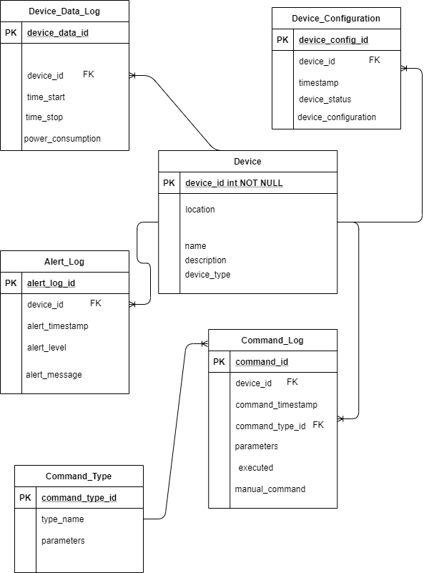

**Attribute Description**

**Table: Device**

Device_id: unique identifier for each device in our smart home

Location: location of that specific device

Name: name of the device

Description: information about the device

Device_type: attribute telling which type of device it is ( whether it is an electronic device or a sensor; if it is an electronic device, then which type of electronic device. If it is a sensor, then which type of sensor)

**Table: Device_Data_Log**

Device_data_id: unique identifier for this log entry

Device_id: The log is about this unique device

Time_start: Timestamp of when the device started

Time_stop: Timestamp of when the device turned off after being started

Power_consumption: Power in kwh consumed by the device when it ran for that time period

**Table: Command_Log**

Command_id: unique identifier of the command

Device_id: to which device did the command was issued

Command-timestamp: Timestamp at which the command was issued

Command_type_id: What type of command it was ( to shut down, to turn on or to change the configuration of the device e.g. lower the temperature)

Parameters: If the command was to change the configuration of the device then what configuration was commanded

Executed: Boolean to check if the command was executed by the device

Manual_Command: Boolean to see whether the command was given by the user or the automated system.

**Table: Command_Type**

Command_type_id: Unique identifier for the command

Type_name: What type of command is this?

Parameters: If this command requires any special parameters then what are they

**Table: Device_Configuration**

Device_config_id: Unique identifier to identify one configuration of a device at a time

Device_id: Which device does this configuration relate to?

Config_timestamp: Timestamp at which the device state was recorded

Device_status: What was the status of the device? On, Off, HIbernate

Device_configuration: What was the configuration of the device at the time?

**Table: Alert_Log**

Alert_log_id: Unique identifier for the entry in the log table

Device_id: Which device does this alert log is about?

Alert_timestamp: Timestamp at which the alert was generated

Alert_level: What’s the level of the alert between 0 and 10?

Alert_message: What message was given to the user when this alert was generated?