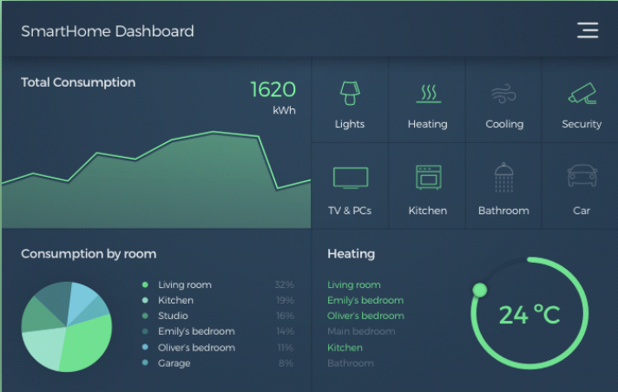

**Purpose:** The dashboard is created to show us the total power consumption in a residence and how power is being distributed across it.

1. The line chart shows that us the consumption of power
2. A filter is used to show power consumption by each appliance on the line chart.
3. Donut chart shows us the room temperature and how heating is being adjusted accordingly in each room.
4. Lastly the pi-chart indicates the consumption of power by each room and indicates that the living room consumes most of the power. Since most family members may dine, watch TV or sit together in the living room hence more consumption. Followed by the kitchen which would have electrical cooking appliances.

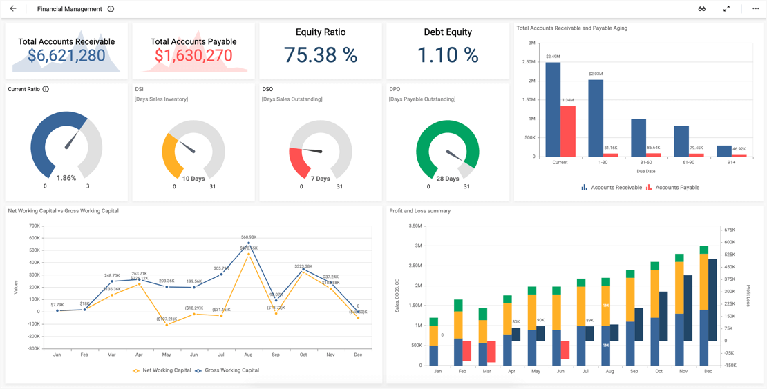

**Purpose:** The dashboard is created to show us the financials of the company.

1. The account receivables are more than account payables hence indicating inefficiency cash liquidity.
2. High equity ratio and low debt ratio shows us that the assets have been financed mostly by equity and the company does not prefer debt financing.
3. Hight current ratio indicates enough liquidity to finance its short-term obligations.
4. The DSI, DSO and DPO indicates a negative cash conversion cycle, hence showing that the company is able to generate revenue from its customers quickly than paying off its obligations to its suppliers.
5. The company is able to convert its receivables to cash with time and is able to pay off its obligations respectively.
6. The line chart shows us that current liabilities were more than current asset during May, June, July, September and December.
7. The bar chart shows us that the company faced losses in February, March and June and no profit or loss in January.