|  |  |  |  |
| --- | --- | --- | --- |
| Group Member | Name | ERP | Roles [Select from: BI Analyst, Feedback Colleague, Stakeholder] |
| 1 | Muhammad Affan | 18019 | BI Analyst /Stakeholder/Feedback Colleague |
| 2 | Myer Ali Iqbal | 17950 | BI Analyst/Stakeholder/Feedback Colleague |

**Assumptions taken by the group in solving this document:**

* Generic Medicine under the column brands is used the most. The generic is assumed to be a pharmaceutical drug that contains the same chemical substance as a drug that belongs to a particular brand for example panadol consists of paracetamol and other generic brands also provide the same chemical substance.
* The column manufacturing site is assumed to be locations of different pharmaceutical companies that are producing medicines in that region.

**Launch Phase**

**Step 1:** Background knowledge of Supply Chain (bulleted list): *You can decide to fill-up the background knowledge template first, and then extract the useful information from there to enter here. Remember that previously successful case studies are important. You can update this section later on by returning from any of the future steps.*

* A Supply Chain is defined as a cycle of producing and selling merchandise, which includes every step from the supply of materials and the production of the merchandise through to their distribution and sale.
* We need to analyze from each and every step from supply to sale, what factors are influencing the cycle and how we can create an efficient cycle for wealth maximization.

**Step 2:** Determine the stakeholder-problem matrix: *What are the supply chain problems being faced by this industry and who are the stakeholders who want this problem solved (add more columns/rows is desired)*

|  |  |
| --- | --- |
|  | <Enter Problem> |
| Business Owner | Deciding the location of factories. Should the factories be located closer to the customers or raw materials. |
| Production Analyst | Production planning and a complete function of demand forecasting. |

**Step 3:** Start Small: Select the problem you want to solve and mention it below:

1. **Deciding the location of factories. Should the factories be located closer to the customers or raw materials.**

**Step 4:** Problem Detail (bulleted list): *Write down the details of the problem identified in matrix above. The purpose here is to clear your own mind about what is the exact issue with a little bit of its detail.*

* The company needs to find a new location for their factory and they need to decide on whether they need to be closer to the customers or raw materials.
* Hence, the biggest factor that has an impact to the decision is freight cost.
* What factors affect the freight cost
* What is the average cost of goods for production and what role does the location play a part in it.

**Step 5:** Your Solution (bulleted list): *What is your solution? How will it solve the problem? It is better to specifically mention it.*

In order to find out which location will be ideal for the new plant we need to do the following

1. Understand which region is the biggest market for these products for the company.
2. What type of dosages does the company operate in.
3. Finding out average freight cost from each country.
4. Then, we need to work on what factors affect freight cost weight, dosage, pack price, delivery delay and shipment mode.
5. What is correlation between freight cost between them
6. Finally using all these factors to find out which manufacturing site is ideal.

**Step 6:** Identify potential metrics/KPIs (bulleted list): *This needs to be done from your previous experience and background knowledge. Consult:*

1. *Average Delivery Delay*
2. *Average Freight Cost*
3. *Average Pack price*

**Step 8:** The first solution: BI Blueprint on paper with Story: *Paste the story below, e.g., paste the pictures of your paperwork in sequence. Also write the feedback of your colleague as a bulleted list and the changes made. Record an audio file with the story and save it as “First.Solution.Audio”. Upload this on LMS.*

Feedback of colleague:

* Top 4 Dosage Forms should be displayed rather than listing them all.
* Avg delay kpi should be present
* Another chart should be there providing the relation between dosage and shipment mode.
* Other factors may impact freight cost so they should also be considered i.e weight,location,country

Changes made:

* Average delay kpi added.
* top n dosage forms are listed.
* Other factors are also included.

Blueprint pictures (paste below in sequence):

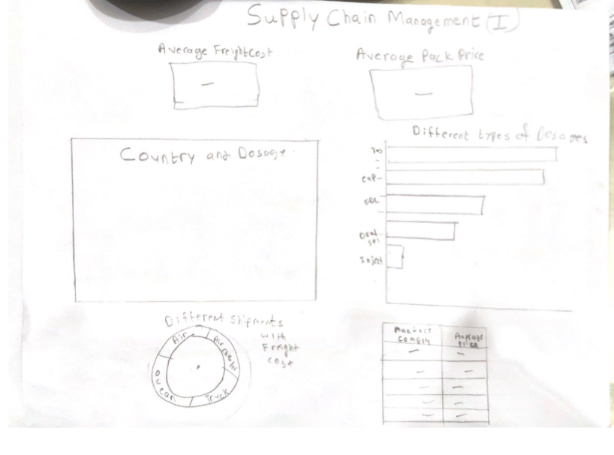

**Wrangle Phase**

**Step 9:** Draw the pipeline of wrangling + analytics on paper: *Paste the snapshots below with explanations.*

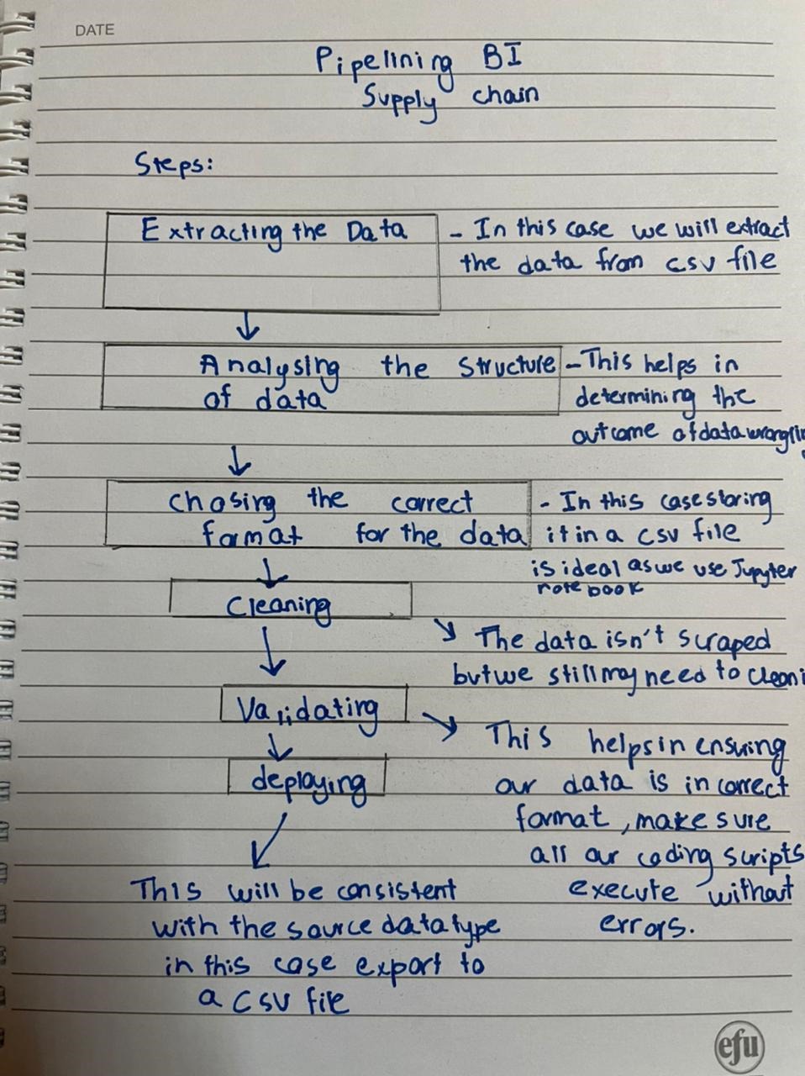

**Brainstorm Phase**

**Step 12:** Modify the pipeline in Step 8 above (if needed): *Paste the story below, e.g., paste the pictures of your paperwork in sequence. Also write the feedback of your colleague as a bulleted list and the changes made. Record an audio file with the story and save it as “Second.Solution.Audio”. Upload this on LMS*

Feedback of colleague:

* We have to categorise the world map for e.g. in which region which dosage form accounts for what proportion.
* There should be a tabular representation of Country and avg Freight cost.
* A chart should be there to help in identifying which dosage forms are transferred using which shipment modes.

Changes made:

* Table showing country and avg freight cost added.
* A chart to analyze trends between dosage and shipment mode is added.

Blueprint pictures (paste below in sequence):

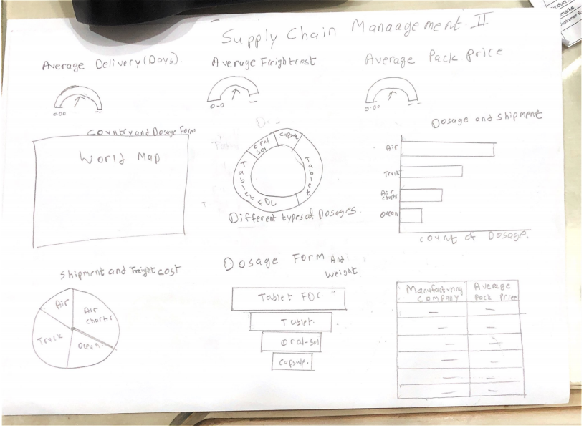

**Dash Phase**

**Step 13:** Which dashboard type are you implementing (Strategic, Operational, Analytics, Tactical): *Mention below and justify:*

* The dashboard that has been implemented is a strategic dashboard. This is used to monitor the status of key performance indicators (KPIs), Since the data behind this dashboard updates on a recurring basis but not frequently. The simple visuals allows the executives to understand the KPIs and according to which decide on how to plan their future investments accordingly.

**Step 14:** Implement on PowerBI and paste all dashboards below: *Also write the feedback of your colleague as a bulleted list and the changes made. Record an audio file with the story and save it as “Third.Solution.Audio”. Upload this on LMS. Here, you must focus 100% on how this story is solving the problem mentioned at the top of the document.*

Feedback of colleague:

* Colour combinations of the charts should be vivid.
* Chart placement should be spaceful.
* Too much text.

Changes made:

* Color scheme is changed and now okay.
* Unnecessary text has been removed

Blueprint pictures (paste below in sequence):

page 1

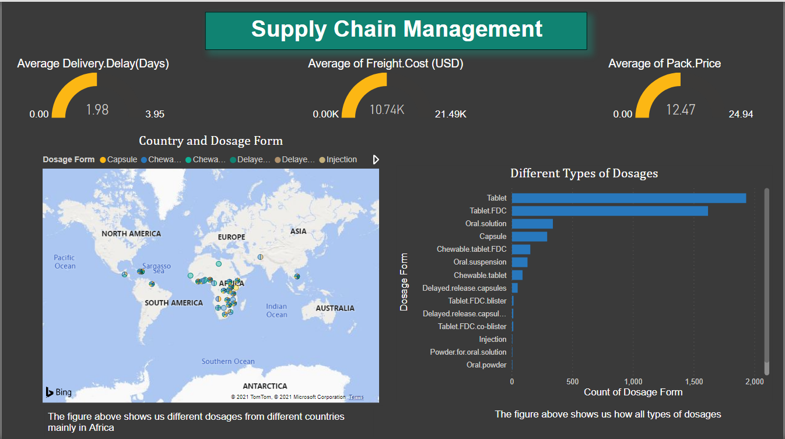

page 2

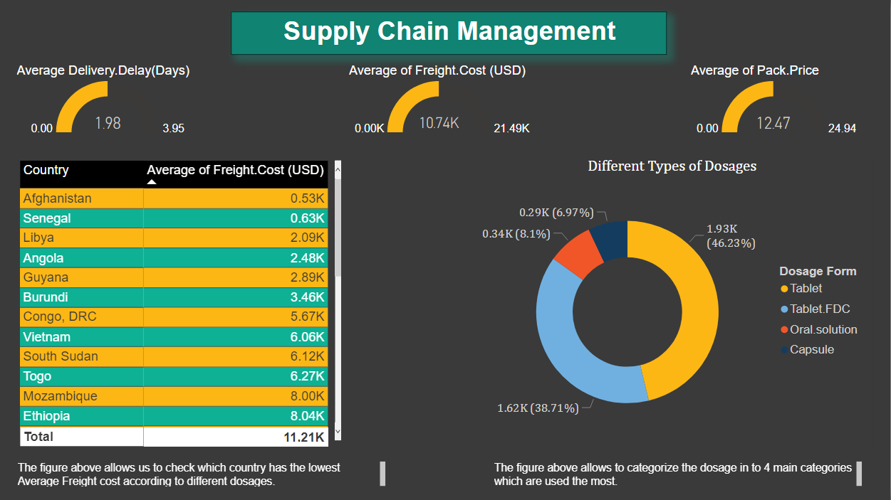

Page 3

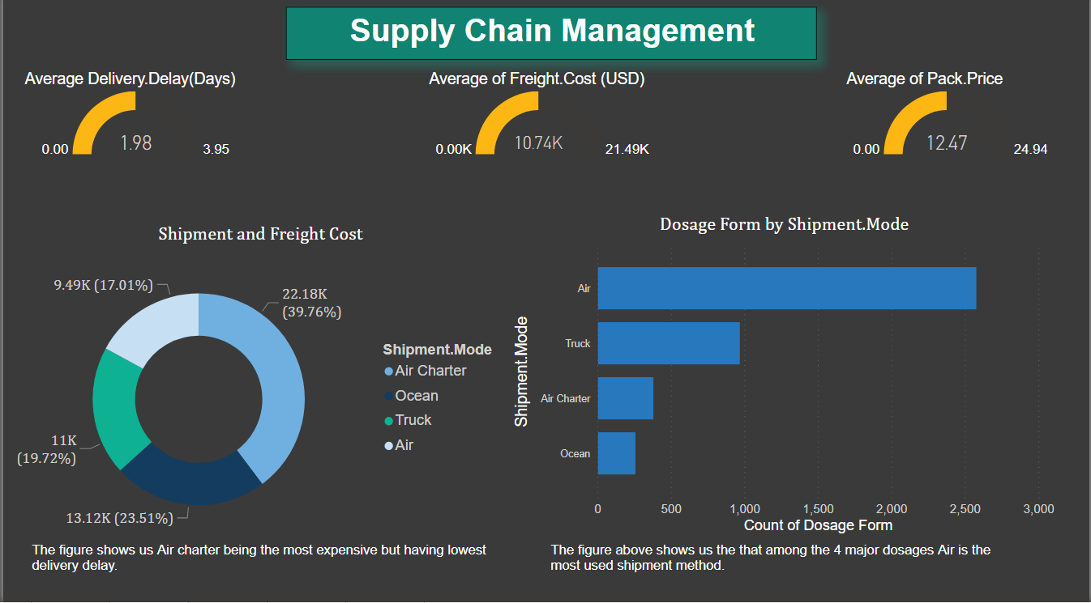

page 4

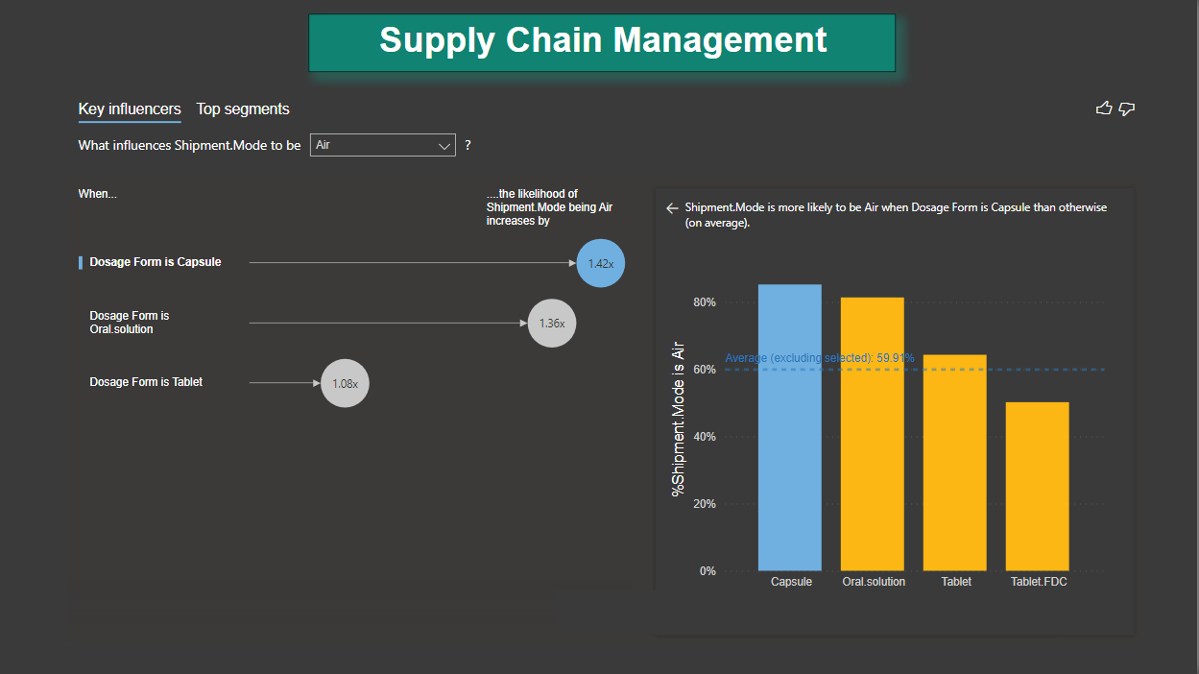

page 5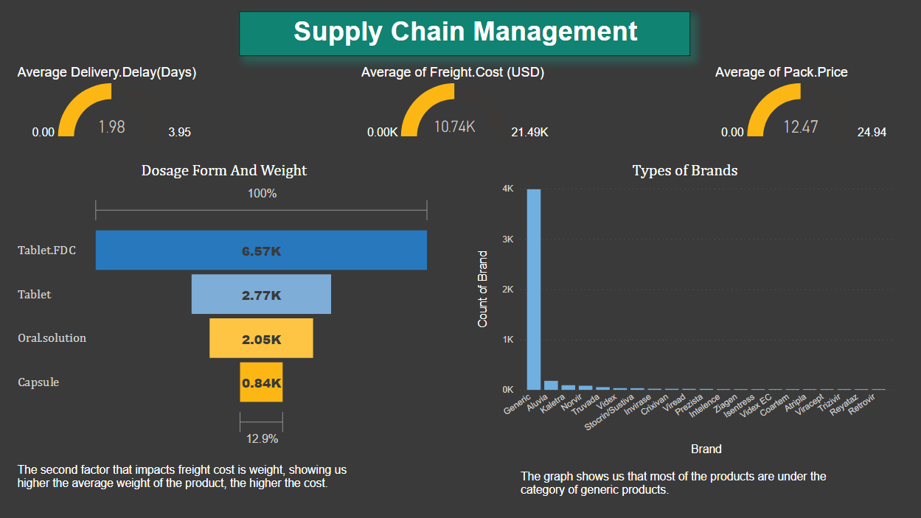

page 6

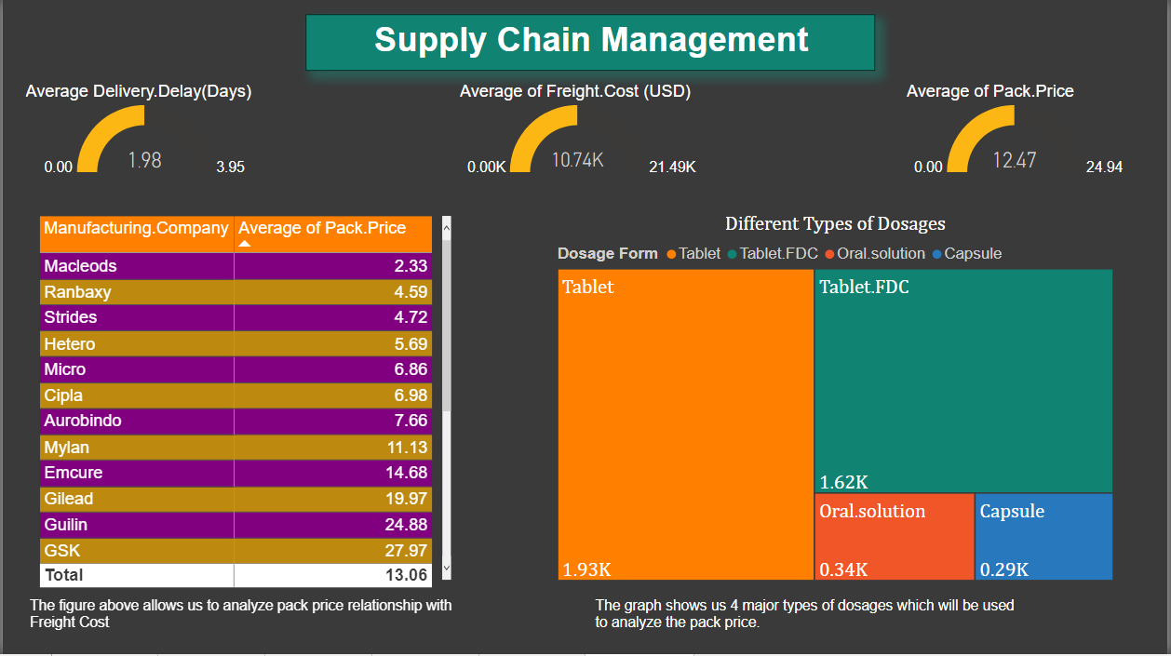

**Step 15:** What are the take-aways of your group from the above exercise. Mention pros and cons.

Pros:

* Make improved business decisions
* Identifying ways to increase operational efficiency for example identifying which factors contribute to Delays in shipment and increased Freight Costs.
* Finding out ways to lower costs for example in this scenario trying to identify factors which can reduce the unit price of the dosages
* Identifying the correlation between different factors or example: Line Item Quantity and Line Item Insurance are highly correlated,
* Identifying trends for example effect of freight cost against shipment mode etc
* Helped us improve the data quality by cleaning the data through wrangling.

Cons:

* The process is time-consuming ,The business may need faster action ; chances are that the problem may become redundant.
* Performance issues in BI tools when importing large data sets.

**Conclusion:**We reached this conclusion after understanding the data and analyzing the KPIs, the company should consider building its new manufacturing plant in India. It has a low average freight cost, low delivery delay and low pack price. This can be seen by Aurobindo Pharma in India who have been to create efficient supply chains.

Outputs Required on LMS:

* Word and PDF versions of this document
* First.Solution.Audio, Second.Solution.Audio and Third.Solution.Audio
* PowerBI project
* Wrangling notebook with interpretations