|  |  |  |  |
| --- | --- | --- | --- |
| Group Member | Name | ERP | Roles [Select from: BI Analyst, Feedback Colleague, Stakeholder] |
| 1 | Haaniyah Muhammad Mundia | 14804 | BI Analyst, Feedback Colleague |
| 2 | Hurma Mahmood | 14885 | BI Analyst, Feedback Colleague |

**Assumptions taken by the group in solving this document:**

**Launch Phase**

**Step 1:** Background knowledge of Supply Chain (bulleted list):

* **Supply Chain** is the network between an organization, resources, individuals and technology which is involved in the sale of a product. Supply chain basically is everything from the delivery of materials from the supplier to the manufacturer to the end-customer.

Link: <https://whatis.techtarget.com/definition/supply-chain#:~:text=A%20supply%20chain%20is%20the,delivery%20to%20the%20end%20user>

* **Understanding Supply Chain** involves number of steps from getting the raw materials to the end-product to the user/customer. These steps consist of getting the raw materials, turning raw material to finished product, delivery these finished product and distributing them to the end-users. These above steps involve many different entities and functions such as vendors, warehouses, retailers, etc. and finance, marketing, operations, etc.

Link: <https://www.investopedia.com/terms/s/supplychain.asp>

* **Supply chain management** is a very important part in an organization’s business. The are many different links in supply chain, when supply chain management is effective it results in faster production cycle, boosting the company’s profitability and lower the overall costs. All of the links are equally important as, if one link breaks it will affect the rest of the chain which will costly to the organization.

Link:<https://www.investopedia.com/terms/s/scm.asp#:~:text=Supply%20chain%20management%20is%20the,competitive%20advantage%20in%20the%20marketplace>

* **Perfect Order Rate** is one of the most important supply chain KPI used by various business organizations. Perfect order rate calculates the error-free rate of how successfully orders are delivered through which one can find out inventory loss, delivery delays or damages. The higher the perfect order rate, the better it is for an organization since this can directly impact your customer retention.

Link: <https://www.datapine.com/blog/supply-chain-metrics-and-kpis/>

* **On-time Delivery** measures the efficiency of the supply chain. It measures the capability of an organization to meet their customers demand in terms of when the requested delivery date versus the numbers of orders. If an organization fails to meet their customer’s request it put negative impact on the organization. It can be calculated by number of delivery on or before requested/promised delivery date divided by the total number of deliveries.

Link: <https://www.rnggc.com/on-time-delivery-performance/#:~:text=On%2Dtime%20delivery%20(OTD),requested%20delivery%20date%20(RDD)>

* **Units per Transaction** measures the average number of units which were purchased over a time period and compare those values to the organization’s target values. This is an important KPI since you can useful insights such as customer purchase trends etc. Units per transactions can be calculated by Number of units sold divided by the total number of transactions.

Link: <https://www.klipfolio.com/resources/kpi-examples/supply-chain/units-per-transaction>

**Step 2: S**takeholder-problem matrix:

|  |  |  |
| --- | --- | --- |
| Stakeholder |  |  |
| Head of Operations / SCM Manager | Which transportation/shipment mode is time and cost effective? | What is the overall delay in order delivery and how can this be reduced? |
| Sales Manager | Which products move out of the inventory fast due to high demand? | Which products are most profitable, and which are not? |

**Step 3:** Start Small: Select the problem you want to solve and mention it below: *if you think you can solve all these problems for all the stakeholders through one story, that is also acceptable. Otherwise, select only a single problem and mention below.*

From the above problem matrix, the problems that we aim to solve through this project are:

* Which transportation/shipment mode is both time and cost effective?
* Which products move out of the inventory fast due to high demand?

**Step 4:** Problem Detail (bulleted list):

* Choosing the right transportation/shipment medium for an order is a key issue. This is because various aspects such as freight cost, weight, urgency of delivery and the place it is being delivered to need to be kept in mind. If freight costs are too high, this would result in lower profits as greater expenses would be incurred, whereas cheaper transport/ shipment mediums would mean compromising on the time.
* To have an estimate of the high demand products that are purchase more often. Hence, to ensure smooth sales operations therefore greater profits, they need to know the inventory levels of these products so that they do not run out of stock during the sales process.

**Step 5:** Your Solution (bulleted list):*.*

* In order to get the best possible prices and service a balance needs to be attained keeping time and cost constraints in mind to achieve the best possible order accuracy and delivery. This would be solved via finding out the average delivery time and the number of orders that are late vs those that are on-time compared to the total orders. Further it would also mean identifying freight costs and delivery-time w.r.t. the transport/shipment mode.
* Solving the problem of finding out the top products would mean identifying products that move out of the inventory fast, and identifying their respective quantities and order patterns along with gauging them with the expense, i.e. the freight cost, incurred compared to their selling price to get a better understanding about the profitability.

**Step 6:** Identify potential metrics/KPIs (bulleted list):

* Order Status
* On-time Delivery
* Freight cost per shipment mode
* Product Order Quantity
* Overall Profits
* Fast Moving Stock

**Step 7:** Potential data that will become available to you

* Import sc.dataset.csv from the Outlook Folder.

**Step 8:** The first solution: BI Blueprint on paper with Story: *Paste the story below, e.g., paste the pictures of your paperwork in sequence. Also write the feedback of your colleague as a bulleted list and the changes made. Record an audio file with the story and save it as “First.Solution.Audio”. Upload this on LMS.*

Feedback of colleague:

* None

Changes made:

* None

Blueprint pictures (paste below in sequence):

**Wrangle Phase**

**Step 9:** Draw the pipeline of wrangling + analytics on paper: *Paste the snapshots below with explanations.*

*<Insert Here>*

**Step 10:** Based on your stakeholder matrix above, make an educated guess about the single-server or multi-server application and draw that on paper: *Paste the snapshots below with explanations.*

In our opinion, this is a multi-server application as it helps not only the Supply Chain or Operations department, but it also provides valuable information to the Sales and Inventory departments, hence serving multiple stakeholders.

**Step 11:** Wrangle the data and interpret the results: *Submit the notebook with interpretations within – focus only on those interpretations which have a relationship with BI outputs (as explained in class). Also try to make a template. The more wrangling you do, the more marks you will get*

The wrangling notebook closely follows the wrangling pipeline shown in Step 9. It is clearly divided amongst various headings with each step followed by a comment to explain the reason behind performing it. The major findings of wrangling are as follows:

* Important KPIs are: Freight Cost, Weight, Line Item Insurance, Line Item Quantity, Pack Price
* Important Dimensions are: Country, Fulfill Via, Shipment Mode, Product Group, Subclassification, Brand, Dosage Form.

Details of each step and their reasoning are mentioned in the wrangling notebook, which is attached in the zip folder.

**Brainstorm Phase**

**Step 12:** Modify the pipeline in Step 8 above (if needed): *Paste the story below, e.g., paste the pictures of your paperwork in sequence. Also write the feedback of your colleague as a bulleted list and the changes made. Record an audio file with the story and save it as “Second.Solution.Audio”. Upload this on LMS.*

Feedback of colleague:

* None

Changes made:

* None

Blueprint pictures (paste below in sequence):

**Dash Phase**

**Step 13:** Which dashboard type are you implementing (Strategic, Operational, Analytics, Tactical): *Mention below and justify:*

* *Analytical: Since this dashboard contains drill down on data and with this ive extracted insights which basically gives us the solution of the problem.*

**Step 14:** Implement on PowerBI and paste all dashboards below: *Also write the feedback of your colleague as a bulleted list and the changes made. Record an audio file with the story and save it as “Third.Solution.Audio”. Upload this on LMS. Here, you must focus 100% on how this story is solving the problem mentioned at the top of the document.*

Feedback of colleague:

* Add pie chart displaying total number of delivery
* Add dosage form by country chart

Changes made:

* Added dosage form by country chart
* Added delivery type in percentage
* Added number of delivery by Shipment Mode

Blueprint pictures (paste below in sequence):

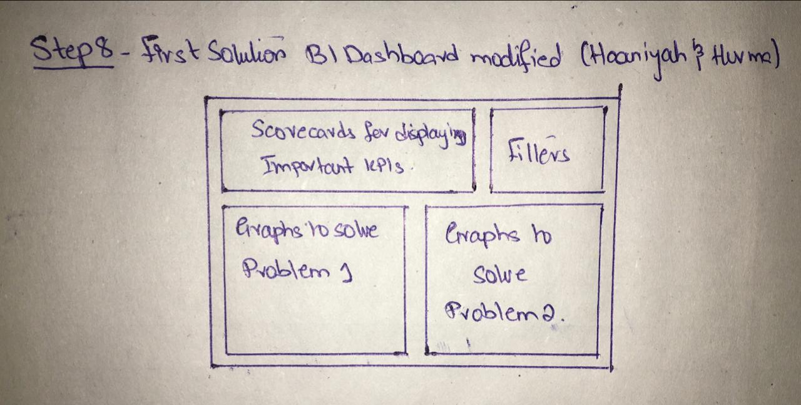

**Step 15:** What are the take-aways of your group from the above exercise. Mention pros and cons.

Pros:

* By doing the entire process from scratch, attaining business knowledge to wrangling and then creating the dashboards, this project greatly improved our understanding of developing effective and meaningful BI dashboards.
* By studying varied datasets that are common in the business world such as this one on supply chain, helped expand our knowledge about the actual business processes and allowed us to map our technical knowledge to real-life scenarios.

Cons:

* None

Outputs Required on LMS:

* Word and PDF versions of this document
* First.Solution.Audio, Second.Solution.Audio and Third.Solution.Audio
* PowerBI project
* Wrangling notebook with interpretations