Name: Hurma Mahmood

ERPN: 14855

**Assignment – DWH Offering Analysis**

Azure: <https://azure.microsoft.com/en-us/resources/videos/introduction-to-azure-sql-data-warehouse/>

1) How are they doing data warehousing?

A Datawarehouse stores the historical data of a business. It is basically the centralized repository of data extracted from various sources that is used to perform analysis and finding a solution for a business problem and then visualize them using tools such as power BI, etc. analysis. Azure SQL Datawarehouse is an MPP-based (massive parallel processing meaning that it can handle to process very large amounts of data in parallel) warehouse which is generally used for big data. It is built on the foundations of SQL Server and SQL Database due to which data loading is made very easy. It is built right on top of Azure Blob Storage which store large amount of unstructured data, here as you can see in the figure below PolyBase query is used to access and load data to Azure SQL Datawarehouse.

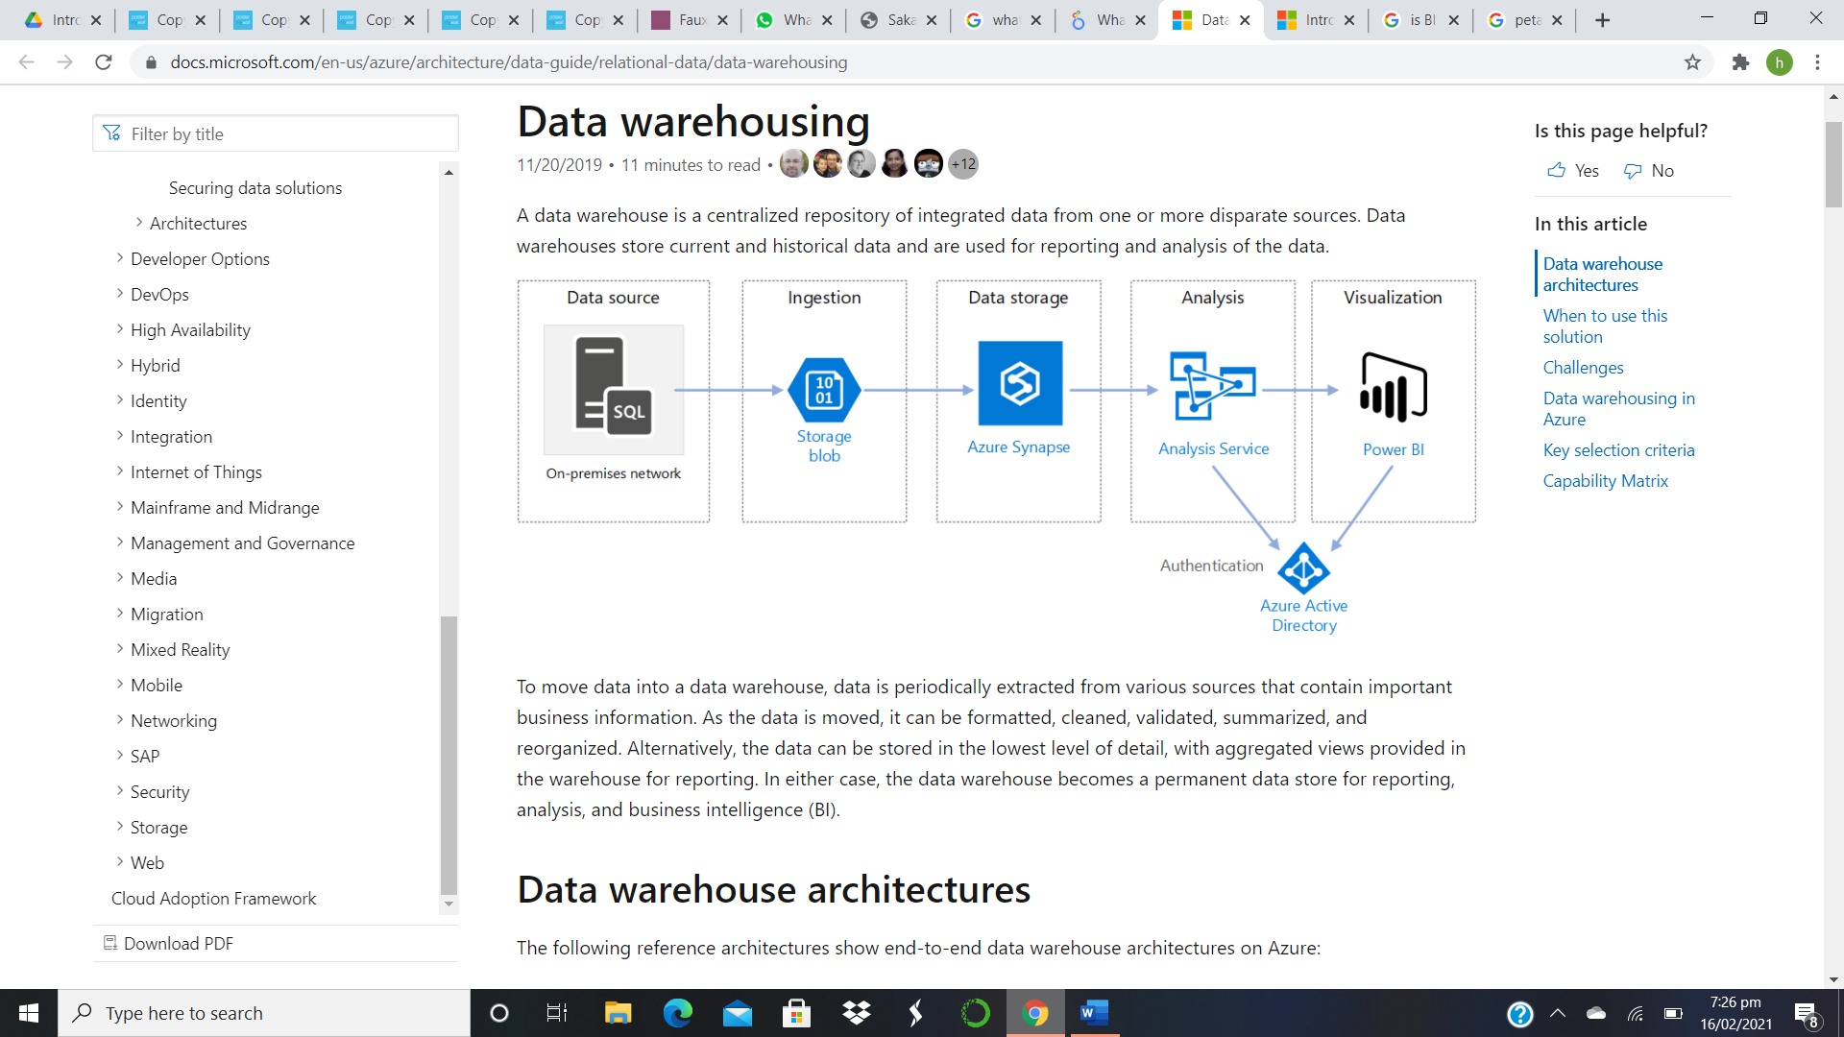

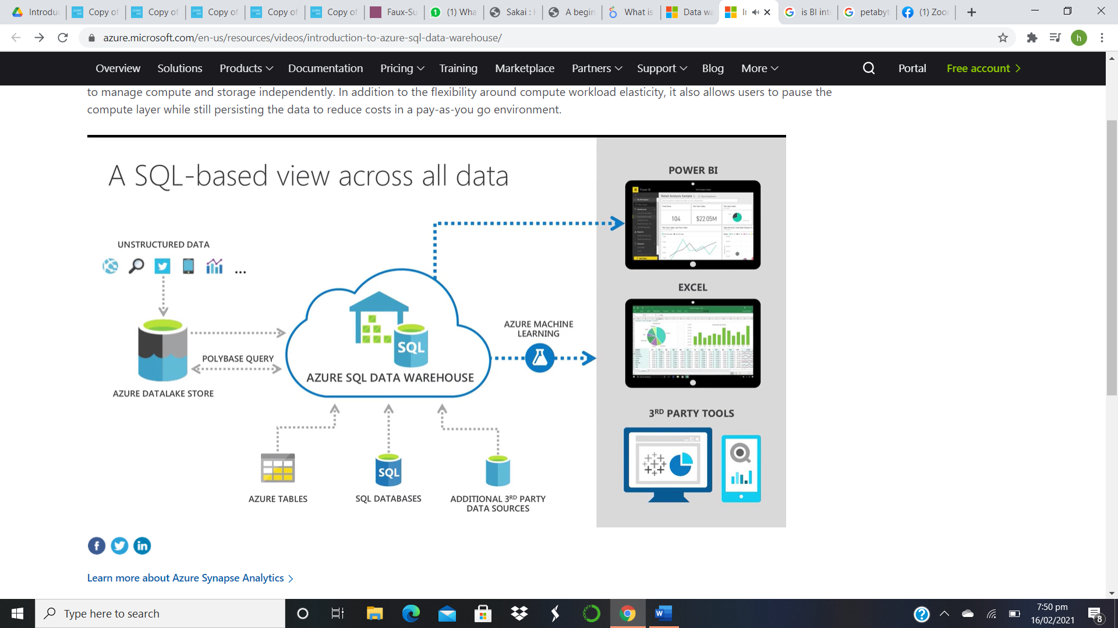

2) Is some level of BI integrated within this tool? If yes, what are the features of this BI offering?

Yes, you can connect your Azure SQL Datawarehouse with power BI as shown in the picture below or you can use DirectQuery for real time access to the data. Power BI is one the best tools for data visualization and therefore offers many features: Customized Dashboards, Reports, Navigation Pane, Datasets, Q&A Question Box, Trend Indicators, Interactive Reports Authoring, Complete Reporting and data visualization tools.

