Business Intelligence - Project

Syeda Sukaina Batool - 19654

Dataset

<https://www.kaggle.com/datasets/mesumraza/pakistan-education-performance-dataset?resource=download>

About

The Dataset consists of a survey on Primary schooling of Performance of Pakistan. It has 5 grades of formal education for children in between ages 5 to 9. The Dataset comprises of Government primary school data and its overall performance over the period of 4 years i.e. 2013 - 2015. It consists of different attributes that contribute towards a better learning experience of children, as Primary education is mandatory and it is the initial step towards shaping a child’s future.

Problem Statement

1- Study the data thoroughly and interpret the problematic areas of the country based on the facilities provided to schools, city and province wise and identify different needs and the room for improvement.

2- Identify the factors that are affecting the education scores of the schools and their impact on the overall Economic growth of Pakistan.

Data Wrangling

Used PowerBI for cleaning of the data, as it provides an extensive view of the data. The steps have been provided in the excel sheet, however the data was mostly clean. For Analysis purposes, Tableau was used as it provides a detailed analysis with the help of stories and dashboards.

Step1:

Done within data.info file

Step2:

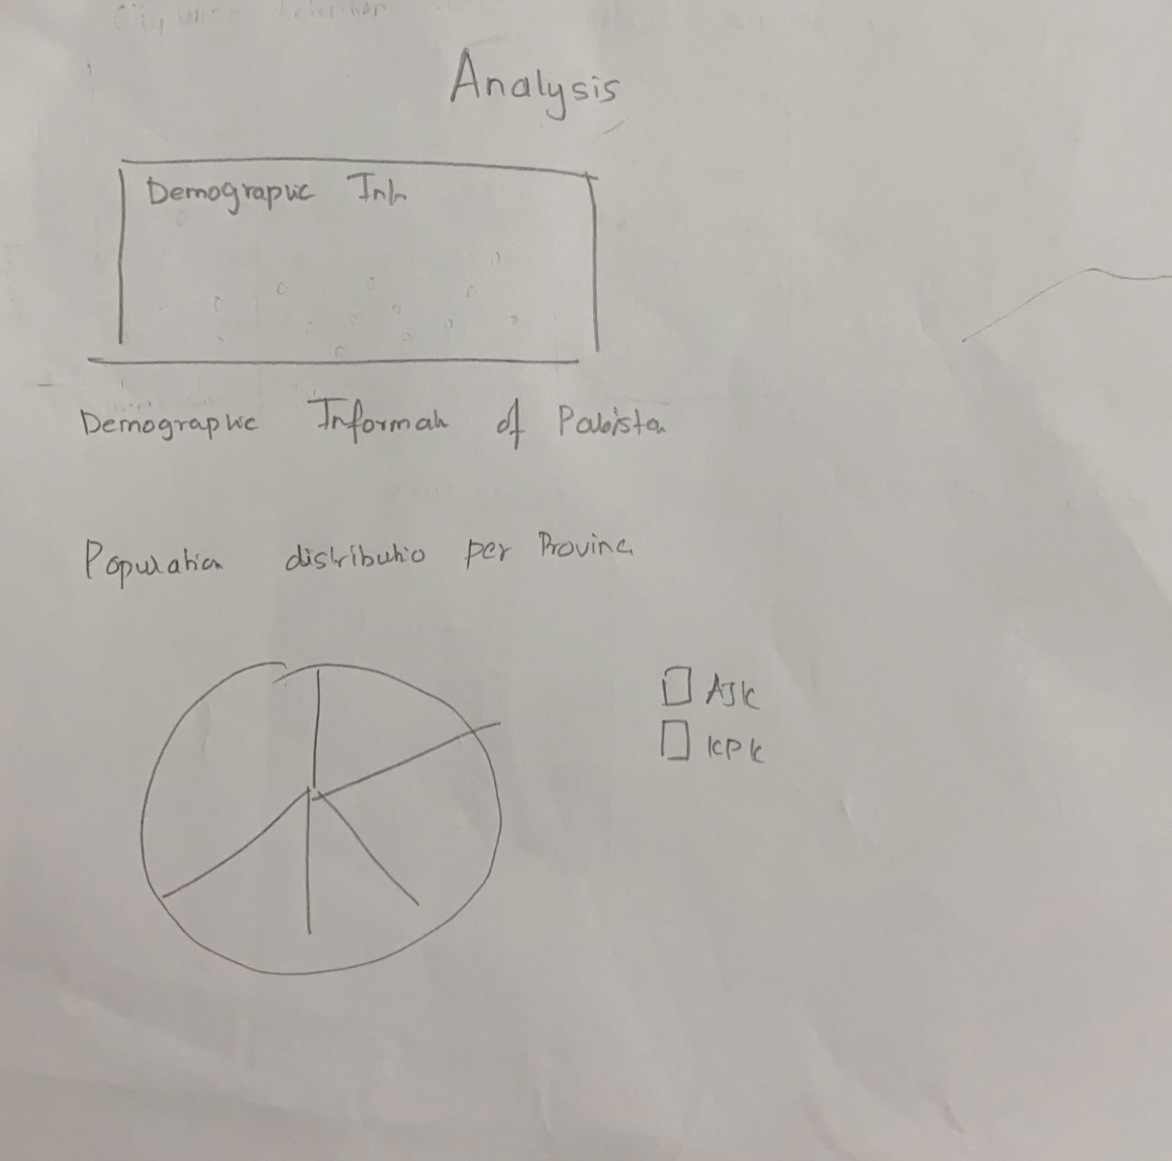

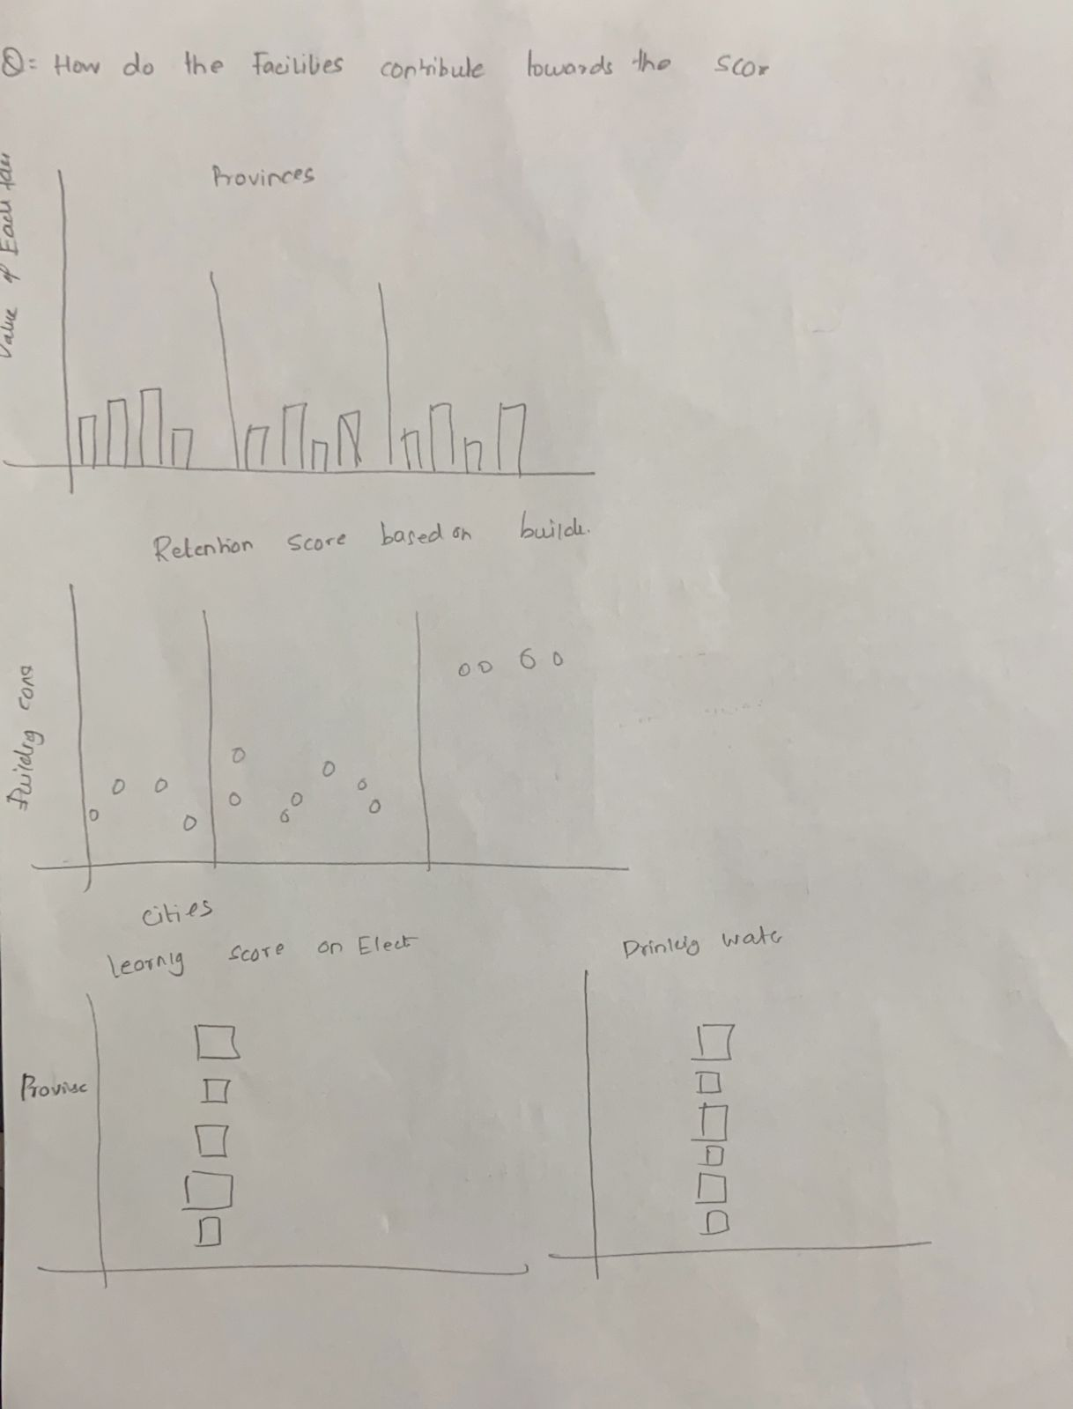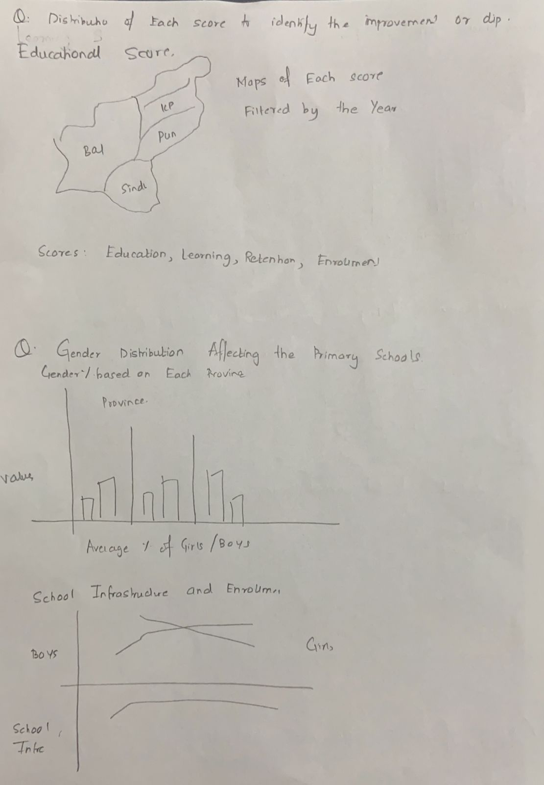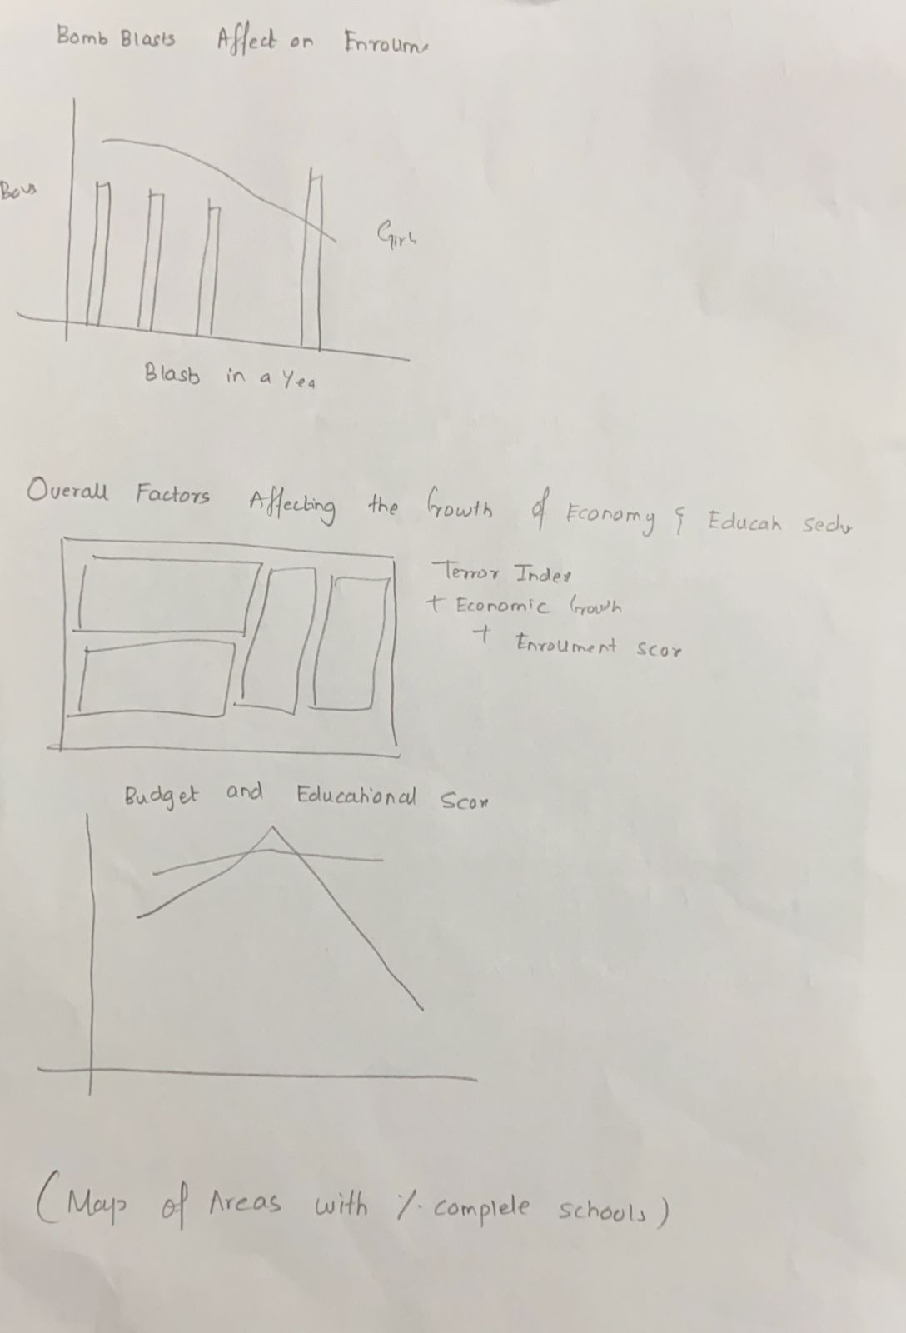

Step3:

Dashboard planning

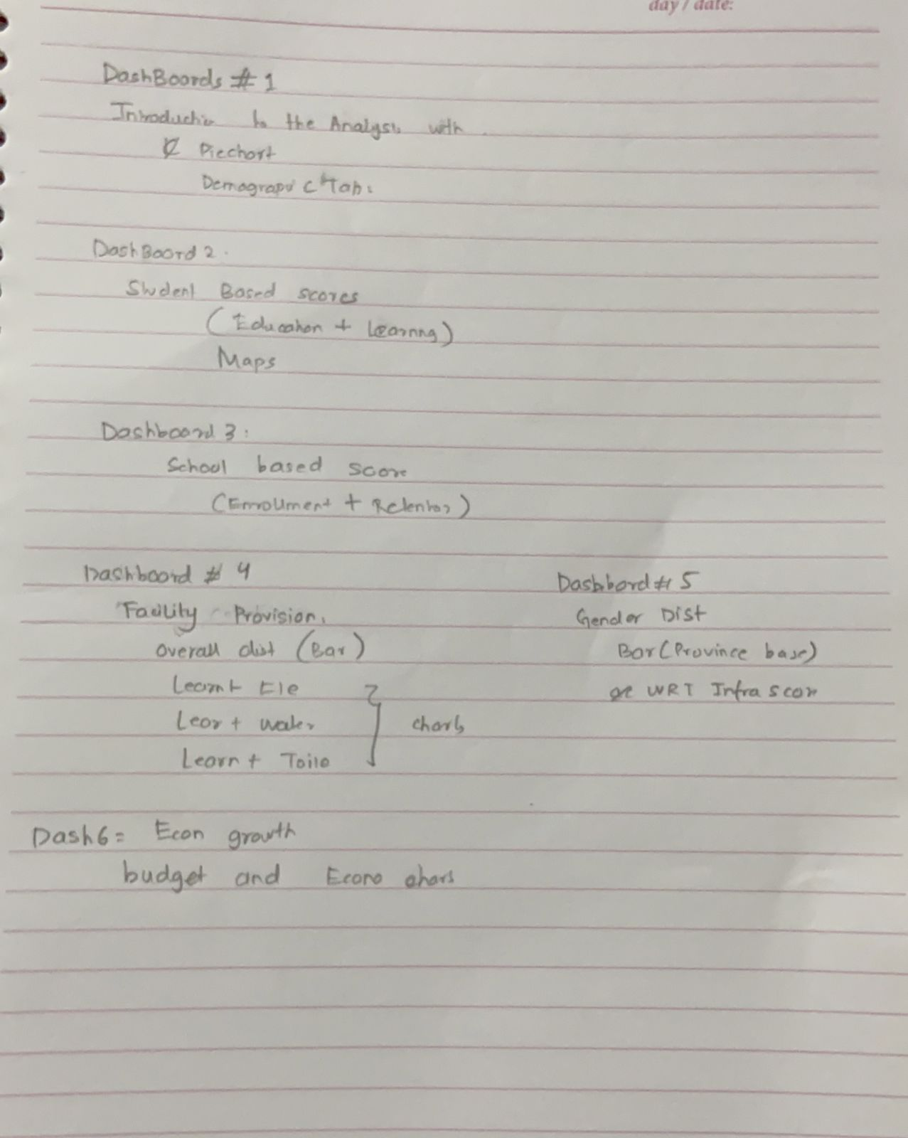

Story Planning

Analysis

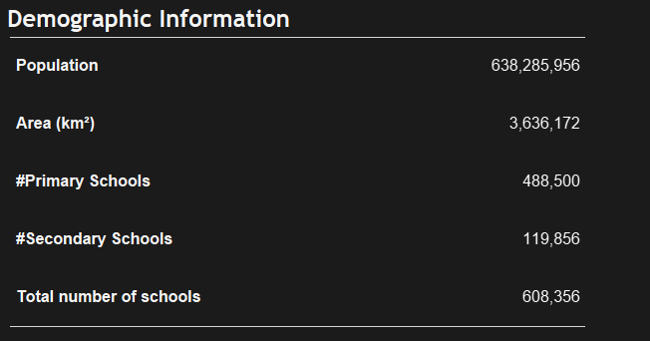

Over the past 3 years, Almost 488,500 schools were viewed that cover up 3,636,172 Km2 land. It can be noted from the above chart that of the total schools in Pakistan almost 80% are of primary classes which identifies a lack of followup education after a child completes primary schooling.

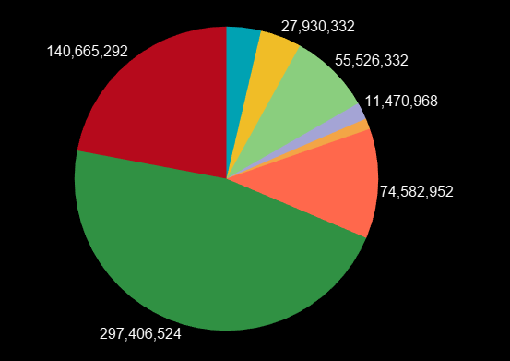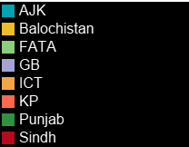

The pie chart shows the distribution of population of each province and district in Pakistan. Sindh and Punjab have the largest slices of the pie as they’re the central and main provinces of Pakistan. Despite covering a vast area, Balochistan is the least populated of all the provinces.

Q1- How do the facilities such as Electricity, drinking water, Boundary wall, safe building conditions contribute towards the Education, learning, retention scores of the school.

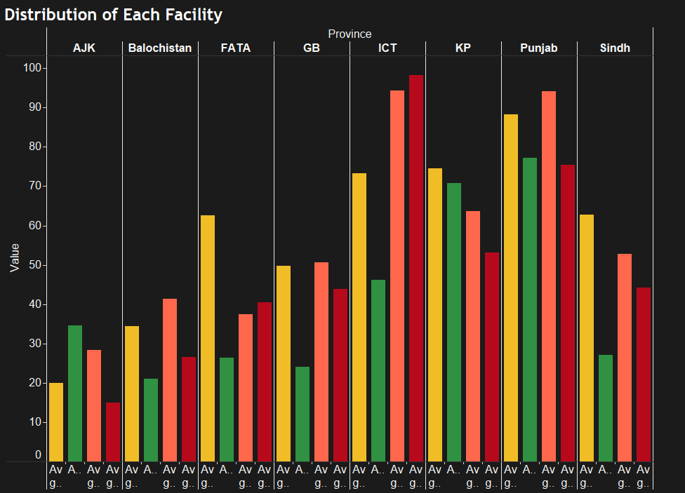

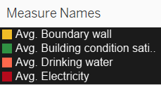

Of All the sectors, Islamabad and Punjab had the higher averages of all the basic facilities of School which in turn means that it has better education scores than the rest of the sectors. Azad Jammu Kashmir reported the least averages of availability of these basic facilities which means the government needs to put in a lot more effort into providing these basic facilities to the schools of AJK. As mentioned above Sindh is 2nd most populated province but it still has a much less average in almost all the facilities. In fact KPK surpasses Sindh in almost all the facilities. It has been previously highlighted by a lot of NGOs and Media, that the condition of Government schools in Sindh is worsening with time and therefore despite free education, majority of parents nowadays do not prefer sending their children to government schools as the children aren’t being provided with basic necessities which in fact is endangering their lives.

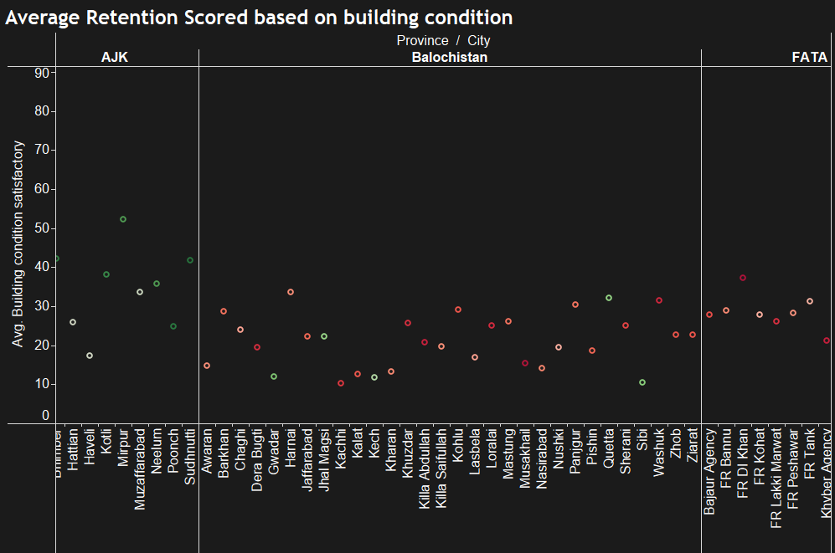

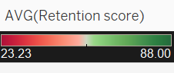

The chart above plots the retention score i.e. No.of students that return back to school after the end of their primary school against the building conditions. It can be noted from above and by scrolling towards the right that schools with better average building conditions had a higher retention score. As observed, Balochistan has a very low retention score in almost every city, the reason for which can be disappointing building conditions as all the markers are shown in the bottom of the graph, implying a lower average of conditions.

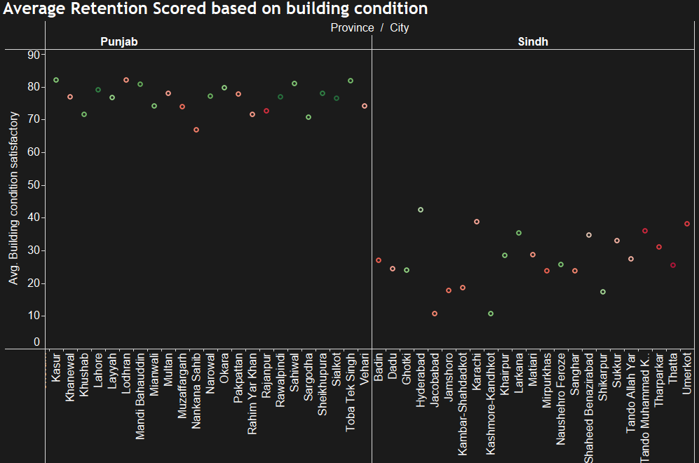

Schools of KPK and Punjab had a lot better building conditions of the primary schools, therefore almost all the schools recorded a higher retention rate as more children felt safe and wanted to come back to school. It is noted that despite being the second largest Province of Pakistan, Sindg recorded very poor building conditions and therefore had a relatively lower retention rate than other provinces. Surprisingly, Karachi the most populated and hub of Pakistan had a below par retention rate as identified by the red colored circle.

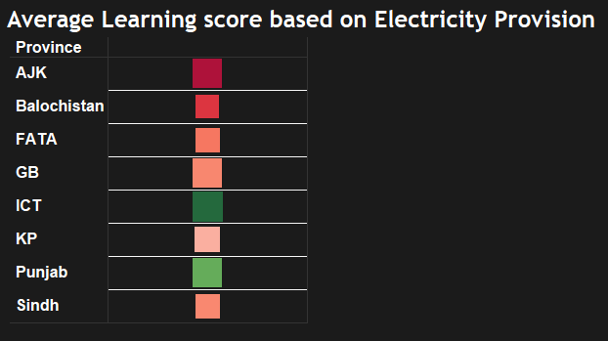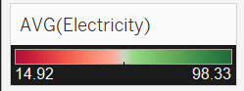

Through the above chart, it is noted that Islamabad being the capital city has the most provision of Electricity and therefore the average learning score is 65%, Punjab also has a relatively better provision of electricity. However all the other sectors/ provinces do not have equal supply of Electricity which can be visible by the decrease in the learning scores of larger regions such as Sindh, KPK and Balochistan. Due to harsh climatic conditions it becomes almost impossible for youngsters to concentrate without proper electricity supply. A report on DAWN 2018 pointed out that almost 23,000 schools in Sindh do not have electricity and this number went up to 31,000 in 2021 suggesting a clear lack of interest from the Sindh government towards the education sector.

Q2- Distribution of Scores of Provinces over the past few years and identify the improvement and decline in the scores.

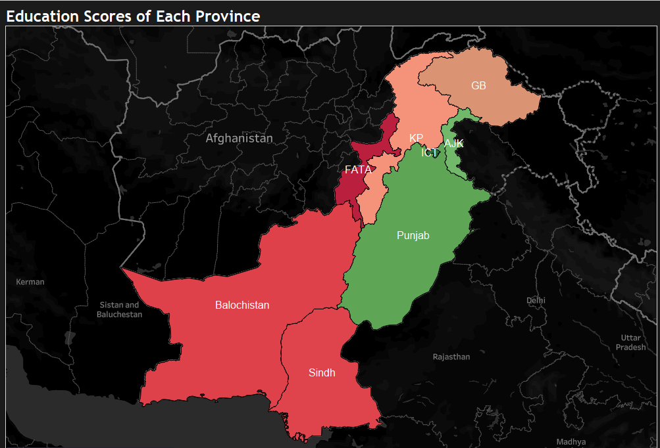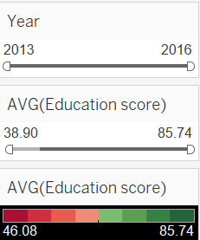

Overall, Punjab and ICT have higher average education scores and the reason is evident from above, as they have been provided with all the basic necessities that other provinces are deprived of. Due to lack of proper facilities in Sindh the Education score wasn’t much during the years 2013 - 2016. However there was an improvement in 2014 which was then followed by a sudden decrease. Islamabad Sector has been separately identified as it is the capital city and it without any doubt had the highest education score in Almost all the years. A surprising trend was of AJK, despite having the least facilities available the students had 2nd highest education score of all the provinces. This suggests the drive of students in that regions towards education, if proper facilities are provided, the students from there can improve Pakistan’s literacy rate. Despite being allotted with every necessity, the scores of Punjab over the years were pretty consistent and no huge spike was observed in the education scores.

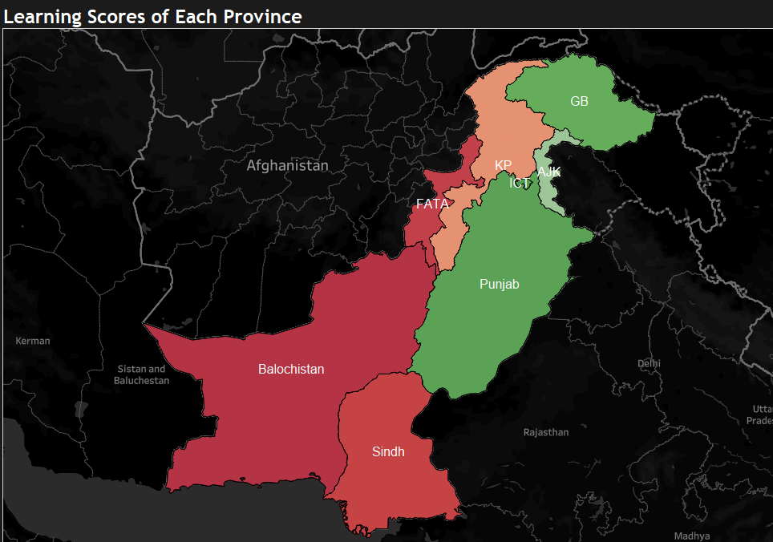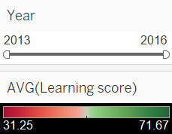

The Learning scores are basic reading and writing scores of students. They are quite consistent with the education score and it is identified by the map, the Sindh and Balochistan have been scoring the least, on the other hand Punjab and AJK has higher average learning scores, however Gilgit baltistan here has relatively higher average than the rest, identifying an improvement in education standards. When slicer applied, it displayed a decrease in scores of Balochistan which is quite alarming.

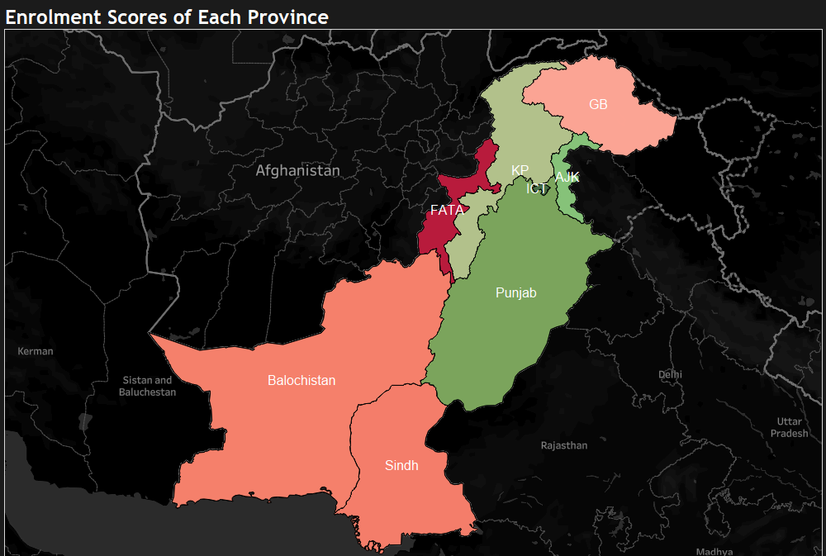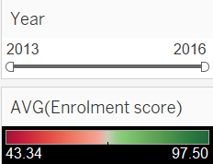

From the above display, it is visible that almost all the provinces had a higher enrolment score except FATA which was a lot lower than the rest. This also implies that despite having poor conditions and basic facilities not being provided, children have been enrolled into school and are motivated to study. If proper measures are taken to make our education system better it can improve our country’s future. However, there was a dip observed in the enrolment scores during the latter years especially in Balochistan and Sindh.

Q3- How is gender distribution in Primary schools affecting the overall Scores.

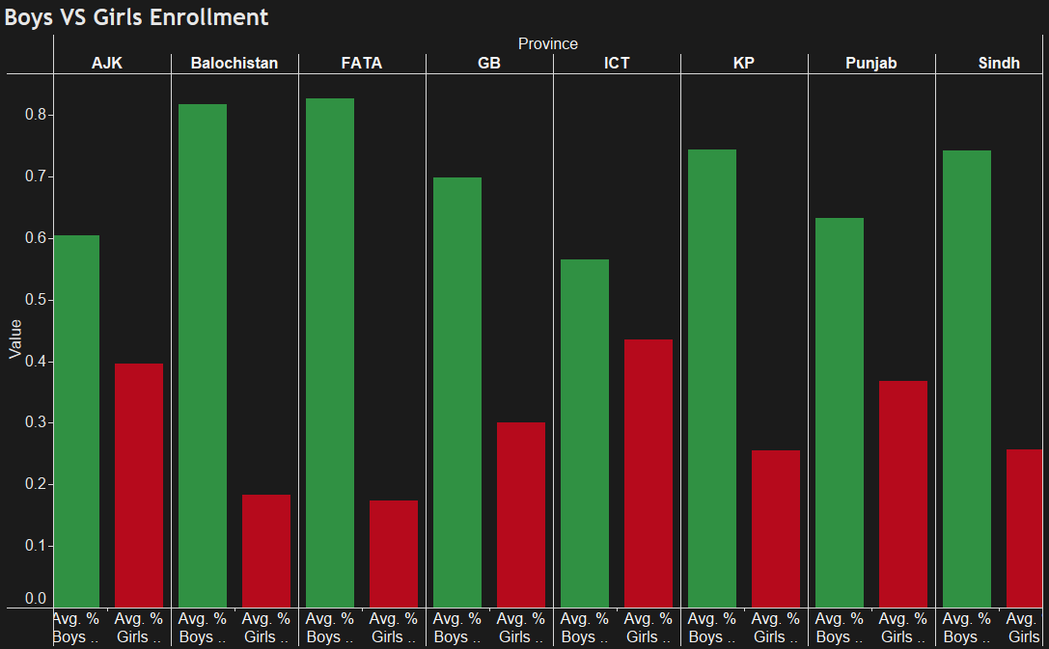

The enrolment of girls in every province/ district is less than that of boys. The major gap was observed in region and FATA and Balochistan where the difference is almost 60%. This also shows that due to less exposure in such areas parents still fear sending girls to schools. However, the gap was minimized in Punjab and Islamabad. Where islamabad had a difference of almost 10% which is quite less as opposed to the rest. The AJK has less population but the results were surprising as the difference between boys and girls enrolment isn’t much.

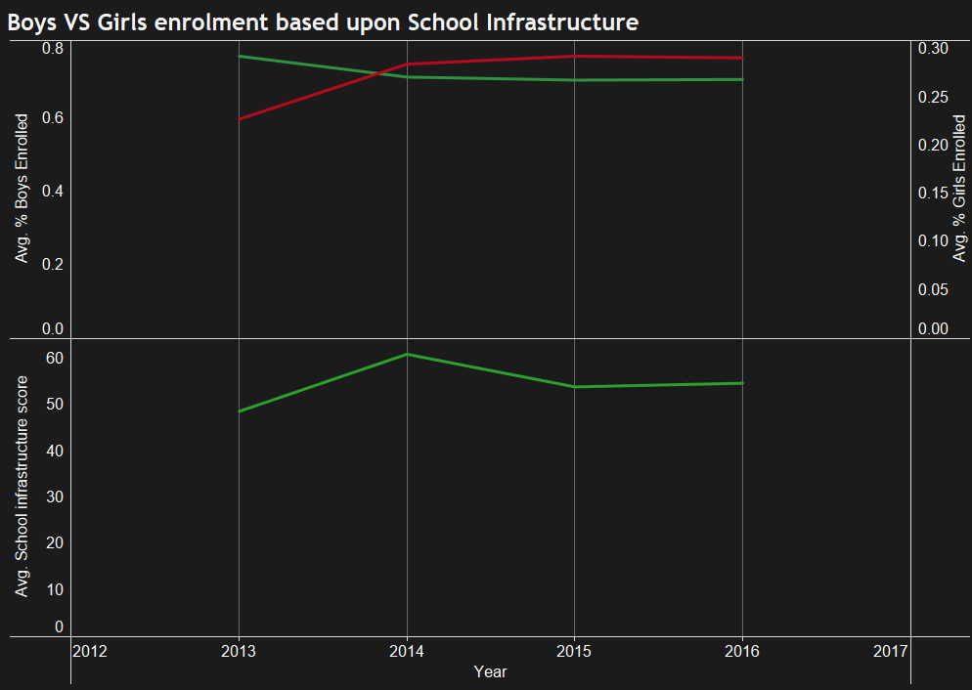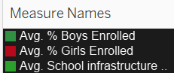

The above graph shows the trend like of enrolment of Boys and girls based upon the school infrastructure score. As Majority parents fear sending their children especially girls to places which unsafe conditions. It can be observed from above that the enrollment percentage for girls increased with every passing year, which indicates that due to more exposure in the recent years and the campaigns by NGOs, more parents are now sending their girls to school. Another observation was, that due to an increase in infrastructure score, the percentage of enrolled girls also increased, which means if government start to build better infrastructure for the schools it can lead to more an increased in the enrolment percentages.

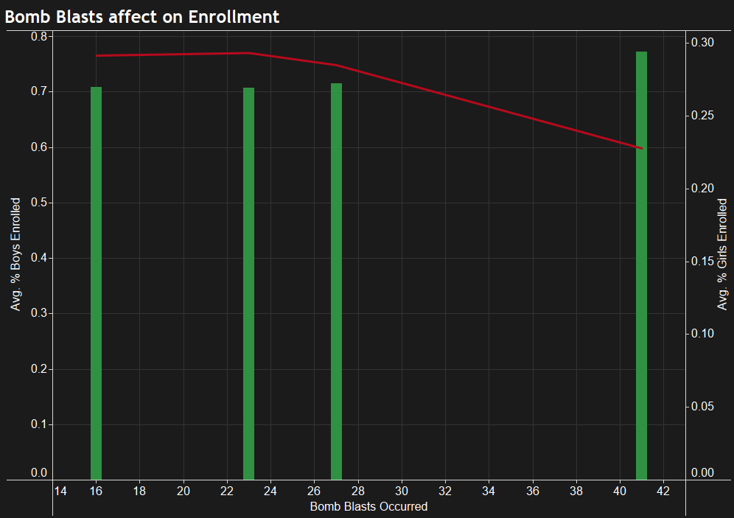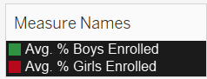

The chart above shows the affect on bomb blasts on the enrollment. There seems to be a trend in the enrollment percentage. With an increase in bomb blasts there was a decrease in % of girls enrolment to schools due to the security reasons therefore, in the year with 42 blasts least percentage of girls enrolment was observed. This clearly identifies that one of the major reason for parents not sending their girls to school is their security. Terrorism and blasts have affected the eductaion in the past.

Q4- How is the overall factors affecting the growth of economic and Education sector in Pakistan.

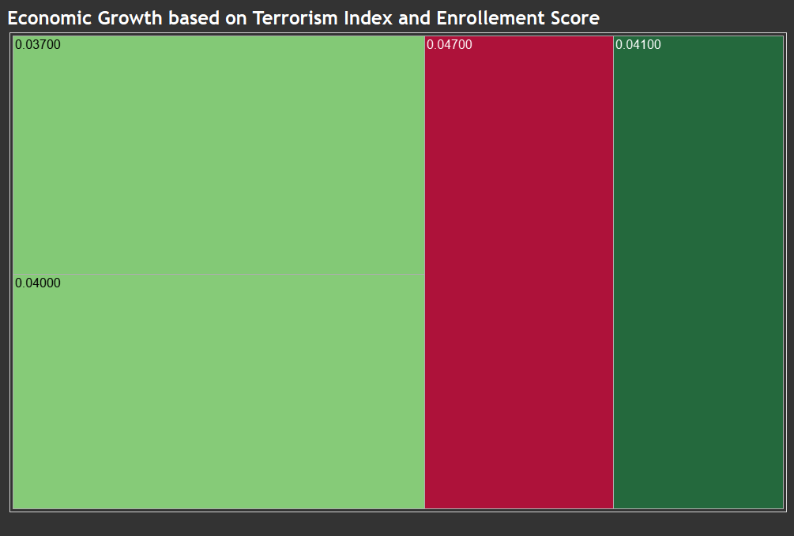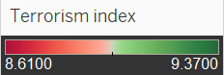

The above charts shows the relation between economic growth and terrorism index in regards with the education score. From the above diagram it can be observed that the less terrorism index the lower the economic growth and therefore the higher would be the enrolment index. As observed above from the dark green segment that the has the lowest enrolment average and highest terrorism index i.e. 9.3700.

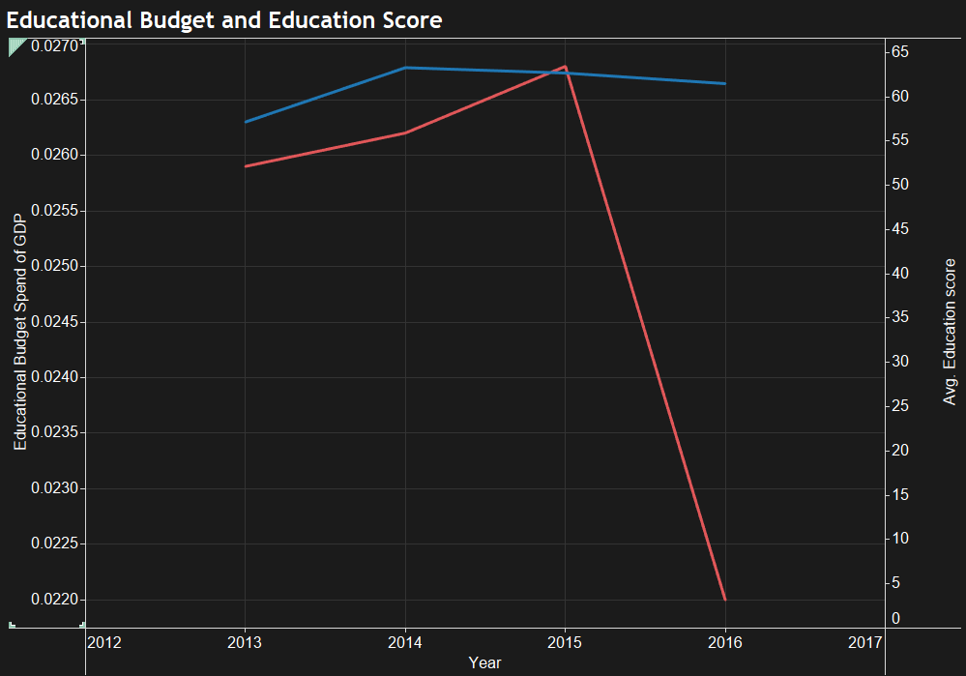

The graph above shows the distribution of education score and the Educational budget. It can be seen from above that in that during the initial years as the as the educational budget was increasing there was an increase in the education score as more importance was being given to it. However in 2016 there was a major dip in the educational budget which in turn caused in decrease in the education score of the students. This means the less that is spent on education the less progress there will be of the students and country will go towards decline.

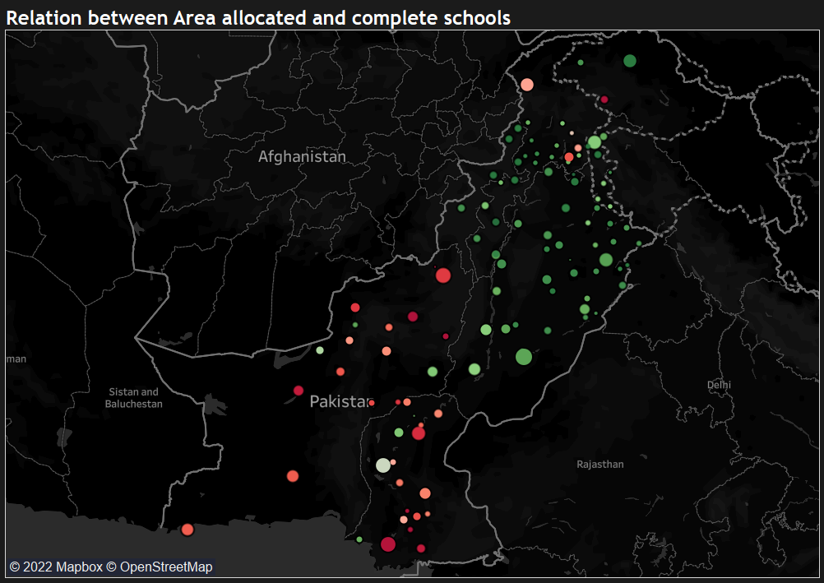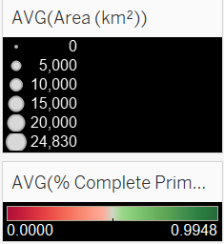

The above map shows the area all over the country with the highest area allocated and corresponding schools in that region that are complete. Punjab has the most area allocated to schools and majority of the schools there are complete as shown by a cluster of greens in Punjab. It can also be observed that a lot of large areas are allocated to schools in Sindh but majority of them are not complete therefore a red is shown there. Even in Balochistan almost all the schools are incomplete, however it can be seen that huge circles indicate a large area allocated to the schools which is not being utilized fully. In KPK the schools are almost complete however the area allocated to schools is less.

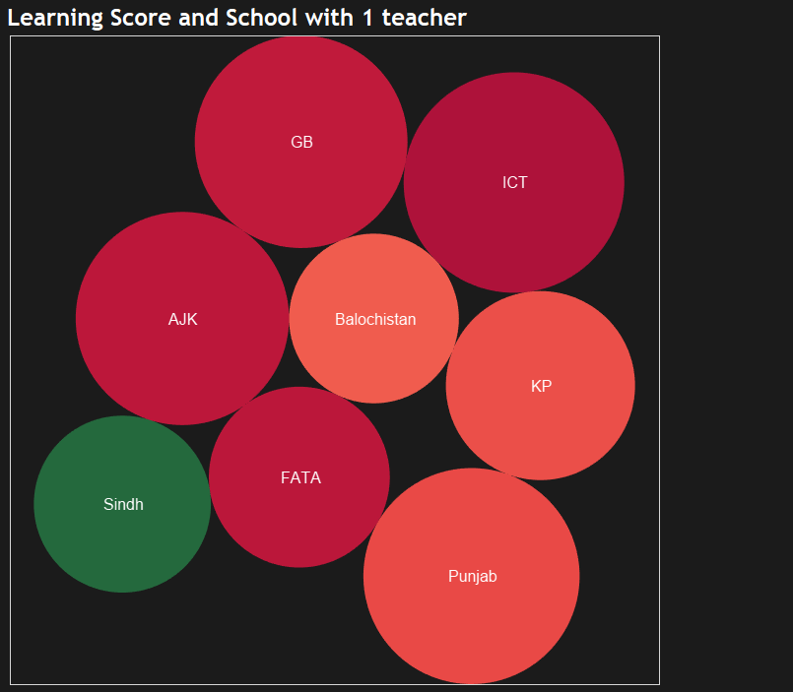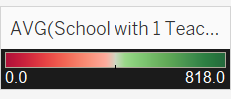

The Above chart shows distribution of schools with a single teacher and its average Learning score. It can be observed from above that sindh has the majority of schools with a single teacher and the rest are quite below sindh. It can also be observed that due to an increase in schools with 1 teacher the learning score is decreased as the circle of Sindh is quite small. Islamabad has no schools with a single teacher and therefore the learning score is quite high, This clearly shows that due to a single teacher majority students aren’t able to focus and therefore are left behind.

Conclusion

The data is very extensive and therefore a lot of possibilities to assess primary education in Pakistan. However, it has been observed throughout that Sindh despite being the 2nd largest province of Pakistan lacks in educational department mostly due to the government not paying attention to it, therefore a lot of effort needs to be put in by the Sindh government to improve the educational standards. There were a lot of large areas allocated to schools but weren’t fully utilized, which is problematic and therefore needs attention from the government right away in order to make it useful and therefore more students can avail the primary education that is the basic need of every child in the country.

It was also observed that throughout the country, not all basic necessities are being provided to children which causes a decrease in the enrollment and education scores. Therefore a proper budget needs to be allocated to the schools as this increases the education rate and the government should keep a check in balance that the budget is used justly and children are being provided with the necessities they require.

It was also observed throughout that AZK despite not being given attention managed to maintain high scores as compared to other districts, which shows promise from the students side, thereby the government should look into it precisely.

STORY

