**Module Design Document**

**For**

**HwTqTrakgCtrl**

**May 9, 2018**

**Prepared For:**

**Software Engineering**

**Nexteer Automotive,**

**Saginaw, MI, USA**

**Prepared By:**

**Software Group,**

**Nexteer Automotive,**

**Saginaw, MI, USAChange History**

|  |  |  |  |
| --- | --- | --- | --- |
| **Description** | **Author** | **Version** | **Date** |
| Initial version | Nimmy Mathews | 1 | 7-Mar-2018 |
| Added new input MotTqCmdOvrl | Nimmy Mathews | 2 | 9-May-2018 |

Table of Contents

Table of Contents 3

1 Introduction 4

1.1 Purpose 4

1.2 Scope 4

2 HwTqTrakgCtrl High-Level Description 5

3 Design details of software module 6

3.1 Graphical representation of HwTqTrakgCtrl 6

3.2 Data Flow Diagram 6

3.2.1 Component level DFD 6

3.2.2 Function level DFD 6

4 Constant Data Dictionary 7

4.1 Program (fixed) Constants 7

4.1.1 Embedded Constants 7

5 Software Component Implementation 8

5.1 Sub-Module Functions 8

5.1.1 Init: HwTqTrakgCtrlInit1 8

5.1.2 Init: HwTqTrakgCtrl_Init 8

5.1.3 Per: HwTqTrakgCtrlPer1 8

5.2 Server Runnables 9

5.3 Interrupt Functions 9

5.4 Module Internal (Local) Functions 9

5.5 GLOBAL Function/Macro Definitions 9

6 Known Limitations with Design 10

7 UNIT TEST CONSIDERATION 11

Appendix A Abbreviations and Acronyms 12

Appendix B Glossary 13

Appendix C References 14

# Introduction

## Purpose

Module Design Document for SF070A_HwTqTrakgCtrl_Impl.

## Scope

The following definitions are used throughout this document:

* **Shall**: indicates a mandatory requirement without exception in compliance.
* **Should**: indicates a mandatory requirement; exceptions allowed only with documented justification.
* **May**: indicates an optional action.

# HwTqTrakgCtrl High-Level Description

This component is used to calculate motor torque command from estimate, torsion bar states, handwheel torque command and tracking control gains.

# Design details of software module

## Graphical representation of HwTqTrakgCtrl

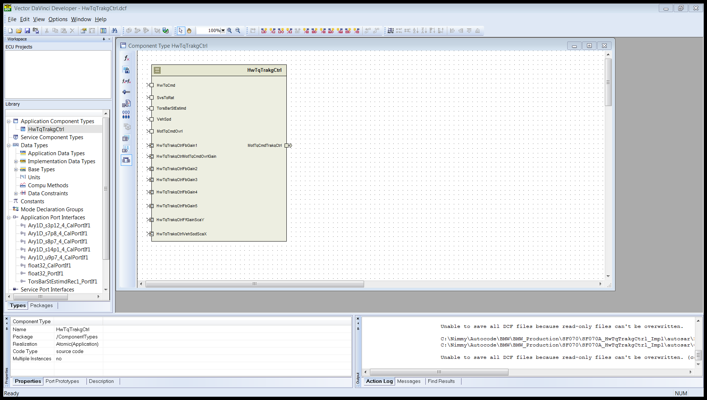

## Data Flow Diagram

Refer FDD

### Component level DFD

Refer FDD

### Function level DFD

Refer FDD

# Constant Data Dictionary

## Program (fixed) Constants

### Embedded Constants

#### Local Constants

|  |  |  |  |
| --- | --- | --- | --- |
| Constant Name | Resolution | Units | Value |
| SYSTQRATMAXVAL_HWNWTMTRPERMOTNWTMTR_F32 | Single precision | HwNwtMtrPerMotNwtMtr | 50 |
| SYSTQRATMINVAL_HWNWTMTRPERMOTNWTMTR_F32 | Single precision | HwNwtMtrPerMotNwtMtr | 10 |

# Software Component Implementation

## Sub-Module Functions

The sub-module functions are grouped based on similar functionality that needs to be executed in a given “State” of the system (refer States and Modes). For a given module, the MDD will identify the type and number of sub-modules required. The sub-module types are described below.

### Init: HwTqTrakgCtrlInit1

#### Design Rationale

Refer FDD

#### Module Outputs

Refer FDD

### Init: HwTqTrakgCtrl_Init

#### Design Rationale

This init function is generated by embedded coder and is not present in the Simulink model.

This function is always empty and is not called.

#### Module Outputs

There are no outputs for this function.

### Per: HwTqTrakgCtrlPer1

#### Design Rationale

Refer FDD

#### Store Module Inputs to Local copies

Refer FDD

#### (Processing of function)………

Refer FDD

#### Store Local copy of outputs into Module Outputs

Refer FDD

## Server Runnables

None

## Interrupt Functions

None

## Module Internal (Local) Functions

None

## GLOBAL Function/Macro Definitions

None

# Known Limitations with Design

None

# UNIT TEST CONSIDERATION

None

1. Abbreviations and Acronyms

| **Abbreviation or Acronym** | **Description** |
| --- | --- |
| FDD | Functional Design Document. (See references) |

1. Glossary

**Note**: Terms and definitions from the source “Nexteer Automotive” take precedence over all other definitions of the same term. Terms and definitions from the source “Nexteer Automotive” are formulated from multiple sources, including the following:

* ISO 9000
* ISO/IEC 12207
* ISO/IEC 15504
* Automotive SPICE® Process Reference Model (PRM)
* Automotive SPICE® Process Assessment Model (PAM)
* ISO/IEC 15288
* ISO 26262
* IEEE Standards
* SWEBOK
* PMBOK
* Existing Nexteer Automotive documentation

| **Term** | **Definition** | **Source** |
| --- | --- | --- |
| MDD | Module Design Document |  |
| DFD | Data Flow Diagram |  |

1. References

| **Ref. #** | **Title** | **Version** |
| --- | --- | --- |
| 1 | AUTOSAR Specification of Memory Mapping (Link:[AUTOSAR_SWS_MemoryMapping.pdf](https://www.autosar.org/fileadmin/files/standards/classic/4-0/software-architecture/implementation-integration/standard/AUTOSAR_SWS_MemoryMapping.pdf)) | v1.4.0 R4.0 Rev 3 |
| 2 | MDD Guideline EA4 | 1.02 |
| 3 | EA4 Software Naming Conventions | 1.0.3 draft |
| 4 | Software Design and Coding Standards | 3.0 draft |
| 5 | SF070A_HwTqTrakgCtrl_Design | See Synergy Sub Project Version |